**G-One**

**A PROJECT REPORT**

**Submitted by :**

**Daraji Bhupendra Sureshbhai**

**194530316015**

**Patel Vraj Yogeshkumar**

**194530316073**

**Asodiya Bhargav Nityaprakash**

**194530316007**

***In fulfillment for the award of the 6th semester***

**DIPLOMA ENGINEERING**

**In**

**Information Technology**

 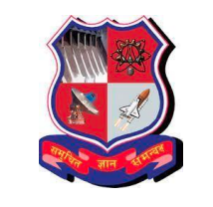

**Aditya Silver Oak Institute of Technology**

**Ahmedabad**

May, 2022