The main idea from this project, is for helping beginner peoples in the FPGA world to:

* Make a good understanding of the VGA functionality in FPGA of the ELBERT V2 Spartan 3A FPGA
* Create a very easy VHDL code for VGA using Xilinx tools.
* To learn how to make your first game on FPGA

**So let’s we start,**

First we need to buy the ELBERT V2 board

<https://numato.com/product/elbert-v2-spartan-3a-fpga-development-board>

Second we need to install on our PC the USB driver for the FPGA

<https://productdata.numato.com/assets/downloads/common/numato_lab_usb_cdc_driver.zip>

Third we need to install the Xilinx program which in my case (Xilinx\14.7 ISE design Suite)

<https://www.xilinx.com/member/forms/download/xef.html?filename=Xilinx_ISE_S6_Win10_14.7_ISE_VMs_0206_1.zip>

Then, we need to install the ElbertV2Config.exe

<https://productdata.numato.com/assets/downloads/fpga/elbertv2/ElbertV2Config.exe>

Now we are ready but before we start, I recommended you to get more information about the Elbert V2 board and about the ISE design suite to initialize your first project directory

<https://docs.numato.com/doc/elbert-v2-spartan-3a-fpga-development-board/>

1. **Understand the VGA:**

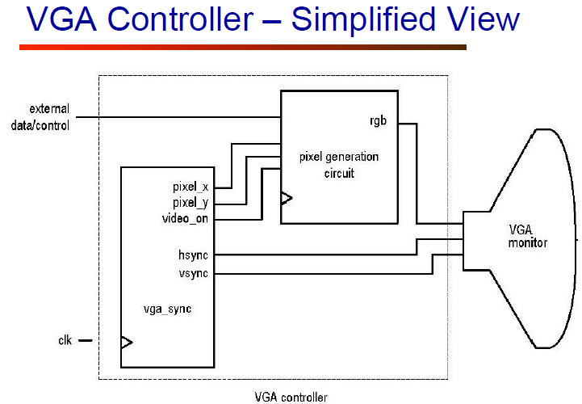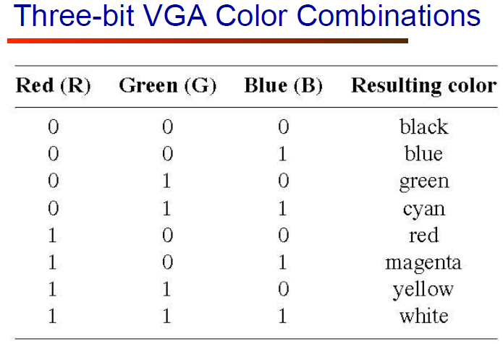

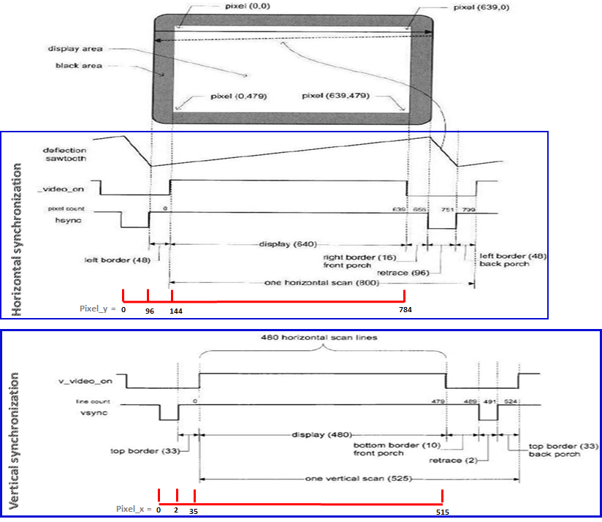

1. **VGA VHDL code**

My code have for module:

* *Topmodule:* responsible of the declaration of the VGA system (input and output).
* U1 - *IN_CLOCK_OUT*: Take a 12 MHz from the Topmodule and generate a 25 MHz clock as output.
* U2 - *counter*: this counter use 25 MHz as input clock and his output it will be used for the synchronization time of *VGA_sync and Topmodule* modules.
* U3 - *VGA_sync*: this module responsible of the vertical and horizontal synchronization and for the video output.

**The code exist on GitHub:**