ARRAY

- ARRAY OPERATOR
In Javascript , the + operator behaves differently based on the data type:

✅ When used with strings, it joins (concatenates) them:

let name = "John";
let greeting = "Hello, " + name;
console.log(greeting); // Output: Hello, John

❌ When used with arrays, it doesn't add or merge them properly:

let arr1 = [1, 2, 3];
let arr2 = [4, 5, 6];

console.log("Using +: " + arr1 + arr2);
// Output: Using +: 1,2,34,5,6
// This is WRONG: It merges them as strings, not numbers or arrays.

✅ Correct way to display arrays:

console.log("Array 1:", arr1);
console.log("Array 2:", arr2);
// Output: Array 1: [1, 2, 3]
// Array 2: [4, 5, 6]

✅ If you want to merge arrays:

let merged = arr1.concat(arr2);
console.log("Merged Array:", merged);
// Output: Merged Array: [1, 2, 3, 4, 5, 6]

🔍 Summary:
Type | Use of + | Output | Recommendation
String | Joins | "Hello, John" | ✅ Use +
Number | Adds | 3 + 2 = 5 | ✅ Use +
Array | Converts to string | [1,2] + [3,4] = "1,23,4" | ❌ Avoid + with arrays

2. ARRAY BRACKET

In JavaScript, [] represents an array. It is used to store multiple values in a single variable, including objects, numbers, strings, or even other arrays.

✅ Example:
let people = [
{ firstname: "vraj", lastname: "valand" }
];

🔍 What is this?
- [] → This is an array.
- { firstname: "vraj", lastname: "valand" } → This is an object.
- So you are creating an array of objects.

📌 Why do we write like this?
This format is very useful when:

1. You have a list of similar items (like users, products, etc.)
let users = [
{ firstname: "vraj", lastname: "valand" },
{ firstname: "ravi", lastname: "patel" },
];

2. You want to loop through them:
users.forEach((user) => {
console.log(user.firstname + " " + user.lastname);
});
// Output:
// vraj valand
// ravi patel

3. You want to access one object by index:

console.log(users[0].firstname); // Output: vraj

💡 Summary:
Symbol | Used For | Example
[] | Arrays | [1, 2, 3]
{} | Objects / Code Block | {key: "value"} or {...code}
() | Grouping / Functions | (x + y) or function() {...}

3. Array Mapping
Array mapping in JavaScript is a technique where we use the map() method to create a new array by applying a function to each element of an existing array, without modifying the original array."
What is Array Mapping?
- map() is a method used to loop through an array and transform each element.
- It returns a new array with the modified values.

🧠 Syntax:
let newArray = oldArray.map(function(item) {
return updatedItem;
});

📘 Example 1: Square each number
let numbers = [1, 2, 3, 4, 5];

let squares = numbers.map(function(num) {
return num * num;
});

console.log(squares); // Output: [1, 4, 9, 16, 25]

📘 Example 2: Using Arrow Function
let squares = numbers.map(num => num * num);

📘 Example 3: Array of Objects
let students = [
{ name: "Vraj", marks: 70 },
{ name: "Ravi", marks: 85 }
];

let namesOnly = students.map(student => student.name);

console.log(namesOnly); // Output: ["Vraj", "Ravi"]

✅ 2. Function in JavaScript
A function is a block of code designed to perform a particular task.

📘 Example 1: Simple function
function greet(name) {
return "Hello, " + name;
}

console.log(greet("Vraj")); // Output: Hello, Vraj

📘 Example 2: Arrow function
let greet = (name) => {
return "Hello, " + name;
};

🧪 Combine map + function:

function double(n) {
return n * 2;
}

let nums = [2, 4, 6];
let doubled = nums.map(double);

console.log(doubled); // Output: [4, 8, 12]

4. Array Function

1. Regular Function Declaration

function add(a, b) {
return a + b;
}
let result = add(5, 3);
console.log(result); // Output: 8

🔍 Explanation:
Line | What it does
function add(a, b) | Declares a named function called add that accepts two parameters a and b.
{ return a + b; } | The function returns the sum of a and b.
let result = add(5, 3); | Calls the function with 5 and 3 → add(5, 3) returns 8.
console.log(result); | Prints the result → 8.

✅ Why use a named function?
- Helpful in debugging (error stack shows add).
- Easier to reuse multiple times.
- Can be hoisted – means you can call it even before it's written in the code.

✅ 2. Arrow Function (anonymous)

const add = (a, b) => {
return a + b;
};

🔍 Explanation:
Line | What it does
const add = | You are storing the function inside a variable called add.
(a, b) => { return a + b; } | This is an arrow function with two inputs. It returns their sum.

⚠️ Why arrow functions don't need a name?
- Because the function is being stored inside a variable, like const add. So the name is not required in the function itself.
- It's called an anonymous function (function without name).
- You call it using the variable: add(5, 3)

✅ 3. Short Arrow Function (1 line)

const add = (a, b) => a + b;

🔍 Explanation:
Line | What it does
(a, b) => a + b | No {} and no return needed if it's just one line. It auto-returns the result.

⚖️ Difference Summary: Regular Function vs Arrow Function
Feature | Regular Function | Arrow Function
Name | Required | Optional (usually stored in variable)
Hoisting | ✅ Yes | ❌ No
this binding | Traditional this context | Inherits this from outer scope (lexical)
Syntax | Longer | Shorter
Use | Useful for methods or hoisting | Useful for small, inline functions

NOTE THIS :
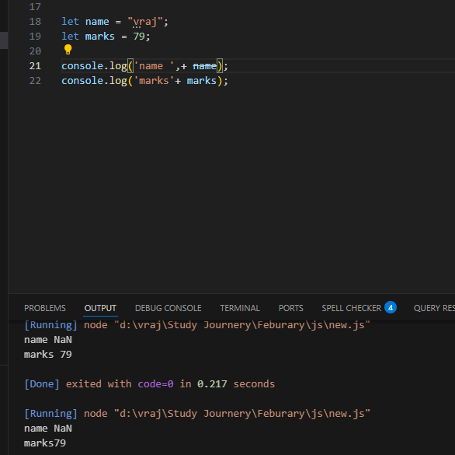
REASON BECAUSE IT IS CONVERTING THE STRING A NUMBER , SO DON’T USE “ ,+ ” TOGETHER IN FUTURE.
HERE USE “, +’ WHICH IS GIVING RESULT NAN

