Module (HTML) - 1

* **Are the HTML tags and elements the same thing?**
* HTML elements can be nested (this means that elements can contain other elements).
* All HTML documents consist of nested HTML elements.
* The following example contains four HTML elements (<html></html>, <body></body>, <h1></h1> etc…)
* Example:<p> xyz </p>
* Given above example is called as html tag.
* For example,
* <!DOCTYPE html>  
  <html>  
  <body>  
    
  <h1>My First Heading</h1>  
    
  </body>  
  </html>
* **What are tags and attributes in HTML?**
* The <img> tag is used to embed an image in an HTML page. The src attribute specifies the path to the image to be displayed
* For example,
* <img src=”jpg”>
* **What are void elements in HTML?**
* Void elements are those element who does not have closing tag ‘</>’
* For example,
* <br>- It is used to break line.
* <img>- It is used to display image in html etc…
* **What are HTML Entities?**
* HTML entities are &c, &r, &pound etc… this represents the symbol of copyright and pound.
* Example,
* &copy;
* &rupee;
* &dollar;
* **What are different types of lists in HTML?**
* There are 3 types of list in HTML

>>Ordered List

>>Definition List

>>Unordered List

For example,

>>Ordered List:-use for list

<ol>

<li>1</li>

<li>2</li>

<li>3</li>

</ol>

o/p:

1.1

2.2

3.3

>>Unordered List:- use for bold

<ul>

<li>1</li>

<li>2</li>

<li>3</li>

</ul>

o/p:

* 1
* 2
* 3
* **What is the 'class' attribute in HTML?**
* The class attribute specifies one or more classmate for an element.
* The class attribute is mostly used to point to a class in a stylesheet.
* For example,
* 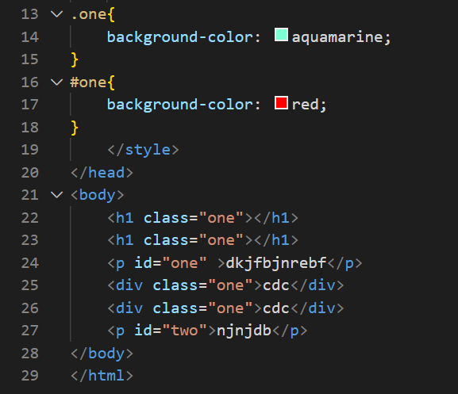
* **What are the various formatting tags in HTML?**
* There are various type of HTML tag they are,
* <br> <strong>
* <i> <em>
* <sup> <sub>
* <u> <ins>etc…
* **How is Cell Padding different from Cell Spacing?**

**Cell Padding:** - Cell padding is the space between the cell edges and the cell content.

By default, the padding is set to 0.

<!DOCTYPE html>

<html>

<head>

<style>

table, th, td {

border: 1px solid black;

border-collapse: collapse;

}

th, td {

padding: 15px;

}

</style>

</head>

<body>

<h2>Cellpadding</h2>

<p>Cell padding specifies the space between the cell content and its borders.</p>

<table style="width:100%">

<tr>

<th>Firstname</th>

<th>Lastname</th>

<th>Age</th>

</tr>

<tr>

<td>Jill</td>

<td>Smith</td>

<td>50</td>

</tr>

<tr>

<td>Eve</td>

<td>Jackson</td>

<td>94</td>

</tr>

<tr>

<td>John</td>

<td>Doe</td>

<td>80</td>

</tr>

</table>

<p><strong>Tip:</strong> Try to change the padding to 5px.</p>

</body>

</html>

o/p

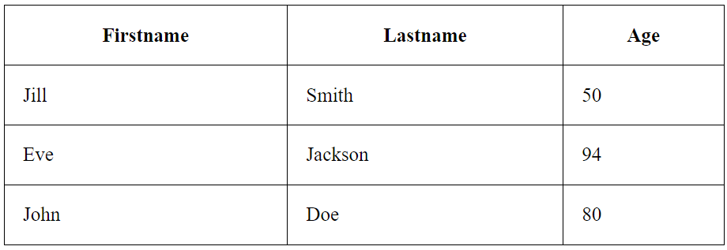

**Cell Spacing: -** Cell spacing is the space between each cell.

By default, the space is set to 2 pixels.

For example,

<!DOCTYPE html>

<html>

<head>

<style>

table, th, td {

border: 1px solid black;

}

table {

border-spacing: 30px;

}

</style>

</head>

<body>

<h2>Cellspacing</h2>

<p>Change the space between the cells with the border-spacing property.</p>

<table style="width:100%">

<tr>

<th>Firstname</th>

<th>Lastname</th>

<th>Age</th>

</tr>

<tr>

<td>Jill</td>

<td>Smith</td>

<td>50</td>

</tr>

<tr>

<td>Eve</td>

<td>Jackson</td>

<td>94</td>

</tr>

<tr>

<td>John</td>

<td>Doe</td>

<td>80</td>

</tr>

</table>

</body>

</html>

O/p

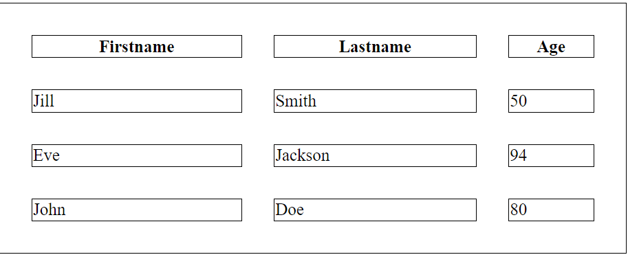

* **How can we club two or more rows or columns into a single row or column in an HTML table?**
* We can merge table cells in HTML.
* It can be done by using the rowspan and colspan attribute in HTML.
* The rowspan is used to merge or combine the number of cells in a row.
* The colspan is used to merge cells in a table.

<!DOCTYPE html>

<html>

<head>

</head>

<body>

<table align="center">

<tr>

<th>Name</th>

<th>Age</th>

</tr>

<tr>

<td>Akku</td>

<td rowspan="2">44</td>

</tr>

<tr>

<td>fahad</td>

</tr>

</table>

</body>

</html>

o/p

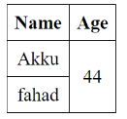

* **How to create a Hyperlink in HTML?**
* <a href=” www.google.com”>click here</a>
* **What is the use of an iframe tag?**
* The HTML <iframe> tag specifies an inline frame.
* An inline frame is used to embed another document within the current HTML document.
* For example, >
* <iframe width="560" height="315" src="https://www.youtube.com/embed/8cQIFxx8M5c" title="YouTube video player" frameborder="0" allow="accelerometer; autoplay; clipboard-write; encrypted-media; gyroscope; picture-in-picture; web-share" allowfullscreen></iframe>



* **What is the use of a span tag? Explain with example?**
* The Span Tag is a paired tag it mean span tag has both open & closing tag & it is mandatory to close the tag.
* The span tag is used for the grouping of inline elements & this tag do not make any visual change by itself.
* 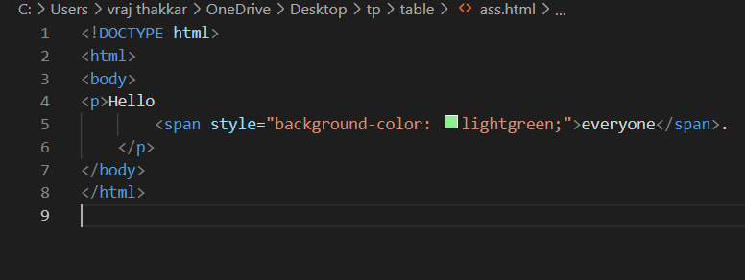
* 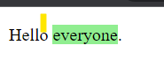
* **How are active links different from normal links?**
* The HTML <a> tag defines a hyperlink

**For example,**

* <a href="*url*">*link text*</a>
* <a href="www.google.com">click here</a>
* **What are the different tags to separate sections of text?**
* There are different types of tags they are,
* <br> this tag is used for break line
* <div>this tag is used for division
* <p>this tag is used for paragraph
* **What is SVG?**
* SVG stands for Scalable Vector Graphics
* SVG is used to define vector-based graphics for the Web
* SVG defines the graphics in XML format
* **What is difference between HTML and XHTML?**

XHTML stands for E**X**tensible **H**yper**T**ext **M**arkup **L**anguage

XHTML is a stricter, more XML-based version of HTML

XHTML is HTML defined as an XML application

XHTML is supported by all major browsers