Module (CSS and CSS 3) .2

* **What are the benefits of using CSS?**
* CSS stand for Cascading Style Sheets.
* It is a tool for styling a web pages.
* CSS make it easier to create and design a website.
* CSS is a tool for creating attractive & accessible web pages.
* **What are the disadvantages of CSS?**
* CSS work differently on different browser.
* There exists a scarcity of security.
* Extra work for developer.
* Confusion due to many CSS levels.
* **What is the difference between CSS2 and CSS3?**

|  |  |
| --- | --- |
| * CSS2 | * CSS3 |
| * CSS2 launched in 1998 | * CSS3 launched in 1999 |
| * css2 had a normally styling. | * Css3 had a better styling. |
| * it has box layout | * It has flexible layout. |
| * support single block only | * Support multi column text block |

* **Name a few CSS style components?**
* Font style, Margin padding, Background Style, Position, Animation style.
* **What do you understand by CSS opacity?**
* Opacity means transparent.
* Opacity comes between 0 to 1.
* For example,
* <html>
* <head>
* <style>
* Opacity=”0.5”;
* </style>
* </head>
* <body></ body>
* </html>
* **How can the background color of an element be changed?**
* We can change background color using “Background-color” property.
* <!DOCTYPE html>
* <html lang="en">
* <head>
* <meta charset="UTF-8">
* <meta http-equiv="X-UA-Compatible" content="IE=edge">
* <meta name="viewport" content="width=device-width, initial-scale=1.0">
* <title>Document</title>
* <style>
* body{
* width: 200px;
* height: 200px;
* /* background-image: url(urus.jpeg); */
* background-repeat: no-repeat;
* }
* /* div{
* color: red;
* } */
* .one{
* height: 200px;
* width: 200px;
* background-color: red;
* }
* </style>
* </head>
* <body>
* <!-- <div>hello world</div> -->
* <div class="one"></div>
* </body>
* </html>

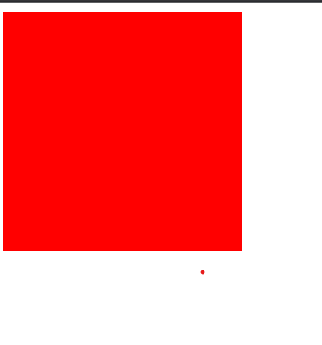

* **How can image repetition of the backup be controlled?**
* For repetitions of an image we can use (background repeat:”no-repeat”)
* <!DOCTYPE html>
* <html lang="en">
* <head>
* <meta charset="UTF-8">
* <meta http-equiv="X-UA-Compatible" content="IE=edge">
* <meta name="viewport" content="width=device-width, initial-scale=1.0">
* <title>Document</title>
* <style>
* body{
* width: 200px;
* height: 200px;
* background-image: url(urus.jpeg);
* background-repeat: no-repeat;
* }
* </style>
* </head>
* <body>
* </body>
* </html>

**o/p**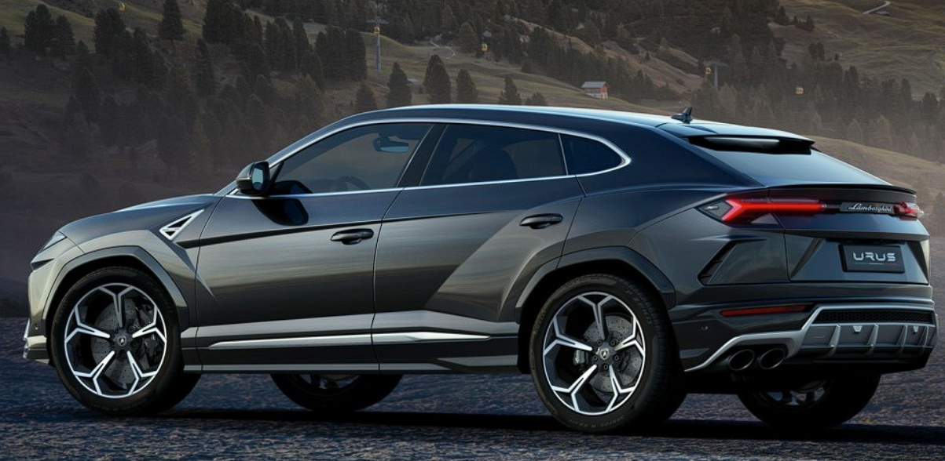

* **What is the use of the background position property?**
* The background position is used in CSS to specify the starting postion of bg image within its element.
* It determines where the bg img will be placed in relation to the element border or padding.
* **Which property controls the image scroll in the background?**
* The property of image scroll is,
* 1.scroll:-The scroll is default value and it allows the background image to scroll along with the content.
* 2.fixed:-This value fixes the background image in place so it remain stationary while the content scrolls.
* 3.local:-This value allows th bg img to scroll with the element it is applied.
* For example,
* body{
* background-image: url(‘background-image.jpg’);
* background-attachment: fixed;
* }
* **Why should background and color be used as separate properties?**
* Background color give to hole body color.
* Color gives only uses for an text.
* <!DOCTYPE html>
* <html lang="en">
* <head>
* <meta charset="UTF-8">
* <meta http-equiv="X-UA-Compatible" content="IE=edge">
* <meta name="viewport" content="width=device-width, initial-scale=1.0">
* <title>Document</title>
* <style>
* body{
* width: 200px;
* height: 200px;
* background-image: url(urus.jpeg);
* }
* div{
* color: red;
* }
* </style>
* </head>
* <body>
* <div>hello world</div>
* </body>
* </html>
* 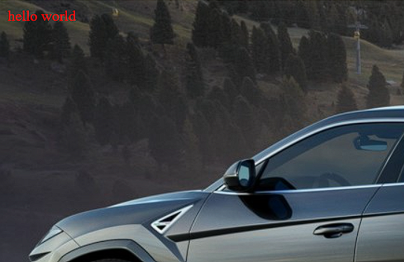
* **How to center block elements using CSS?**
* To center block elements using CSS, you can use 2 different methods they are,
* write code in <center> tag </center> to center element.
* Text-align: using text-align center to center the block element.
* <!DOCTYPE html>
* <html lang="en">
* <head>
* <meta charset="UTF-8">
* <meta http-equiv="X-UA-Compatible" content="IE=edge">
* <meta name="viewport" content="width=device-width, initial-scale=1.0">
* <title>Document</title>
* <style>
* #one1{
* background-color: aqua;
* text-align: center;
* }
* #one2{
* background-color: aqua;
* }
* </style>
* </head>
* <body>
* <h1 id="one1">Hello World</h1>
* <center>
* <h1 id="one2">This is a heading</h1>
* </center>
* </body>
* </html>

**o/p**

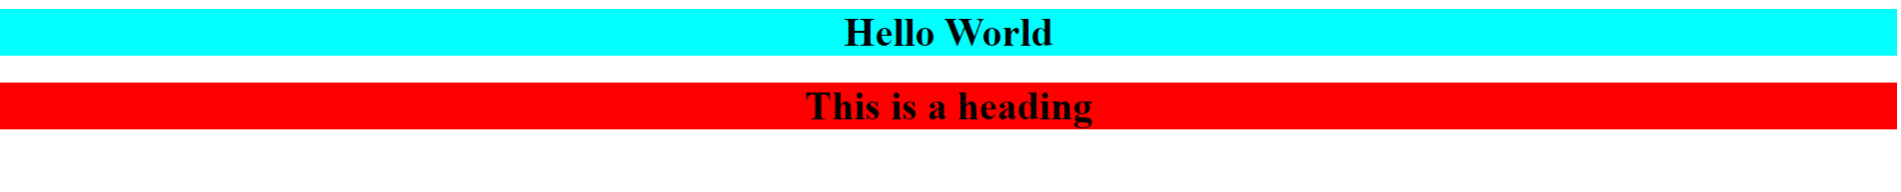

* **What are the ways to integrate CSS as a web page?**
* **Inline CSS:** In this method, you include CSS styles directly within the HTML elements using the style attribute
* **For example,**

<p style="color: blue; font-size: 16px;">This is a paragraph with inline CSS.</p>

* **Internal CSS:** With internal CSS, you define the styles within the <style> tags within the HTML <head> section.
* **For example,**

<!DOCTYPE html>

<html>

<head>

<title>Internal CSS Example</title>

<style>

p {

color: blue;

font-size: 16px;

}

</style>

</head>

<body>

<p>This is a paragraph with internal CSS.</p>

</body>

</html>

* **External CSS**: This is the most common and recommended method for integrating CSS into a web page. In this approach, you create a separate CSS file with a .css extension and link it to your HTML file using the <link> tag.
* **For example,**

Html code

<!DOCTYPE html>

<html>

<head>

<title>External CSS Example</title>

<link rel="stylesheet" type="text/css" href="styles.css">

</head>

<body>

<p>This is a paragraph with external CSS.</p>

</body>

</html>

Css code,

p {

color: blue;

font-size: 16px;

}

* **What is embedded style sheets?**
* Embedded style sheets, also known as internal style sheets.
* In the case of embedded style sheets, the CSS rules are placed within the <style> element, which is typically located in the <head> section of an HTML document. The CSS rules specified within the <style> element will only affect the HTML elements contained within that particular document.
* **For example,**
* <!DOCTYPE html>

<html>

<head>

<title>Embedded Style Sheet Example</title>

<style>

body {

background-color: #f2f2f2;

font-family: Arial, sans-serif;

}

h1 {

color: #333333;

}

p {

font-size: 16px;

line-height: 1.5;

}

</style>

</head>

<body>

<h1>Welcome to My Website</h1>

<p>This is an example of using embedded style sheets.</p>

</body>

</html>

* **What are the external style sheets?**
* External style sheets are files that contain CSS (Cascading Style Sheet) code and are referenced by HTML documents to control the visual appearance and layout of web pages.
* They provide a way to separate the presentation (styling) of a website from its structure (HTML) and behavior (JavaScript).
* By placing CSS code in an external style sheet, you can define a set of styles that can be applied to multiple web pages within a website.
* <!DOCTYPE html>
* <html>
* <head>
* <link rel=”stylesheet” href=”style.css”>
* </head>
* </body>
* </html>
* **What are the advantages and disadvantages of using external style sheets?**
* **Adv. Of external style sheet**
* External style sheets allow for a clear separation between the content (HTML) and the presentation (CSS).
* This separation makes it easier to manage and maintain large websites or applications as changes to the design can be made in a single file, affecting multiple pages.
* Changes can be made centrally in the external style sheet, and those changes will automatically be applied to all the pages that link to it.
* **Disadv. Of external style sheet**
* When using external style sheets, each page that links to the style sheet will require an additional server request to fetch the CSS file.
* External style sheets rely on an additional file, which needs to be loaded separately from the HTML document. If the style sheet fails to load or is missing, the webpage may not be styled correctly or may lose its formatting altogether.
* **What is the meaning of the CSS selector?**
* It is a fundamental part of CSS (Cascading Style Sheets) and is used to apply styles, such as colors, fonts, layouts, and other visual properties, to elements on a web page.
* The CSS selector syntax allows you to specify the elements you want to target based on their tag name, class, ID, attributes, or their relationship to other elements.
* **What are the media types allowed by CSS?**
* **Screen sizes for CSS media**
* 0-480 (smaller smartphones)
* 481-768 (Tablet and larger smartphones)
* 769-1279 (Laptop and desktops)
* 1280+ (Larger desktops)
* **What is the rule set?**
* Rule set is a selector, property and value.
* Structure of rule set
* Selector {
* Property: value;
* }
* **Create layout?**
* <!DOCTYPE html>
* <html lang="en">
* <head>
* <meta charset="UTF-8">
* <meta http-equiv="X-UA-Compatible" content="IE=edge">
* <meta name="viewport" content="width=device-width, initial-scale=1.0">
* <title>Document</title>
* <style>
* #o{
* display: flex;
* justify-content: space-evenly;
* }
* #one{
* height: 300px;
* width: 300px;
* border: 2px solid black;
* }
* .two{
* height: 110px;
* width: 200px;
* background-color: black;
* color: white;
* padding-top: 50px;
* padding-left: 100px;
* }
* .three{
* width: 300px;
* height: 100px;
* margin-top: 5px;
* margin-left: 5px;
* }
* #t{
* display: flex;
* justify-content: space-evenly;
* margin-top: 20px;
* }
* #oneb{
* height: 30px;
* width: 60px;
* background-color: rgba(128, 128, 128, 0.509);
* margin-left: 10px;
* }
* #twob{
* height: 30px;
* width: 60px;
* background-color:  rgba(128, 128, 128, 0.509);
* margin-left: -5px;
* }
* </style>
* </head>
* <body>
* <!-- box one  -->
* <div id="o">
* <div id="one">
* <div class="two">div1</div>
* <div class="three"> Lorem ipsum dolor, sit amet consectetur  adipisicing elit. Assumenda cupiditate recusa  labore dolore accusantium autem temporibus </div>
* <button id="oneb">View</button>
* <button id="twob">Edit</button>
* </div>
* <div id="one">
* <!-- box two  -->
* <div class="two">div2</div>
* <div class="three"> Lorem ipsum dolor, sit amet consectetur  adipisicing elit. Assumenda cupiditate recusa  labore dolore accusantium autem temporibus </div>
* <button id="oneb">View</button>
* <button id="twob">Edit</button>
* </div>
* <div id="one">
* <!-- box three  -->
* <div class="two">div3</div>
* <div class="three"> Lorem ipsum dolor, sit amet consectetur  adipisicing elit. Assumenda cupiditate recusa  labore dolore accusantium autem temporibus </div>
* <button id="oneb">View</button>
* <button id="twob">Edit</button>
* </div>
* </div>
* <div id="t">
* <div id="one">
* <!-- box four  -->
* <div class="two">div4</div>
* <div class="three"> Lorem ipsum dolor, sit amet consectetur <br> adipisicing elit. Assumenda cupiditate recusa <br> labore dolore accusantium autem temporibus </div>
* <button id="oneb">View</button>
* <button id="twob">Edit</button>
* </div>
* <div id="one">
* <!-- box five  -->
* <div class="two">div5</div>
* <div class="three"> Lorem ipsum dolor, sit amet consectetur <br> adipisicing elit. Assumenda cupiditate recusa <br> labore dolore accusantium autem temporibus </div>
* <button id="oneb">View</button>
* <button id="twob">Edit</button>
* </div>
* <div id="one">
* <!-- box six  -->
* <div class="two">div6</div>
* <div class="three"> Lorem ipsum dolor, sit amet consectetur <br> adipisicing elit. Assumenda cupiditate recusa <br> labore dolore accusantium autem temporibus </div>
* <button id="oneb">View</button>
* <button id="twob">Edit</button>
* </div>
* </div>
* </body>
* </html>
* **o/p**

