**Phase - 6 OOP Programs**

**Practical-1**

**Aim: Create an Add to Cart system for only Grocery itemes**

**such as :**

**. Breads, Wheat, Milk, Soup, Frozen Foods, Cheese.**

**Customer can buy these items in any quantity he/she**

**wants.A customer can add /update/delete any itself in any**

**quantity whenever he/she wants.**

**Give customer a final bill including all types of TAX on**

**total price. Identify if a customer can pay bill or not**

**with his/her available wallet amount.**

**Program:**

**Output:**

**Practical-2**

**Aim: A Businessman was bankrupted in a Scan with a minimal**

**amount left in a bank of ₹.18,000. After some months of hardwork**

**,he earned external amount of ₹.1,20,000.Now he might be goes to**

**the bank and do a deposit or withdraw some money as he wants.**

**Prepare a C++ solution for this scenario with all required validations and criterias.**

**Program:**

#include<iostream>

#include<string.h>

using namespace std;

class business

{

private:

char acc_no1[100]="1234567890";

char pass1[100]="709678";

char acc_no[100], pass[100];

char name[100];

int amt,c,d;

public:

void businessman()

{

cout<<endl<<"=> Enter Name: ";

fflush(stdin);

gets(name);

cout<<"=> Enter Account Number: ";

fflush(stdin);

gets(acc_no);

cout<<"=> Enter Password: ";

fflush(stdin);

gets(pass);

}

void List()

{

cout<<endl<<"* [1] Deposite "<<endl;

cout<<"* [2] Withdraw "<<endl;

cout<<"* [0] Exit "<<endl;

}

void solution()

{

if(strcmp(acc_no1,acc_no)==0 && strcmp(pass1,pass)==0 )

{

cout<<"=> Enter Total Amount: ";

cin>>amt;

if(amt==18000)

{

do{

List();

cout<<"=> Enter Your Choice: ";

cin>>c;

if(c==1)

{

cout<<"- How many deposite:- ";

cin>>d;

amt+=d;

cout<<endl<<"- Your balance : "<<amt<<endl;

}

else if(c==2)

{

cout<<"- How many Withdraw:- ";

cin>>d;

amt-=d;

cout<<endl<<"- Your balance is: "<<amt<<endl;

}

else if(c!=0)

{

cout<<endl<<"- Please, Enter Valid Value...."<<endl;

}

}while(c!=0);

}

else

{

cout<<endl<<"- Sorry, You aren't able to open..."<<endl;

}

}

else

{

cout<<endl<<"- Please Enter Right Account no and Password...."<<endl;

}

}

};

int main()

{

business b1;

b1.businessman();

b1.solution();

return 0;

}

**Output:**

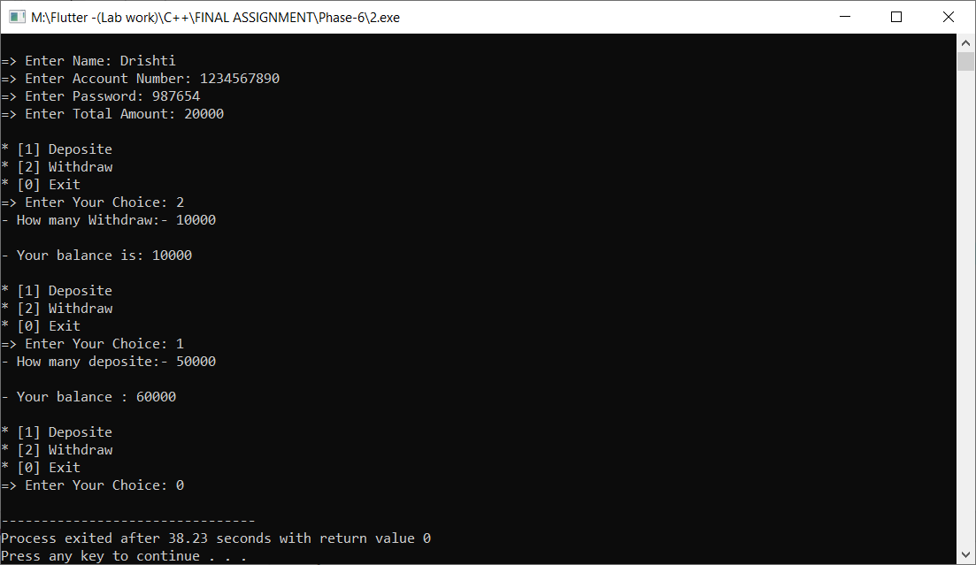

**Practical-3**

**Aim: An Auction is helding at Arizona for selling an old haunted**

**house. For the reason, this is a haunted house,only three gigantic companies took a part in this Auction.Sell this haunted house to the highest bidder with count of three. Use C++ with all required criteria**

**to build this type of Auction System.**

**Program:**

#include<iostream>

#include<string.h>

using namespace std;

class Auction

{

private:

int a,b,c,choice;

public:

void sell()

{

do{

cout<<endl<<"=> Enter 1 Company Prize: ";

cin>>a;

cout<<endl<<"=> Enter 2 Company Prize: ";

cin>>b;

cout<<endl<<"=> Enter 3 Company Prize: ";

cin>>c;

if(a>b)

{

if(a>c)

{

cout<<endl<<" First Company Win Successfully...."<<endl;

}

else

{

cout<<endl<<" Third Company Win Successfully...."<<endl;

}

}

else

{

if(b>c)

{

cout<<endl<<" Second Company Win Successfully...."<<endl;

}

else

{

cout<<endl<<" Third Company Win Successfully...."<<endl;

}

}

cout<<endl<<"* Press 1 for Continue.."<<endl;

cout<<"* Press 0 for Exit.."<<endl;

cout<<endl<<" Enter Choice: ";

cin>>choice;

}while(choice!=0);

}

};

int main()

{

Auction a1;

a1.sell();

return 0;

}

**Output:**

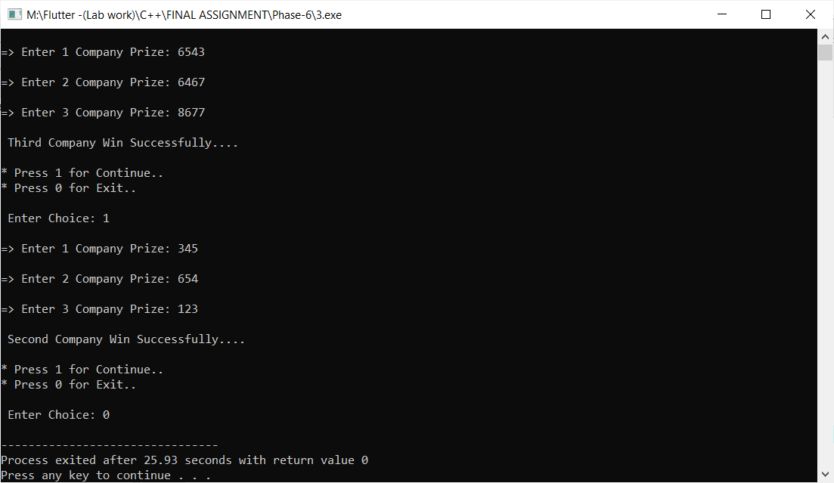

**Practical-4**

**Aim: Build a C++ system which predict a total profit of a Cashew**

**Company in Goa.If this company sells 1,23,500 piece of cashews in 1 month,then it generates total of ₹.78,000 in a month.Help this company**

**by producing 10X more cashews in 3 months and display total revenue**

**with increment percentage.**

**Program:**

#include<iostream>

#include<string.h>

using namespace std;

class Cashew

{

private:

int c=123500, Rs=78000, S_C , amt , p;

public:

void sell()

{

S_C = c*10;

amt = Rs*10;

p = ((S_C*100)/c)/3;

}

void getdata()

{

sell();

cout<<endl<<"-> This Company should Producing "<<S_C<<" Cashew."<<endl;

cout<<endl<<"-> Total Revenue with increment percentage is : "<<p<<"%"<<endl;

}

};

int main()

{

Cashew c1;

c1.getdata();

return 0;

}

**Output:**

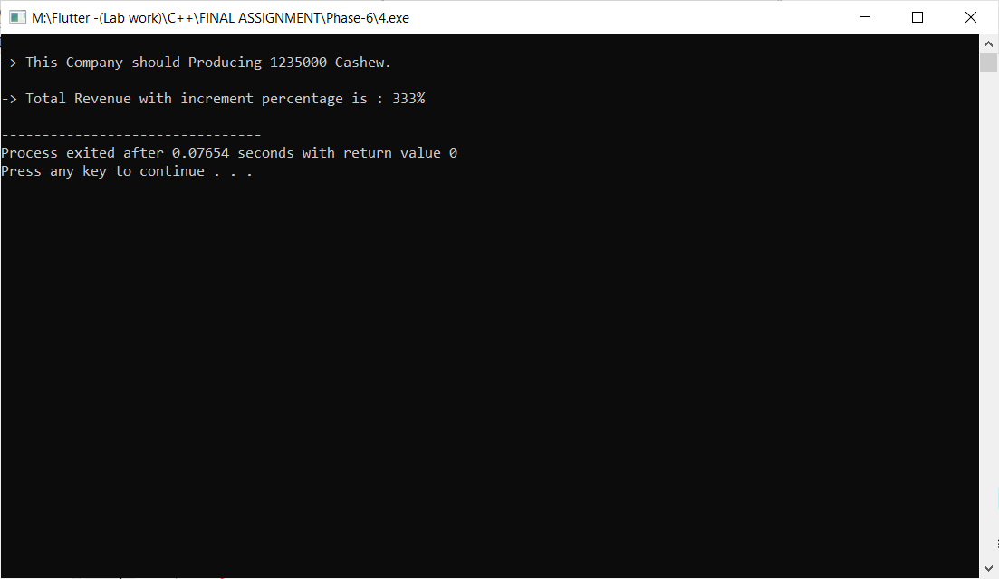

**Practical-5**

**Aim: The two short sides of a right triangle are 6 cm and 13 cm.Find**

**the length of the third side using Pythagoras Theorem with help of C++.**

**Program:**

#include<iostream>

#include<string.h>

#include<math.h>

using namespace std;

class Sides

{

private :

int AB ; // AC^2 = AB^2 + BC^2

int BC ;

int AC ;

int p;

public :

void Side_setData()

{

this->AB = 13;

this->BC = 6;

cout <<endl<<"-------------------------------------"<<endl;

cout <<"=> AC^2 = AB^2 + BC^2 :- "<<endl;

cout <<"-------------------------------------"<<endl;

cout <<endl<<"=> First Side (AB) : "<<this->AB;

cout <<endl<<"=> Second side (BC) : "<<this->BC;

cout <<endl<<endl<<"-------------------------------------";

}

void getData()

{

AC = (AB*AB)+(BC*BC);

p = sqrt(AC);

cout <<endl<<"=> Third Side (AC) : "<<p <<endl;

cout <<"-------------------------------------"<<endl;

}

};

int main()

{

Sides s1;

s1.Side_setData();

s1.getData();

return 0;

}

**Output:**

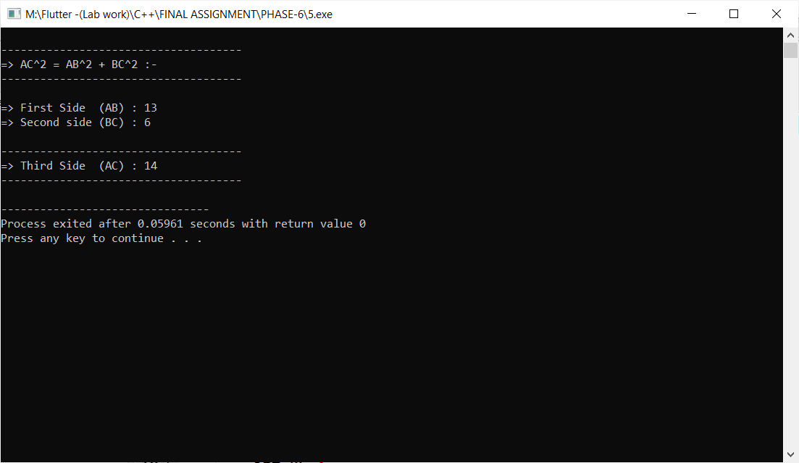

**Practical-6**

**Aim: TA 26 m long rope is stretched from the top of a 13 m**

**tree to the ground. Find the distance between the tree and the**

**end of the rope on the ground.**

**Program:**

#include<iostream>

#include<string.h>

using namespace std;

class Distance

{

private:

int a=26-13 ;

int b=13;

int c;

int d;

int temp=0;

public:

void getdata()

{

d=(a*a)+(b*b);

c = d/ 2;

while(c!=temp)

{

temp = c;

c = (d/temp + temp)/2;

}

cout<<endl<<"=> The distance between the tree and the end of the rope on the ground is: "<<c<<endl;

}

};

int main()

{

Distance d1;

d1.getdata();

return 0;

}

**Output:**

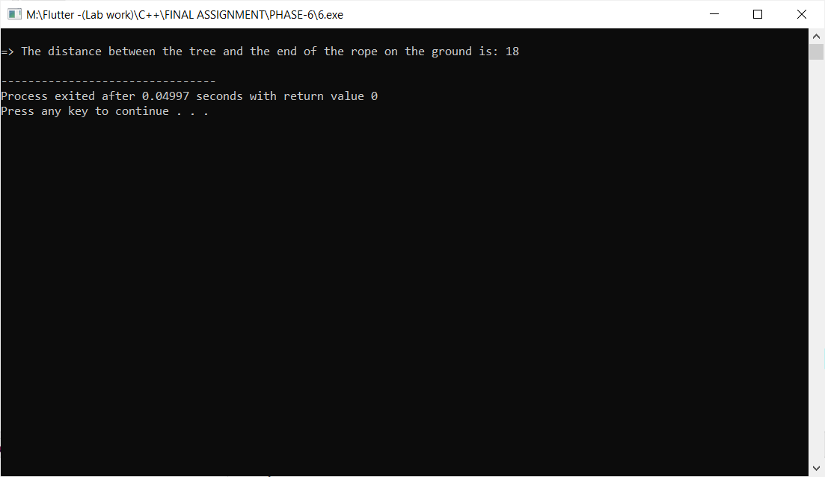

**Practical-7**

**Aim: Build a C++ system which helps a Mathematician to figure out**

**the type of a Triangle. Bases on Pythagoras’ theorem, find out if a tria-**

**ngle is: obtuse, right or acute.**

**Program:**

#include<iostream>

using namespace std;

class Square

{

private:

int a;

int b;

int c;

int sum;

public:

void S()

{

cout <<endl<< "=> Enter value of a :- "; cin >> this->a;

cout << "=> Enter value of b :- "; cin >> this->b;

cout << "=> Enter value of c :- "; cin >> this->c;

c= c*c;

sum = (a*a)+(b*b);

if(c==sum)

{

cout <<endl<< "- Right....";

}

else if (c>sum)

{

cout <<endl<< "- Obtuse....";

}

else

{

cout <<endl<< "- Acute....";

}

}

};

int main()

{

Square s1;

s1.S();

return 0;

}

**Output:**

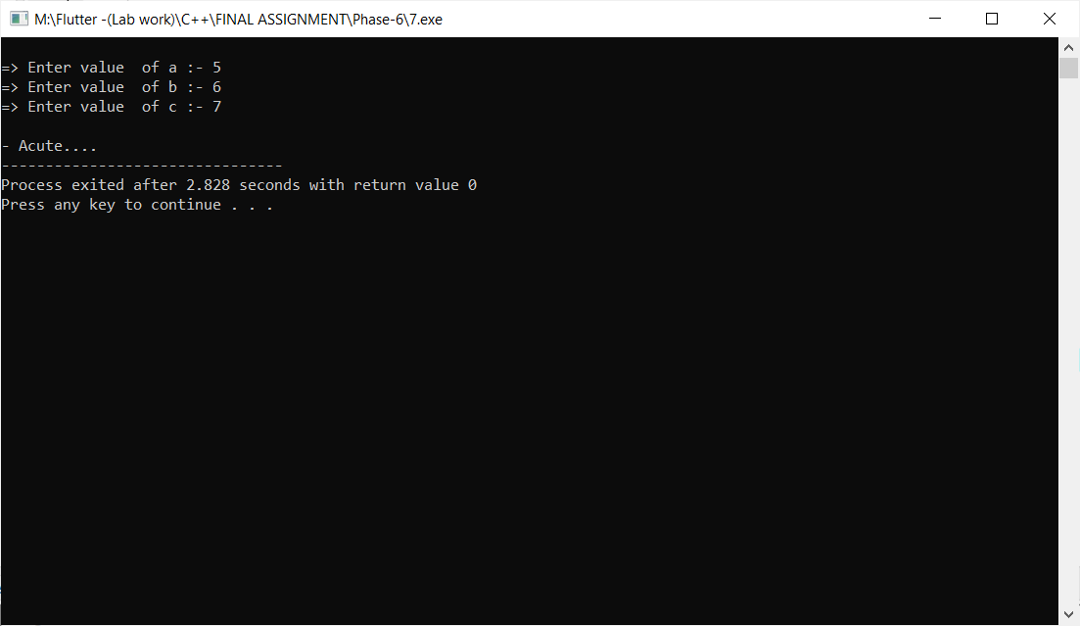

**Practical-8**

**Aim: A 15 m fire-fighter’s ladder is leaning against the wall. If the**

**ground distance between the foot of the ladder and the wall is 7 m, \**

**what is the wall’s height?**

**Program:**

#include<iostream>

#include<string.h>

#include<math.h>

using namespace std;

class Distance

{

private:

int a = 15;

int b = 7;

int c;

int k;

public:

void getData()

{

c=(a*a)+(b*b);

k=sqrt(c);

cout <<endl<<"- Height of wall : "<<k;

}

};

int main()

{

Distance d1;

d1.getData();

return 0;

}

**Output:**

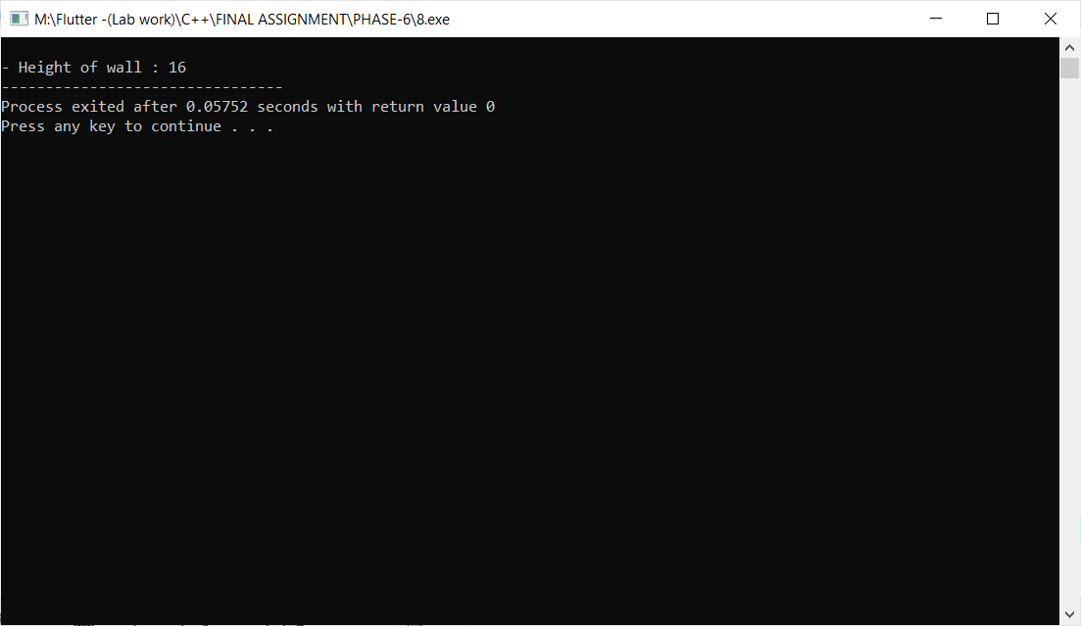

**Practical-9**

**Aim: Design a GST Calculator in C++ to find total TAX on various types**

**of categorized items. Apply proper types of Indian GST TAX varients based on different types of Goods. GST have been divided into four GST rates – 5%,**

**12%, 18%, and 28% by the GST Council.**

**Program:**

#include<iostream>

#include<string.h>

using namespace std;

class GST_cal

{

private:

int price;

int gst;

int total_price;

public :

void setData()

{

cout <<"......... * GST Calculator * ........."<<endl;

cout <<endl<<"=> Enter Price : ";

cin >>this->price;

}

void getData()

{

if(price<=500)

{

gst=(price*5)/100;

}

else if(price>=500 && price<=1000)

{

gst=(price*12)/100;

}

else if(price>=1000 && price<=2000)

{

gst=(price*18)/100;

}

else

{

gst=(price*28)/100;

}

total_price = price+gst;

cout <<endl<<"=> Total GST price : "<<gst <<endl;

cout <<endl<<"---------------------------------------"<<endl;

cout <<"=> Total TAX : "<<total_price;

cout <<endl<<"---------------------------------------"<<endl;

}

};

int main()

{

GST_cal g1;

g1.setData();

g1.getData();

return 0;

}

**Output:**

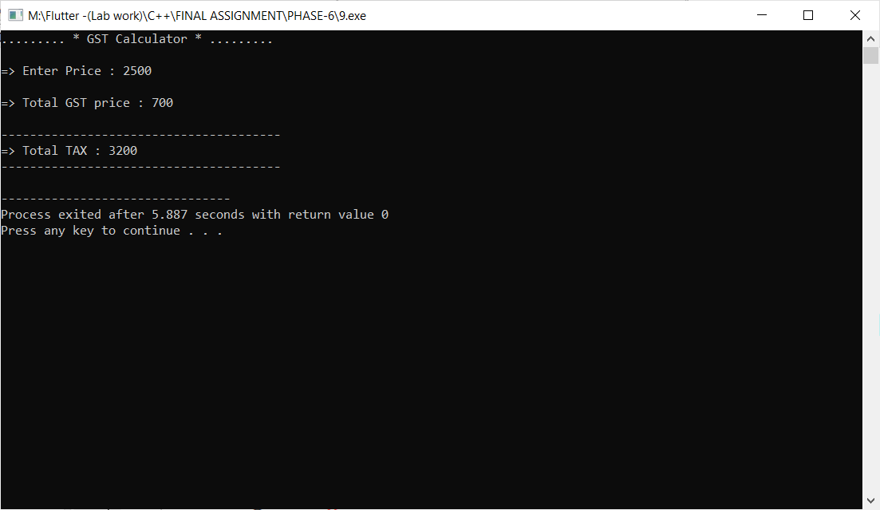

**Practical-10**

**Aim: Develop a C++ solution by which a user can add/subtract/multiply/**

**divide two Complex numbers with help of Operator Overloading concept.**

**In context of math, a complex number contains two parts: a real part and**

**an imagenary part.**

**Program:**

**Output:**

**Practical-11**

**Aim: Build an Indian Regional Festival system in C++. User can enter**

**any date of current running year, and bases on that date display which**

**festival will be coming on that date.**

**Program:**

#include<iostream>

#include<string.h>

using namespace std;

class Festival

{

private :

int date;

int month;

public :

void setData()

{

cout <<endl<<"=> Enter Month : ";

cin >>this->month;

cout <<"=> Enter Date : ";

cin >> this->date;

}

void getData()

{

cout <<endl<<"=> "<<date<<"/"<<month<<"/"<<"2022"<<endl;

if(date==14 && month==1)

{

cout <<endl<<"- Makar Sanskranti";

}

else if(date==17 && month==1)

{

cout <<endl<<"- Pongal";

}

else if(date==16 && month==2)

{

cout <<endl<<"- Basant panchami";

}

else if(date==1 && month==3)

{

cout <<endl<<"- Mahashivratri";

}

else if(date==17 && month==3)

{

cout <<endl<<"- Holika Dahan";

}

else if(date==18 && month==3)

{

cout <<endl<<"- Holi";

}

else if(date==16 && month==4)

{

cout <<endl<<"- Hanuman Jayanti";

}

else if(date==3 && month==5)

{

cout <<endl<<"- Akshaya Tritiya";

}

else if(date==2 && month==8)

{

cout <<endl<<"- Naga Panchami";

}

else if(date==31 && month==9)

{

cout <<endl<<"- Ganesh Chaturthi";

}

else if(date==3 && month==10)

{

cout <<endl<<"- Navratri";

}

else if(date==10 && month==10)

{

cout <<endl<<"- Dusshera";

}

else if(date==23 && month==10)

{

cout <<endl<<"- Dhanteras";

}

else if(date==24 && month==10)

{

cout <<endl<<"- Diwali";

}

else if(date==26 && month==10)

{

cout <<endl<<"- Bhai Dooj";

}

else

{

cout <<endl<<"- Invalid Choice....";

}

}

};

int main()

{

Festival f1;

f1.setData();

f1.getData();

return 0;

}

**Output:**

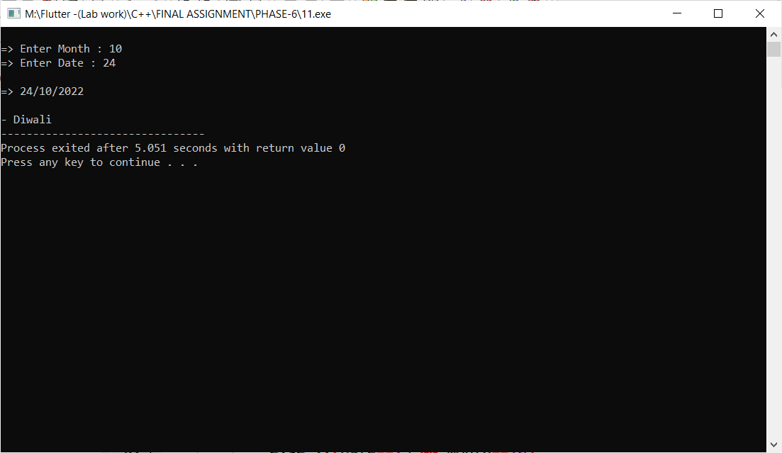

**Practical-12**

**Aim: Prince wants to create a 24 Hr time convertor app in C++. In**

**this app, user can provide any 24 Hr time he/she wants but output must**

**be produced in 12 Hr format.**

**For example,**

**i/p: 15 Hr, 32 Minutes**

**o/p: 3:32 PM**

**Program:**

#include<iostream>

#include<string.h>

using namespace std;

class Time_Convertor

{

private:

int hr;

int min;

public:

Time_Convertor()

{

cout <<endl<<"=> Enter Hour : ";

cin >>this->hr;

cout <<endl<<"=> Enter Minute : ";

cin >>this->min;

}

void TC_getData()

{

if(hr<=12)

{

cout <<endl<<"=> Time(12 hr) : "<<hr <<":" <<min <<endl;

}

else

{

cout <<endl<<"=> Time(12 hr) : "<<hr-12 <<":" <<min <<endl;

}

}

};

int main()

{

Time_Convertor t;

t.TC_getData();

return 0;

}

**Output:**

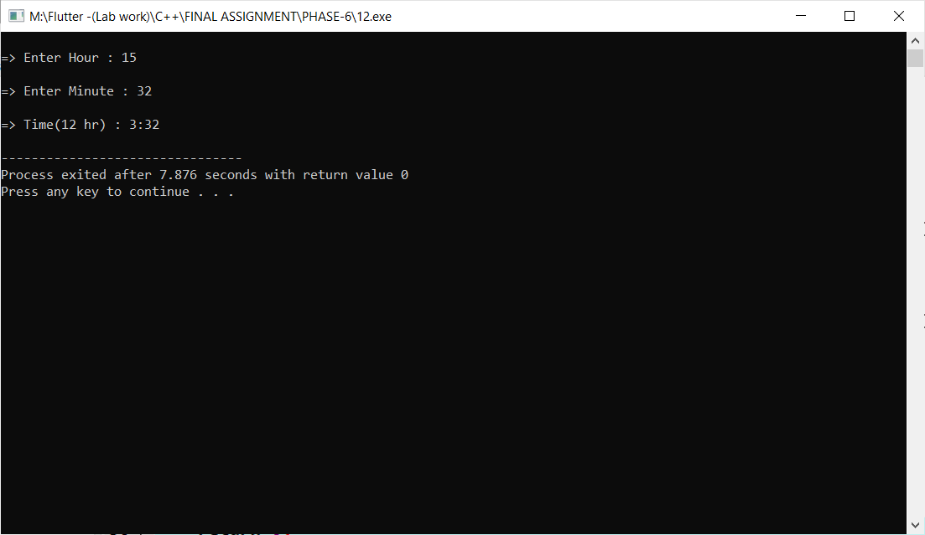

**Practical-13**

**Aim: Build a Counter App in C++ using OOP concept. Initially the**

**counter meant to be set as a value 0 using constructor. By pressing UP**

**Arrow from keyboard, counter will be increment and by pressing DOWN Arrow, counter will be decrement. You can use ASCII value concept by**

**achieving this type of functionality at the execution time of a Program.**

**Program:**

#include<iostream>

#include<string.h>

using namespace std;

class Counter

{

private:

int n;

public:

void setData()

{

cout <<endl<<"=> Enter value of n : ";

cin >> this->n;

}

void List()

{

cout <<endl<<"(1) Press 1 for Increment "<<endl;

cout <<"(2) Press 2 for Decrement "<<endl;

}

void Increment()

{

n=n+1;

cout <<endl<<"-------------------------------"<<endl;

cout <<"=> Increment value : "<<n <<endl;

cout <<"-------------------------------"<<endl;

}

void Decrement()

{

n=n-1;

cout <<"-------------------------------"<<endl;

cout <<"=> Decrement value : "<<n <<endl;

cout <<"-------------------------------"<<endl;

}

};

int main()

{

Counter c1;

c1.setData();

int choice;

cout <<"-------------------------------"<<endl;

c1.List();

cout <<endl<<" => Enter your choice : ";

cin >>choice;

if(choice==1)

{

c1.Increment();

}

else if(choice==2)

{

c1.Decrement();

}

else

{

cout <<"-> Invalid choice..";

}

return 0;

}

**Output:**

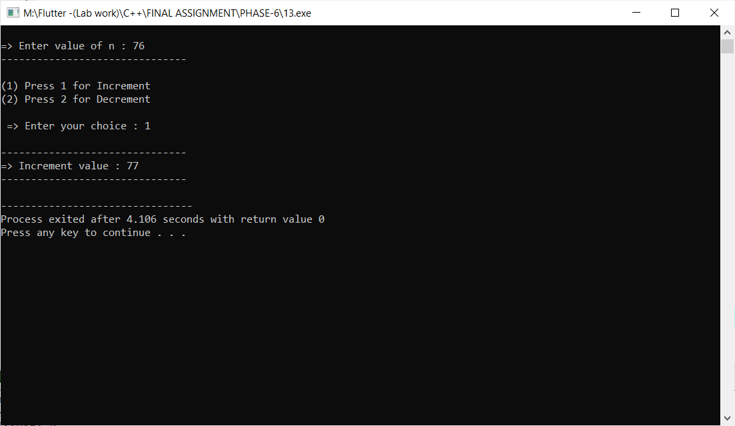

**Practical-14**

**Aim: Calculate an Electricity Bill of a House of one month**

**based on total units burned. Develop a C++ solution for**

**this calculation.**

**Program:**

#include<iostream>

#include<string.h>

using namespace std;

class Electricity_Bill

{

private:

int unit;

int total;

int t;

public:

Electricity_Bill()

{

cout <<endl<<"=> Enter Total Unit Usage : ";

cin >> unit;

}

void getData()

{

if(unit>0 && unit<=100)

{

cout <<endl<<"=> Your Bill Amount : ";

cout <<unit*5;

}

else if(unit>100 && unit<=200)

{

cout <<endl<<"=> Your Bill amount : ";

cout <<(100*5)+(unit-100)+7;

}

else if(unit>200 && unit<=300)

{

cout <<endl<<"=> Your Bill amount : ";

cout <<(100*5)+(100*7)+(unit-200)*10;

}

else

{

cout <<endl<<"=> Your Bill amount : ";

cout <<"No value";

}

}

};

int main()

{

Electricity_Bill e1;

e1.getData();

return 0;

}

**Output:**

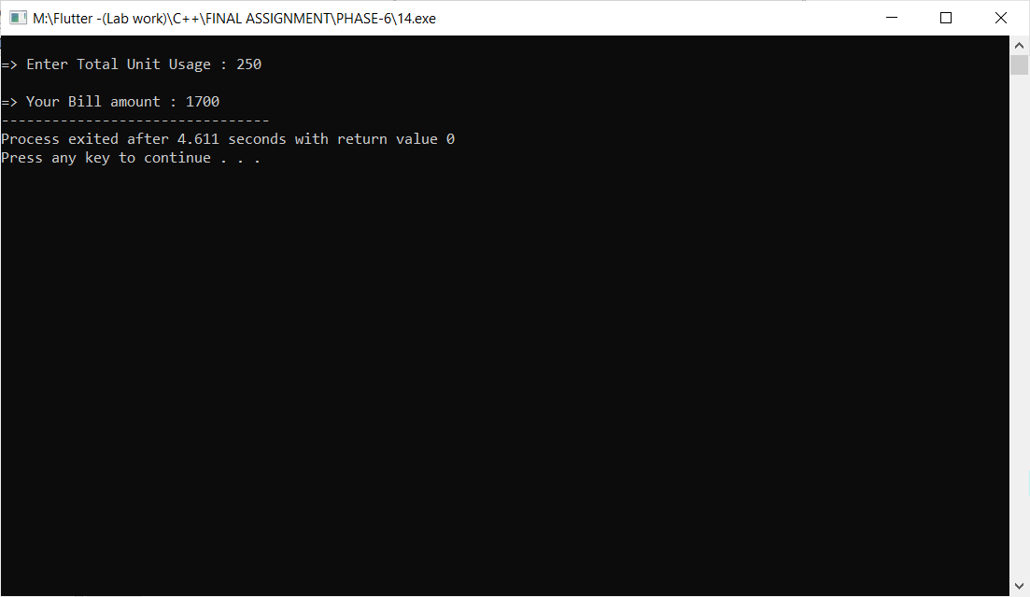

**Practical-15**

**Aim: Calculate toal coast to apply a Solar Powered Panels for your**

**Home Rooftop. Apply all types of government aid percentage to find reasonable coast.**

**Program:**

#include<iostream>

#include<string.h>

using namespace std;

class Solar

{

private:

int cell;

int power;

int price;

int del_chrg =1000;

int ord_chrg =150;

int f_c = 1500;

int total;

public:

Solar()

{

cout <<endl<<"=> Enter Number of cell : ";

cin >> cell;

cout <<"=> Enter power : ";

cin >> power;

}

void getData()

{

if(cell<=70)

{

price = 15000;

}

else if(cell<=150)

{

price=25000;

}

else

{

price=45000;

}

total=price+((price*20)/100)+del_chrg+ord_chrg+f_c;

cout<<endl<<"- Total Cost : " <<price <<endl;

cout<<"- Total GST : " <<(price*20)/100<<endl;

cout<<"- Total Delivery Charge : "<<del_chrg<<endl;

cout<<"- Total Other Charge : "<<ord_chrg<<endl;

cout<<"- Total Fitting Charge : "<<f_c<<endl<<endl;

cout<<"....................................."<<endl;

cout<<"- Total Cost : "<<total<<endl;

cout<<"....................................."<<endl;

}

};

int main()

{

Solar s1;

s1.getData();

return 0;

}

**Output:**

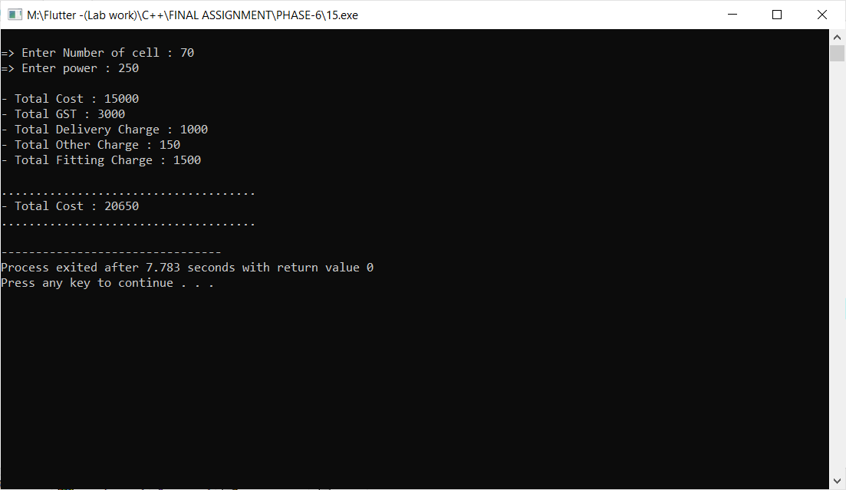

**Practical-16**

**Aim: Find Volume of a Box using Parameterized Constructor**

**and figure out if that is odd or even number.**

**Program:**

#include<iostream>

#include<string.h>

using namespace std;

class Box

{

private:

int volume;

public:

//Parameterized constructor

Box(int l , int b , int h)

{

volume = l*b*h;

cout <<endl <<"-> Volume of Box : "<<volume <<endl;

if(volume%2==0)

{

cout <<endl <<"-> This volume of box is even number ."<<endl;

}

else

{

cout <<endl <<"-> This volume of box is odd number ."<<endl;

}

}

};

int main()

{

int l ,b,h;

cout

cout <<"Enter Length : ";

cin >> l;

cout <<"Enter Breadth : ";

cin >> b;

cout <<"Enter Height : ";

cin >> h;

Box b1(l,b,h);

return 0;

}

**Output:**

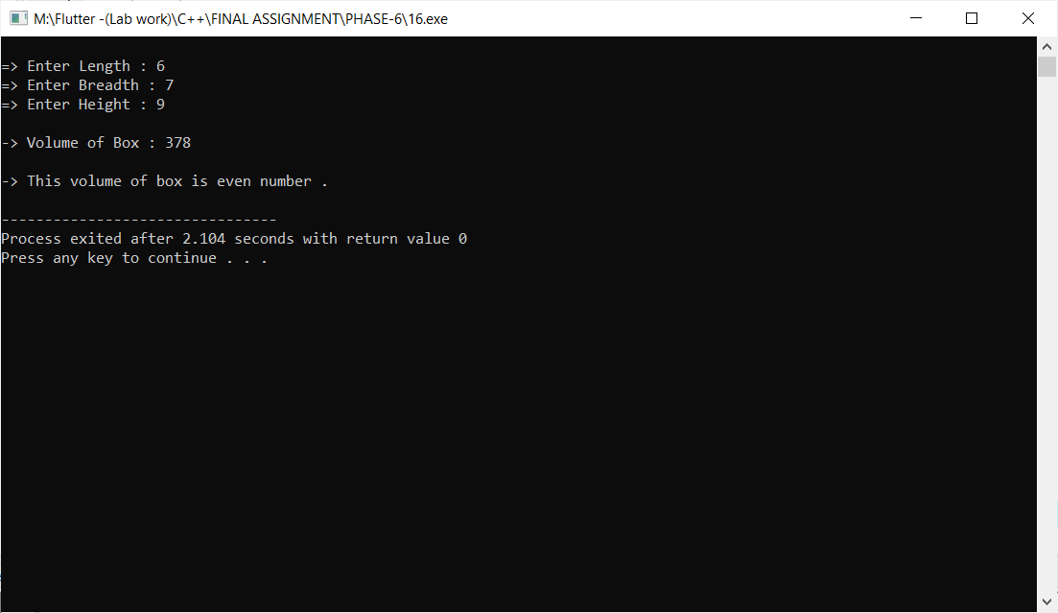

**Practical-17**

**Aim: By creating below mentioned inherited structure of classes, Assume suitable data and member methods for creating a Cricket scenario and listing score tables for top five players.**

**Program:**

**Output:**

**Practical-18**

**Aim: Help Ayush to perfom given operation:**

**a. Assume any number**

**b. Add 8 in that number**

**c. Multiply it with 3**

**d. Subtract 12 from it**

**e. Add another 5 into that**

**f. Add your birth year in it**

**g. Subtract current year from that**

**Finally display which number he get after performing all**

**above mentioned operations and find is it divisible by 7**

**or not.**

**Program:**

**Output:**

**Practical-19**

**Aim: Help a builder to build a house as same as**

**structurized as below:**

**Assume suitable data and member methods. You can add your**

**own functionalities to enhance this solution.**

**Program:**

#include<iostream>

#include<string.h>

using namespace std;

class House

{

public:

void HouseData()

{

cout <<" Welcome "<<endl;

cout <<" This is my house."<<endl;

}

};

class Kitchen : public House

{

public:

void KitchenData()

{

HouseData();

cout <<" There is a big kitchen in my house.";

}

};

class Bedroom : public House

{

public:

void BedroomData()

{

cout <<" There are four bedroom in my house."<<endl;

}

};

class Backyard : public House

{

public:

void BackyardData()

{

cout <<" This is backyard area in my house."<<endl;

}

};

class Dinning_table : public Kitchen

{

public :

void Dinning_tableData()

{

KitchenData();

cout <<endl<<" This is a Dinning table."<<endl;

}

};

class Bathroom : public Bedroom

{

public:

void BathroomData()

{

cout <<" This is a bathroom."<<endl;

BedroomData();

}

};

class Garage : public Backyard

{

public :

void GarageData()

{

BackyardData();

cout <<" This is a garage."<<endl;

}

};

int main()

{

Dinning_table d1;

Bathroom b1;

Garage g1;

d1.Dinning_tableData();

b1.BedroomData();

g1.GarageData();

return 0;

}

**Output:**

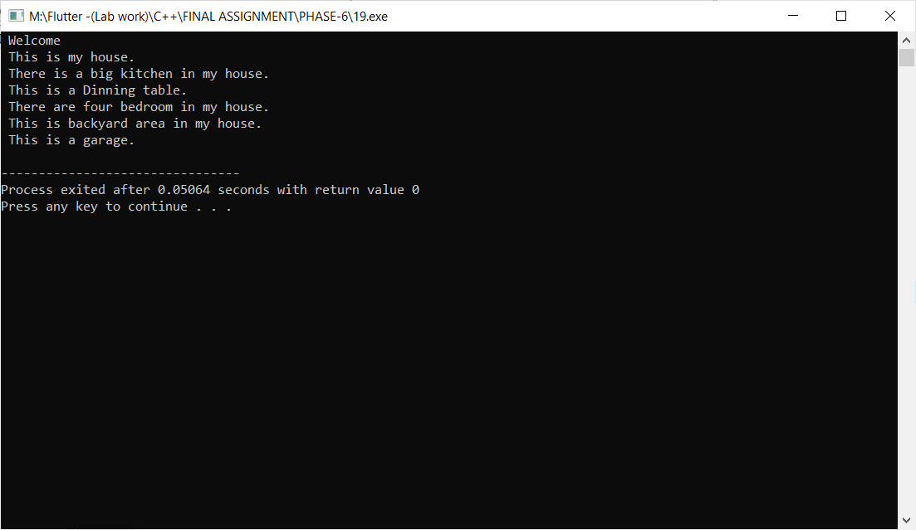

**Practical-20**

**Aim: A Higher Secondary School opens after COVID-19 crisis**

**and admission process will be starting for registration**

**of students. Help administration department for**

**registering student information such liker**

**stu_i**

**stu_nam**

**stu_ag**

**stu_cours**

**stu_emai**

**stu_college**

**Program:**

#include<iostream>

#include<string.h>

using namespace std;

class Student

{

private :

int stu_id;

char stu_name[100];

int stu_age;

char stu_course[100];

char stu_email[100];

static char stu_college[100];

public :

void Stu_setData()

{

cout << endl<<"- Enter Student Id : ";

cin >> this->stu_id;

cout <<"- Enter Student Name : ";

cin >> this->stu_name;

cout <<"- Enter Student Age : ";

cin >> this->stu_age;

cout <<"- Enter Student Course : ";

cin >> this->stu_course;

cout <<"- Enter Student Email : ";

cin >> this->stu_email;

}

void Stu_getData()

{

cout <<endl<<"=> Enter Student Information : "<<endl<<endl

<<"- ID : "<<this->stu_id <<endl

<<"- Name : "<<this->stu_name <<endl

<<"- Age : "<<this->stu_age <<endl

<<"- Course : "<<this->stu_course <<endl

<<"- Email : "<<this->stu_email <<endl

<<"- College : "<<this->stu_college<<endl;

}

};

char Student :: stu_college[100] = "M.K.Gandhi College";

int main()

{

Student s1[100];

int i,n;

cout <<endl<<"=> How many Students : ";

cin >> n;

for(i=0;i<n;i++)

{

s1[i].Stu_setData();

cout <<endl<<"----------------------------------"<<endl;

}

for(i=0;i<n;i++)

{

s1[i].Stu_getData();

cout <<endl<<"----------------------------------"<<endl;

}

return 0;

}

**Output:**

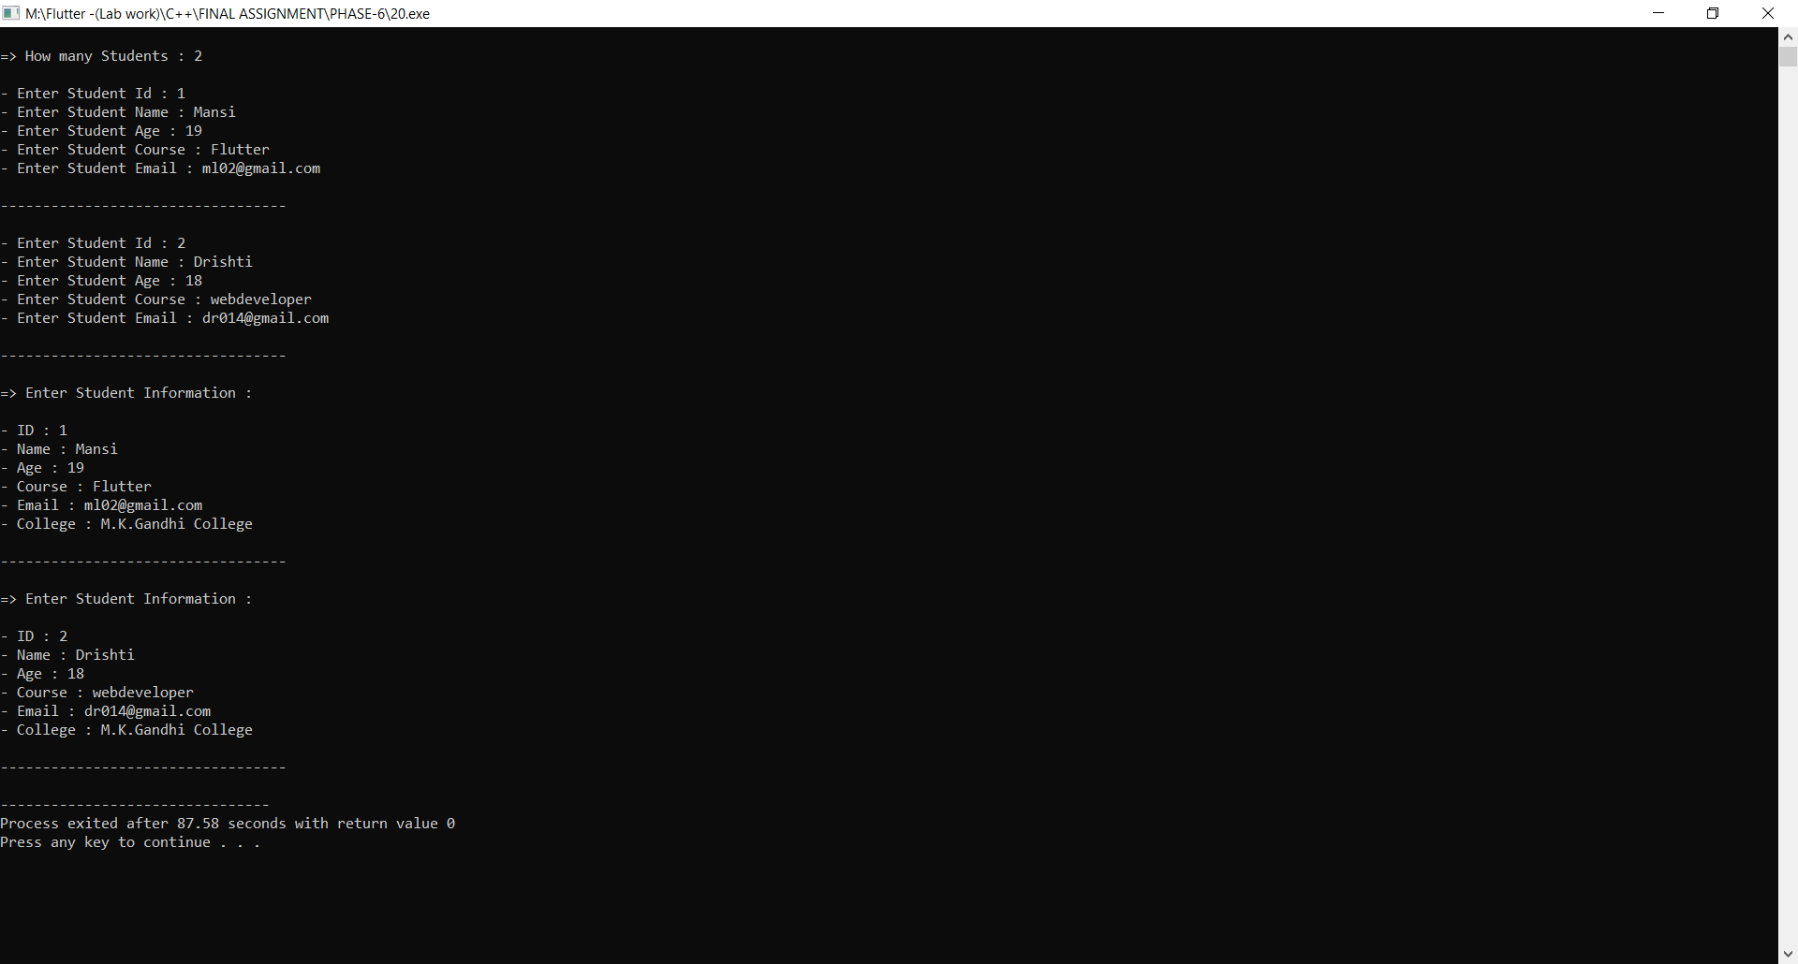

**Practical-21**

**Aim: Build a C++ solution which returns array of all ASCII values of alphabets skipping 3 characters. Use concept of Constructors. After re-**

**turning that array, find addition of that values and decide whether it is**

**a odd or even number.**

**Program:**

#include<iostream>

#include<string.h>

using namespace std;

class Alphabets

{

private :

char i;

int k = 0;

int s=0;

public :

Alphabets()

{

cout <<"=> All ASCII value of Alphabets : "<<endl<<endl;

for(i='a';i<='z';i+=3)

{

k= k+i;

cout <<"- Character "<<i <<" = " <<int(i) <<endl;

}

for(i='a';i<='z';i+=3)

{

s= s+i;

}

cout <<endl<<"=> Sum of a Character : "<<s <<endl;

if(k%2==0)

{

cout <<endl<<"=> Even Number...";

}

else

{

cout <<endl<<"=> Odd Number...";

}

}

};

int main()

{

Alphabets();

return 0;

}

**Output:**

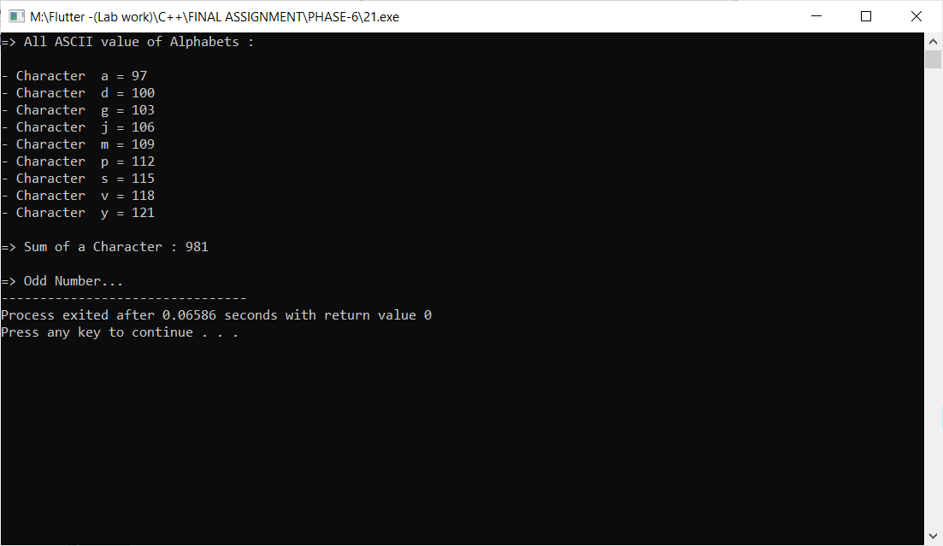

**Practical-22**

**Aim: A Global survey held to collect information about**

**hotels all around the world. Provide a C++ solution to**

**create a class Hotel with fields like**

**hotel_i**

**hotel_nam**

**hotel_typ**

**hotel_staff_siz**

**hotel_room_siz**

**hotel_establish_yea**

**hotel_countr**

**hotel_rating_typ**

**hotel_website**

**Illustrate the use of strict encapsulation with this**

**keyword.**

**Program:**

#include<iostream>

#include<string.h>

using namespace std;

class Hotel

{

private:

int hotel_id;

char hotel_name[100];

char hotel_type[100];

char hotel_staff_size[100];

int hotel_room_size;

int hotel_establish_year;

char hotel_country[100];

int hotel_rating_type;

char hotel_website[100];

public:

void Hotel_setData()

{

cout <<endl<<"Enter Hotel Id : ";

cin >>this->hotel_id;

cout <<"Enter Hotel Name : ";

cin >>this->hotel_name;

cout <<"Enter Hotel Type : ";

cin >>this->hotel_type;

cout <<"Enter Hotel Staff size : ";

cin >>this->hotel_staff_size;

cout <<"Enter Hotel Room size : ";

cin >>this->hotel_room_size;

cout <<"Enter Hotel Established year : ";

cin >>this->hotel_establish_year;

cout <<"Enter Hotel Country : ";

cin >>this->hotel_country;

cout <<"Enter Hotel Rating type : ";

cin >>this->hotel_rating_type;

cout <<"Enter Hotel website : ";

cin >>this->hotel_website;

}

void Hotel_getData()

{

cout <<endl<<"------ -: Enter Hotel Details :- ------"<<endl

<<" ID : "<<this->hotel_id <<endl

<<" Name : "<<this->hotel_name <<endl

<<" Type : "<<this->hotel_type <<endl

<<" Staff size : "<<this->hotel_staff_size <<endl

<<" Room size : "<<this->hotel_room_size <<endl

<<" Established year : "<<this->hotel_establish_year <<endl

<<" Country : "<<this->hotel_country <<endl

<<" Rating type : "<<this->hotel_rating_type <<endl

<<" website : "<<this->hotel_website <<endl;

}

};

int main()

{

Hotel h[100];

int i,n;

cout <<endl<<" How many Hotel information : ";

cin >>n;

for(i=0;i<n;i++)

{

h[i].Hotel_setData();

}

for(i=0;i<n;i++)

{

h[i].Hotel_getData();

}

return 0;

}

**Output:**

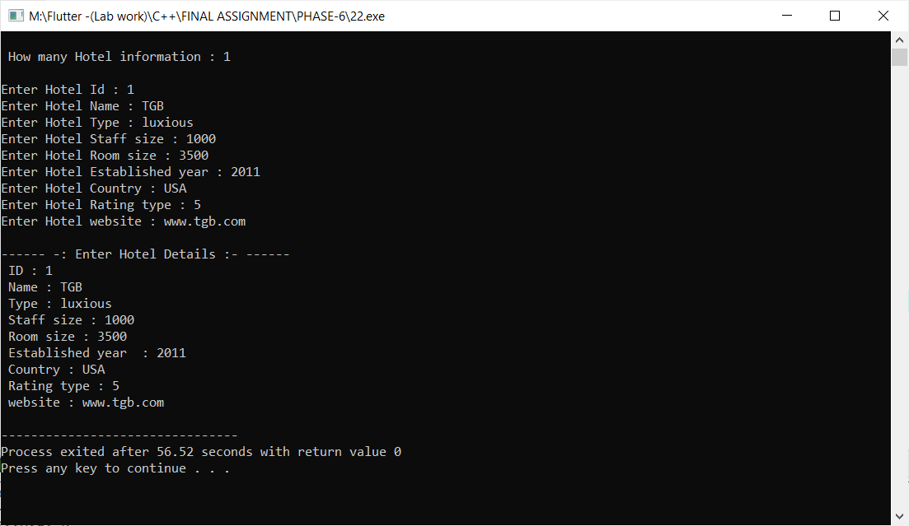

**Practical-23**

**Aim: Jemin wants to create an automate system which compare two**

**given strings and it returns 1 if both strings are same and 0 otherwise.**

**Create a C++ system for helping Jemin using overloading concept.**

**Program:**

#include<iostream>

#include<string.h>

using namespace std;

class String

{

public:

int setdata(char a[], char b[])

{

if(strcmp(a,b)==0)

{

return 1;

}

else

{

return 0;

}

}

};

int main()

{

String s1;

char f[100], s[100];

int n;

cout<<endl<<"=> Enter First Message : ";

gets(f);

cout<<endl<<"=> Enter Second Message : ";

gets(s);

n=s1.setdata(f,s);

if(n==1)

{

cout<<endl<<"=> Both Message is Same..."<<endl;

}

else

{

cout<<endl<<"=> Both Message isn't Same..."<<endl;

}

return 0;

}

**Output:**

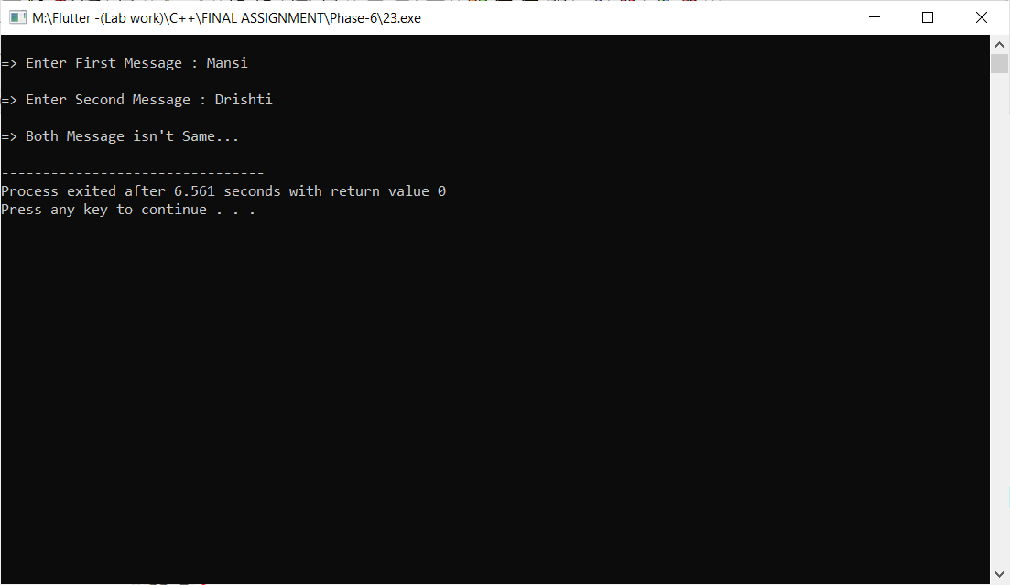

**Practical-24**

**Aim: Design a swapping program using only constructors for**

**helping Devansh to gain passing marks in examination.**

**Program:**

#include<iostream>

#include<string.h>

using namespace std;

class Swap_Mark

{

public:

int a;

int b;

public:

Swap_Mark()

{

cout <<"--------------------------------------"<<endl;

cout <<"=> After Swapping Passing Mark :- "<<endl;

cout <<"--------------------------------------"<<endl;

cout <<endl<<" * Enter Original Mark : ";

cin >> a;

cout <<endl<<" * Enter Passing Mark : ";

cin >> b;

// "<<endl <<" a : "<<a <<endl <<" b :"<<b <<endl;

a = a+b;

b = a-b;

a = a-b;

cout <<endl<<"--------------------------------------"<<endl;

cout <<"=> Before Swapping Passing Mark :- "<<endl;

cout <<"--------------------------------------"<<endl;

cout <<endl<<" * Original Mark : "<<a;

cout <<endl<<endl<<" * Passing Mark : "<<b;

}

};

int main()

{

Swap_Mark();

return 0;

}

**Output:**

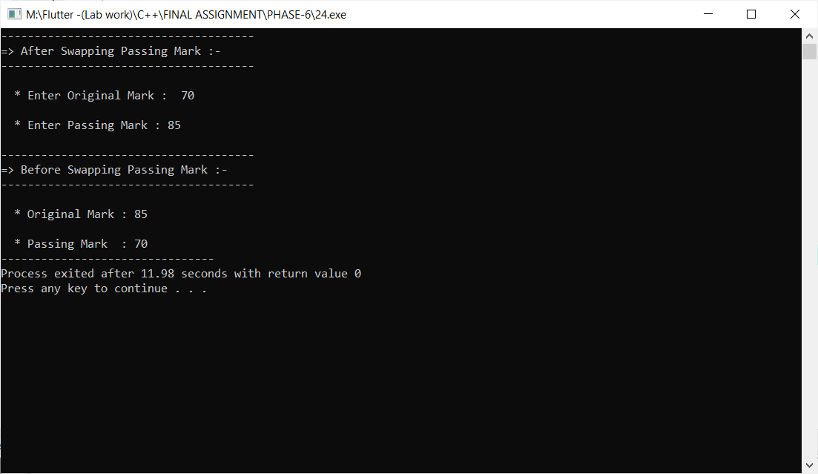

**Practical-25**

**Aim: Create a C++ Base class Shape with a constructor for providing**

**values for width and height. Then define two derived classes Triangle**

**and Rectangle, that calculate the area of the shape area(). In the main,**

**define two objects: a triangle and a rectangle and then call the area()**

**function by this two objects.**

**Program:**

#include<iostream>

#include<string.h>

using namespace std;

class Shape

{

public :

int width;

int height;

public :

void S1_Data()

{

cout <<"- Enter Width : ";

cin >>this->width;

cout <<"- Enter Height : ";

cin >>this->height;

}

};

class Triangle : public Shape

{

public:

int area;

public :

void T_Data()

{

S1_Data();

area = (width*height)/2;

cout <<endl<<"- Area of Triangle : "<<area <<endl;

}

};

class Rectangle : public Shape

{

public:

int area;

public :

void r_Data()

{

S1_Data();

area = (width*height);

cout <<endl<<"- Area of Rectangle : "<<area <<endl<<endl;

}

};

int main()

{

Rectangle r1;

Triangle T1;

cout<<"-------------------------------------"<<endl;

cout <<"=> Find Area of Rectangle :- "<<endl;

cout<<"-------------------------------------"<<endl;

r1.r_Data();

cout<<"-------------------------------------"<<endl;

cout <<"=> Find Area of Triangle :- "<<endl;

cout<<"-------------------------------------"<<endl;

T1.T_Data();

return 0;

}

**Output:**

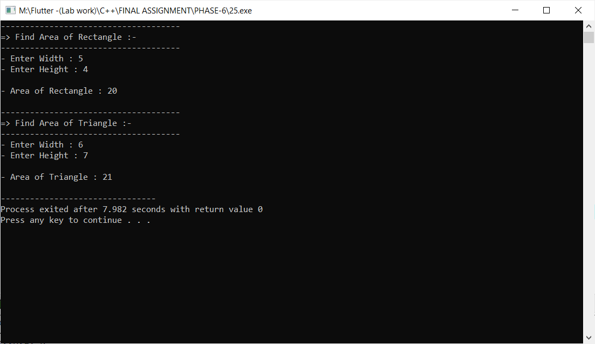

**Practical-26**

**Aim: By using Multilevel Inheritance, implement below mentioned**

**structure in C++ for employee records system.**

**Use proper implementation of Encapsulation, static keyword and**

**Inheritance when needed.**

**Program:**

#include<iostream>

#include<string.h>

using namespace std;

class A

{

public :

int emp_id;

char emp_name[100];

int emp_age;

int emp_salary;

int emp_experience;

char emp_role[100];

char emp_email[100];

static char emp_company_name[100];

};

class B : public A

{

public :

void setB()

{

cout << endl<<"------------ -: Details of Employee :- ------------"

<<endl <<endl;

cout << "~ Enter id :- ";

cin >> this->emp_id;

cout << "~ Enter name :- ";

cin >> this->emp_name;

cout << "~ Enter age :- ";

cin >> this->emp_age;

}

};

class C : public B

{

public :

void setC()

{

cout << "~ Enter salary :- ";

cin >> this->emp_salary;

cout << "~ Enter experience :- ";

cin >> this->emp_experience;

cout << "~ Enter role :- ";

cin >> this->emp_role;

cout << "~ Enter email :- ";

cin >> this->emp_email;

cout << endl;

}

};

class D : public C

{

public :

void getAllData()

{

cout << endl<<endl

<<"------------ -: Details of Employee :- ------------"<<endl <<endl;

cout << "~> Id :- " << this->emp_id << endl;

cout << "~> Name :- " << this->emp_name << endl;

cout << "~> Age :- " << this->emp_age << endl;

cout << "~> Salary :- " << this->emp_salary << endl;

cout << "~> Experience :- " << this->emp_experience << endl;

cout << "~> Role :- " << this->emp_role << endl;

cout << "~> Email :- " << this->emp_email << endl;

cout << "~> Company name :- " << this->emp_company_name << endl;

}

};

char A :: emp_company_name[100] = "Code Red Technology";

int main()

{

D s[100];

int i,n;

cout <<"~> How many employee :- "; cin >> n;

cout << endl;

for(i=0;i<n;i++)

{

s[i].setB();

s[i].setC();

}

for(i=0;i<n;i++)

{

s[i].getAllData();

}

return 0;

}

**Output:**

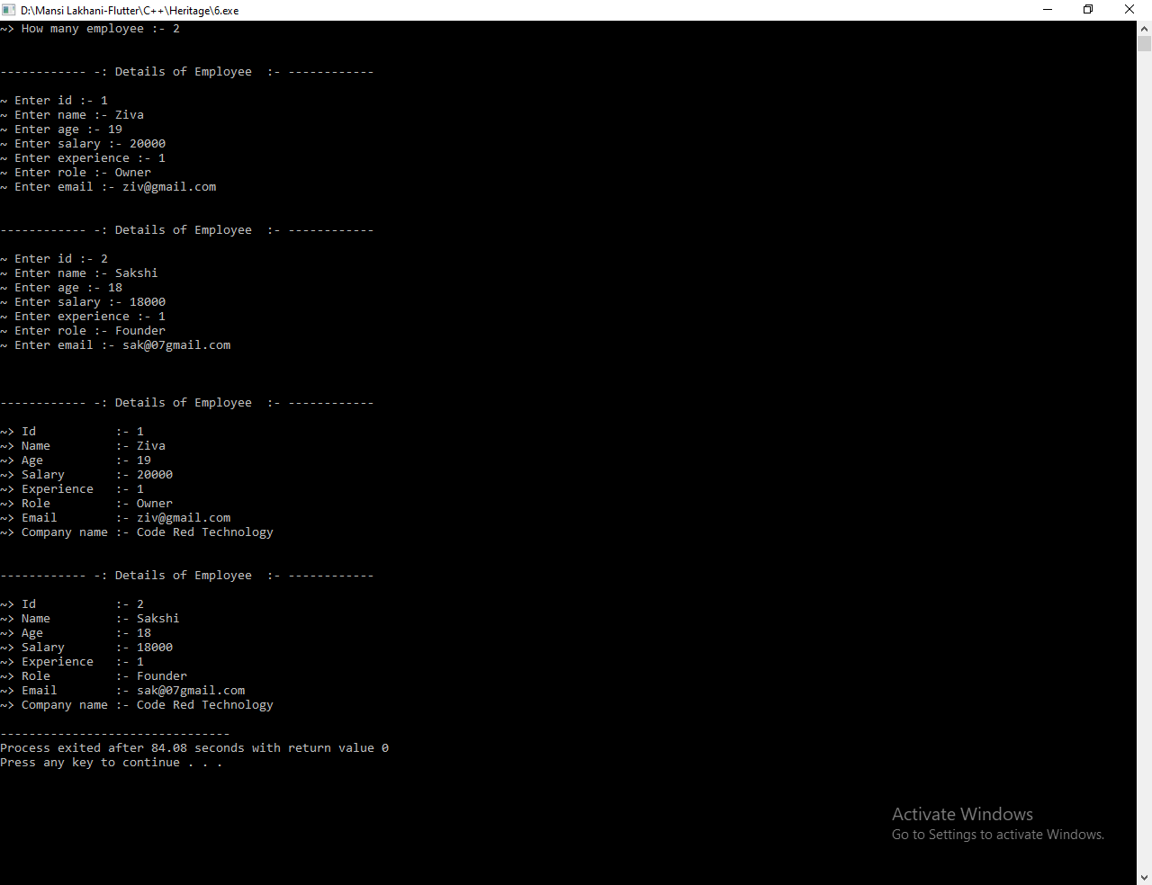

**Practical-27**

**Aim: Reserve Bank of India pre-defines a Rate of Interest (ROI) for**

**all banks across the Nation. But some private sector banks can apply**

**different ROI. Use inheritance and polymorphism concept to illustrate**

**this scenario.**

**Program:**

#include<iostream>

#include<string.h>

using namespace std;

class BOB

{

public :

void R_of_Int()

{

cout<<"------------------- * BOB * -------------------"<<endl;

cout <<endl<<"=> Pre-defines a Rate of Interest is 7.25% "<<endl<<endl;

}

};

class SBI : public BOB

{

public :

void R_of_Int()

{

cout<<"------------------- * SBI * -------------------"<<endl;

cout <<endl<<"=> Pre-defines a Rate of Interest is 6.25% "<<endl<<endl;

}

};

class RBI : public SBI

{

public :

void R_of_Int()

{

cout<<"------------------- * RBI * -------------------"<<endl;

cout <<endl<<"=> Pre-defines a Rate of Interest is 3.35% "<<endl<<endl;

BOB::R_of_Int();

SBI::R_of_Int();

}

};

int main()

{

RBI r1;

r1.R_of_Int();

return 0;

}

**Output:**

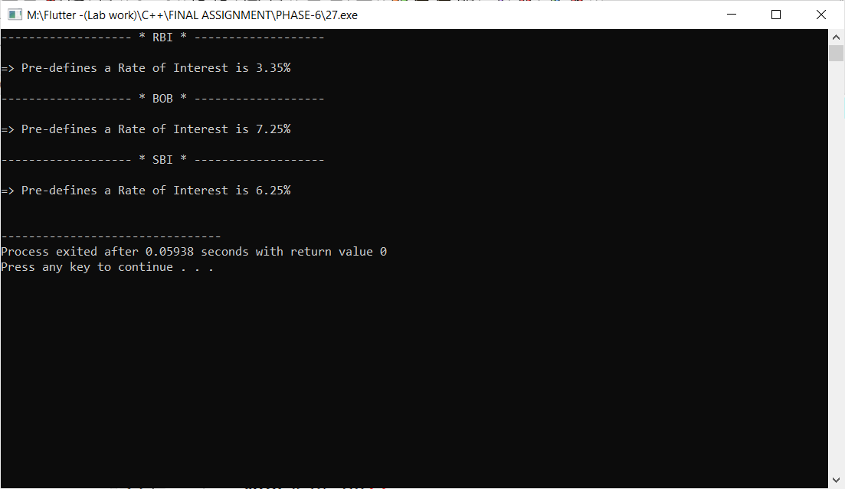

**Practical-28**

**Aim: One character is common in both Marvel & DC universe**

**named “Access”. Implement below mentioned structure using**

**proper inheritance concept and with assumable fields and**

**methods. You can create and use any type of methods and**

**illustrations to enhance this program as per your**

**preference.**

**Program:**

#include<iostream>

#include<string.h>

using namespace std;

class Universe

{

public:

void U_getData()

{

cout <<endl<<"=> This is a universe :- "<<endl;

}

};

class Marvel : public Universe

{

public:

void M_getdata()

{

cout <<"- This is a Marvel class of a universe ."<<endl;

}

};

class DC : public Universe

{

public:

void D_getdata()

{

cout <<"- This is a DC class of a universe ."<<endl;

}

};

class MHeroes :public Marvel

{

public:

void MH_getData()

{

cout <<"- This is a MHeroes class of a Marvel ."<<endl;

}

};

class DCHeroes :public DC

{

public:

void DC_getData()

{

cout <<"- This is a DCHeroes class of a DC ."<<endl;

}

};

class Access : public MHeroes , public DCHeroes

{

public:

void AC_getData()

{

Marvel::U_getData();

M_getdata();

D_getdata();

cout <<endl<<"=> This is Access class :-"<<endl;

MH_getData();

DC_getData();

}

};

int main()

{

Access a1;

a1.AC_getData();

return 0;

}

**Output:**

