**Phase-1 Basic Programs**

**Practical-1**

**Aim: Meena face an isuue to perform a mathematical operation to find a cube of any number. Write a C++ Program which helps Meena to solve her issue.**

**Program:**

#include<iostream>

#include<string.h>

using namespace std;

int main()

{

int num,sum;

cout << "* Enter any number :- ";

cin >> num;

sum=num*num*num;

cout << endl << "=> Cube of " << num

<< " number :- " << sum;

return 0;

}

**Output:**

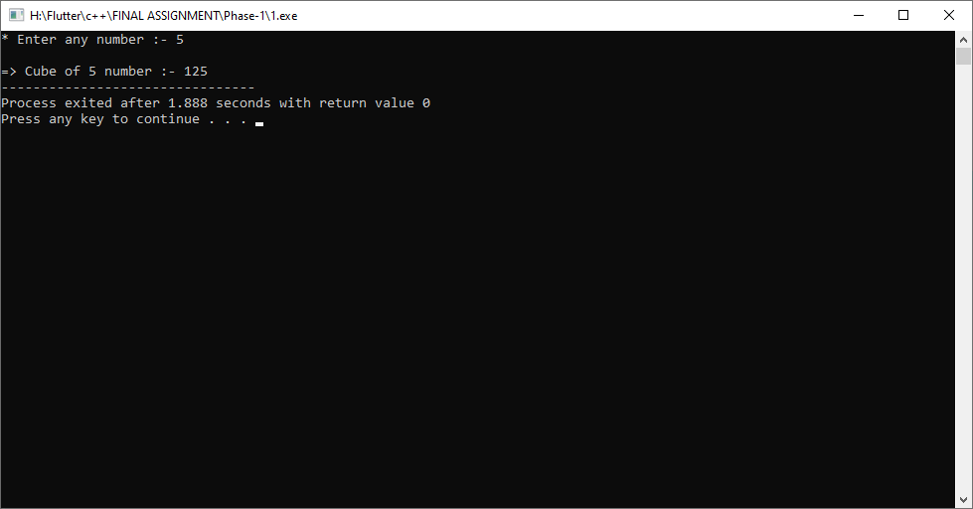

**Practical-2**

**Aim: Sameer is too weak to find multiplication of any three numbers.**

**Write a C++ Program which helps Sameer to solve his issue.**

**Program:**

#include<iostream>

#include<string.h>

using namespace std;

int main()

{

int n1,n2,n3,sum;

cout << "* Enter first number :- "; cin >> n1;

cout << "* Enter second number :- "; cin >> n2;

cout << "* Enter third number :- "; cin >> n3;

sum=n1*n2*n3;

cout << endl << "=> Multiplication of three number :- " << sum;

return 0;

}

**Output:**

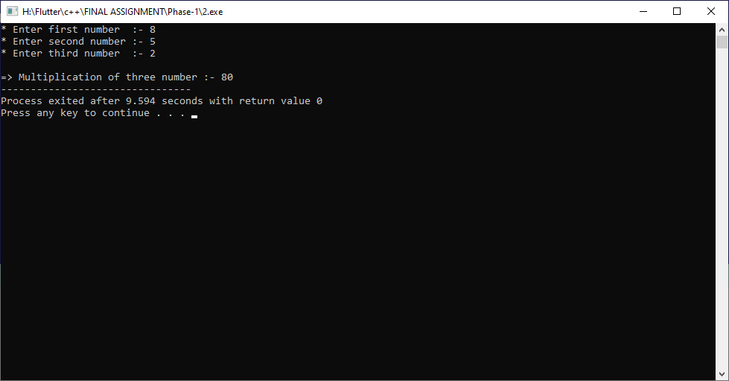

**Practical-3**

**Aim: A student in a fifth class encounters a very easy maths problem to find quotient and remainder. Write a C++ Program which provides a solution for this particular problem.**

**Program:**

#include<iostream>

#include<string.h>

using namespace std;

int main()

{

int n1,n2,quotient,remainder;

cout << "* Enter first number :- "; cin >> n1;

cout << "* Enter second number :- "; cin >> n2;

quotient = n1/n2;

cout << endl << "=> Quotient of two number :- " << quotient;

remainder = (n1-(n1/n2)*n2);

cout << endl << "=> Remainder of two number :- " << remainder;

return 0;

}

**Output:**

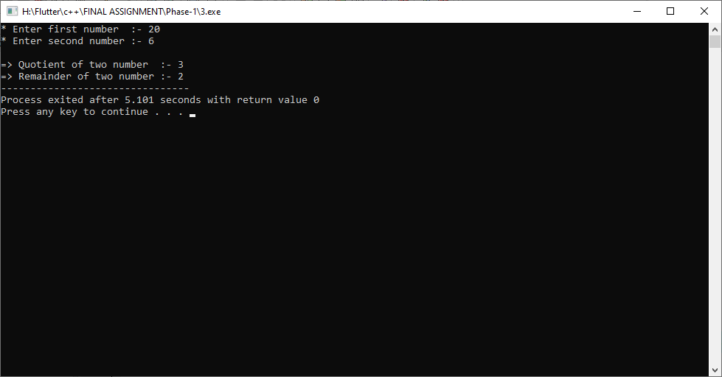

**Practical-4**

**Aim: Two classmates wants to exchange their seating with each other. But the problem is that there are only two chairs in the small classroom which already aquires by them. Write a C++ Program which provides a solution for this particular problem.**

**Program:**

#include<iostream>

#include<string.h>

using namespace std;

int main()

{

int n1,n2;

cout << "* Enter the value of a :- "; cin >> n1;

cout << "* Enter the value of b :- "; cin >> n2;

n1 = n1+n2;

n2 = n1-n2;

n1 = n1-n2;

cout << endl << "=> After swep value " << endl;

cout << endl << "=> Value of a :- " << n1;

cout << endl << "=> Value of b :- " << n2;

return 0;

}

**Output:**

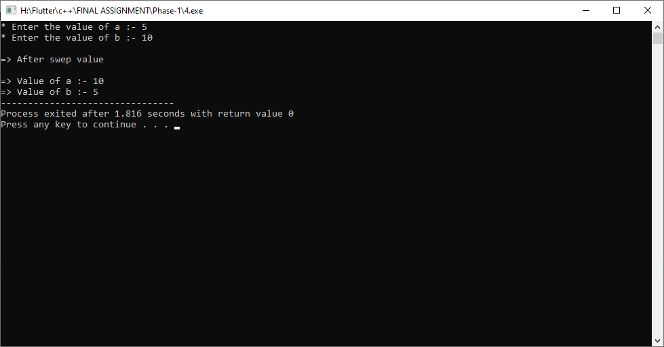

**Practical-5**

**Aim: Two college collegues had argue with a ASCII value conversion method. Write a C++ Program which provides a solution for their issue.**

**Program:**

#include<iostream>

#include<string.h>

using namespace std;

int main()

{

char argue;

int convert;

cout << "* Enter any arguement :- ";

cin >> argue;

convert = argue;

cout << endl << "=> ASCII value " << argue

<< " of :- " << convert;

return 0;

}

**Output:**

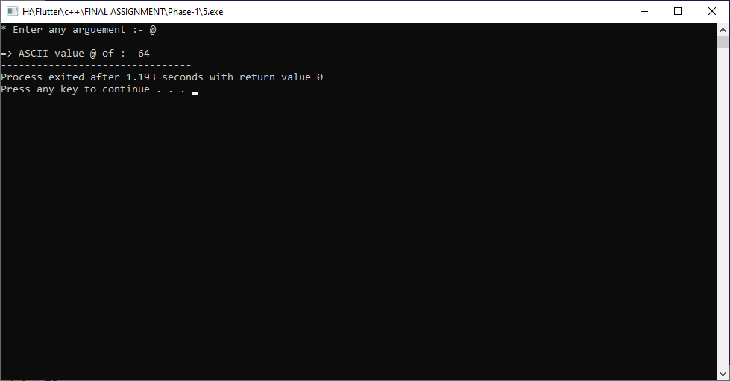

**Practical-6**

**Aim: An IT company wants to generate random number of 6 digits long and send it to its employees. Write a C++ Program to help this IT company.**

**Program:**

#include<iostream>

#include<time.h>

#include<stdlib.h>

using namespace std;

int main()

{

unsigned int token = (unsigned int)time(NULL);

srand(token);

cout << endl << "=> IT company generate random number of 6 digits

long for employees : "

<< (rand()%100000+1000000);

return 0;

}

**Output:**

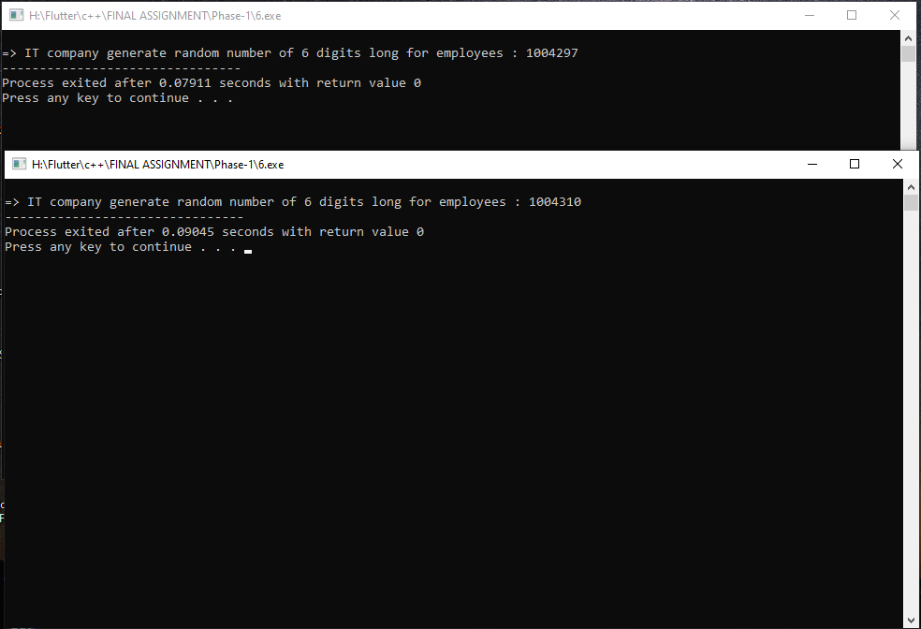

**Practical-7**

**Aim: Priyank needs to find an average of three numbers to gain required passing marks in exam. Write a C++ Program to helps Priyank to solve his issue.**

**Program:**

#include<iostream>

#include<string.h>

using namespace std;

int main()

{

int a,ave;

cout << "* Minimum passing marks :- ";

cin >> ave;

a = (ave*3)/3;

cout << endl << endl

<< "=> Minimum passing all three subject marks required :- "

<< a;

return 0;

}

**Output:**

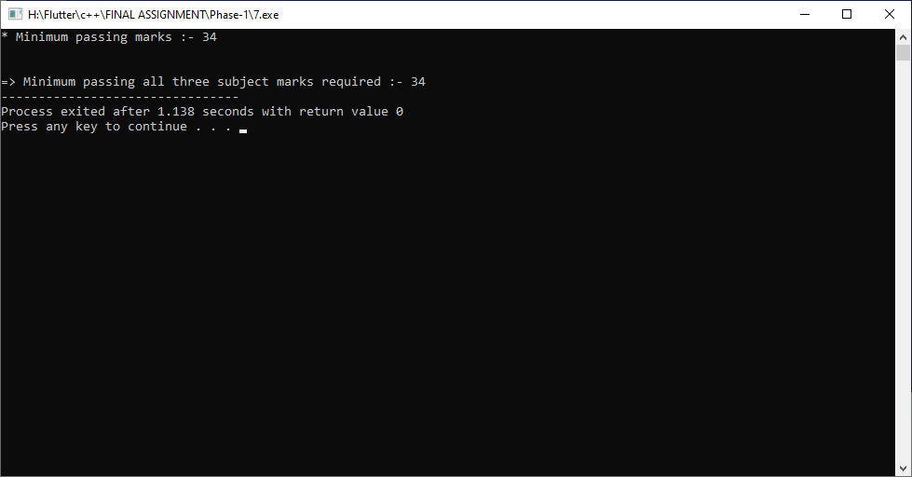

**Practical-8**

**Aim: A sport coach needs to convert submitted participants’ inches into feet and inches for height measurement. Write a C++ Program to provide a solution for this.**

**Program:**

#include<iostream>

#include<string.h>

using namespace std;

int main()

{

int feet,inch;

cout << "* Enter inch for height measurement :- ";

cin >> inch;

feet = inch/12;

cout << endl << endl

<< "=> Your height is :- " << feet << " feet";

return 0;

}

**Output:**

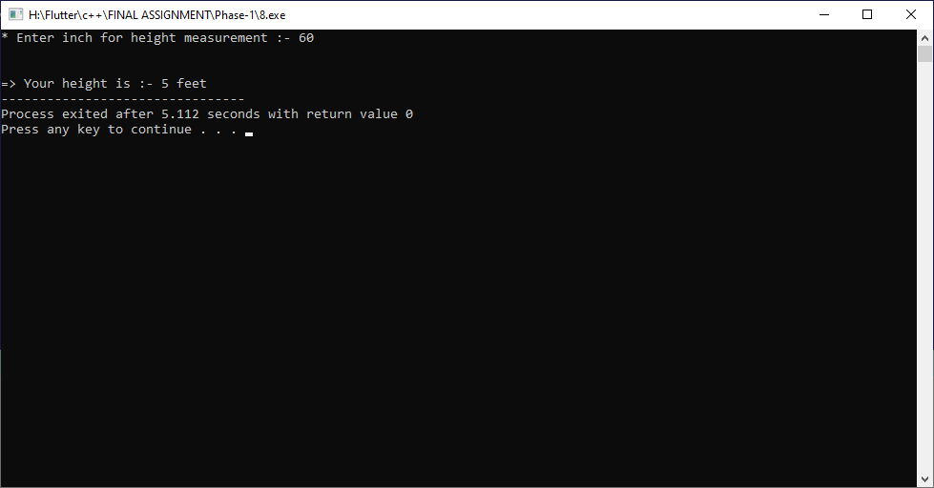

**Practical-9**

**Aim: An innocent boy must have to solve that how to raise any number(Base) to power N for proving his common ability among all classmates. Write a C++ Program to provide a solution for this boy.**

**Program:**

#include<iostream>

#include<string.h>

using namespace std;

int main()

{

int power,work,time;

cout << "* The work of giving power to an innocent boy :- ";

cin >> work;

cout << "* The time of giving power to an innocent boy :- ";

cin >> time;

power=work/time;

cout << endl << endl

<< "=> The boy got this power :- " << power << " power";

return 0;

}

**Output:**

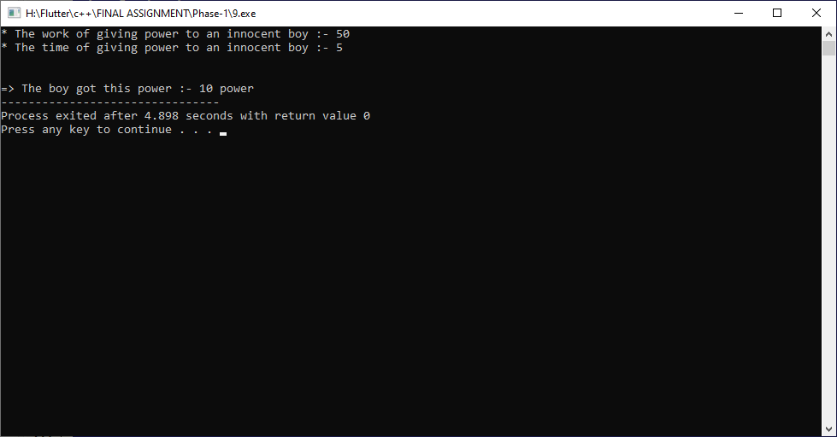

**Practical-10**

**Aim: A brand new smart device which meant to convert total provided Days Into Years, Weeks and Days. But for some technical interruption, that device stops working properly. Write a C++ Program to provide a solution for this.**

**Program:**

#include<iostream>

#include<string.h>

using namespace std;

int main()

{

int days,months,years;

cout << "* Enter days :- ";

cin >> days;

years = (days/30)/12;

months = (days/30)%12;

days = (days%12);

cout << endl << endl

<< "=> Total years :- " << years << " year" << endl

<< "=> Total months :- " << months << " month" << endl

<< "=> Total days :- " << days << " day" << endl;

return 0;

}

**Output:**

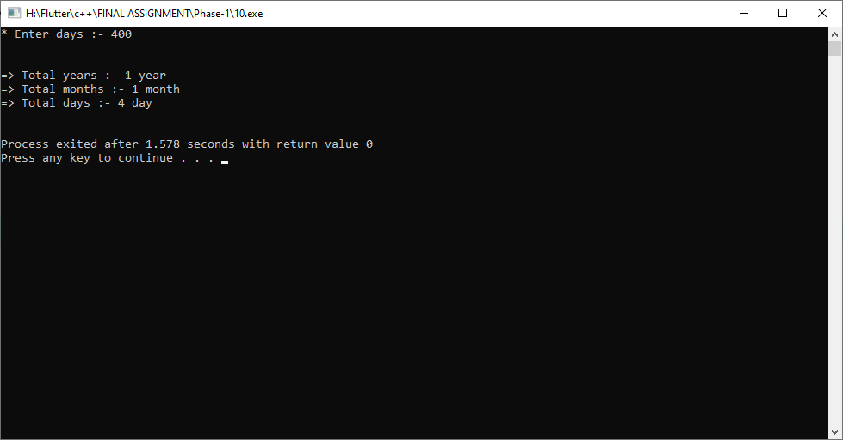

**Practical-11**

**Aim: Raman have an idea to impress his Computer Teacher by solving Square Root of a number without using any programming library. Write a C++ Program to help Raman.**

**Program:**

#include<iostream>

#include<math.h>

#include<string.h>

using namespace std;

int main()

{

int number,sequrt;

cout << "* Enter any number for find squre root :- ";

cin >> number;

sequrt = sqrt(number);

cout << endl << endl

<< "=> Squre root of given number :- " << sequrt;

return 0;

}

**Output:**

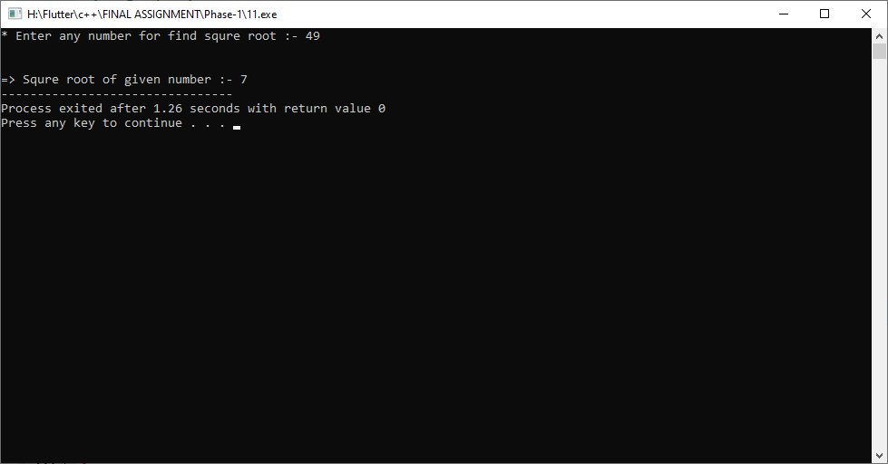

**Practical-12**

**Aim: A math teacher wants to teach how to find a Simple Interest. Write a C++ Program to provide a solution for this.**

**Program:**

#include<iostream>

#include<string.h>

using namespace std;

int main()

{

int p,r,t,SI;

cout << "* Enter principal for find simple interest. :- ";

cin >> p;

cout << "* Enter rate for find simple interest. :- ";

cin >> r;

cout << "* Enter time for find simple interest. :- ";

cin >> t;

SI = (p*r*t)/100;

cout << endl << endl

<< "=> Simple Interest :- " << SI;

return 0;

}

**Output:**

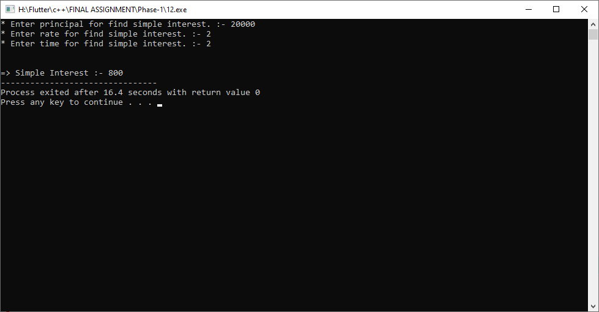

**Practical-13**

**Aim: A fourth standard student forced by his teacher to identify if a given Character is Uppercase, Lowercase, Digit or Special Character. Write a C++ Program to help that student.**

**Program:**

#include<iostream>

#include<string.h>

using namespace std;

int main()

{

char ch;

cout << "* Enter any character :- ";

cin >> ch;

if(ch >= 'A' && ch <= 'Z')

{

cout << endl << endl

<< "=> This character is upper case alphabet.";

}

else if(ch >= 'a' && ch <= 'z')

{

cout << endl << endl

<< "=> This character is lower case alphabet.";

}

else if(ch >= '0' && ch <= '9')

{

cout << endl << endl

<< "=> This character is digit.";

}

else

{

cout << endl << endl

<< "=> This character is special character.";

}

return 0;

}

**Output:**

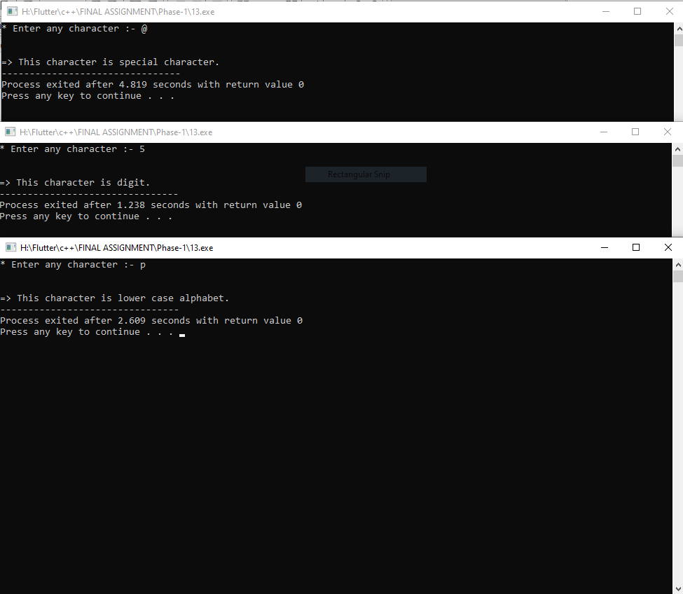

**Practical-14**

**Aim: Gaurav must have to teach his little 5 years old baby to check whether a given year is leap year or not. Write a C++ Program to provide a solution for Gaurav.**

**Program:**

#include<iostream>

#include<string.h>

using namespace std;

int main()

{

int year;

cout << "* Enter any year for check leap year or not leap year :- ";

cin >> year;

if(year%4==0)

{

cout << endl << endl

<< "=> This year is leap year.";

}

else

{

cout << endl << endl

<< "=> This year is not leap year.";

}

return 0;

}

**Output:**

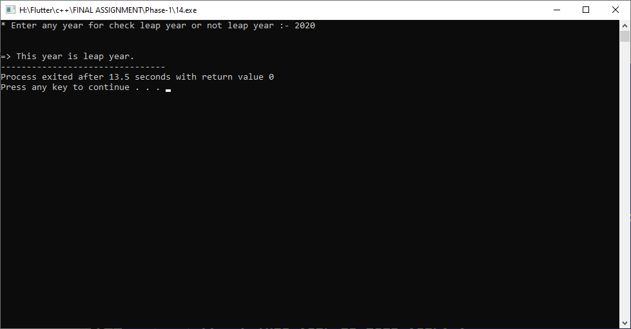

**Practical-15**

**Aim: Aaryan is constantly trying to Check Whether a character is Vowel or Consonant. But for some unknown reason he just cannot remember difference between vowel and consonant. Write a C++ Program to provide a better solution to Aaryan.**

**Program:**

#include<iostream>

#include<string.h>

using namespace std;

int main()

{

char ch;

cout << "* Enter any character for check vowel or consonant :- ";

cin >> ch;

if(ch=='A' || ch=='a' || ch=='E' || ch=='e' ||

ch=='I' || ch=='i' || ch=='O' || ch=='o' ||

ch=='U' || ch=='u')

{

cout << endl << endl

<< "=> This character is vowel character.";

}

else

{

cout << endl << endl

<< "=> This character is consonant character.";

}

return 0;

}

**Output:**

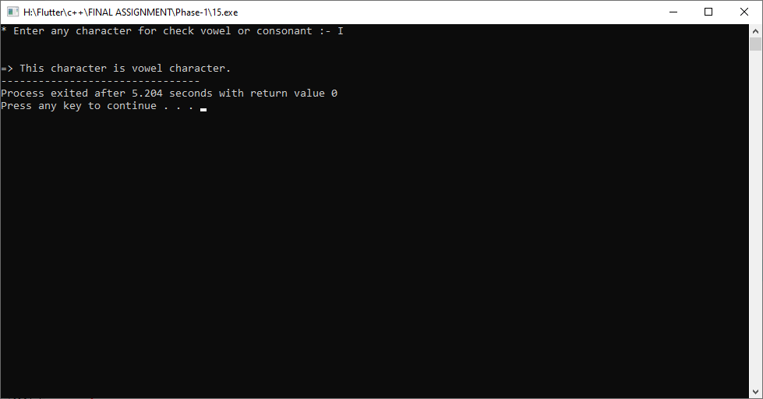

**Practical-16**

**Aim: Two friends are playing a game in which they have to check whether a given number is Even or Odd. Help them to Write a C++ Program for that.**

**Program:**

#include<iostream>

#include<string.h>

using namespace std;

int main()

{

int num;

cout << "* Enter any number for check even or odd number :- ";

cin >> num;

if(num%2==0)

{

cout << endl << endl

<< "=> This number is Even number.";

}

else

{

cout << endl << endl

<< "=> This number is Odd number.";

}

return 0;

}

**Output:**

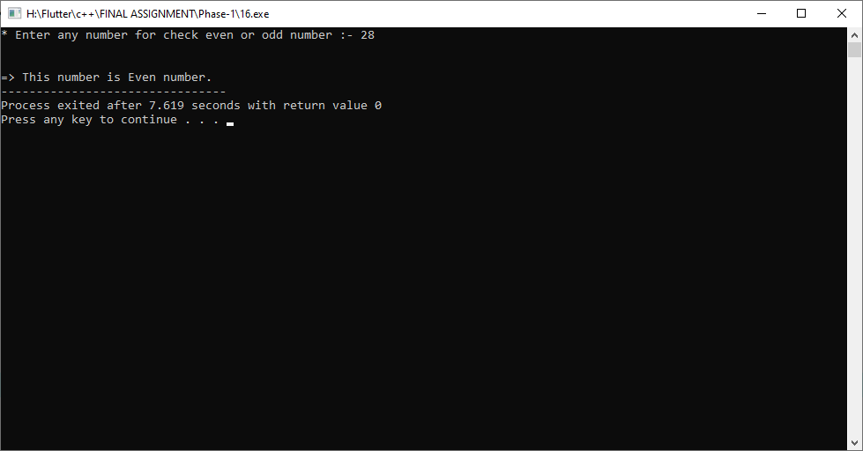

**Practical-17**

**Aim: Sameer needs to master a technique to find if a given number is Prime number or not for his best presentation at the Teachers Day to impress his Math teacher. Help sameer to Write a C++ Program with best technique.**

**Program:**

#include<iostream>

#include<string.h>

using namespace std;

int main()

{

int num,i,flag=0;

cout << "* Enter any number for check prime or not prime number :- ";

cin >> num;

for(i=2;i<=num;i++)

{

if(num%i!=0)

{

flag++;

}

}

if(flag==num-2)

{

cout << endl << endl

<< "=> This number is Prime number.";

}

else

{

cout << endl << endl

<< "=> This number is not Prime number.";

}

return 0;

}

**Output:**

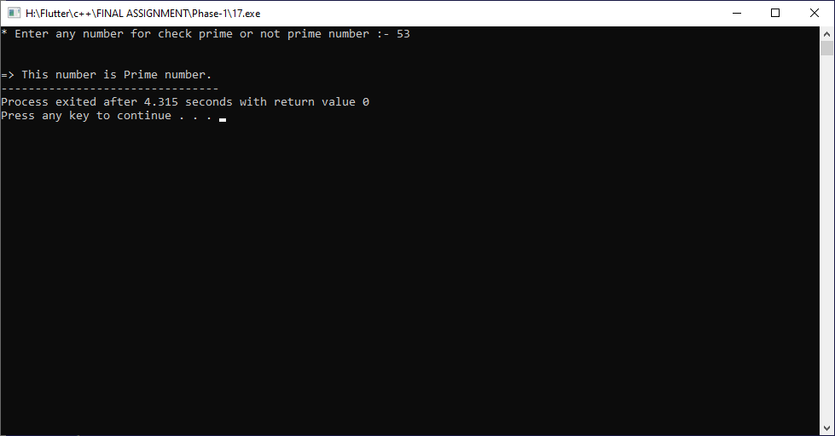

**Practical-18**

**Aim: Tushar is trying very hard to teach his classmate Harsh that how to find Factorial of a Number. Write a C++ Program for Tushar with best possibe technique.**

**Program:**

#include<iostream>

#include<string.h>

using namespace std;

int main()

{

int num,i;

cout << "* Enter any number for find factorial number :- ";

cin >> num;

for(i=num-1;i>=1;i--)

{

num=num*i;

}

cout << endl << endl

<< "=> This factorial number is :- " << num;

return 0;

}

**Output:**

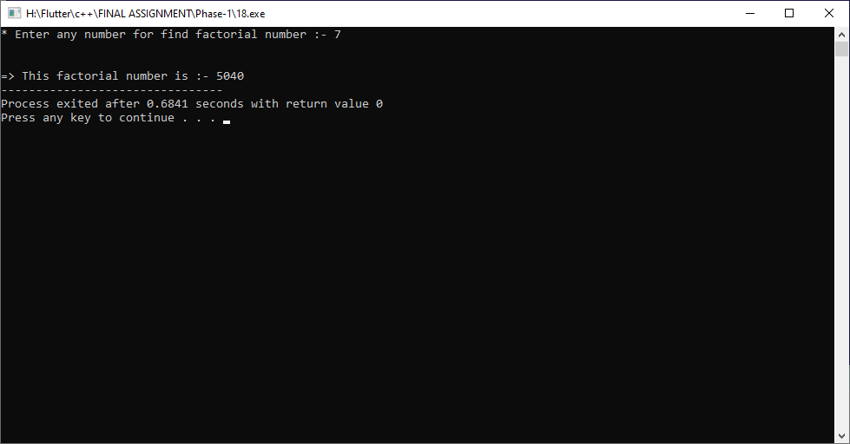

**Practical-19**

**Aim: Write a C++ program to Print Table of any Number less than 10. A group of needy newbie math students will appriciate your help for your help.**

**Program:**

#include<iostream>

#include<string.h>

using namespace std;

int main()

{

int num,i,sum;

cout << "* Enter any number between 1 to 10 for find table of given number :- ";

cin >> num;

if(num<=10)

{

for(i=1;i<=10;i++)

{

sum=num*i;

cout << endl << num << " * " << i << " = " << sum;

}

}

else

{

cout << endl << endl

<< "=> Invalid choice.......";

}

return 0;

}

**Output:**

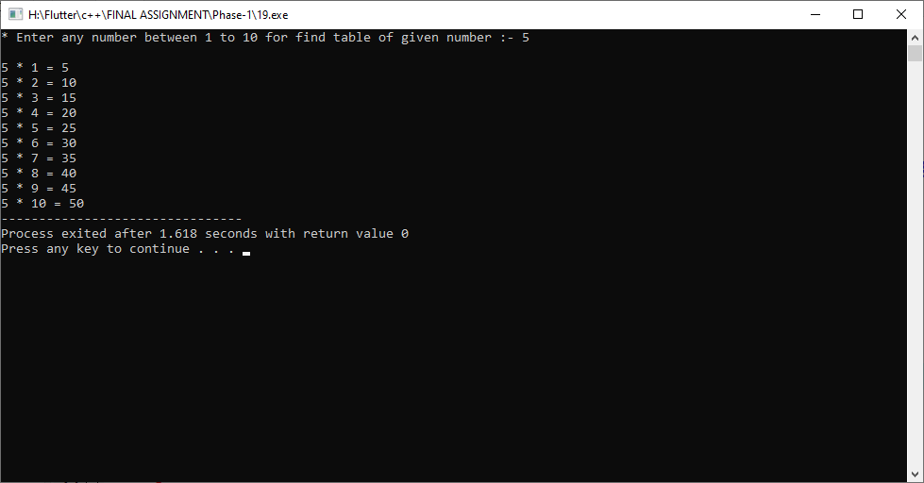

**Practical-20**

**Aim: A Teacher give a punishment to all students to find reverse numbers of given 3 random numbers by logically under 15 minutes. Write a C++ Program to provide a solution for this problem.**

**Program:**

#include<iostream>

#include<string.h>

using namespace std;

int main()

{

int num,rev=0,i;

for(i=1;i<=3;i++)

{

cout << "* Enter "<< i <<" number for find reverse number :- ";

cin >> num;

while(num>0)

{

rev = (rev*10) + num%10;

num = num/10;

}

cout << endl

<< "=> Reverse number is :- " << rev << endl << endl;

rev=0;

}

return 0;

}

**Output:**

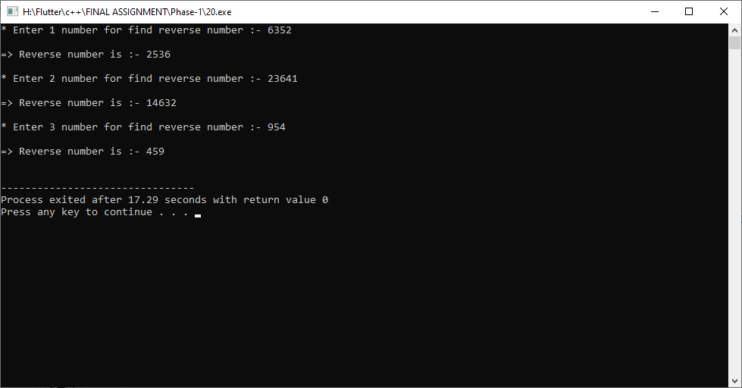

**Practical-21**

**Aim: Priya wants to teach his newly enrolled boy that how to find number of Digits in any number. Write a C++ Program to provide a solution for this problem.**

**Program:**

#include<iostream>

#include<string.h>

using namespace std;

int main()

{

int num,count=0;

cout << "* Enter any number for find Digit of number :- ";

cin >> num;

while(num>0)

{

num = num/10;

count++;

}

cout << endl

<< "=> Digits of given number :- " << count;

return 0;

}

**Output:**

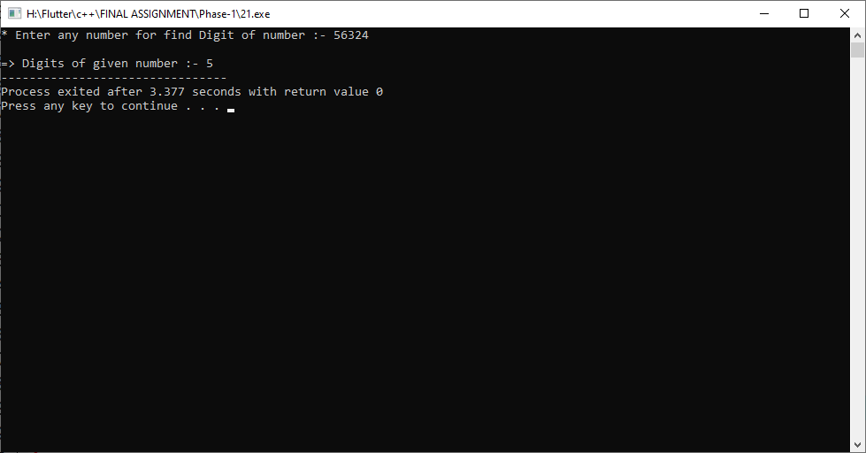

**Practical-22**

**Aim: Write a C++ Program to find Fibonacci Series upto N numbers to help Darshan by passing fastest-finger first round for entering Coding Quiz competition.**

**Program:**

#include<iostream>

#include<string.h>

using namespace std;

int main()

{

int num,i,a=0,b=1,c;

cout << "* Enter any number :- ";

cin >> num;

cout << endl << "=> Fibonacci series upto given number :- "

<< endl << a << " " << b << " ";

for(i=2;i<num;i++)

{

c=b+a;

a=b;

b=c;

cout << c << " ";

}

return **0;**

}

**Output:**

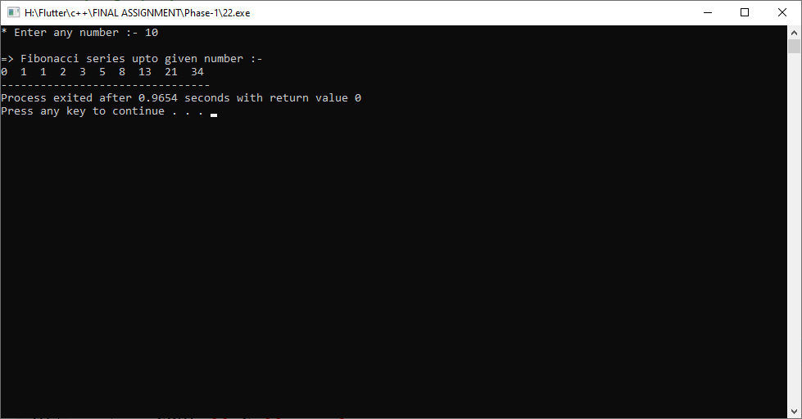

**Practical-23**

**Aim: By writing a logic for checking if a given number is Armstrong or Not, Mayur will be qualified for an entrance exam. Write a C++ Program for Mayur to qualify.**

**Program:**

#include<iostream>

#include<string.h>

using namespace std;

int main()

{

int num,temp,rev=0,con=0;

cout << "* Enter any number for find armstrong or not :- ";

cin >> num;

temp = num;

while(num>0)

{

rev = num%10;

con = con+(rev*rev*rev);

num = num/10;

}

if(con==temp)

{

cout << endl << endl

<< "=> This number is armstrong number.";

}

else

{

cout << endl << endl

<< "=> This number is not armstrong number.";

}

return 0;

}

**Output:**

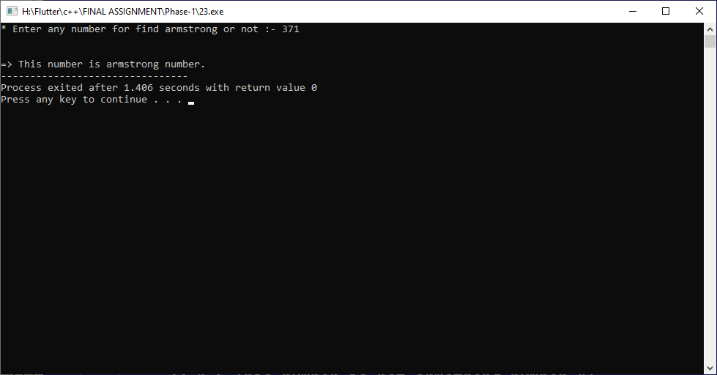

**Practical-24**

**Aim: By writing a logic for checking if a given string is Palindrom or Not, Apexa will be qualified for an entrance exam. Write a C++ Program for Apexa to qualify.**

**Program:**

#include<iostream>

#include<string.h>

using namespace std;

int main()

{

char str[100];

int start,end,flag=1;

cout << "* Enter any string for check palindrom or not :- ";

cin >> str;

start = 0;

end = strlen(str)-1;

while(start<end)

{

if(str[start] != str[end])

{

flag=0;

break;

}

start++;

end--;

}

if(flag)

{

cout << endl << endl

<< "=> This string is palindrom string.";

}

else

{

cout << endl << endl

<< "=> This string is not palindrom string.";

}

return 0;

}

**Output:**

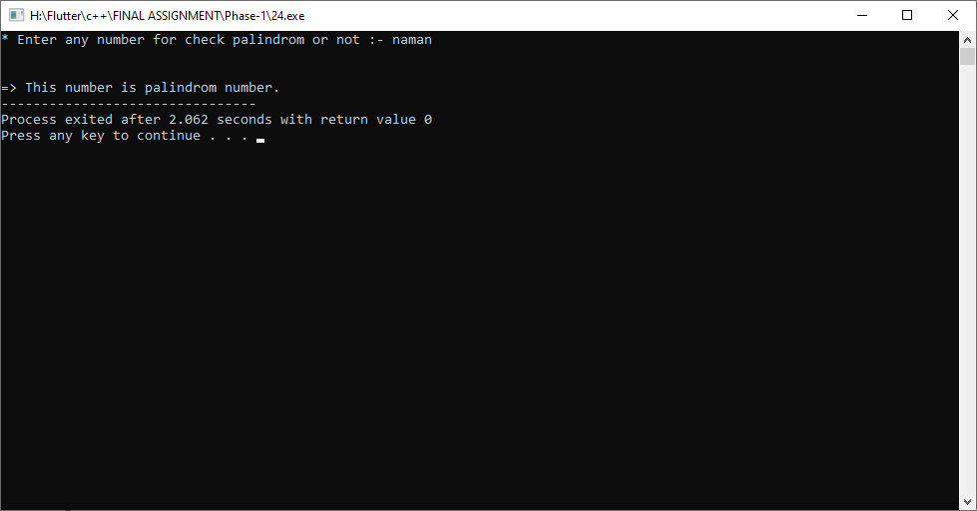

**Practical-25**

**Aim: By using an easy technique, Write a C++ program to Find Largest Number among four numbers to help Prisha boost-up her confidence in logical building process.**

**Program:**

#include<iostream>

#include<string.h>

using namespace std;

int main()

{

int a,b,c,d;

cout << "* Enter the value of a :- "; cin >> a;

cout << "* Enter the value of b :- "; cin >> b;

cout << "* Enter the value of c :- "; cin >> c;

cout << "* Enter the value of d :- "; cin >> d;

(a>b)

? (a>c)

? (a>d)

? cout << endl << "=> a is maximum."

: cout << endl << "=> d is maximum."

: (c>d)

? cout << endl << "=> c is maximum."

: cout << endl << "=> d is maximum."

: (b>c)

? (b>d)

? cout << endl << "=> b is maximum."

: cout << endl << "=> d is maximum."

: (c>d)

? cout << endl << "=> c is maximum."

: cout << endl << "=> d is maximum.";

return 0;

}

**Output:**

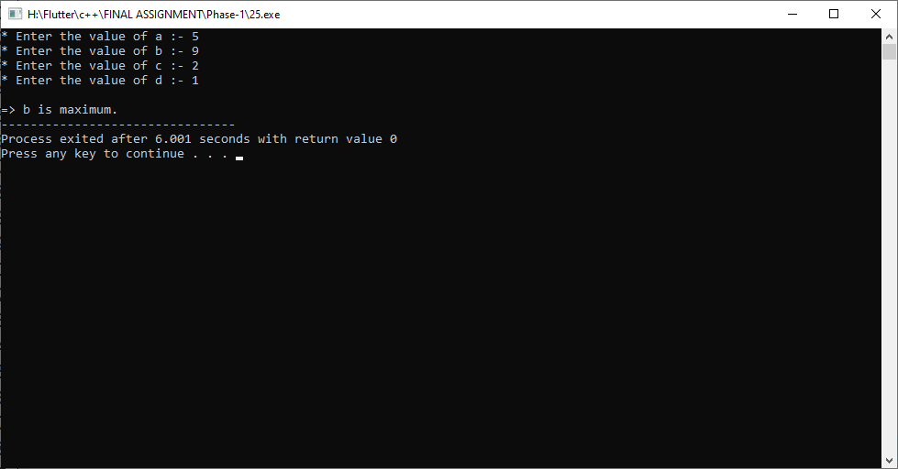

**Practical-26**

**Aim: Develop a simple comparision system which identify if given number is Palindrome or not. By this system, a bank employee will appriciate your help. Write a C++ program for developing this system.**

**Program:**

#include<iostream>

#include<string.h>

using namespace std;

int main()

{

int num,temp,rev=0;

cout << "* Enter any number for check palindrome or not :- ";

cin >> num;

temp=num;

while(num>0)

{

rev = (rev*10) + num%10;

num = num/10;

}

if(rev==temp)

{

cout << endl << endl

<< "=> This number is palindrom number.";

}

else

{

cout << endl << endl

<< "=> This number is not palindrom number.";

}

return 0;

}

**Output:**

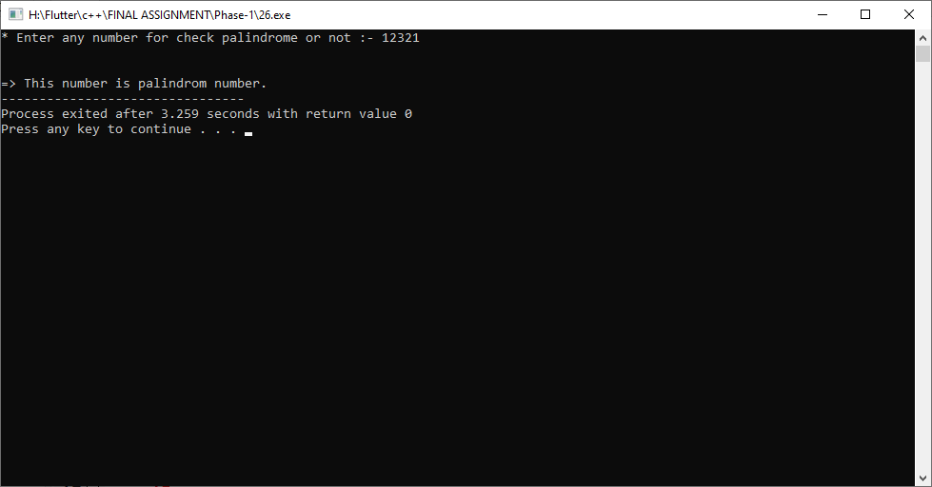

**Practical-27**

**Aim: Create a addition logic to find sum of all digits of a given number to surpass a very challenging dream of Tanmay. Write a C++ program to develop this system for Tanmay.**

**Program:**

#include<iostream>

#include<string.h>

using namespace std;

int main()

{

int num,temp,rev=0,con=0;

cout << "* Enter any number for find armstrong or not :- ";

cin >> num;

temp = num;

while(num>0)

{

rev = num%10;

con = con+rev;

num = num/10;

}

cout << endl << endl

<< "=> Sum of all digits of a given number :- "

<< con;

return 0;

}

**Output:**

