**Phase-2 Numerical Programs**

**Practical-1**

**Aim: Kashyap has difficulty to remember multiplication tables. Write a C++ Program which generates multiplication tables between n1 and n2 provided values.**

**Program:**

#include<iostream>

#include<string.h>

using namespace std;

int main()

{

int n1,n2,i,j,sum;

cout << "=> Enter first (n1) number :- ";

cin >> n1;

cout << "=> Enter second (n2) number :- ";

cin >> n2;

for(j=n1;j<=n2;j++)

{

for(i=1;i<=10;i++)

{

sum = j*i;

cout << endl << j << " * " << i << " = " << sum;

}

cout << endl << "------------";

}

return 0;

}

**Output:**

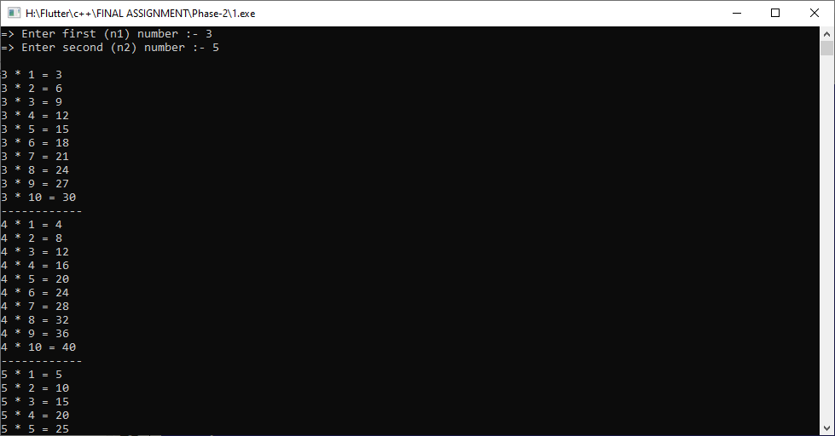

**Practical-2**

**Aim: A Math problem to find average of all even numbers from n Natural numbers raise difficulty to all 5th standard students. Write a C++ Program to help them.**

**Program:**

#include<iostream>

#include<string.h>

using namespace std;

int main()

{

int n,ave=0,i,count=0;

cout << "=> Enter any number :- ";

cin >> n;

cout << endl << "=> All even number :- " << endl;

for(i=1;i<=n;i++)

{

if(i%2==0)

{

ave=ave+i;

count++;

cout << i << " ";

}

}

ave=ave/count;

cout << endl << endl

<< "=> Average of all even number from n numbers :- " << ave;

return 0;

}

**Output:**

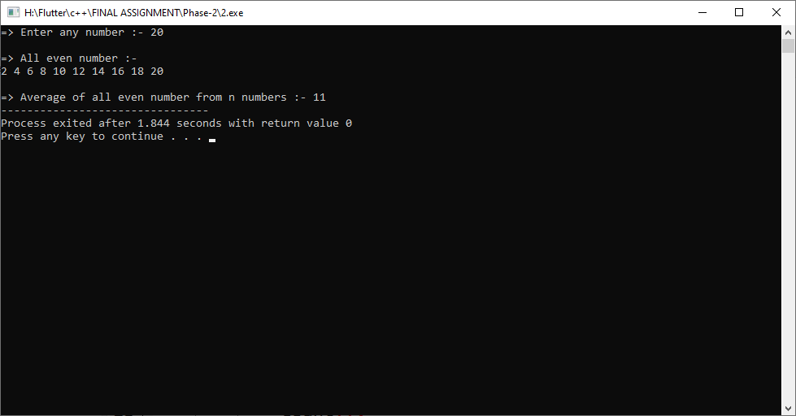

**Practical-3**

**Aim: Write a C++ Program to solve this mathematical equation to find out write answer for passing maths’s exam: 2(x-3)=4x-1**

**Program:**

#include<iostream>

#include<string.h>

using namespace std;

int main()

{

int x;

/*

2(x-3) = 4x-1

2x-6 = 4x-1

2x-6+6 = 4x-1+6

2x = 4x+5

2x = -5

x = (-5/2)

*/

x=(-5/2);

cout << endl << "=> Sum of x = " << x;

return 0;

}

**Output:**

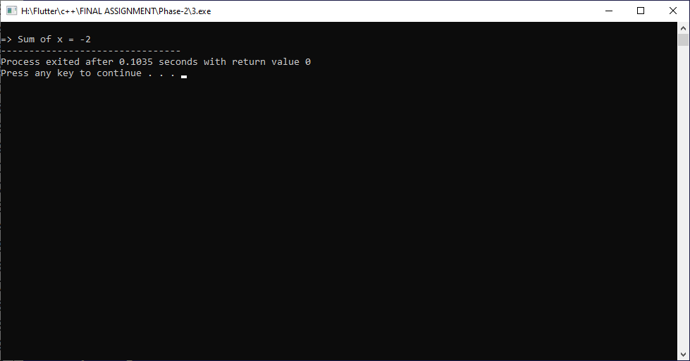

**Practical-4**

**Aim: Write a C++ Program which finds the area of triangle whose base is 56 units and height is 21 units. Also print sum of all digits of that area of triangle.**

**Program:**

#include<iostream>

#include<string.h>

using namespace std;

int main()

{

int b=56,h=21,a,sum=0,rev=0;

cout << "* base :- " << b << endl;

cout << "* hight :- " << h << endl;

a = (h*b)/2;

cout << endl << "=> Area of tringle :- " << a;

while(a>0)

{

rev = a%10;

sum = sum+rev;

a = a/10;

}

cout << endl << endl

<< "=> Sum of all digits of a given number :- "

<< sum;

}

**Output:**

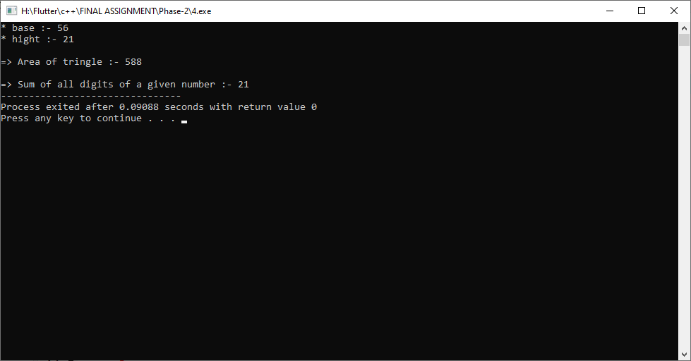

**Practical-5**

**Aim: A Prime School wants an automate system for generating students grades.**

**If marks in Maths>80, Phy>75 and Chem>72 then generate Grade A.**

**If marks in 60<=Maths<=80, 55<=Phy<=75 and 50<=Chem<=72 then generate Grade B.**

**If marks in 40<=Maths<60, 35<=Phy<55 and 35<=Chem<50 then generate Grade C.**

**Apply Grade D (Fail) if minimum criteria of marks doesn’t satisfy by any student.**

**Write a C++ Program for generating total N number of**

**students grades for this Prime School.**

**Program:**

**#include<iostream>**

**#include<string.h>**

**using namespace std;**

**int main()**

**{**

int phy,che,maths;

cout << "=> Enter marks of physics :- ";

cin >> phy;

cout << "=> Enter marks of chemistry :- ";

cin >> che;

cout << "=> Enter marks of maths :- ";

cin >> maths;

if(maths>80 && phy>75 && che >72)

{

cout << endl << "=> Your grade is A.";

}

else if ( (maths>=60 && maths<=80) ||

(phy>=55 && phy<=75) ||

(che>=50 && che<=70) )

{

cout << endl << "=> Your grade is B.";

}

else if ( (maths>=40 && maths<60) ||

(phy>=35 && phy<55) ||

(che>=35 && che<50) )

{

cout << endl << "=> Your grade is C.";

}

else

{

cout << endl << "=> Your grade is D.";

}

return 0;

}

**Output:**

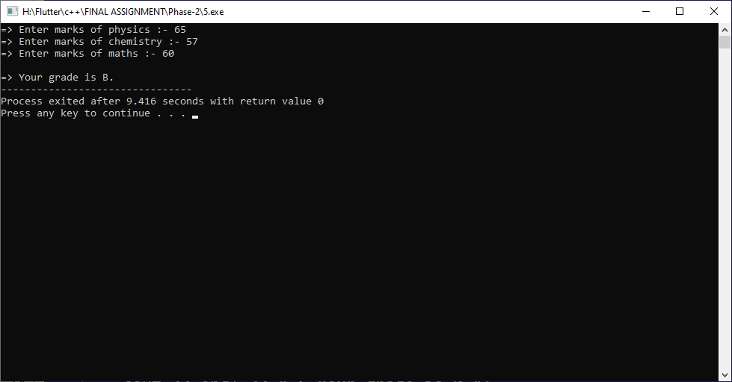

**Practical-6**

**Aim: Design a Calculator for an arithmetic operations in which user can do all basic operations as many times he/she wants until he/she exit from that. Use C++ as a primary language to accomplish this challenge.**

**Program:**

#include<iostream>

#include<string.h>

using namespace std;

int main()

{

int a,b,choice,sum;

while(choice != 0)

{

cout << "* Press 1 for addition." << endl;

cout << "* Press 2 for substrection." << endl;

cout << "* Press 3 for multiplication." << endl;

cout << "* Press 4 for devision." << endl;

cout << "* Press 5 for modulas." << endl;

cout << "* Press 0 for Exit." << endl;

cout << endl << "=> Enter your choice :- ";

cin >> choice;

switch(choice)

{

case 1:

cout << endl << "=> Enter value of a :- "; cin >> a;

cout << "=> Enter value of b :- "; cin >> b;

sum=a+b;

cout << endl << "=> Sum :- " << sum;

break;

case 2:

cout << endl << "=> Enter value of a :- "; cin >> a;

cout << "=> Enter value of b :- "; cin >> b;

sum=a-b;

cout << endl << "=> Sum :- " << sum;

break;

case 3:

cout << endl << "=> Enter value of a :- "; cin >> a;

cout << "=> Enter value of b :- "; cin >> b;

sum=a*b;

cout << endl << "=> Sum :- " << sum;

break;

case 4:

cout << endl << "=> Enter value of a :- "; cin >> a;

cout << "=> Enter value of b :- "; cin >> b;

sum=a/b;

cout << endl << "=> Sum :- " << sum;

break;

case 5:

cout << endl << "=> Enter value of a :- "; cin >> a;

cout << "=> Enter value of b :- "; cin >> b;

sum=a-(a/b)*b;

cout << endl << "=> Sum :- " << sum;

break;

case 0:

break;

default:

cout << endl << "=> Invalid choice.......";

break;

}

cout << endl << "----------------------------------" << endl;

}

return 0;

}

**Output:**

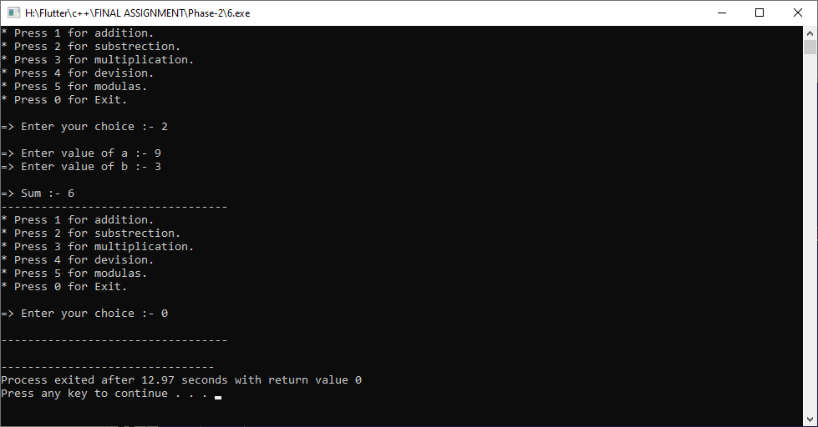

**Practical-7**

**Aim: Prepare a Calculator which only performs Circle related mathematical operations like finding Area of Circle, Perimeter of Circle and Conversion of radius into Diameter. All operations are continuous until user wish to exit. By using C++, create this calculator for a batch of bacholers.**

**Program:**

#include<iostream>

#include<string.h>

using namespace std;

int main()

{

int r,choice,sum;

float PI =3.14;

while(choice != 0)

{

cout << "* Press 1 for find area of circle." << endl;

cout << "* Press 2 for find perimeter of circle." << endl;

cout << "* Press 3 for conversion of radius into Diameter." << endl;

cout << "* Press 0 for Exit." << endl;

cout << endl << "=> Enter your choice :- ";

cin >> choice;

switch(choice)

{

case 1:

cout << endl << "=> Enter value of radius :- "; cin >> r;

sum=PI*r*r;

cout << endl << "=> Sum :- " << sum;

break;

case 2:

cout << endl << "=> Enter value of radius :- "; cin >> r;

sum=2*PI*r;

cout << endl << "=> Sum :- " << sum;

break;

case 3:

cout << endl << "=> Enter value of radius :- "; cin >> r;

sum=2*r;

cout << endl << "=> Sum :- " << sum;

break;

case 0:

break;

default:

cout << endl << "=> Invalid choice.......";

break;

}

cout << endl << "----------------------------------" << endl;

}

return 0;

}

**Output:**

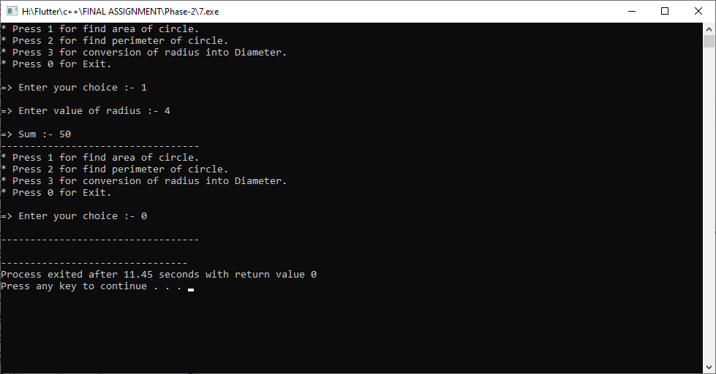

**Practical-8**

**Aim: A Computer Teacher wants to teach a 10th standard class that how a computer converts any decimal value into binary value. Help that teacher by developing C++ program for this urpose.**

**Program:**

#include<iostream>

#include<string.h>

using namespace std;

void decToBinary(int n)

{

int binaryNum[100];

int i = 0,j;

while (n > 0)

{

binaryNum[i] = n % 2;

n = n / 2;

i++;

}

cout << endl << "=> Convert decimal into binary :- ";

for (j=i-1; j>=0; j--)

{

cout << binaryNum[j];

}

}

int main()

{

int n;

cout << "=> Enter any decimal number :- "; cin >> n;

decToBinary(n);

return 0;

}

**\**

**Output:**

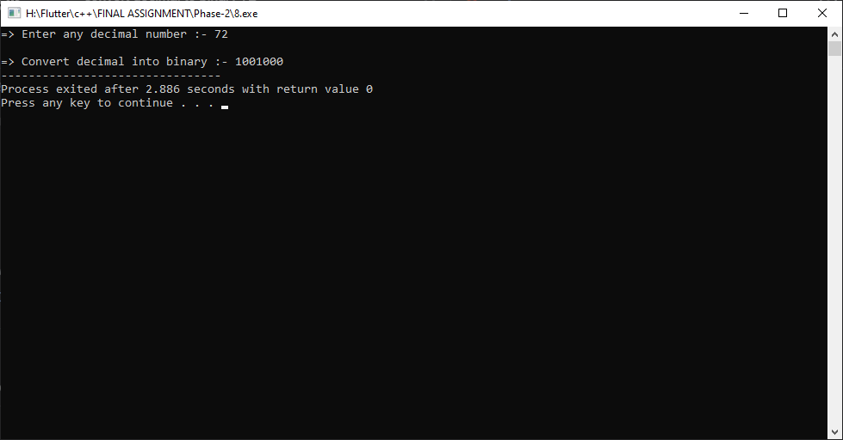

**Practical-9**

**Aim: A Hospital Staff needs a BMI Calculator for rapidly check BMI values of any patient. Design a BMI Calculator by using C++ to provide this facility to all Hospital staff members.**

**Program:**

#include<iostream>

#include<string.h>

using namespace std;

class BMICalculator

{

private:

int w, h;

float bmi;

public:

BMICalculator()

{

cout<<"* Enter Your Weight in ponds: "; cin>>w;

cout<<"* Enter Your Height in inches: "; cin>>h;

}

void check()

{

bmi = (w*703)/(h*h);

if(bmi > 25)

{

cout<<endl<<"=> Your BMI is = "

<<bmi<<" Overweight"<<endl;

}

else if(bmi<25 && bmi>18.5)

{

cout<<endl<<"=> Your BMI is = "

<<bmi << " Optimal"<<endl;

}

else

{

cout<<endl<<"=> Your BMI is = "

<<bmi<<" Underweight"<<endl;

}

}

};

int main()

{

BMICalculator b1;

b1.check();

return 0;

}

**Output:**

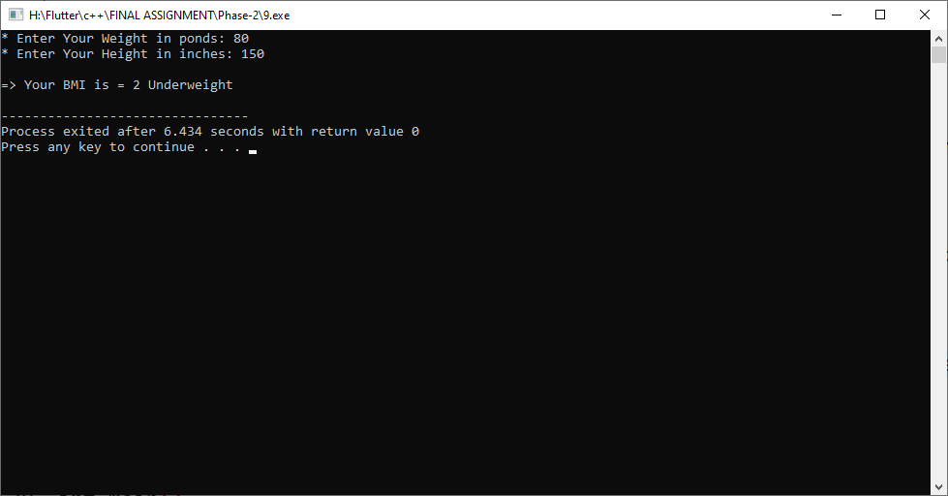

**Practical-10**

**Aim: An average consumer established his own business shop. He went to C.A for maintain all his accounts related queries. Now, help that C.A to build GST calculator for ease of calculation.**

**Program:**

#include<iostream>

#include<string.h>

using namespace std;

class Business

{

private:

int o,n;

double gst;

public:

Business()

{

cout<<"* Enter net price of product: "; cin>>n;

cout<<"* Enter original prise of product: "; cin>>o;

}

void GST()

{

gst = ((n-o)*100)/o;

cout<<endl<<"=> GST of this product is = "<<gst<<endl;

}

};

int main()

{

Business b1;

b1.GST();

return 0;

}

**Output:**

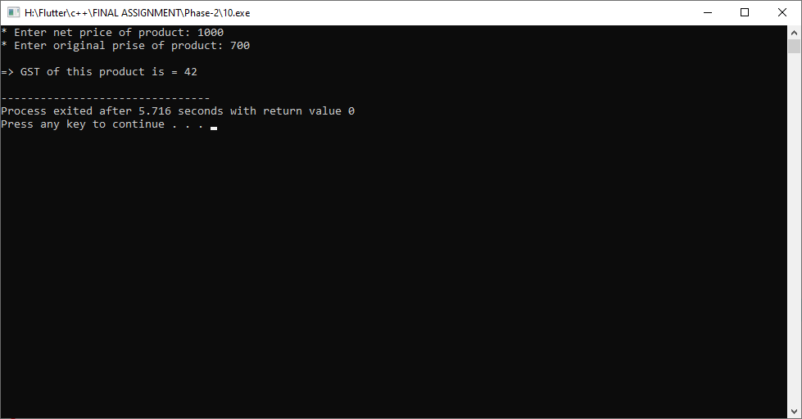

**Practical-11**

**Aim: A Mountain Tracker needs a Temperature Converter for maintaining his tracking at Mount Everest. Build temperature converter for that tracker using C++ as your primary language.**

**Program:**

#include<iostream>

#include<string.h>

using namespace std;

class Tracker

{

private:

int n;

float c,f;

public:

void Data()

{

cout<<"=> Press 1 for celcius to farenheit."<<endl;

cout<<"=> Press 2 for fahrenheit to celsius."<<endl;

}

void Celcius()

{

cout<<endl<<"* Enter temperature in celsius: "; cin>>n;

f=((9/5)*n)+32;

cout<<endl<<"=> Fahrenheit = "<<f;

}

void Fahrenheit()

{

cout<<endl<<"* Enter temperature in fahrenheit: "; cin>>n;

c=(n-32)*(9/5);

cout<<endl<<"=> Celcius = "<<c<<endl;

}

};

int main()

{

Tracker t1;

int c;

t1.Data();

cout<<endl<<"* Enter your Choice: ";

cin>>c;

if(c==1)

{

t1.Celsius();

}

else

{

t1.Fahrenheit();

}

return 0;

}

**Output:**

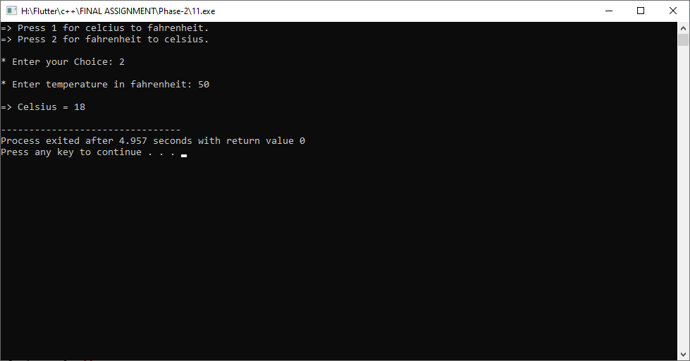

**Practical-12**

**Aim: Nishant trapped in a cyber game, in which he only gets some random amount of seconds for determining at which exact time he has to leave that game. Write a C++ program which converts that seconds into HH:MM:SS format.**

**Program:**

#include<iostream>

#include<string.h>

using namespace std;

class Nishant

{

private:

int hour, minute, second, n;

public:

Nishant()

{

cout<<"* Enter total seconds: "; cin>>n;

}

void converter()

{

hour = n/3600;

minute = (n%3600)/60;

second = (n%3600)%60;

cout<<endl<<"=> Convert into HH:MM:SS = "

<<hour<<" : "<<minute<<" : "<<second<<endl;

}

};

int main()

{

Nishant n1;

n1.converter();

return 0;

}

**Output:**

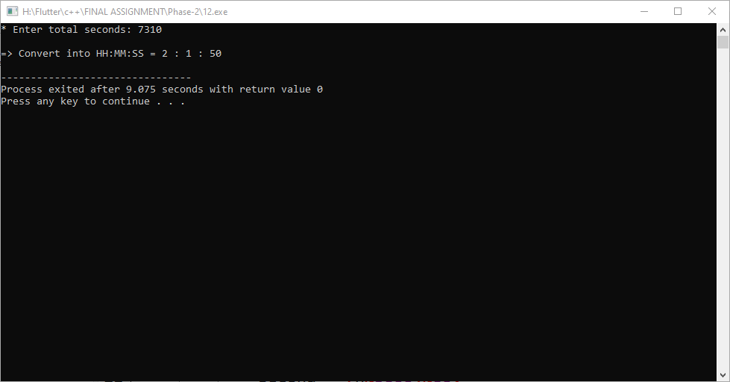

**Practical-13**

**Aim: Design an EMI Calculator for deciding accurate EMI price of ex-showroom car models to help an executive to easily guide his consumers. Use C++ to build this type of system.**

**Program:**

#include<iostream>

#include<string.h>

using namespace std;

class EMICalculator

{

private:

int amount, month, sum;

public:

EMICalculator()

{

cout<<"* Enter total amount: "; cin>>amount;

cout<<"* Enter total months: "; cin>>month;

}

void EMI()

{

sum = amount/month;

cout<<endl<<"=> Your monthly EMI = "<<sum;

}

};

int main()

{

EMICalculator e1;

e1.EMI();

return 0;

}

**Output:**

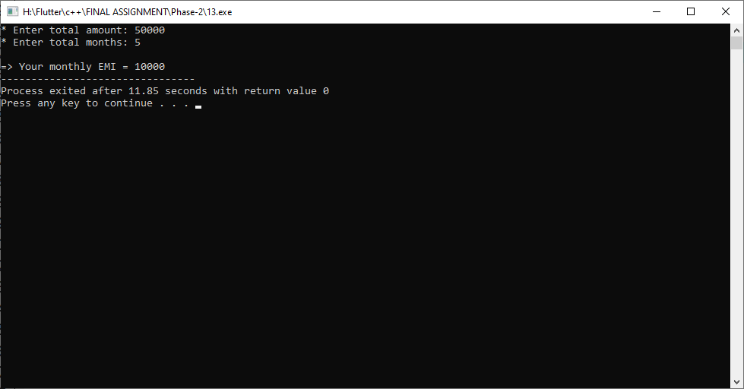

**Practical-14**

**Aim: Develop a solution for Income Tax Department for identify which person have to pay how much tax basis on his/her income using C++ and pre-defined percentage criteria for tax calculation.**

**Program:**

#include<iostream>

#include<string.h>

using namespace std;

class TaxDepartment

{

private:

int income, tax;

public:

TaxDepartment()

{

cout<<"* Enter your income: "; cin>>income;

}

void Tax()

{

if(income<=200000)

{

cout<<endl<<"=> You don't need to pay any tax.";

}

else if(income>200000&&income<=500000)

{

tax = (income-200000)/10;

cout<<endl<<"=> Your Tax Amount = "<<tax;

}

else if(income>500000&&income<=1000000)

{

tax = ((income-500000)/10*2)+30000;

cout<<endl<<"=> Your Tax Amount = "<<tax;

}

else

{

tax = (((income-1000000)/10)*3)+130000;

cout<<endl<<"=> Your Tax Amount = "<<tax;

}

}

};

int main()

{

TaxDepartment t1;

t1.Tax();

return 0;

}

**Output:**

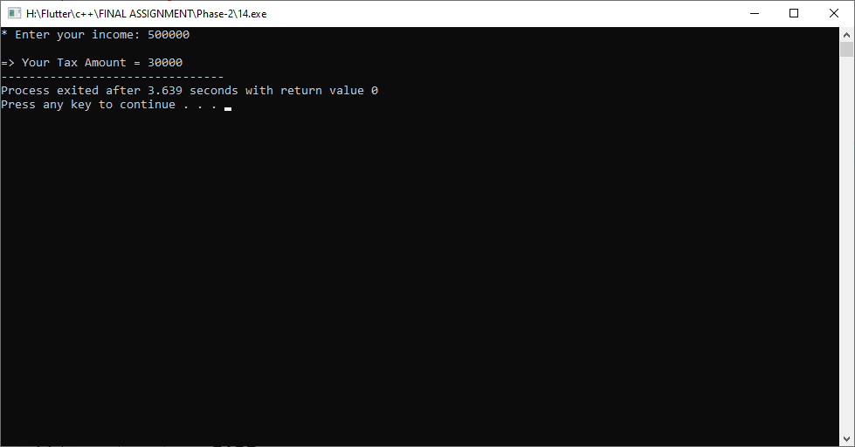

**Practical-15**

**Aim: A new OLED Smart TV as a gift from a bussiness with emersive 32*52 inch size is arrived at occation of Dashera in the house of Mayer. Now Mayer has to decide that how much of minimum wll area (width * hight) will be required to fit that new TV so that evevn after applying that TV, 10 inch of margin still available around TV. Help Mayer to indentify the solution by using c++.**

**Program:**

#include<iostream>

#include<string.h>

using namespace std;

class TV

{

private:

int w=32, h=52;

public:

void Cover()

{

cout<<"=> Smart TV is 32*52 inch."<<endl;

cout<<endl<<"* Wall Height*Width is = "<<w+20

<<" * "<<h+20<<endl;

cout<<endl<<"=> Total area that covered TV is = "

<<(w+20)*(h+20)<<endl;

}

};

int main()

{

TV t1;

t1.Cover();

return 0;

}

**Output:**

