**Phase-3 String Programs**

**Practical-1**

**Aim: Nayan bet ₹.1200 to his friend Kartik if he find frequency of each characters in given String. Whereas Dhruv bet ₹.1500 to his friend Piyush if he finds it first. Provide a C++ program to help this fellows so that they can play this interesting game.**

**Program:**

#include<iostream>

#include<stdio.h>

using namespace std;

class String

{

private:

char a[100];

int b[100];

int i,j,count;

public:

String()

{

cout<<"* Enter any string : "; cin>>this->a;

}

void Frequency()

{

for(i=0;a[i]!=NULL;i++)

{

count=1;

for(j=i+1;a[j]!=NULL;j++)

{

if(a[i]!='-1')

{

if(a[i]==a[j])

{

count++;

a[j]='-1';

}

}

b[i]=count;

}

}

cout << endl;

for(i=0;a[i]!=NULL;i++)

{

if(a[i]!='1')

{

cout<<"=> Frequency of "<<this->a[i]

<<" is "<<this->b[i]<<endl;

}

}

}

};

int main()

{

String s1;

s1.Frequency();

return 0;

}

**Output:**

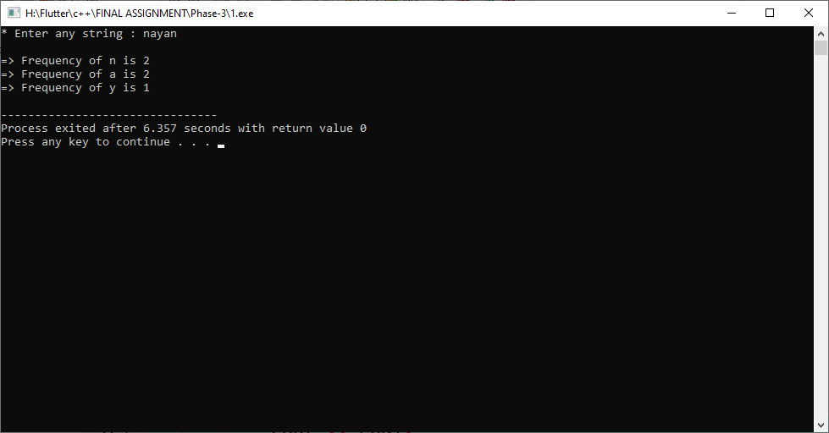

**Practical-2**

**Aim: Design a system in which if a length of a String is greater than 3 and less than 9, then it returns reverse of that string. Otherwise, it returns sum of each letters’ ASCII value. Use C++ for building this type of system.**

**Program:**

#include<iostream>

#include<string.h>

using namespace std;

class String

{

public:

char a[100];

int count=0, i, sum=0;

public:

String()

{

cout<<"* Enter any string: ";

cin>>this->a;

}

void ASCII()

{

for(i=0;a[i]!='\0';i++)

{

count++;

}

if(count>=3&&count<=9)

{

cout << endl << "=> Reverce of string :- " << strrev(a);

}

else

{

for(i=0;a[i]!='\0';i++)

{

sum += a[i];

}

cout<<endl <<"=> Sum of all letters ASCII value: "<<this->sum;

}

}

};

int main()

{

String s1;

s1.ASCII();

return 0;

}

**Output:**

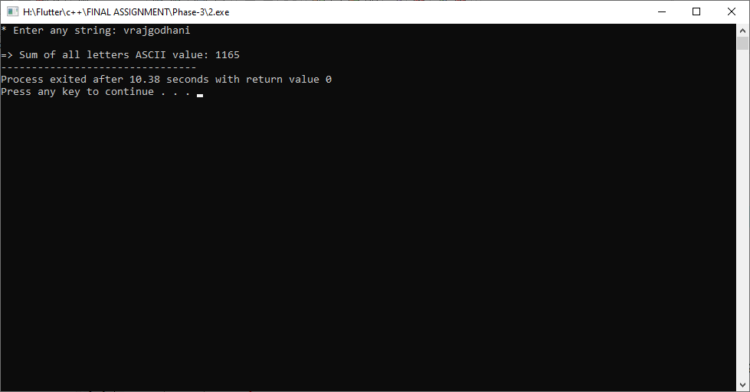

**Practical-3**

**Aim: An IT company named “HAXM Pvt. Ltd.” released an open competition to create a startup level User Authentication system.**

**This system must have these functionalitiess**

**p User can register with email and password**

**p User can login with proper email and password**

**p User can delete his/her account~ Criterias for user authentications**

**p A password must contain at least one digit, one special symbol, one lowercase letter and one uppercase letter while user try to register}**

**p Email and Password must be same while user login**

**p After user account deletion, user cannot be able to login again**

**Design a C++ system for this competition for the price money ₹.2500**

**[Hint You can use multiple String Arrays]**

**Program:**

#include<iostream>

#include<string.h>

using namespace std;

class IT

{

private:

char email[100], pass[100], email1[100], pass1[100];

int i,l=0,u=0,d=0,s=0,a=0;

public:

void menu()

{

cout<<"=> Press 1 for registrartion."<<endl;

cout<<"=> Press 2 for login."<<endl;

cout<<"=> Press 3 for deletion."<<endl;

cout<<"=> Press 0 for exit."<<endl;

}

void registration()

{

cout<<endl<<"* Enter Email: "; cin>>email;

cout<<"* Enter Password: "; cin>>pass;

for(i=0;pass[i]!='\0';i++)

{

if(pass[i]>='a'&&pass[i]<='z')

{

l++;

}

else if(pass[i]>='A'&&pass[i]<='Z')

{

u++;

}

else if(pass[i]>='0'&&pass[i]<='9')

{

d++;

}

else

{

s++;

}

}

if(l>=1 && u>=1 && d>=1 && s>=1)

{

cout<<endl<<"=> Registration successfully."<<endl;

a++;

}

else

{

cout<<endl<<"=> Please enter valid Password."

<<endl;

}

}

void login()

{

if(a>=1)

{

cout<<endl<<"Enter Email: "; cin>>this->email1;

cout<<"Enter Password: "; cin>>this->pass1;

if(strcmp(email1, email)==0 && strcmp(pass1, pass)==0)

{

cout<<endl<<"=> Login successfully."<<endl;

}

else

{

cout<<endl

<<"=> Please Enter right password and email."<<endl;

}

}

else

{

cout<<endl<<"=> You can't login before registration."

<<endl;

}

}

void deletion()

{

if(a>=1)

{

cout<<endl<<"Enter Email: "; cin>>email1;

cout<<"Enter Password: "; cin>>pass1;

if(strcmp(email1, email)==0 && strcmp(pass1, pass)==0)

{

for(i=0;email[i]!='\0';i++)

{

email[i]='0';

}

for(i=0;pass[i]!='\0';i++)

{

pass[i]='0';

}

cout<<"=> Deletion successfully."<<endl;

}

else

{

cout<<endl

<<"=> Please enter right password and email."<<endl;

}

}

else

{

cout<<endl

<<"=> You can't deletion before registration."<<endl;

}

}

};

int main()

{

IT i1;

int choice;

do

{

i1.menu();

cout<<endl<<"Enter Your Choice: "; cin>>choice;

if(choice==1)

{

i1.registration();

}

else if(choice==2)

{

i1.login();

}

else if(choice==3)

{

i1.deletion();

}

else if(choice!=0)

{

cout<<endl<<"=> Please Enter Valid Value..."<<endl;

}

cout<<endl<<endl;

}while(choice!=0);

return 0;

}

**Output:**

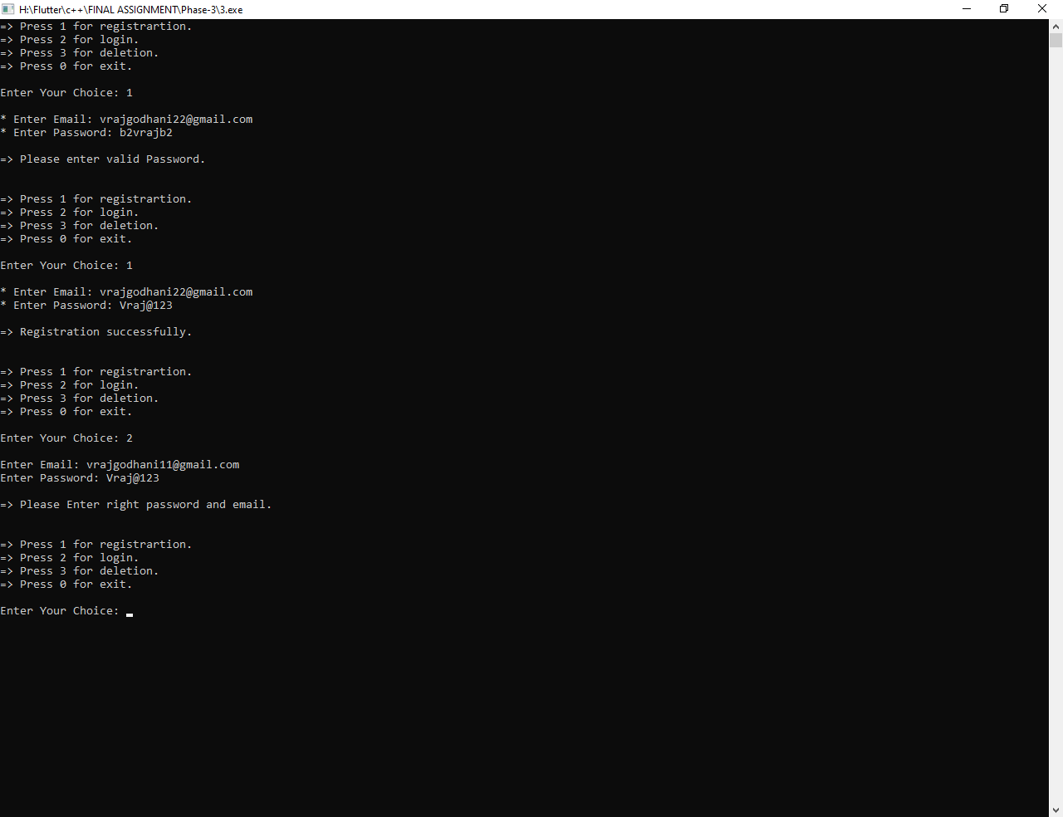

**Practical-4**

**Aim: A Refugee camp have shortage of registering refugees which are coming from Afghanistan. So registration team split up their register documents in two teams: One note down first name along with passport id, another one note down last name along with that passport id. Now while entering that all data as a final stage, a Computer operator needs a system which automatically merge first name and last name together as per reference of passport id. So design this type of system in C++ to help that Refugee camp.**

**Program:**

#include<iostream>

#include<string.h>

using namespace std;

class Passport

{

private:

char firstname[100], lastname[100], passport[100], fullname[100];

int a,b,c;

public:

void setdata()

{

cout<<"=> Enter first name: "; cin>>this->firstname;

cout<<"=> Enter Last name: "; cin>>this->lastname;

cout<<"=> Enter Passport ID: "; cin>>this->passport;

}

void getdata()

{

strcpy(fullname, strcat(firstname,lastname));

cout<<endl<<"=> Full Name: "<<this->fullname;

cout<<endl<<"=> Passport ID: "<<this->passport<<endl;

}

};

int main()

{

Passport p1;

p1.setdata();

p1.getdata();

return 0;

}

**Output:**

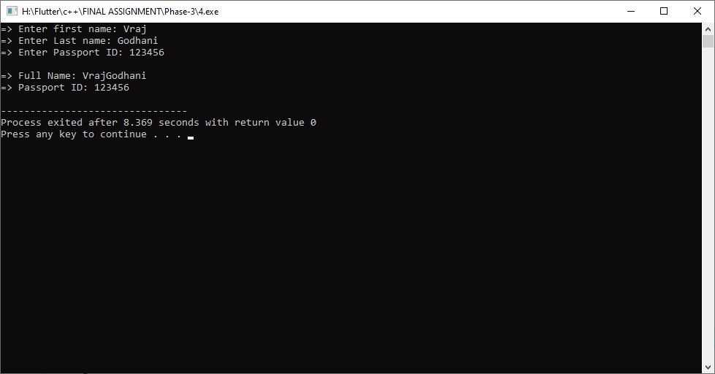

**Practical-5**

**Aim: An Indian Airport needs an identification system to easily extract all types of vowels, consonants, digits and spacial symbols from Highjackers’ communicative messages to identify their next move. Help Indian Airlines by building a C++ program which prime purpose is to identify all string literals.**

**Program:**

#include<iostream>

#include<string.h>

using namespace std;

class Airport

{

private:

char a[100],v1[100],c1[100],s1[100],d1[100];

int i,v=0,c=0,s=0,d=0;

public:

Airport()

{

cout<<"* Enter any string :- ";

cin>>this->a;

}

void getData()

{

for(i=0;a[i]!='\0';i++)

{

if(a[i]=='a'||a[i]=='e'||a[i]=='i'||a[i]=='o'||a[i]=='u'||

a[i]=='A'||a[i]=='E'||a[i]=='I'||a[i]=='O'||a[i]=='U')

{

v1[v]=a[i];

v++;

}

else

{

c1[c]=a[i];

c++;

}

if(a[i]>='a'&&a[i]<='z'||a[i]>='A'&&a[i]<='Z')

{

}

else if(a[i]>='0'&&a[i]<='9')

{

d1[d]=a[i];

d++;

}

else

{

s1[s]=a[i];

s++;

}

}

cout<<endl<<"=> Vowels = ";

for(v=0;v1[v]!='\0';v++)

{

cout<<v1[v];

}

cout<<endl<<"=> Consonants = ";

for(c=0;c1[c]!='\0';c++)

{

if(c1[c]>='b'&&c1[c]<='z')

{

cout<<c1[c]<<" ";

}

}

cout<<endl<<"=> Digits = ";

for(d=0;d1[d]!='\0';d++)

{

cout<<d1[d]<<" ";

}

cout<<endl<<"=> Special Symbols = ";

for(s=0;s1[s]!='\0';s++)

{

cout<<s1[s]<<" ";

}

}

};

int main()

{

Airport a1;

a1.getData();

return 0;

}

**Output:**

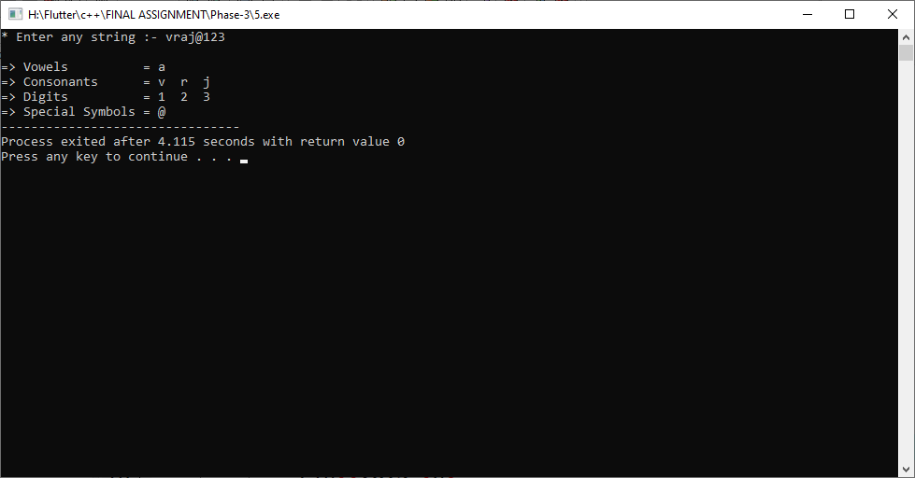

**Practical-6**

**Aim: Design a system for “Dare to Win” game scenario. In this game, two participants have to guess any situation or work which he/she wants to be done by opposition player. So both player write their intended dare works and now a system will swap that both dare works and provide that to other opposite players. Write a C++ program to help swapping that dare works.**

**Program:**

#include<iostream>

#include<string.h>

using namespace std;

class DareGame

{

private:

char a[100],b[100],c[100],name1[100],name2[100];

public:

DareGame()

{

cout<<"* Enter first name: "; cin>>this->name1;

cout<<"* Enter Dare 1: "; cin>>this->a;

cout<<"* Enter second name: "; cin>>this->name2;

cout<<"* Enter Dare 2: "; cin>>this->b;

}

void swap()

{

strcpy(c, b);

strcpy(b, a);

strcpy(a, c);

cout<<endl<<"=> Dare for "<<this->name1

<<" is being "<<this->a<<endl;

cout<<"=> Dare for "<<this->name2

<<" is being "<<this->b<<endl;

}

};

int main()

{

DareGame d1;

d1.swap();

return 0;

}

**Output:**

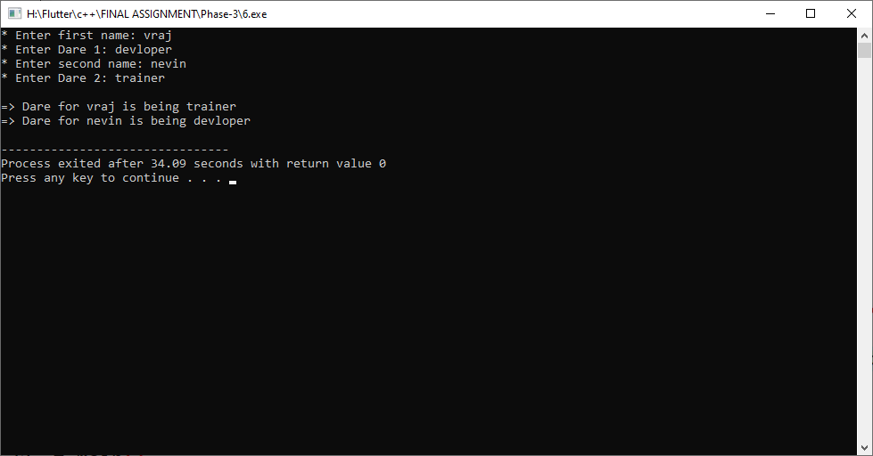

**Practical-7**

**Aim: Build a C++ program which helps students that how to convert a given string in lowercase, uppercase, title case and toggle case whenever they wants by passing their choice.**

**Program:**

#include<iostream>

#include<string.h>

using namespace std;

class Converter

{

private:

char a[100];

int i;

public:

void cases()

{

cout<<"=> Press 1 for lowercase"<<endl;

cout<<"=> Press 2 for uppercase"<<endl;

cout<<"=> Press 3 for titlecase"<<endl;

cout<<"=> Press 4 for togglecase"<<endl;

}

void Lowercase()

{

cout<<endl<<"* Enter any string :- "; cin>>this->a;

for(i=0;a[i]!='\0';i++)

{

if(a[i]>='A'&&a[i]<='Z')

{

a[i] = a[i]+32;

}

}

cout<<"=> Lowercase is: "<<this->a<<endl;

}

void Uppercase()

{

cout<<endl<<"* Enter any string :- "; cin>>this->a;

for(i=0;a[i]!='\0';i++)

{

if(a[i]>='a'&&a[i]<='z')

{

a[i] = a[i]-32;

}

}

cout<<"=> Uppercase is: "<<this->a<<endl;

}

void Titlecase()

{

cout<<endl<<"* Enter any string :- "; cin>>this->a;

if(a[0]>='a'&&a[0]<='z')

{

a[i] = a[i]-32;

}

cout<<" Titlecase is: "<<this->a<<endl;

}

void Togglecase()

{

cout<<endl<<"* Enter any string :- "; cin>>this->a;

for(i=0;a[i]!='\0';i++)

{

if(a[i]>='a'&&a[i]<='z')

{

a[i] = a[i]-32;

}

else if(a[i]>='A'&&a[i]<='Z')

{

a[i] = a[i]+32;

}

}

cout<<"=> Togglecase is: "<<this->a<<endl;

}

};

int main()

{

Converter c1;

int choice;

c1.cases();

cout<<endl<<"* Enter your choice: ";

cin>>choice;

if(choice==1)

{

c1.Lowercase();

}

else if(choice==2)

{

c1.Uppercase();

}

else if(choice==3)

{

c1.Titlecase();

}

else if(choice==4)

{

c1.Togglecase();

}

else

{

cout<<endl<<"=> Invalid choice..."<<endl;

}

return 0;

}

**Output:**

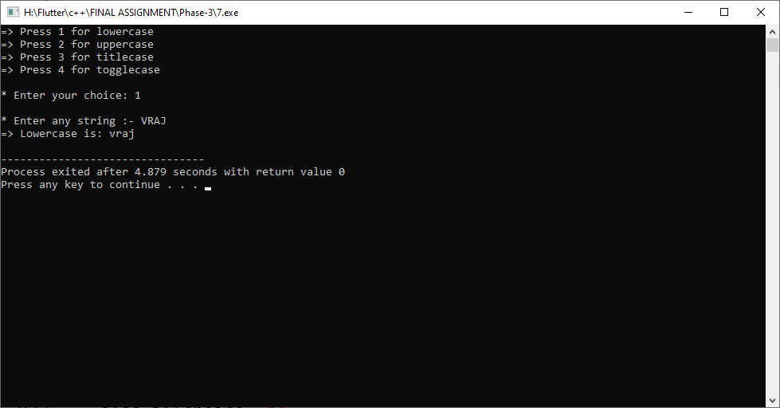

**Practical-8**

**Aim: Build a C++ program which detects if a given word contains any vowels or not. And if it contains, then count how many total vowels are present and which they are. Also returns average value of total vowels’ ASCII values’. Based on that average value, decide word’s level!**

**If 10<=average<=1 , then a word is “SMOO"HER**

**If 1 <average<=30, then a word is “SOBER**

**If average>=30, then a word is “HARER**

**If average==0, then a word is “GORGEOUS”**

**Program:**

#include<iostream>

#include<stdio.h>

using namespace std;

class Word

{

private:

char a[100];

int c=0, sum=0, i, ave;

public:

Word()

{

cout<<"* Enter any string :- "; cin >> this->a;

}

void answer()

{

for(i=0;a[i]!='\0';i++)

{

if(a[i]=='a'||a[i]=='e'||a[i]=='i'||a[i]=='o'||a[i]=='u'||

a[i]=='A'||a[i]=='E'||a[i]=='I'||a[i]=='O'||a[i]=='U')

{

c++;

sum += int(a[i]);

}

}

ave = sum/c;

cout<<endl<<"=> Total vowels are present in massage is :- "

<<c<<endl;

cout<<"=> Average of total vowels ASCII values is :- "<<ave<<endl;

cout<<endl<<"=> Word Level is :- ";

if(ave==0)

{

cout<<"Gorgeous"<<endl;

}

else if(ave>=30)

{

cout<<"Harer"<<endl;

}

else if(1 <ave&&ave<=30)

{

cout<<"Sober"<<endl;

}

else if(10<=ave&&ave>=1)

{

cout<<"Smooher"<<endl;

}

}

};

int main()

{

Word w1;

w1.answer();

return 0;

}

**Output:**

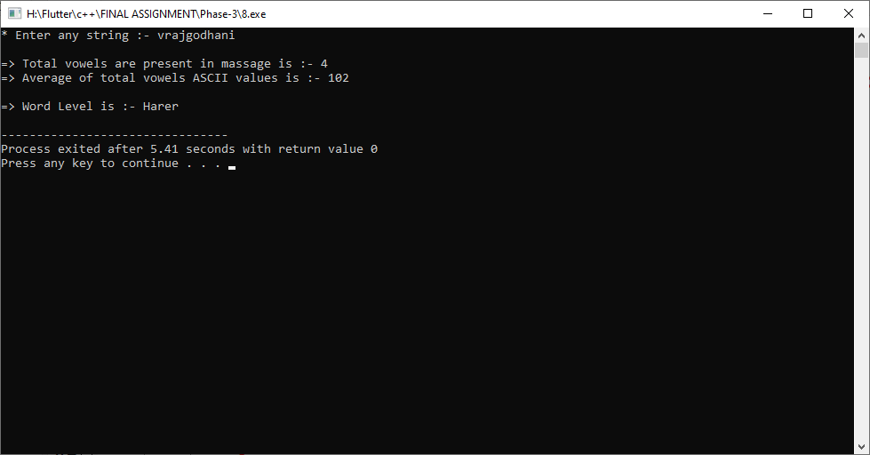

**Practical-9**

**Aim: Create an Instagram filter by which we can easily extract all digits and special symbols from any username. By doing so, we can retrieve a pure username with only alphabets within it. Use C++ as a prime language to do so.**

**Program:**

#include<iostream>

#include<stdio.h>

using namespace std;

class Instagram

{

private:

char a[100], b[100];

int i, j=0;

public:

Instagram()

{

cout<<"* Enter your username :- "; cin>>this->a;

}

void UserName()

{

for(i=0;a[i]!='\0';i++)

{

if(a[i]>='a'&&a[i]<='z'||a[i]>='A'&&a[i]<='Z')

{

b[j]=a[i];

j++;

}

}

cout<<endl<<"=> Your name is :- "<<this->b<<endl;

}

};

int main()

{

Instagram i1;

i1.UserName();

return 0;

}

**Output:**

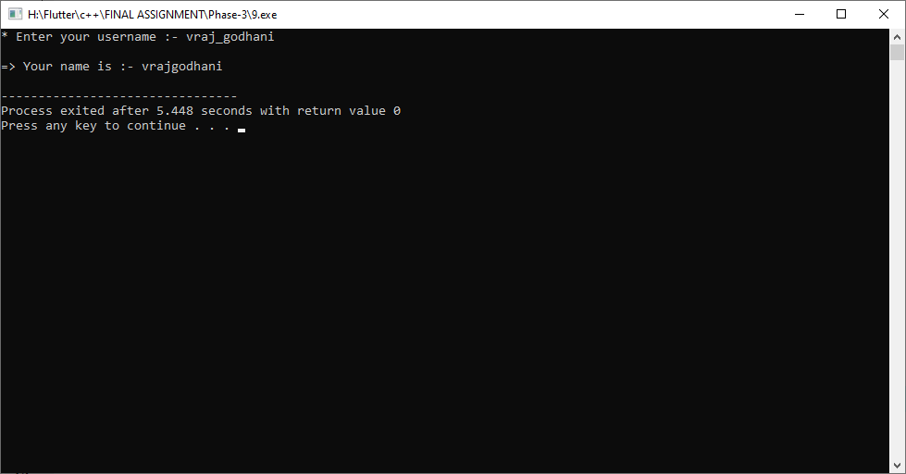

**Practical-10**

**Aim: List of some historical words by some famous Philosopher has been written in his diary. But all that words are only can be read if we put that word in front of mirror. So write a C++ program to design it.**

**Program:**

#include<iostream>

#include<string.h>

using namespace std;

class Historical

{

private:

char a[100];

public:

Historical()

{

cout<<"* Enter historical words :- "; cin>>this->a;

}

void Philosopher()

{

cout<<endl<<"=> Front of mirror Word is :- "<<strrev(a)<<endl;

}

};

int main()

{

Historical h1;

h1.Philosopher();

return 0;

}

**Output:**

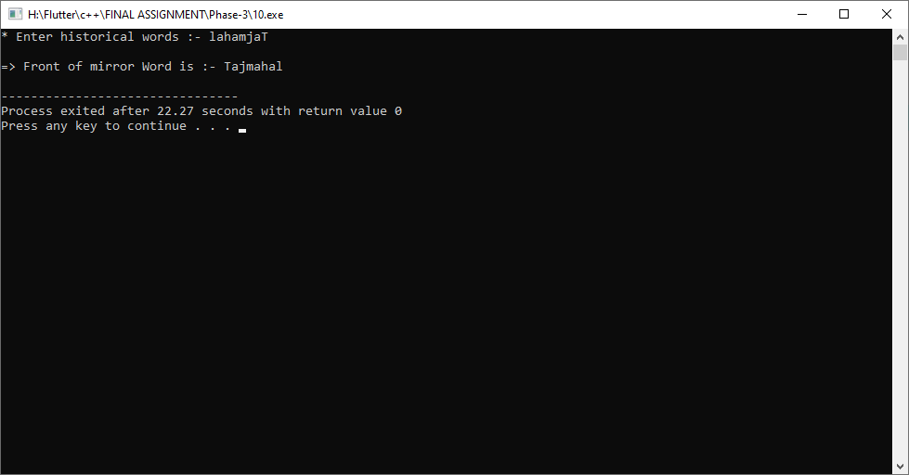

**Practical-11**

**Aim: Build a system which converts given message into Ciphertext by adding custom letter or ASCII value. Also provide decoding for that encoded text to understand Indian Army to secure internal communication between soldiers. Help them by creating a C++ program.**

**Program:**

#include<iostream>

#include<string.h>

using namespace std;

class Army

{

private:

char a[100];

int b[100];

int i, n;

public:

void coding()

{

cout<<"=> Press 1 for incoding massage."<<endl;

cout<<"=> Press 2 for decoding massage."<<endl;

}

void Incoding()

{

cout<<"* Enter any string :- "; cin>>this->a;

cout<<endl<<"=> Your string incoding is :- ";

for(i=0;a[i]!='\0';i++)

{

cout<<int(a[i]);

}

cout<<endl;

}

void Decoding()

{

cout<<endl<<"=> What is your code number :- ";

cin>>n;

cout<<endl;

for(i=0;i<n;i++)

{

cout<<"* Enter Number: ";

cin>>b[i];

}

cout<<"=> Your string decoding is: ";

for(i=0;i<n;i++)

{

cout<<char(b[i]);

}

cout<<endl;

}

};

int main()

{

Army a1;

int choice;

a1.coding();

cout<<endl<<" Enter Your Choice: ";

cin>>choice;

if(choice==1)

{

a1.Incoding();

}

else if(choice==2)

{

a1.Decoding();

}

else if(choice!=0)

{

cout<<endl<<"=> Invalid choice...."<<endl;

}

return 0;

}

**Output:**

