**Project - 1**

**Aim: Write a Dart Program to get and print total three**

**employees information using user input and**

**Map data entry(use MapEntry class)**

**Take blow mention attributes for one employee :**

**id**

**name**

**age**

**salary**

**Program:**

import 'dart:io';

void main() {

int id, age, salary;

String name;

Map a = {};

print('-------- * Details of Employees * --------\n');

for (int i = 1; i <= 3; i++) {

stdout.write('=> Enter Employee ID : ');

id = int.parse(stdin.readLineSync()!);

stdout.write('=> Enter Employee Name : ');

name = stdin.readLineSync()!;

stdout.write('=> Enter Employee Age : ');

age = int.parse(stdin.readLineSync()!);

stdout.write('=> Enter Employee Salary : ');

salary = int.parse(stdin.readLineSync()!);

print('\n');

MapEntry ml = MapEntry('Emp_ID', id);

MapEntry m2 = MapEntry('Emp Name ', name);

MapEntry m3 = MapEntry('Emp_Age ', age);

MapEntry m4 = MapEntry('Emp_Salary ', salary);

a.addEntries([ml, m2, m3, m4]);

print(a);

for (int i = 1; i <= 3; i++) {

stdout.write('=> Enter Employee ID : ');

id = int.parse(stdin.readLineSync()!);

stdout.write('=> Enter Employee Name : ');

name = stdin.readLineSync()!;

stdout.write('=> Enter Employee Age : ');

age = int.parse(stdin.readLineSync()!);

stdout.write('=> Enter Employee Salary : ');

salary = int.parse(stdin.readLineSync()!);

print('\n');

MapEntry m1 = MapEntry('Emp_ID', id);

MapEntry m2 = MapEntry('Emp_Name ', name);

MapEntry m3 = MapEntry('Emp_Age', age);

MapEntry m4 = MapEntry('Emp_ Salary ', salary);

a.addEntries([ml, m2, m3, m4]);

print(a);

print('\n');

}

}

}

**Output:**

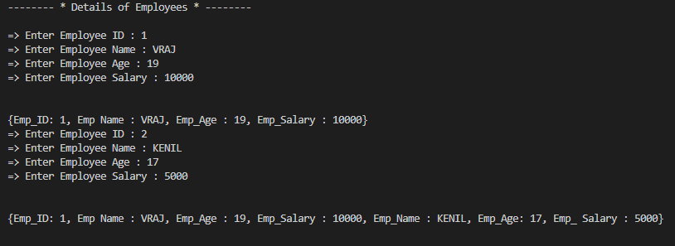

**Project - 2**

**Aim: Write a Dart Program to print all unique elements from a List.**

**Elements may be redundant while entering into**

**a List. Usr can only enter elements of String datatype.**

**Program:**

import 'dart:io';

void main() {

List a = [];

int n;

String s;

stdout.write('=> How many elements : ');

n = int.parse(stdin.readLineSync()!);

print('\n=> Elements of String : ');

for (int i = 0; i < n; i++) {

s = stdin.readLineSync()!;

a.add(s);

Set ans = a.toSet();

print(ans.toList());

}

}

**Output:**

