**Extending Care to the Home - Enabling Health Workers**

**CS 837: Healthcare Application Development**

**Milestone -1**

**Guided By**

|  |
| --- |
| **T K Srikanth** |
| **Prof.**  **International Institute of Information Technology, Bangalore** |
|  |
| **Jayaa Shree Laxmi Kishoore** |
| **Teaching Assistant** |



**International Institute of Information Technology, Bangalore**

Created by:

**Team - 12**

|  |
| --- |
| **Tanvi Motwani** |
| **MT2023149** |
| **Tanvi.Motwani@iiitb.ac.in** |

|  |  |  |
| --- | --- | --- |
| **Arjun Gangani** |  | **Harsh Ranpariya** |
| **MT2023153** |  | **MT2023164** |
| **Arjun.Gangani@iiitb.ac.in** |  | **Harsh.Ranpariya@iiitb.ac.in** |
|  |  |  |
| **Vraj Jatin Naik** |  | **Nikita Gupta** |
| **MT2023050** |  | **MT2023132** |
| **Vraj.Naik@iiitb.ac.in** |  | **Nikita.Gupta@iiitb.ac.in** |

# TABLE OF CONTENTS

1. Problem Statement 3
2. Actors and their roles 4
3. Diagrams 7

3.1 Flow Diagrams 7

3.2 Use Case - Diagrams 9

# Problem Statement:

* **Project No – 6:**
* Field health workers visit houses and screen all members of a family using standardized questionnaire
* Those identified with mental health conditions are referred to doctor for local area
* Doctor evaluates and prescribes treatment, and any follow-up needed. Records diagnosis with ICD10 codes (entry should be simple)
* Health worker should track and complete follow-ups. App helps them with schedule, alerts etc.
* Tablet-based app for health worker. Should support offline capability
* Doc can view data of patients they have treated, as well as summary data of patients in their local area (e.g. district or taluka)
* Provides API for state level dashboard that shows data across such programs
* Multi-lingual (for field worker)

# Actors and their Roles:

1. Admin
2. Supervisor
3. Doctor
4. Health Care Worker

**Roles:**

1. **Admin:**

* Admin will login
* On Landing screen admin can view the number of registered doctors, supervisors and health workers.
* By clicking on one of the cards, admin can view the list of registered doctors, supervisors and health workers respectively.
* Admin can add new health worker/doctor/supervisor

1. **Supervisor:**

* Supervisor will login
* Can view the areas that are assigned to him
* By clicking on the card of specific area, he can view the list of health workers corresponding to that area
* The list of health workers will also contain information related to whether or not the follow up has been completed.
* If there are no health workers corresponding to the given area then popup will be shown which says No data found
* Can handle missed follow ups if any by contacting health worker

1. **Doctor:**

* Doctor will login
* On Landing the screen the doctor can view the list of patients that have been referred to him
* Doctor can also view bucket cards which will indicate the number of new patients that have been scheduled for appointments and total number of patients
* By clicking on one of the patients from list the demographics of patient will open on right half, where doctor can view information related to the patient
* Doctor can view patient medical history.
* By clicking on add/edit prescription, doctor can add details related to checkup and can upload prescription
* Doctor can schedule follow up if required
* Doctor can view dashboard which contains graphical representation of the total patients treated and corresponding to which disease
* In dashboard doctor can also view the district level statistics.
* Doctor can also view/edit his profile.

1. **Field Health Worker:**

* Healthcare worker can login by username and password
* On forget password OTP verification with mobile number is provided
* On Home page he can view two options:
  + Register people
  + Follow ups
* On clicking register people he can register patient with all the demographics details.
* After submitting registration form, he can carry out standard questionary.
* After completing questionnaires, he can view results and based on that patient will be referred to doctor of local area.
* On home page by clicking on Follow up, he can view the list of follow ups and can mark done for the follow ups he has completed.
* By clicking on patient with follow up, he can view the prescription and the instruction added by doctor.
* And following that he will carry out follow up questionary with patient.
* Offline capabilities: Access to patient schedules for follow-ups. Questionnaire administration offline, with data synchronization upon network availability.
* Ability to view and update patient records offline.
* Notification System: Reminder notifications for upcoming follow-ups.
* Multilingual support with local languages.

# Diagrams

**3.1 Work Flow Diagram:**

**3.1.1 Admin:**

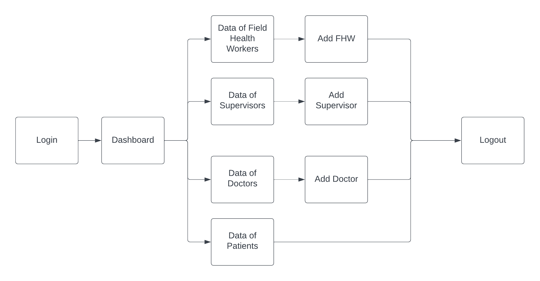

**3.1.2 Supervisor:**

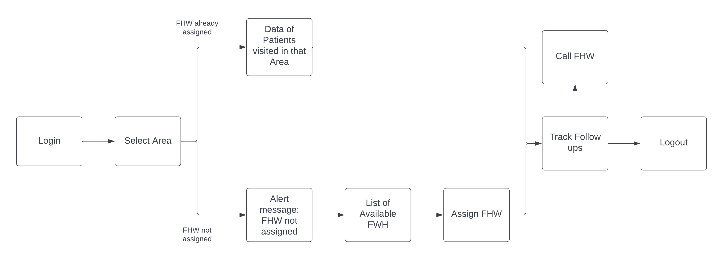

**3.1.3 Doctor:**

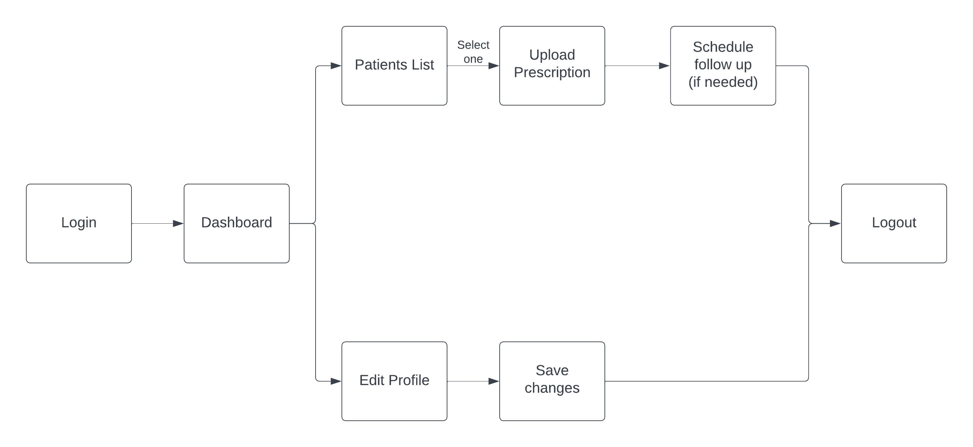

**3.1.4 Healthcare Worker:**

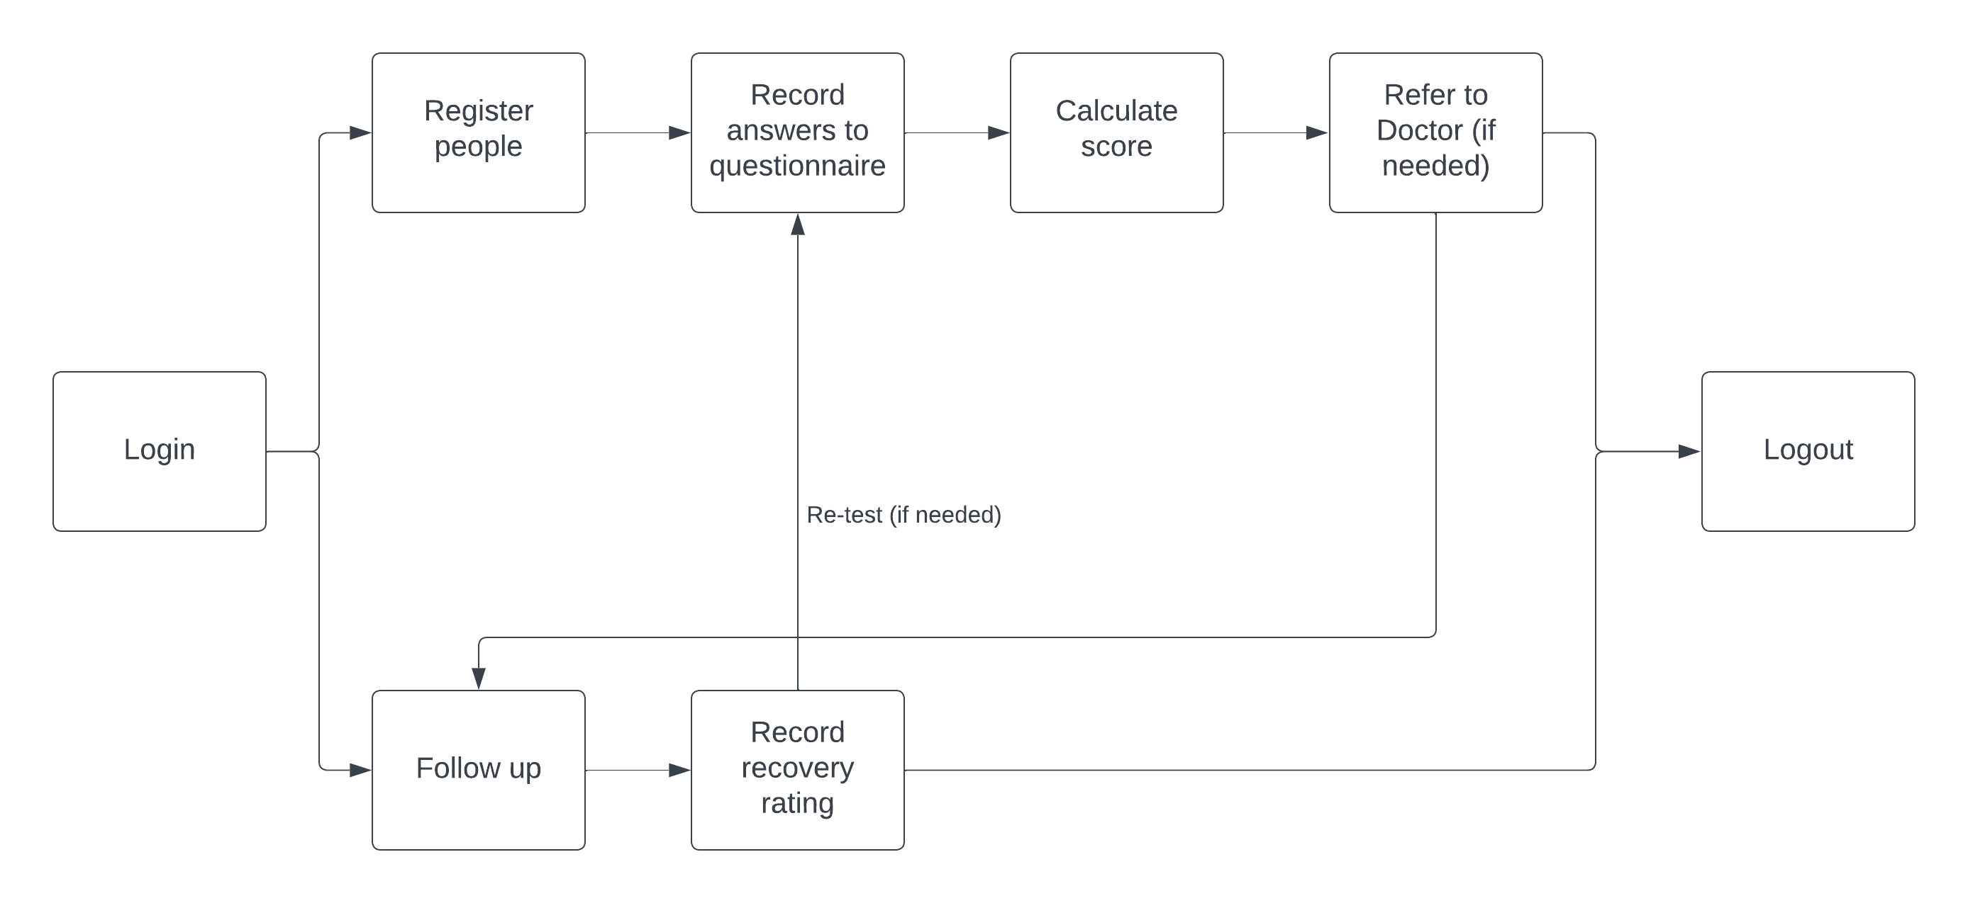

**3.2 Use Case Diagram:**

**3.2.1 Web Application**

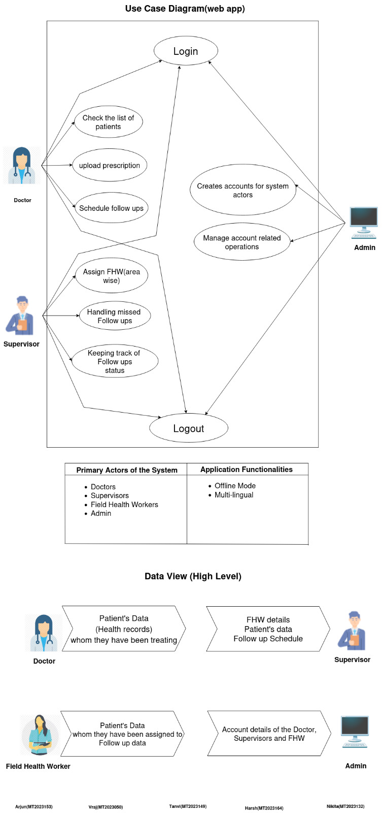

**3.2.2 Mobile Application:**

