

**MINI PROJECT REPORT**

**DATABASE MANAGEMENT SYSTEM**

**Birla Vishvakarma Mahavidyalaya**

**Engineering College, Vallabh Vidyanagar**

PROJECT TITLE :

**KABADDI MANAGEMENT SYSTEM**

By

Vraj Patel(23CP071)

Krince Visoriya (23CP069)

1. Introduction

This project presents a database management system for managing kabaddi data, including details about players, teams, seasons, matches, and statistics. The system is designed to efficiently manage and retrieve data related to kabaddi matches, teams, and players, as well as to provide comprehensive statistics and information about team performances across seasons.

2.Functional Requirement

* Entities

1. **Player**
   * Attributes:
     + Player_ID (Primary Key)
     + Name
     + Date_of_Birth
     + Position
2. **Team**
   * Attributes:
     + Team_ID (Primary Key)
     + Name
     + Coach
     + City
3. **Season**
   * Attributes:
     + Season_ID (Primary Key)
     + Season_Name
     + Start_Date
     + End_Date
4. **Match**
   * Attributes:
     + Match_ID (Primary Key)
     + Date
     + Team1_Score
     + Team2_Score
     + Winning_Team
     + Venue
     + Season_ID (Foreign Key to Season)
     + Team1_ID (Foreign Key to Team)
     + Team2_ID (Foreign Key to Team)
5. **Team_Stats**
   * Attributes:
     + Stats_ID (Primary Key)
     + Team_ID (Foreign Key to Team)
     + Raider_Point
     + Tackle_Point
     + Extra_Point
     + Match_ID (Foreign Key to Match)
6. **Player_Team**
   * Attributes:
     + PlayerTeam_ID (Primary Key)
     + First_Match_Date
     + Last_Match_Date
     + Total_RaidPoint
     + Total_Tackle
     + Average_RaidPoint
     + Average_TacklePoint
     + Player_ID (Foreign Key to Player)
     + Team_ID (Foreign Key to Team)
     + Season_ID (Foreign Key to Season)

**Relationships:**

1. **Player and Team:**
   * Many-to-Many relationship through the Player_Team table.
   * A player can belong to many teams, and a team can have many players over different seasons.
2. **Team and Match:**
   * One-to-Many relationship between Team and Match.
   * Each match involves two teams (Team1_ID and Team2_ID), and a team can participate in many matches.
3. **Match and Season:**
   * Many-to-One relationship from Match to Season.
   * Each match is part of a season, while a season can have many matches.
4. **Team and Team_Stats:**
   * One-to-Many relationship between Team and Team_Stats.
   * Each team has statistics for each match.
5. **Player_Team and Season:**
   * Many-to-One relationship between Player_Team and Season.
   * A player’s participation in a team is tied to a specific season.

3.ER Diagram

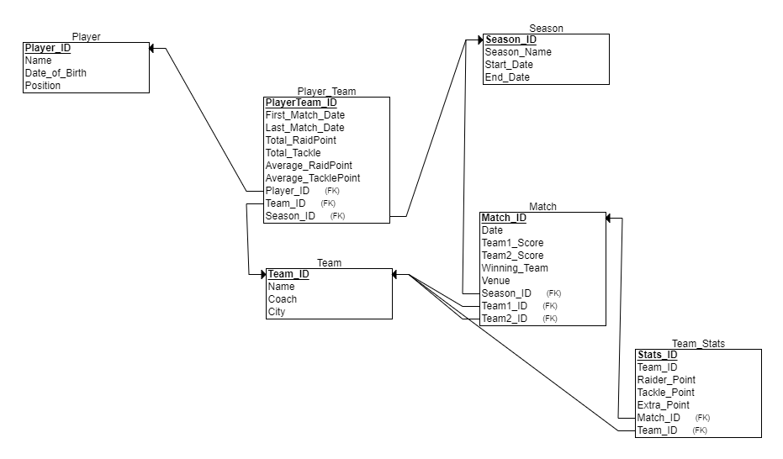4.Relational Diagram

5.Normalization

**Table Player**

* Player_ID → Name, Date_of_Birth, Position  
  (The Player_ID uniquely determines the player’s name, date of birth, and position.)
* 1NF: The table is in 1NF because each attribute contains atomic values and there are no repeating groups.
* 2NF: It is in 2NF because the non-key attributes are fully functionally dependent on the primary key .
* 3NF: It is in 3NF because there are no transitive
* BCNF: It is also in BCNF since the only functional dependency is on the primary key.

Highest Normal Form: BCNF

**Candidate Key:**

* **Player_ID** is the only candidate key since it uniquely identifies each row in the table.

**Table Team**

* Team_ID → Name, Coach, City  
  (The Team_ID uniquely determines the team’s name, coach, and city.)

**Candidate Key:**

* **Team_ID** is the only candidate key as it uniquely identifies each row in the table.
* **1NF**: The table is in **1NF** as it has atomic values, and each row is unique.
* **2NF**: It is in **2NF** because all non-key attributes are fully dependent on the primary key.
* **3NF**: There are no transitive, so it is in **3NF**.
* **BCNF**: The table also satisfies **BCNF** because the primary key is the only determinant for the functional dependencies.

**Highest Normal Form: BCNF**

**Table Season**

* Season_ID → Season_Name, Start_Date, End_Date  
  (The Season_ID uniquely determines the season's name, start date, and end date.)
* **1NF**: The table is in **1NF** as it contains atomic values, and each record is unique.
* **2NF**: It is in **2NF** because all non-key attributes are fully dependent on the primary key.
* **3NF**: There are no transitive dependencies, so it is in **3NF**.
* **BCNF**: The table is also in **BCNF**, as all functional dependencies depend on the primary key.

**Highest Normal Form: BCNF**

**Candidate Key:**

* **Season_ID** is the only candidate key since it uniquely identifies each season.

**Table Match**

* **Match_ID → Date, Team1_Score, Team2_Score, Winning_Team, Venue, Season_ID, Team1_ID, Team2_ID**
* **1NF**: The table is in **1NF** because all values are atomic, and there are no repeating groups.
* **2NF**: It is in **2NF** because all non-key attributes are fully dependent on the primary key.
* **3NF**: There are no transitive dependencies, so it is in **3NF**.
* **BCNF**: The table is in **BCNF** as the only determinant is the primary key.

**Highest Normal Form: BCNF**

**Candidate Keys:**

* **Match_ID**

**uniquely identify each match.**

**Table Team_Stats**

* **Stats_ID → Team_ID, Raider_Point, Tackle_Point, Extra_Point, Match_ID**
* **1NF**: The table is in **1NF** as all attributes are atomic, and there are no repeating groups.
* **2NF**: It is in **2NF** because all non-key attributes are fully dependent on the primary key.
* **3NF**: There are no transitive dependencies, so it is in **3NF**.
* **BCNF**: The table is in **BCNF** because the primary key is the only determinant.

**Highest Normal Form: BCNF**

**Candidate Keys:**

* **Stats_ID**

**uniquely identify each team's statistics for a match.**

**Table Player_Team**

* **PlayerTeam_ID → First_Match_Date, Last_Match_Date, Total_RaidPoint, Total_Tackle, Average_RaidPoint, Average_TacklePoint, Player_ID, Team_ID, Season_ID**
* **1NF**: The table is in **1NF** since it contains atomic values, and there are no repeating groups.
* **2NF**: The table is in **2NF** because all non-key attributes are fully dependent on the primary key.
* **3NF**: There are no transitive dependencies, so the table is in **3NF**.
* **BCNF**: The table is in **BCNF** because the only determinant is the primary key **Highest Normal Form: BCNF**
* **Candidate Keys:**
* **PlayerTeam_ID**

**Both keys uniquely identify a player's participation in a specific team during a season.**

1. **Schema In pgAdmin**

**CREATE TABLE Player**

**(**

**Player_ID INT NOT NULL,**

**Name VARCHAR(100) NOT NULL,**

**Date_of_Birth DATE NOT NULL,**

**Position VARCHAR(50) NOT NULL,**

**PRIMARY KEY (Player_ID)**

**);**

**-- Insert data into Player table**

**INSERT INTO Player (Player_ID, Name, Date_of_Birth, Position)**

**VALUES (1, 'Ajay Thakur', '1986-05-01', 'Raider'),**

**(2, 'Pardeep Narwal', '1997-02-16', 'Raider'),**

**(3, 'Manjeet Chhillar', '1986-08-18', 'All-Rounder');**

**(4, 'Rahul Chaudhari', '1993-06-16', 'Raider'),**

**(5, 'Surjeet Singh', '1990-08-10', 'Defender'),**

**(6, 'Naveen Kumar', '2000-02-07', 'Raider'),**

**(7, 'Deepak Niwas Hooda', '1994-06-10', 'All-Rounder'),**

**(8, 'Sandeep Narwal', '1993-04-01', 'Defender'),**

**(9, 'Mohit Chhillar', '1992-07-13', 'Defender'),**

**(10, 'Fazel Atrachali', '1992-03-29', 'Defender');**

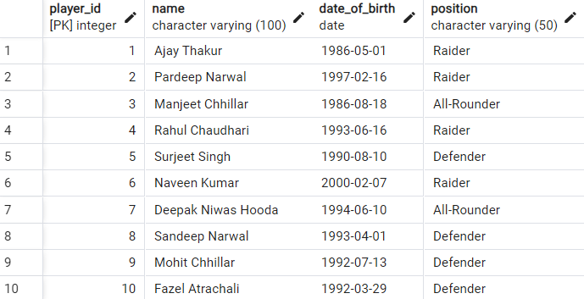

CREATE TABLE Team

( Team_ID INT NOT NULL,

Name VARCHAR(100) NOT NULL,

Coach VARHAR(100) NOT NULL,

City VARCHAR(100) NOT NULL,

PRIMARY KEY (Team_ID));

-- Insert data into Team table

INSERT INTO Team (Team_ID, Name, Coach, City)

VALUES (1, 'Bengal Warriors', 'BC Ramesh', 'Kolkata'),

(2, 'Patna Pirates', 'Ram Mehar Singh', 'Patna'),

(3, 'Dabang Delhi', 'Krishan Kumar Hooda', 'Delhi'),

(4, 'Tamil Thalaivas', 'Udayakumar D', 'Chennai'),

(5, 'U Mumba', 'Sanjeev Kumar', 'Mumbai');

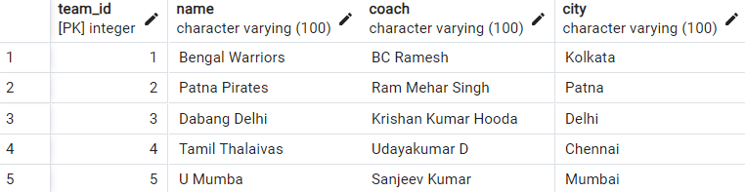

CREATE TABLE Season

(

Season_ID INT NOT NULL,

Season_Name VARCHAR(50) NOT NULL,

Start_Date DATE NOT NULL,

End_Date DATE NOT NULL,

PRIMARY KEY (Season_ID)

);

-- Insert data into Season table

INSERT INTO Season (Season_ID, Season_Name, Start_Date, End_Date)

VALUES (1, 'Season 8', '2021-07-20', '2021-10-10'),

(2, 'Season 9', '2022-07-15', '2022-10-01'),

(3, 'Season 7', '2020-07-15', '2020-10-01');

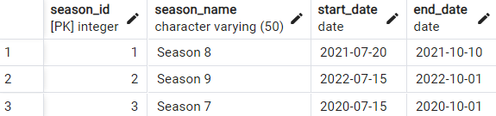

CREATE TABLE Match

(

Match_ID INT NOT NULL,

Date DATE NOT NULL,

Team1_Score INT NOT NULL,

Team2_Score INT NOT NULL,

Winning_Team INT NOT NULL,

Venue VARCHAR(100) NOT NULL,

Season_ID INT NOT NULL,

Team1_ID INT NOT NULL,

Team2_ID INT NOT NULL,

PRIMARY KEY (Match_ID),

FOREIGN KEY (Season_ID) REFERENCES Season(Season_ID),

FOREIGN KEY (Team1_ID) REFERENCES Team(Team_ID),

FOREIGN KEY (Team2_ID) REFERENCES Team(Team_ID)

);

-- Insert data into Match table

INSERT INTO "Match" (Match_ID, Date, Team1_Score, Team2_Score, Winning_Team, Venue, Season_ID, Team1_ID, Team2_ID)

VALUES (1, '2021-07-21', 40, 35, 1, 'Bangalore', 1, 1, 2),

(2, '2021-07-25', 30, 25, 3, 'Delhi', 1, 3, 4),

(3, '2021-07-28', 45, 20, 5, 'Mumbai', 1, 5, 1),

(4, '2022-07-17', 35, 32, 2, 'Chennai', 2, 2, 4),

(5, '2022-07-19', 38, 31, 3, 'Kolkata', 2, 3, 5);

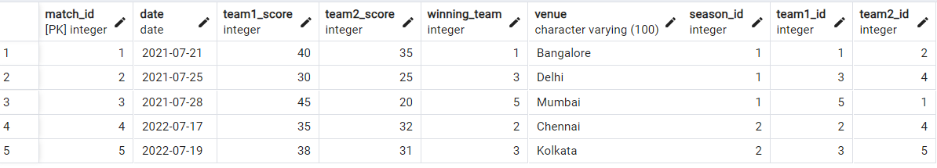

CREATE TABLE Team_Stats

(

Stats_ID INT NOT NULL,

Team_ID INT NOT NULL,

Raider_Point INT NOT NULL,

Tackle_Point INT NOT NULL,

Extra_Point INT NOT NULL,

Match_ID INT NOT NULL,

PRIMARY KEY (Stats_ID),

FOREIGN KEY (Match_ID) REFERENCES "Match"(Match_ID),

FOREIGN KEY (Team_ID) REFERENCES Team(Team_ID)

);

-- Insert data into Team_Stats table

INSERT INTO Team_Stats (Stats_ID, Team_ID, Raider_Point, Tackle_Point, Extra_Point, Match_ID)

VALUES (1, 1, 20, 15, 5, 1),

(2, 2, 15, 10, 10, 1),

(3, 3, 18, 12, 5, 2),

(4, 4, 12, 8, 5, 2),

(5, 5, 22, 18, 5, 3),

(6, 1, 25, 15, 5, 3),

(7, 2, 20, 12, 6, 4),

(8, 4, 15, 8, 9, 4),

(9, 3, 28, 14, 5, 5),

(10, 5, 24, 15, 8, 5);

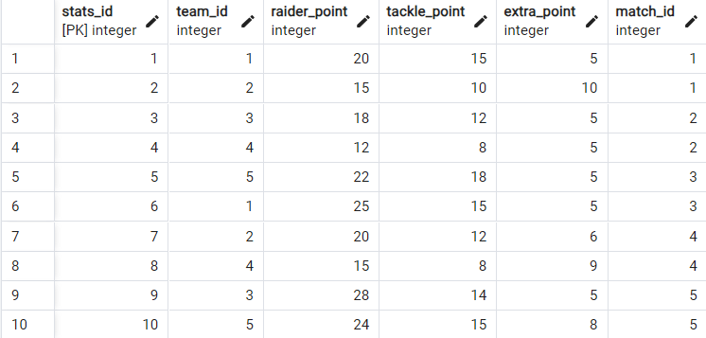

CREATE TABLE Player_Team

(

PlayerTeam_ID INT NOT NULL,

First_Match_Date DATE NOT NULL,

Last_Match_Date DATE NOT NULL,

Total_RaidPoint INT NOT NULL,

Total_Tackle INT NOT NULL,

Average_RaidPoint FLOAT NOT NULL,

Average_TacklePoint FLOAT NOT NULL,

Player_ID INT NOT NULL,

Team_ID INT NOT NULL,

Season_ID INT NOT NULL,

PRIMARY KEY (PlayerTeam_ID),

FOREIGN KEY (Player_ID) REFERENCES Player(Player_ID),

FOREIGN KEY (Team_ID) REFERENCES Team(Team_ID),

FOREIGN KEY (Season_ID) REFERENCES Season(Season_ID)

);

-- Insert data into Player_Team table

INSERT INTO Player_Team (PlayerTeam_ID, First_Match_Date, Last_Match_Date, Total_RaidPoint, Total_Tackle, Average_RaidPoint, Average_TacklePoint, Player_ID, Team_ID, Season_ID)

VALUES (1, '2021-07-21', '2021-10-10', 150, 50, 7.5, 2.5, 1, 1, 1),

(2, '2021-07-21', '2021-10-10', 120, 40, 6.0, 2.0, 2, 2, 1),

(3, '2021-07-25', '2021-10-10', 110, 50, 5.5, 2.5, 3, 3, 1),

(4, '2020-07-15', '2020-10-01', 140, 60, 7.0, 3.0, 4, 4, 3),

(5, '2022-07-17', '2022-10-01', 90, 30, 4.5, 1.5, 5, 5, 2),

(6, '2022-07-17', '2022-10-01', 95, 35, 4.75, 1.75, 6, 3, 2),

(7, '2021-07-28', '2021-10-10', 80, 40, 4.0, 2.0, 7, 1, 1),

(8, '2022-07-19', '2022-10-01', 110, 50, 5.5, 2.5, 8, 5, 2);

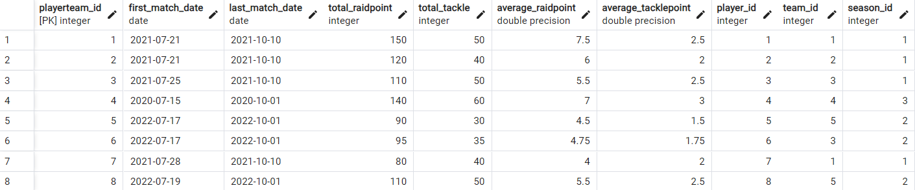

**QUERY**

**1. Get All Matches Played by a Specific Team**

SELECT Match_ID, Date, Team1_Score, Team2_Score

FROM Match

WHERE Team1_ID = 1 OR Team2_ID = 1;

**2.Find Total Raider Points for a Team in a Match**

SELECT Raider_Point

FROM Team_Stats

WHERE Team_ID = 1 AND Match_ID = 1;

**3.Find all teams that participated in matches where the venue was 'Kolkata Stadium'.**

SELECT Name

FROM Team

WHERE Team_ID IN (

SELECT Team1_ID

FROM Match

WHERE Venue = 'Kolkata Stadium'

);



**4.List Players Who Have Never Played in a Match**

SELECT Name

FROM Player

WHERE Player_ID NOT IN (

SELECT DISTINCT Player_ID

FROM Player_Team

);

**5.Find Teams That Have Not Won Any Match**

SELECT T.Name

FROM Team T

WHERE T.Team_ID NOT IN (

SELECT M.Winning_Team

FROM Match M

);

**6.Find teams that have scored more than 30 points in every match they played.**

SELECT Name

FROM Team T

WHERE 30 < ALL (

SELECT M.Team1_Score

FROM Match M

WHERE M.Team1_ID = T.Team_ID

);

**7.Find players who played in the 2023 season.**

SELECT Name

FROM Player

WHERE Player_ID IN (

SELECT Player_ID

FROM Player_Team

WHERE Season_ID = (

SELECT Season_ID FROM Season WHERE Season_Name = '2023'

)

);

**8.Find all players who have played in matches that took place in the 'Mumbai Stadium'.**

SELECT Name

FROM Player

WHERE Player_ID IN (

SELECT Player_ID

FROM Player_Team

WHERE Team_ID IN (

SELECT Team1_ID FROM Match WHERE Venue = 'Mumbai Stadium'

UNION

SELECT Team2_ID FROM Match WHERE Venue = 'Mumbai Stadium'

)

);

**9.Find Player with the Most Total Raid Points**

SELECT P.Name, PT.Total_RaidPoint, PT.Season_ID, S.Season_Name

FROM Player P

JOIN Player_Team PT ON P.Player_ID = PT.Player_ID

JOIN Season S ON PT.Season_ID = S.Season_ID

WHERE PT.Total_RaidPoint = (

SELECT MAX(PT2.Total_RaidPoint)

FROM Player_Team PT2

);

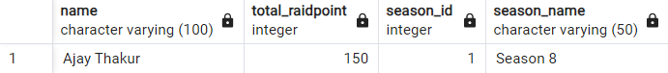

**10.Get all matches with team names**

SELECT M.Match_ID, M.Date, T1.Name AS Team1, T2.Name AS Team2, M.Team1_Score, M.Team2_Score, M.Winning_Team

FROM Match M

JOIN Team T1 ON M.Team1_ID = T1.Team_ID

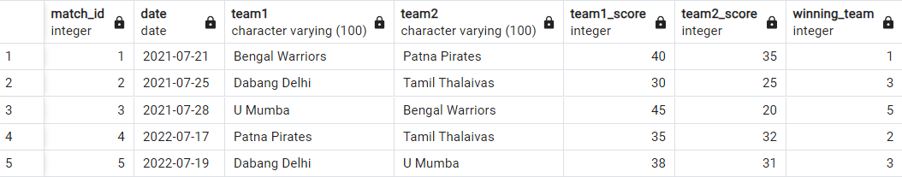JOIN Team T2 ON M.Team2_ID = T2.Team_ID;