RankMeNow
A simple guide to locations, reviews, responses, team invites, templates, and auto reply.
On the phone, Reviews and Responses are buttons at the bottom. Locations, templates, and auto reply are under More. Team is under More, then Settings, then Team. On the website, the same items are in the side menu.
Locations
A location is one of your properties. Open More, then Locations. You can add your own property, or a competitor you only want to watch.
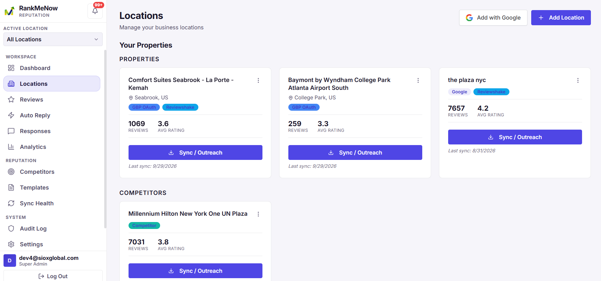
Creating a location from Google
Use this when you want Google reviews, and when you want to post replies back to Google.
1. Open More, then Locations.
2. Tap Sign in with Google.
3. Finish signing in in the browser, then come back and pull down to refresh.
4. Tap Add next to the property you want.
A badge that says Added means that listing is already a location. Reconnect Google starts sign-in again. Disconnect Google signs that account out.
Creating a location from a Maps link
1. Copy the link from Google Maps.
2. Open More, then Locations.
3. Paste it under From a Google Maps link.
4. Tap Read link.
5. Check the name and address, then tap Create location.
A Maps link fills in the address. It does not pull in Google reviews. Use Sign in with Google for that.
Creating a location by hand
1. Open More, then Locations.
2. Tap Add location manually.
3. Choose Own location or Competitor.
4. Type the name. Address, city, country, phone, website, and Google place ID are optional.
5. Tap Create location.
Editing a location
1. Open More, then Locations.
2. Tap Edit on the property.
3. Change the fields you need.
4. Tap Save changes.
Deleting a location
1. Open More, then Locations.
2. Tap Delete.
3. Confirm.
This removes the location from RankMeNow. It does not delete the listing on Google or Booking.com.
Syncing reviews
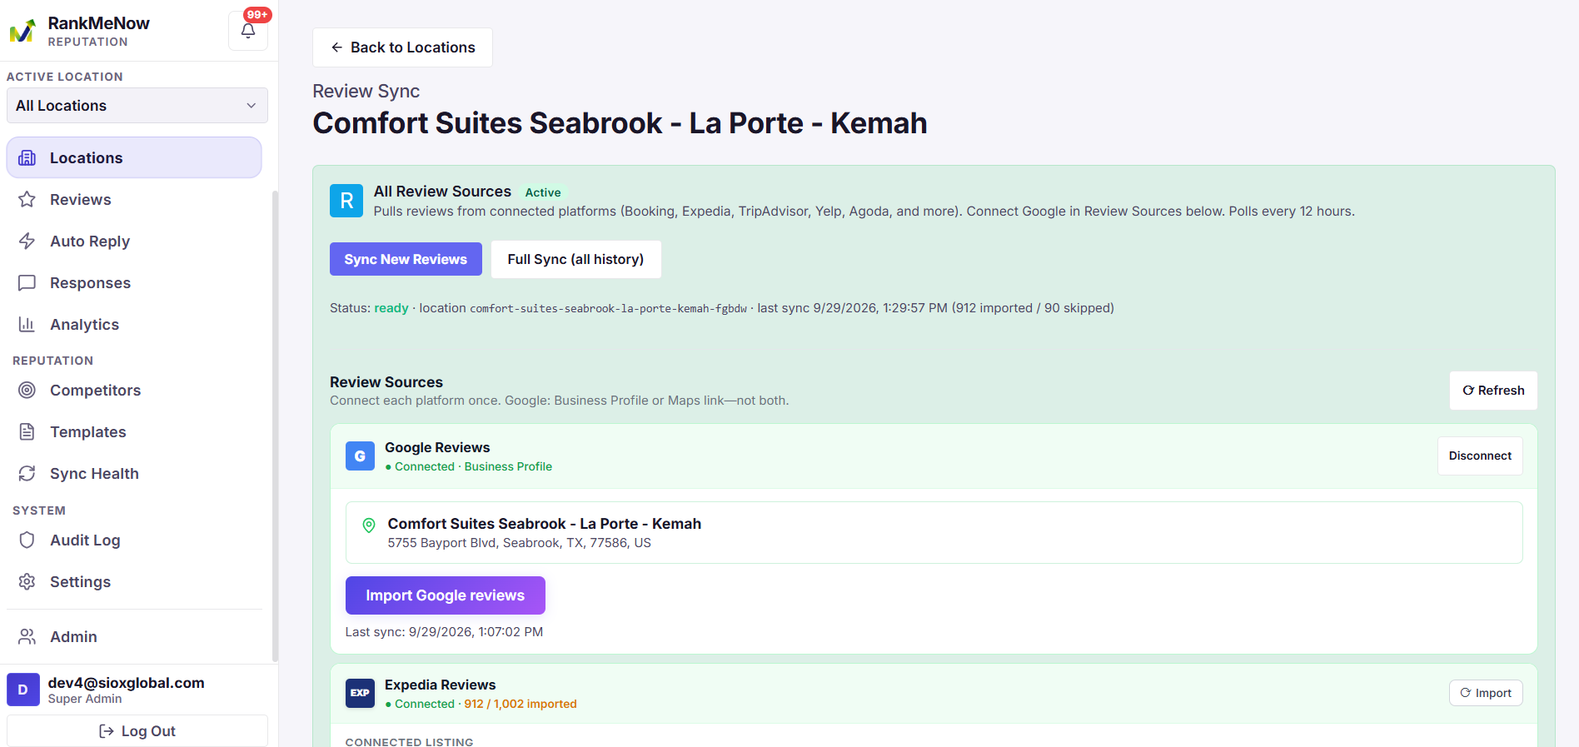
Tap Sync on a location. That screen is where reviews come in for that property.
• Tap Connect Google if this property is not linked yet.
• Tap Sync now to pull the latest Google reviews.
• Tap Disconnect to remove the Google link for this property.
Connecting other review sites
Still on the Sync screen, use Review sources.
1. Tap the site: Booking.com, Expedia, TripAdvisor, Yelp, Agoda, Hotels.com, or Airbnb.
2. Paste the public listing page. Use the page a guest would open, not a login page.
3. Tap Connect source.
4. Tap Sync on that row later, or tap Sync all sources to refresh every connected site.
Example Booking.com link: https://www.booking.com/hotel/us/harbor-inn.html
Reviews
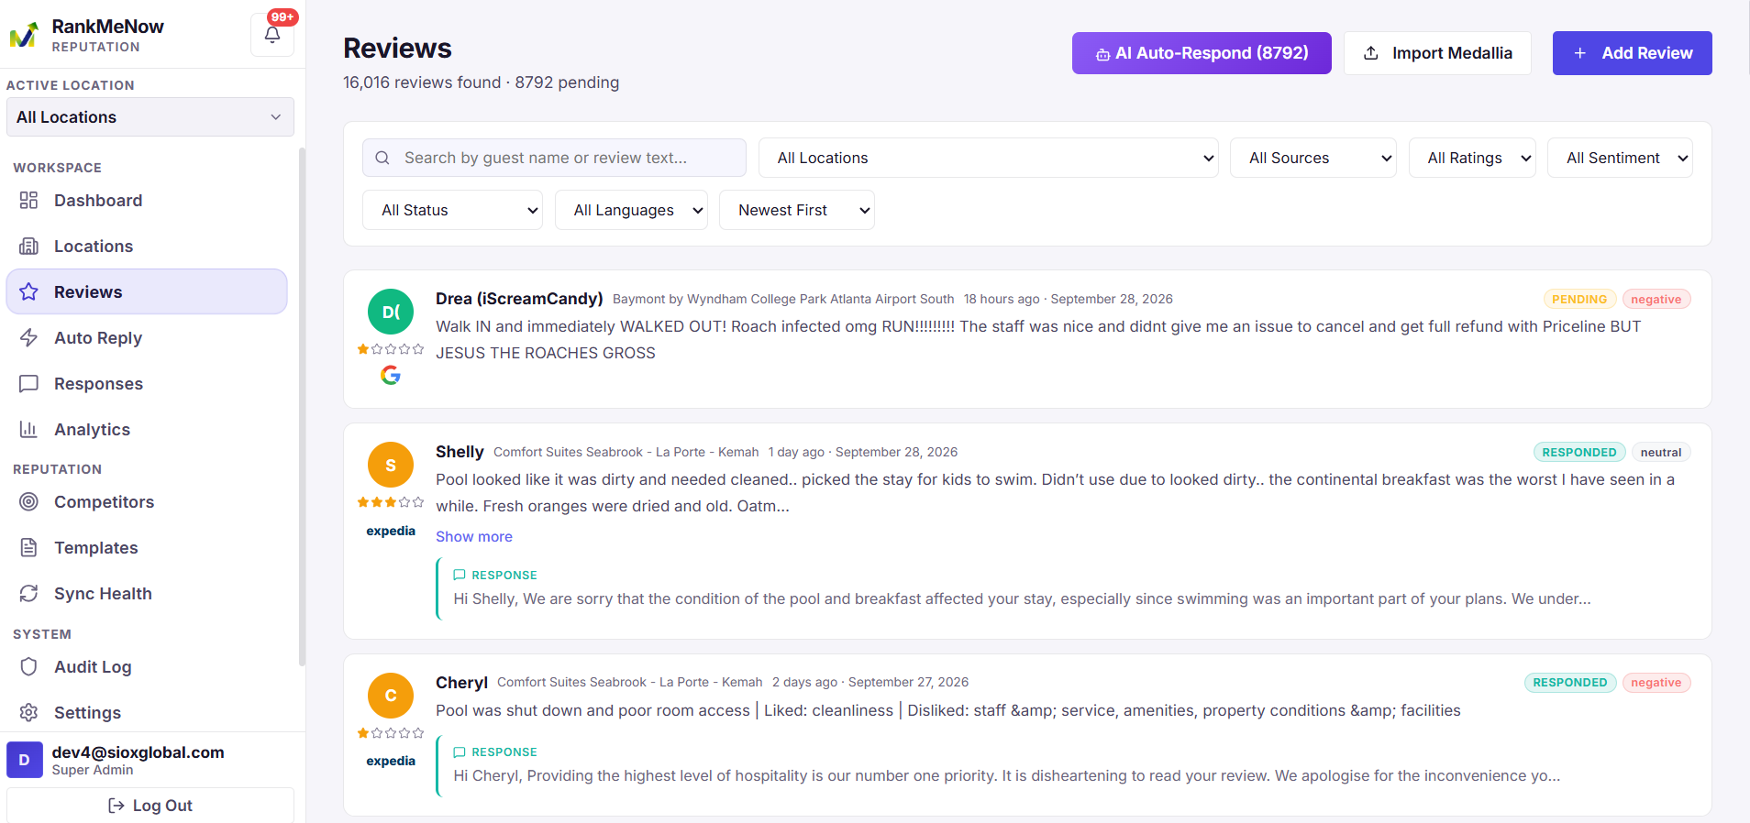
Reviews is the list of what guests wrote. Open the Reviews button at the bottom. The pill at the top says All locations or a property name. Tap it to choose one property or the whole group.
Finding a review
1. Open Reviews.
2. Search by guest name or by words in the review.
3. Tap a star filter, such as 1★, to see only that rating.
4. Tap positive, neutral, or negative.
5. Tap pending for reviews that still need a reply, or responded for finished ones.
6. Tap a source, such as Google, to hide the other sites.
If there is more than one page, use Previous and Next at the bottom.
Replying to a review
1. Tap the review.
2. Read it. Tap Open listing if you want the original page.
3. Optional: pick a tone — warm, professional, apologetic, or brief.
4. Tap Generate AI for a draft you can edit, or AI & save to create and save it in one step.
5. Or write the reply yourself.
6. Tap Save response.
Example: “Hi Maya, thank you for staying at Harbor Inn. We are glad the team made the trip easy.”
If your role cannot publish, the reply waits under Responses for someone to approve. If you can publish a Google review, you can also tap Post to Google on the saved reply.
Adding a review yourself
Use this for a comment that never arrived on its own, such as a card left at the desk.
1. On Reviews, tap Add review.
2. Pick the location.
3. Enter the guest name, a title if you have one, and the review.
4. Pick the stars, and positive, neutral, or negative.
5. Tap Save review.
Importing a Medallia file
1. On Reviews, tap Medallia.
2. Pick the location those surveys belong to.
3. Tap Preview file and choose the export.
4. Tap Import file.
Deleting a review
Open the review and tap Delete review. This removes it from RankMeNow. It does not delete it from Google or Booking.com.
Responses
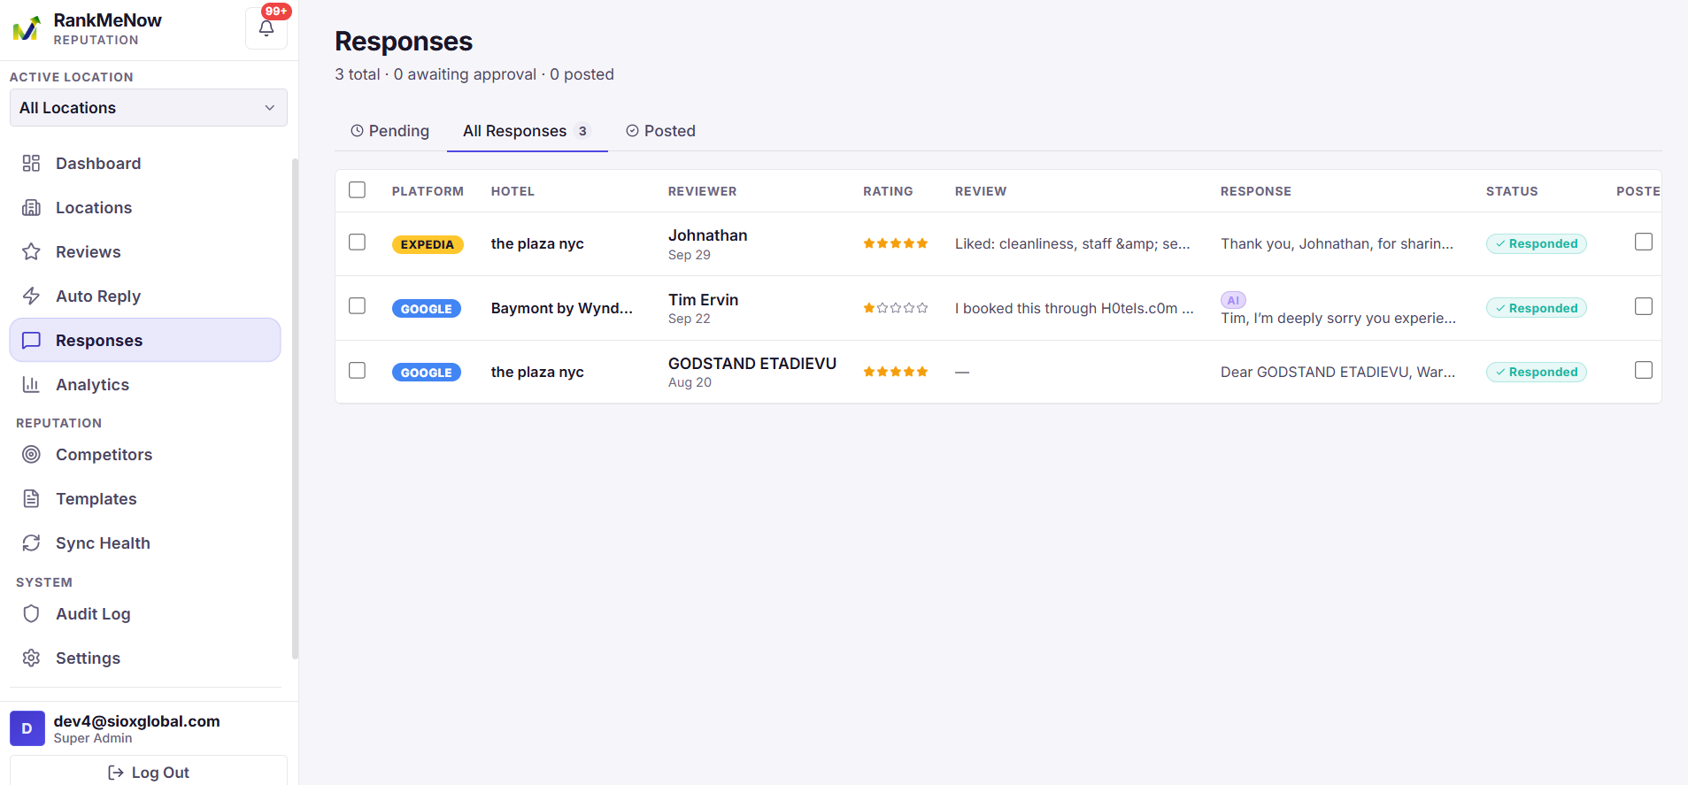
A response is the reply attached to a review. Open the Responses button at the bottom. If a red number is showing, drafts are waiting. Start on Pending.
The four lists
• Pending — drafts waiting for a person to approve them
• All — saved replies that are not marked as posted
• Posted — replies someone marked as already on the review site
• Mine — items assigned to you
Approving a reply
1. Open Responses and stay on Pending.
2. Read the guest’s review, then tap Open reply.
3. Change anything that is wrong. Check the guest’s name and any promise you are making.
4. Tap Approve.
Tap Regenerate if you want a new draft. Tap Reject to throw the draft out. “Due 4h” means you should answer soon. “Overdue 1d” means the guest has already been waiting.
Editing a reply
1. Tap Open reply.
2. Change the text.
3. Tap Save edit to keep the wording without approving yet, or tap Approve when it is ready.
Marking a reply as posted
1. Open the reply.
2. Tap Mark posted after the reply is live on the review site.
3. Tap Unmark posted if you marked it by mistake.
Tap Copy if you need to paste the text into Google, Booking.com, or an email.
Posting to Google
1. Open a reply that belongs to a Google review.
2. Make sure that location is connected to Google.
3. Tap Post to Google.
Assigning a reply
1. Open the reply.
2. Tap a teammate’s name to assign it to them, or tap Assign me to take it yourself.
Deleting a reply
Open the reply and tap Delete. This removes the reply from RankMeNow.
Team invites
Team is where you invite people and choose what they can do. Open More, then Settings, then Team. Owners and admins can invite people.
What each role can do
• Owner — owns the workspace
• Admin — can manage people, billing, and settings
• Manager — can run locations, templates, auto reply, and approvals
• Responder — can write and work on replies. A good role for the front desk.
• Viewer — can look, but cannot change anything
Inviting someone
1. Open More, then Settings, then Team.
2. Type their email.
3. Tap a role.
4. Tap the locations they should see. To limit someone to one hotel, select only that hotel.
5. Tap Create invitation.
6. Copy the link and send it to them.
Example: Sam works at one inn. Invite Sam as responder and select only that inn.
Accepting an invite
1. On the sign-in screen, tap Accept it under “Have a team invite?”
2. Paste the token from the invitation.
3. Tap Look up. Check that the organization and role look right.
4. Add your name and a password.
5. Tap Join workspace.
Changing a role
1. Open More, then Settings, then Team.
2. Find the person under Members.
3. Tap the new role.
Removing someone
1. Open More, then Settings, then Team.
2. Find the person under Members.
3. Tap Remove and confirm.
Canceling an invite
Under Pending invitations, tap Revoke. That link stops working if they have not joined yet.
Templates
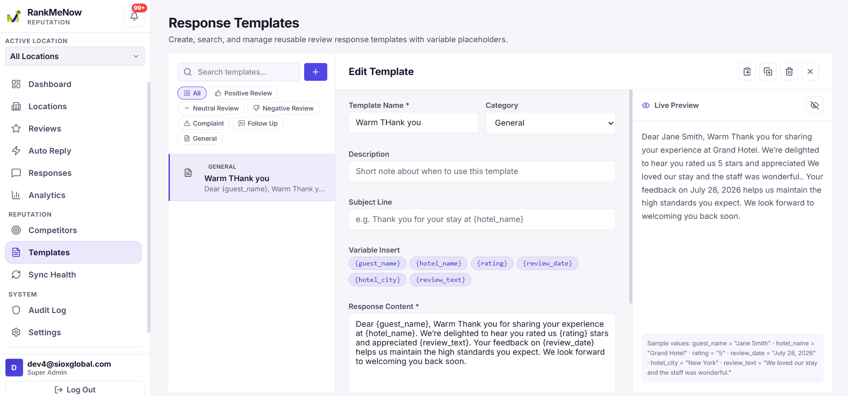
A template is a reply you can reuse. Open More, then Templates. You can search by name, and filter by category: positive, neutral, negative, complaint, follow up, or general.
Creating a template
1. Tap New template.
2. Type a short name, such as “5-star thank you”.
3. Pick a category.
4. Write the reply. Tap a chip such as {guest_name} to insert it.
5. Tap Save template.
Tap Generate with AI if you want a first draft. Read it before you save. Tap Show preview to see the reply with sample names filled in.
Words the template fills in
• {guest_name} — the guest’s name
• {hotel_name} — your property name
• {rating} — the star rating
• {review_date} — the date of the review
• {hotel_city} — the city
• {review_text} — the review itself. You rarely need this.
Example: “Hi {guest_name}, thank you for the {rating}-star note about {hotel_name}.” On Maya’s review that becomes “Hi Maya, thank you for the 5-star note about Harbor Inn.”
Using a template on a review
1. Open the review.
2. Tap the template’s name under the reply box.
3. The guest’s name and the other details are filled in.
4. Edit anything you want, then tap Save response.
Copying or deleting a template
• Duplicate makes a copy, so you can change it without losing the original.
• Delete removes it. If Auto Reply was using that template, pick a new one afterward.
Auto Reply
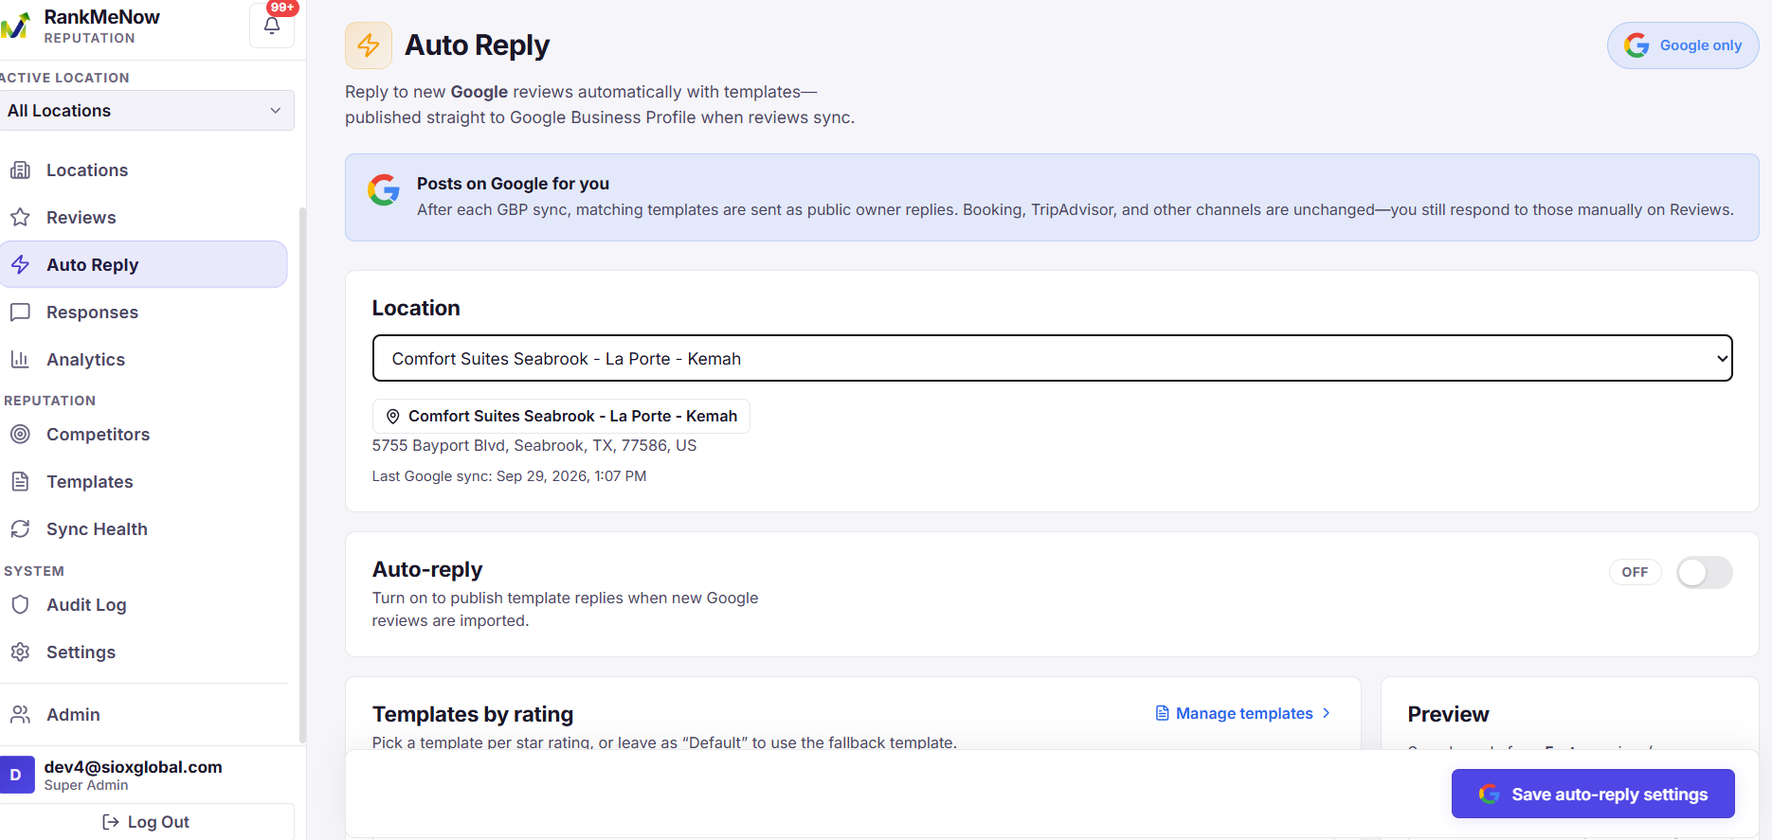
Auto Reply sends a template answer for new Google reviews, based on the star rating. Open More, then Auto Reply. Owners, admins, and managers can change it. Each location has its own setting.
Turning Auto Reply on
1. Tap the location at the top.
2. Under Default template, tap the template to use when a star level does not have its own.
3. For each star level from 5 down to 1, tap a template, or leave Default.
4. Turn Enabled on only after a default template is chosen.
5. Tap Save auto-reply.
A simple setup: a short thank-you for 5-star and 4-star reviews, and an apology for 2-star and 1-star reviews.

