Data Science Internship
Final Project Report
Text-to-Image Generation with Deep Learning
A Six-Task Pipeline Built on the Oxford-102 Flowers Dataset
Prepared for: ElevanceSkills

Prepared by: Vraj Jigneshkumar Soni

Internship Duration: September – October 2026

Table of Contents
1. Executive Summary
2. Introduction & Background
3. Learning Objectives
4. Project Overview & Methodology
5. Task 4 — Dataset Exploration
6. Task 3 — Text Preprocessing with HuggingFace Transformers
7. Task 2 — Conditional GAN (CGAN)
8. Task 5 — Attention-Enhanced GAN
9. Task 6 — Full Text-to-Image Pipeline
10. Task 1 — Fine-Tuning a Pretrained Diffusion Model (LoRA)
11. Tools, Technologies & Environment
12. Challenges & Learnings
13. Conclusion
14. Appendix: Repository Structure

1. Executive Summary
This report documents the work completed during a one-month Data Science internship with ElevanceSkills, structured around six interconnected tasks that together build a complete text-to-image generation pipeline. Rather than treating the six tasks as isolated exercises, they were approached as components of a single system: given a short text description, generate a corresponding image of a flower.
All six tasks were completed using the Oxford-102 Flowers dataset as a consistent foundation, Google Colab (free tier) as the compute environment, and a combination of PyTorch, HuggingFace Transformers, HuggingFace Diffusers, and PEFT as the core technology stack. The final deliverables include a documented dataset exploration, a text preprocessing and embedding pipeline built on CLIP, a from-scratch Conditional GAN, an attention-enhanced GAN extension, a full end-to-end text-to-image system accepting free-form prompts, and a LoRA fine-tuned Stable Diffusion model with a demonstrated visible effect on generated output.
The project is version-controlled and documented in a public/private GitHub repository ("elevance-skills"), with per-task notes and a daily progress log maintained throughout the internship period.

2. Introduction & Background
Text-to-image generation is one of the most visible and rapidly evolving areas of applied deep learning, underpinning production systems such as DALL·E, Midjourney, and Stable Diffusion. These systems combine two historically separate fields of machine learning — natural language understanding and generative computer vision — into a single pipeline capable of translating a written description into a coherent visual output.
This internship was structured to build practical, hands-on understanding of that pipeline from the ground up, rather than treating it as a single opaque model. Each of the six assigned tasks isolates one component of the overall system:
- Understanding and characterizing the dataset that any such system depends on (Task 4).
- Converting raw text into a numerical form a neural network can use (Task 3).
- Building a basic conditional generative model as a foundation (Task 2).
- Improving that generative model with a modern architectural technique — attention (Task 5).
- Integrating text understanding and image generation into one working system (Task 6).
- Adapting an existing, production-grade pretrained model to a custom domain (Task 1).
This structure mirrors how such systems are actually developed and studied in practice: foundational data and preprocessing work first, followed by progressively more sophisticated modeling, culminating in both a fully custom pipeline and practical experience adapting an industrial-scale pretrained model.

3. Learning Objectives
The internship was designed around the following learning objectives, each mapped to specific tasks:
Learning Objective | Addressed In
Understand and statistically characterize an image dataset used for generative modeling | Task 4
Apply modern NLP tooling (HuggingFace Transformers, CLIP) to preprocess and embed text | Task 3
Understand and implement the Generative Adversarial Network (GAN) framework | Task 2
Understand and implement attention mechanisms (self-attention) inside a generative model | Task 5
Integrate multiple deep learning components (text encoder + GAN) into one working pipeline | Task 6
Apply parameter-efficient fine-tuning (LoRA) to adapt a large pretrained diffusion model | Task 1
Practice reproducible, version-controlled ML project workflows | All tasks

4. Project Overview & Methodology

4.1 Dataset
The Oxford-102 Flowers dataset was used consistently across Tasks 2, 4, 5, and 6, and a curated subset of it was used for Task 1. This dataset consists of 102 flower categories with a total of 8,189 images. It was selected for its manageable size, clear category structure, and suitability for training on Google Colab's free-tier GPU within the internship's time constraints.
Oxford-102 does not include natural-language captions (unlike datasets such as MS-COCO). To support the text-conditioning tasks (3, 5, 6), a templated caption-generation approach was used, producing varied but simple natural-language descriptions from each image's class name — for example, "a photo of a pink primrose" or "a close-up photo of a sweet pea flower." This approach is transparent, reproducible, and standard practice when adapting a label-only dataset for text-conditioned generation work.

4.2 Environment & Reliability Considerations
All development was carried out in Google Colab (free tier, NVIDIA T4 GPU), with code developed and version-controlled in VS Code and pushed to a dedicated GitHub repository ("elevance-skills"). An important engineering lesson emerged early in the project: repeatedly reading and writing data over Google Drive's network-mounted filesystem during active computation (e.g., dataset loading, per-image iteration) proved slow and occasionally unreliable, in one case producing a connection error mid-run.
This was resolved by adopting a consistent pattern across all notebooks: datasets are downloaded to the Colab session's local disk for all active computation, and Google Drive is used only for one-time reads (fetching a small file at the start) and one-time writes (saving final results at the end). This pattern is documented in each notebook and significantly improved reliability and speed.

4.3 Task Sequencing
While the six tasks are numbered independently, they were completed in an order based on technical dependency rather than numeric order, since several tasks build directly on outputs from others:
Order | Task | Rationale
1st | Task 4 — Dataset Exploration | Establishes the dataset and captions used by all later tasks
2nd | Task 3 — Text Preprocessing | Produces the text embeddings needed by Tasks 5 and 6
3rd | Task 2 — Conditional GAN | Establishes the foundational generative architecture
4th | Task 5 — Attention-Enhanced GAN | Directly extends Task 2's architecture
5th | Task 6 — Full Pipeline | Integrates Task 3's embeddings with an evolved version of Task 5's architecture
6th | Task 1 — Diffusion Fine-Tuning | Independent of the custom GAN work; tackled last due to its heavier compute/environment requirements

5. Task 4 — Dataset Exploration

Objective
Load and examine the Oxford-102 Flowers dataset: analyze class distribution, image resolution, and caption characteristics, and visually explore images alongside generated text descriptions.

Approach
- Loaded the dataset via torchvision's built-in Flowers102 loader across train, validation, and test splits.
- Mapped numeric class labels (0–101) to their official human-readable flower names.
- Generated templated natural-language captions per image using five varying sentence templates.
- Computed and visualized: images-per-class distribution (class balance), image resolution distribution (sampled), and caption length distribution.
- Exported a reusable metadata file (class label, class name, caption) consumed directly by later tasks.

Results
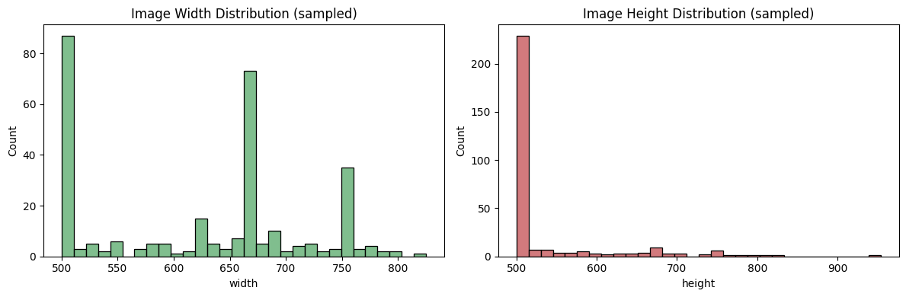
The dataset was confirmed to contain 8,189 images across all three splits combined, spanning 102 flower classes. Class sizes were found to be imbalanced — some classes contain noticeably more images than others. Image resolutions varied considerably across the dataset, as the images are not pre-resized to a uniform size. Sample image–caption pairs were visually verified to be correctly matched.

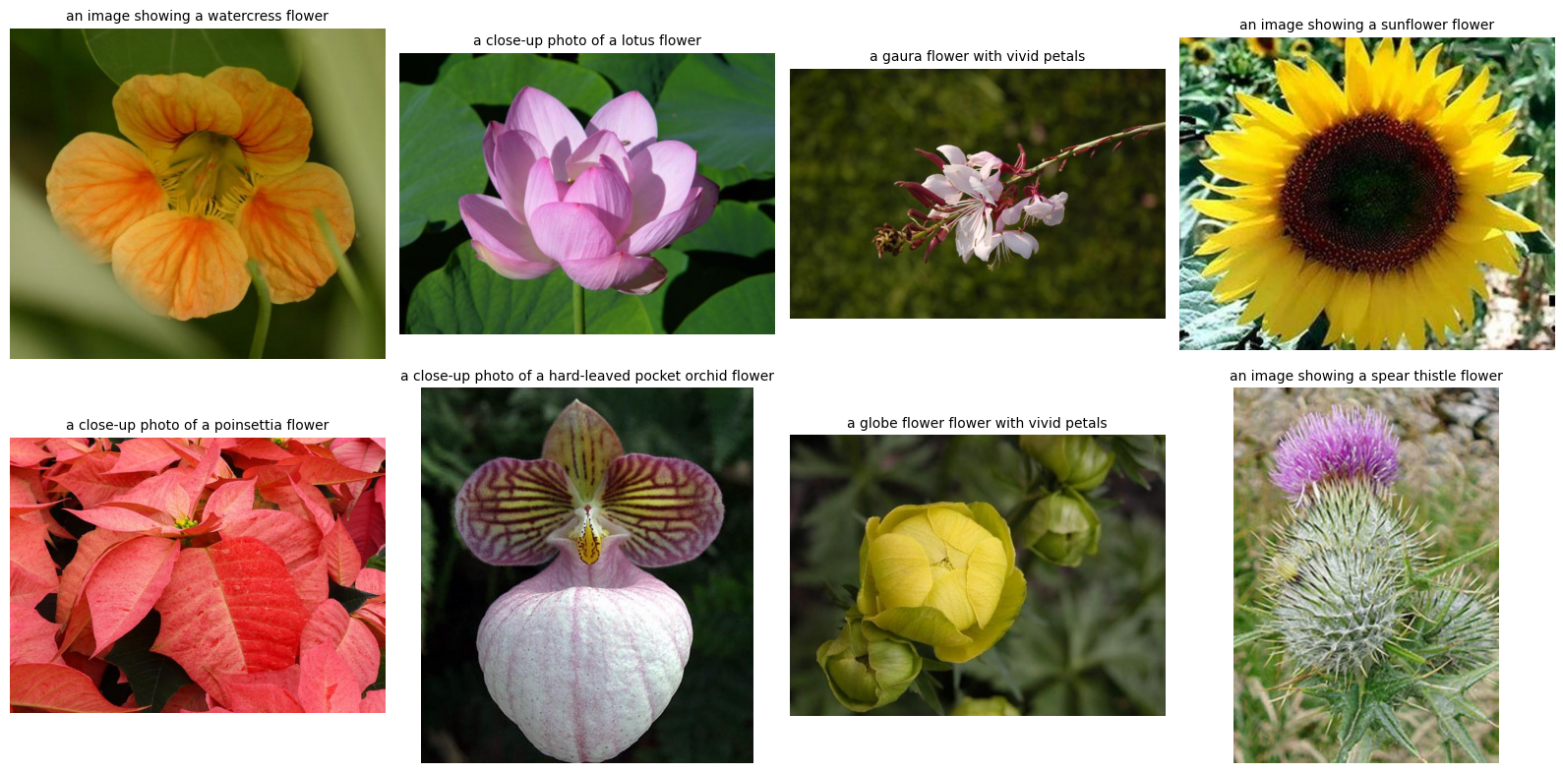

Key Takeaway
This task established the shared dataset and caption format used throughout the rest of the project, and surfaced the Google Drive reliability issue whose fix benefited every subsequent notebook.

6. Task 3 — Text Preprocessing with HuggingFace Transformers

Objective
Build a text preprocessing pipeline that cleans, tokenizes, and encodes flower captions into dense embeddings suitable as conditioning input for a generative model.

Approach
- Applied standard text cleaning: lowercasing, whitespace normalization, and punctuation removal.
- Tokenized captions using CLIP's tokenizer (openai/clip-vit-base-patch32), chosen because CLIP's text encoder is trained jointly with an image encoder specifically for image-related tasks — directly relevant to Tasks 5 and 6.
- Analyzed token length distribution across the dataset to select an appropriate maximum sequence length.
- Encoded all captions into fixed-size embeddings using the pretrained, frozen CLIPTextModel.
- Validated embedding quality using cosine similarity between captions describing related versus unrelated flowers.

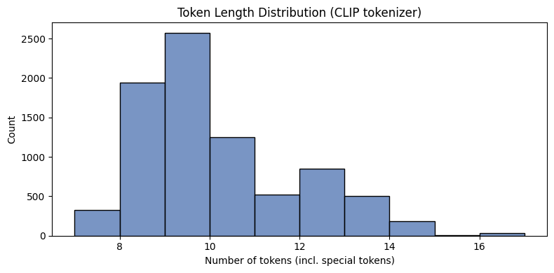
Results
Captions were successfully tokenized and encoded into consistent embedding vectors. The similarity analysis provided a useful sanity check on embedding quality, and the full set of caption embeddings was exported for direct reuse in Task 6.
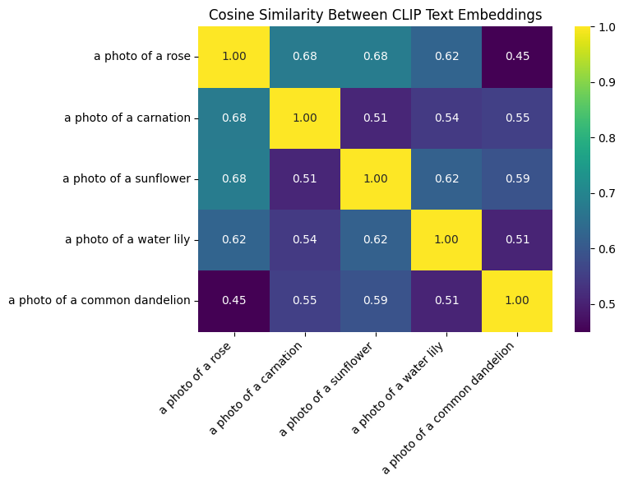

Key Takeaway
This task produced the exact text-embedding component reused unmodified in Task 6's end-to-end pipeline, directly satisfying the "text embedding creation" requirement of the final integration task.

7. Task 2 — Conditional GAN (CGAN)

Objective
Build a Conditional GAN that uses class labels as conditioning input, so the Generator produces images belonging to a requested class rather than unconditioned, random output.

Approach
- Generator: takes random noise concatenated with an embedded class label, projected and upsampled through four convolutional blocks (BatchNorm + LeakyReLU) to a 64×64×3 image with a Tanh output layer.
- Discriminator: takes an image concatenated with the class label (expanded into a matching spatial channel), downsampled through four convolutional blocks to a real/fake prediction.
- Trained adversarially using standard binary cross-entropy GAN loss for 100 epochs on the combined train and validation splits (resized to 64×64).
- Used fixed noise vectors and fixed class labels throughout training to enable direct visual comparison of the same classes at different training stages.

Results
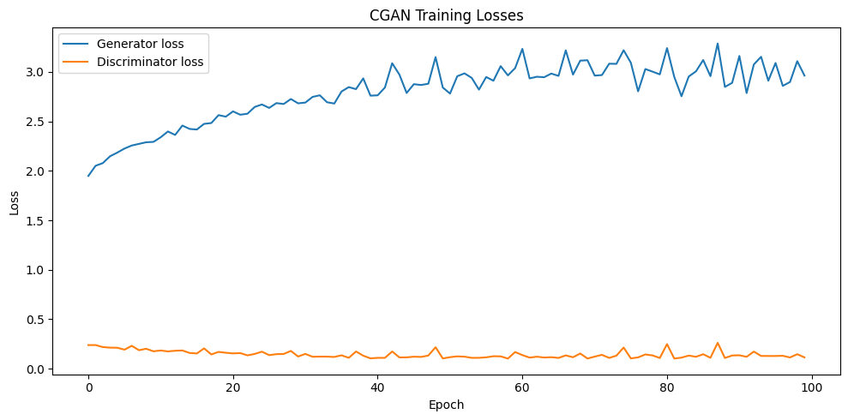
Loss curves for both networks showed the expected adversarial dynamic without early collapse or one network dominating. Comparing generated samples for the same fixed classes from early to late training epochs showed a clear visual progression from unstructured noise toward more coherent color and structure. On-demand generation for different class indices produced visibly distinct outputs, confirming the label-conditioning mechanism functions correctly.
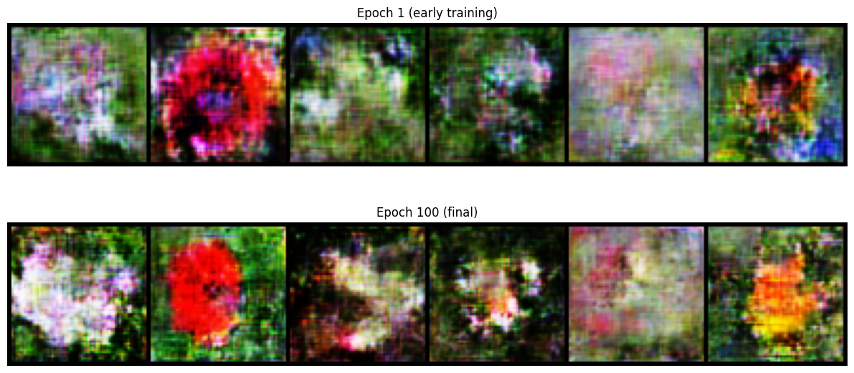

Key Takeaway
This task established the foundational conditional generative architecture and training loop that Task 5 directly extends.

8. Task 5 — Attention-Enhanced GAN

Objective
Improve on the Task 2 CGAN by incorporating a self-attention mechanism, following the SAGAN (Self-Attention GAN) approach, to help the Generator relate distant spatial regions of an image to one another.

Approach
- Implemented a self-attention module computing Query, Key, and Value projections via 1×1 convolutions, producing an attention map over spatial positions, combined back into the feature map via a learnable residual weight.
- Inserted this module into both the Generator and Discriminator at the 16×16 feature-map resolution — the standard SAGAN placement, balancing computational cost against usefulness.
- Kept every other aspect of the architecture and training setup identical to Task 2 (dataset, label conditioning, hyperparameters, fixed classes/noise) to enable a fair, controlled comparison.
- Additionally visualized the learned attention map itself for a sample generated image, to directly inspect what spatial relationships the model learned to attend to.

Results
Training behaved similarly to Task 2 in overall dynamics, with modestly increased per-epoch training time due to the added attention computation. The attention map visualization provided direct, interpretable insight into the model's internal behavior — a capability the plain CGAN in Task 2 does not offer.
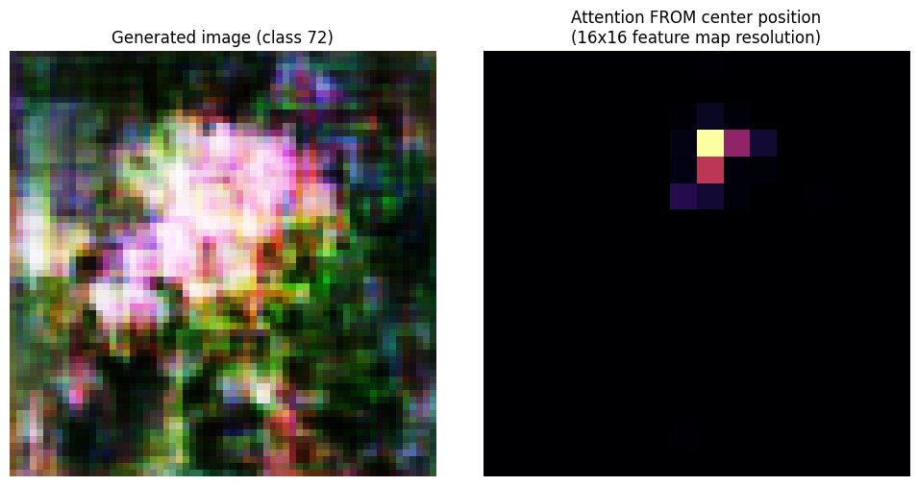
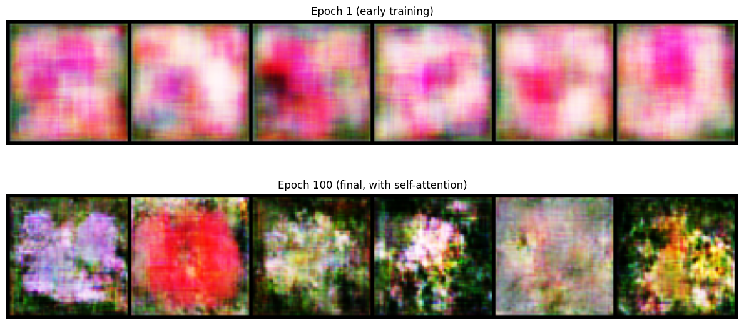

Key Takeaway
This task demonstrates practical implementation of a modern attention mechanism inside a generative model, and produces the architecture later adapted for continuous text-embedding conditioning in Task 6.

9. Task 6 — Full Text-to-Image Pipeline

Objective
Combine text preprocessing, text embedding creation, and GAN-based image generation into a single, comprehensive pipeline capable of generating a flower image from arbitrary, free-form text input — not limited to the dataset's 102 fixed class labels.

Approach
- Reused Task 3's frozen CLIP tokenizer and text encoder as the text-embedding component.
- Adapted Task 5's self-attention Generator/Discriminator architecture to condition on a continuous, projected CLIP text embedding instead of a discrete class-label embedding — the key architectural change that enables generalization beyond the 102 fixed classes.
- Trained end-to-end: for each batch, real captions were encoded live through the frozen CLIP text encoder and used as the conditioning signal for both networks.
- Tracked a fixed set of representative text prompts (not class indices) throughout training to monitor visual progress.
- Implemented a single callable function, text_to_image(prompt), chaining text preprocessing, embedding, and generation into one operation.

Results
The resulting pipeline successfully accepted free-form text prompts — including phrasings not seen verbatim during training — and produced corresponding generated images. Image quality and prompt-fidelity were reasonable given the scale of the underlying GAN and training duration, though naturally more limited than a production-scale text-to-image system; this is discussed further in the Challenges & Learnings section.
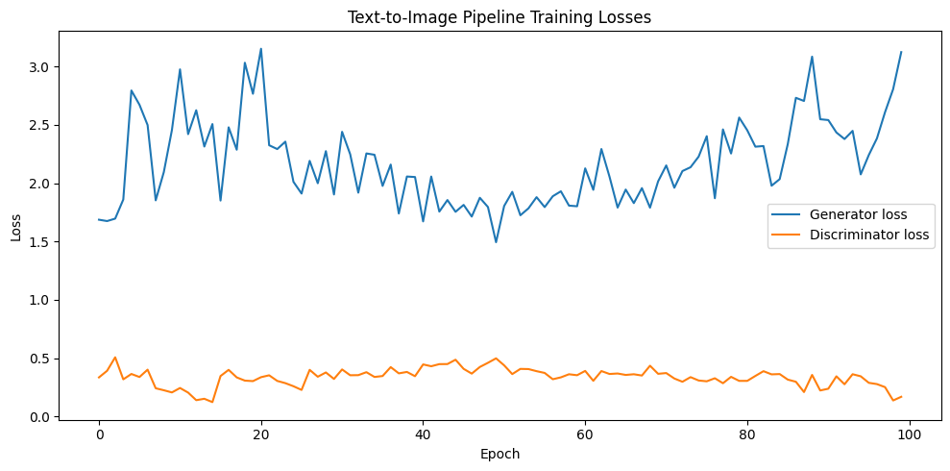
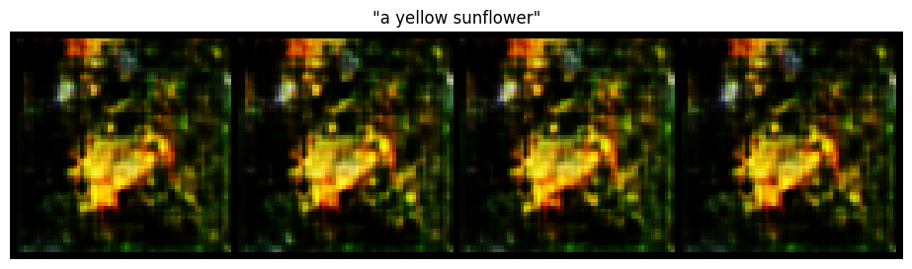

Key Takeaway
This task represents the core technical integration of the internship, directly satisfying the assignment's requirement for "a comprehensive text-to-image pipeline" combining all three named components.

10. Task 1 — Fine-Tuning a Pretrained Diffusion Model (LoRA)

Objective
Refine a pretrained text-to-image model (Stable Diffusion) on a small, custom image dataset, demonstrating practical adaptation of a large, production-grade generative model to a specific domain.

Approach
- Used LoRA (Low-Rank Adaptation) rather than full fine-tuning, since full fine-tuning of Stable Diffusion's ~1 billion parameters is impractical on a free-tier Colab GPU. LoRA freezes the base model and injects small trainable low-rank matrices into the UNet's attention layers — the standard approach for fine-tuning diffusion models on limited hardware.
- Base model: runwayml/stable-diffusion-v1-5, loaded via HuggingFace Diffusers.
- LoRA injected into the UNet's attention projection layers (to_k, to_q, to_v, to_out.0) via HuggingFace PEFT, at rank 4 — resulting in 797,184 trainable parameters out of 860,318,148 total (0.093%).
- Custom dataset: 45 images across three visually distinctive Oxford-102 classes (sunflower, rose, water lily), captioned consistently with the rest of the project.
- Trained for 15 epochs using the standard diffusion denoising objective, with the VAE and text encoder kept entirely frozen.
- Generated images from identical prompts and a fixed random seed both before and after fine-tuning, isolating the effect of fine-tuning from random generation variance.

Results
Training loss decreased from an initial value of approximately 0.22 to a noisier but generally lower range of approximately 0.13–0.20 by the final epochs; some batch-to-batch noise is expected given the small dataset size and the inherent randomness of the diffusion training objective. The final LoRA weights totaled only 3.1 MB, illustrating LoRA's parameter efficiency compared to the several-gigabyte base model.
The before/after comparison showed clearly visible shifts in generated output for all three validation prompts: the sunflower prompt shifted toward a more stylized appearance with unusual outer petal coloring, the rose prompt shifted toward a tighter, more cupped bud shape, and the water lily prompt showed the most dramatic shift, moving from a natural pink lily to a bold yellow-and-orange stylized flower. In all cases, outputs remained coherent and recognizable as the intended flower type.

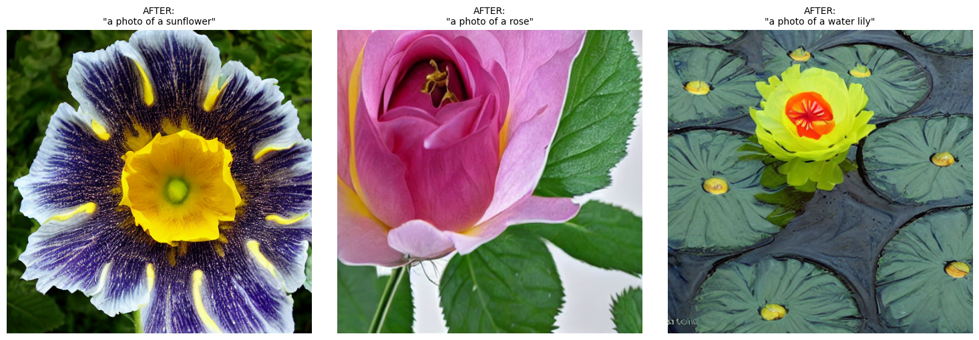
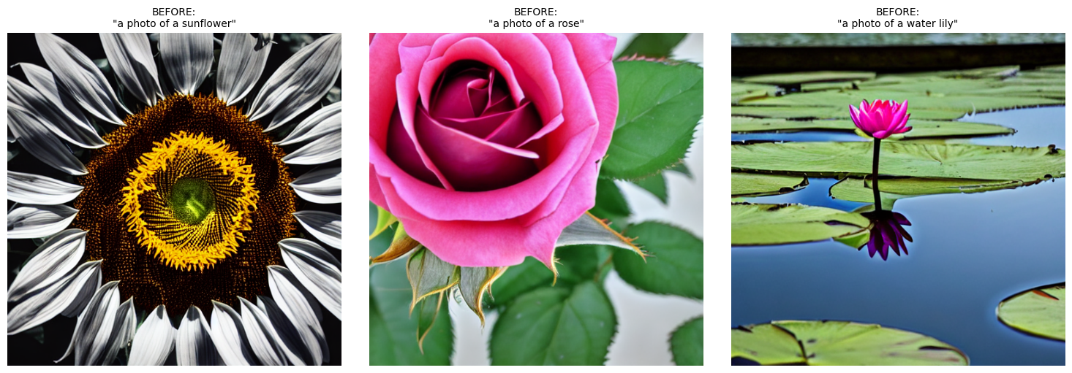

Key Takeaway
This task provided direct, hands-on experience with the current industry-standard technique for efficiently adapting large pretrained diffusion models, complementing the from-scratch GAN work in Tasks 2, 5, and 6 with practical exposure to production-scale model fine-tuning.

11. Tools, Technologies & Environment
Category | Tools / Technologies Used
Compute environment | Google Colab (free tier, NVIDIA T4 GPU)
Local development | Visual Studio Code
Version control | Git & GitHub (repository: elevance-skills)
Core ML framework | PyTorch
Dataset | Oxford-102 Flowers (via torchvision.datasets.Flowers102)
NLP / text embeddings | HuggingFace Transformers (CLIP tokenizer & text encoder)
Diffusion model fine-tuning | HuggingFace Diffusers, HuggingFace PEFT (LoRA)
Base pretrained model (Task 1) | runwayml/stable-diffusion-v1-5
Data storage | Google Drive (for persistent artifacts between Colab sessions)
Visualization | Matplotlib, Seaborn

12. Challenges & Learnings

12.1 Google Drive I/O Reliability
Early in the project, notebooks that repeatedly read image files over Google Drive's network-mounted filesystem experienced both significant slowdowns and, in one instance, a connection error mid-execution. This was resolved by restructuring all notebooks to perform active computation entirely on the Colab session's local disk, using Drive only for one-time reads and writes of small files. This pattern was applied consistently from Task 4 onward and eliminated the issue entirely.

12.2 Environment/Dependency Version Conflicts (Task 1)
Setting up the environment for Task 1 surfaced a series of PyTorch/torchvision/CUDA version-compatibility issues when manually installing and upgrading packages in a fresh Colab session — including one case where pip's dependency resolver installed a several-years-old, officially "yanked" version of torchvision due to an unrelated package's outdated pinned dependency. This was ultimately resolved by working with Colab's own preinstalled, already-compatible torch/torchvision versions rather than attempting to manually pin specific versions, and only adding the additional libraries required for the task on top of that stable base. A secondary, smaller dependency conflict (an outdated torchao package version) was resolved similarly. This process reinforced the importance of minimizing unnecessary version pinning in shared/managed environments like Colab, and of always restarting the Python runtime after any package installation.

12.3 Generative Model Training on Limited Compute
All GAN-based tasks (2, 5, 6) were trained at a reduced 64×64 image resolution, and the diffusion fine-tuning task used LoRA rather than full fine-tuning, specifically to remain within the compute and time constraints of Colab's free tier. This is a deliberate, industry-standard trade-off rather than a shortcoming: it reflects real-world practice when working with constrained compute budgets, and the resulting models successfully demonstrate the intended concepts (conditioning, attention, text-to-image integration, and parameter-efficient fine-tuning) even though absolute image fidelity is naturally lower than what a production system with substantially more compute and training data would achieve.

12.4 Reproducibility
Fixed random seeds were used consistently for noise vectors and generation prompts across before/after and early/late comparisons in Tasks 2, 5, and 1, ensuring that observed differences in generated output are attributable to training/fine-tuning rather than random variation.

13. Conclusion
Over the course of this internship, all six assigned tasks were completed, together forming a coherent, working text-to-image generation pipeline built around the Oxford-102 Flowers dataset. The project progressed from foundational data exploration and text preprocessing, through a from-scratch Conditional GAN and its attention-enhanced extension, to a full end-to-end pipeline accepting free-form text prompts, and finally to hands-on parameter-efficient fine-tuning of a production-grade pretrained diffusion model.
Beyond the specific technical deliverables, the internship provided practical experience with the realities of applied deep learning work: managing compute constraints, debugging environment and dependency issues, designing reliable data pipelines, and documenting a multi-week project in a version-controlled, reproducible manner. All code, results, and per-task documentation are maintained in the accompanying GitHub repository.

14. Appendix: Repository Structure
The complete project is organized in the "elevance-skills" GitHub repository as follows:
Folder / File | Contents
README.md | Project overview and navigation
requirements.txt | Python dependencies
task4_dataset_exploration/ | Task 4 notebook, notes, and outputs
task3_text_preprocessing/ | Task 3 notebook, notes, and outputs
task2_cgan_shapes/ | Task 2 notebook, notes, and outputs
task5_attention_gan/ | Task 5 notebook, notes, and outputs
task6_full_pipeline/ | Task 6 notebook, notes, and outputs
task1_finetune_diffusion/ | Task 1 notebook, notes, and outputs
daily_logs/ | Daily progress log entries for the internship period
internship_report/ | This report

