PS C:\Users\bvala> ssh-keygen

Generating public/private rsa key pair.

Enter file in which to save the key (C:\Users\bvala/.ssh/id_rsa): id_rsa.pub

Enter passphrase (empty for no passphrase):

Enter same passphrase again:

Your identification has been saved in id_rsa.pub

Your public key has been saved in id_rsa.pub.pub

The key fingerprint is:

SHA256:I9a6fDqWKZfKP2I61LzmMZMoY5VA/YamkgeDFfPLzAQ bvala@Valarmathy

The key's randomart image is:

+---[RSA 3072]----+

| .E. |

|. .= |

|.o = |

|+ .B.+ . |

| +o=* o S |

|o.+.oo o . |

|++. =..+ |

|.o..*=O.. |

| .*+B== |

+----[SHA256]-----+

PS C:\Users\bvala> cat ~/.ssh/id_rsa.pub

ssh-rsa  bvala@Valarmathy

PS C:\Users\bvala> ssh root@157.245.138.19

The authenticity of host '157.245.138.19 (157.245.138.19)' can't be established.

ED25519 key fingerprint is SHA256:GWlfl4Q1BwGj6I1KJ5f9dx0DkLwfqSNIi5T8+UQH1hA.

This key is not known by any other names

Are you sure you want to continue connecting (yes/no/[fingerprint])? yes

Warning: Permanently added '157.245.138.19' (ED25519) to the list of known hosts.

[root@week02 ~]#

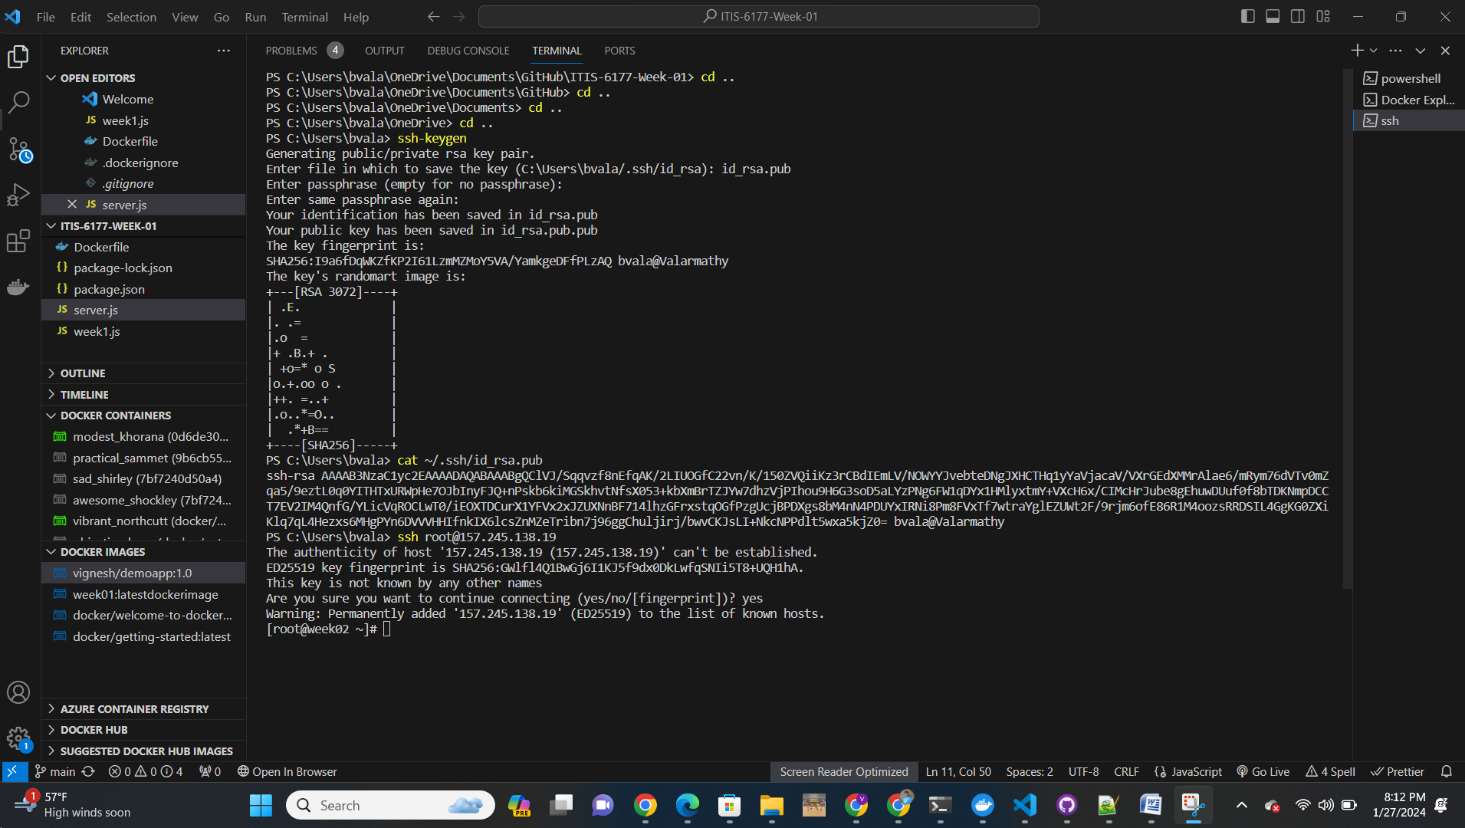

C:\Users\bvala>ssh root@159.89.84.173

The authenticity of host '159.89.84.173 (159.89.84.173)' can't be established.

ED25519 key fingerprint is SHA256:kcQxuNRLKrmykFN6NIMg202ORGegX8QLKUlcMLqp58s.

This key is not known by any other names

Are you sure you want to continue connecting (yes/no/[fingerprint])? yes

Warning: Permanently added '159.89.84.173' (ED25519) to the list of known hosts.

[root@week02 ~]#

