PROJECT DOCUMENTATION REPORT
CINEMATE
A Modern, Multi-Device Movie Discovery Application
Submitted in partial fulfilment of the requirements for
UI Design – Flutter (CS506PC) External Laboratory Examination

Particulars | Details
Student Name | Sardar Jugraj Singh
Roll Number / Hall Ticket Number | 24XV1M0541
Programme & Branch | B. Tech - CSE
Institution | CR Rao AIMSCS
Academic Year | 2026 - 2027
Semester | III - I
Repository: https://github.com/VrajeshChary/cinemate-vrajesh-jugraj

1. About the Project
CINEMATE is a simple, modern movie discovery app made with Flutter and Dart. It looks like a clean movie streaming app where users can browse movies, search for any film by title, check ratings and movie stories, and save their favourite movies.
The app is built to work smoothly on mobile phones, tablets, laptops, and large desktop screens. It opens in a clean light theme by default, and users can tap a button on the top bar to switch to dark mode whenever they want.
2. Why We Built This Project
• Learn Flutter Basics: To show how Flutter widgets, rows, columns, and grids are used to build clean screens.
• Work Across Different Screens: To make one app that fits phones, tablets, and computers automatically without breaking.
• Get Real Data: To fetch live movie posters, titles, and ratings from the internet using the TMDB API.
• Manage App Data: To keep track of saved favourite movies across all screens using Provider.
3. Tools and Technologies Used
• Flutter: Google's UI toolkit used to build the web and mobile app from a single codebase.
• Dart: The programming language used to write the application logic.
• TMDB API: The Movie Database API, used to get live movie titles, posters, and details.
• Provider: A simple tool to remember favourite movies and handle light/dark mode.
• GitHub & Vercel: GitHub to store our code, and Vercel to host the live website online.
4. Main Screens and Features
1. Home Screen: Shows a large featured movie poster at the top, a horizontal list of trending movies, and a grid of popular movies.
2. Movie Details Screen: When you tap any movie, this screen opens to show the full storyline, release year, genre, star rating, and an Add to Favourites button.
3. Search Screen: Users can type any movie name to search for it in real time.
4. Favourites Screen: Displays all the movies you have saved. You can also remove movies from this list with one tap.
5. Light and Dark Theme: Starts in light theme by default, with a Sun/Moon button at the top to toggle dark mode.
6. Offline Support: If the internet is disconnected, the app automatically shows 10 built-in sample movies so it never crashes.

5. Key Code Snippets
A. Starting the App and Setting Providers (main.dart):
void main() {
runApp(
MultiProvider(
providers: [
ChangeNotifierProvider(create: (_) => FavouritesProvider()),
ChangeNotifierProvider(create: (_) => ThemeProvider()),
],
child: const CinemateApp(),
),
);
}

B. Fetching Movies from TMDB API (movie_service.dart):
Future<List<Movie>> getPopularMovies() async {
try {
final response = await http.get(Uri.parse('$_baseUrl/movie/popular?api_key=$_apiKey'));
if (response.statusCode == 200) {
final data = json.decode(response.body);
return (data['results'] as List).map((item) => Movie.fromJson(item)).toList();
}
} catch (e) {
// If offline, return pre-loaded sample movies
}
return sampleMovies;
}

C. Switching Between Light and Dark Mode (theme_provider.dart):
class ThemeProvider extends ChangeNotifier {
ThemeMode _themeMode = ThemeMode.light;
bool get isDarkMode => _themeMode == ThemeMode.dark;
void toggleTheme() {
_themeMode = isDarkMode ? ThemeMode.light : ThemeMode.dark;
notifyListeners(); // Updates the UI instantly
}
}

6. How It Was Deployed Online
The project code was pushed to GitHub. We connected the repository to Vercel, which automatically downloads Flutter, builds the web version using 'flutter build web --release', and hosts it live on the internet.
7. Application Output Previews
Below are sample previews of the running application on Laptop and Mobile screens:
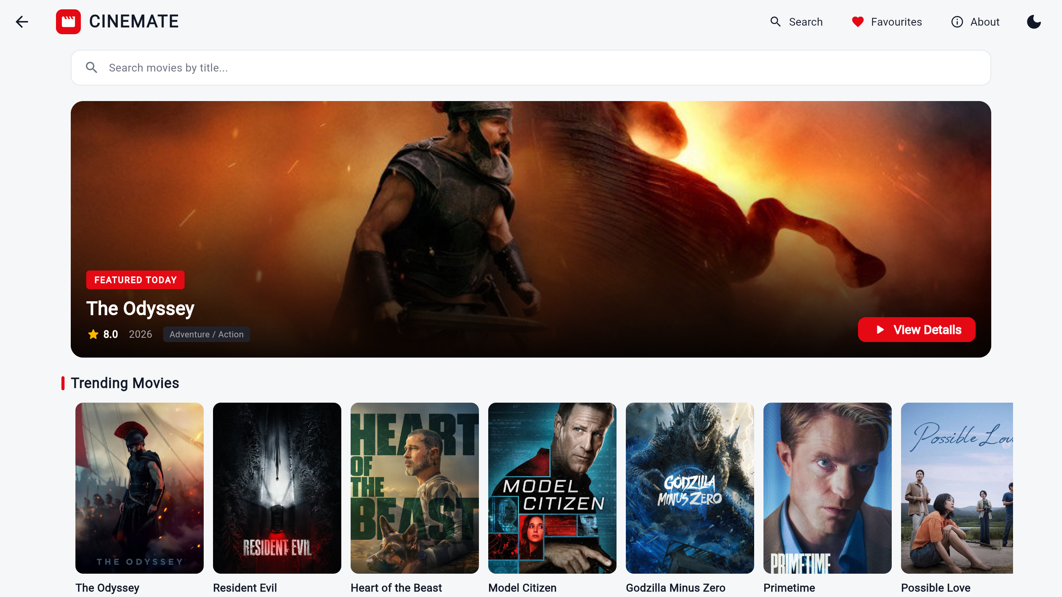
Output Preview: Laptop View (1366x768)

