PROJECT DOCUMENTATION REPORT
CINEMATE
________________________________________
A Simple, Responsive Movie Discovery Web and Mobile Application Built with Flutter, Dart, and REST API Integration
Submitted in partial fulfilment of the requirements for
UI Design – Flutter (CS506PC) External Laboratory Examination

Particulars | Details
Student Name | M Vrajesh Chary
Roll Number / Hall Ticket Number | 24XV1M0526
Programme & Branch | B. Tech - CSE
Institution | CR Rao AIMSCS
Academic Year | 2026 - 2027
Semester | III - I
Project Repository: https://github.com/VrajeshChary/cinemate-vrajesh-jugraj

1. Application Name and Introduction
Application Name: CINEMATE — A Modern Movie Discovery Application
CINEMATE is a modern, responsive cross-platform movie discovery web and mobile application developed using Google's Flutter framework and Dart programming language. Designed specifically to satisfy the curriculum objectives of the CS506PC Flutter laboratory examination, the project demonstrates how professional, visually attractive user interfaces can be constructed using clean, beginner-friendly, and maintainable software engineering practices.
The application delivers a streaming-platform-like user experience, allowing users to browse trending releases, inspect popular cinema, search for titles in real time, view detailed movie profiles (including storylines, runtimes, genres, and ratings), and bookmark titles to a persistent favourites list. To ensure optimal accessibility, the application defaults to a crisp Light Theme and features an instant header toggle to a Netflix-inspired Dark Cinematic Theme, adapting fluidly across all display viewports including Mobile, Tablet, Laptop, and Desktop screens.
2. Purpose and Objectives
2.1 Project Purpose
The primary purpose of CINEMATE is to provide an academic implementation of fundamental mobile application development concepts taught in UI Design – Flutter (CS506PC). It demonstrates how declarative UI composition, reactive state management, asynchronous REST networking, and responsive design come together in a working full-stack client product without relying on overcomplicated third-party frameworks.
2.2 Key Objectives
• Multi-Device Responsive Design: Implement four distinct responsive tiers (Mobile: 360–600px, Tablet: 601–1024px, Laptop: 1025–1440px, and Desktop: >1440px) using MediaQuery to guarantee adaptive presentation.
• RESTful API Integration: Perform asynchronous HTTP GET requests to The Movie Database (TMDB) API to fetch real-time movie titles, metadata, backdrops, and runtimes.
• Predictable State Management: Demonstrate both local state management using StatefulWidget (setState) and global application state management using Provider (ChangeNotifier) for bookmarked favourites and theme mode switching.
• Offline Fault Tolerance: Ensure 100% application reliability by engineering an automated fallback dataset of 10 pre-loaded high-definition movies when network connectivity is lost.
• Modern Material Theming: Configure ThemeData for both Light and Dark modes with centralized color palettes and adaptive contrast.
• Clean Architecture: Maintain a modular, easily explainable folder structure comprising models, screens, widgets, services, and theme definitions.
• Continuous Cloud Deployment: Deploy the compiled web application to Vercel with Single Page Application (SPA) rewrite rules and automated build pipelines.
3. Tools and Technologies Used
Category | Tool / Technology | Description & Role
UI Framework | Flutter 3.27+ (Stable) | Cross-platform framework for compiling native Web and Mobile code from a single Dart codebase.
Programming Language | Dart 3.6+ | Strongly-typed, object-oriented language with sound null safety and async/await primitives.
Design System | Material Design 3 | Provides modern UI components including Card, Scaffold, AppBar, ListView, GridView, and InkWell.
State Management | Provider (^6.1.2) | Implements ChangeNotifierProvider and MultiProvider for reactive global state without architectural bloat.
Networking | http Package (^1.2.2) | Executes asynchronous REST HTTP GET requests, URI parsing, and JSON decoding.
External REST API | The Movie Database (TMDB) | Provides production-grade movie metadata, poster paths, vote averages, genres, and runtimes.
Testing Suite | Flutter Test (Built-in) | Executes automated unit and widget verification tests for core UI components and providers.
Build & CI/CD | Vercel & vercel-build.sh | Automated cloud compilation of Flutter Web with SPA client-side routing support.
Version Control | Git & GitHub | Source code management, branch tracking, and remote code synchronization.
4. Features and Functionalities Implemented
1. Adaptive Light & Dark Theming: The application defaults to a clean, high-contrast Light Theme (#F6F7F9 background, white cards, dark gray typography) and provides an interactive Sun/Moon toggle button in the top AppBar to switch seamlessly to the Netflix-inspired Dark Cinematic Theme (#101014 background, #22222B cards, #E50914 red accents).
2. Four-Tier Multi-Device Responsiveness: Using MediaQuery and LayoutBuilder, the app dynamically scales its layout: Mobile (<=600px: 2 columns, compact header), Tablet (601–1024px: 3-4 columns), Laptop (1025–1440px: 4-5 columns within a 1240px container tailored for 1366x768 screens), and Desktop (>1440px: 6 columns with max 1400px container).
3. Featured Movie Hero Banner: Highlights the top trending blockbuster at the top of the Home Screen with a high-resolution backdrop image, dark gradient overlay, release year, star rating, genre tag, and a 'View Details' action button.
4. Horizontal Trending Carousel: Implements an efficient ListView.builder scrolling horizontally to showcase trending films with smooth momentum physics.
5. Proportional Popular Movies Grid: Implements a responsive GridView.builder with childAspectRatio: 0.62. Movie posters expand proportionally inside cards, eliminating blank vertical gaps.
6. Real-Time Title Search: Features an interactive search screen with live text change listener, clear query button, loading indicator, and intuitive empty-state feedback.
7. Theatrical Movie Details View: Displays detailed storyline summaries, release years, runtimes, vote averages, and genres with Hero transition animations connecting posters between screens.
8. Persistent Global Favourites: Allows users to add and remove movies from a bookmarks collection with reactive synchronization across all screens powered by Provider.
9. Offline Data Resilience: Features automatic error catching during REST API calls to seamlessly fall back to 10 pre-loaded HD sample movies if internet connectivity drops.

5. Important Code Snippets & Explanations
5.1 Application Entry Point & MultiProvider (lib/main.dart)
Demonstrates application initialization, MultiProvider configuration combining FavouritesProvider and ThemeProvider, and named route declarations:
void main() {
runApp(
MultiProvider(
providers: [
ChangeNotifierProvider(create: (_) => FavouritesProvider()),
ChangeNotifierProvider(create: (_) => ThemeProvider()),
],
child: const CinemateApp(),
),
);
}
class CinemateApp extends StatelessWidget {
const CinemateApp({super.key});
@override
Widget build(BuildContext context) {
final themeProvider = Provider.of<ThemeProvider>(context);
return MaterialApp(
title: 'CINEMATE',
debugShowCheckedModeBanner: false,
theme: AppTheme.lightTheme, // Default Light Theme
darkTheme: AppTheme.darkTheme, // Dark Cinematic Theme
themeMode: themeProvider.themeMode, // Dynamically Toggled
initialRoute: HomeScreen.routeName,
routes: {
HomeScreen.routeName: (context) => const HomeScreen(),
SearchScreen.routeName: (context) => const SearchScreen(),
FavouritesScreen.routeName: (context) => const FavouritesScreen(),
AboutScreen.routeName: (context) => const AboutScreen(),
},
);
}
}

5.2 Asynchronous REST API Client (lib/services/movie_service.dart)
Demonstrates asynchronous HTTP GET calls to TMDB, JSON deserialization, and graceful offline fallback:
class MovieService {
static const String _apiKey = 'd361048f37280ac3a4920d2e64a968a3';
static const String _baseUrl = 'https://api.themoviedb.org/3';
Future<List<Movie>> getPopularMovies() async {
try {
final uri = Uri.parse('$_baseUrl/movie/popular?api_key=$_apiKey');
final response = await http.get(uri);
if (response.statusCode == 200) {
final data = json.decode(response.body);
final List results = data['results'] ?? [];
return results.map((json) => Movie.fromJson(json)).toList();
}
} catch (e) {
// Return offline sample dataset on network failure
}
return sampleMovies;
}
}

5.3 Global Theme State Manager (lib/services/theme_provider.dart)
Demonstrates state encapsulation with ChangeNotifier and app-wide UI rebuild notifications:
class ThemeProvider extends ChangeNotifier {
ThemeMode _themeMode = ThemeMode.light; // Default to Light
ThemeMode get themeMode => _themeMode;
bool get isDarkMode => _themeMode == ThemeMode.dark;
void toggleTheme() {
_themeMode = isDarkMode ? ThemeMode.light : ThemeMode.dark;
notifyListeners(); // Triggers app-wide reactive rebuild
}
}

5.4 Four-Tier Responsive Breakpoint Engine (lib/screens/home_screen.dart)
Demonstrates adaptive column calculation and viewport width constraint handling using MediaQuery:
final screenWidth = MediaQuery.of(context).size.width;
final int crossAxisCount;
final double horizontalPadding;
final double maxContentWidth;
if (screenWidth > 1440) {
// 1. Desktop (>1440px)
crossAxisCount = 6;
horizontalPadding = 36.0;
maxContentWidth = 1400.0;
} else if (screenWidth > 1024) {
// 2. Laptop (1025px - 1440px: 1366x768 / 1280x800)
crossAxisCount = screenWidth > 1200 ? 5 : 4;
horizontalPadding = 28.0;
maxContentWidth = 1240.0;
} else if (screenWidth > 600) {
// 3. Tablet (601px - 1024px)
crossAxisCount = screenWidth > 800 ? 4 : 3;
horizontalPadding = 20.0;
maxContentWidth = 960.0;
} else {
// 4. Mobile (<= 600px)
crossAxisCount = 2;
horizontalPadding = 12.0;
maxContentWidth = double.infinity;
}

5.5 Proportional Movie Card Widget (lib/widgets/movie_card.dart)
Demonstrates InkWell ripple effects, Hero transitions, and Expanded layout preventing card spacing gaps:
Widget build(BuildContext context) {
final posterWidget = Hero(
tag: 'movie-poster-${movie.id}',
child: MoviePoster(
imageUrl: movie.posterUrl,
width: isGrid ? double.infinity : width,
height: isGrid ? double.infinity : posterHeight,
borderRadius: 10,
fit: BoxFit.cover,
),
);
return InkWell(
onTap: onTap,
borderRadius: BorderRadius.circular(10),
child: Column(
crossAxisAlignment: CrossAxisAlignment.start,
children: [
if (isGrid) Expanded(child: posterWidget) else posterWidget,
const SizedBox(height: 8),
Text(
movie.title,
maxLines: 1,
overflow: TextOverflow.ellipsis,
style: TextStyle(color: AppTheme.getTextColor(context), fontWeight: FontWeight.w600),
),
Row(
mainAxisAlignment: MainAxisAlignment.spaceBetween,
children: [
Text(movie.releaseYear, style: TextStyle(color: AppTheme.getSecondaryTextColor(context))),
Row(
children: [
const Icon(Icons.star_rounded, color: AppTheme.starRatingColor, size: 16),
Text(movie.voteAverage.toStringAsFixed(1), style: const TextStyle(fontWeight: FontWeight.bold)),
],
),
],
),
],
),
);
}

6. Deployment Details
CINEMATE is configured for continuous cloud deployment on Vercel's global edge network with single-page application (SPA) client-side routing.
6.1 CI/CD Automated Build Pipeline (vercel-build.sh)
Vercel uses an automated bash build script to download the Flutter SDK, pre-cache web dependencies, and compile the release binary on every push to the main Git branch:
#!/bin/bash
set -e
# 1. Download Flutter SDK if not cached
if [ ! -d "flutter" ]; then
git clone https://github.com/flutter/flutter.git --depth 1 -b stable flutter
fi
# 2. Add Flutter to environment PATH
export PATH="$(pwd)/flutter/bin:$PATH"
# 3. Enable Web and fetch dependencies
flutter config --enable-web --no-analytics
flutter precache --web
flutter pub get
# 4. Compile optimized web release
flutter build web --release --base-href /

6.2 SPA Client-Side Routing Configuration (vercel.json)
To ensure client-side routes (e.g. /search, /favourites, /about) resolve properly when reloaded by the browser, Vercel routes all non-static asset requests to index.html:
{
"version": 2,
"buildCommand": "bash vercel-build.sh",
"outputDirectory": "build/web",
"cleanUrls": true,
"routes": [
{ "handle": "filesystem" },
{ "src": "/(.*)", "dest": "/index.html" }
]
}

7. Application Screenshots (UI Output)
The following figures show actual screenshots of the running CINEMATE application captured across different device viewports and screens:
Figure 7.1: Desktop Layout (> 1440px Viewport)
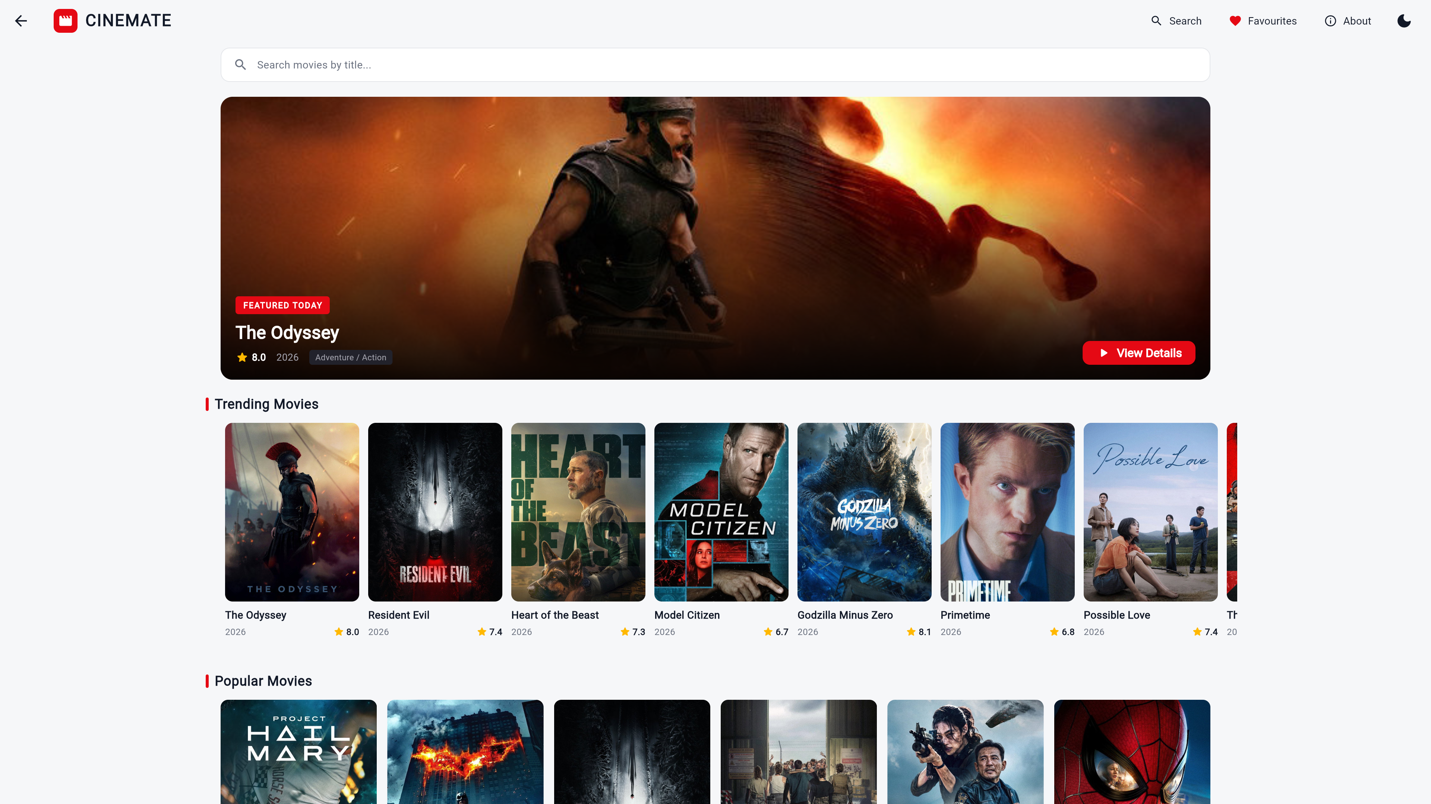
Figure 7.2: Laptop Layout (1025px - 1440px Viewport)
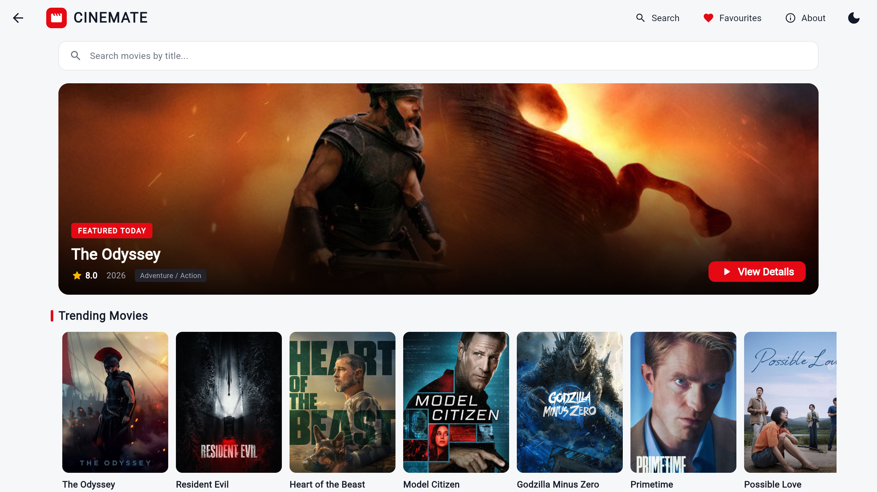
Figure 7.3: Tablet Layout (601px - 1024px Viewport)
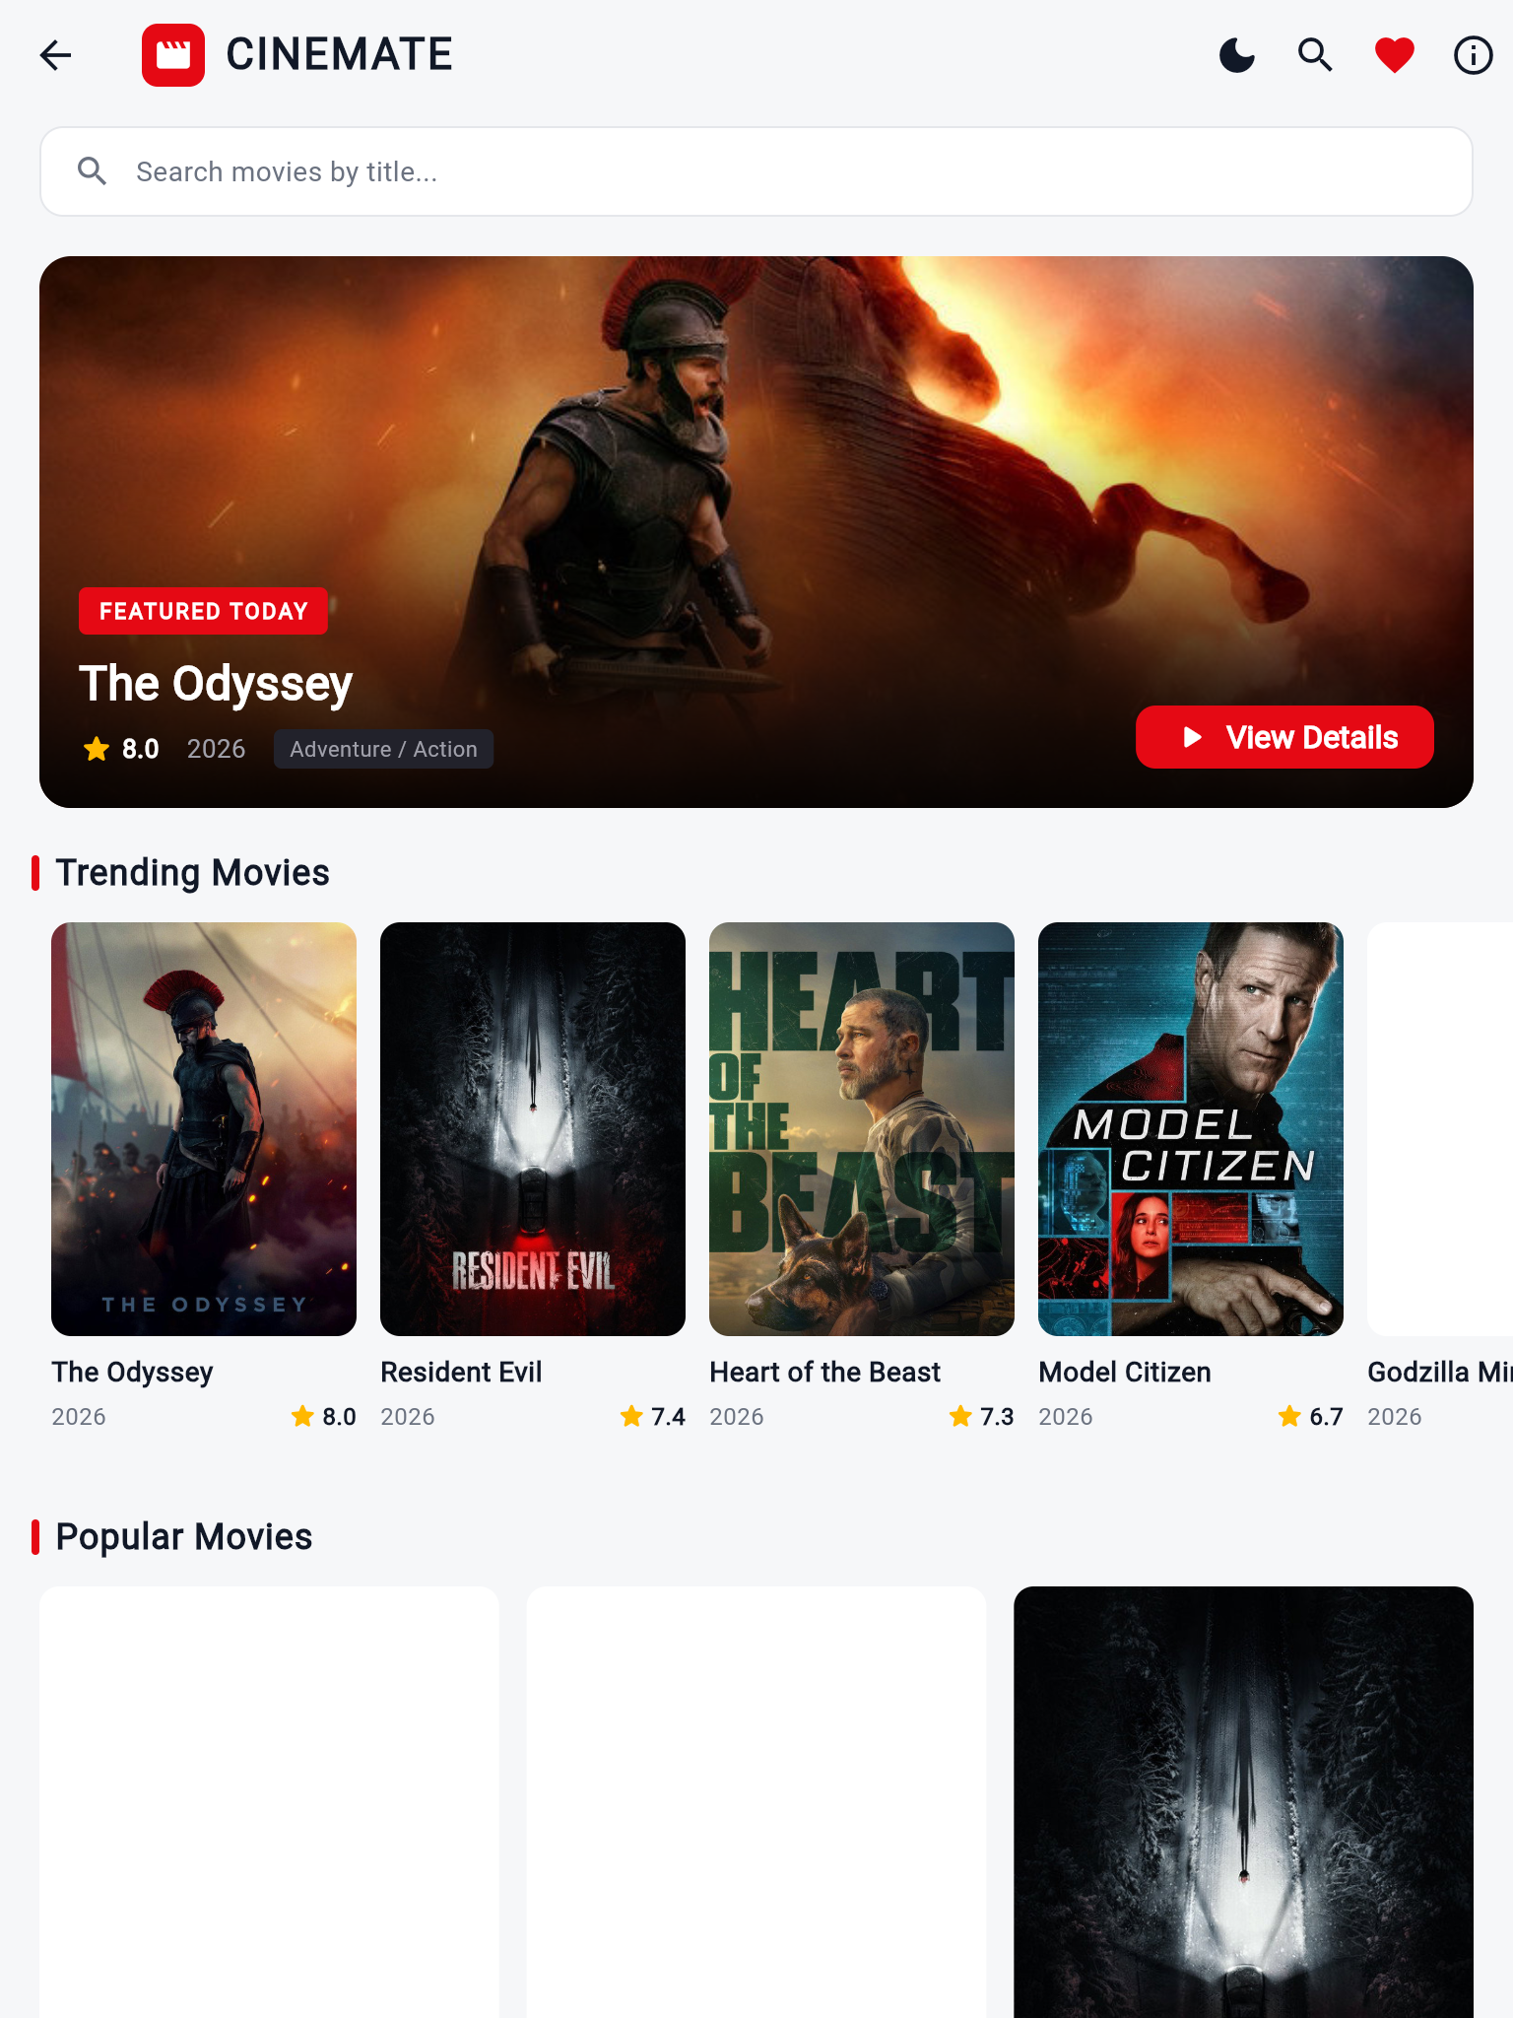
Figure 7.4: Mobile Layout (360px - 600px Viewport)
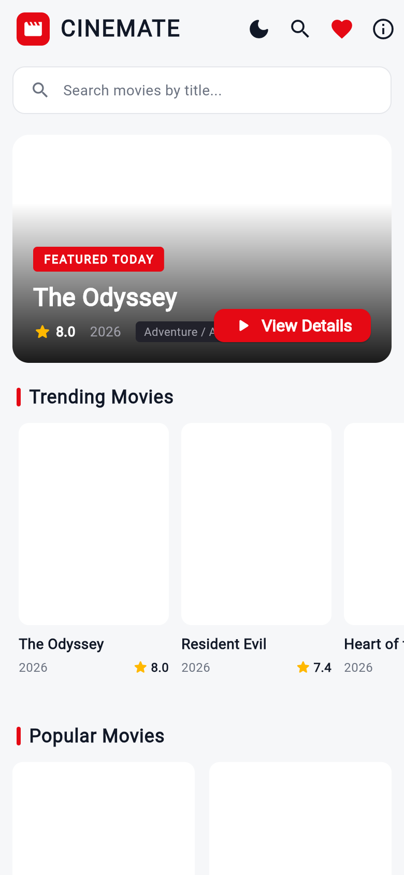
Figure 7.5: Real-Time Search Screen
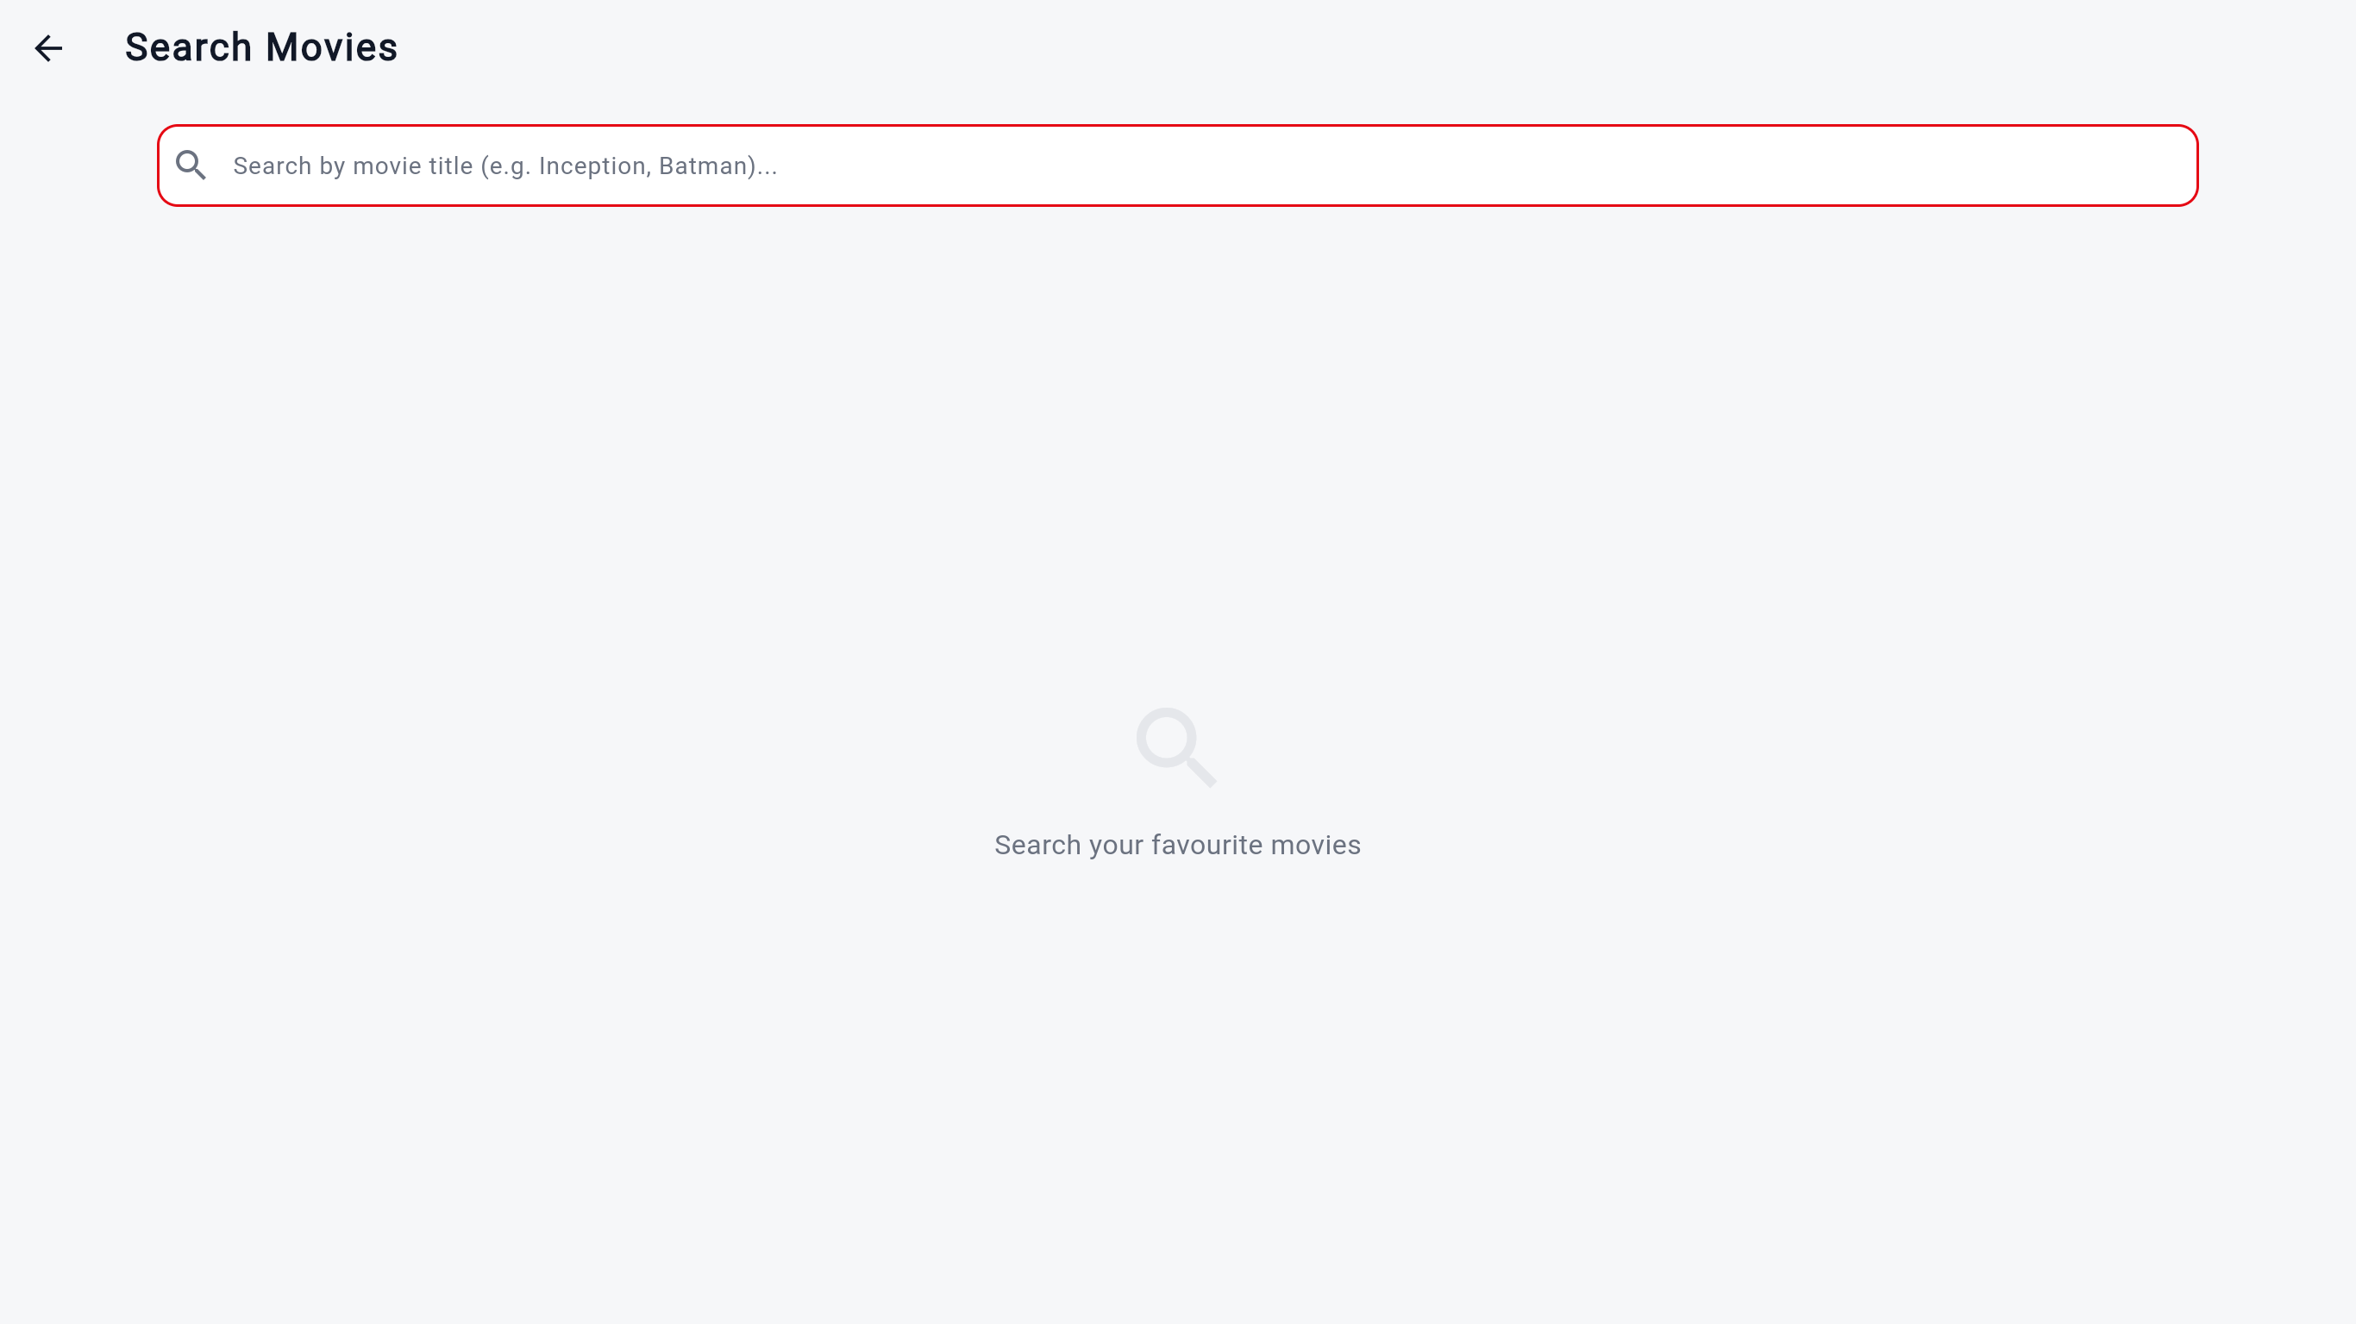
Figure 7.6: Curated Favourites Screen
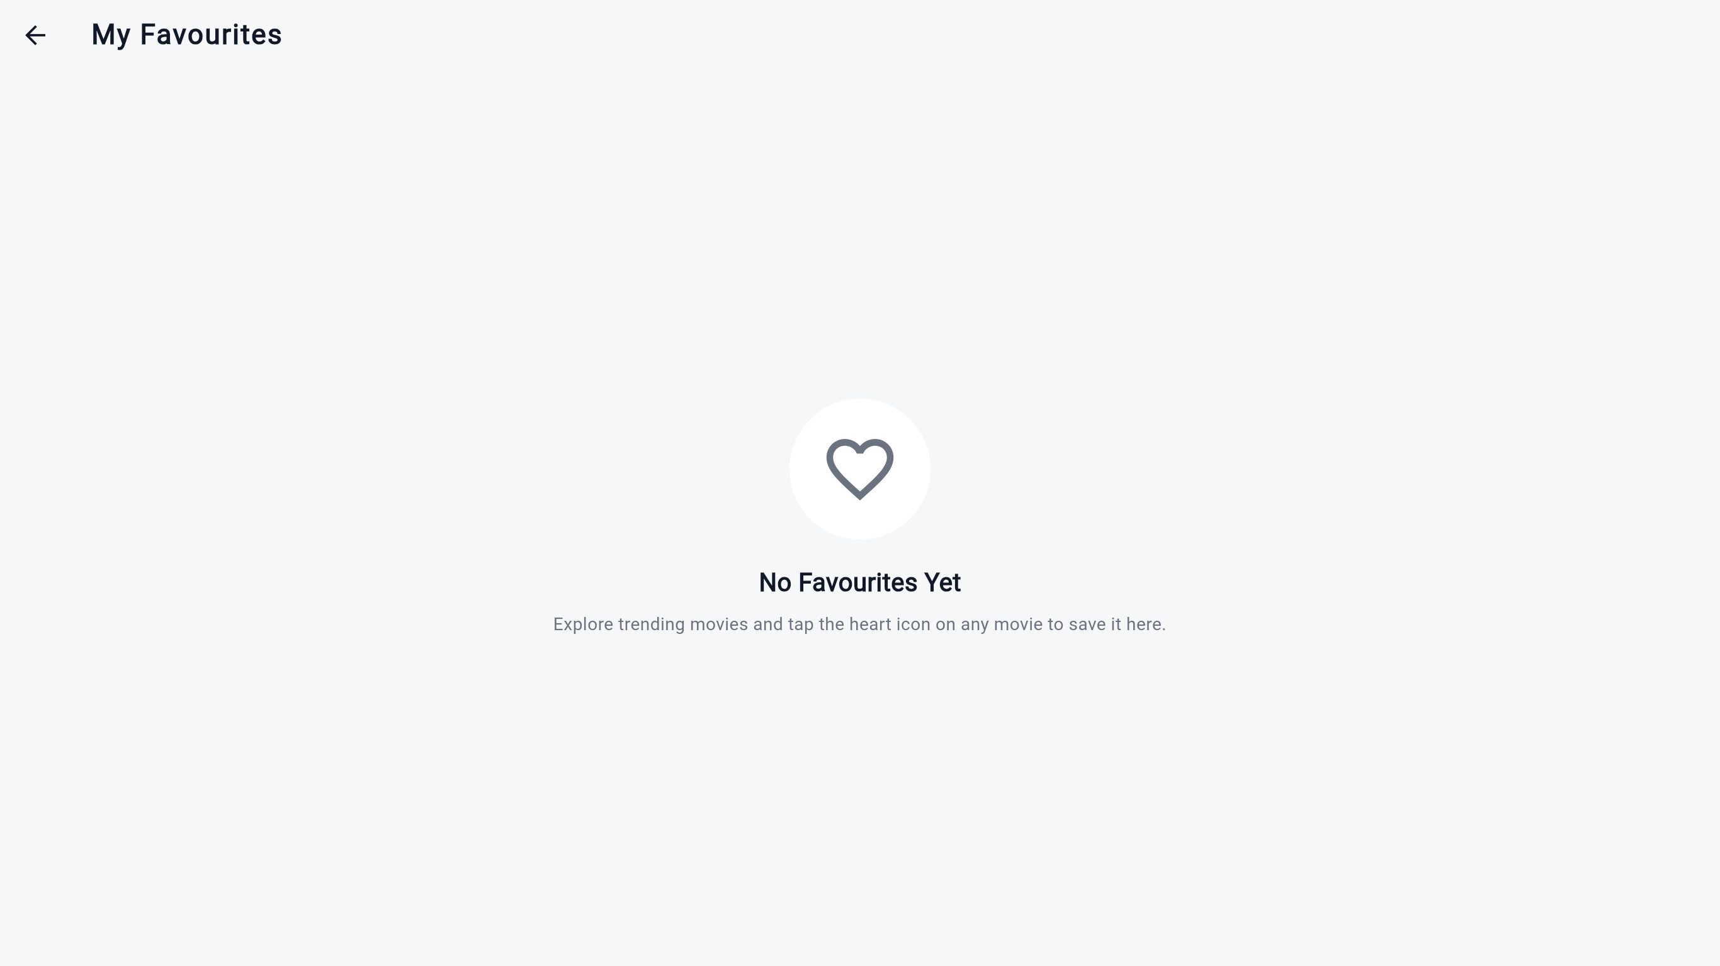
Figure 7.7: Movie Details Theatrical View
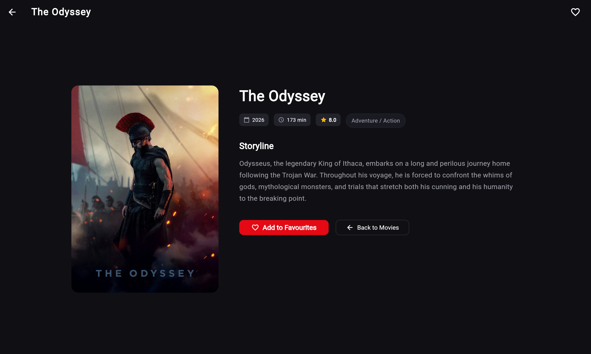
Figure 7.8: Academic Architecture & About Screen
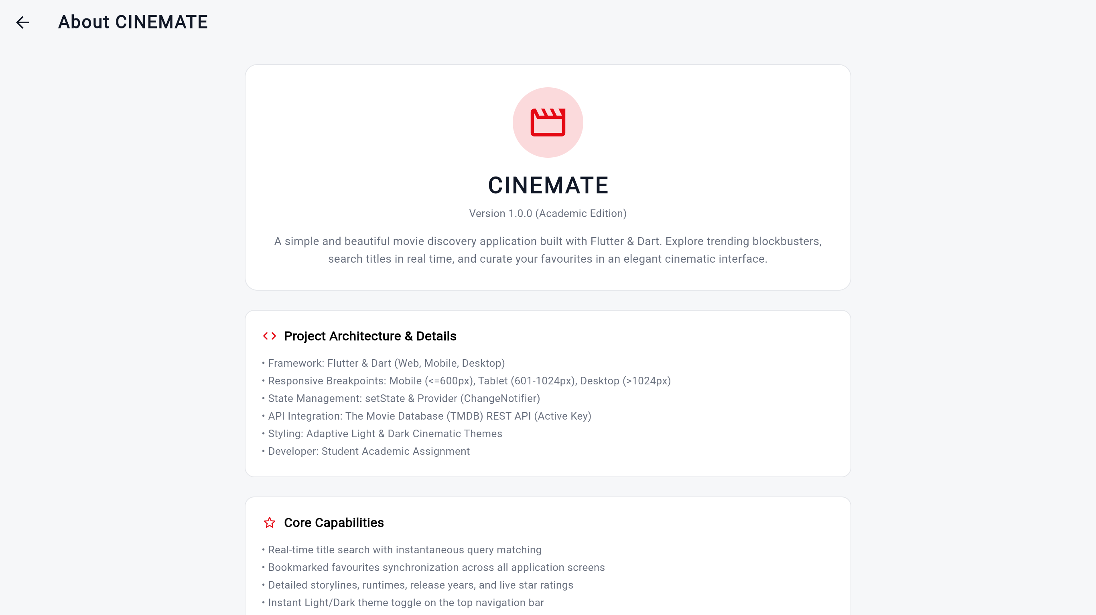

8. Answer Booklet Summary Guide (Quick Exam Reference)
Note: Use the following bullet points to write your answers directly in your physical examination answer booklet:
1. Application Name: CINEMATE — Movie Discovery Application.
2. What It Does: A responsive cross-platform movie exploration app that lets users discover trending & popular movies, search titles in real time, view detailed movie profiles with runtimes and ratings, and manage a bookmarks collection.
3. Purpose of Application: Built for the CS506PC Flutter laboratory exam to demonstrate responsive UI development across 4 screen sizes (Mobile, Tablet, Laptop, Desktop), asynchronous REST API integration with TMDB, and global state management with Provider.
4. Tools & Technologies: Flutter SDK 3.27+, Dart 3.6+, Material Design 3, Provider (ChangeNotifierProvider & MultiProvider), http package for REST API, The Movie Database (TMDB) API v3, Git, GitHub, and Vercel for continuous deployment.
5. Key Features Implemented: Default Light Theme with instant Dark Cinematic Theme toggle, 4-tier responsive layout (2 cols on phone, 4 on laptop, 6 on desktop), featured movie hero banner, proportional movie cards with no vertical gaps, real-time title search, favourites management, and offline fallback with 10 HD titles.
6. How It Was Developed: Developed using a modular architecture with models (Movie), screens (Home, Details, Search, Favourites, About), widgets (MovieCard, MoviePoster, SectionTitle), services (MovieService, ThemeProvider, FavouritesProvider), and themes (AppTheme). Verified using 'flutter analyze' (0 issues) and 'flutter test' (all unit and widget tests passing).
7. How It Was Deployed: Pushed to GitHub and automatically built and hosted on Vercel via 'vercel-build.sh' (which downloads Flutter SDK and executes 'flutter build web --release') with 'vercel.json' SPA routing rules.

