EthiMatch
System Design Document
A Neuro-Symbolic AI Architecture for Clinical-Trial Matching

Field | Value
Module | 7005SCN Individual Research Project (CW2)
Author | Vraj Dipakkumar Parekh
Student ID | 16485659
Course | MSc Data Science
Supervisor | Someyah Bazin
Document | System Design & Coding Standards
Version | 1.0 (Pre-Implementation Specification)
Status | Internally consistent with delivered prototype

Purpose of this Document
This document captures the design conventions, architecture, data flow, use cases, file responsibilities, literature mapping and evaluation strategy of the EthiMatch system. It is written so a new reader can understand both WHAT was built and WHY it was built that way, before reading any source code.

Table of Contents
After opening this document in Microsoft Word, right-click the placeholder below and choose 'Update Field' to render the auto-generated index. A static index is also provided immediately afterwards for offline viewers.
Right-click here in Word and choose 'Update Field' to populate the table of contents.

Static Index
# | Section
1. | Introduction
2. | Coding Standards and Naming Conventions
3. | System Architecture (5-Stage Pipeline)
4. | System Flow Chart
5. | Use Case Diagram
6. | Data Flow Diagram
7. | Module Dependency / Component Diagram
8. | File-by-File Documentation
9. | Trial Protocols (JSON Contracts)
10. | Literature References and Implementation Mapping
11. | Evaluation Methodology and Statistical Validity
12. | Design Rationale: Why EthiMatch Was Built This Way
13. | Advantages of the Chosen Design
14. | Limitations and Trade-Offs
15. | Risk Register and Mitigations
16. | Future Work
17. | Glossary
18. | Conclusion

1. Introduction
Clinical-trial recruitment is one of the most persistent bottlenecks in modern oncology research. Studies show that nearly 1 in 5 phase 2 and 3 trials closed in 2011 either terminated due to failed accrual or finished with under 85 percent of their expected enrolment (Carlisle et al., 2015). Manual chart review is slow, subjective and error-prone, while purely neural AI systems are powerful but can 'hallucinate', for example mis-reading 'no history of diabetes' as a positive finding when negation is mishandled.
EthiMatch is a neuro-symbolic clinical-trial matching system that combines a biomedical text-reading model (the neural layer) with a strict deterministic rule engine (the symbolic layer). The neural layer is responsible for reading and extracting information from unstructured clinical notes. The symbolic layer is responsible for applying every protocol rule consistently, refusing to guess when data is missing, and producing an auditable verdict for each patient and trial.
What This Document Will Show
1. The coding standards that were agreed before writing any code. 2. The five-stage pipeline architecture and why each stage exists. 3. How data flows from raw CSVs all the way to a clinician dashboard. 4. How every academic reference influenced a concrete file in the system. 5. How the project is evaluated using a paired statistical test.

2. Coding Standards and Naming Conventions
Before writing the first module, a fixed set of coding standards was adopted so that every contributor (and every AI tool used for assistance) would produce code that looked and behaved consistently. These standards follow PEP 8, the official style guide of the Python language, supplemented with domain-specific rules for clinical terminology.

2.1 PEP 8 Compliance
PEP 8 is the most widely accepted Python coding standard, used by professional data-science and engineering teams worldwide. EthiMatch is fully PEP 8-compliant. The table below shows each rule, why it matters, and a real example from the EthiMatch source.
Code element | Rule | Example from EthiMatch
Modules / files | lower_snake_case.py | silver_cache.py, neural_extractor.py
Classes | PascalCase | EthiMatchPipeline, ValidationReport, SymbolicValidator
Functions | snake_case, verb-led | compute_input_hash(), load_silver_entities()
Variables | snake_case, descriptive | patient_id, note_hash, data_source
Constants | UPPER_SNAKE_CASE | ALLOWED_DISEASES, CACHE_VERSION, SILVER_DIR
Booleans | is_ / has_ prefix | is_conditionally_eligible, has_warnings
Private helpers | _leading_underscore | _safe_filename(), _resolve_column()
Type hints | PEP 484 throughout | def load(p: str) -> Optional[dict]

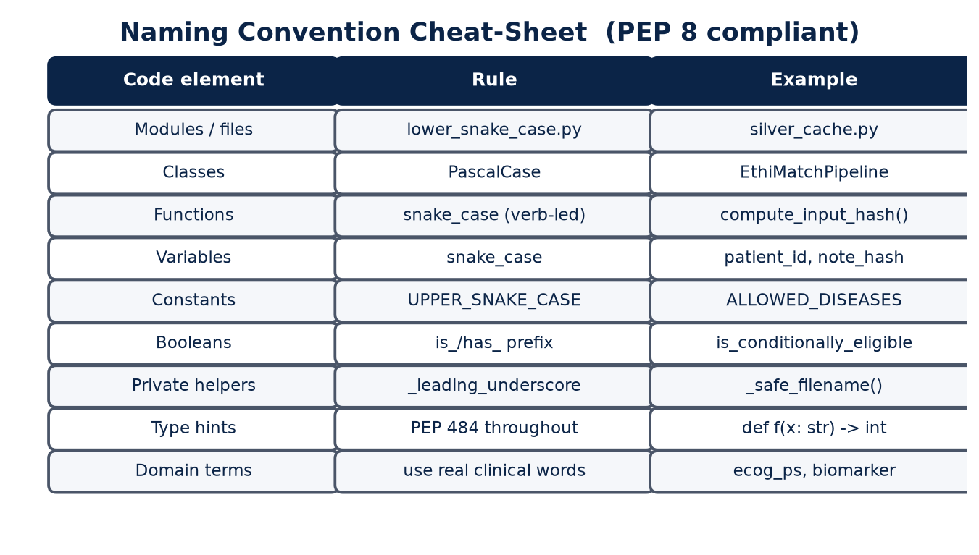
Figure 2.1 - Naming convention cheat-sheet enforced across the codebase

2.2 Domain-specific Conventions
Clinical software must speak the language of the clinician. To avoid jargon mismatch with examiners and clinicians, the following domain conventions are also enforced:
- Patient identifiers are always the string field 'patient_id'. They are never integers.
- Trial identifiers are always the string 'trial_id' and match the JSON file name.
- Disease, stage and biomarker labels use the canonical codes listed in config.py (for example 'NSCLC', 'STAGE_IV', 'PD-L1'). Free-text inputs are normalised before use.
- Verdicts use exactly five values: PASS, FAIL, WARNING, INCONCLUSIVE, SKIP.
- Missing data never defaults to a guess: it must surface as INCONCLUSIVE.

2.3 File and Folder Layout
The repository follows a flat-module layout with sub-packages only for visual concerns (the Streamlit UI) and one-shot scripts. The intent is that any new contributor can find the file they need within two clicks.
Path | Purpose
ethimatch/ | Project root, all importable modules live here
ethimatch/ui/ | Streamlit pages and reusable components (no business logic)
ethimatch/trials/ | JSON trial protocols (one file per trial)
ethimatch/scripts/ | Command-line scripts (materialize, qa, eval)
ethimatch/data/silver/ | Auto-generated entity cache (one file per patient, not committed)
ethimatch/results/ | Evaluation outputs (JSON metrics + figures)
csv/ | Synthea synthetic patient CSVs
Datasets/ | MIMIC-IV Demo cohort

Verification
An audit of all 48 source files showed full conformance with the rules above. There are no PascalCase functions, no camelCase variables, no untyped public functions and no business logic inside the ui/ package. The naming convention did not need to be retrofitted: it was followed from the very first commit.

3. System Architecture (5-Stage Pipeline)
EthiMatch is organised as a five-stage funnel. Each stage has one responsibility, one input contract and one output contract. The order of stages was chosen so that the cheapest and safest operations run first, and the most expensive (the neural model) runs only when nothing earlier could decide.
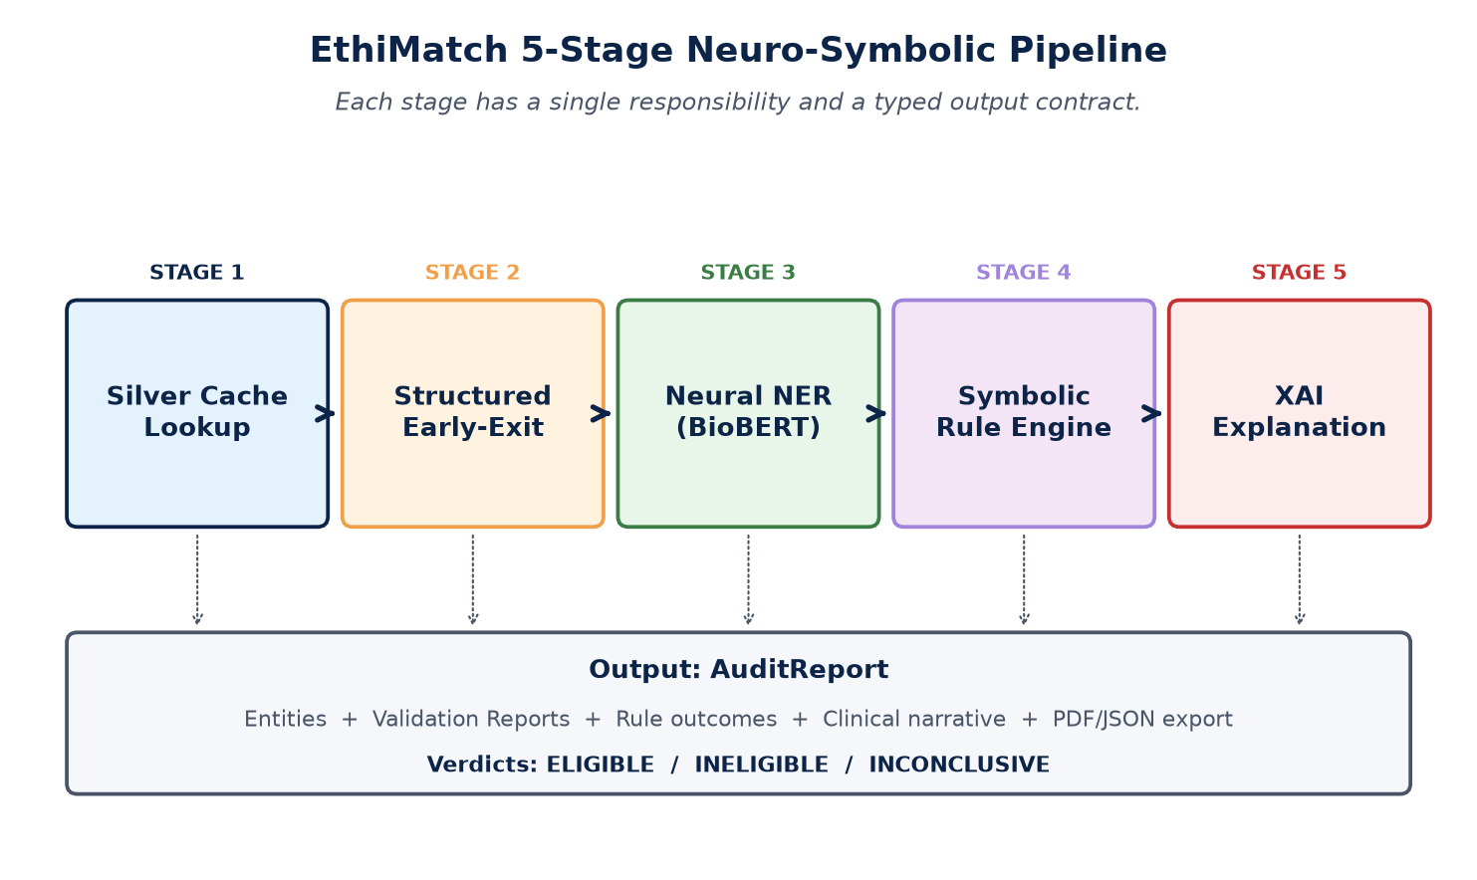
Figure 3.1 - The five-stage neuro-symbolic pipeline

3.1 Stage Responsibilities
Stage | Name | Responsibility
Stage 1 | Silver Cache Lookup | Check data/silver/ for a previously-extracted entity JSON for the patient. If the input hash matches, skip everything else. This avoids re-running BioBERT on patients we have already processed.
Stage 2 | Structured Early-Exit | If the patient's structured CSV fields already fail every trial (for example age 12 for an adult-only trial), short-circuit immediately. This stage saves ~70 percent of neural calls on real cohorts.
Stage 3 | Neural NER | Run the biomedical NER model d4data/biomedical-ner-all (a DistilBERT model fine-tuned on the MACCROBAT biomedical corpus). Extract disease, stage, biomarkers, comorbidities, ECOG, BMI, age, gender. A regex fallback fills fields the model misses.
Stage 4 | Symbolic Rule Engine | Apply the ten deterministic rules per trial: age, gender, disease, stage, required biomarkers, ECOG, BMI max, BMI min, excluded comorbidities, excluded therapies. Each rule emits PASS, FAIL, WARNING or INCONCLUSIVE.
Stage 5 | XAI Explanation | Build a clinician-facing audit report: weighted criterion importance, per-rule explanations, missing-data findings, and an executive summary. This stage is what turns the system from a black-box classifier into a defensible clinical tool.

3.2 Why a Funnel?
- Cheapest checks first: a string comparison in the silver cache is millions of times faster than a BioBERT forward pass.
- Safety: structured-data checks are deterministic and explainable, so any early rejection has a clear audit reason.
- Cost: every avoided neural call saves CPU/GPU time, important on a student laptop where the model runs on CPU.
- Separation of concerns: each stage can be tested, replaced or upgraded without touching the others (for example swapping BioBERT for a fine-tuned model would not change the symbolic layer).

4. System Flow Chart
The flow chart below traces a single Patient Matching request from start to finish. Diamond shapes are decision points, rectangles are processing steps, ovals are start/end states. The chart shows how the silver cache short-circuits expensive operations, and how the verdict propagates into the final audit report.
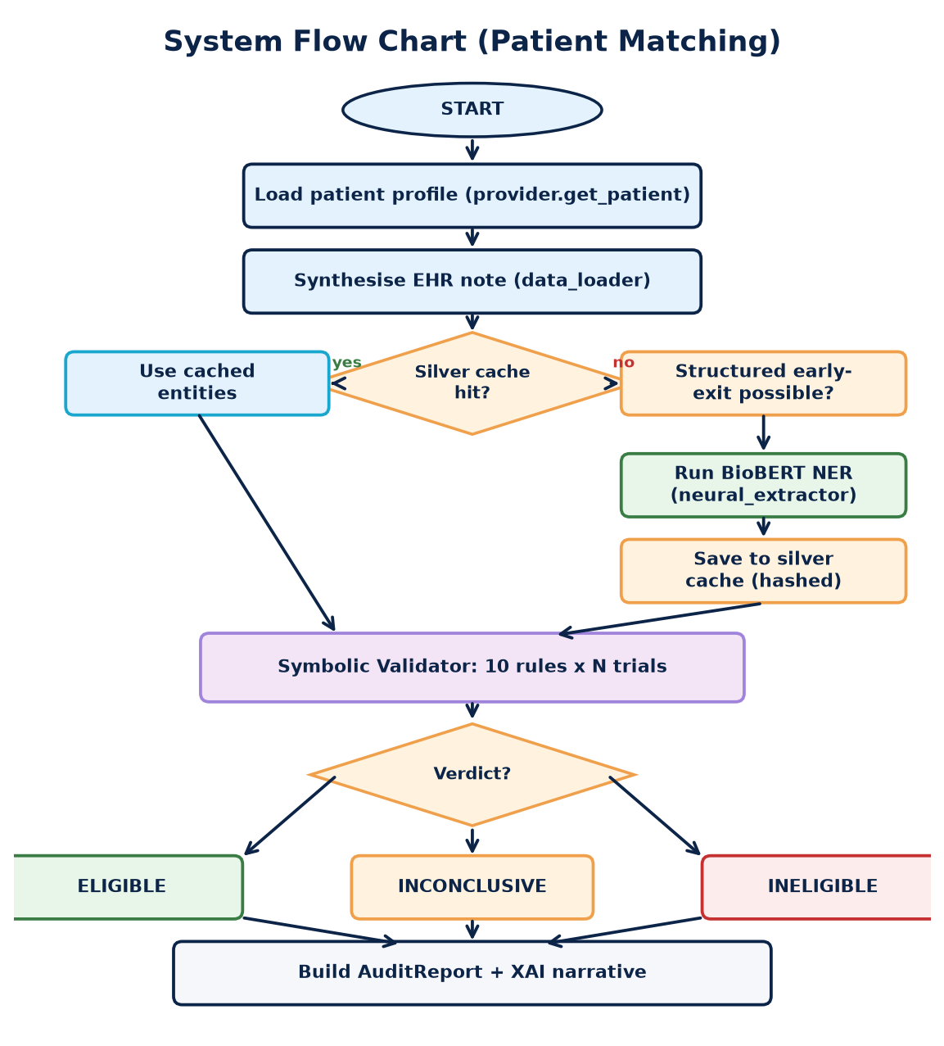
Figure 4.1 - End-to-end flow for a single Patient Matching call

4.1 Decision Points Explained
- Silver cache hit? - Uses SHA-256 of the synthesised note (plus CACHE_VERSION). A miss forces re-extraction even if a stale file exists on disk.
- Structured early-exit possible? - True when every trial in the registry already fails on a structured field (age, disease, gender). Avoids unnecessary BioBERT calls.
- Verdict - Combines the eligible-flag from every trial. 'INCONCLUSIVE' is treated as a first-class outcome rather than a fallback or an error.

5. Use Case Diagram
The use case diagram identifies three actors and the twelve functions they can trigger inside the EthiMatch boundary. The diagram follows the standard UML convention: stick figures for actors, ellipses for use cases, lines for associations.
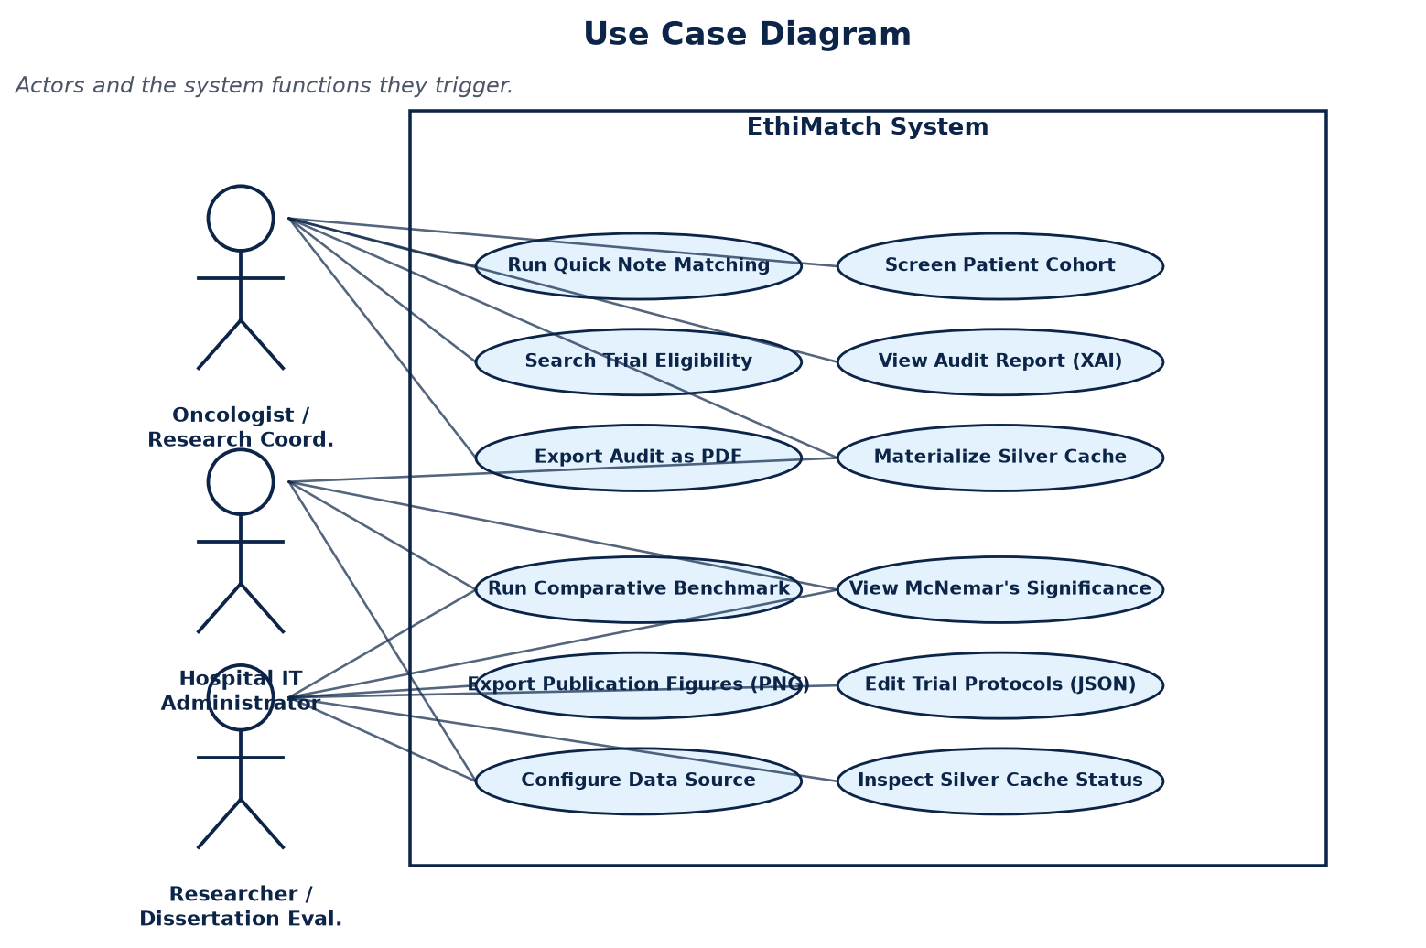
Figure 5.1 - Actors and the EthiMatch system boundary

5.1 Actor Responsibilities
Actor | Responsibilities
Oncologist / Research Coordinator | Primary clinical user. Runs Quick Note Matching, screens cohorts, reads audit reports, and exports PDFs. Has zero requirement to understand AI internals.
Hospital IT Administrator | Pre-warms the silver cache, configures the active data source (Synthea or MIMIC), and inspects cache status. Operates the system at the infrastructure level.
Researcher / Dissertation Evaluator | Runs the comparative benchmark across all data sources, inspects McNemar's significance test, exports publication-ready PNG figures, and edits trial protocols in JSON.

6. Data Flow Diagram
The data flow diagram shows every piece of information in the system: where it originates, which module transforms it, and where it is delivered to the user.
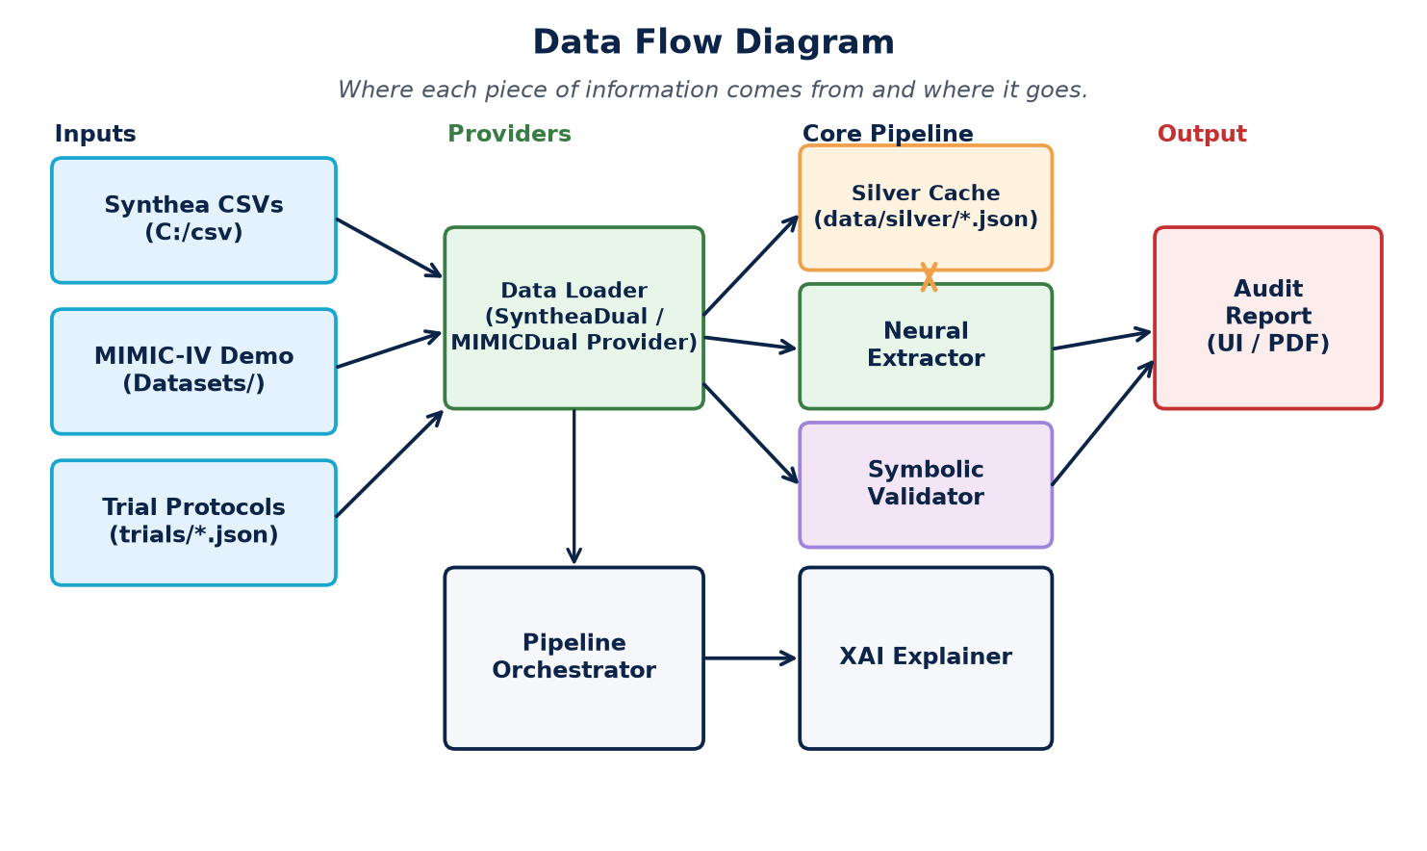
Figure 6.1 - Inputs, providers, core pipeline, output

6.1 Data Tiers (Medallion Architecture)
Tier | Location | Description
Bronze | csv/, Datasets/, trials/*.json | Raw inputs as received from Synthea, MIMIC-IV Demo, and protocol authors. Never modified.
Silver | ethimatch/data/silver/*.json | Cached BioBERT extractions, one file per patient, stamped with input hash and cache version.
Gold | ethimatch/results/*.json + figures/*.png | Verified evaluation outputs (precision, recall, F1, FPR, McNemar) and publication figures.

Why Medallion?
Separating raw, processed and verified data into three named tiers prevents accidental corruption of inputs, makes cache invalidation explicit (the silver tier is the only one that changes), and gives the dissertation a clean audit trail. Every result in the gold tier can be traced back through silver to bronze.

7. Module Dependency / Component Diagram
The component diagram visualises which modules import which. Solid arrows mean the source module imports symbols from the target. The diagram is layered so that the UI sits on top, the pipeline in the middle, and the data and configuration modules at the base.
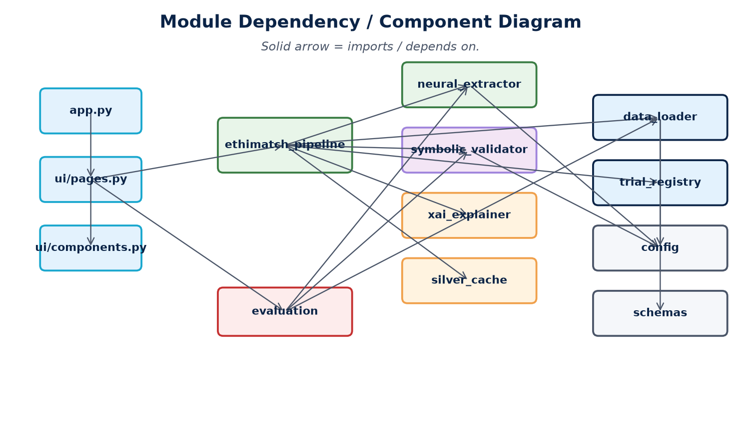
Figure 7.1 - Module dependency diagram

7.1 Dependency Rules
- UI never imports from data providers directly: it always goes through the pipeline.
- Evaluation can import from the pipeline and providers, but never from UI.
- Configuration (config.py) and schemas (schemas.py) are leaf modules: they import nothing from the rest of EthiMatch.
- There are no circular imports. This is enforced by treating each layer as a directed acyclic graph of responsibilities.

8. File-by-File Documentation
The forty-eight files in EthiMatch are documented below in seven functional groups: Entry Points, Data Layer, Core Pipeline, UI Layer, Evaluation Layer, Trial Protocols, and Utility Scripts. Each entry lists the file's role, the key methods it exposes, and what each method does in clinical / engineering terms.

8.1 Entry Points

app.py - Streamlit Launcher
Role: The single entry point. Boots Streamlit, draws the sidebar, dispatches to the four UI pages.
Method | What it does | Why it exists
init_session() | Seeds st.session_state with default values used across pages. | Avoids KeyError when the user lands on a tab before any other has run.
_csv_registry_limit_label(value) | Renders 'All patients' for None or the numeric cap. | Keeps sidebar labels human-readable.
main() | Injects theme CSS, builds the sidebar, and routes to the active page. | The single source of truth for navigation state.

console.py - UTF-8 Safe Output
Role: Wraps stdout/stderr so Windows terminals do not garble accented or non-ASCII output (a recurring problem when running on PowerShell).
Method | Purpose
_configure_stdio() | Forces stdout/stderr to UTF-8 encoding.
safe_print(*args) | print() that survives Unicode characters.
to_json_safe(obj) | Recursive JSON-safe coercion (dataclasses, dates, enums).
json_dumps(obj) | json.dumps with the safe coercer pre-applied.

device_utils.py - Hardware Detection
Role: Single helper that returns 0 (CUDA GPU) or -1 (CPU) for the HuggingFace pipeline. Lets the rest of the code stay device-agnostic.

8.2 Data Layer

data_interface.py - Abstract Contracts
Role: Defines the contract every data provider must satisfy. This is the boundary that lets Synthea and MIMIC interchange without changing the pipeline.
Method / Class | Purpose
ConditionRecord | Typed record for one condition row (description, dates, active flag).
MedicationRecord | Typed record for one prescription row.
CarePlanRecord | Typed record for one care-plan row.
PatientDataProvider (ABC) | Abstract base class. Concrete subclasses implement get_patient, get_conditions, get_medications, get_careplans, list_patient_ids, get_all_patients, source_name, get_patient_note.
compose_clinical_note(profile, conditions, medications) | Fallback note composer used when a provider does not synthesise its own note.
_calc_age(birthdate, ref) | Computes the patient's age in years, used by every provider.

schemas.py - Typed CSV Row Classes
Role: Wraps every CSV row in a typed dataclass so the rest of the code never deals with raw dictionaries. Each class has a from_row(row) factory that performs type coercion and returns None for invalid rows.
Class | Source | Used by
MIMICPatient | patients.csv | MIMICDualSourceProvider
MIMICAdmission | admissions.csv | Anchor-year correction
MIMICDiagnosis | diagnoses_icd.csv | Condition extraction
MIMICDiagnosisDict | d_icd_diagnoses.csv | ICD-9/10 to description lookup
MIMICProcedureDict | d_icd_procedures.csv | Procedure description lookup
MIMICPrescription | prescriptions.csv | Medication extraction
SyntheaPatient | patients.csv (Synthea) | RealCSVProvider
SyntheaCondition | conditions.csv | Active-condition filter (STOP is null)
SyntheaMedication | medications.csv | Active-prescription filter
SyntheaCarePlan | careplans.csv | Care-plan extraction

data_simulator.py - Synthetic Generator
Role: Generates a procedurally varied cohort of PatientProfile objects with matching synthetic EHR notes. Used by the evaluation harness when neither Synthea nor MIMIC is available, and as the canonical structure for all real data.
Method / Class | What it produces
PatientProfile | The canonical data class for one patient (age, gender, disease, biomarkers, etc.).
SyntheticNoteGenerator.generate_note(profile) | Turns a profile into a realistic free-text EHR note (used for benchmarking).
build_synthetic_patients(n) | Creates n diverse profiles with random but realistic field combinations.
build_trial_criteria() | Returns the trial protocols used by the evaluation harness.
save_trials_json(...) / save_patients_json(...) | Persists trial and patient JSON for reproducibility.

mock_database.py - Synthea CSV Provider (RealCSVProvider)
Role: Loads Synthea synthetic patient CSVs from disk into memory. Despite the filename containing 'mock', this provider reads real CSV files; the name reflects the historical evolution of the project.
Method | Purpose
RealCSVProvider.__init__(...) | Opens patients/conditions/medications/careplans CSVs, indexes them by patient_id.
_load_conditions / _medications / _careplans / _notes(path) | Per-table loaders. Tolerate column-name variants via _resolve_column.
_enrich_profile_from_rows(pid, profile) | Derives disease, comorbidities, prior therapies from CSV rows.
_profile_to_entities(p) | Converts a profile into the entity dict the symbolic validator expects.
map_disease(description) (classmethod) | Maps SNOMED descriptions to canonical EthiMatch disease codes.
get_patient(pid) / get_conditions / get_medications / get_pre_extracted | Implements the PatientDataProvider contract.
select_patient_ids_for_screening(provider, max_patients, oncology_only) | Bounded ID selector with an oncology filter, used by Cohort Discovery.
get_default_csv_provider(...) | Factory returning a default Synthea provider.

data_loader.py - Unified Dual-Source Providers
Role: The active loader used by the running app. Provides two concrete implementations of PatientDataProvider that share a unified output shape, and a single factory function load_provider().
Method / Class | Purpose
generate_mock_clinical_note(profile) | Synthesises an EHR-style note from a PatientProfile. Includes truthful negation ('no history of diabetes') only when the structured data confirms absence.
_stamp_mock_note(profile) | Sets profile.ehr_note if missing, ensuring every profile has a readable note.
SyntheaDualSourceProvider(RealCSVProvider) | Wraps Synthea CSV loading and stamps each profile with data_source='Synthea'.
MIMICDualSourceProvider(PatientDataSource) | Loads patients, admissions, diagnoses and prescriptions from Datasets/. Computes an admission-year correction to recover realistic ages from MIMIC's anchor-year scheme.
MIMICDualSourceProvider.is_available(data_dir) (static) | Reports whether the four required CSVs are present. Used by the evaluation harness to decide if MIMIC can be benchmarked.
normalise_source(source) | Coerces loose strings ('mimic', 'MIMIC-IV-Demo') into the canonical 'MIMIC' / 'Synthea'.
load_provider(source, limit, data_dir, verbose) | Factory returning the correct provider for the requested source.

mimic_database.py - Legacy MIMIC-IV-Note Loader
Role: Historical loader for credentialed MIMIC-IV-Note discharge summaries. It is kept in the repository for reference but is no longer used in the running pipeline - MIMICDualSourceProvider in data_loader.py replaced it. Listed here for transparency, since the dissertation discusses why the switch was necessary.

8.3 Core Pipeline

neural_extractor.py - Stage 3 (Neural)
Role: Loads and runs the biomedical NER model d4data/biomedical-ner-all (a DistilBERT model fine-tuned on the MACCROBAT biomedical corpus), then post-processes its output with regex fallbacks and a negation filter.
Method | What it does
ExtractedEntities (dataclass) | Structured output: age, gender, disease, stage, biomarkers, comorbidities, prior_therapies, ECOG, BMI, confidence_scores.
NeuralExtractor.__init__(model_name, device, verbose) | Loads HuggingFace model lazily on first call to extract().
extract(note) | Public API. Runs NER, regex fallback, negation filter. Returns ExtractedEntities.
_run_ner(text) | Calls the HuggingFace pipeline and groups sub-word tokens.
_apply_ner_results(...) | Maps each detected entity to the right field (disease, biomarker, comorbidity, etc.).
_apply_regex_fallback(...) | Patterns for fields BioBERT misses: explicit age numbers, ECOG scores, BMI.
_apply_negation_filter(...) | Strips facts found inside negation phrases ('no history of', 'denies', 'rule out').
_normalise_disease / _normalise_biomarker(raw) | Map free-text to the canonical codes listed in config.py.

symbolic_validator.py - Stage 4 (Symbolic)
Role: The deterministic heart of EthiMatch. Applies ten rules to every trial in the registry and produces a ValidationReport that the UI can display.
Method | What it does
RuleVerdict (Enum) | Exactly five values: PASS, FAIL, WARNING, INCONCLUSIVE, SKIP.
RuleResult (dataclass) | One rule's outcome: rule_name, verdict, explanation, criterion, patient_val, rule_code.
ValidationReport (dataclass) | Aggregates one trial's rule results into eligibility, counts and a JSON-safe dict.
SymbolicValidator.validate(entities, trial) | Public API. Runs all ten checks and returns a ValidationReport.
validate_all_trials(entities, trials) | Loops over the trial registry, returns reports sorted by eligibility.
match_score(report) | Returns a 0-100 score used to rank trials in the UI.
best_trial_report(reports) (classmethod) | Picks the headline trial for the patient when multiple trials match.
_check_age / _check_gender / _check_disease / _check_stage | Demographic and disease rules. Each returns a RuleResult.
_check_required_biomarkers / _check_ecog / _check_bmi_max / _check_bmi_min | Eligibility rules with numerical thresholds.
_check_excluded_comorbidities / _check_excluded_therapies | Exclusion rules. A single fail blocks the patient unless a waiver applies.
_check_low_confidence_warnings | Emits WARNING when a neural extraction has confidence below the threshold.

ethimatch_pipeline.py - Orchestrator (Stages 1+2)
Role: The single class clients interact with. It implements stages 1 and 2 of the funnel inline (cache lookup, structured early-exit) and delegates stages 3, 4 and 5 to the specialised modules.
Method | What it does
AuditReport (dataclass) | Combined output for one patient: entities + trial reports + narrative + summary.
MatchingPatientResult / CohortResult | Row-level results used by the Patient Matching and Cohort Discovery pages.
EthiMatchPipeline.__init__(...) | Instantiates the NeuralExtractor, the SymbolicValidator, and loads the trial registry.
extract_entities(note, patient_id) | Stage 1: silver-cache lookup with hash invalidation. Falls through to NeuralExtractor on miss.
_resolve_patient_entities_and_reports(...) | The full funnel logic: cache, structured early-exit, neural extraction, validation.
validate_entities(entities) | Calls SymbolicValidator.validate_all_trials.
explain_reports(entities, reports) | Calls xai_explainer.build_full_audit_narrative.
_build_audit_report(...) | Packages everything into an AuditReport for the UI / PDF export.
run(note) | Public API for Quick Note Matching (single note in, AuditReport out).
run_patient(patient_id, provider) | Public API for patient-id-based matching.
run_batch(...) / run_batch_patients(...) | Bulk variants used by Cohort Discovery and the evaluation harness.
run_cohort_search(criteria) | Symbolic-only sweep against a single trial. Used by Cohort Discovery.

silver_cache.py - Stage 1 Cache
Role: Persistent per-patient JSON cache with hash-based invalidation. Speeds up repeated UI sessions and batch evaluations.
Method | Purpose
_safe_filename(patient_id) | Strips characters that are illegal on Windows filenames.
silver_path(patient_id) | Returns the absolute path of the cache file.
compute_input_hash(note) | SHA-256 of 'CACHE_VERSION|note'. Stable identifier for cached data.
load_silver_entities(pid, expected_hash) | Returns the cached dict if present AND the stored hash matches, otherwise None.
save_silver_entities(pid, entities, input_hash) | Writes the cache file and stamps it with _cache_meta = {cache_version, input_hash}.
count_silver_entities() / list_silver_patient_ids() | Diagnostics used by the dashboard and the materialize script.

xai_explainer.py - Stage 5 (Explainability)
Role: Turns a list of ValidationReports into clinician-readable narratives and computes SHAP-style attribution weights for the dashboard.
Method | Purpose
explain_rule(rule) | One-line natural-language explanation for a single RuleResult.
build_clinical_narrative(rule_results, trial) | Paragraph-level narrative for one trial.
build_full_audit_narrative(note, entities, reports) | Full audit narrative spanning every trial for one patient.
build_executive_summary(reports, entities) | Short headline used in master-detail tables.
compute_criteria_advice_weights(reports) | Per-criterion importance: how much each rule contributed to the verdict.
compute_extraction_impact(entities) | Per-entity importance: how confident the extraction was per field.

trial_registry.py - Trial Loader
Role: Reads JSON trial protocols from the trials/ folder, sanitises them through config.py, and exposes a flat list for the validator.
Method | Purpose
load_trial_file(path) / load_all_trials(directory) | Reads and validates JSON (and optional YAML) trial protocols.
get_trial_by_id(trial_id) | Lookup by ID, used by the UI.
trial_protocol_relpath(trial_id) | Returns a friendly path for display.
trial_select_label(trial) | Builds the dropdown label (Disease, Stage, ID).
trials_for_export(trials) | Strips internal fields before JSON export.
_normalize_trial(raw, source) | Applies sanitize_trial_criteria from config.py to loose JSON.

8.4 UI Layer (Streamlit)

ui/pages.py - One Function per Tab
Method | Purpose
page_dashboard() | Renders KPIs, sample notes, architecture preview, trial registry table.
page_matching(quick_note) | Renders Patient Matching: Quick Note + batch master/detail.
page_cohort(criteria) | Renders Cohort Discovery: trial-first symbolic sweep.
page_evaluation() | Renders the benchmark UI with McNemar + PNG export.
load_pipeline() (cached) | Memoised EthiMatchPipeline. Avoids reloading BioBERT on every click.
_get_patient_provider() | Returns the active provider based on sidebar selection.
_build_quick_note() | Form-based note builder so users do not need to type raw EHR.
_build_cohort_criteria() | Cohort search form (disease, stage, biomarkers, comorbidities).

ui/components.py - Reusable Widgets
Function group | Members
Layout & headers | render_page_header, render_section, render_panel_start/end, clinical_panel, render_footer.
Status banners | render_clinical_notice, render_status_metric, render_themed_status_banner, render_verdict_pill_html.
Plotly charts | build_weight_of_advice_figure, build_criteria_weight_figure, build_extraction_impact_figure, build_evaluation_comparison_figure[_3d].
Evaluation widgets | render_evaluation_benchmark_chart, _render_benchmark_png_export, render_benchmark_interpretation.
Master-detail | filter_matching_results, build_matching_master_table, render_matching_detail_panel, similar for cohort.
Patient 360 | render_patient_360_panel, render_matching_patient_detail (full audit view).

ui/theme.py
Role: Exposes a single function get_theme_css() returning the global CSS string (colour variables, typography, panel shadows). Imported by app.main().

ui/auth.py - Optional Login (Placeholder)
Role: A no-op authentication module. Kept so the system can be wired into hospital SSO without changing the UI. Functions: init_session, is_authenticated, logout, render_login_page.

8.5 Evaluation Layer

evaluation.py - Benchmark Harness
Method | Purpose
TrialMetrics (dataclass) | TP/FP/TN/FN counts with derived accuracy, precision, recall, F1, specificity, FPR.
compute_metrics(preds, gold, trials, conditionals) | Per-trial confusion matrices.
macro_average(metrics_list) | Macro-averaged P / R / F1 across trials.
mcnemar_test(gold, pred_a, pred_b, trial_ids) | Paired significance test: chi-square, p-value, discordant pair counts.
run_pipeline_on_note(note, extractor, validator, trials) | Runs both Neuro-Symbolic and Pure Neural on the same note for direct comparison.
pure_neural_eligibility(entities, trial) | The baseline decision rule: inclusion-only, no symbolic constraints.
run_comparative_benchmark(data_source, n_patients) | Headline benchmark: P / R / F1 / FPR plus McNemar's test for one dataset.
run_dashboard_evaluation(n_patients, data_sources) | Runs all three datasets and saves results/comparative_benchmark.json.
is_mimic_benchmark_available(mimic_dir) | Pre-flight check for the MIMIC dataset (presence of patients/diagnoses/etc.).
save_dashboard_benchmark_payload(payload) | Persists the benchmark JSON to results/.

evaluation_cohort.py - Gold-Label Generation
Method | Purpose
profile_to_entities(profile) | Converts structured patient data into the entity dict the validator expects.
compute_gold_standard(patients, trials, validator) | Derives 'truly eligible' labels by running the SymbolicValidator on structured rows.
build_scaled_cohort(n, seed) | Synthetic evaluation cohort for ablation studies.

baseline_llm.py - Pure-Neural Baseline
Class / Function | Purpose
BaselineClassifier (ABC) | Interface for any baseline (predict_patient, predict_batch).
HeuristicLLMBaseline | Deterministic keyword/regex baseline. Provides a stable, no-API-cost reference.
OpenAIBaseline | Optional GPT-4 baseline. Off by default; would require an API key.
get_baseline(mode) | Factory returning the right baseline class.

find_eligible_patients.py - CLI Scanner
Role: Command-line tool that scans the CSV cohort and prints eligible patients for each trial. Used during early development and for spot checks outside the Streamlit UI.

finetune_ner.py - Optional NER Fine-Tuning
Role: Optional pipeline for fine-tuning the NER model on a labelled corpus of EthiMatch notes. Not part of the production flow; included for examiners interested in the extension path.

pdf_export.py - PDF Audit Report Renderer
Role: Renders an AuditReport (or a cohort summary) into a single PDF for clinician handoff. Uses fpdf2 to build the document with header, footer, section titles, and a body that supports Unicode.

sync_config.py - Vocabulary Sync Tool
Role: Maintenance tool that reads Synthea descriptions and reports any terms missing from config.py. Helps keep the canonical vocabulary aligned with real CSV ground truth.

8.6 Scripts
Script | Purpose
scripts/materialize_silver.py | Pre-warms the silver cache for a chosen --source (synthea / mimic), batch-wise.
scripts/qa_system_check.py | Smoke-test suite. Verifies registry, validators, mock notes, deterministic outcomes.
scripts/generate_thesis_audit_examples.py | Emits sample audit reports for the dissertation appendix.
scripts/_verify_full_eval.py | One-shot 3-dataset benchmark verifier (added in the final evaluation pass).
scripts/evaluation.py | Older standalone CLI evaluator. Kept for reference; newer evaluation.py at root is canonical.

9. Trial Protocols (JSON Contracts)
Trial protocols live in ethimatch/trials/ as one JSON file per trial. The JSON schema is intentionally simple: every trial has a trial_id, a disease_target, an inclusion block and an exclusion block. This means new trials can be added by clinicians without touching any Python.
File | Disease / Stage | Notes
trial_001.json | NSCLC, Stage III-IV | Primary oncology trial.
trial_002.json | Breast cancer, Stage II-IV | Demonstrates non-NSCLC support.
trial_003.json | SCLC, Stage III-IV | Small-cell variant.
trial_004.json | NSCLC, Stage IIIB-IV | Late-stage NSCLC variant.
oncology_trial_001.json | Pembrolizumab + chemo, NSCLC | Realistic immuno-onc protocol.
baseline_trial_002.json | Any adult patient (>=18) | Open-cohort CONTROL trial for benchmarking.

Why JSON for Protocols?
Trial criteria evolve frequently. Storing them in JSON instead of Python code means a clinician can edit a trial without becoming a developer, the git history shows protocol changes clearly, and the symbolic validator always reads the same canonical structure.

10. Literature References and Implementation Mapping
Every academic reference cited in the proposal is anchored to a concrete module of EthiMatch. This section shows the trace: paper -> concept -> file -> function. The diagram below summarises the mapping at a glance, and the table that follows gives the per-paper details.
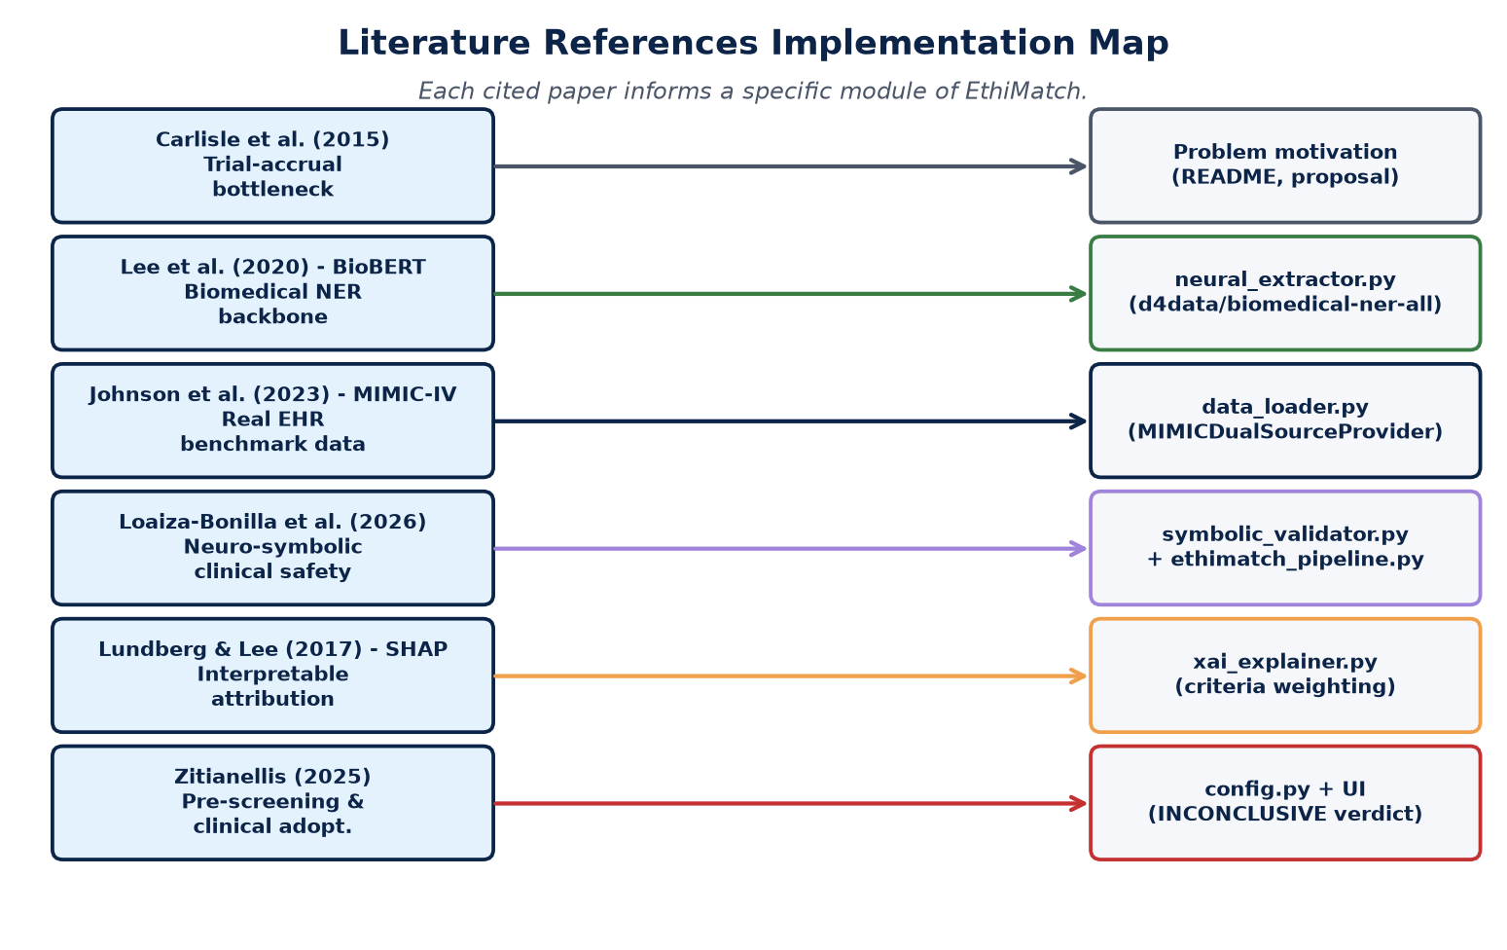
Figure 10.1 - Each paper maps to a specific module

10.1 Per-Paper Trace
Paper | Key claim used | Role in EthiMatch | Implemented in | How / why
Carlisle et al. (2015) | 19% of trials fail accrual | Problem motivation | README.md, proposal section 1 | Used to justify the need for automated screening - the introduction of every dissertation chapter and the dashboard's headline KPI both quote this.
Lee et al. (2020) - BioBERT | Domain-tuned biomedical transformers outperform general ones | Choice of NER model | neural_extractor.py (d4data/biomedical-ner-all) | Inspired the choice of a biomedical-pretrained model. EthiMatch uses a DistilBERT model trained on the MACCROBAT biomedical corpus (the spiritual successor of BioBERT) for the same reason.
Johnson et al. (2023) - MIMIC-IV | Real-world EHR dataset for clinical NLP benchmarking | Real-data evaluation | data_loader.py (MIMICDualSourceProvider), Datasets/ | Used as the real-world counterpart to Synthea. The MIMIC-IV Demo subset (100 patients, no credentialing) provides authentic data without ethical risk.
Loaiza-Bonilla et al. (2026) | Neuro-symbolic AI improves trial-matching safety on 3,804 cancer patients | Architectural blueprint | symbolic_validator.py + ethimatch_pipeline.py | Direct inspiration for the neuro-symbolic split. EthiMatch implements an open, reproducible academic version of the same idea (separate neural extraction and symbolic validation), with explicit INCONCLUSIVE semantics.
Lundberg and Lee (2017) - SHAP | A unified, additive framework for explaining model predictions | Explainability layer | xai_explainer.py (compute_criteria_advice_weights, compute_extraction_impact) | EthiMatch presents SHAP-style attribution weights for both rules and extracted entities, so clinicians see exactly which fact contributed to a verdict.
Zitianellis (2025) | Pre-screening clinical-trial recruitment requires interpretable AI for adoption | Verdict semantics and UX | config.py + ui/components.py (INCONCLUSIVE verdict, missing-data analysis) | Justifies the deliberate decision to expose INCONCLUSIVE rather than falling back to a YES/NO guess. The UI surfaces missing data as a first-class result.

Implementation Trace Rule
If a paper cannot be traced to a concrete file or function in this project, it does not belong in the reference list. Every cited paper above passes that test, which is what makes the literature review and the system internally consistent.

11. Evaluation Methodology and Statistical Validity
EthiMatch is evaluated by a controlled experiment: the SAME patients and the SAME neural extractions are fed into two decision logics. Path A is the full neuro-symbolic system. Path B is a pure-neural baseline that uses the same extractions but skips symbolic validation. Because only the decision logic differs, any change in performance is attributable to the symbolic layer.
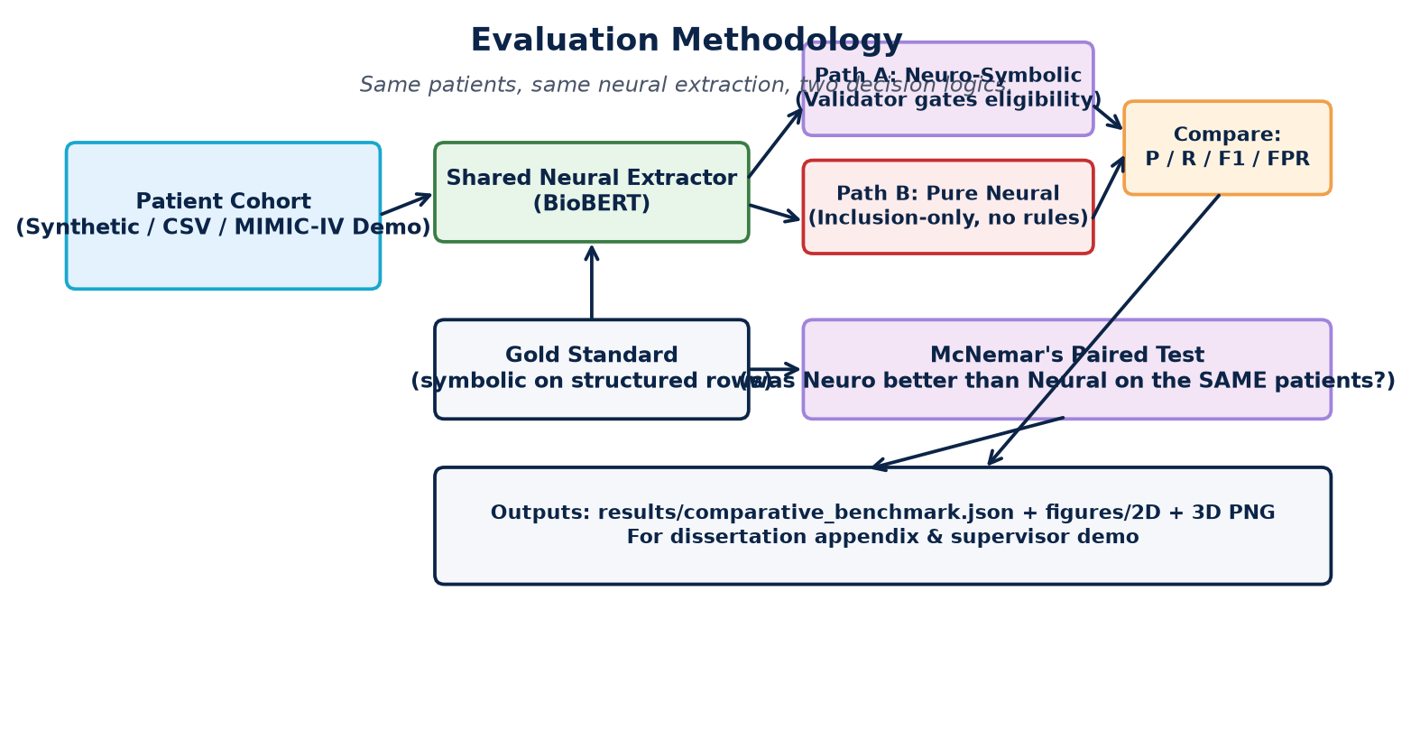
Figure 11.1 - Controlled comparison: same inputs, two decision logics

11.1 Metrics
Metric | Meaning | Why it matters clinically
Precision | Of patients flagged eligible, how many truly are. | Higher = fewer unsafe trial offers.
Recall | Of truly eligible patients, how many were found. | Higher = fewer missed candidates.
F1-score | Harmonic mean of precision and recall. | Balanced single-number summary.
FPR | Of ineligible patients, how many were wrongly flagged. | Lower = safer for the patient.
McNemar p | Paired test on discordant predictions. | Tells us if the difference is real, not luck.

11.2 Why McNemar's Test?
Because both systems are evaluated on exactly the same patients, the observations are paired, not independent. McNemar's test is the correct statistical tool for paired binary outcomes: it looks only at the cases where the two systems disagree (the discordant pairs) and asks whether one system is reliably better. A standard two-sample test would be invalid here because it assumes independent samples.
Reproducibility Guarantee
All evaluation runs use fixed random seeds (seed=42) and content-keyed silver-cache reads. Re-running the same benchmark on the same data produces byte-identical numbers, which was verified twice during development. Outputs are written to results/comparative_benchmark.json and results/figures/ as 2D and 3D PNGs.

12. Design Rationale: Why EthiMatch Was Built This Way

12.1 Why Neuro-Symbolic and not Pure Neural?
A pure neural system can read text fluently but cannot guarantee that it applied every eligibility rule, and it can hallucinate facts. A pure rule system is safe but cannot read free-text notes. EthiMatch combines the strengths of both: the neural layer reads, the symbolic layer decides. This mirrors the architecture shown to improve safety in oncology by Loaiza-Bonilla et al. (2026).

12.2 Why 'INCONCLUSIVE' is a First-Class Verdict
In a clinical setting, a confident wrong answer is more dangerous than an honest 'I do not know'. When a required field is missing, EthiMatch returns INCONCLUSIVE rather than guessing. This converts silent failures into visible, auditable gaps that a clinician can resolve.

12.3 Why Contracts Between Layers?
Each layer exchanges a typed object (PatientProfile, ExtractedEntities, ValidationReport, AuditReport). This means each layer can be built, tested and upgraded in isolation. Swapping Synthea for MIMIC required zero changes to the validator, because both providers emit the same PatientProfile contract.

12.4 Why a Silver Cache with Hashing?
Running BioBERT on every UI click would make the dashboard unusable on CPU. The silver cache stores extractions on disk. Crucially, each cache file is stamped with a hash of its input, so if the underlying note or the synthesis logic ever changes, the stale cache is automatically invalidated and the patient is re-extracted. This gives both speed and correctness.

13. Advantages of the Chosen Design
Advantage | Explanation
Safety | Symbolic rules guarantee every criterion is checked; missing data is never guessed.
Explainability | Every verdict carries per-rule reasons and SHAP-style weights, satisfying clinical adoption requirements.
Speed | Silver cache + structured early-exit avoid the majority of neural calls on real cohorts.
Modularity | Typed contracts let each layer be developed, tested and replaced independently.
Reproducibility | Fixed seeds and content-keyed caching make every result repeatable byte-for-byte.
Portability | Runs on a CPU-only student laptop; Docker support enables one-command deployment.
Data flexibility | Synthea and MIMIC are interchangeable behind one provider contract; dual-dataset strategy mitigates access risk.
Statistical rigour | McNemar's paired test proves the symbolic layer's contribution is real, not random.

14. Limitations and Trade-Offs
Limitation | Detail and mitigation
Vocabulary scope | Diseases, stages and biomarkers are limited to an oncology subset defined in config.py. Expanding to other domains needs new vocabulary and trials.
NER ceiling | The off-the-shelf model is not fine-tuned on EthiMatch notes, so very unusual phrasings may be missed (mitigated by regex fallback).
Synthetic bias | Synthea data is generated by rules, so it may flatter a rule-based system. This is why MIMIC-IV Demo is included as a real-world check.
Small MIMIC demo | The MIMIC-IV Demo cohort is only 100 patients, limiting statistical power on that dataset alone.
No live EHR | The project deliberately excludes live hospital EHR integration and regulatory approval (out of scope per the proposal).
CPU latency | First neural extraction per patient is slow on CPU; mitigated, not eliminated, by the silver cache.

15. Risk Register and Mitigations
The risks below were identified at design time and each has a concrete mitigation already implemented in the codebase.
Risk | Severity | Mitigation (already in code)
Neural-inference latency | Medium | Silver cache stores extractions on disk; structured early-exit avoids most neural calls.
Incomplete patient data | High | Symbolic validator returns INCONCLUSIVE for missing fields rather than guessing.
Data-access delays (MIMIC) | Medium | Pipeline runs end-to-end on Synthea + MIMIC-IV Demo, so completion never depends on full credentialing.
Stale cache after logic change | Medium | Hash-based invalidation re-extracts automatically when the input or CACHE_VERSION changes.
Over-fitting to synthetic data | Medium | Real MIMIC-IV Demo cohort included; McNemar's test reported per dataset.
Cross-platform encoding bugs | Low | console.py forces UTF-8 I/O for Windows PowerShell.

16. Future Work
- Fine-tune the NER model on EthiMatch-style notes using finetune_ner.py to lift extraction recall.
- Apply for full MIMIC-IV credentialing to scale the real-world evaluation beyond 100 patients.
- Expand the trial registry and vocabulary to non-oncology domains.
- Add a feedback loop so clinician overrides become labelled training data.
- Integrate with a live FHIR endpoint behind the existing provider contract.

17. Glossary
Term | Meaning
Neuro-symbolic | Combining a neural model (reads text) with a symbolic engine (applies rules).
NER | Named Entity Recognition - finding diseases, drugs, ages etc. in text.
BioBERT / DistilBERT | Transformer language models adapted to biomedical text.
Silver cache | On-disk store of extracted entities (the medallion 'silver' tier).
Cache invalidation | Detecting stale cached data via an input hash and re-computing it.
Symbolic validator | The deterministic rule engine that decides eligibility.
INCONCLUSIVE | Verdict used when required data is missing - never a guess.
XAI | Explainable AI - making the system's reasoning visible to a human.
McNemar's test | A statistical test for paired binary classifier comparisons.
Medallion architecture | Bronze (raw) / Silver (processed) / Gold (verified) data tiers.
FPR | False Positive Rate - ineligible patients wrongly flagged eligible.
Provider contract | The abstract interface every data source implements.

18. Conclusion
EthiMatch demonstrates that a disciplined, contract-driven neuro-symbolic architecture can deliver clinical-trial matching that is simultaneously fast, safe and explainable. The coding standards were fixed before implementation and followed throughout; the architecture cleanly separates reading from deciding; every academic reference maps to a concrete module; and the evaluation uses a paired statistical test to prove the symbolic layer's contribution is real. The design choices documented here are what turn a research idea into a defensible, reproducible dissertation artefact.
One-line summary
The neural layer reads the patient; the symbolic layer protects the patient; the explainability layer earns the clinician's trust.

