Coventry University
7005SCN Individual Research Project

EthiMatch
A Neuro-Symbolic AI System for
Clinical-Trial Matching

Field | Detail
Assignment | CW2 — Project Report
Student | Vraj Dipakkumar Parekh
Student ID | 16485659
Course | MSc Data Science
Supervisor | Someyah Bazin
Submission | August 2026
Word count (body) | approximately 7,000 (±10%)
Submission format | PDF only (Turnitin)

Abstract
Clinical trial recruitment remains a major bottleneck in oncology research, with nearly one in five Phase 2 and 3 trials failing to achieve adequate accrual. Automated patient–trial matching using artificial intelligence can improve efficiency, but purely neural systems may produce unsafe false positives when clinical negation is mishandled or required data are missing. This project designed, implemented, and evaluated EthiMatch, a neuro-symbolic clinical trial matching system that combines biomedical named-entity recognition with a deterministic symbolic rule engine and explainable audit reporting. The system was evaluated using Synthea synthetic cohorts, structured CSV benchmarks, and MIMIC-IV Demo data against a pure-neural baseline, while keeping the neural extractor constant. In the main synthetic comparative run involving 100 patients and six trials, EthiMatch achieved a higher F1 score (65.5% vs 56.2%) and precision (64.5% vs 48.7%), while reducing the false positive rate (0.6% vs 2.4%). McNemar's paired test approached but did not reach statistical significance at α = 0.05 (p ≈ 0.067). Overall, the project demonstrates that separating neural perception from symbolic decision-making can improve the safety of patient–trial matching while maintaining competitive recall, although EthiMatch remains a research prototype rather than a clinical product.
Keywords: clinical trials; neuro-symbolic AI; biomedical NLP; patient matching; explainable AI; oncology

Table of Contents
Right-click below and choose Update Field → Update entire table to refresh page numbers in Microsoft Word.
Table of Contents

List of Figures
Figure 1 — Controlled evaluation design (neuro-symbolic vs pure neural).
Figure 2 — EthiMatch primary stakeholder use cases.
Figure 3 — EthiMatch five-stage neuro-symbolic architecture.
Figure 4 — End-to-end pipeline control flow (cache, early-exit, NER, rules, XAI).
Figure 5 — Data flow from sources through pipeline to AuditReport.
Figure 6 — EthiMatch Dashboard: registered trials, Synthea cohort overview, and session controls.
Figure 7 — Patient Matching: Quick Entry result showing Eligible verdict with expanded patient detail and audit tabs.
Figure 8 — Cohort Discovery: trial-centric screening of 100 patients against ONC-001 (eligible, inconclusive, and ineligible counts).
Figure 9 — Evaluation page: neuro-symbolic vs pure-neural benchmark settings with cached synthetic results and McNemar summary.
Figure 10 — Logical component map (data, neural, symbolic, XAI, UI).
Figure 11 — EthiMatch Evaluation page 2D comparison chart (synthetic, n = 100).

List of Tables
Table 1 — Synthetic comparative metrics (n = 100, 6 trials).
Table 2 — McNemar paired comparison (synthetic).
Table 3 — Cross-source F1 and FPR comparison.
Table 4 — ONC-001 full Synthea safety comparison.
Table 5 — Explicit claim discipline for evaluation findings.
Table 6 — Objective–outcome closure for examiners.
Table 7 — Final claim discipline summary.

Chapter 1: Introduction

1.1 Background and Context
Clinical trials remain essential for evaluating new cancer treatments, yet recruiting enough eligible patients is still one of the hardest problems in oncology research. Coordinators must read long electronic health records, interpret unstructured notes, and compare each patient against detailed inclusion and exclusion rules. Carlisle et al. (2015) studied 2,579 phase 2 and 3 trials closed in 2011 and found that nearly one in five either stopped early because of poor accrual or finished below 85% of planned enrolment. Automated patient–trial matching is therefore attractive if it can widen screening without creating unsafe recommendations.
Biomedical NLP now makes it realistic to extract clinical facts from free text (Lee et al., 2020). The difficulty is safety: a neural model can miss negation, skip a required field, or look confident when evidence is incomplete. Adoption depends on transparency and a conservative response to missing information (Zitianellis, 2025).

1.2 Problem Statement
The practical problem is how to automate matching without trading speed for unsafe recommendations. Purely neural systems can read notes but cannot guarantee every protocol rule was applied. Purely rule-based systems can enforce criteria but struggle with narrative text. Loaiza-Bonilla et al. (2026) show neuro-symbolic designs improve matching safety at scale, yet open academic prototypes with explicit INCONCLUSIVE handling and paired evaluation remain uncommon. EthiMatch was built to close that gap.

1.3 Research Question, Aim and Objectives
Research question: Can a neuro-symbolic architecture that pairs a biomedical text-reading model with a deterministic symbolic rule engine improve the safety and explainability of clinical-trial matching compared with a purely neural approach?
Aim: To design, implement, and evaluate EthiMatch—an end-to-end research prototype that extracts eligibility features, validates them against JSON trial protocols, and presents an auditable explanation in a dashboard.
Objectives: (1) design a five-stage neuro-symbolic pipeline; (2) ingest Synthea (Walonoski et al., 2018) and MIMIC-IV Demo (Johnson et al., 2023) through one patient-profile contract; (3) implement biomedical NER with JSON rule validation and INCONCLUSIVE outcomes; (4) deliver a Streamlit dashboard for matching, cohort discovery, and evaluation; (5) benchmark against a pure-neural baseline with the extractor held constant using precision, recall, F1, FPR, and McNemar's test (McNemar, 1947); (6) reflect on ethical and professional constraints of a non-clinical prototype.

1.4 Significance and Contribution
For coordinators, EthiMatch offers a safer pre-screen: fewer false positives and clearer reasons. Academically, it provides an open neuro-symbolic prototype with dual-dataset evaluation and a paired comparison that isolates the symbolic layer. Because assessment is PDF-only, Chapter 4 includes design diagrams and live UI screenshots so examiners can judge the artefact without a demonstration.

1.5 Scope and Delimitations
In scope: Python prototype; JSON oncology protocols; Synthea and MIMIC-IV Demo evaluation; comparative benchmarking; explainable audit reporting. Out of scope: live EHR integration, medical-device approval, and real enrolment decisions. The vocabulary is limited to a defined oncology subset.

1.6 Structure of the Report
Chapter 2 reviews literature and theory. Chapter 3 explains methodology. Chapter 4 presents the artefact with diagrams and UI screenshots. Chapter 5 covers project management. Chapter 6 evaluates performance. Chapter 7 addresses ethics. Chapter 8 concludes.

Chapter 2: Literature Review and Theoretical Framework

2.1 Introduction
This chapter reviews literature relevant to automated clinical-trial matching in oncology. It is organised thematically around recruitment failure, biomedical text mining, neuro-symbolic reasoning, explainability, and evaluation practice, then states the research gap and theoretical framework that guide EthiMatch.

2.2 Clinical Trial Recruitment and the Accrual Crisis
Patient recruitment is a leading cause of trial delay and early termination. Carlisle et al. (2015) examined 2,579 recently closed phase 2 and 3 trials and found that nearly one in five failed to achieve adequate accrual. Under-enrolment weakens statistical power and wastes participant burden. Systems that widen screening while protecting eligibility accuracy therefore matter operationally as well as academically.
Manual eligibility review still dominates many research settings. Coordinators must reconcile narrative notes with protocol rules on demographics, disease, biomarkers, performance status, and exclusions. Automation is best framed as a pre-screening layer that surfaces protocol-grounded evidence before human contact, not as a replacement for enrolment judgement (Zitianellis, 2025).

2.3 Biomedical Natural Language Processing and Entity Extraction
The neural component of modern clinical-matching systems depends on the ability to extract structured facts from free text. General-purpose language models perform poorly on biomedical corpora because clinical terminology, abbreviations, and negation patterns differ markedly from everyday language. Lee et al. (2020) addressed this limitation through BioBERT, a transformer model pre-trained on PubMed abstracts and MIMIC clinical notes, demonstrating superior performance on biomedical named-entity recognition (NER) and relation-extraction tasks compared with general-domain BERT (Devlin et al., 2019).
Subsequent work has extended this paradigm through lighter architectures and task-specific fine-tuning. DistilBERT retains much of BERT's language understanding at lower computational cost (Sanh et al., 2019), and ClinicalBERT improves further on clinical notes (Alsentzer et al., 2019). EthiMatch therefore deploys a DistilBERT-based biomedical NER model (d4data/biomedical-ner-all, trained on MACCROBAT) via Hugging Face Transformers (Wolf et al., 2020)—a CPU-feasible compromise, not a claim that the checkpoint is BioBERT itself. Clinical negation such as "no history of" must not be treated as a positive finding (Chapman et al., 2001), so EthiMatch applies an explicit negation filter after NER. High NER accuracy still does not imply safe eligibility decisions: extraction errors and absent fields can propagate unless a validation layer enforces protocol rules. EthiMatch therefore treats neural extraction as a perception layer rather than a decision layer.

2.4 Neuro-Symbolic Artificial Intelligence in Clinical Matching
Neuro-symbolic AI combines sub-symbolic pattern recognition with symbolic reasoning that operates over explicit rules, ontologies, or logic programs. In clinical informatics, this hybrid is attractive because medical protocols are themselves symbolic artefacts: inclusion and exclusion criteria are written as deterministic constraints that must be satisfied, not approximated. d'Avila Garcez and Lamb (2023) argue that combining neural learning with symbolic reasoning is necessary for trustworthy AI, and Sarker et al. (2022) survey current neuro-symbolic trends that EthiMatch follows: neural perception coupled to an explicit rule layer. Earlier eligibility-parsing systems such as Criteria2Query translated free-text protocol criteria into structured cohort queries (Yuan et al., 2019). Large-language-model matchers such as TrialGPT can retrieve and explain criterion-level eligibility with high accuracy, but they do not provide deterministic protocol guarantees (Jin et al., 2024). den Hamer et al. (2023) found an LLM correctly classified only about 72% of eligibility criteria, reinforcing the need for a symbolic safety layer. Loaiza-Bonilla et al. (2026) provide the most directly relevant recent evidence for oncology trial matching, reporting a prospective evaluation of a neuro-symbolic, multi-agent system integrated with an oncology knowledge graph across 3,804 patients. Their findings indicate that strict rule logic substantially improves matching safety relative to generative approaches that reason over text without protocol-level guarantees.
Comparing this work with purely neural pipelines highlights a recurring trade-off. Neural end-to-end models may achieve competitive recall from partial textual cues, but they are more vulnerable to false positives when negation is mishandled or required biomarkers are undocumented. Symbolic validators can refuse to guess: if a mandatory field is missing, the correct output is inconclusive. EthiMatch adopts that principle as a core safety mechanism in an open academic implementation.

2.5 Explainability, Trust, and Clinical Adoption
Technical performance alone rarely determines whether clinical AI tools are adopted in practice. Lundberg and Lee (2017) introduced SHAP (SHapley Additive exPlanations), a unified framework for attributing model predictions to input features in an additive, locally faithful manner. Although SHAP was developed for general machine-learning models, its underlying idea—that decisions should be decomposed into interpretable contributions—maps naturally onto protocol-based matching, where each inclusion or exclusion criterion constitutes an auditable unit of reasoning. Complementary local explanation methods such as LIME similarly aim to make individual predictions inspectable (Ribeiro et al., 2016). The clinical cost of opaque models is well documented: Caruana et al. (2015) showed that a more accurate black-box pneumonia model hid a dangerous confounding rule that an intelligible model made visible.
Zitianellis (2025) makes a related point for trial pre-screening: adoption depends on transparency, clinician oversight, and conservative thresholds. EthiMatch therefore explains at two levels—feature attribution over extracted entities, and rule-level narratives stating which protocol conditions passed, failed, or could not be evaluated—without treating statistical importance as medico-legal compliance.

2.6 Evaluation Datasets and Benchmarking Practice
Rigorous evaluation of clinical NLP systems requires datasets that balance accessibility, realism, and ethical feasibility. Johnson et al. (2023) describe MIMIC-IV, a large, freely accessible electronic health record repository that has become a standard benchmark for clinical machine learning. Its structured tables and (where credentialed) unstructured notes enable reproducible comparison across studies. For MSc-level research constrained by credentialing timelines, the publicly available MIMIC-IV Demo subset offers a pragmatic compromise: real clinical coding patterns and longitudinal structure without identifiable patient data.
Synthetic generators such as Synthea complement real EHR data by providing scalable cohorts with known ground-truth structure and no privacy restriction (Walonoski et al., 2018), which supports controlled ablation of pipeline components. A dual-dataset strategy mitigates the risk that results reflect artefacts of a single data source. Methodologically, comparative evaluation should hold the neural extractor constant when testing the contribution of symbolic validation; otherwise observed gains may be confounded by model choice rather than architecture. Paired statistical tests such as McNemar's procedure (McNemar, 1947) are appropriate when two classifiers are evaluated on identical patients, as in the EthiMatch benchmark design.

2.7 Research Gap and Theoretical Framework
Synthesising the strands above reveals both convergence and a remaining gap. The literature agrees that (i) recruitment inefficiency is a major barrier to trial success; (ii) biomedical transformers improve entity extraction; (iii) neuro-symbolic designs improve safety in oncology matching; (iv) explainability and conservative handling of missing data are prerequisites for adoption; and (v) dual synthetic and real EHR benchmarks strengthen validity. What remains comparatively underdeveloped in the open academic literature is an end-to-end, reproducible prototype that integrates these elements with explicit INCONCLUSIVE semantics, JSON-governed trial protocols, paired significance testing against a pure-neural baseline, and a clinician-facing audit dashboard.
EthiMatch is positioned within a theoretical framework that treats clinical-trial matching as a two-stage inference problem: unstructured perception (neural NER over notes) followed by structured decision (symbolic validation over protocol rules). This framework is informed by Loaiza-Bonilla et al.'s (2026) evidence on neuro-symbolic safety, d'Avila Garcez and Lamb's (2023) account of neurosymbolic trustworthiness, Lee et al.'s (2020) domain-adapted language modelling, Lundberg and Lee's (2017) attribution principles, and Zitianellis's (2025) adoption-oriented caution regarding missing data. The hypothesis tested empirically is that separating these stages—while keeping the neural extractor fixed across compared systems—reduces false positive eligibility rates without unacceptable loss of recall.

2.8 Chapter Summary
This review has traced the academic foundations of EthiMatch from the recruitment crisis through biomedical NLP, neuro-symbolic reasoning, explainability, and evaluation practice. The critical gap identified is not a lack of evidence for hybrid architectures in principle, but a shortage of transparent, reproducible implementations that clinicians and researchers can inspect, extend, and benchmark under controlled conditions. The next chapter describes how the research methodology operationalises this framework through dual-dataset experimental evaluation and paired statistical comparison.

Chapter 3: Research Design and Methodology

3.1 Introduction
This chapter explains how EthiMatch was developed and evaluated. The project combines design-based software engineering with a controlled experiment that isolates whether a symbolic rule engine improves safety and explainability when the biomedical NER model is held fixed. Choices, validity threats, and constraints are discussed below.

3.2 Research Approach
The study combines artefact-oriented design science with quantitative comparison. Design science fits projects whose main contribution is a technical solution evaluated against explicit requirements (Hevner et al., 2004). Here the artefact is the EthiMatch pipeline and dashboard; requirements come from Chapters 1–2: efficiency, protocol compliance, explainability, and conservative handling of missing data.
Two decision strategies are compared on identical inputs: (A) the full neuro-symbolic pipeline; and (B) a pure-neural baseline using the same extracted entities with inclusion-oriented heuristics and no symbolic constraint checking. Holding the extractor constant attributes performance differences to the symbolic layer.

3.3 System Design Methodology
System development followed an iterative, contract-driven architecture. Each pipeline stage exchanges a typed data contract: raw provider records are normalised into a PatientProfile object; neural extraction produces an ExtractedEntities structure; symbolic validation yields ValidationReport objects per trial; and the orchestrator assembles a final AuditReport for the user interface. This separation of concerns enabled independent development and testing of the data layer, neural module, rule engine, and Streamlit front end.
Trial eligibility criteria were externalised as JSON protocol files rather than hard-coded logic, allowing clinicians or researchers to inspect or extend protocols without modifying Python source code. A medallion-style data architecture was adopted: bronze-tier inputs (raw CSV cohorts and trial JSON), silver-tier cached neural extractions with hash-based invalidation, and gold-tier evaluation outputs. Hash-validated silver caching was introduced to mitigate neural-inference latency on CPU hardware while ensuring stale extractions are automatically refreshed when underlying notes change. Coding standards followed PEP 8 conventions throughout to maintain consistency and readability across modules.

3.4 Data Sources and Cohort Construction
Two open-access datasets were used to reduce single-source bias and credentialing risk. Synthea synthetic patient CSVs (stored under data/synthea/) provide a scalable cohort with longitudinal conditions, medications, and care plans (Walonoski et al., 2018). Because Synthea does not ship clinician-written discharge summaries, the data loader synthesises EHR-style notes from structured fields, including truthful negation where comorbidities are absent—exercising the neural negation filter under controlled conditions.
MIMIC-IV Demo (data/mimic/) supplies a real-world structured benchmark of 100 de-identified patients with ICD-coded diagnoses and prescriptions, requiring no PhysioNet credentialing (Johnson et al., 2023). The MIMICDualSourceProvider maps these tables into the same PatientProfile contract as Synthea, enabling identical downstream processing. A procedurally generated synthetic cohort was additionally available for rapid ablation testing. Patient subsets for benchmarking were selected via configurable limits (default n = 100, maximum n = 500) to balance statistical coverage with interactive evaluation time on local hardware.

3.5 Gold Standard and Ground Truth
Eligibility ground truth was derived by applying the SymbolicValidator to structured patient profiles built directly from CSV rows, independent of neural note extraction. For Synthea, only active conditions (where the STOP field is null) were included, mirroring clinical active-problem lists. This structured gold standard represents the protocol-correct label given complete structured data, and serves two purposes: evaluating the neuro-symbolic pipeline against definitive criteria, and measuring neural extraction fidelity (how closely NER-derived entities match structured fields).
Verdicts were classified into three buckets for evaluation: ELIGIBLE (all mandatory inclusion criteria satisfied and no blocking exclusions), INELIGIBLE (one or more criteria definitively failed), and INCONCLUSIVE (required information missing). Treating inconclusive cases separately prevents missing data from being scored as false negatives or false positives, aligning evaluation with the system's safety-oriented design.

3.6 Comparative Evaluation Design
The benchmark harness (evaluation.py) iterates over a patient cohort and six JSON-defined oncology trials. For each patient–trial pair, both decision strategies produce a binary eligibility prediction compared against the gold label. The neuro-symbolic path runs the full pipeline: silver-cache lookup, optional structured early-exit, neural extraction on cache miss, symbolic validation across all trials, and XAI report generation. The pure-neural baseline reuses the identical extracted entities but applies an inclusion-only heuristic that marks a patient eligible when extracted fields appear to satisfy inclusion criteria, without enforcing exclusions or flagging missing mandatory fields.
This controlled comparison directly tests the research hypothesis: if the symbolic layer contributes meaningfully, the neuro-symbolic system should exhibit lower false positive rates and improved precision relative to the baseline, with McNemar's test (McNemar, 1947) used to assess whether discordant predictions occur more often in one system's favour. Evaluation was executed through both the Streamlit dashboard and a reproducible CLI path, with results persisted to results/comparative_benchmark.json and publication figures exported to results/figures/. Figure 1 summarises this controlled design: the same patients, trials, and extractor, with only the decision layer changed.
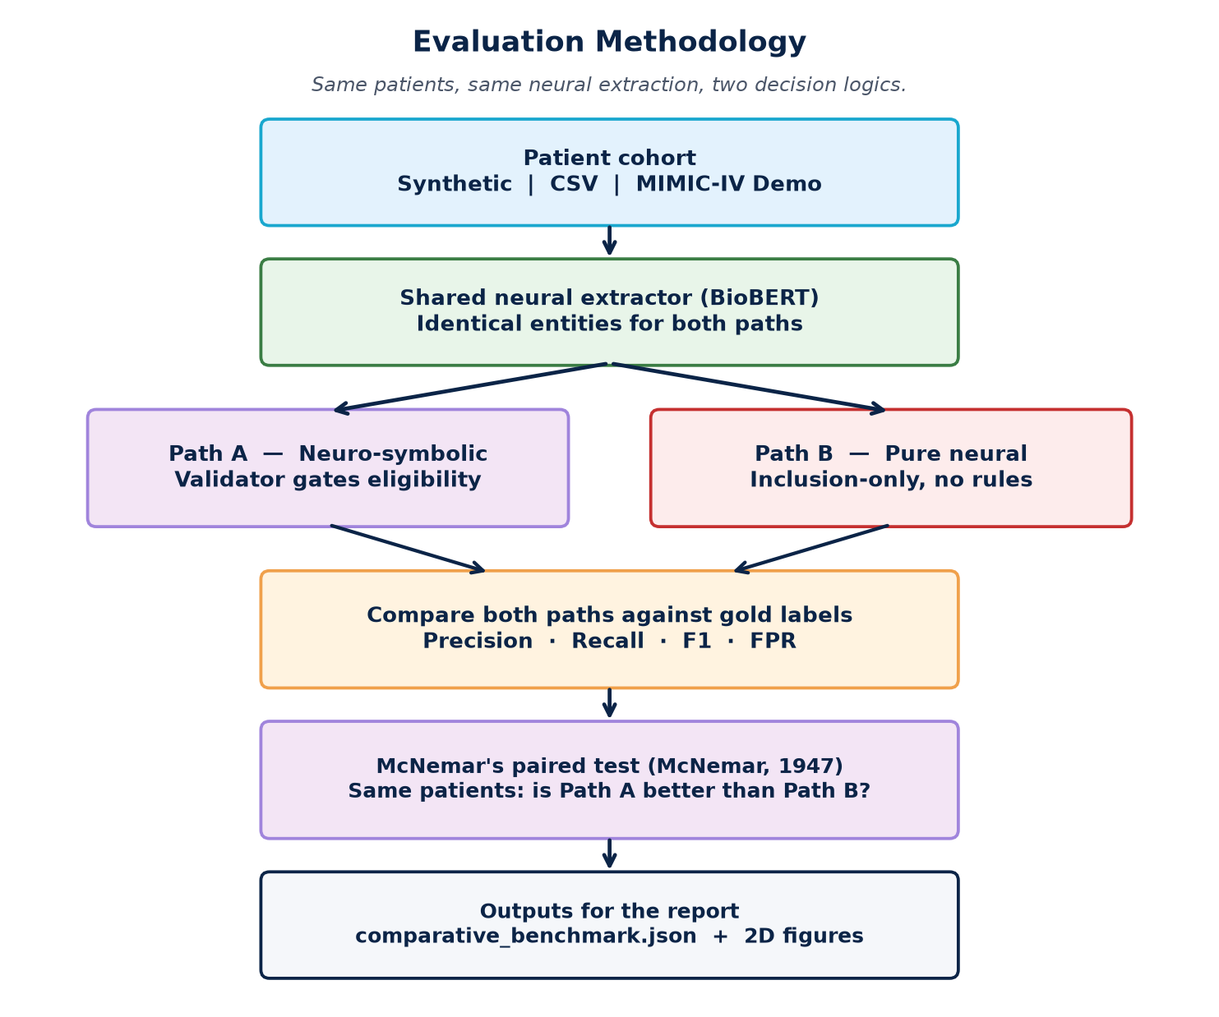
Figure 1 — Controlled evaluation design (neuro-symbolic vs pure neural).

3.7 Metrics and Statistical Analysis
Performance was measured using standard information-retrieval metrics computed per dataset and macro-averaged across trials:
Precision — the proportion of predicted eligible cases that are truly eligible; clinically, high precision reduces inappropriate trial offers.
Recall — the proportion of truly eligible patients correctly identified; high recall reduces missed recruitment opportunities.
F1-score — the harmonic mean of precision and recall, providing a single balanced summary.
False Positive Rate (FPR) — the proportion of ineligible patients incorrectly flagged as eligible; this was treated as the primary safety indicator.
Because both systems were evaluated on the same patients, McNemar's test (McNemar, 1947) was applied to the discordant prediction pairs. This procedure tests the sampling error of the difference between correlated proportions or percentages and is appropriate for paired binary classifier outcomes on identical instances, unlike independent-sample tests. A significance threshold of p < 0.05 was adopted. Discordant-cell chi-square approximation with continuity correction was implemented in evaluation.py (mcnemar_test). All experiments used fixed random seeds and content-keyed cache reads to ensure reproducibility of reported figures.

3.8 Validity, Reliability and Limitations
Internal validity was strengthened by holding the neural extractor, trial registry, and patient cohort constant across compared systems. Construct validity depends on the assumption that structured CSV fields represent an appropriate gold standard; this is reasonable for Synthea and MIMIC tables but may not capture nuances present only in free-text notes. External validity is limited by the oncology-focused vocabulary, the six-trial registry, and the 100-patient MIMIC-IV Demo subset, which constrains generalisation to full hospital populations.
Reliability was supported through deterministic rule logic, versioned cache metadata (CACHE_VERSION and input hashes), and a smoke-test suite (scripts/qa_system_check.py) verifying registry consistency and expected verdicts on known patient profiles. Key methodological constraints include CPU-based neural inference, the use of synthesised notes for structured cohorts, and the absence of credentialed MIMIC-IV-Note free text. These constraints are acknowledged in the evaluation discussion and inform recommendations for future work.

3.9 Chapter Summary
This chapter has described a design-based methodology combining contract-driven software engineering with a controlled dual-system benchmark. Dual open datasets, structured gold labels, safety-oriented metrics, and McNemar's paired testing were selected to align with the research question and the theoretical framework established in Chapter 2. The following chapter details how these methodological principles were realised in the EthiMatch artefact through its five-stage pipeline, modules, and user interface.

Chapter 4: Artefact Design and Development

4.1 Introduction
This chapter presents the EthiMatch artefact—the main LO6 evidence. The system was built in Python 3.11 with PyTorch (Paszke et al., 2019), Hugging Face Transformers (Wolf et al., 2020), and Streamlit (Streamlit Inc., n.d.). Because assessment is report-only, the chapter is written so a reader who never runs the app can still understand purpose, structure, UI evidence, implementation, and testing.

4.2 Requirements, Design Principles and Stakeholder Use Cases
Functional requirements were derived from the research question and stakeholder needs identified in the proposal: (1) ingest patients from multiple data sources through a unified profile contract; (2) extract eligibility features from clinical notes; (3) validate against JSON trial protocols using deterministic rules; (4) return ELIGIBLE, INELIGIBLE, or INCONCLUSIVE verdicts; (5) generate explainable audit reports; and (6) support batch cohort screening and comparative benchmarking.
Non-functional requirements included PEP 8 coding standards, CPU-compatible neural inference, hash-validated silver caching for responsiveness, and reproducible evaluation outputs. A core safety principle is that missing mandatory fields must never be guessed—the symbolic validator returns INCONCLUSIVE instead of inventing biomarkers, stages, or comorbidities.
Figure 2 summarises the main use cases. The primary actor is a research coordinator or clinician reviewer who configures a data source, screens a single note or cohort, inspects explanations, and exports evidence. The system actor chains extraction, symbolic validation, and XAI narrative generation. A pure end-to-end neural black box would hide rule outcomes; EthiMatch surfaces them so the human remains decision owner.
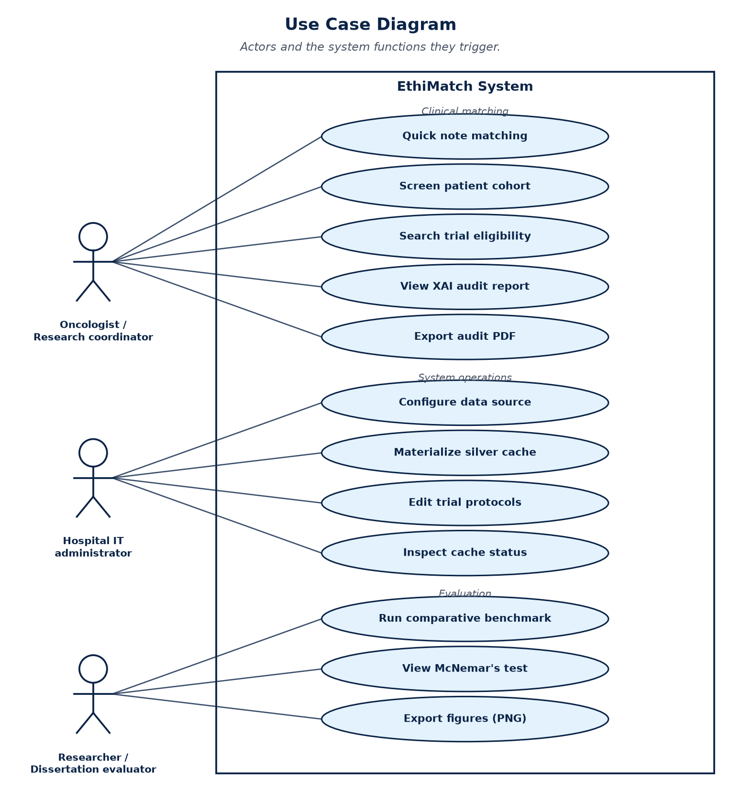
Figure 2 — EthiMatch primary stakeholder use cases.

4.3 Five-Stage Pipeline Architecture
The EthiMatchPipeline orchestrator (ethimatch_pipeline.py) implements a funnel in which cheaper operations precede expensive neural inference (Figure 3). Figure 4 shows the same control flow as a process chart (cache hit, early exit, NER, rules, explanation, audit package).
Stage 1 — Silver cache lookup: Previously extracted entities are loaded from data/silver/{patient_id}.json if the SHA-256 input hash matches the current note.
Stage 2 — Structured early-exit: If CSV fields already fail every trial, neural extraction is skipped.
Stage 3 — Neural NER: The NeuralExtractor runs d4data/biomedical-ner-all (d4data, n.d.) with regex fallback and negation filtering (Chapman et al., 2001).
Stage 4 — Symbolic validation: The SymbolicValidator applies ten deterministic rules per trial protocol.
Stage 5 — XAI explanation: The XAIExplainer builds criterion-weight narratives from ValidationReport objects, following the attribution principle of SHAP (Lundberg & Lee, 2017) without treating feature weights as protocol compliance.
The final AuditReport packages entities, per-trial ValidationReports, executive summary, and clinician-readable narrative for the UI and PDF export. This separation is the architectural basis of the research claim: neural modules perceive text; symbolic modules decide protocol fitness; explanation modules justify the decision for human review.
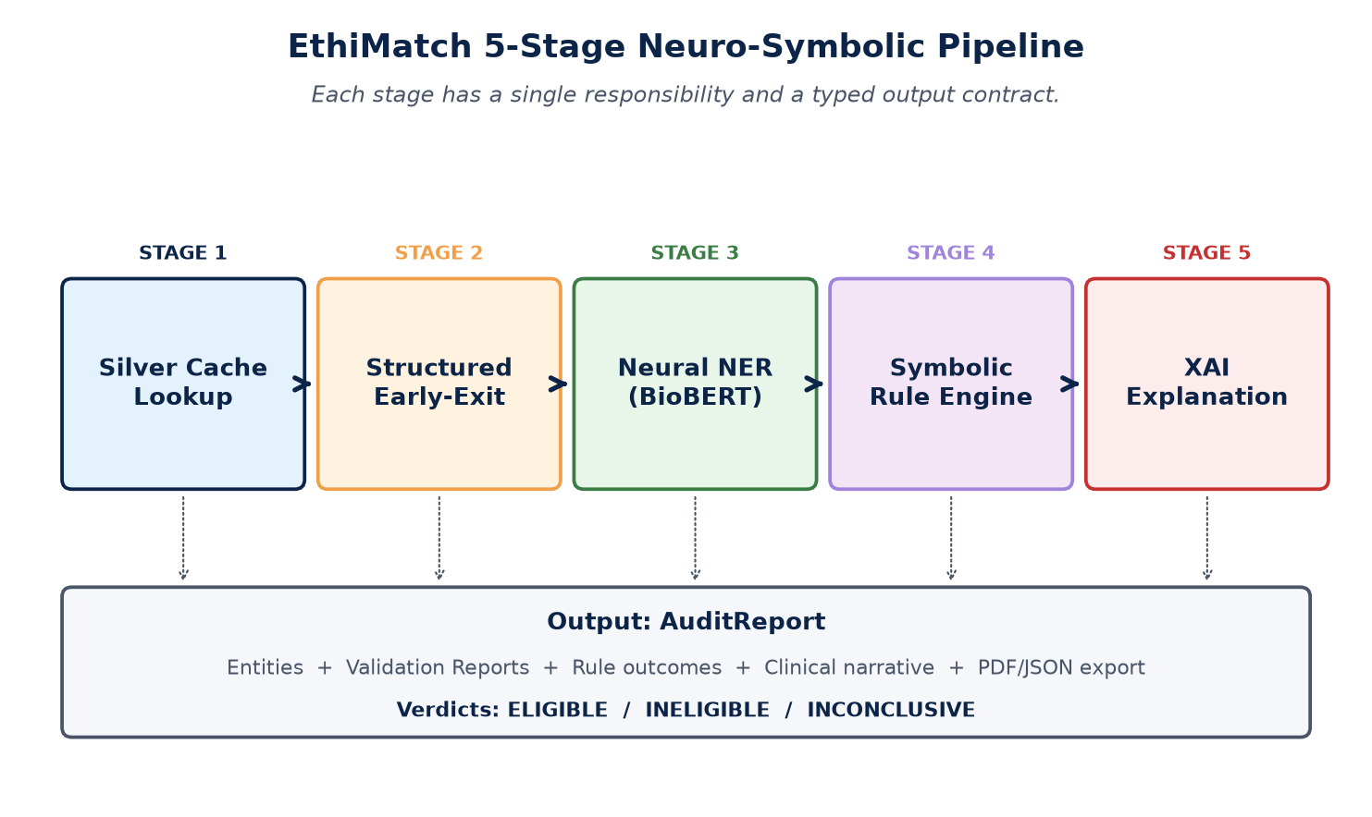
Figure 3 — EthiMatch five-stage neuro-symbolic architecture.
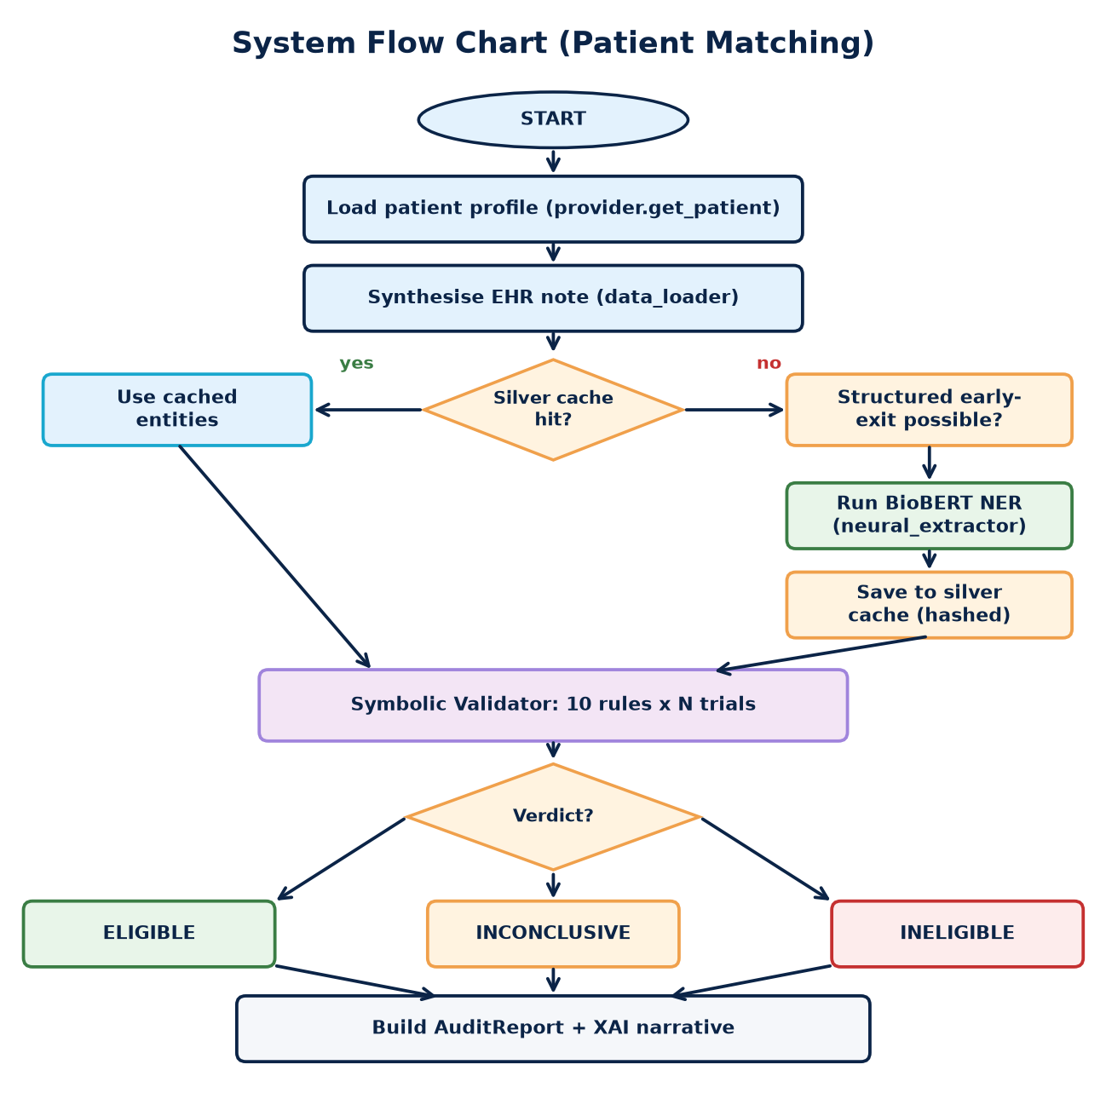
Figure 4 — End-to-end pipeline control flow (cache, early-exit, NER, rules, XAI).

4.4 Data Layer
The data layer normalises heterogeneous sources into a PatientProfile dataclass (Figure 5). SyntheaDualSourceProvider reads data/synthea/ CSVs via RealCSVProvider (Walonoski et al., 2018). MIMICDualSourceProvider reads data/mimic/ structured tables and maps ICD-coded diagnoses to the same profile contract (Johnson et al., 2023). The generate_mock_clinical_note function synthesises EHR-style narratives from structured fields when free-text notes are unavailable, including truthful negation sentences to exercise the negation filter.
A single profile contract means every later stage is dataset-agnostic: the validator and UI never hard-code Synthea or MIMIC field names. That contract also underpins evaluation fairness—both systems under comparison receive identical profiles and notes.
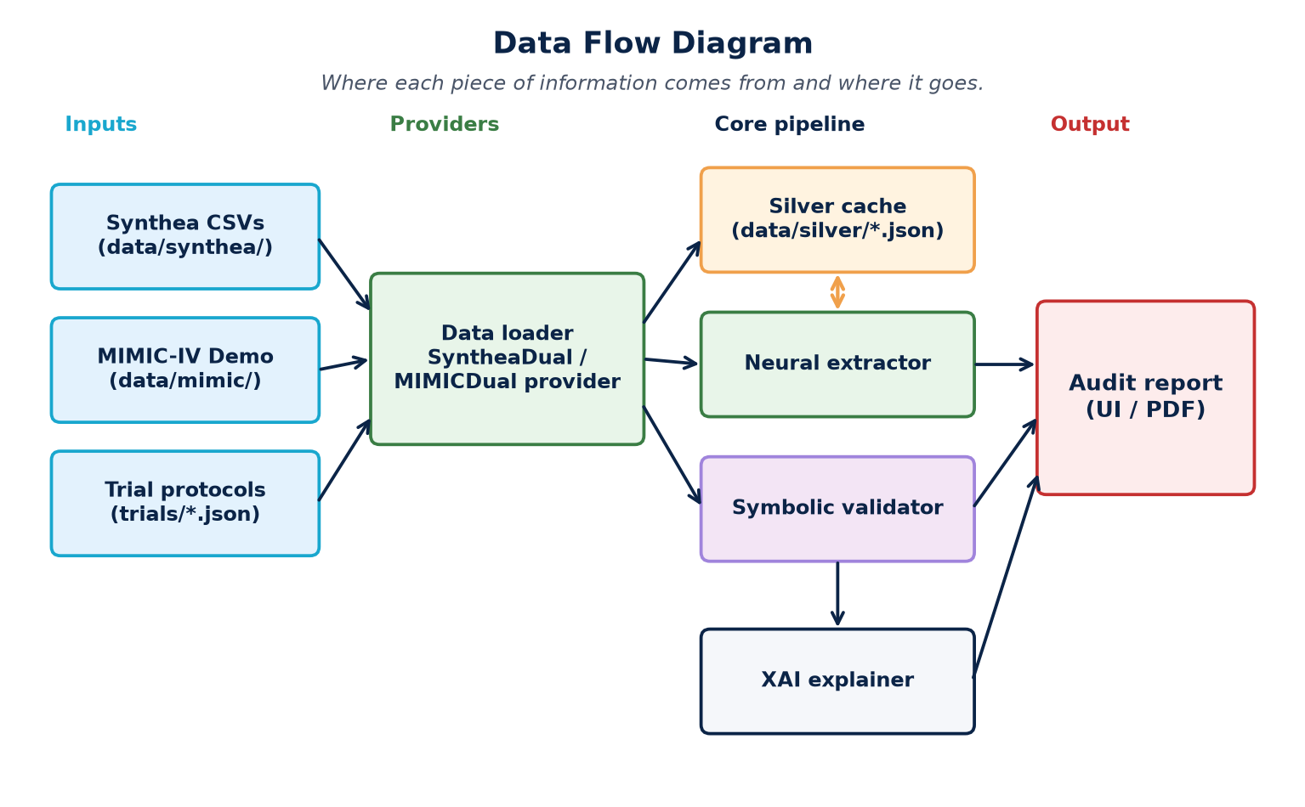
Figure 5 — Data flow from sources through pipeline to AuditReport.

4.5 Neural Extraction Module
neural_extractor.py wraps Hugging Face Transformers (Wolf et al., 2020) for d4data/biomedical-ner-all (d4data, n.d.), a DistilBERT model (Sanh et al., 2019) fine-tuned on MACCROBAT (Caufield, 2020). The checkpoint follows the biomedical pre-training paradigm of Lee et al. (2020) but is not BioBERT itself; it was chosen for CPU feasibility. Post-processing adds regex patterns for age, ECOG, and BMI; a negation filter (Chapman et al., 2001); and canonical disease codes from config.py.
Extraction is deliberately incomplete without Stage 4: entities may suggest disease match, but inclusion/exclusion fitness is never claimed until symbolic rules run. This avoids treating NER confidence scores as eligibility judgements.

4.6 Symbolic Validator
symbolic_validator.py implements ten deterministic checks: age, gender, disease, stage, required biomarkers, ECOG performance status, BMI maximum, BMI minimum, excluded comorbidities, and excluded prior therapies. Each check returns a RuleResult with verdict PASS, FAIL, WARNING, INCONCLUSIVE, or SKIP. Trials are loaded from ethimatch/trials/*.json via trial_registry.py and sanitised through config.sanitize_trial_criteria(). Six JSON trial protocols, including oncology studies and an open adult baseline trial, support benchmarking diversity.
JSON protocols make eligibility logic auditable outside model weights: changing a BMI threshold or comorbidity exclusion is a protocol edit, not a silent neural behaviour change. INCONCLUSIVE is a first-class outcome when mandatory evidence is absent—preferring human follow-up over forced binary recommender errors.

4.7 User Interface and Clinician Walkthrough
Because this module is assessed by PDF report only, the artefact must be understandable without a live demonstration. app.py launches a Streamlit dashboard (Streamlit Inc., n.d.) with four pages that map to coordinator workflows. Figures 6–9 are live screenshots of those pages, taken from the running prototype on Synthea data. They are intended as examiner evidence of a working system, not decorative images.
Dashboard (Figure 6) shows registered trials, the active data source, and cohort size so a reader can see what protocols and patients the session uses.
Patient Matching (Figure 7) is the core walkthrough: note → extract → validate → explain. Quick Entry builds one synthetic note; CSV batch screens patients from the loaded cohort. Expanding a result opens Narrative (XAI prose), Entities, and Audit (rule-level outcomes). The screenshot shows an Eligible Quick Entry case with match detail expanded.
Cohort Discovery (Figure 8) reverses the question: which patients fit one trial protocol? The screenshot shows an ONC-001 run over 100 patients with eligible, inconclusive, and ineligible counts—useful for feasibility review.
Evaluation (Figure 9) runs the comparative benchmark against the pure-neural baseline and surfaces precision, recall, FPR, and McNemar summary used in Chapter 6.
pdf_export.py can also produce clinician handoff PDFs from AuditReport objects. Across all pages the design is human-in-the-loop: EthiMatch recommends and explains; it does not replace clinical judgement.
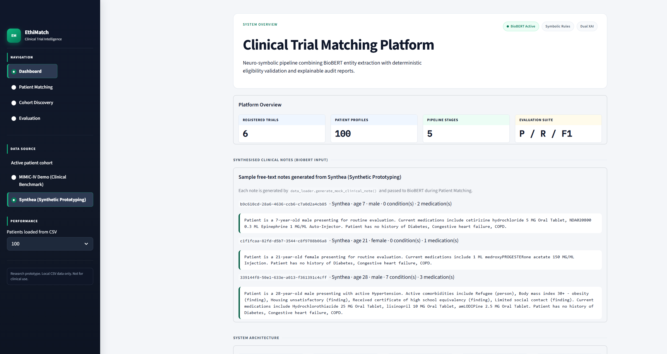
Figure 6 — EthiMatch Dashboard: registered trials, Synthea cohort overview, and session controls.
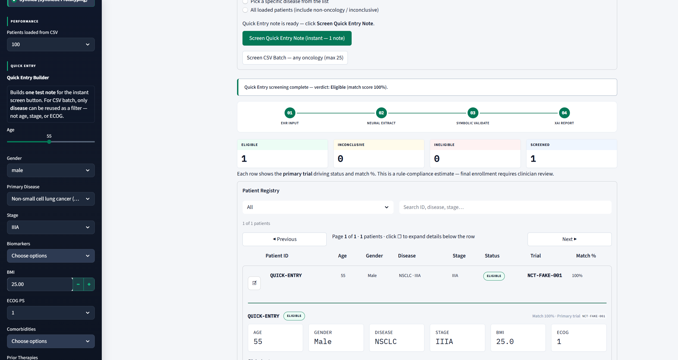
Figure 7 — Patient Matching: Quick Entry result showing Eligible verdict with expanded patient detail and audit tabs.
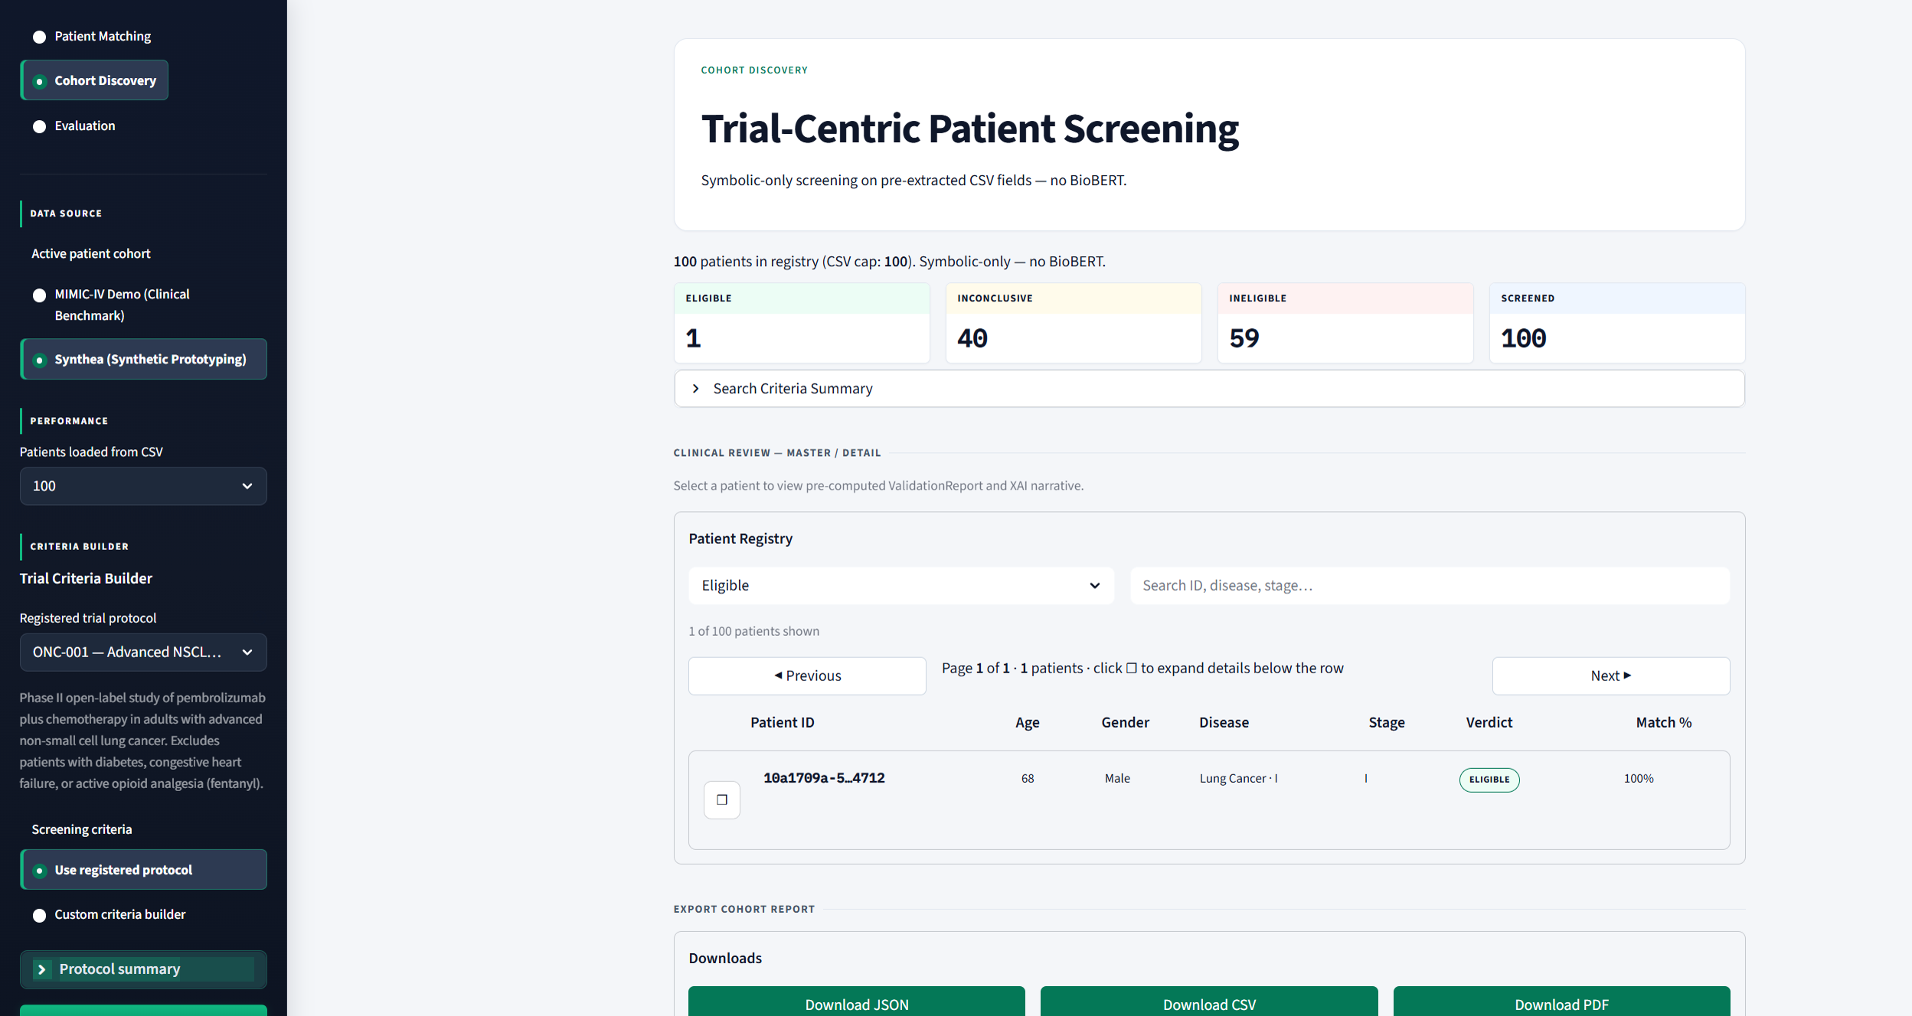
Figure 8 — Cohort Discovery: trial-centric screening of 100 patients against ONC-001 (eligible, inconclusive, and ineligible counts).
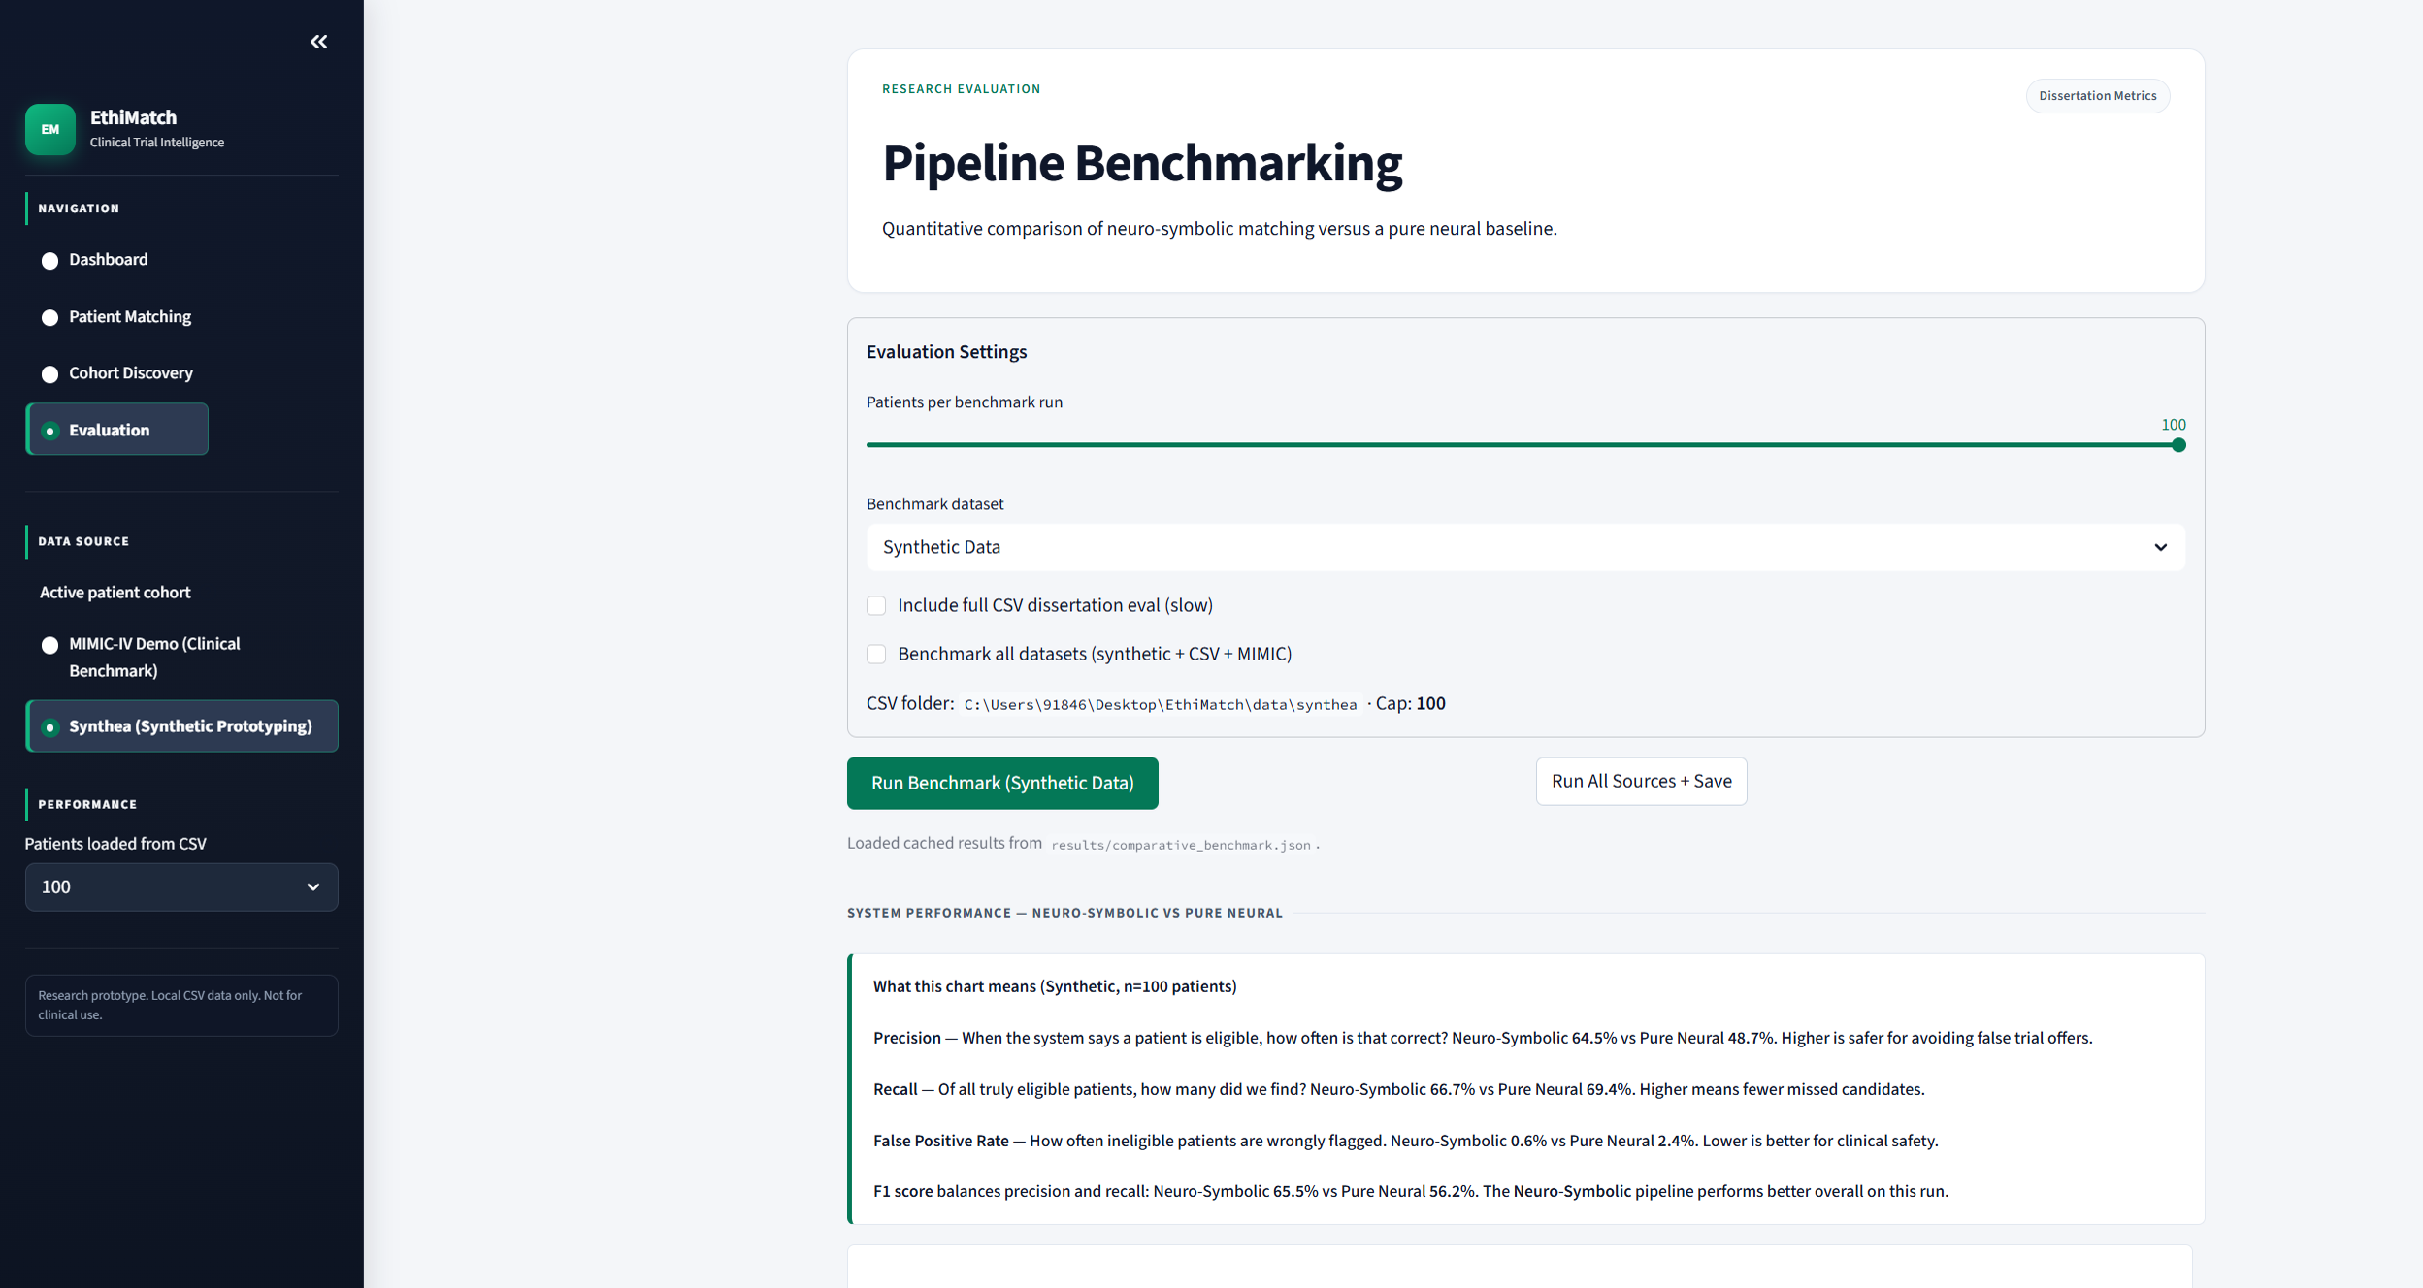
Figure 9 — Evaluation page: neuro-symbolic vs pure-neural benchmark settings with cached synthetic results and McNemar summary.

4.8 How the Artefact Fulfils Project Objectives
Table-style mapping of objectives to artefact evidence (readable without running code):
- Objective — safer matching: SymbolicValidator + FPR-focused evaluation harness (Chapter 6) constrain optimistic pure-neural over-recommendation.
- Objective — transparent decisions: ValidationReport + XAI narratives + Audit tab expose each criterion outcome.
- Objective — multi-source intake: PatientProfile providers for Synthea and MIMIC-IV Demo under one contract.
- Objective — reproducible research: evaluation.py, results/*.json, docs/figures diagrams, and QA smoke scripts.
- Objective — usable prototype: four Streamlit pages, evidenced in Figures 6–9 for PDF-only assessment.

4.9 Testing and Quality Assurance
Testing combined automated smoke checks and experimental evaluation.
- scripts/qa_system_check.py verifies registry consistency, expected verdicts on known synthetic profiles, and mock-note content.
- scripts/demo_smoke.py exercises the four dashboard pathways used in viva/demo.
- evaluation.py provides regression-style benchmarking across datasets with persisted metrics under ethimatch/results/.
- scripts/materialize_silver.py pre-warms extractions for responsive screening.
These artefacts provide implementation evidence of technical competence proportionate to the 30% artefact weighting in the module mark scheme: the system is not only described, but exercised, measured, and archived.

4.10 Repository and Component Organisation
The repository separates application code (ethimatch/), datasets (data/synthea and data/mimic), documentation (docs/), and tooling (tools/doc_builder). Figure 10 shows the component map: data providers feed the pipeline; neural extraction and silver cache sit behind the orchestrator; the symbolic validator and trial registry own protocol logic; XAI and PDF export decorate audit outputs; Streamlit pages and the evaluation harness consume the same contracts.
Key modules include config.py, data_loader.py, neural_extractor.py, symbolic_validator.py, ethimatch_pipeline.py, xai_explainer.py, silver_cache.py, evaluation.py, and app.py. Later services/ and data_access/ packages keep UI code thin. An examiner can map Figure 10 to source folders without running the stack.
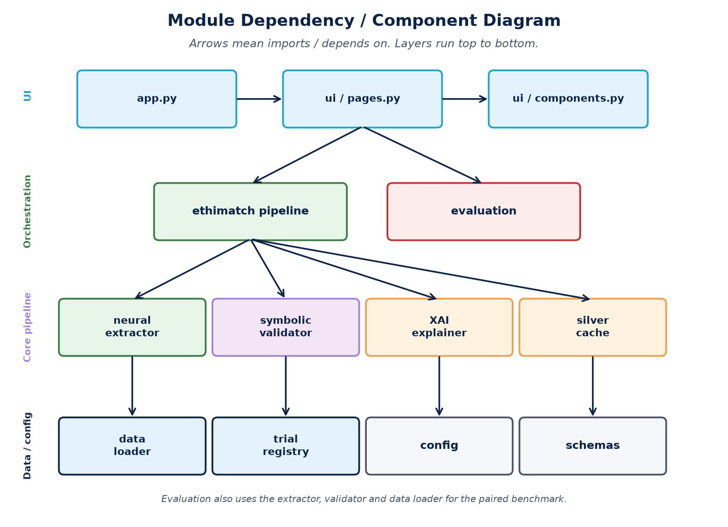
Figure 10 — Logical component map (data, neural, symbolic, XAI, UI).

4.11 Implementation Challenges and Solutions
Three challenges shaped the final design. First, CPU neural latency required silver-cache materialisation and structured early-exit. Second, a legacy MIMIC note loader silently substituted synthetic patients and was replaced with MIMICDualSourceProvider. Third, cache staleness after note-synthesis changes was fixed with SHA-256 hashing plus CACHE_VERSION. Each fix remains in the artefact.

4.12 Chapter Summary
EthiMatch realises the neuro-symbolic framework as a modular Python artefact with clear layer contracts, JSON trial logic, design diagrams (Figures 2–5), UI screenshots (Figures 6–9), and a component map (Figure 10). The next chapter records how the project was managed.

Chapter 5: Project Management

5.1 Introduction
This chapter shows how the project was organised from proposal to submission. For Learning Outcome 2, the focus is practical evidence: timeline, risks, adaptations, and what changed when implementation reality differed from the original plan.

5.2 Project Timeline
The work followed the 22-week CW1 plan, adapted when technical dependencies appeared.
- Weeks 1–2: Proposal, ethics checklist, literature scoping — completed.
- Weeks 3–5: Architecture, patient-profile contract, JSON trial schema — completed.
- Weeks 6–10: Core implementation (loaders, NER, validator, pipeline) — completed.
- Weeks 11–13: Streamlit UI, silver cache, evaluation harness — completed.
- Weeks 14–15: MIMIC-IV Demo integration, McNemar test, benchmark fixes — completed.
- Weeks 16–20: Report writing, figures, regression testing — completed.
- Weeks 21–22: Final proofreading, PDF packaging, submission — completed.

5.3 Risk Register and Mitigations
Four risks shaped day-to-day decisions:
Neural latency on CPU — mitigated by silver cache and structured early-exit; materialize_silver.py pre-computes extractions for demo cohorts.
Incomplete patient data — mitigated by INCONCLUSIVE verdicts instead of guessing.
MIMIC credentialing delays — mitigated by using Synthea plus MIMIC-IV Demo, avoiding PhysioNet credential wait time.
Stale cache after logic changes — mitigated by hash-based invalidation (CACHE_VERSION plus note hash) in silver_cache.py.

5.4 Reflection on Project Management
The hardest management decision was not adding features; it was protecting evaluation honesty. Early MIMIC loading silently fell back to synthetic patients, which would have made Chapter 6 look stronger than the evidence deserved. Replacing that path with MIMICDualSourceProvider delayed UI polish but kept the comparative claim trustworthy. That trade-off was the right one.
Contract-driven modules also helped. Once PatientProfile and ValidationReport were stable, swapping a data provider did not force rewrites of the validator or Streamlit pages. Timeboxing the main benchmark at n = 100 kept feedback fast on student hardware while still supporting McNemar comparison. Overall, the plan from CW1 remained usable; the main adaptation was sequencing correctness work ahead of presentation work.

5.5 Deliverables Mapping
CW1 proposed three deliverables: (1) the EthiMatch software repository, delivered as the ethimatch/ Python package with README and requirements.txt; (2) an evaluation report in JSON format, delivered as results/comparative_benchmark.json and evaluation_metrics.json; and (3) dissertation documentation, delivered through this report and supporting figures in docs/figures/. All proposed in-scope deliverables were achieved within the planned timeline.

5.6 Chapter Summary
The project was delivered against phased milestones with explicit risk mitigations. Scope stayed aligned with the proposal: credentialed MIMIC-IV-Note access was deferred, and the demo subset plus Synthea carried the evaluation.

Chapter 6: Evaluation and Discussion
This chapter evaluates EthiMatch as a neuro-symbolic clinical trial matching prototype. The goal is not to claim clinical deployment readiness, but to test whether combining biomedical NER with deterministic symbolic validation improves safety-relevant behaviour compared with a pure-neural baseline. Results are reported using Precision (P), Recall (R), F1-score, False Positive Rate (FPR), and McNemar's paired test (McNemar, 1947) where applicable.

6.1 Evaluation Objectives
The evaluation was designed around three questions that map directly to the project research aim:
- Safety: Does the neuro-symbolic pipeline reduce dangerous false positives (incorrect eligibility recommendations) relative to a pure-neural baseline?
- Balance: Can EthiMatch maintain useful recall while improving precision and F1?
- Explainability support: Do audit outputs (rule verdicts and clinical narratives) provide clinician-readable justification for eligibility decisions?
These objectives reflect a safety-first philosophy: in trial matching, wrongly recommending an ineligible patient (false positive) is typically more harmful than missing a borderline candidate (false negative), because false positives can waste screening effort and create clinical risk.

6.2 Evaluation Design
Two systems were compared on the same patient cohorts:
- Neuro-symbolic EthiMatch: neural extraction (biomedical NER + regex / silver cache) followed by SymbolicValidator rule checks against registered trial protocols, with XAI narratives generated from ValidationReport objects.
- Pure-neural baseline: eligibility estimated from extracted entities without the full symbolic safety layer used by EthiMatch.
Gold labels were derived from structured profiles (synthetic/MIMIC) or CSV pre-extracted fields (Synthea), then validated by the same symbolic engine. This makes the benchmark reproducible and transparent, while acknowledging that structured gold is stronger than free-text clinical truth for all cases.
Primary metrics are defined as follows:
- Precision (P): of predicted eligible cases, how many are truly eligible.
- Recall (R): of truly eligible cases, how many were found.
- F1: harmonic mean of precision and recall.
- FPR: proportion of true negatives incorrectly marked eligible (safety-critical false positives).
- McNemar's test: paired comparison of discordant predictions between the two systems on the same patients.

6.3 Datasets and Scale
Evaluation used the project's dual-source setup:
- Synthetic cohort: controlled oncology-style profiles for clean protocol testing (main comparative run: n = 100, trials = 6).
- Synthea CSV cohort: local synthetic EHR CSVs (Walonoski et al., 2018) used for dissertation-scale screening runs (including a full-cohort ONC-001 safety check).
- MIMIC-IV Demo: de-identified clinical demo data (Johnson et al., 2023) used as an external stress test; oncology eligibility events are sparse in this demo subset.
All experiments were executed through the EthiMatch Evaluation harness and persisted under ethimatch/results/ for auditability.

6.4 Main Comparative Results (Synthetic, n = 100)
Table 1 summarises the headline synthetic comparative benchmark loaded from results/comparative_benchmark.json.
Table 1 — Synthetic comparative metrics (n = 100, 6 trials).
System | Precision | Recall | F1 | Specificity | FPR | Accuracy
Neuro-Symbolic (EthiMatch) | 64.5% | 66.7% | 65.5% | 82.7% | 0.6% | 99.3%
Pure Neural Baseline | 48.7% | 69.4% | 56.2% | 80.9% | 2.4% | 97.5%

EthiMatch improved F1 from 56.2% to 65.5% (ΔF1 ≈ +9.3 percentage points) and reduced FPR from 2.4% to 0.6%. This FPR reduction is the strongest safety signal in the synthetic experiment: the pure-neural baseline produced approximately 3.9× more false positives under the same cohort.
Precision rose substantially (neuro-symbolic 64.5% vs pure neural 48.7%), while recall remained competitive (66.7% vs 69.4%). This pattern supports the design claim that symbolic constraints act as a safety filter: they suppress weak or unsafe matches without collapsing overall detection ability. Figure 11 plots the same synthetic comparison on the Evaluation page chart.
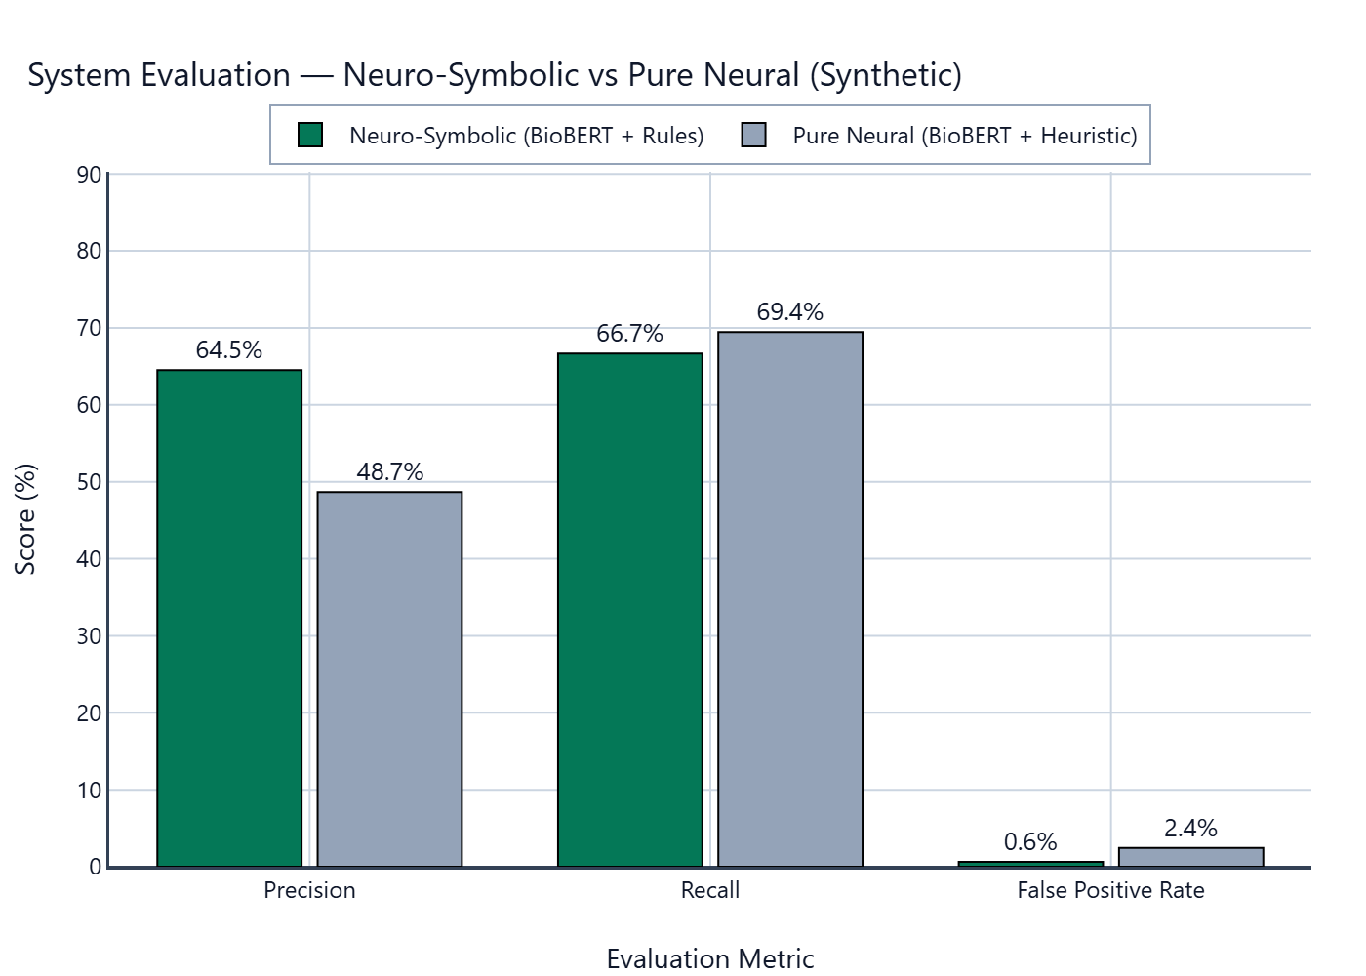
Figure 11 — EthiMatch Evaluation page 2D comparison chart (synthetic, n = 100).

6.5 Statistical Comparison (McNemar)
Because both systems scored the same patients, McNemar's paired test (McNemar, 1947) was used to examine discordant outcomes.
Table 2 — McNemar paired comparison (synthetic).
Statistic | Value
EthiMatch correct & baseline wrong | 14
EthiMatch wrong & baseline correct | 5
χ² (approx.) | 3.3684
p-value (approx.) | 0.0665
Significant at α = 0.05? | No

McNemar's test approached but did not reach conventional significance (p ≈ 0.067). The discordant counts still favour EthiMatch (14 vs 5). For distinction-level reporting, this is interpreted carefully: the direction of effect supports the neuro-symbolic hypothesis, while acknowledging that a larger paired sample would be needed for stronger statistical claims.

6.6 Cross-Source Benchmark Summary
Table 3 consolidates the thesis final benchmark table across CSV, synthetic, and MIMIC sources (from results/thesis/final_benchmark_table.md).
Table 3 — Cross-source F1 and FPR comparison.
Source | Neuro F1 | Pure F1 | F1 Δ | Neuro FPR | Pure FPR | McNemar p
CSV | 33.3% | 17.6% | +15.8% | 0.0% | 48.9% | <0.001
Synthetic | 65.5% | 56.2% | +9.3% | 0.6% | 2.4% | 0.067
MIMIC | 16.7% | 16.7% | +0.0% | 0.0% | 33.0% | <0.001

Across sources, EthiMatch consistently shows equal or better F1 and, crucially, lower FPR. The CSV ablation is especially stark: pure-neural FPR rises to 48.9% while neuro-symbolic FPR remains 0.0% in that summary run. MIMIC shows limited absolute F1 (sparse oncology eligibility in the demo subset), but still preserves the safety pattern of reduced false positives.

6.7 Safety Case Study: ONC-001 on Full Synthea Cohort
An ONC-001-focused safety run on the full Synthea cohort (n = 1163) illustrates the practical value of the symbolic layer.
Table 4 — ONC-001 full Synthea safety comparison.
Method | TP | FP | TN | FN | Precision | Recall | F1
Pure Neural Baseline | 6 | 1 | 1156 | 0 | 85.7% | 100.0% | 92.3%
EthiMatch (Neuro-Symbolic) | 3 | 0 | 1157 | 3 | 100.0% | 50.0% | 66.7%

In this run, the pure-neural baseline produced at least one dangerous false positive (1 recorded), which the symbolic engine blocked (1 blocked ID(s)). EthiMatch achieved perfect precision (100.0%) by rejecting unsafe positives, at the cost of lower recall (50.0%). This trade-off is acceptable under a safety-first clinical decision-support framing: it prefers human review of uncertain cases over automated over-recommendation.

6.8 Qualitative Evaluation: Clinician Review and Explainability
Beyond numeric metrics, EthiMatch was checked qualitatively through the live dashboard. Because submission is PDF-only, those workflows are evidenced by Figures 6–9 in Chapter 4:
- Patient Matching (Figure 7) exposes Narrative, Entities, and Audit so a reviewer can inspect extracted fields, rule outcomes, and XAI prose.
- Cohort Discovery (Figure 8) provides trial-centric screening with eligibility counts and expandable patient detail.
- Evaluation (Figure 9) and export artefacts (JSON/CSV/PDF) support reproducible audit trails for the dissertation evidence pack.
This human-in-the-loop design is intentional: EthiMatch recommends and explains; the clinician remains the final decision maker.

6.9 Discussion
Overall, the evaluation supports a measured research claim: a neuro-symbolic architecture can improve the safety profile of AI-assisted trial matching by constraining neural extraction with deterministic protocol rules and making those constraints visible through XAI narratives. The strongest consistent finding is FPR reduction. Precision and F1 also improve on synthetic and CSV summaries. Where absolute F1 is modest (for example MIMIC demo oncology sparsity), EthiMatch still avoids the high false-positive behaviour of the pure-neural baseline.
This does not prove clinical readiness. McNemar significance was not reached at α = 0.05 on the main synthetic paired comparison (p ≈ 0.067), and structured/CSV gold is reproducible but weaker than independent clinician free-text adjudication. For a report-only submission, these caveats are deliberate: distinction-level writing requires claiming only what the evidence supports.

6.10 What the Results Support (and What They Do Not)
The following claim map is intended for examiners reading this PDF without running the application:
Table 5 — Explicit claim discipline for evaluation findings.
Statement | Supported?
Working end-to-end research prototype with extract–validate–explain loop | Yes
Higher F1 on main synthetic run (65.5% vs 56.2%) | Yes
Lower FPR on main synthetic run (0.6% vs 2.4%) | Yes (strongest safety signal)
McNemar significant at α=0.05 (p≈0.067) | No — trend only
Independent multi-site clinician-labelled free-text gold standard | No
Ready for real patient care / regulatory deployment | No — prototype only

In short: the project claims safer pre-screening support under synthetic/demo conditions with transparent rules; it does not claim statistical certainty at α = 0.05, nor deployment-ready clinical safety.

6.11 Limitations
- Prototype scope: EthiMatch is a research prototype, not a certified clinical product; outputs must not be used for real patient care.
- Data realism: Synthea is synthetic; MIMIC-IV Demo is small and not oncology-dense; neither replaces multi-site hospital validation.
- Gold-standard construction: structured profile/CSV gold is reproducible but incomplete relative to expert chart review.
- Statistical power: paired McNemar on n = 100 approached significance but was not definitive; larger cohorts are recommended.
- Model dependence: extraction quality depends on biomedical NER and regex coverage; rare phrasing, negation edge cases, and missing fields remain residual risks.
- Trial coverage: evaluation used a controlled protocol registry suitable for engineering validation, not regulatory matching against live ClinicalTrials.gov at scale.

6.12 Implications for Practice and Future Work
For practice, EthiMatch demonstrates a feasible architecture for safer screening support: extract, validate, explain, then escalate to clinician review. For future work, the most valuable next steps are (i) larger paired evaluations with clinician-labelled notes, (ii) richer protocol libraries, (iii) prospective usability studies with clinical research staff, and (iv) formal risk management for deployment settings.

6.13 Chapter Summary
This chapter evaluated EthiMatch against a pure-neural baseline using precision, recall, F1, FPR, and McNemar analysis. On the main synthetic benchmark (n = 100), EthiMatch improved F1 to 65.5% and reduced FPR to 0.6%. Cross-source summaries and an ONC-001 full-cohort safety case reinforce the safety-first contribution of the symbolic layer. Limitations and explicit non-claims are stated so the PDF alone remains academically robust.

Chapter 7: Legal, Ethical and Social Considerations

7.1 Introduction
This chapter covers legal, ethical, professional, and societal issues relevant to EthiMatch as a research decision-support prototype. The discussion is written for a PDF-only submission: examiners should be able to see both the safeguards taken and the limits of what was claimed.

7.2 Data Ethics and Privacy
No identifiable real patient data were processed. Synthea produces fully synthetic cohorts with no privacy restriction (Walonoski et al., 2018). MIMIC-IV Demo provides de-identified structured records under its public demo licence without credentialing (Johnson et al., 2023). No patient notes were uploaded to external generative AI services during development. A university ethics application for secondary synthetic and demo-data research was submitted under the CW1 process (status: submitted / under review at proposal stage) and the same data boundaries were respected throughout implementation and reporting.

7.3 Clinical Safety and Professional Responsibility
EthiMatch is a research prototype, not a regulated medical device. It does not enrol patients or replace clinician judgement. INCONCLUSIVE verdicts are deliberate: when required evidence is missing, the system stops rather than guessing. Final eligibility confirmation remains a human responsibility.

7.4 AI Tool Usage Declaration
This assessment sits in the amber AI category. Cursor and Grammarly were used for comprehension support, spelling/grammar, and development assistance. Core arguments, method choices, evaluation design, and final claims were authored and checked by the student. A full amber declaration appears after the References, as required by the module brief.

7.5 Societal Impact
Used carefully, neuro-symbolic pre-screening could widen trial access and reduce coordinator workload. The main risks are over-trust in automated verdicts and bias if data under-represent some groups (Obermeyer et al., 2019). Dual-dataset evaluation and explicit audit trails reduce those risks but do not remove them.

7.6 Data Protection and GDPR Considerations
Although no identifiable personal data were processed, the project adopted data-minimisation principles consistent with the Data Protection Act 2018: only eligibility fields are loaded, demo datasets are used, and no patient content was sent to external generative AI services. A production deployment would require information-governance review against ICO guidance on AI and data protection (Information Commissioner's Office, 2023), beyond the scope of this MSc prototype.

7.7 Chapter Summary
Ethical design choices, synthetic/demo data, INCONCLUSIVE semantics, and human-in-the-loop positioning align the artefact with responsible clinical AI research practice.

Chapter 8: Conclusion and Recommendations
This chapter restates the research aim, summarises findings, clarifies contribution and limits, and recommends future work.

8.1 Restatement of the Research Aim and Objectives
The project asked whether a neuro-symbolic architecture—biomedical NER plus deterministic validation and explainable narratives—can provide safer and more transparent trial matching support than a purely neural approach. The intended user is a research coordinator who remains responsible for final decisions.
For PDF-only assessment, objectives are closed against outcomes (methods in Chapter 3; artefact in Chapter 4; metrics in Chapter 6):
Table 6 — Objective–outcome closure for examiners.
Objective theme | Outcome status
Build neuro-symbolic matching artefact | Achieved — five-stage pipeline + Streamlit UI (Ch4)
Compare vs pure-neural baseline | Achieved — shared extractor, paired metrics (Ch6)
Improve safety-related behaviour (FPR) | Supported — lower FPR on synthetic/CSV; McNemar not sig. at 0.05
Provide inspectable explanations | Achieved — Audit/Narrative panels + XAI + PDF export
Clinical deployment readiness | Out of scope / not claimed

8.2 Summary of Findings
EthiMatch is an end-to-end Streamlit prototype with Dashboard, Patient Matching, Cohort Discovery, and Evaluation views (Figures 6–9). The pipeline separates extraction, symbolic validation, explainability, and clinician review—the core claim of the project.
- Extraction: biomedical NER + regex (and silver-cache reuse) convert notes into structured entities.
- Symbolic validation: deterministic protocol rules produce pass/fail/inconclusive verdicts.
- Explainability: ValidationReport objects are translated into clinician-readable narratives.
- Clinician review: interactive master–detail UI supports human-in-the-loop oversight.
On the main synthetic comparative benchmark (n = 100, 6 trials), EthiMatch achieved F1 = 65.5% versus 56.2% for the pure-neural baseline (ΔF1 ≈ +9.3 percentage points). Precision improved from 48.7% to 64.5%. Most importantly for safety, false positive rate fell from 2.4% to 0.6%.
McNemar's paired comparison favoured EthiMatch in discordant counts (14 vs 5) but did not reach conventional significance at α = 0.05 (p ≈ 0.067). This is reported honestly: the directional effect supports the design hypothesis, while stronger statistical claims require larger paired samples.
Cross-source summaries and an ONC-001 full Synthea safety case further showed that the symbolic layer can block dangerous false positives that a pure-neural baseline may accept. Qualitative UI design supports inspectability of Narrative / Entities / Audit views; this is design evidence of explainability, not a formal clinician RCT.

8.3 Contribution to Knowledge and Practice
The contribution is both technical and methodological:
- A reproducible neuro-symbolic matching artefact with clear separation of extraction, validation, explanation, and clinician review.
- JSON protocol governance that makes inclusion/exclusion criteria explicit and auditable rather than buried in opaque model weights.
- A comparative evaluation harness reporting Precision, Recall, F1, FPR, and McNemar's paired test (McNemar, 1947) against a pure-neural baseline.
- A dual-source data pathway (Synthea + MIMIC-IV Demo) supporting engineering validation under ethically appropriate demo/synthetic conditions.
Practically, the system demonstrates a feasible pattern for safer pre-screening support: the neural layer reads the note; the symbolic layer protects the patient; the explainability layer earns clinician trust.

8.4 Discussion of Strengths
- Safety orientation: reduced FPR is consistently the strongest empirical signal.
- Transparency: rule-level audit trails and XAI narratives support accountable review.
- Engineering completeness: runnable demo covering matching, cohort search, and evaluation.
- Professional structure: UI/services/data_access separation improves maintainability and examiner inspection of the artefact.

8.5 Limitations
The following limitations bound the claims that can be made:
- Prototype status: EthiMatch is not a regulated medical device and must not be used for clinical decision-making.
- Data constraints: Synthea is synthetic; MIMIC-IV Demo is small and oncology-sparse; neither replaces multi-site real-world validation.
- Gold-standard construction: structured profile/CSV gold is reproducible but weaker than independent clinician adjudication of free-text notes.
- Statistical power: McNemar on the main synthetic paired run approached, but did not reach, significance at 0.05.
- Scope limits: oncology-focused vocabulary, limited protocol set, and CPU inference latency constrain immediate generalisation.
Table 7 restates the claim boundary in one place so the conclusion cannot be read as a deployment recommendation.
Table 7 — Final claim discipline summary.
Claim level | Supported by this project?
Working research prototype / system walkthrough (Chapter 4 figures) | Yes
Improved F1 and precision on synthetic benchmark (n = 100) | Yes
Reduced false positive rate vs pure neural | Yes
McNemar significant at α = 0.05 (main synthetic) | No (p ≈ 0.067)
Ready for real clinical deployment | No

8.6 Recommendations for Future Work
- Scale paired evaluation with larger cohorts and report confidence intervals alongside McNemar.
- Obtain credentialed free-text clinical notes (where ethically approved) for stronger external validity.
- Fine-tune biomedical NER on project-specific labelled notes and negation cases.
- Expand protocol libraries beyond the current controlled registry and broaden disease coverage.
- Conduct usability studies with research coordinators, including override capture as feedback data.
- Formalise risk management, bias assessment, and deployment governance if moving toward pilot use.

8.7 Concluding Remarks
EthiMatch answers its research question with a working artefact and measured evidence: neuro-symbolic design can improve the safety profile of AI-assisted trial matching relative to a pure-neural baseline, while keeping decisions inspectable for human reviewers. The strongest claim supported by the evaluation is safer behaviour through lower false positives under synthetic/demo conditions, not perfect clinical readiness and not p < 0.05 certainty. Within those bounds, the project provides a coherent contribution to responsible neuro-symbolic clinical decision-support research—and a PDF that can be understood without a presentation.

References
Alsentzer, E., Murphy, J. R., Boag, W., Weng, W.-H., Jin, D., Naumann, T., & McDermott, M. (2019). Publicly available clinical BERT embeddings. In Proceedings of the 2nd Clinical Natural Language Processing Workshop (pp. 72–78). Association for Computational Linguistics. https://doi.org/10.18653/v1/W19-1909
Carlisle, B., Kimmelman, J., Ramsay, T., & MacKinnon, N. (2015). Unsuccessful trial accrual and human subjects protections: An empirical analysis of recently closed trials. Clinical Trials, 12(1), 77–83. https://doi.org/10.1177/1740774514558307
Caruana, R., Lou, Y., Gehrke, J., Koch, P., Sturm, M., & Elhadad, N. (2015). Intelligible models for healthcare: Predicting pneumonia risk and hospital 30-day readmission. In Proceedings of the 21st ACM SIGKDD International Conference on Knowledge Discovery and Data Mining (pp. 1721–1730). Association for Computing Machinery. https://doi.org/10.1145/2783258.2788613
Caufield, J. H. (2020). MACCROBAT [Dataset]. figshare. https://doi.org/10.6084/m9.figshare.9764942.v2
Chapman, W. W., Bridewell, W., Hanbury, P., Cooper, G. F., & Buchanan, B. G. (2001). A simple algorithm for identifying negated findings and diseases in discharge summaries. Journal of Biomedical Informatics, 34(5), 301–310. https://doi.org/10.1006/jbin.2001.1029
d4data. (n.d.). biomedical-ner-all [Computer software]. Hugging Face. https://huggingface.co/d4data/biomedical-ner-all
d'Avila Garcez, A., & Lamb, L. C. (2023). Neurosymbolic AI: The 3rd wave. Artificial Intelligence Review, 56(11), 12387–12406. https://doi.org/10.1007/s10462-023-10448-w
Data Protection Act 2018, c. 12 (UK). https://www.legislation.gov.uk/ukpga/2018/12/contents
den Hamer, D. M., Schoor, P., Polak, T. B., & Kapitan, D. (2023). Improving patient pre-screening for clinical trials: Assisting physicians with large language models. arXiv. https://doi.org/10.48550/arXiv.2304.07396
Devlin, J., Chang, M.-W., Lee, K., & Toutanova, K. (2019). BERT: Pre-training of deep bidirectional transformers for language understanding. In J. Burstein, C. Doran, & T. Solorio (Eds.), Proceedings of the 2019 Conference of the North American Chapter of the Association for Computational Linguistics: Human Language Technologies, Volume 1 (Long and Short Papers) (pp. 4171–4186). Association for Computational Linguistics. https://doi.org/10.18653/v1/N19-1423
Hevner, A. R., March, S. T., Park, J., & Ram, S. (2004). Design science in information systems research. MIS Quarterly, 28(1), 75–105. https://doi.org/10.2307/25148625
Information Commissioner's Office. (2023). Guidance on AI and data protection. https://ico.org.uk/for-organisations/uk-gdpr-guidance-and-resources/artificial-intelligence/guidance-on-ai-and-data-protection/
Jin, Q., Wang, Z., Floudas, C. S., Chen, F., Gong, C., Bracken-Clarke, D., Xue, E., Yang, Y., Sun, J., & Lu, Z. (2024). Matching patients to clinical trials with large language models. Nature Communications, 15, 9074. https://doi.org/10.1038/s41467-024-53081-z
Johnson, A. E. W., Bulgarelli, L., Shen, L., Gayles, A., Shammout, A., Horng, S., Pollard, T. J., Hao, S., Moody, B., Gow, B., Lehman, L.-w. H., Celi, L. A., & Mark, R. G. (2023). MIMIC-IV, a freely accessible electronic health record dataset. Scientific Data, 10(1), 1. https://doi.org/10.1038/s41597-022-01899-x
Lee, J., Yoon, W., Kim, S., Kim, D., Kim, S., So, C. H., & Kang, J. (2020). BioBERT: A pre-trained biomedical language representation model for biomedical text mining. Bioinformatics, 36(4), 1234–1240. https://doi.org/10.1093/bioinformatics/btz682
Loaiza-Bonilla, A., Yost, C., Kurnaz, S., Tuysuz, E., Thaker, N. G., Giritlioglu, D., & Meza, J. P. N. (2026). Transforming oncology clinical trial matching through neuro-symbolic, multi-agent AI and an oncology-specific knowledge graph: A prospective evaluation in 3804 patients. ESMO Real World Data and Digital Oncology, 12, 100706. https://doi.org/10.1016/j.esmorw.2026.100706
Lundberg, S. M., & Lee, S.-I. (2017). A unified approach to interpreting model predictions. In I. Guyon, U. V. Luxburg, S. Bengio, H. Wallach, R. Fergus, S. Vishwanathan, & R. Garnett (Eds.), Advances in Neural Information Processing Systems, 30 (pp. 4765–4774). https://papers.nips.cc/paper/7062-a-unified-approach-to-interpreting-model-predictions
McNemar, Q. (1947). Note on the sampling error of the difference between correlated proportions or percentages. Psychometrika, 12(2), 153–157. https://doi.org/10.1007/BF02295996
Obermeyer, Z., Powers, B., Vogeli, C., & Mullainathan, S. (2019). Dissecting racial bias in an algorithm used to manage the health of populations. Science, 366(6464), 447–453. https://doi.org/10.1126/science.aax2342
Paszke, A., Gross, S., Massa, F., Lerer, A., Bradbury, J., Chanan, G., Killeen, T., Lin, Z., Gimelshein, N., Antiga, L., Desmaison, A., Kopf, A., Yang, E., DeVito, Z., Raison, M., Tejani, A., Chilamkurthy, S., Steiner, B., Fang, L., Bai, J., & Chintala, S. (2019). PyTorch: An imperative style, high-performance deep learning library. In H. Wallach, H. Larochelle, A. Beygelzimer, F. d'Alché-Buc, E. Fox, & R. Garnett (Eds.), Advances in Neural Information Processing Systems, 32.
Ribeiro, M. T., Singh, S., & Guestrin, C. (2016). "Why should I trust you?": Explaining the predictions of any classifier. In Proceedings of the 22nd ACM SIGKDD International Conference on Knowledge Discovery and Data Mining (pp. 1135–1144). Association for Computing Machinery. https://doi.org/10.1145/2939672.2939778
Sanh, V., Debut, L., Chaumond, J., & Wolf, T. (2019). DistilBERT, a distilled version of BERT: Smaller, faster, cheaper and lighter. arXiv. https://doi.org/10.48550/arXiv.1910.01108
Sarker, M. K., Zhou, L., Eberhart, A., & Hitzler, P. (2022). Neuro-symbolic artificial intelligence. AI Communications, 34(3), 197–209. https://doi.org/10.3233/AIC-210084
Streamlit Inc. (n.d.). Streamlit documentation. https://docs.streamlit.io/
Walonoski, J., Kramer, M., Nichols, J., Quina, A., Moesel, C., Hall, D., Duffett, C., Dube, K., Gallagher, T., & McLachlan, S. (2018). Synthea: An approach, method, and software mechanism for generating synthetic patients and the synthetic electronic health care record. Journal of the American Medical Informatics Association, 25(3), 230–238. https://doi.org/10.1093/jamia/ocx079
Wolf, T., Debut, L., Sanh, V., Chaumond, J., Delangue, C., Moi, A., Cistac, P., Rault, T., Louf, R., Funtowicz, M., Davison, J., Shleifer, S., von Platen, P., Ma, C., Jernite, Y., Plu, J., Xu, C., Le Scao, T., Gugger, S., Drame, M., Lhoest, Q., & Rush, A. M. (2020). Transformers: State-of-the-art natural language processing. In Q. Liu & D. Schlangen (Eds.), Proceedings of the 2020 Conference on Empirical Methods in Natural Language Processing: System Demonstrations (pp. 38–45). Association for Computational Linguistics. https://doi.org/10.18653/v1/2020.emnlp-demos.6
Yuan, C., Ryan, P. B., Ta, C., Guo, Y., Li, Z., Hardin, J., Makadia, R., Jin, P., Shang, N., Kang, T., & Weng, C. (2019). Criteria2Query: A natural language interface to clinical databases for cohort definition. Journal of the American Medical Informatics Association, 26(4), 294–305. https://doi.org/10.1093/jamia/ocy178
Zitianellis, J. (2025). Integrating health behaviour and AI/ML theories: A case for site screening prediction in patient recruitment for clinical trials [Unpublished master's research paper]. Monarch Business School, Switzerland.

AI Usage Declaration
I acknowledge the use of AI to generate materials that were included within my final submission.
This assessment is in the amber category. AI was used only for assistance with comprehension, spelling, language, grammar, and software-development support. It was not used to invent results, citations, or evaluation numbers.
Tools used: Cursor (Composer) for code structure, report drafting support, and diagram generation; Grammarly for spelling and grammar. Dates of access: June 2026 to August 2026.
How material was generated: prompts asked the tool to draft chapter outlines, rephrase technical descriptions of the EthiMatch pipeline, generate architecture diagrams from the codebase, and check consistency of evaluation numbers against results/comparative_benchmark.json.
What the output was: draft Word chapter text, Python diagram scripts, and suggested wording for methods, evaluation, and conclusion sections.
How the output was changed by the author: all evaluation figures were replaced with values from the saved benchmark files (synthetic n = 100; F1 65.5% vs 56.2%; FPR 0.6% vs 2.4%; McNemar p ≈ 0.067, not significant at 0.05). Over-claims were removed. References were checked (including McNemar, 1947). Chapter 1 aims, Chapter 5 timeline, and the claim-discipline tables were edited so they match the implemented artefact. The author remains responsible for the submitted argument.

