SENTIMENT ANALYSIS AND PREDICTION SYSTEM
USING PYTHON AND MACHINE LEARNING
B.Tech Computer Science Project Report

Abstract
This project presents a beginner-friendly sentiment analysis system for short social-media posts and comments. The application classifies text into positive, negative, or neutral sentiment. It uses TF-IDF to represent text as numeric features and Logistic Regression for classification. A Streamlit interface lets users enter text, view the predicted class, and inspect class probability estimates. The included dataset is a small illustrative teaching sample; therefore, any reported metrics are only a demonstration of the evaluation workflow and cannot establish real-world accuracy.

1. Introduction
Social platforms contain large volumes of opinions, feedback, and reactions. Manual review is time-consuming. Sentiment analysis applies natural language processing (NLP) and machine learning to estimate the polarity of text. This project demonstrates a simple, reproducible pipeline suitable for a B.Tech implementation.

2. Problem Statement
Build a Python application that accepts a social-media post or comment and automatically predicts whether its overall sentiment is positive, negative, or neutral, while providing a basic model evaluation.

3. Objectives
- Prepare a labeled text dataset with three sentiment classes.
- Transform text into numerical features using TF-IDF.
- Train a Logistic Regression classifier.
- Evaluate performance on a held-out stratified test set.
- Create an interactive Streamlit interface for prediction and dataset exploration.
- Document limitations and responsible use.

4. Tools and Technologies
- Python 3.10 or newer
- Pandas for dataset loading and cleaning
- Scikit-learn for TF-IDF, model training, splitting, and evaluation
- Joblib for serializing the complete model pipeline
- Streamlit for the user interface
- Matplotlib for system diagrams

5. System Architecture
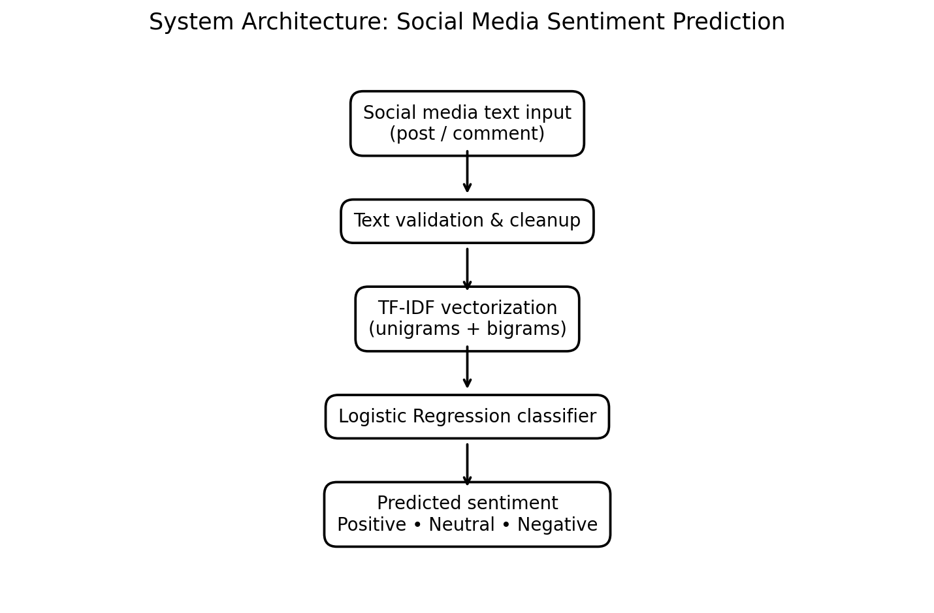
The user enters text in the Streamlit application. The trained pipeline converts it to TF-IDF features and passes those features to the Logistic Regression classifier. The application displays one of three labels and the model's class probability estimates.

6. Dataset and Preprocessing
The project includes data/social_media_sentiment.csv with text and sentiment columns. Labels are positive, negative, and neutral. The included 75 examples are balanced and manually written for demonstration, not a substitute for a real-world benchmark. The training script removes missing/empty records, normalizes labels, removes duplicate text, and uses a stratified 75/25 train/test split.
For a stronger submission, replace this sample with a larger dataset obtained under an appropriate license. Document its source, collection method, label definitions, language coverage, and any filtering. Keep duplicates and near-duplicates from leaking across splits.

7. Methodology
TF-IDF (Term Frequency–Inverse Document Frequency) represents words and two-word phrases numerically. The classifier learns weights that help separate the three sentiment labels. A scikit-learn Pipeline keeps feature extraction and classification together so the same processing is applied during training and prediction.

8. Implementation Steps
- Install Python and the packages listed in requirements.txt.
- Create and activate a virtual environment.
- Run python train_model.py to train and evaluate the model.
- The script writes sentiment_pipeline.joblib and evaluation_metrics.json.
- Run streamlit run app.py to launch the web interface.
- Enter sample text and inspect the predicted class and probability chart.

9. Evaluation
The training script reports accuracy, per-class precision, recall, F1-score, and a confusion matrix. Accuracy is the fraction of correct predictions. Precision measures the proportion of predictions for a class that are correct; recall measures the proportion of actual examples of a class that are found; F1-score is their harmonic mean. Macro F1 is useful when class distribution is imbalanced.
Do not claim a high score based on the tiny demonstration dataset. Results can change substantially with different splits and are likely to overestimate performance on familiar writing patterns. For a fair evaluation, use a larger independent test set, tune only on training/validation data, and conduct error analysis.

10. Testing Plan
Test | Input example | Expected behavior
Positive | Love this update; it works brilliantly! | Likely positive
Negative | The app crashes every time I open it. | Likely negative
Neutral | The meeting starts at 3 PM. | Likely neutral
Empty input | (blank) | Show validation message
Mixed sentiment | Looks good but battery life is poor. | May be ambiguous
Sarcasm | Great, another outage. | May be misclassified

11. Limitations
- Small training dataset limits generalization.
- TF-IDF models do not fully understand meaning, context, or word order.
- Sarcasm, slang, emojis, spelling variations, and code-switching can reduce performance.
- Probability estimates are not necessarily calibrated confidence scores.
- The model predicts overall polarity, not sentiment toward a particular aspect or entity.

12. Future Enhancements
- Use a larger, licensed social-media dataset with documented annotation guidelines.
- Compare Multinomial Naive Bayes, Linear SVM, Logistic Regression, and a transformer model.
- Add confusion-matrix plots, downloadable results, and sentiment trends over time.
- Explore multilingual and aspect-based sentiment analysis.
- Add explainability by showing influential words and perform systematic error analysis.

13. Conclusion
The project demonstrates an end-to-end NLP workflow: data preparation, feature extraction, model training, evaluation, and deployment through a web interface. It is appropriate as a learning baseline. Reliable conclusions require a much larger and representative dataset and independent testing.

Appendix: Run Commands
Windows:
python -m venv venv
venv\Scripts\activate
pip install -r requirements.txt
python train_model.py
streamlit run app.py
macOS/Linux:
python3 -m venv venv
source venv/bin/activate
pip install -r requirements.txt
python train_model.py
streamlit run app.py

