The reference links followed to setup the installation of Oracle 12c on RHEL 7.2

(with some upgradations according to the versions)

1. <http://www.tecmint.com/setting-up-prerequisites-for-oracle-12c-installation/>
2. <http://www.tecmint.com/oracle-12c-installation-in-centos-6/>

Issue with verification of key

<http://rafudb.blogspot.in/2015/10/installing-oracle-12102-on-red-hat-7.html>

sysctl changes

1. <http://www.cyberciti.biz/faq/rhel-centos-linux-7-restart-networking-command-line/>
2. <https://www.certdepot.net/rhel7-use-sysctl/>

Firewall saving : (Error and resolution)

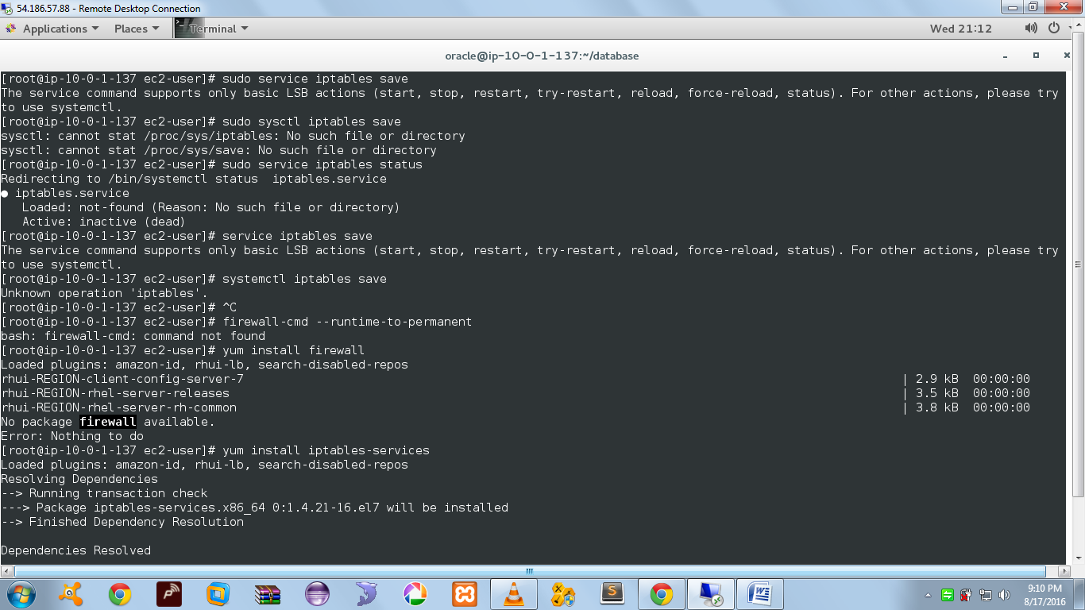

<http://serverfault.com/questions/674874/is-there-a-way-to-run-just-save-with-firewalld-in-rhel7>

The version of firewalld in RHEL 7.0 has no "save" script and no way to copy the running firewall configuration to the permanent configuration. You save a firewall change with firewalld by adding --permanent to the command line making the change. Without it, any change you make is temporary and will be lost when the system restarts.

For example:

EXTRA

firewall-cmd --add-service=http # Running config

firewall-cmd --add-service=http --permanent # Startup config

Later (post-RHEL 7) versions of firewalld do include a way to save the running configuration, and this is available now in Fedora and in RHEL 7.1. In this case the command is simply:

firewall-cmd --runtime-to-permanent

Make sure you have the iptables-services package installed. This legacy package provides the systemd scripts for the previous iptables invocation. This package is not always installed, depending on your installation choices when you installed (or upgraded).

yum install iptables-services //IMPORTANT

And of course, if possible, you should use the new firewalld system. It should only be necessary to revert to the old system if firewalld fails to provide a feature you need.

To update security

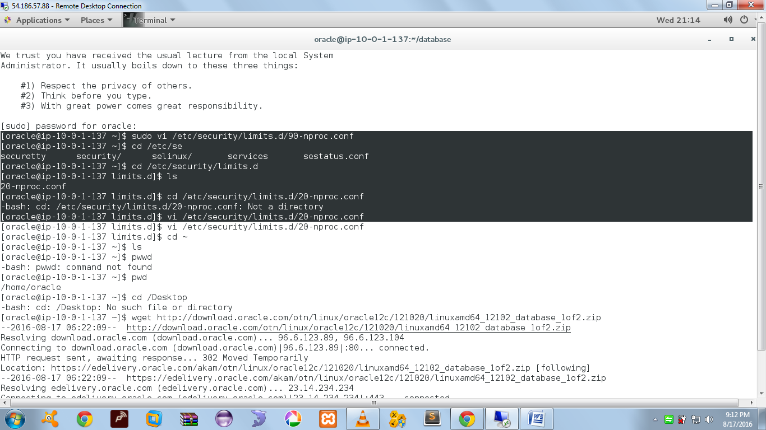

sudo vim /etc/security/limits.d/90-nproc.conf

in place of 90-nproc.conf

it has 20-nproc.conf

All commands under Oracle User

1 ulimit -Sn

2 ulimit -Hn

3 ulimit -Su

4 ulimit -Ss

5 ulimit -Hs

6 sudo vi /etc/security/limits.conf

7 sudo vi /etc/security/limits.d/90-nproc.conf

8 cd /etc/security/limits.d

9 ls

10 cd /etc/security/limits.d/20-nproc.conf

11 vi /etc/security/limits.d/20-nproc.conf

12 cd ~

13 ls

14 pwwd

15 pwd

16 cd /Desktop

17 wget http://download.oracle.com/otn/linux/oracle12c/121020/linuxamd64_12102_database_1of2.zip

18 wget http://download.oracle.com/otn/linux/oracle12c/121020/linuxamd64_12102_database_2of2.zip

19 ls

20 unzip linuxamd64_12c_database_1of2.zip

21 yum install unzip

22 sudosu

23 yum install unzip

24 unzip linuxamd64_12c_database_1of2.zip

25 ls

26 unzip linuxamd64_12102_database_1of2.zip

27 unzip linuxamd64_12102_database_1of2.zip && unzip linuxamd64_12102_database_2of2.zip

28 cat linuxamd64_12102_database_1of2.zip linuxamd64_12102_database_2of2.zip

29 cat linuxamd64_12102_database_1of2.zip linuxamd64_12102_database_2of2.zip > oracle.zip

30 zip -F oracle.zip

31 sudosu

32 zip -F oracle.zip

33 ls

34 unzip linuxamd64_12102_database_2of2.zip

35 unzip oracle.zip

36 ls

37 unzip linuxamd64_12102_database_1of2.zip

38 cd /etc/sshd

39 cd /etc/ssh

40 ls

41 sudo vi sshd_config

42 sudo vi ssh_config

43 sudo vi sshd_config

44 cd ..

45 ls

46 exit

47 ls

48 zip -F archive.zip --output linuxamd64_12102_database_1of2.zip && linuxamd64_12102_database_2of2.zip

49 ls

50 mkdir test

51 tar -xvf linuxamd64_12102_database_1of2.zip -C test/

52 unzip -v linuxamd64_12102_database_1of2.zip -C test/

53 unzip -v linuxamd64_12102_database_1of2.zip

54 unzip -v linuxamd64_12102_database_1of2.zip linuxamd64_12102_database_2of2.zip

55 unzip oracle.zip

56 ls

57 sudo yum -y install unzip

58 sudo vi /etc/ssh/sshd_config

59 scp linuxamd64_12102_database_1of2.zip oracle@52.67.15.21

60 ls

61 cp linuxamd64_12102_database_* test/

62 cd test/

63 ls

64 cd ..

65 rm linuxamd64_12102_database_*

66 ls

67 cd /

68 ls

69 cd /tmp/

70 ls

71 sudo vi /etc/ssh/ssh_config

72 sudo vi /etc/ssh/sshd_config

73 cd /home/ec2-user/

74 exit

75 ls

76 sudo

77 cd /tmp/

78 ls

79 exit

80 ls

81 ls -l

82 unzip linuxamd64_12102_database_*

83 unzip linuxamd64_12102_database_1of2.zip -C test/

84 sudo unzip linuxamd64_12102_database_1of2.zip -C test/

85 sudo unzip linuxamd64_12102_database_1of2.zip

86 ls

87 sudo unzip linuxamd64_12102_database_2of2.zip

88 ls

89 cd database/

90 ls

91 history

All commands in Vranda as User

1 viter

2 ls

3 vikey.pem

4 cd Desktop

5 chmod 400 latest_Couch.pem

6 clear

7 ls

8 ssh -ilatest_couch.pem root@52.36.200.151

9 ssh -i /latest_couch.pem root@52.36.200.151

10 clear

11 ssh

12 ssh -i /hello.pem 52.36.200.151

13 clear

14 vihello.pem

15 clear

16 ls

17 chmod 666 hello.pem

18 ssh -i /hello.pem 52.36.200.151

19 ssh -ihello.pem 52.36.200.151

20 ls

21 clear

22 gcc

23 sudo yum update

24 clear

25 sudo yum update -y

26 clear

27 ls

28 ssh -ihello.pem 52.36.200.151

29 ssh -ihello.pem 52.25.171.160

30 chmod 400 hello.pem

31 refresh

32 clear

33 ssh -ihello.pem 52.25.171.160

34 clear

35 ssh -ilatest_couch.pem 52.25.171.160

36 clear

37 ssh -ilatest_couch.pem centos@52.25.171.160

38 ssh -i /latest_couch.pem centos@52.25.171.160

39 cd.

40 cd ..

41 ls

42 pwd

43 ssh -i /Desktop/latest_couch.pem centos@52.25.171.160

44 cd

45 ls

46 vigitlb.pem

47 chmod 0400 gitlb.pem

48 ls

49 ssh -igitlb.pem ubuntu@52.67.10.240

50 ssh -igitlb.pem ubuntu@52.67.94.182

51 ls

52 cd Desktop

53 ls

54 ssh -iOpen_Stack.pem ubuntu@52.67.33.111

55 chmod 400 Open_Stack.pem

56 ssh -iOpen_Stack.pem ubuntu@52.67.33.111

57 ls

58 cd Desktop

59 ls

60 ssh -iOpenStack.pem ec2-user@52.67.58.77

61 chmod 400 Open_Stack.pem

62 ssh -iOpenStack.pem ec2-user@52.67.58.77

63 ssh -iOpen_Stack.pem ec2-user@52.67.58.77

64 clear

65 ls

66 ssh -iOpen_Stack.pem ubuntu@52.67.71.162

67 ssh -iOpen_Stack.pem ubuntu@52.67.16.107

68 ssh -iOpen_Stack.pem ec2-user@52.67.98.151

69 ssh -iOpen_Stack.pem ubuntu@52.67.110.12

70 cd Desktop

71 ssh -icouch.pem ec2-user@52.67.89.26

72 cd Desktop

73 ls

74 sudochmod 400 couch.pem

75 ssh -icouch.pem ec2-user@52.67.105.116

76 chmod 400 couch.pem

77 ssh -icouch.pem ec2-user@52.67.105.116

78 ssh -icouch.pem ec2-user@52.67.69.84

79 cd Desktop

80 ls

81 ssh -icouch.pem ec2-user@52.67.105.93

82 cd Desktop

83 ssh -icouch.pem ec2-user@52.67.69.84

84 ls

85 cd Desktop/

86 ls

87 ssh -icouch.pem ec2-user@52.67.105.93

88 cd Desktop

89 ls

90 chmod 400 proxy.pem

91 ssh -iproxy.pem ec2-user@54.206.34.22

92 cd Desktop

93 ls

94 ssh -icouch.pem ec2-user@52.67.5.126

95 sudobahs

96 su -

97 sudosu -

98 cd Desktop

99 ls

100 cd Desktop -icouch.pem ec2-user@52.67.105.93

101 ssh -icouch.pem ec2-user@52.67.105.93

102 cd Desktop

103 ls

104 ssh -icouch.pem ec2-user@52.67.5.126

105 cdDdesktop

106 cd Desktop

107 vitrial.pem

108 chmod 400 trial.pem

109 ssh -itrial.pem ubuntu@54.246.147.222

110 vitrial.pem

111 ssh -itrial.pem ubuntu@54.246.147.222

112 ssh -itrial.pem ubuntu@54.246.147.221

113 cd Desktop

114 ls

115 ssh -itrial.pem ubuntu@54.194.240.222

116 vicouch.pem

117 cd Desktop

118 ssh -icouch.pem ec2-user@52.67.129.62

119 cd Desktop

120 ssh -icouch.pem ec2-user52.67.5.126

121 ssh -icouch.pem ec2-user@52.67.5.126

122 cd Desktop

123 ssh -icouch.pem ec2-user@52.67.129.35

124 cd Desktop

125 ssh -icouch.pem ec2-user@52.67.103.59

126 dockerps

127 cd Desktop

128 viiot.pem

129 chmod 400 iot.pem

130 ssh -iiot.pem ec2-user@52.67.103.127

131 cd Desktop

132 ssh -icouch.pem ec2-user@52.67.103.59

133 ls

134 unzip linuxamd64_12102_database_1of2.zip

135 ls

136 cd database/

137 ls

138 cd ..

139 scp linuxamd64_12102_database_1of2.zip ec2-user@52.67.15.21:/home/oracle

140 scp linuxamd64_12102_database_1of2.zip ec2-user@10.0.1.137:/home/oracle

141 scp linuxamd64_12102_database_1of2.zip oracle@10.0.1.137:/tmp

142 scp linuxamd64_12102_database_1of2.zip oracle@52.67.15.21:/home/oracle

143 sudoscp linuxamd64_12102_database_1of2.zip oracle@52.67.15.21:/home/oracle

144 sudosu -

145 scp linuxamd64_12102_database_1of2.zip oracle@52.67.15.21:/home/oracle

146 scp -i linuxamd64_12102_database_1of2.zip oracle@52.67.15.21:/home/oracle couch.pem

147 ls -l

148 chmod 400 linuxamd64_12102_database_1of2.zip

149 scp -i linuxamd64_12102_database_1of2.zip oracle@52.67.15.21:/home/oracle couch.pem

150 ls -l

151 scp linuxamd64_12102_database_1of2.zip oracle@52.67.15.21:/home/oracle

152 scp linuxamd64_12102_database_1of2.zip oracle@52.67.15.21

153 scp linuxamd64_12102_database_1of2.zip oracle@52.67.15.21:/home/oracle/

154 scp linuxamd64_12102_database_1of2.zip oracle@52.67.15.21:/tmp/

155 scp -v linuxamd64_12102_database_1of2.zip oracle@52.67.15.21:/tmp/

156 vi /etc/ssh/sshd_config

157 vi /etc/ssh/ssh_config

158 scp -icouch.pem linuxamd64_12102_database_1of2.zip ec2-user@52.67.15.21

159 scp -icouch.pem linuxamd64_12102_database_1of2.zip ec2-user@52.67.15.21:/tmp/

160 scp -icouch.pem linuxamd64_12102_database_2of2.zip ec2-user@52.67.15.21:/tmp/

161 history

All commands as Ec2-User (Root)

1 cd /etc/yum.repos.d

2 wget https://public-yum.oracle.com/public-yum-ol6.repo

3 yum install wget

4 wget https://public-yum.oracle.com/public-yum-ol6.repo

5 wget https://public-yum.oracle.com/public-yum-ol6.repo --no-check-certificate

6 df -h

7 hostname

8 ifconfig | grepinet

9 lsb_release -a

10 cd /

11 yum install lsb_release

12 sudo yum clean metadata &&sudo yum upgrade

13 sudo yum clean metadata &&sudo yum upgrade --skip-broken

14 yum check

15 sudo vim /etc/sysconfig/selinux

16 sudo vi /etc/sysconfig/selinux

17 sudoinit 6

18 sudo yum install binutils.x86_64 compat-libcap1.x86_64 compat-libstdc++-33.x86_64 compat-libstdc++-33.i686 \

19 wget http://public-yum.oracle.com/RPM-GPG-KEY-oracle-ol7 -O /etc/pki/rpm-gpg/RPM-GPG-KEY-oracle

20 sudo yum install binutils.x86_64 compat-libcap1.x86_64 compat-libstdc++-33.x86_64 compat-libstdc++-33.i686 \

21 sudo vim /etc/sysctl.conf

22 sudo vi /etc/sysctl.conf

23 sudo vi /usr/lib/sysctl.d/00-system.conf

24 sudosysctl -p

25 sudosysctl.d/00-system.conf -p

26 sudosysctl -p

27 cat /usr/lib/sysctl.d/00-system.conf

28 sudosystemctl restart network

29 sudosystemctl status network

30 sysctl1 -a

31 sysctl -a

32 sudoinit 6

33 yum install unzip

34 su -oracle

35 cd ..

36 cd ..

37 cd ~

38 ls

39 exit

40 yum install zip

41 exit

42 sudogroupadd -g 54321 oracle

43 sudogroupadd -g 54322 dba

44 sudogroupadd -g 54323 oper

45 sudouseradd -u 54321 -g oracle -G dba,oper oracle

46 sudousermod -a -G wheel oracle

47 sudopasswd oracle

48 sudoiptables -F

49 sudo service iptables save

50 sudosysctliptables save

51 sudo service iptables status

52 serviceiptables save

53 systemctliptables save

54 firewall-cmd --runtime-to-permanent

55 yum install firewall

56 yum install iptables-services

57 serviceiptables save

58 sudochkconfigiptables on

59 sudomkdir -p /u01/app/oracle/product/12.1.0/db_1

60 sudochown -R oracle:oracle /u01

61 sudochmod -R 775 /u01

62 ls -l /u01

63 vi /home/oracle/.bash_profile

64 su - oracle

65 su -oracle

66 exit

67 so -oracle

68 su -oracle

69 su - oracle

70 ls

71 ls

72 cd /home/ec2-user

73 ls

74 visudo

75 vi /etc/passwd

76 vi /etc/group

77 su - oracle

78 ls

79 cd /tmp

80 ls

81 cp linuxamd64_12102_database_* /home/oracle

82 sudosu - oracle

83 cd ..

84 ls

85 history

All commands as Ec2-user

1 sudosu

2 sudo yum clean metadata &&sudo yum upgrade

3 sudo yum install binutils.x86_64 compat-libcap1.x86_64 compat-libstdc++-33.x86_64 compat-libstdc++-33.i686 \

4 wget http://public-yum.oracle.com/RPM-GPG-KEY-oracle-ol7 -O /etc/pki/rpm-gpg/RPM-GPG-KEY-oracle

5 sudosu

6 sudogroupadd -g 54321 oracle

7 sudosu

8 sudosu

9 history

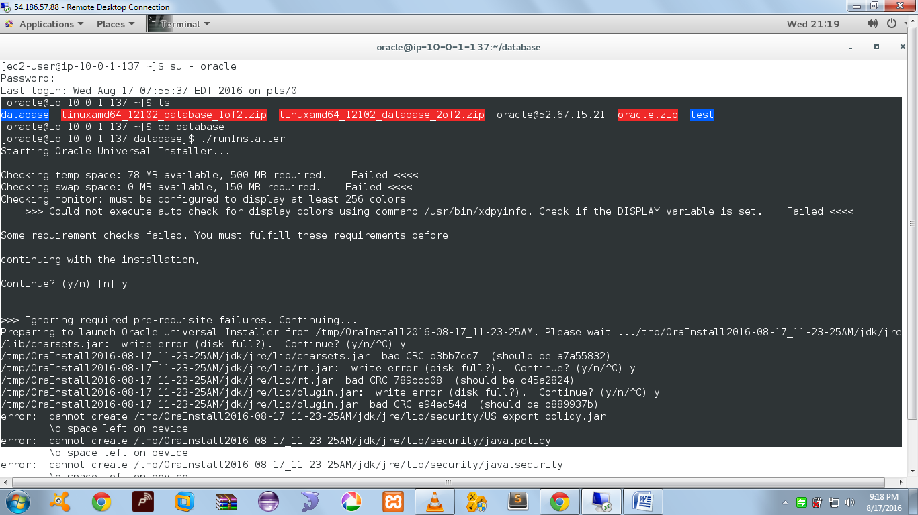

Error Stack :

[oracle@ip-10-0-1-137 ~]$ ls

database linuxamd64_12102_database_1of2.zip linuxamd64_12102_database_2of2.zip oracle@52.67.15.21 oracle.zip test

[oracle@ip-10-0-1-137 ~]$ cd database

[oracle@ip-10-0-1-137 database]$ ./runInstaller

Starting Oracle Universal Installer...

Checking temp space: 78 MB available, 500 MB required. Failed <<<<

Checking swap space: 0 MB available, 150 MB required. Failed <<<<

Checking monitor: must be configured to display at least 256 colors

>>> Could not execute auto check for display colors using command /usr/bin/xdpyinfo. Check if the DISPLAY variable is set. Failed <<<<

Some requirement checks failed. You must fulfill these requirements before

continuing with the installation,

Continue? (y/n) [n] y

>>> Ignoring required pre-requisite failures. Continuing...

Preparing to launch Oracle Universal Installer from /tmp/OraInstall2016-08-17_11-23-25AM. Please wait .../tmp/OraInstall2016-08-17_11-23-25AM/jdk/jre/lib/charsets.jar: write error (disk full?). Continue? (y/n/^C) y

/tmp/OraInstall2016-08-17_11-23-25AM/jdk/jre/lib/charsets.jar bad CRC b3bb7cc7 (should be a7a55832)

/tmp/OraInstall2016-08-17_11-23-25AM/jdk/jre/lib/rt.jar: write error (disk full?). Continue? (y/n/^C) y

/tmp/OraInstall2016-08-17_11-23-25AM/jdk/jre/lib/rt.jar bad CRC 789dbc08 (should be d45a2824)

/tmp/OraInstall2016-08-17_11-23-25AM/jdk/jre/lib/plugin.jar: write error (disk full?). Continue? (y/n/^C) y

/tmp/OraInstall2016-08-17_11-23-25AM/jdk/jre/lib/plugin.jar bad CRC e94ec54d (should be d889937b)

error: cannot create /tmp/OraInstall2016-08-17_11-23-25AM/jdk/jre/lib/security/US_export_policy.jar

No space left on device

error: cannot create /tmp/OraInstall2016-08-17_11-23-25AM/jdk/jre/lib/security/java.policy