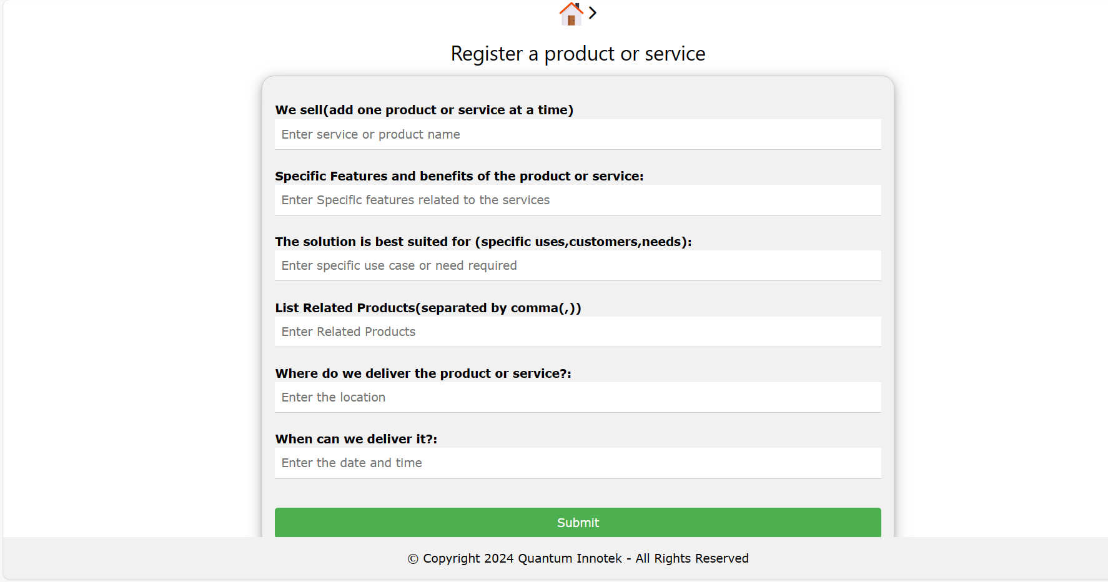

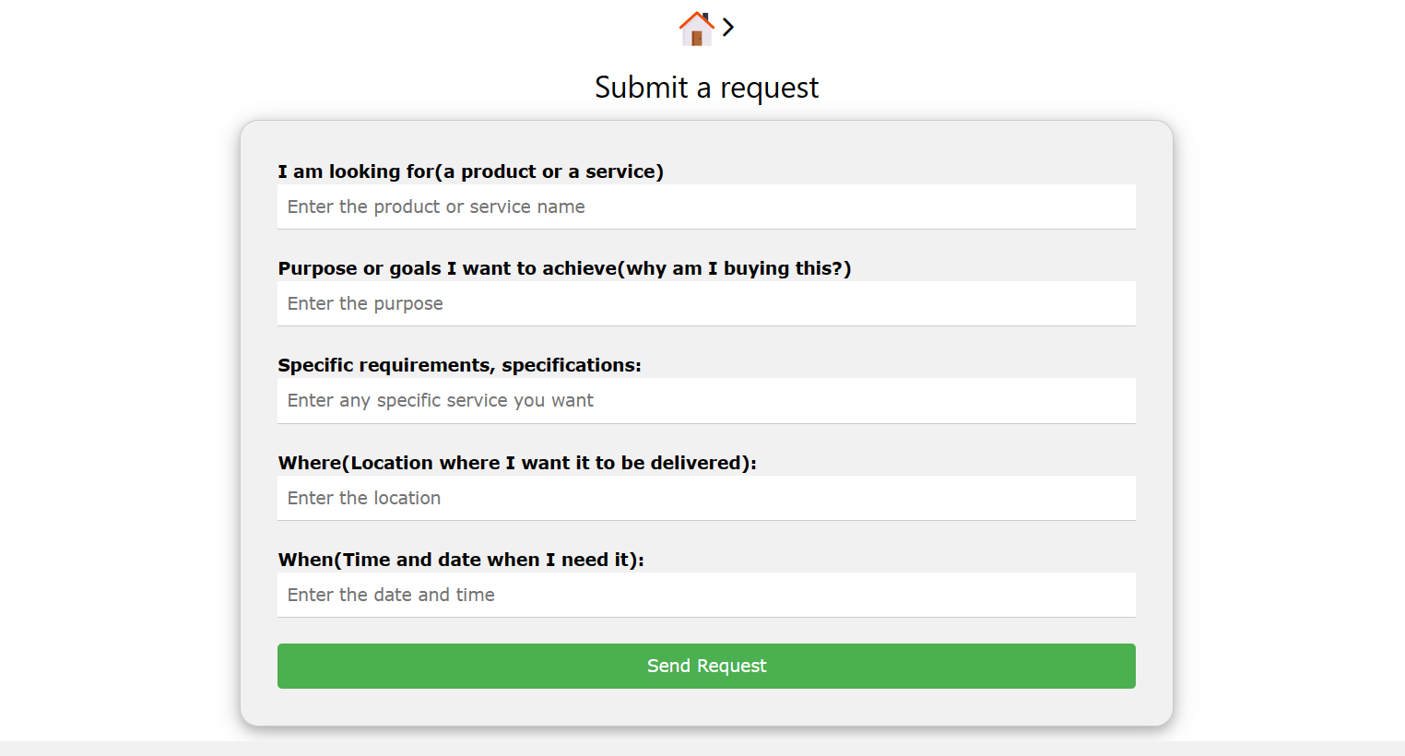

Reference Website:
https://www.flaticon.com/icons
https://www.freepik.com/icons
Icons:
Must be transparent background
Fully describe the idea
Icons should have Soft corner/edges

