- Dataset — COMPLETED
- Historical stock data of
🏢 Reliance Industries Limited
- From 2015 till present
- Daily frequency
- 2750+ observations
- Variables:
  - Date
  - Close
  - High
  - Low
  - Open
  - Volume
can show:
- Source: Yahoo Finance (via yfinance)
- Time span
- Number of observations
- Preprocessing / Data Cleaning — COMPLETED
Step 1: Remove metadata rows
Step 2: Rename Date column
Step 3: Convert Date to Date type
Step 4: Convert numeric columns
Step 5: Validate structure
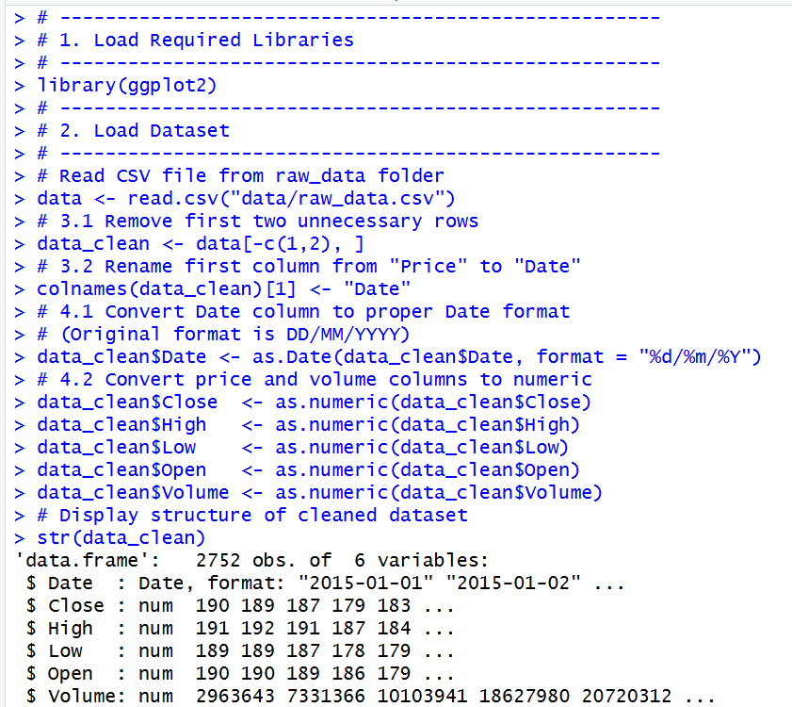
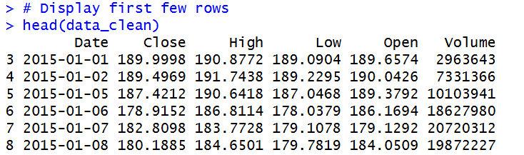

- Graphs & DATA VISUALIZATION SECTION (Completed )
We created 5 strong visualizations:
- Closing Price Trend
Code:
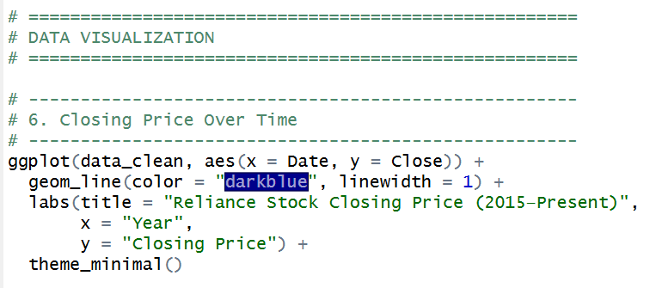
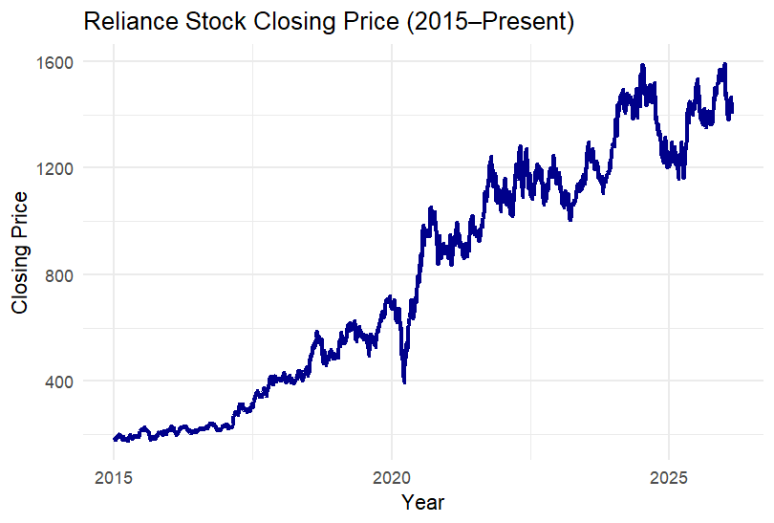
What This Does
• Shows long-term movement
• Reveals trend
• Shows major shocks
What You Should Observe
- Strong upward trend over years
- Sharp fall during COVID (2020)
- Increasing volatility after 2020
What To Say in Presentation
The closing price shows a clear upward trend over time, indicating non-stationarity. A significant dip is observed during the COVID-19 market crash, followe
d by strong recovery and volatility expansion.

- Trading Volume Trend
Code:
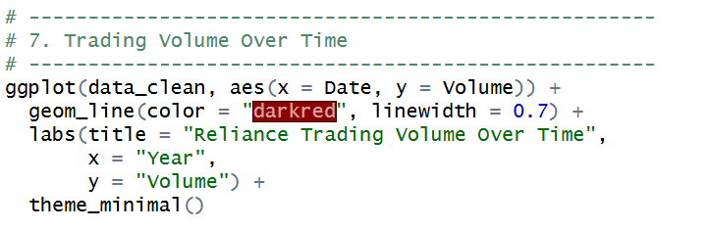
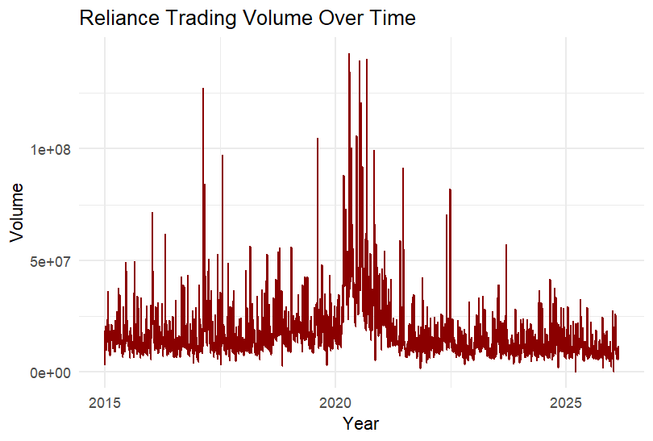
What This Shows
• Market participation
• Investor activity
• Panic buying/selling
What You Should Observe
- Volume spikes during crisis periods
- Higher trading activity during volatility
What To Say
Trading volume spikes during major market events, indicating increased investor participation and market uncertainty.

- Price Distribution
Code:
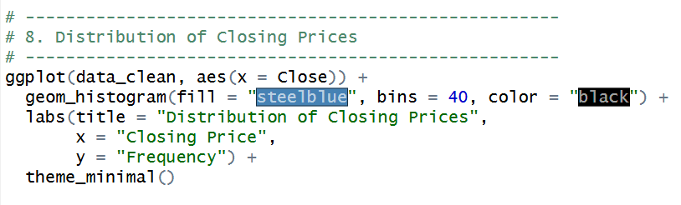
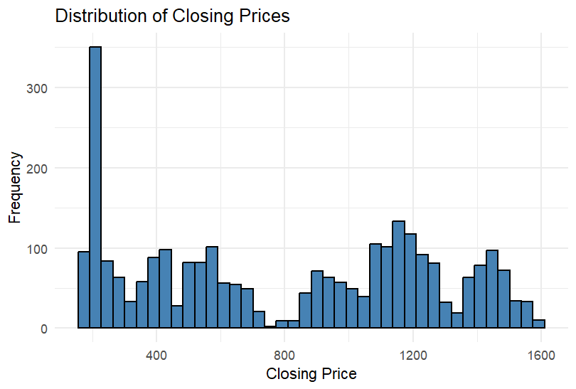
What This Shows
• Whether prices are symmetric
• Whether distribution is skewed
Observation
Stock prices usually show:
- Right-skewed distribution
- More data concentrated in recent higher price ranges
What To Say
The distribution of closing prices is right-skewed, reflecting long-term price growth over the observed period.

- Differenced Series Plot
Code:
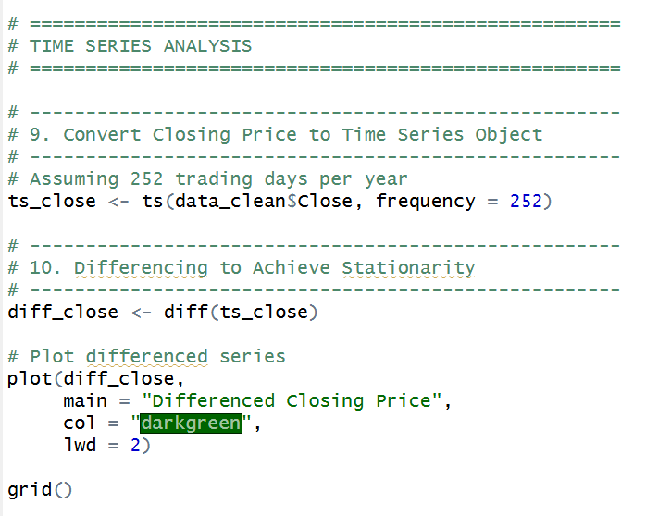
This shows stationarity visually.
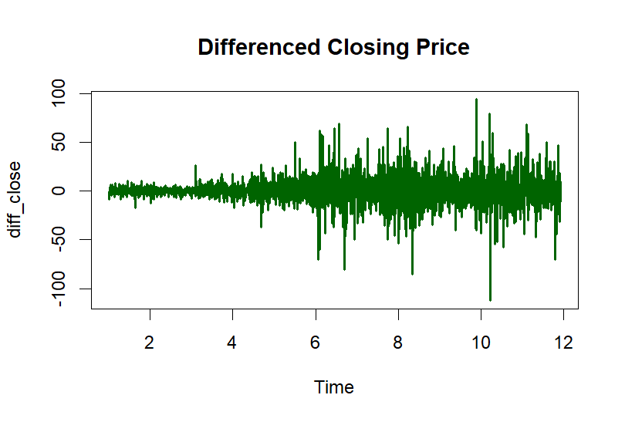
What This Does
Removes trend by computing:
Price_today − Price_yesterday
What You Should Observe
- No upward trend
- Fluctuates around zero
- More stable variance
What To Say
After first differencing, the series fluctuates around zero without a visible trend, suggesting stationarity suitable for ARIMA modeling.

- ACF & PACF Plots
Code:
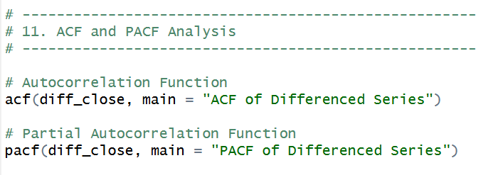
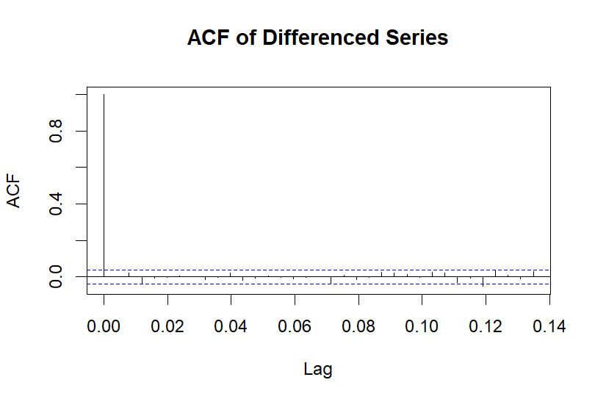
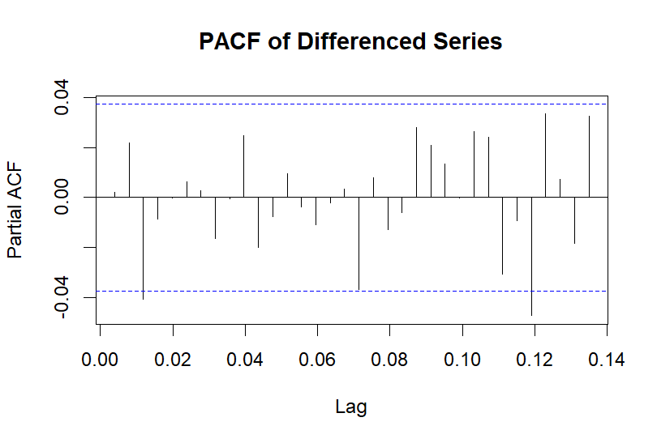
What These Show
ACF → correlation with past values
PACF → direct correlation with past values
What You Should Observe
- Initial significant spikes
- Gradual decay
What To Say
The ACF and PACF plots were analyzed to determine appropriate AR and MA components for the ARIMA model.

- Proposed Models — PARTIALLY DONE
Proposed Models:
- Naïve Forecast Model (Baseline)
- ARIMA Model
- Auto ARIMA Optimization
Model Comparison Criteria:
- RMSE
- Forecast Accuracy
- Residual Diagnostics
1. Naïve Forecast Model (Baseline)
What it is:
Tomorrow’s price = Today’s price.
Mathematically:
$${\hat{Y}}_{t+1}=Y_{t}$$

Why propose it?
Because:
- Every forecasting model must beat a simple baseline.
- It acts as performance benchmark.
- Professors like this.

What to say in PPT:
A naïve forecasting model is proposed as a baseline to compare the performance of more advanced statistical models.

2. ARIMA Model (Core Model)
Full name:
AutoRegressive Integrated Moving Average.
Model form:
$$ARIMA(p,d,q)$$
Where:
- p = autoregressive order
- d = differencing order
- q = moving average order

Why propose ARIMA?
- Designed for time-series data
- Handles trend via differencing
- Widely used in financial forecasting
- Interpretable model

Why suitable here?
Because:
- Stock prices show autocorrelation
- Series becomes stationary after differencing
- ARIMA models short-term dynamics

What to say in PPT:
ARIMA is selected as the primary statistical model due to its ability to capture autoregressive and moving average components in stationary time series data.

3. Auto ARIMA (Optimized ARIMA)
This is not a different model.
It is an automatic parameter selection version.
Uses:
- AIC minimization
- Statistical optimization

Why include it?
- Reduces manual bias
- Selects best p, d, q automatically
- Improves model efficiency

What to say:
Auto ARIMA is used to automatically determine optimal model parameters using AIC-based optimization.

REPORT
Introduction
This project analyzes the historical stock data of Reliance Industries Ltd. from 2015 to the present. The objective is to:
- Clean and preprocess raw stock data
- Visualize price and volume trends
- Study distribution of prices
- Perform basic time series analysis
- Examine stationarity using differencing
- Analyze ACF and PACF plots

2️⃣ Loading Required Libraries
library(ggplot2)
Explanation:
The ggplot2 library is used for creating professional and customizable data visualizations.

3️⃣ Loading the Dataset
data <- read.csv("data/raw_data.csv")
Explanation:
The dataset is loaded from a CSV file containing historical stock prices.

4️⃣ Data Cleaning
4.1 Remove Unnecessary Rows
data_clean <- data[-c(1,2), ]
Explanation:
The first two rows were removed as they likely contained unwanted headers or metadata.

4.2 Rename Column
colnames(data_clean)[1] <- "Date"
Explanation:
The first column was renamed to “Date” for clarity and easier reference.

5️⃣ Data Type Conversion
5.1 Convert Date Format
data_clean$Date <- as.Date(data_clean$Date, format = "%d/%m/%Y")
Explanation:
The date was originally stored as character format (DD/MM/YYYY).
It was converted to proper Date format for time series analysis and plotting.

5.2 Convert Numeric Columns
data_clean$Close <- as.numeric(data_clean$Close)
data_clean$High <- as.numeric(data_clean$High)
data_clean$Low <- as.numeric(data_clean$Low)
data_clean$Open <- as.numeric(data_clean$Open)
data_clean$Volume <- as.numeric(data_clean$Volume)
Explanation:
Stock prices and volume were converted to numeric format to allow mathematical calculations and plotting.

6️⃣ Checking Data Structure
str(data_clean)
head(data_clean)
Explanation:
- str() verifies correct data types.
- head() displays the first few rows to confirm successful cleaning.

📈 Data Visualization

7️⃣ Closing Price Over Time
ggplot(data_clean, aes(x = Date, y = Close)) +
geom_line(color = "darkblue", linewidth = 1) +
labs(title = "Reliance Stock Closing Price (2015–Present)",
x = "Year",
y = "Closing Price") +
theme_minimal()
🔎 Interpretation:
- The closing price shows an overall upward trend over time.
- There are noticeable fluctuations indicating market volatility.
- Major jumps or drops may correspond to economic events or company news.
This indicates that the stock is non-stationary due to trend presence.

8️⃣ Trading Volume Over Time
ggplot(data_clean, aes(x = Date, y = Volume)) +
geom_line(color = "darkred", linewidth = 0.7) +
labs(title = "Reliance Trading Volume Over Time",
x = "Year",
y = "Volume") +
theme_minimal()
🔎 Interpretation:
- Volume spikes indicate periods of high trading activity.
- These may correspond to:
  - Earnings announcements
  - Market crashes
  - Major economic events
Volume helps identify investor interest and volatility.

9️⃣ Distribution of Closing Prices
ggplot(data_clean, aes(x = Close)) +
geom_histogram(fill = "steelblue", bins = 40, color = "black") +
labs(title = "Distribution of Closing Prices",
x = "Closing Price",
y = "Frequency") +
theme_minimal()
🔎 Interpretation:
- The histogram shows the frequency distribution of stock prices.
- If skewed right → indicates strong growth period.
- If symmetric → indicates stable movement.
The distribution helps understand price concentration levels.

📊 Time Series Analysis

🔟 Convert to Time Series Object
ts_close <- ts(data_clean$Close, frequency = 252)
Explanation:
- 252 trading days are assumed per year.
- This converts the data into a time series object for analysis.

1️⃣1️⃣ Differencing the Series
diff_close <- diff(ts_close)
plot(diff_close,
main = "Differenced Closing Price",
col = "darkgreen",
lwd = 2)
grid()
🔎 Interpretation:
- Differencing removes trend from the series.
- The differenced plot appears more stable.
- This suggests that first differencing may help achieve stationarity.
Thus, the original series is likely integrated of order 1 (I(1)).

1️⃣2️⃣ ACF and PACF Analysis
acf(diff_close, main = "ACF of Differenced Series")
pacf(diff_close, main = "PACF of Differenced Series")
🔎 Interpretation:
- ACF (Autocorrelation Function):
  - Shows correlation with previous lags.
  - If it cuts off quickly → MA model may be suitable.
- PACF (Partial Autocorrelation Function):
  - Helps identify AR terms.
  - If PACF cuts off after lag k → AR(k) model may fit.
These plots help in selecting ARIMA model parameters (p, d, q).

✅ Conclusion
- The original closing price series is non-stationary.
- After first differencing, the series appears more stable.
- ACF and PACF plots suggest the data may be modeled using an ARIMA model.
- Further steps could include:
  - Augmented Dickey-Fuller (ADF) Test
  - ARIMA model fitting
  - Forecasting future stock prices

