Zhaomin Liu
Melbourne, VIC| +61 0403 712 671 | 2697218661@qq.com

[LinkedIn Profile : https://www.linkedin.com/in/zhaomin-liu-609a6a3b8/]

[GitHub Portfolio : https://github.com/Vril2563]

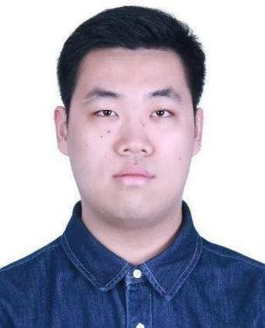

Professionals Summary
Bachelor of Information Technology graduate from Monash University (Dec 2024) with a strong passion for game development and 3D art. Proficient in Unreal Engine 5, Unity, Maya, and Blender, with a proven track record of delivering full-cycle game projects, including 3D modeling, VFX, and level design. Experienced in VR/AR animation and immersive environment creation. Currently holding a Temporary Graduate Visa (Subclass 485) and available for full-time employment.

Technical Skills
- Game Engines: Unreal Engine 5 (VFX, Blueprints, Rendering), Unity (Playmaker, Animation, Particle Systems)
- 3D & VFX: Maya, Blender, Substance Painter, 3D Modeling (Characters, Environments, Props), UV Mapping, Texturing
- Programming & Web: C++, JavaScript, Web Development (HTML/CSS)
- Design: Level Design, System Balancing, Board Game Design, UI/UX Design
- Soft Skills: Project Planning, Team Leadership, Problem Solving, Team management, Co-operation
- Community management skills: familiar with Discord、BiliBili and other social software, able to manage Discord groups and handle almost all functions in Discord.
- Communication skills: Familiar with how to communicate and serve customers/clients well, and good at solving different situation between team members. Able to work in a fast pace、heavy pressure and complicate environment.

Professional Experience

Tutor & Client Service Representative | Baiyu Education Institution | China |Full-time
June 2025 – Feb 2026
● Delivered personalized mathematics, Basic Programming and English tutoring to high school students, improving their academic performance.
● Acted as a liaison between students and parents, effectively communicating progress and addressing client concerns to ensure satisfaction.

Freelancer AI Trainer | LDP AI | Online(Remote) |Part-time | Sep 2024 – Now
● Use my voice to train new AI model to enhance their ability to understand voice command
● Use my mobile app experience in university to set up the navigation and map functions for the AI model

Python Tutor | Play AI |Melbourne | May 2026 – Now
● Use my professional Python and 3D modelling knowledge to teach students from age 8 - 22
● Use my game development experience to guide students between 14 - 22 to complete their game competition projects.

Full-time Courrier | Uber |Melbourne/Online | Sept 2026 – Now
● Food Delivery

Projects
Dungeon Ghost Hunter (2D Pixel Game) | Unity
[ https://github.com/Vril2563/2d-game ]
- Weapon & Combat System: Designed a balanced weapon system featuring a slow-firing pistol (6 bullets, quick reload) and a high-damage rifle (slower reload). Implemented bullet physics and collision detection.
- Health & UI: Developed a visual health system using pixel art hearts (3 hearts, 0.5 points each) with audio feedback. Programmed health pickups and death spawning mechanics.
- Level Design: Created a modular dungeon layout with interconnected rooms. Implemented a "Roguelike-lite" mechanic where players must clear each room to unlock the next path.
- Visual Aesthetics: Hand-drew pixel art assets for environments (purple floors, stone walls) and UI elements to ensure cohesive game art style.

VR Arena Animation (Immersive Experience) | Unity
[ https://github.com/Vril2563/VR-Animation ]

- Environment & Lighting: Constructed a mountainous terrain and night skybox. Utilized Directional Lights and Point Lights to set a dramatic nocturnal atmosphere.
- VFX & Particles: Created complex particle systems including ambient dust, animated fire circles (with motion blur and HDR), ghost effects, and gladiator foam animations.
- Post-Processing: Enhanced realism using Color Grading (+20 Temp), Bloom, Grain, and Ambient Occlusion.
- Animation: Rigged and animated 3D assets including a rotating artifact/core and falling swords using Sequencer. Board Game Designer | Monash University Faculty of IT | Melbourne, VIC
- Collaborated in a team to design a board game, winning an Honors Prize in the academic course.
- Spearheaded Level Design, Narrative Storytelling, and Character Balance to ensure engaging gameplay.
- Contributed as Level Designer and System Balancer for a 2D dungeon crawler game developed within a tight deadline.

In My Mind (3D FPS Game) | Unreal Engine
[ https://github.com/Vril2563/3d-fps-game ]

● Environment Art style: I completed this project in a university team and I am the 3D artist of this team. I determined the art style of all scenes in this game.
● 3D models: I created most objects we need in each level. Due to the different design of each level, I choose different style of models. I combined the classical building styles, future, classical sci-fi and Bio punk in our levels.
● Combat Mechanism: I designed a frenzy mechanism to encourage the player to engage with enemies frequently to obtain source and recover health.

Scary Skelly (Board Game)
[ https://github.com/Vril2563/board-game ]

● Character Design: I designed the role and abilities of each character and set up their basic value
● Level Design: Thanks to my experience in DND games, I created the pixel map and designed different routes for players to cooperate and explore the game world
● Enemy Design: I created the appearance of some enemies and designed their combat mechanism and abilities

Education
Bachelor of Information Technology | Monash University | Melbourne, VIC Graduated: December 2024

Relevant Coursework
3D Modeling, VR/AR Animation, C++ Programming, Web Development

Visa Status
Temporary Graduate Visa (Subclass 485) – Full Work Rights

Introduction of my work
(Please check my Git Portfolio to find more projects)

Part 1 2D Game Development
(Project under the 2D game repository in my Git Portfolio)

Game Analysis:

Weapon system
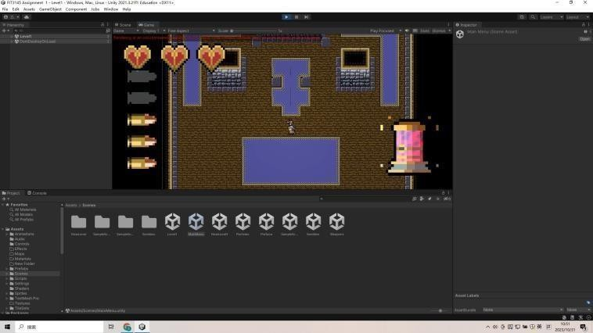
Our player can pick up a pistol at the beginning of the game to go through a tutorial level, the player can press the left mouse button to shoot enemies or enemies’ bullets. Pistols have 6 bullets in each mag, the player has to reload after every 6 shoots.
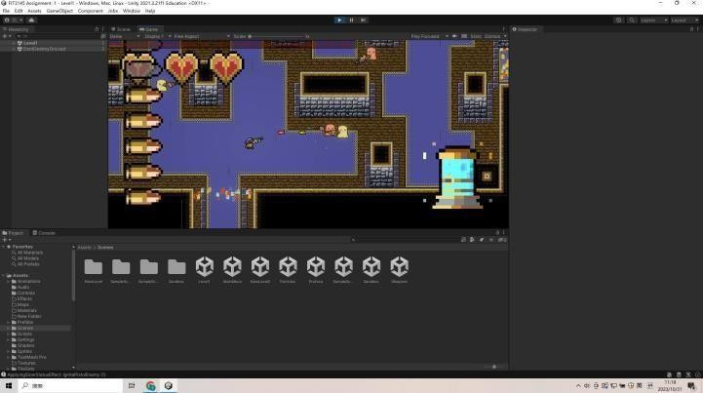

The player can destroy the enemies’ bullets by 1 pistol bullet and kill a ghost by 5 pistol bullets. But the player needs to remember that the pistol bullet projectile velocity is a little slower than enemies’ bullets. We designed it in this way to tell the player that he/she needs to practice this skill rather than destroying enemies’ bullets easily.

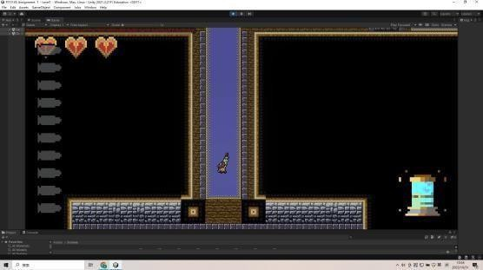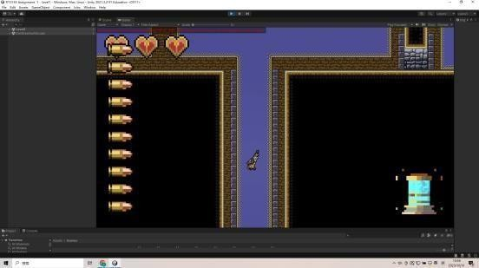

After the tutorial level, the player will enter the main level of our game. Then the player will find a rifle on the path to the next room after he/she killed all enemies in the first room. This rifle has stronger fire power and higher projectile velocity. But the player will spend a longer time reloading it. It can also destroy the enemies’ bullets with 1 shot and kill a ghost with 6 bullets.
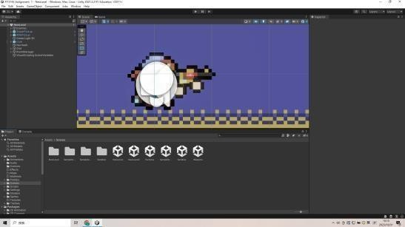
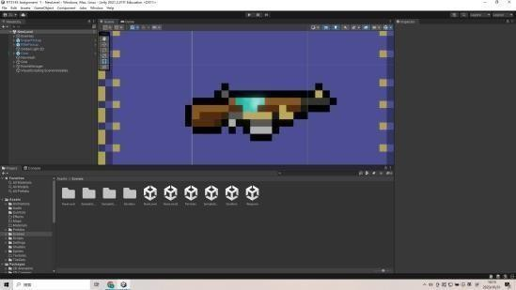

For the aesthetics of our weapons, we made both 2 weapons with pixel graphs to match the art style of our project. The appearance of weapons was based on the structure of real weapons but we replaced some parts with our own design. We also added the dynamic material for the body of weapons to improve the appearance in game.

Health system
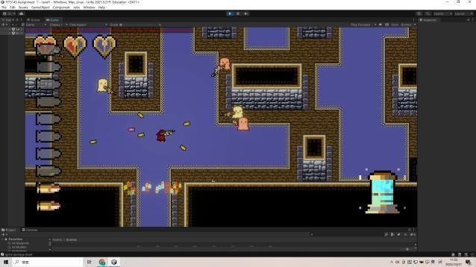

For the health system of my game, the player will have 3 hearts as the health point and lose 0.5 point every time he/she takes a certain amount of damage. We set the sound effect to remind the player and UI will also show the change of health. The player cannot recover the health automatically, he/she must find the collectable loot in levels to recover the health. The player will lose 0.5 health point for every time

he/she hurted by enemies’ with 2 bullets, which means he/she can only take 12 bullets total. If the player loses all health points, it will spawn at the start point of the current level.
For aesthetics, we made the health UI with pixel graphs and the appearance is heart. We divided each heart to 2 parts to count each part as 0.5 health point, which is very clear to the player. Then the player can choose different strategies to fight based on the health point left. In this section, mechanics influenced the aesthetics.

Level design
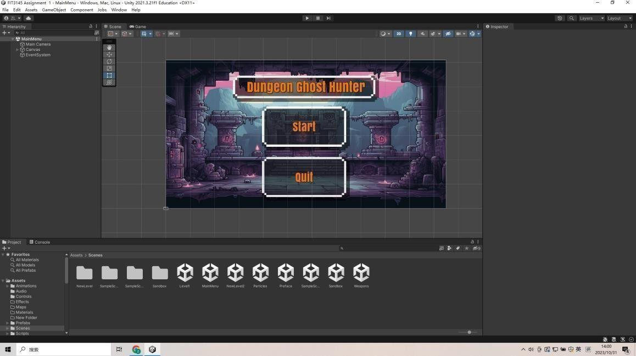

For our level design, I will also analyze the mechanics in it first. Our level design began with the main menu UI. Actually we didn’t take this into consideration at first, but after we discussed our assets from Assignment 1A we realized that a main menu will be necessary. So we made this main menu, the player can press the start to begin or press quit to leave the game. If the player pressed the start button, he/she will get a narrative content about our game background and then enter the tutorial level.
For the aesthetics section, we decided to make a cartoon style background to give a good impression for new players. Then we included the name of our game at the top of the screen and made all buttons easy and clear. UI should not be complicated and difficult to learn.

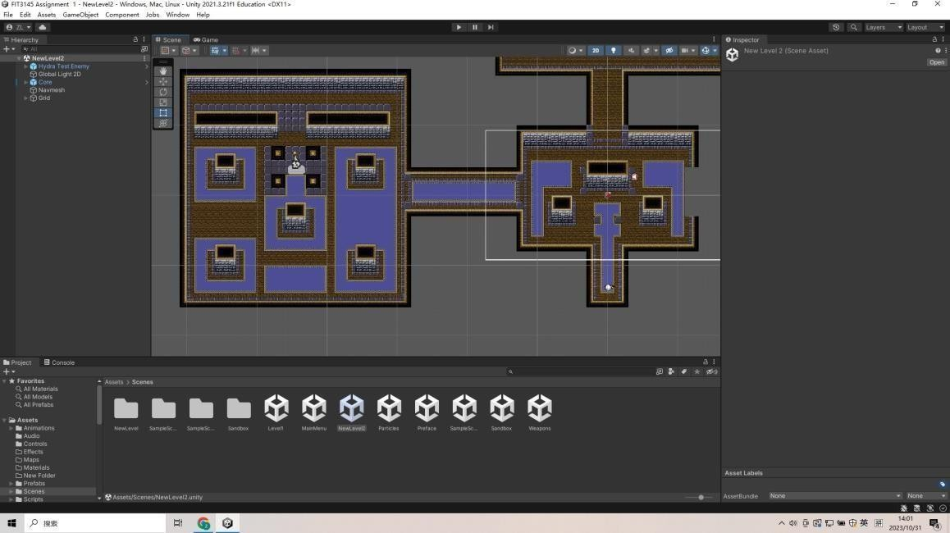
This is the tutorial level of our game. The player will learn about how to move and use weapons to fight with enemies. Then he/she can find out how to use covers to hide the bullets from enemies and kill them all to enter the next room. We will also remind the player the information about the health UI and reload the UI, then he/she will have enough knowledge to enter the level1.
For aesthetics, we chose the pixel graphs to build the map which is easy to achieve a good effect. We chose the purple pixel graph to make floor, black and brown pixel graph for dirty and gray pixel graph as stone. Then we combined all things together and fulfilled our level prototype, and set some of the parts unable to cross to make sure the player can use that as cover to hide from enemies’ bullets.
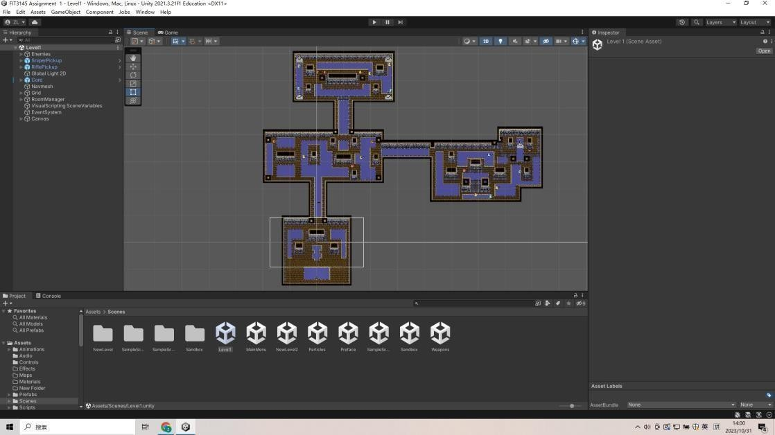

This is the overview of our level 1. It includes a lot of rooms and all rooms connected by the paths. But the player has to kill all enemies in the current room to unlock the path to the next room. We will provide the loot on the path for the player to collect. For the start point to level1, the player can find a rifle on the path. Then the player will face a lot of enemies in the first room of the level 1, he/she should use the weapons and covers carefully to kill them all. After all enemies in this room are eliminated, one of the paths towards other rooms will be unlocked. Which is the rogue-like element of our level 1, we just made a limited rogue-like element to make sure the player won’t get tired.

Part 2 VR Animation
(Project under the VR-animation repository in my Git Portfolio, I include a full introduction this project to describe other parts that I didn’t mention this resume)

Terrain
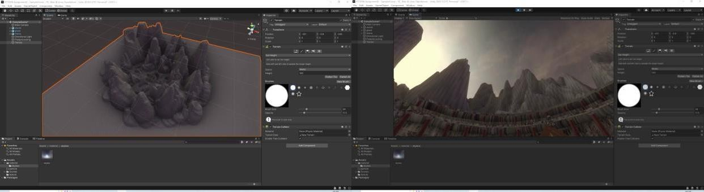
For my terrain, I believe that mountain is the most suitable one for my scene. So I created some mountains by set height tool and smoothed that.
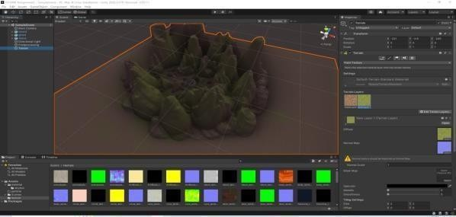
Then I painted the terrain with grass and rock textures.

Skybox
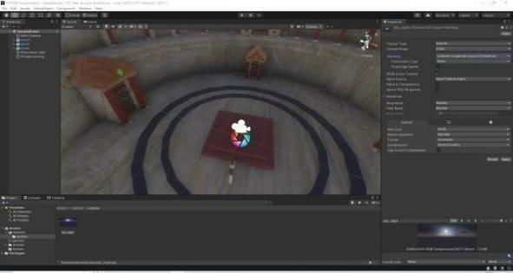
For my skybox, I chose the sky night and imported as texture then made the material.
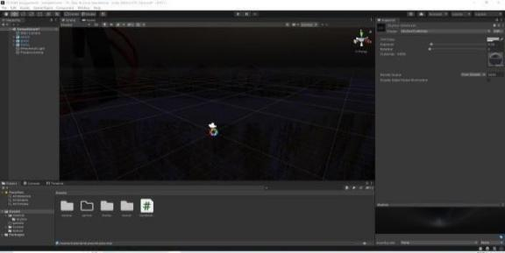
Then I adjusted the exposure to make sure my scene is dark enough at the beginning.

Light
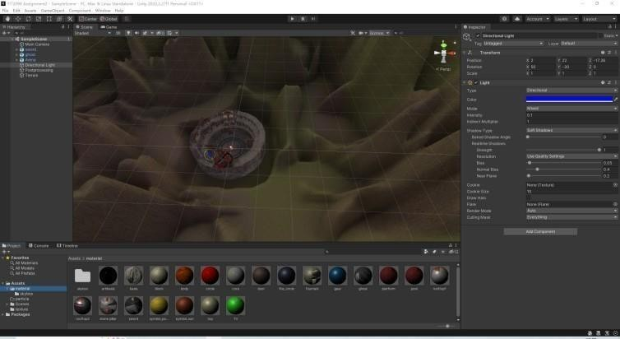
At the beginning of my light process, I reduced the intensity of directional light to enhance the night experience
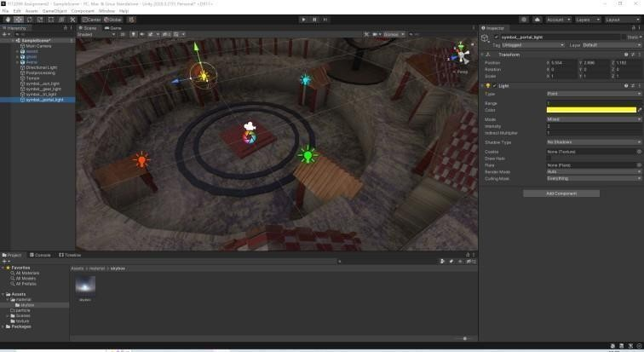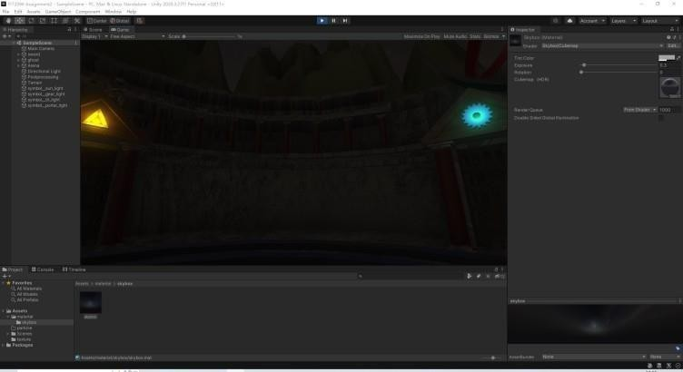
Then I added the point lights to symbols on each gate. User can see 4 symbols at the beginning.

Particles
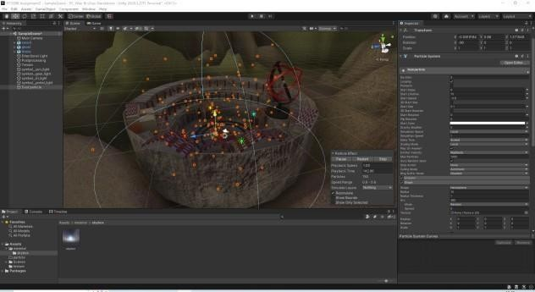
My first particle system is my dust particle. Dust is very important for my scene,I need dust to emphasize the atmosphere of an arena. I set the shape to hemisphere and gave the dark yellow color over time to make this particle system.

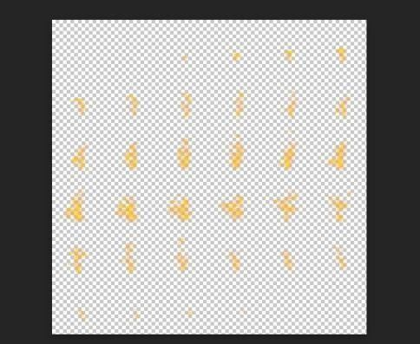
My second particle system is my fire particle. I want to make a fire circle, then I can animate it. At first, I gave the motion blur in photo pea to this flame texture.
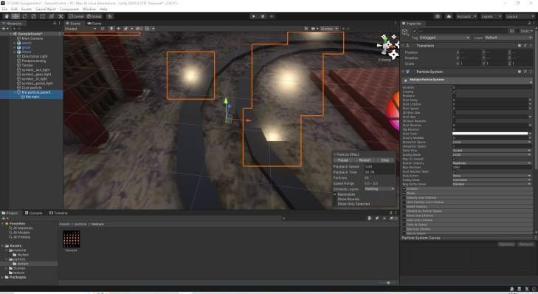
Then I created the fire parent and a child fire main under it.
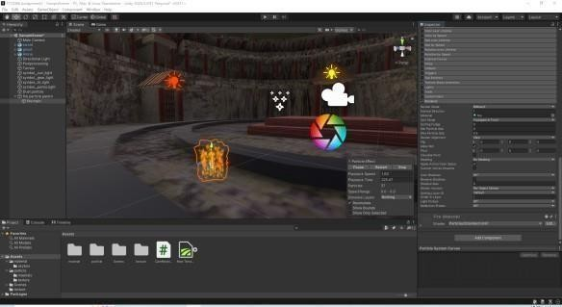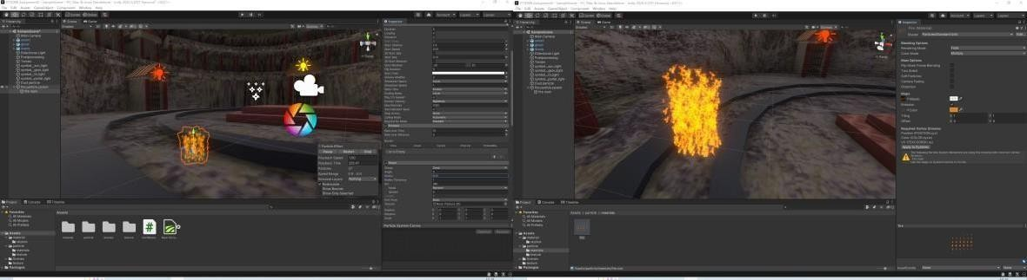
I applied the texture to my fire main and adjusted the life time and size to make the fire. And adjusted the HDR color to enhance the brightness.
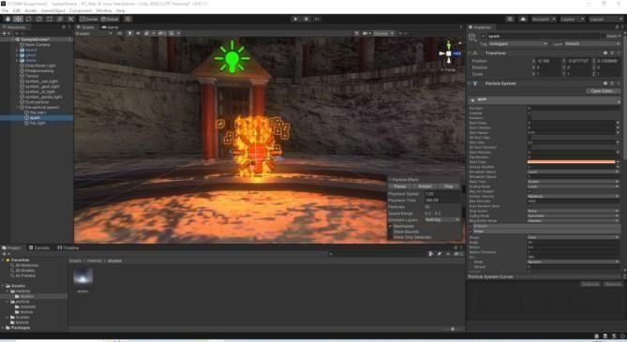
I also gave a particle system as spark near my fire and a point light to make it real.

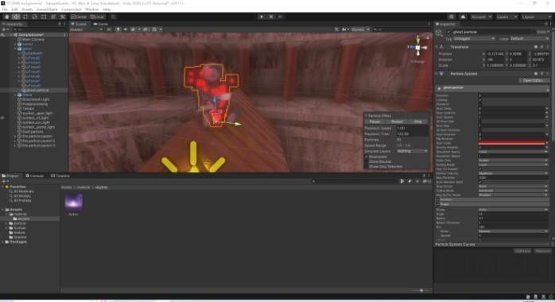
Third particle is my ghost particle, I created a particle system with red color for it.
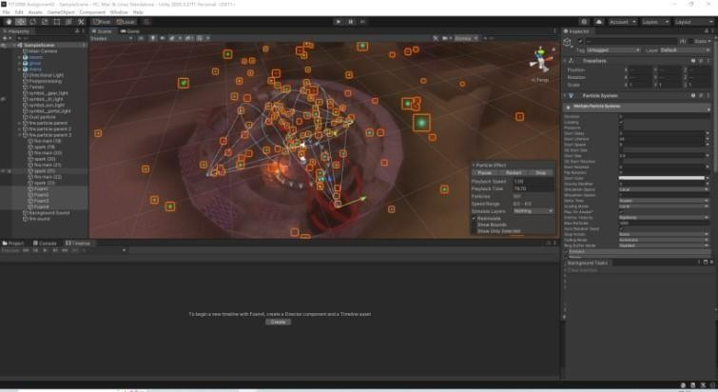
My last particle is the foam for gladiators. It will be shown to user after the fire animation. I made 4 particle systems with 4 colors. User will see it for 10 seconds, then foam will disappear. This particle system will influence the view of user if I don’t turn it off.

Post-processing
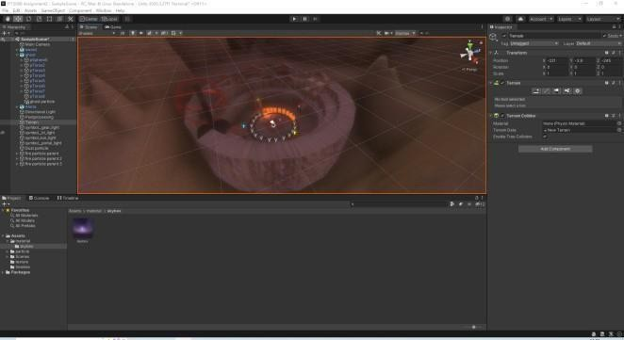
For my post-processing, I gave +20 temperature by color grading at first.
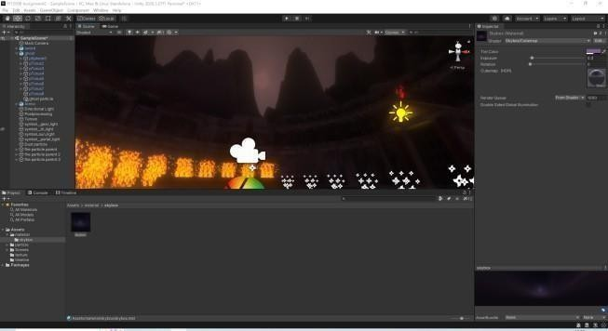
Then I added the bloom, but just a little. I found that strong bloom will influence player’s view. Grain is a good effect here, I added a little to simulate the film.

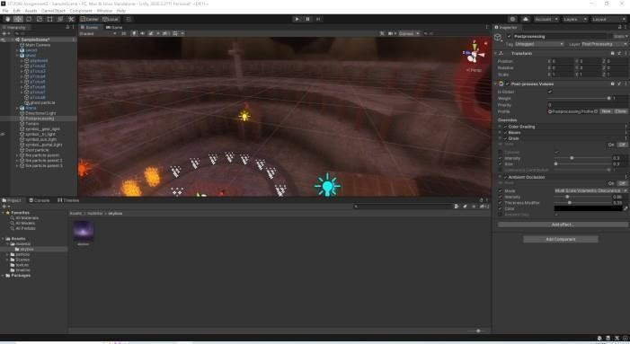
At the end, I gave the ambient occlusion to make my arena closer to real arena. Ambient occlusion can bring the realistic shadow to my scene.

Animation(Moving objects)
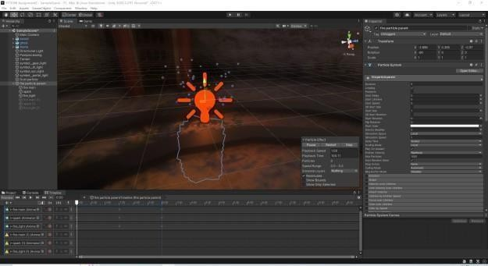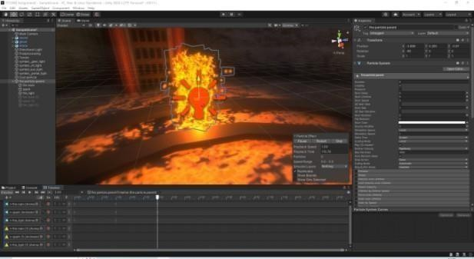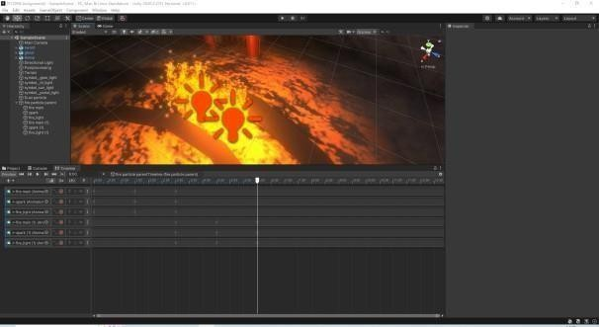
I created my first animation for my fire particle. I reduced the size of spark and intensity of light, put down the fire at the beginning. Then changed them back to original value. At the end, I duplicated to fulfill my fire circle.
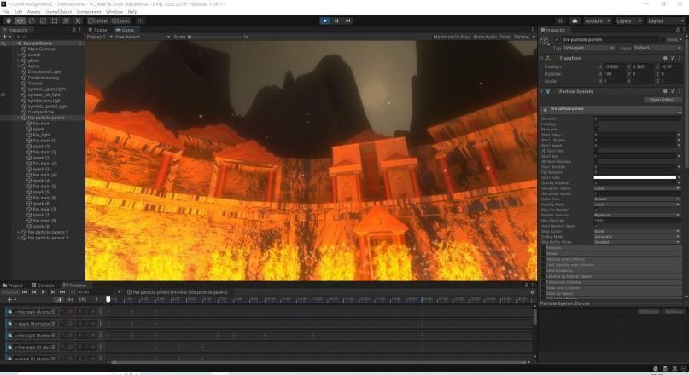
At the end of this animation, I gave higher light intensity to make my scene better.

My second animation is my artifact animation.
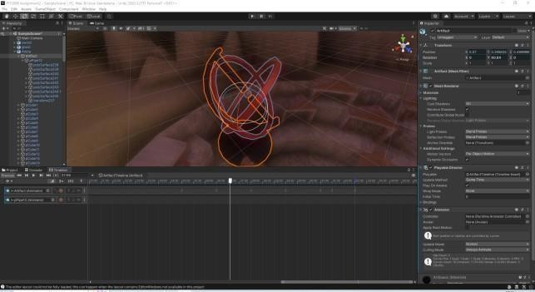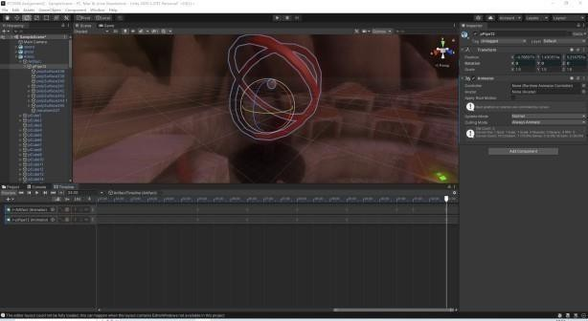
I created an animation track and animated the artifact and core separately. The core will move faster than artifact. I set the artifact to rotate 90 degrees every 3 seconds, but core will rotate 180 degrees every 3 seconds.
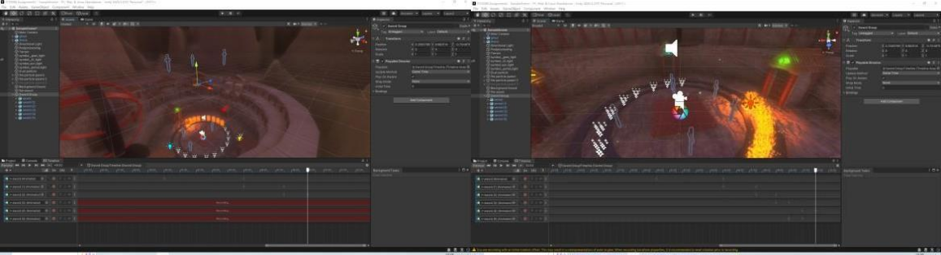
Then I animated the swords. My swords will drop down from sky. So I duplicated 6 swords and put the at the top of camera, then drop down to the ground.
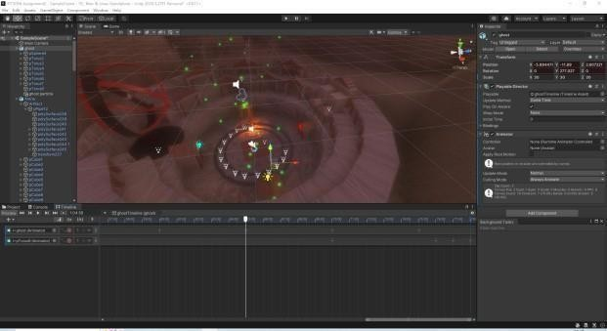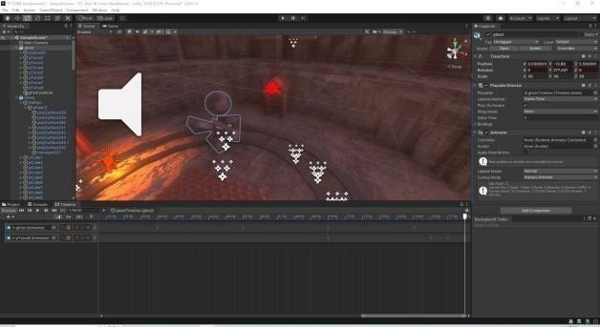

My last animation is ghost animation. This ghost will go around the arena and get closer to user then rotate itself.

