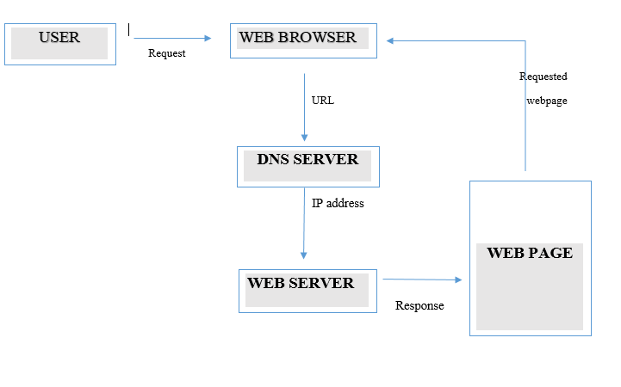

Website is a collection of web pages that are linked together to form a structured document.

**User** requests a website through a **web browser** by typing the domain name. Domain name is the address to get the website and is unique to every website. Web browsers usually interact with IP addresses, so it takes help from the **DNS server**, which is the phonebook of the internet. DNS translates each domain name to IP address, so it will be easier for web browsers to interact with the **web server** in which the website is hosted. So the web browser requests a copy of the **web page** from the server, and finally translating the codes on the web page to present the information on the screen.