**HandsOn1**

import './App.css'

function App() {

  return (

    <>

      <h1>This is my first session</h1>

    </>

  )

}

export default App

**HandsOn 02**

import React from 'react'

function Home() {

  return (

    <div>

      Welcome to Home page student management port

    </div>

  )

}

export default Home

import React from 'react'

function About() {

  return (

    <div>

       Welcome to about page student management port

    </div>

  )

}

export default About

import React from 'react'

function Contact() {

  return (

    <div>

       Welcome to contact page student management port

    </div>

  )

}

export default Contact

import './App.css'

import Contact from './components/Contact'

import About from './components/About'

import Home from './components/Home'

function App() {

  return (

    <>

      <Home/>

      <About/>

      <Contact/>

    </>

  )

}

export default App

**HandsOn 3**

import React from 'react';

import '../Styles/mystyle.css';

function CalculateScore({ Name, School, total, goal }) {

  const perTodec = (val) => {

    return val.toFixed(2) + '%';

  };

  const calScore = (total, goal) => {

    return perTodec(total / goal * 100);

  };

  return (

    <div className="formatstyle">

      <h1 style={{ color: 'brown' }}>Student Details</h1>

      <div className="Name">

        <b><span>Name:</span></b>

        <span>{Name}</span>

      </div>

      <div className="School">

        <b><span>School:</span></b>

        <span>{School}</span>

      </div>

      <div className="Total">

        <b><span>Total:</span></b>

        <span>{total}</span>

        <span> Marks</span>

      </div>

      <div className="Score">

        <b>Score:</b>

        <span>{calScore(total, goal)}</span>

      </div>

    </div>

  );

}

export default CalculateScore;

**HandsOn 4**

class Post {

constructor(id, title, body) {

this.id = id;

this.title = title;

this.body = body;

}

}

export default Post;

import React from 'react';

class Posts extends React.Component {

constructor(props) {

super(props);

this.state = {

posts: [],

error: null

};

}

loadPosts() {

fetch('https://jsonplaceholder.typicode.com/posts')

.then(response => response.json())

.then(json => this.setState({ posts: json }))

.catch(error => this.setState({ error: error }));

}

componentDidMount() {

this.loadPosts();

}

componentDidCatch(error, info) {

alert(`An error occurred: ${error.message}`);

this.setState({ error: error });

}

render() {

return (

<div>

<h1>Posts</h1>

<hr />

{this.state.posts.map(post => (

<div key={post.id}>

<h2>{post.title}</h2>

<p>{post.body}</p>

</div>

))}

</div>

);

}

}

export default Posts;

import React from 'react';

import Posts from './Posts'; // Import the Posts component

import './App.css';

function App() {

return (

<div className="App">

<Posts /> {/* Add the Posts component here */}

</div>

);

}

export default App;

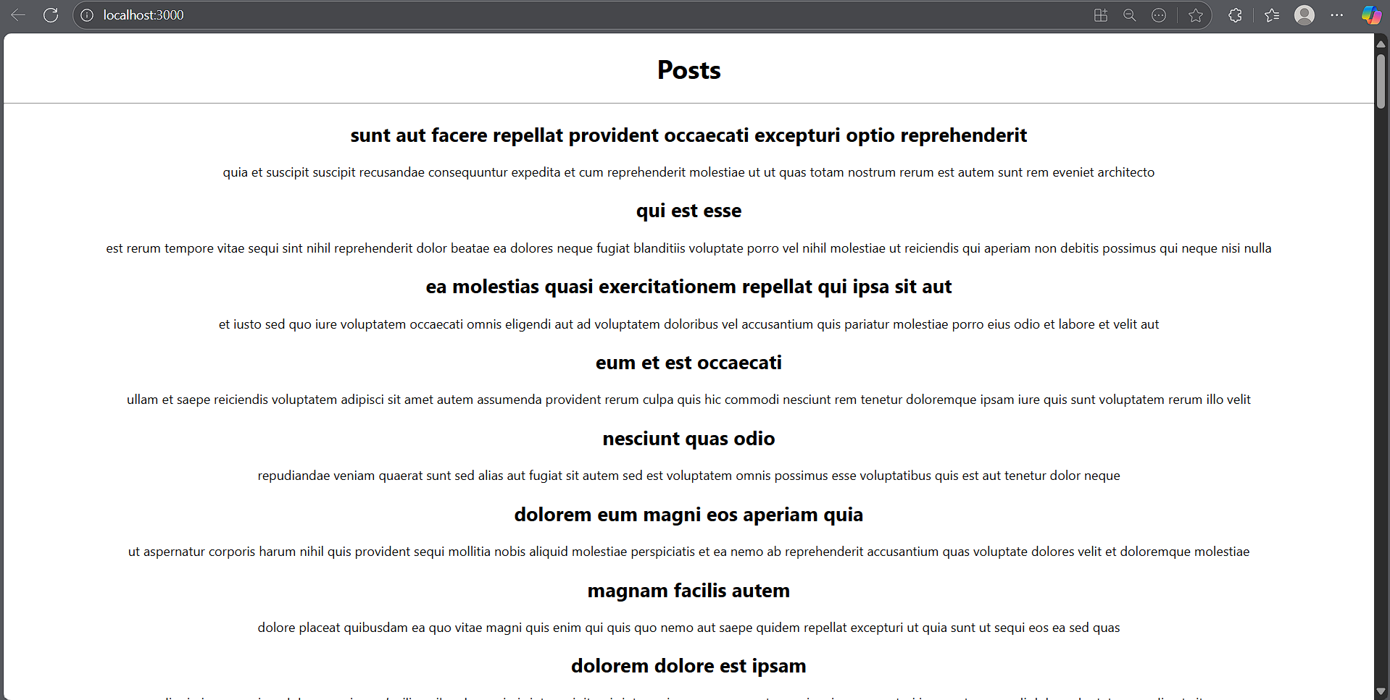

**HandsOn 5**

import styles from './CohortDetails.module.css';

import React from 'react';

function CohortDetails(props) {

const headerStyle = {

  color: props.cohort.currentStatus.toLowerCase() === 'ongoing' ? 'green' : 'blue'

};

    return (

        <div className={styles.box}>

            <h3 style={headerStyle}>

                {props.cohort.cohortCode} -

                <span>{props.cohort.technology}</span>

            </h3>

            <dl>

                <dt>Started On</dt>

                <dd>{props.cohort.startDate}</dd>

                <dt>Current Status</dt>

                <dd>{props.cohort.currentStatus}</dd>

                <dt>Coach</dt>

                <dd>{props.cohort.coachName}</dd>

                <dt>Trainer</dt>

                <dd>{props.cohort.trainerName}</dd>

            </dl>

        </div>

    );

}

export default CohortDetails;

.box {

  width: 300px;

  display: inline-block;

  margin: 10px;

  padding: 10px 20px;

  border: 1px solid black;

  border-radius: 10px;

}

dt {

  font-weight: 500;

}

