**HandsOn 9**

function ListofPlayers() {

const players = [

{ name: 'Jack', score: 50 },

{ name: 'Michael', score: 70 },

{ name: 'John', score: 40 },

{ name: 'Ann', score: 61 },

{ name: 'Elisabeth', score: 61 },

{ name: 'Sachin', score: 95 },

{ name: 'Dhoni', score: 100 },

{ name: 'Virat', score: 84 },

{ name: 'Jadeja', score: 64 },

{ name: 'Raina', score: 75 },

{ name: 'Rohit', score: 80 }

];

const playersBelow70 = players.filter(player => player.score <= 70);

return (

<div>

<h1>List of Players</h1>

<ul>

{players.map((player, index) => (

<li key={index}>Mr. {player.name} {player.score}</li>

))}

</ul>

<hr />

<h1>List of Players having Scores Less than 70</h1>

<ul>

{playersBelow70.map((player, index) => (

<li key={index}>Mr. {player.name} {player.score}</li>

))}

</ul>

</div>

);

}

export default ListofPlayers;

const T20Players = ['First Player', 'Second Player', 'Third Player'];

const RanjiTrophyPlayers = ['Fourth Player', 'Fifth Player', 'Sixth Player'];

export const IndianPlayersList = [...T20Players, ...RanjiTrophyPlayers];

export function OddPlayers({ players }) {

const [first, , third, , fifth] = players;

return (

<div>

<h1>Odd Players</h1>

<ul>

<li>First: {first}</li>

<li>Third: {third}</li>

<li>Fifth: {fifth}</li>

</ul>

</div>

);

}

export function EvenPlayers({ players }) {

const [, second, , fourth, , sixth] = players;

return (

<div>

<h1>Even Players</h1>

<ul>

<li>Second: {second}</li>

<li>Fourth: {fourth}</li>

<li>Sixth: {sixth}</li>

</ul>

</div>

);

}

export function MergedPlayersList({ players }) {

return (

<div>

<h1>List of Indian Players Merged:</h1>

<ul>

{players.map((player, index) => (

<li key={index}>Mr. {player}</li>

))}

</ul>

</div>

);

}

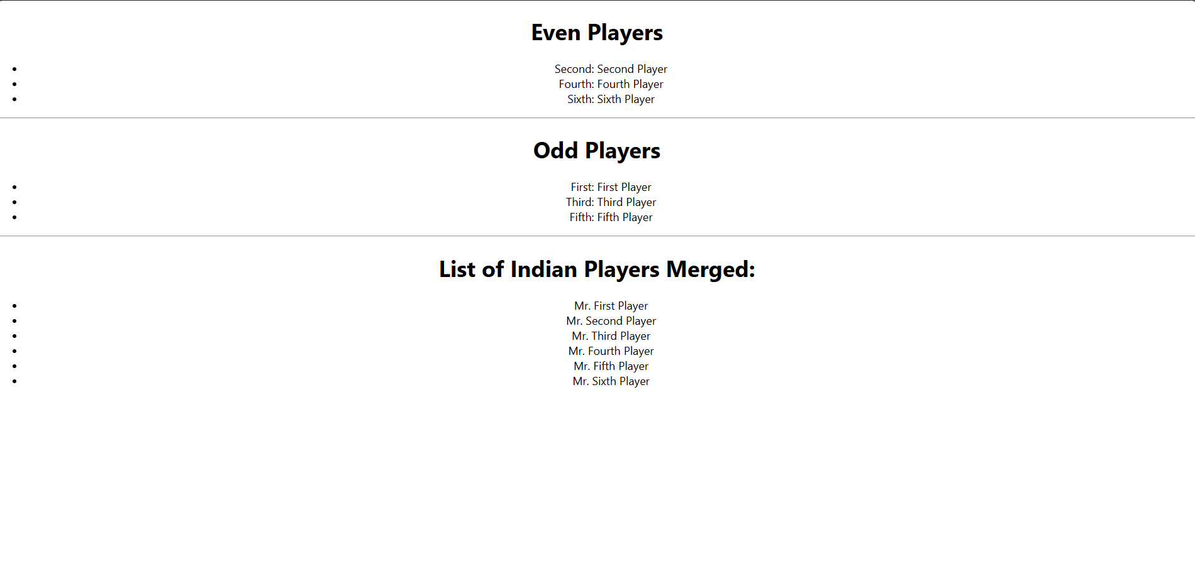

**HandsOn 10**

import './App.css';

function App() {

const heading = 'Office Space, at Affordable Range';

const officeSpaces = [

{

name: 'DBS',

rent: 50000,

address: 'Chennai'

},

{

name: 'WeWork',

rent: 75000,

address: 'Bengaluru'

},

{

name: 'CoWrks',

rent: 59000,

address: 'Mumbai'

}

];

return (

<div className="App">

<h1>{heading}</h1>

<img src="office-space.jpg" width="300px" alt="Modern Office Space" />

{officeSpaces.map((office, index) => {

// 4. Apply CSS based on a condition

const rentStyle = {

color: office.rent <= 60000 ? 'red' : 'green'

};

return (

<div key={index}>

<h2>Name: {office.name}</h2>

<h3 style={rentStyle}>Rent: Rs. {office.rent}</h3>

<h4>Address: {office.address}</h4>

<hr />

</div>

);

})}

</div>

);

}

export default App;

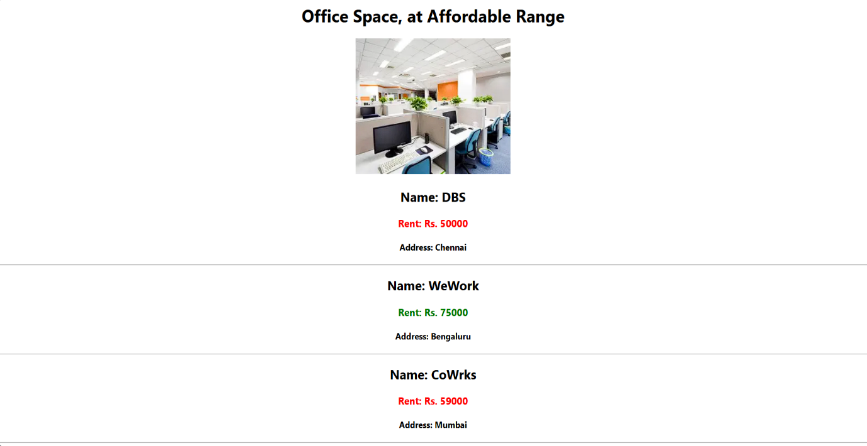

**HandsOn 11**

import React, { useState } from 'react';

function CurrencyConvertor() {

const [rupees, setRupees] = useState('');

const [euros, setEuros] = useState(0);

//Using a fixed rate for this example.

const conversionRate = 90.5;

const handleSubmit = (event) => {

event.preventDefault();

const result = rupees / conversionRate;

setEuros(result.toFixed(2)); // Format to 2 decimal places

};

return (

<div>

<h2>Currency Converter</h2>

<form onSubmit={handleSubmit}>

<input

type="number"

value={rupees}

onChange={(e) => setRupees(e.target.value)}

placeholder="Enter Rupees (INR)"

/>

<button type="submit">Convert</button>

</form>

<h3>Euros (EUR): €{euros}</h3>

</div>

);

}

export default CurrencyConvertor;

import React, { useState } from 'react';

import CurrencyConvertor from './CurrencyConvertor';

import './App.css';

function App() {

const [count, setCount] = useState(0);

const handleIncrement = () => {

setCount(prevCount => prevCount + 1);

alert('Hello! You increased the count.');

};

const handleDecrement = () => {

setCount(prevCount => prevCount - 1);

};

const sayMessage = (message) => {

alert(message);

};

return (

<div className="App">

<h1>Event Handling Examples</h1>

<h2>Counter</h2>

<h3>Count: {count}</h3>

<button onClick={handleIncrement}>Increment</button>

<button onClick={handleDecrement}>Decrement</button>

<hr />

<button onClick={() => sayMessage('Welcome')}>Say Welcome</button>

<button onClick={() => alert('I was clicked')}>Click Me (Synthetic Event)</button>

<hr />

<CurrencyConvertor />

</div>

);

}

export default App;

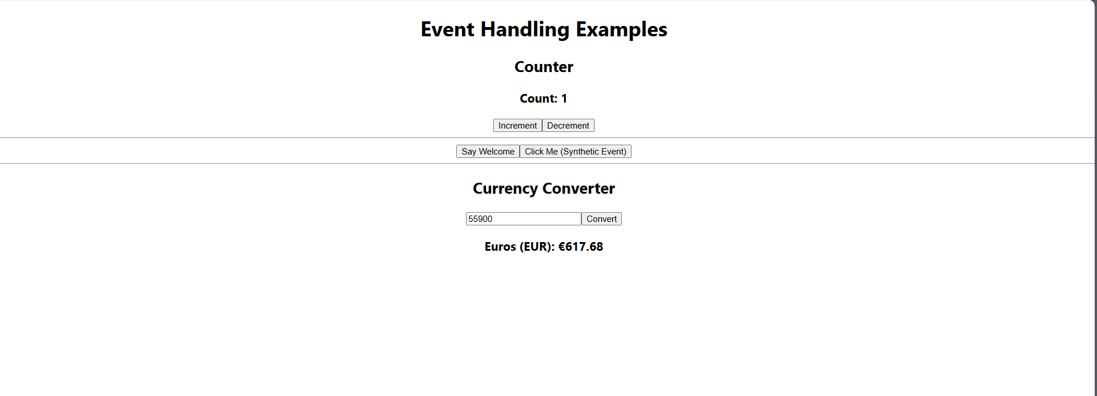

**HandsOn 12**

import React, { useState } from 'react';

import './App.css';

const LoginButton = ({ onClick }) => (

  <button onClick={onClick}>Login</button>

);

const LogoutButton = ({ onClick }) => (

  <button onClick={onClick}>Logout</button>

);

const UserPage = ({ onLogoutClick }) => (

  <div>

    <h1>Welcome back</h1>

    <LogoutButton onClick={onLogoutClick} />

  </div>

);

const GuestPage = ({ onLoginClick }) => (

  <div>

    <h1>Please sign up.</h1>

    <p>Flight Details: Hyderabad to Bengaluru, 8:00 AM</p>

    <LoginButton onClick={onLoginClick} />

  </div>

);

function App() {

  const [isLoggedIn, setIsLoggedIn] = useState(false);

  const handleLogin = () => setIsLoggedIn(true);

  const handleLogout = () => setIsLoggedIn(false);

  return (

    <div className="App">

      {isLoggedIn ? (

        <UserPage onLogoutClick={handleLogout} />

      ) : (

        <GuestPage onLoginClick={handleLogin} />

      )}

    </div>

  );

}

export default App;

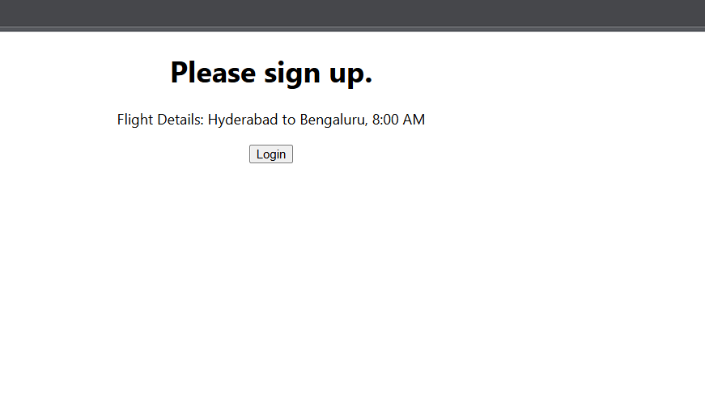

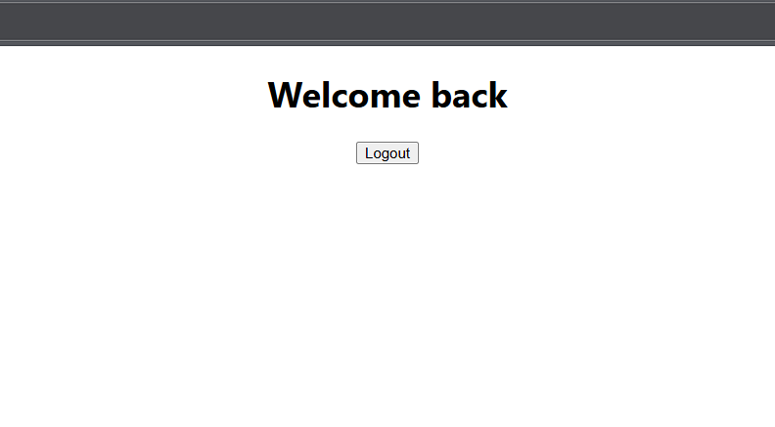

**HandsOn 13**

function BookDetails() {

return (

<div>

<h2>Book Details</h2>

<p>Title: React in Action</p>

<p>Author: Mark Tielens Thomas</p>

</div>

);

}

export default BookDetails;

function BlogDetails() {

return (

<div>

<h2>Blog Details</h2>

<p>Title: Understanding React Hooks</p>

<p>Author: Jane Doe</p>

</div>

);

}

export default BlogDetails;

function CourseDetails() {

return (

<div>

<h2>Course Details</h2>

<p>Course: Fullstack React Bootcamp</p>

<p>Duration: 4 weeks</p>

</div>

);

}

export default CourseDetails;

import { useState } from 'react';

import './App.css';

import BookDetails from './BookDetails';

import BlogDetails from './BlogDetails';

import CourseDetails from './CourseDetails';

function App() {

const [view, setView] = useState('book');

const renderComponent = () => {

if (view === 'book') return <BookDetails />;

else if (view === 'blog') return <BlogDetails />;

else if (view === 'course') return <CourseDetails />;

else return <p>Select a valid view</p>;

};

return (

<div className="App">

<h1>Conditional Rendering in React</h1>

{renderComponent()}

<hr />

{view === 'book' ? <p>Viewing Book</p> : <p>Not viewing book</p>}

{view === 'blog' && <p>You are now viewing a blog</p>}

<hr />

<button onClick={() => setView('book')}>Book</button>

<button onClick={() => setView('blog')}>Blog</button>

<button onClick={() => setView('course')}>Course</button>

</div>

);

}

export default App; 