Read Alberto Cairo’s work, [Graphics Lies, Misleading Visuals](http://infovis.fh-potsdam.de/readings/Cairo2015.pdf)

Locate an example of a misleading visual that uses one or more of the mechanisms for misleading that Cairo outlines in his book chapter: (1) Hiding relevant data; (2) Displaying too much data and obscuring reality; (3) Distorting data through visual forms.

**Covid-19 Misleading visual**

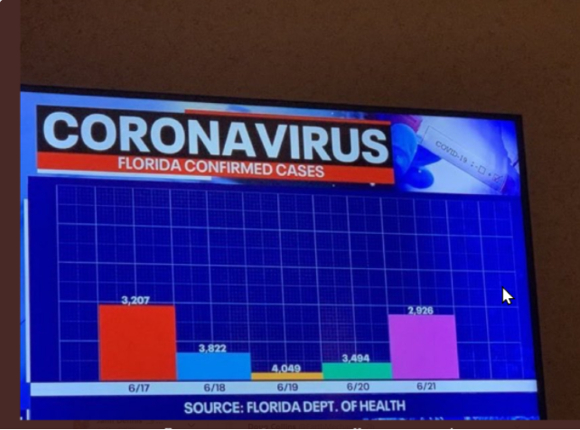

[Image]( https://viz.wtf/image/625905143078141953)

This is a visual which was aired upon television which might create misunderstanding about a serious topic amongst people.

**PROMPT**

1. What is the source of the visual? (e.g., URL or bibliographic citation)
2. Who is the intended audience (i.e., decoders)? How do you know this?

1.**Source of the visual is :**https://viz.wtf

2. As this is a graph representing covid-19 spread of Florida, every individual living in that region can be considered as intended audience. Apart from this , people who are not from that region and are journaling and surveying about corona virus can be intended audience.

- I know about this from my knowledge that if some region specific news is aired then it is mostly for the people living in that state , region or country.

**PROMPT**

1. Identify the specific component(s) of the visual that is/are misleading
2. For each part(s) of the visualization that is/are misleading, identify the mechanism that is used: hiding relevant data to highlight what benefits us; displaying too much data to obscure reality; using graphic forms in inappropriate ways (distorting the data)
3. Explain how the mechanisms are used to mislead

* This graph uses hiding relevant data to highlight what benefits us and using graphic forms in inappropriate ways (distorting data) as it's misleading techniques.
* Here they have shown a bar graph displaying the number of covid-19 positive cases is Florida from 6/17 to 6/21. This information might be misleading as it is only showing data within a specific period of time. They are basically hiding relevant data to highlight what benefits them. To display the current scenario they should have displayed data of longer duration from maybe when they received their first covid-19 positive case. For providing even a better insight upon the information they should have compared their cases with various different countries so that the public viewing can know at which number Florida stands in number of covid-19 positive cases.
* The graph which they have shown uses graphic information in inappropriate manner. Here we can see that on 6/17 the number of covid-19 cases are 3,207 which has a Y-axis height more that the number of cases on 6/18 which are 3,822 which is even greater that the cases on 6/20 which 4,049.This graph makes a U-shaped curve when it was actually supposed to make a bell-shaped curve. Here we can say that the height of the bars should have increased but instead it is decreasing.
* From this we can conclude that this graph hides relevant data and also uses graphic forms in inappropriate ways.