1. Problem statement
This project aims to predict whether a bank client will subscribe to a term deposit based on selected customer and campaign-related variables from the Bank Marketing dataset. The problem is important because banks use direct marketing campaigns to promote financial products, and being able to predict customer response can help improve marketing efficiency and decision-making. In this study, the target variable is y, which indicates whether the client subscribed to the term deposit.

2. Project objective
The main objective of this project is to analyze customer and marketing data and build a dataset that can be used to predict term deposit subscription outcomes. Specifically, the project focuses on identifying patterns in selected variables such as age, job, balance, housing loan, personal loan, call duration, number of campaign contacts, and previous campaign outcome. The project also aims to prepare the dataset for classification modeling and provide insights into which factors may influence customer subscription behavior.

3. Data source
The dataset used in this project is the Bank Marketing dataset from the UCI Machine Learning Repository. This is a public dataset containing information related to direct marketing campaigns conducted by a Portuguese banking institution. For this project, the file used is bank-full.csv, which includes customer demographic information, financial indicators, and campaign-related attributes. This dataset was chosen because it is suitable for binary classification and provides enough variables for preprocessing, exploratory data analysis, and model development.

4. Data collection methodology
The data for this project was collected from a public secondary source rather than through direct surveys, APIs, or web scraping. The dataset was downloaded in CSV format from the UCI Machine Learning Repository and imported into Google Colab for analysis. Since the dataset was already structured and labeled, the data collection process mainly involved obtaining the file, selecting relevant variables, and preparing the dataset for further preprocessing and analysis. This approach is appropriate for the project because it allows the team to focus on data mining techniques rather than primary data gathering.

5. Dataset description
The dataset contains customer and campaign-related information used to predict whether a client subscribes to a term deposit. For this project, only a selected subset of variables was used in order to keep the scope manageable and focused. The chosen variables are age, job, balance, housing, loan, duration, campaign, and poutcome, with y used as the target variable. These variables were selected because they represent a mix of demographic, financial, and campaign outcome information that may influence customer response to marketing efforts.

6. Data schema / structure
The project dataset can be organized into three main groups of variables. The first group consists of numeric variables, including age, balance, duration, and campaign. The second group consists of categorical variables, including job, housing, loan, and poutcome. The third group is the target variable, y, which indicates whether the client subscribed to a term deposit. This simple structure helps organize the dataset clearly and supports preprocessing and classification modeling.

7. Data preprocessing
Several preprocessing steps were performed to prepare the dataset for analysis and modeling. First, only the selected variables relevant to the project scope were retained from the original dataset. Next, the dataset was checked for missing values, duplicates, and data type consistency. Binary categorical variables such as housing, loan, and y were converted into numerical form using 0 and 1 encoding. In addition, multi-category variables such as job and poutcome were transformed using one-hot encoding to make them suitable for machine learning models. After preprocessing, the cleaned dataset was saved as a new file for use in the modeling stage.

8. Exploratory data analysis (EDA)
Exploratory Data Analysis was conducted to better understand the patterns and distributions within the selected variables before model building. The analysis included examining the distribution of the target variable, customer age, account balance, job categories, and previous campaign outcomes. Visualizations such as bar charts and histograms were used to identify class imbalance, common customer characteristics, and possible relationships between selected features and subscription outcomes. This step was important because it helped reveal trends in the data and provided a better understanding of which variables may influence customer behavior.

9. EDA interpretation
The exploratory analysis showed that the number of customers who did not subscribe to a term deposit was much higher than the number who did subscribe, indicating class imbalance in the dataset. The age distribution suggested that most customers were within the adult and middle-aged range. The balance variable appeared unevenly distributed, with many lower values and a smaller number of very high balances, suggesting a right-skewed pattern. The job-based comparison indicated that subscription behavior may differ across occupational categories. In addition, the previous campaign outcome appeared to be related to current subscription decisions, suggesting that past marketing interactions may influence future responses.

10. Cleaned dataset handoff statement
After preprocessing was completed, the cleaned dataset was exported as bank_cleaned.csv for use in the modeling stage. This file contains the selected variables in machine-learning-ready form, including encoded categorical features and the target variable y. The cleaned dataset was then prepared for handoff to the second team member, who is responsible for classification modeling, model comparison, and evaluation. This division of work supports parallel progress and improves project efficiency.

11. Limitation statement
One limitation of this project is the inclusion of the variable duration, which represents the length of the last contact with the customer. Although this variable may be highly predictive of subscription outcome, it is only known after the call has taken place. This means that while it may improve model performance, it may be less practical for predicting outcomes before a marketing call is completed. This limitation should be considered when interpreting the results and can be discussed as part of the project’s future work or recommendations.

Exploratory Data Analysis (EDA)

Figure 1. Distribution of customers who subscribed and did not subscribe
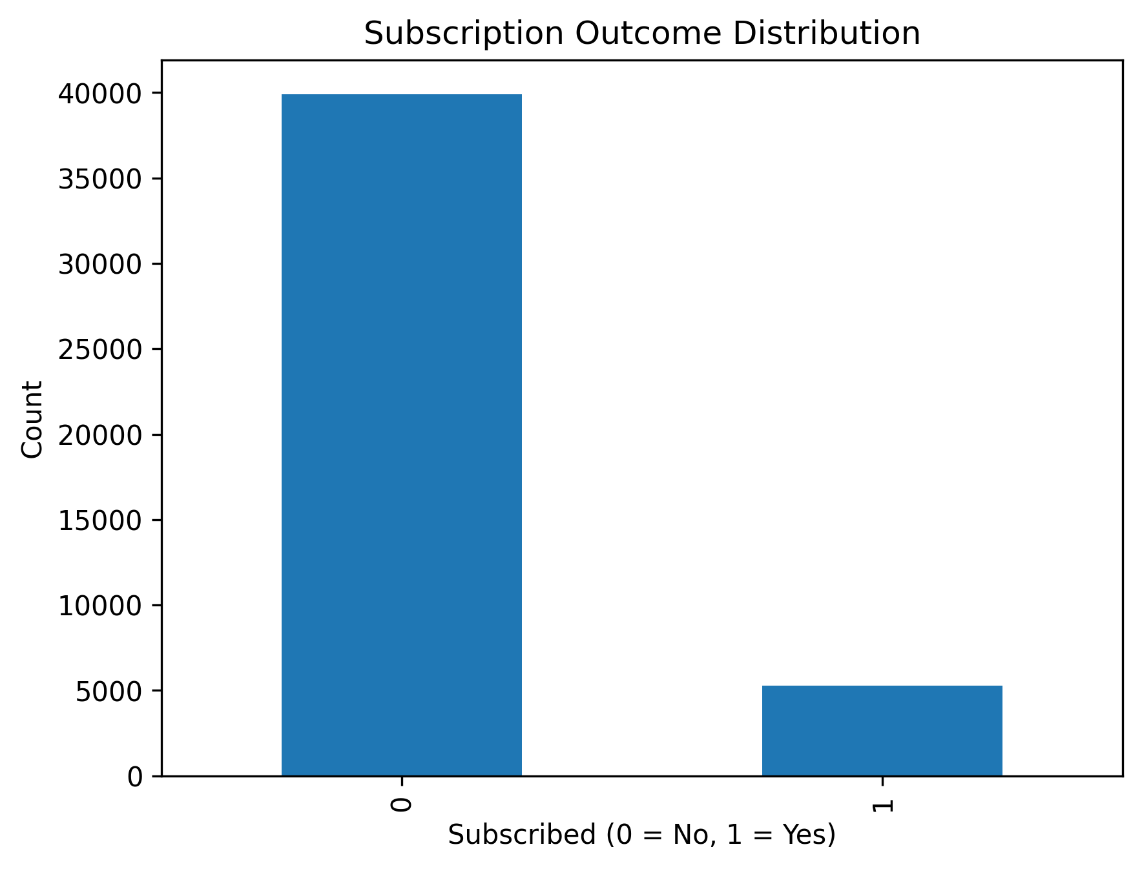

Figure 2. Age distribution of bank customers
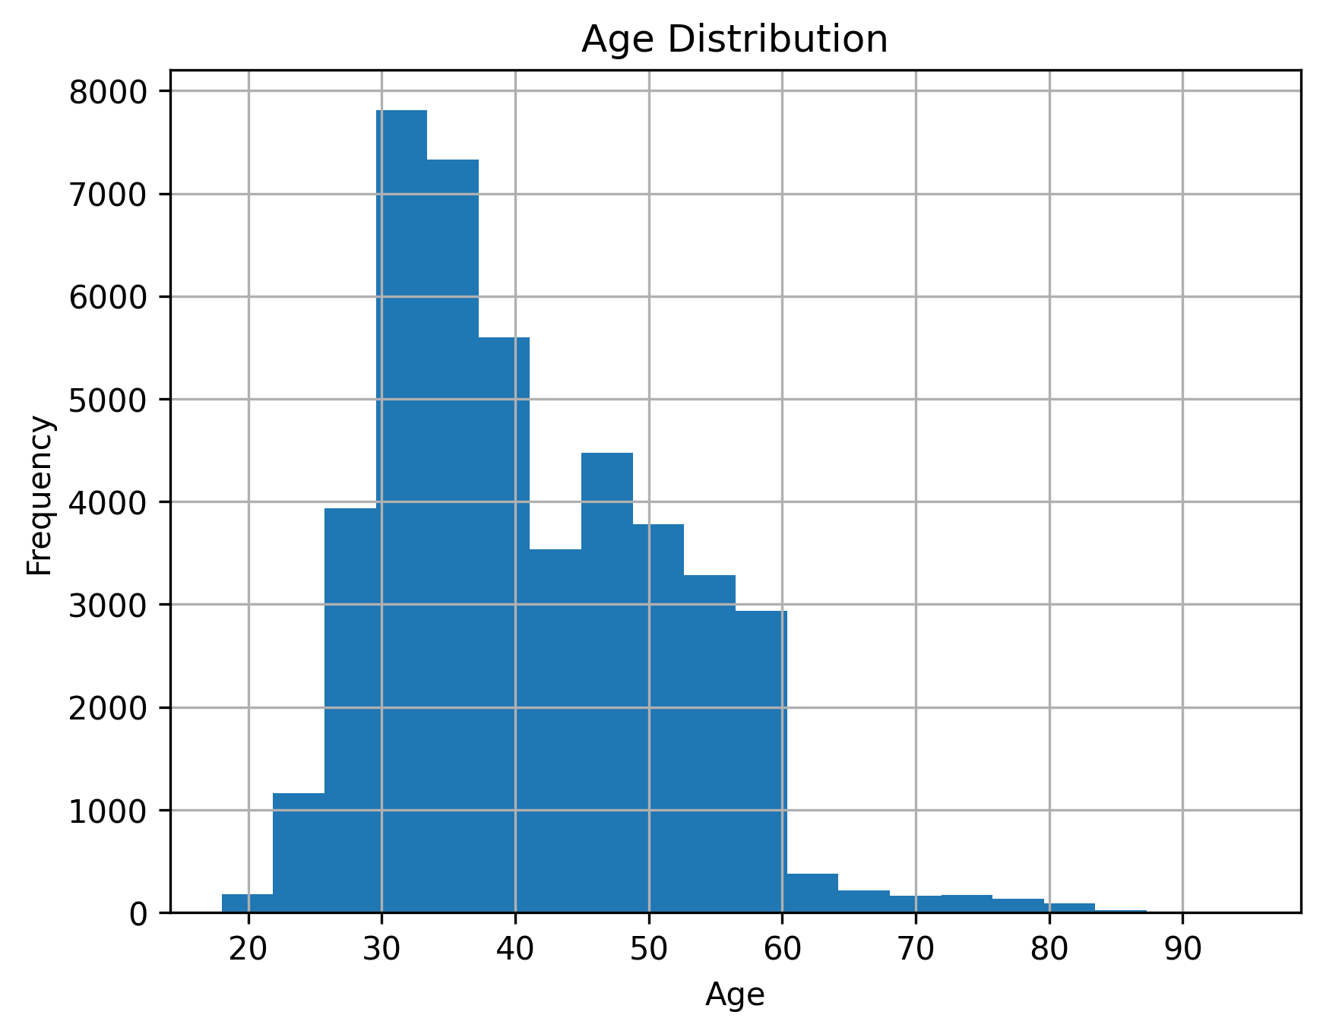

Figure 3. Distribution of customer account balance
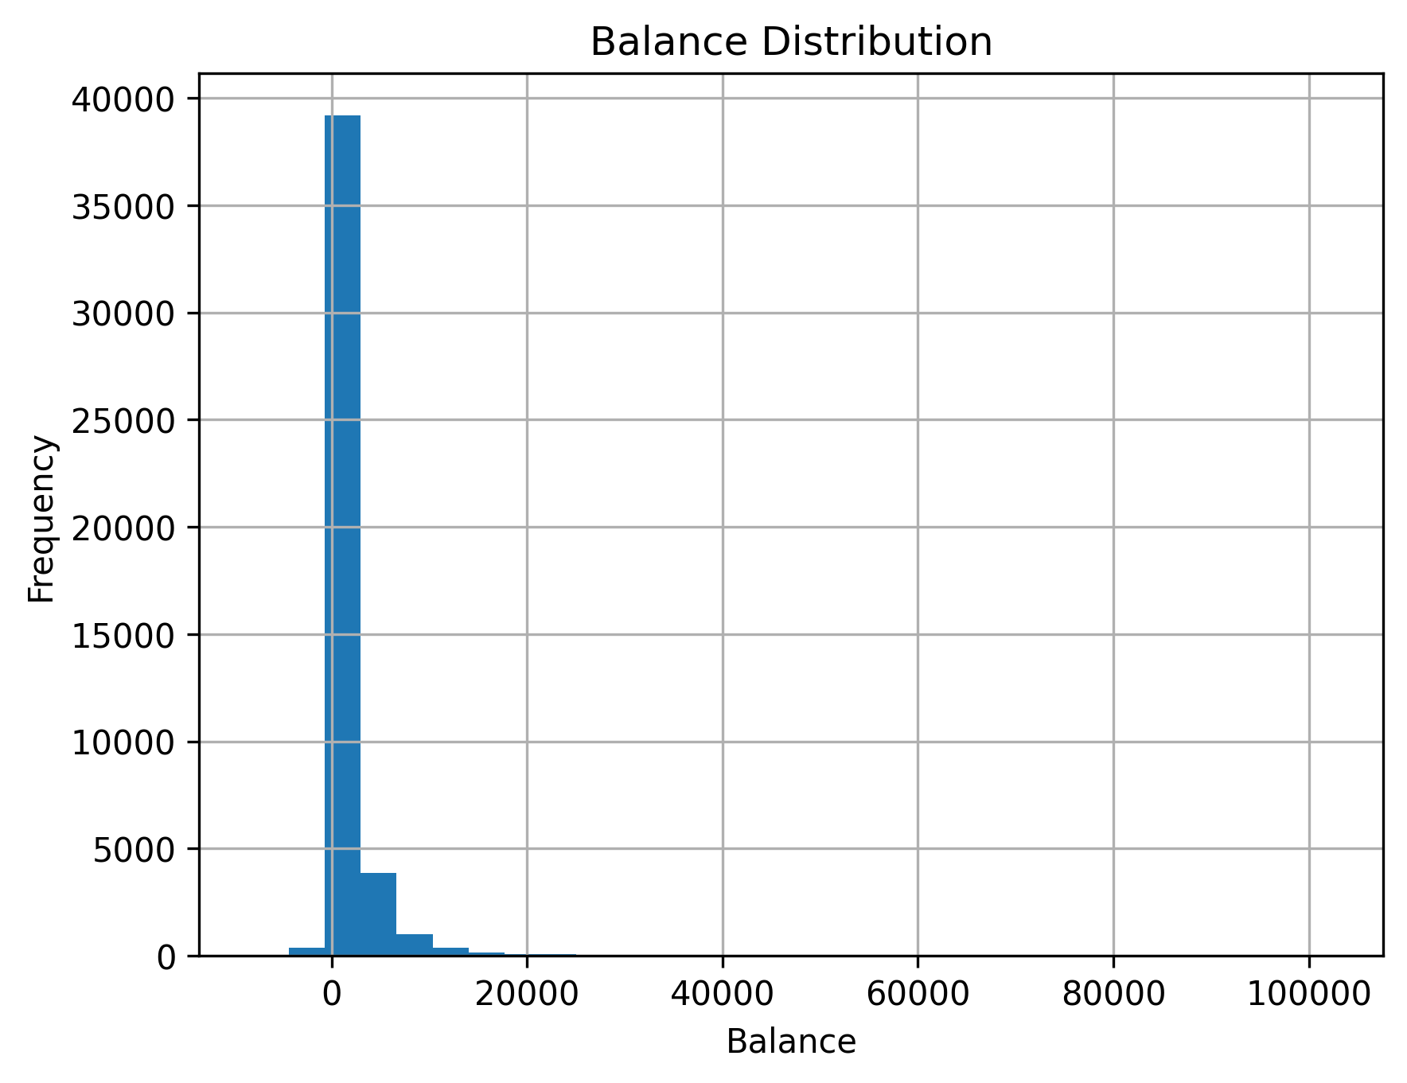

Figure 4. Relationship between job type and subscription outcome
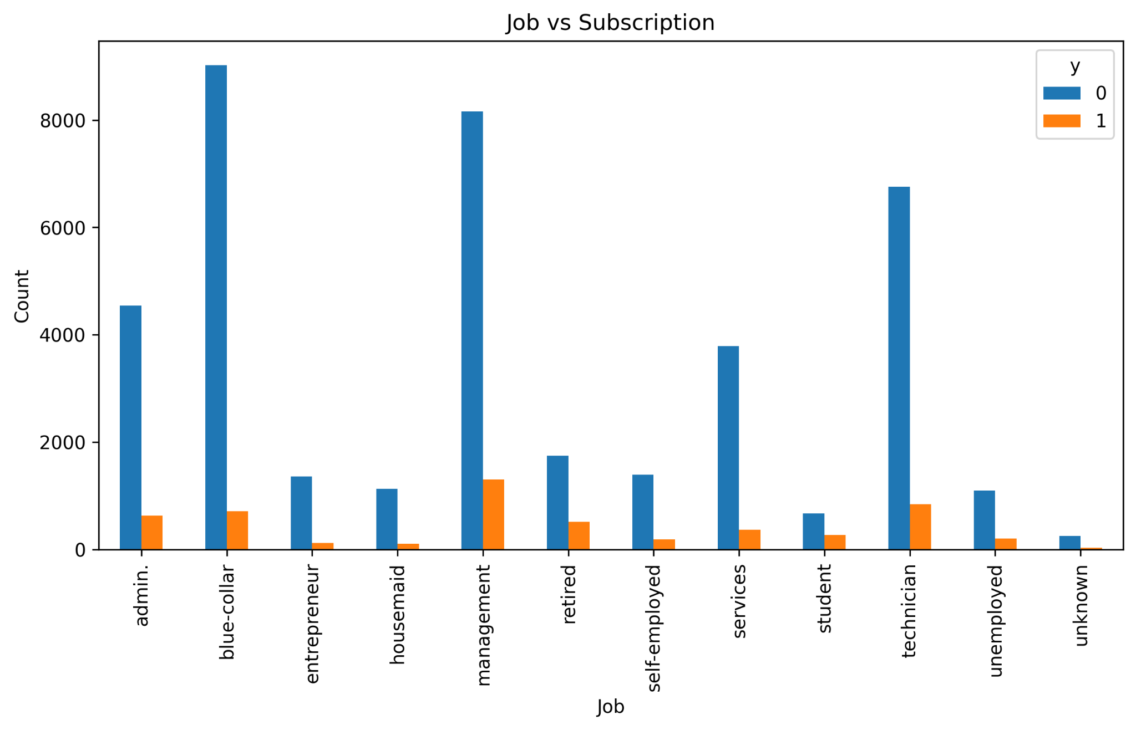

Figure 5. Relationship between previous campaign outcome and subscription outcome
