STARTUP FAILURE PREDICTION
USING FUNDING TRAJECTORIES
An Explainable Machine Learning Approach

AI in Finance Course – CSF 3127

Mahathi Subramanian – 240958037
Vritika Vinod – 240958035

Abstract
This project examines whether observable startup funding trajectories contain information that can help distinguish companies labelled as operating from companies labelled as failed. Company-level funding features are derived from funding-round histories and evaluated using supervised classification. The implemented dashboard compares Logistic Regression, Random Forest and Extra Trees and presents the model output as an Operating or Failed classification. In the current model-comparison experiment, Logistic Regression provides the strongest minority-class detection among the three evaluated models at the fixed 0.50 threshold: it identifies 3 of the 8 failed companies in the out-of-fold predictions, whereas the two tree ensembles identify none. Although Random Forest has the highest overall accuracy (95.3%), its failure recall is zero, illustrating why accuracy alone is inadequate for this imbalanced dataset. The results should be interpreted as an exploratory classification exercise rather than a validated forecast of future failure. The final modelling workbook contains 169 companies, including 8 labelled failed and 161 labelled operating. The earlier project draft describes a broader 1,106-company pool; the precise filtering and reconciliation between these populations must be documented from the data-preparation records before submission.
Keywords: startup failure, funding trajectories, venture capital, imbalanced classification, Logistic Regression, explainable machine learning, investor decision support.

1. Introduction

1.1 Background and motivation
Startups contribute to economic activity through innovation, employment and the development of new products and services. At the same time, young companies operate under uncertainty and may face constraints related to capital availability, market adoption and the ability to sustain operations. Investors therefore assess more than the total amount of capital a startup has raised. The sequence and timing of funding rounds, changes in round size, progression across funding stages and participation by investors may also provide useful context about a company’s financing history.
A funding trajectory represents the pattern of financing observed over time. Two companies with similar cumulative funding may have very different trajectories: one may have raised several rounds at regular intervals, while another may have had a long gap after its last observed round. These patterns motivate the use of engineered trajectory features rather than relying only on a single cumulative funding figure.

1.2 Aim and problem statement
The aim of this project is to build and test a machine-learning method that uses available company data and funding history to sort startups by their recorded status: Operating or Failed. The project also builds an investor dashboard that lets users look at a startup profile see a model classification compare how the model works and test records at once with a CSV file.
The task is a status classification problem that relies on the labels that're already in the dataset. This task is not, in its form a proven early-warning system that can predict a future failure at a fixed past date. The status labels that are available are static. This project has not set a clear historical cutoff that makes sure all predictor data were known before the outcome.

1.3 Objectives
- Understand how the observable funding features change between failed and operating startups.
- Create funding trajectory features using the round dates, funding amounts, stage and investors.
- Identify useful features to differentiate between closed and operating companies.
- Build and compare supervised machine learning classifiers.
- Calculate the performance using metrics appropriate to a imbalanced outcome variable. These include precision, recall, F1-score and PR-AUC.
- Analyse the model using SHAP.

1.4 Research questions
- RQ1: How do observable funding-trajectory characteristics differ between companies labelled Operating and Failed?
- RQ2: Which funding-trajectory features are useful to the evaluated classifiers when distinguishing the two recorded statuses?
- RQ3: Which of the evaluated machine-learning models provides the most useful classification performance for the minority Failed class?
- RQ4: How can model outputs be presented in an investor-facing interface while communicating uncertainty and limitations?

1.5 Scope and contribution
The project focuses on structured company-level information and observed funding-round histories. The implemented dashboard supports individual startup assessment, model selection, classification-threshold adjustment, batch CSV prediction and display of model metrics. The intended contribution is an integrated workflow that combines funding-trajectory feature engineering, minority-class-aware model evaluation and an accessible interface for exploratory investor screening.

2. Literature Review

2.1 Overview
The project looks at company data and the history of funding rounds. The dashboard that was built helps people examine one startup at a time pick a model change the classification threshold run predictions from a CSV file and show how the model is doing. The goal is to give a path that joins the way funding history is turned into useful features tests the model while paying attention to the small group of cases and offers a friendly interface for investors to explore.

The system does not replace legal or commercial due diligence. The tools that are ready do not capture everything that matters, such as how a founder can run a company, how well a product fits a market, how the company is governed how customers stay how good the revenue is or other reasons why a startup might fail. The project should therefore be seen as a helper, for decision making not as a tool that tells investors what to do on its own.

2.2 Summary of research contributions and gaps
Research paper | Contribution to the present project | Research gap relative to this project
CapitalVX: A Machine Learning Model for Startup Selection and Exit Prediction (2021) | This paper uses Crunchbase venture capital and start-up data to predict various outcomes relating to the start-up, including failure, IPO/acquisition, staying private and receiving further funding. This is the most relevant to our target variable, with the use of company funding data. | CapitalVX has a wide range of features and exit types, however, we have simplified the outcome variable to whether the company was closed or open. We have also ensured that the features used relate to engineering features around company funding. The abstract can also provide support for our outcome and funding prediction task. However, any features mentioned in the SHAP section should be confirmed by reading the full paper.
Predicting the Success of Startups Using a Machine Learning Approach (2024) | This paper investigates the use of machine learning and explainability techniques to predict the success of a start-up. This is relevant to our paper as it provides information on comparing models and interpreting feature importance using SHAP and permutation importance | The study looks at predicting the success of start-ups but we have focused more on funding rounds throughout this project. We have also clearly defined our negative class as being closed companies. Any feature importance claims (i.e., last raised amount was very important) should be confirmed by looking at the results tables/figures within the paper.
Using Machine Learning to Demystify Startups’ Funding, Post-Money Valuation, and Success (2021/2022) | Ang, Chia and Saghafian build a model based on Crunchbase funding information and descriptions of startups, to predict post money valuations and probabilities of success for startups. This considers funding, geographical and sector aspects. | They look at valuations and general success factors (such as acquisition or IPO). In this project we are not looking at valuations but instead at whether a startup is closed or operational using features of trajectories across rounds.
How to Succeed in the Market? Predicting Startup Success Using a Machine Learning Approach (2023) | We focus on valuations and common success factors, such as acquisitions or IPOs. We focus on whether the startup is closed or active based on features of trajectories through different rounds. | This paper looks at macro factors relating to startup success and industry characteristics. In this project we look at funding trajectories at the company level and the binary outcome of closed/open. The summary doesn’t indicate that variables at the city level are independently significant.
A Machine Learning, Bias-Free Approach for Predicting Business Success Using Crunchbase Data (2021) | In this paper, they tackle the look-ahead bias problem explicitly by limiting the predictors to information available at the time of the prediction. This work is relevant when designing a realistic prediction experiment. Among the features identified as important are country/region and industry. | This paper forecasts business success from a large sample of data from Crunchbase. However, this project has taken heed of the warning of temporal leakage by Sharchilev and colleagues when creating features for the funding trajectory.
Web-Based Startup Success Prediction (2018) | Sharchilev and colleagues explore predicting success of startups online and predicting future funding based on initial seed/angel investment. This provides evidence that factors other than total cumulative funding can be used to predict startup success. | The aim of this study is highly related to securing further investment and does not necessarily indicate business failure or success. Instead a binary variable has been created based on the status of the company. The observed funding rounds have been analysed.
A Machine Learning Approach to Entrepreneurial Finance Modelling (2023) | Berre explores how machine learning and segmentation can be applied to entrepreneurial finance. Including selecting startups, valuing and survivability. Factors that may affect the success are identified including revenue, risk, firm age, financial accessibility, industry, business model, geographical and intellectual property | This is a conceptual chapter and therefore does not directly test the variables within this projects funding trajectory. A number of concepts have been implemented into this project based on the available data regarding companies and funding rounds.
Machine Learning-Based Prediction of Startup Success and Using Founder’s Background and Funding Features (2025) | This conference paper aims to predict successful startups based on founder characteristics and funding characteristics. This is an interesting example of using funding characteristics alongside founder/team characteristics | The variables provided by this dataset do not seem to provide enough detail regarding founder characteristics to include in the project. Therefore, only funding and company characteristics were considered. The full text for the source used for this draft was not available, therefore it is important to check the detailed methods and findings of the paper before making specific claims.
Startup Success Predictor: A Machine Learning-Based Forecasting Framework for Early-Stage Venture Assessment (2026) | This is a paper describing the comparison between models using Logistic Regression, SVM, Random Forest and Gradient Boosting on startup data (from 2026). | This project will look at a similar set of classifiers. However, it focuses on the available funding trajectory variables. This means that the data isn’t very detailed (as it has been made available). I would recommend referring to the proceedings paper to check any claims about the performance.
A Leakage-Controlled, Calibration-First Evaluation of Machine Learning Models for Startup-Outcome Prediction (2026) | Khamphukun and Narkbunnum evaluate startup outcome models using a leakage controlled and calibration first approach. The authors show that by removing correlated features and survivorship bias accumulating features, the apparent prediction performance decreases. This shows that there is a risk of over optimism. | Rather than a new approach to modelling funding trajectories, this paper represents a recent methodological benchmark. We must also decide on an observation cut-off, try to eliminate the incorporation of post-outcome information and take into account calibration as well as discrimination.
Predicting the Outcome of Startups: Less Failure, More Success (2016) | In this work, Krishna, Agrawal and Choudhary suggest a method to predict the outcome of startups based on various factors such as size and time to seed funding and Series A funding. | This allows for a milestone based approach to be taken. This study uses engineering features such as round count, time period funded, between round gap and amount funded to look into the funding history of the company. Where possible.
Machine Learning for Liquidity Risk Modelling: A Supervisory Perspective (2022) | This study compares machine learning techniques to a conventional statistical benchmark, to classify liquidity risk in Portuguese banking institutions. Overall it supports the application of supervised classification techniques and model comparisons when assessing financial risks. | This is a completely different application (liquidity risk in banks) and so serves more as an indirect source of information about methodologies. It is also a very different target and data structure than what we are considering here.
Machine Learning and Company Failure Prediction: Evidence from South Africa (2025) | This paper compares various machine learning techniques with traditional logit analysis to predict company failure on a sample of South African listed companies. The results show that no one machine learning technique is best at predicting the failure of companies each year. | This study considers only listed companies rather than start-ups, and therefore considers a small sample size (N=56). This can be an issue when comparing models using start-up level funding data as there are few failures in the current project.
Predicting Business Bankruptcy: A Comparative Analysis with Machine Learning Models (2024) | This study considers only listed companies rather than start-ups, and therefore considers a small sample size (N=56). This can be an issue when comparing models using start-up level funding data as there are few failures in the current project. | Our paper considers corporate bankruptcy and traditional macro/financial firm level variables. However, our current project exploits the unique characteristics of startups and pays close attention to the minority class of failed startups.
Does ESG Predict Business Failure in Brazil? An Application of Machine Learning Techniques (2024) | Kaleem et al studied 235 Brazilian businesses and used machine learning and PCA on 40 variables. They found that ESG related factors can be useful in predicting business failure. This shows that including untraditional characteristics of a business can provide more information.. | This study does not consider startups. It focuses on existing Brazilian companies and ESG factors. This project takes into account non-financial contextual factors (such as sector and country) where possible but focuses on financial aspects of investment.

2.3 Research gap and project positioning
The reviewed work establishes that startup outcomes and business failure can be studied using structured company, funding and contextual variables. The project is positioned more narrowly around features derived from observed funding-round sequences, including round counts, disclosed funding amounts, timing gaps, stage progression and investor participation. It also places emphasis on the minority Failed class rather than relying on overall accuracy alone.
A key methodological issue identified in the literature is the risk of look-ahead or survivorship bias. If a feature is calculated using information recorded after a company’s failure or after the point at which an investor would have made a decision, it may make a classifier appear more useful than it would be in a genuine prospective setting. The current implementation recognises this limitation but does not claim to have solved it.

3. Methodology

3.1 Research design
The project uses a supervised binary-classification design. Each company is represented by a set of company-level and funding-trajectory features and a binary status label. In the modelling workbook used for the dashboard, model_label = 0 represents Operating and model_label = 1 represents Failed. The classifier learns patterns associated with these labels and returns a class prediction based on a model score and a decision threshold.

3.2 Dataset and sample definition
The initial report draft describes a broader population of 1,106 companies with at least one dated funding round: 52 labelled closed/failed and 1,054 labelled operating, with acquired and IPO companies excluded. The final filtered workbook used in the dashboard is a different, smaller modelling sample of 169 companies: 161 Operating and 8 Failed. These figures must not be presented as though they describe the same sample. The data-preparation history should be used to document exactly which filters, exclusions, joins or completeness requirements reduced the broader pool to the final 169-company file.
Dataset stage | Companies | Operating | Failed | Interpretation
Broader population described in initial draft | 1,106 | 1,054 | 52 | Draft-level population; filtering lineage needs to be documented.
Final filtered modelling workbook used by dashboard | 169 | 161 | 8 | Population on which the reported dashboard model comparison is based.

The final modelling sample is highly imbalanced: Failed companies represent approximately 4.7% of the 169 observations. This class distribution makes accuracy alone an inadequate measure of model usefulness. It also means that cross-validation folds contain very few Failed examples, so the reported minority-class metrics can vary substantially with a different sample or split.

3.3 Data preprocessing
The modelling data contains company-level funding features derived from funding-round information. The final model file contains numeric trajectory variables and the binary target label. Data preparation should be described using the actual preprocessing script or notebook, including duplicate handling, missing-value treatment, invalid values, transformations, scaling and any feature exclusions. Do not state that a preprocessing operation was performed unless it is confirmed in the code used to generate the final modelling file.
One feature, rounds_per_company_year, was entirely missing in the final data and was excluded. Any feature with extensive missingness or unreliable interpretation should be reviewed before model fitting. The treatment of missing values must be consistent between training data and new records uploaded to the dashboard.

3.4 Funding-trajectory feature engineering
The feature set is designed to represent several dimensions of a company’s observed funding history. The variables include:
Feature group | Examples from final feature set | Purpose
Funding frequency | observed_funding_rounds; dated_funding_rounds; rounds_per_observed_funding_year | Number and frequency of observed financing events.
Funding magnitude | observed_total_funding_usd; average_round_amount_usd; median_round_amount_usd; largest_round_amount_usd | Scale and distribution of disclosed funding.
Timing and duration | observed_funding_span_days; company_age_at_first_observed_round_years; company_age_at_last_observed_round_years | Length and age context of observed financing activity.
Inter-round gaps | average_days_between_observed_rounds; median_days_between_observed_rounds; funding_gap_std_days; last_funding_gap_days; prior_funding_gap_median_days | Spacing and variability between observed rounds.
Funding progression | disclosed_amount_growth_first_to_last; recent_vs_previous_round_amount_growth; recent_round_amount_share_of_total | Changes in disclosed round amounts across the observed sequence.
Funding slowdown | funding_slowdown_ratio; funding_gap_change_days | Change in the time between rounds.
Stage progression | distinct_funding_stages; latest_observed_stage; stage_advances_observed; highest_observed_stage_rank; distinct_known_stage_levels | Observed progression across financing stages.
Investor participation | average_investor_count_per_round; max_investor_count_in_round; investor_count_change_first_to_last; investor_count_growth_first_to_last; investor_participation_trend | Breadth and change in investor participation.
Disclosure / context | amounts_disclosed_share; total_news_mentions; founded_year | Availability of disclosed funding amounts and limited company context.

Funding amounts are not disclosed for every round in many startup datasets. Therefore, amount-based variables describe disclosed amounts rather than necessarily representing the complete economic funding history. Gap-based variables also depend on the availability and accuracy of funding dates. Companies with only one dated round cannot have an inter-round gap calculated; such values may remain missing and require the preprocessing treatment documented in the implementation.

3.5 Exploratory data analysis
The analysis should describe the class distribution, the number of observed funding rounds, funding amounts, funding stages, inter-round gaps, missingness and relationships among engineered variables. The final report should include only charts that were actually generated from the final 169-company modelling file. The following figures are recommended for insertion if they exist in the project outputs:
- Class distribution (Operating versus Failed).
- Distribution of observed funding-round counts.
- Distribution of disclosed total funding (with a suitable scale or transformation).
- Funding-gap distribution or comparison by recorded status.
- Missing-value overview for the main trajectory features.
- Correlation heatmap for selected numeric features.
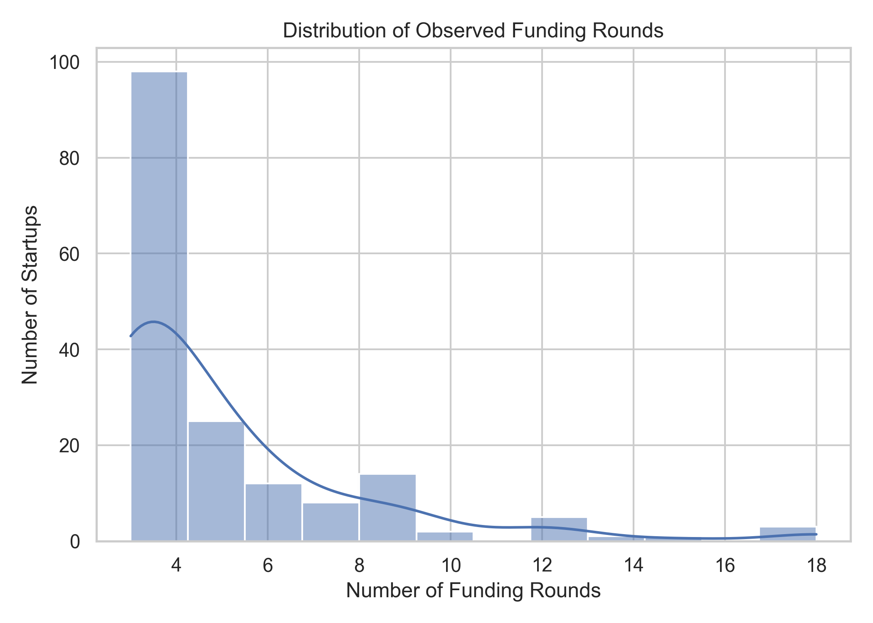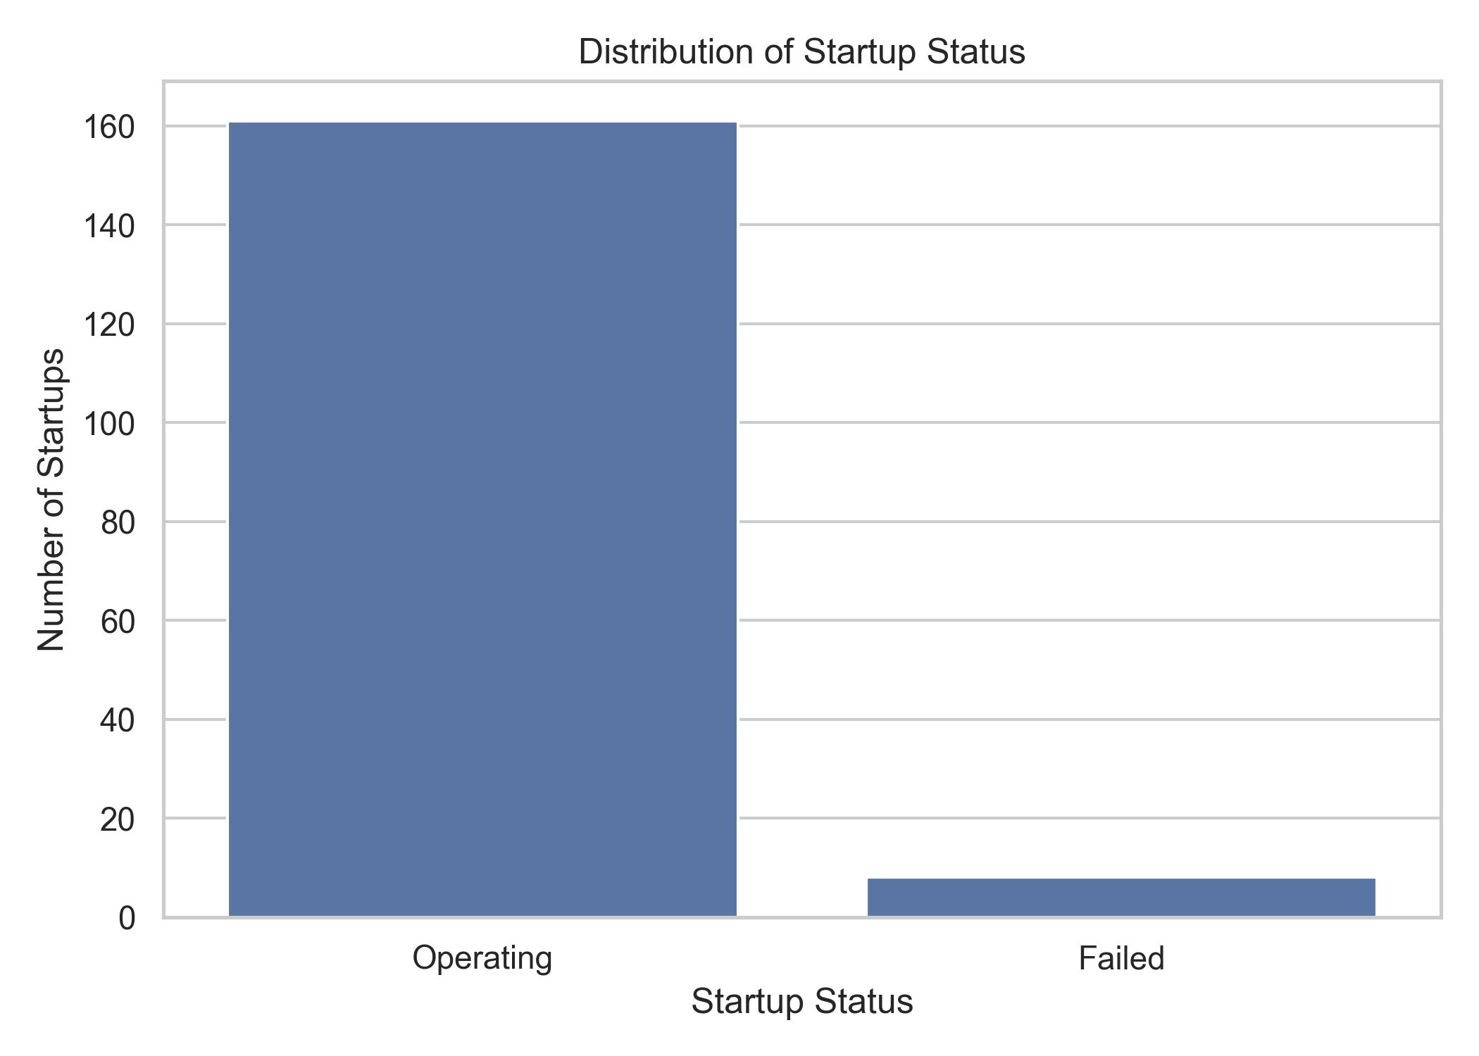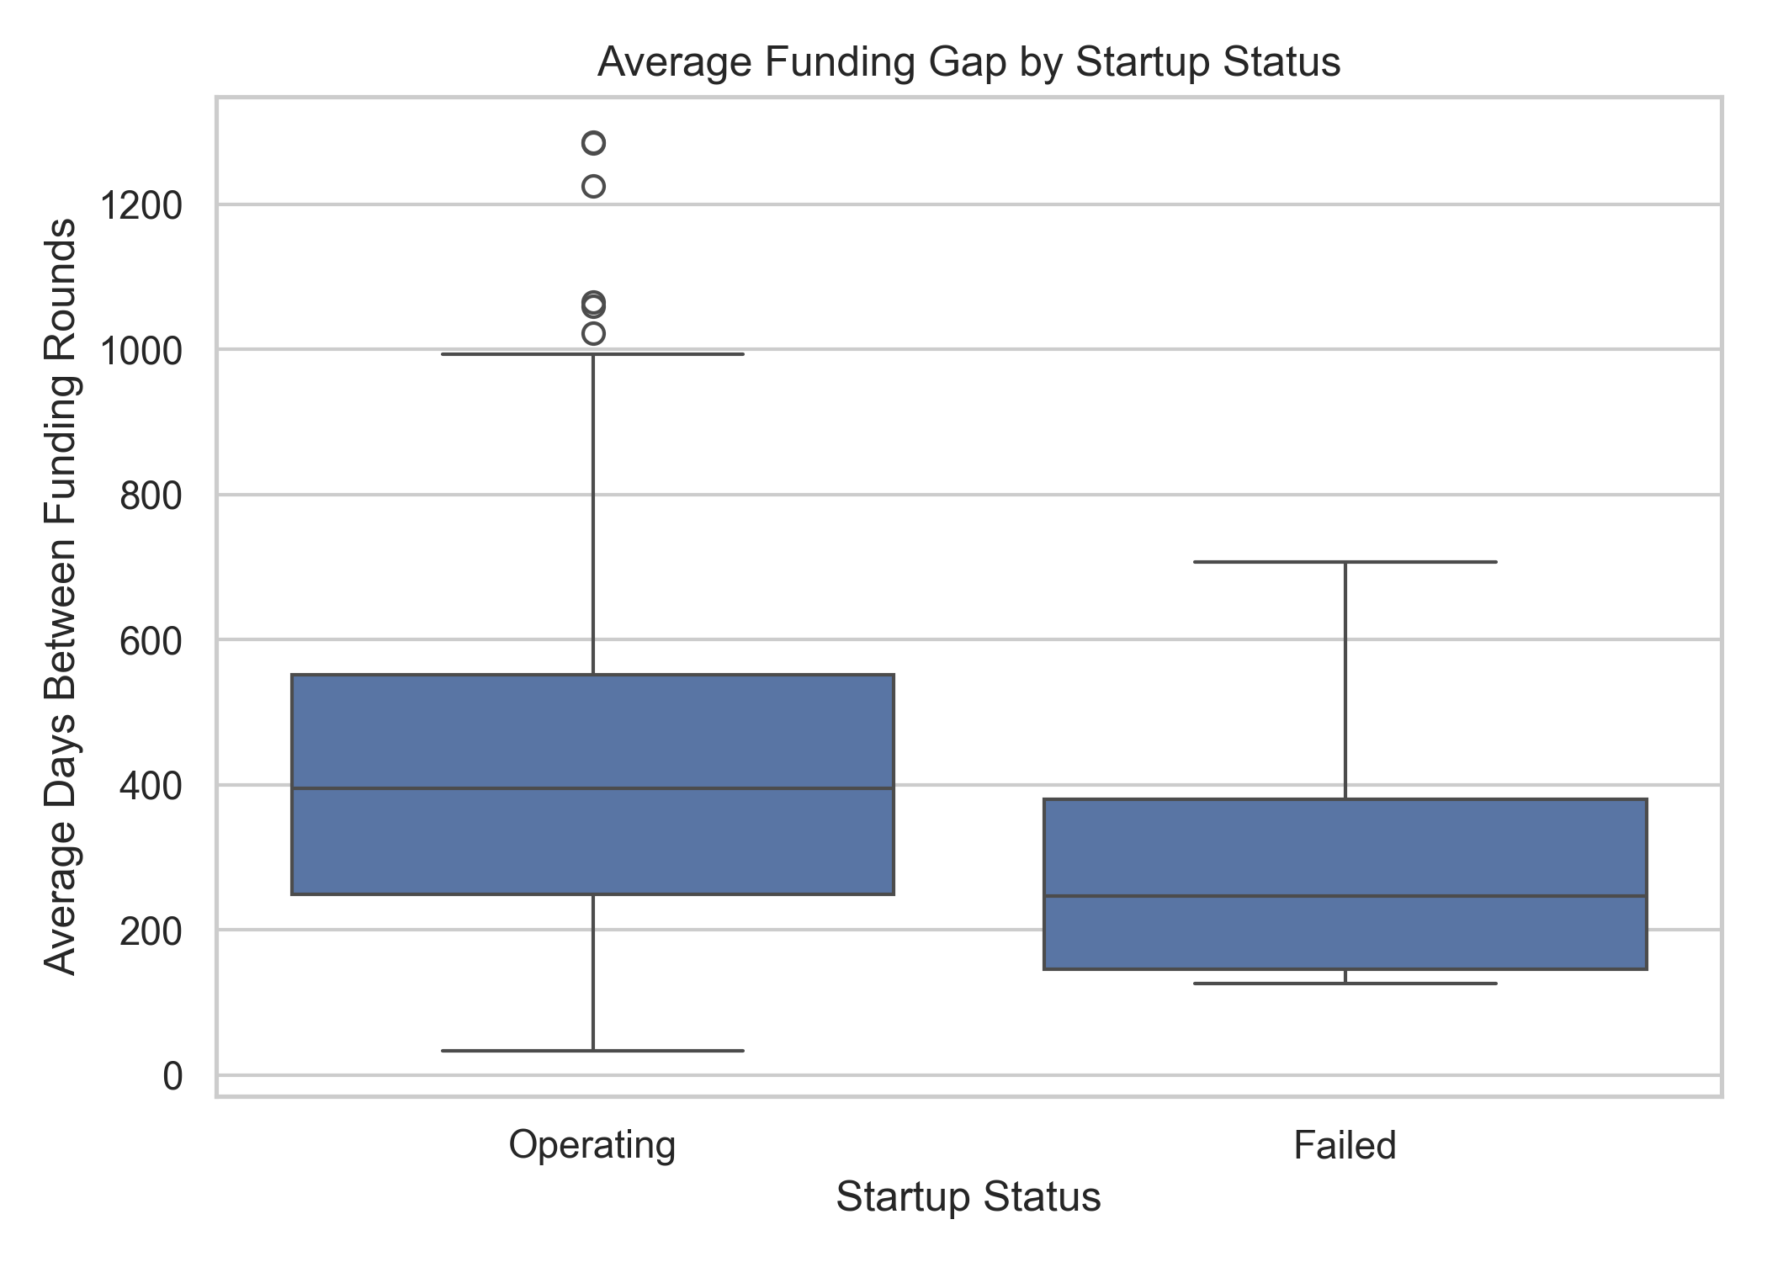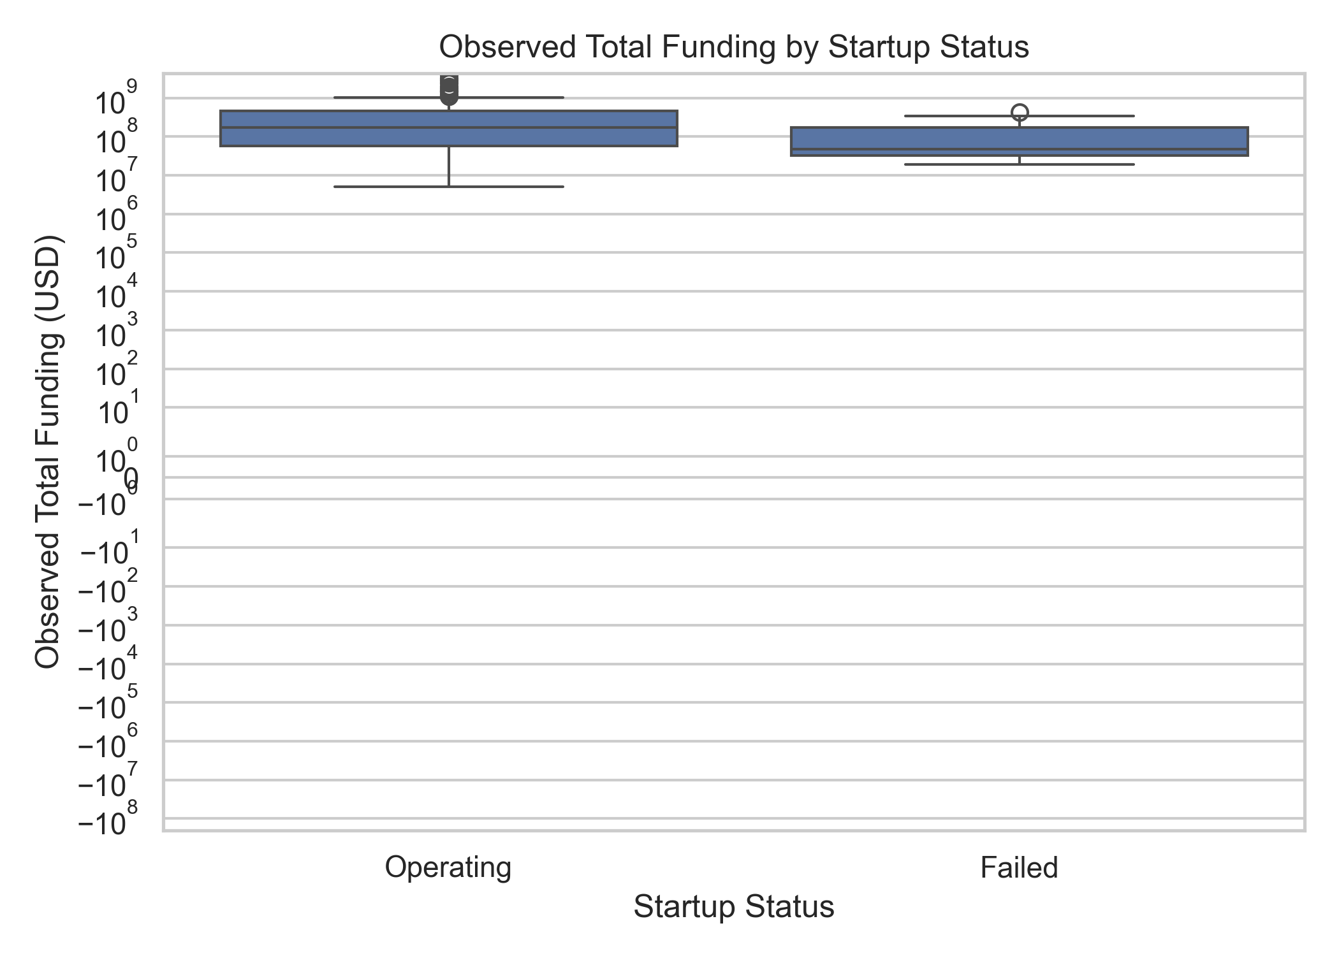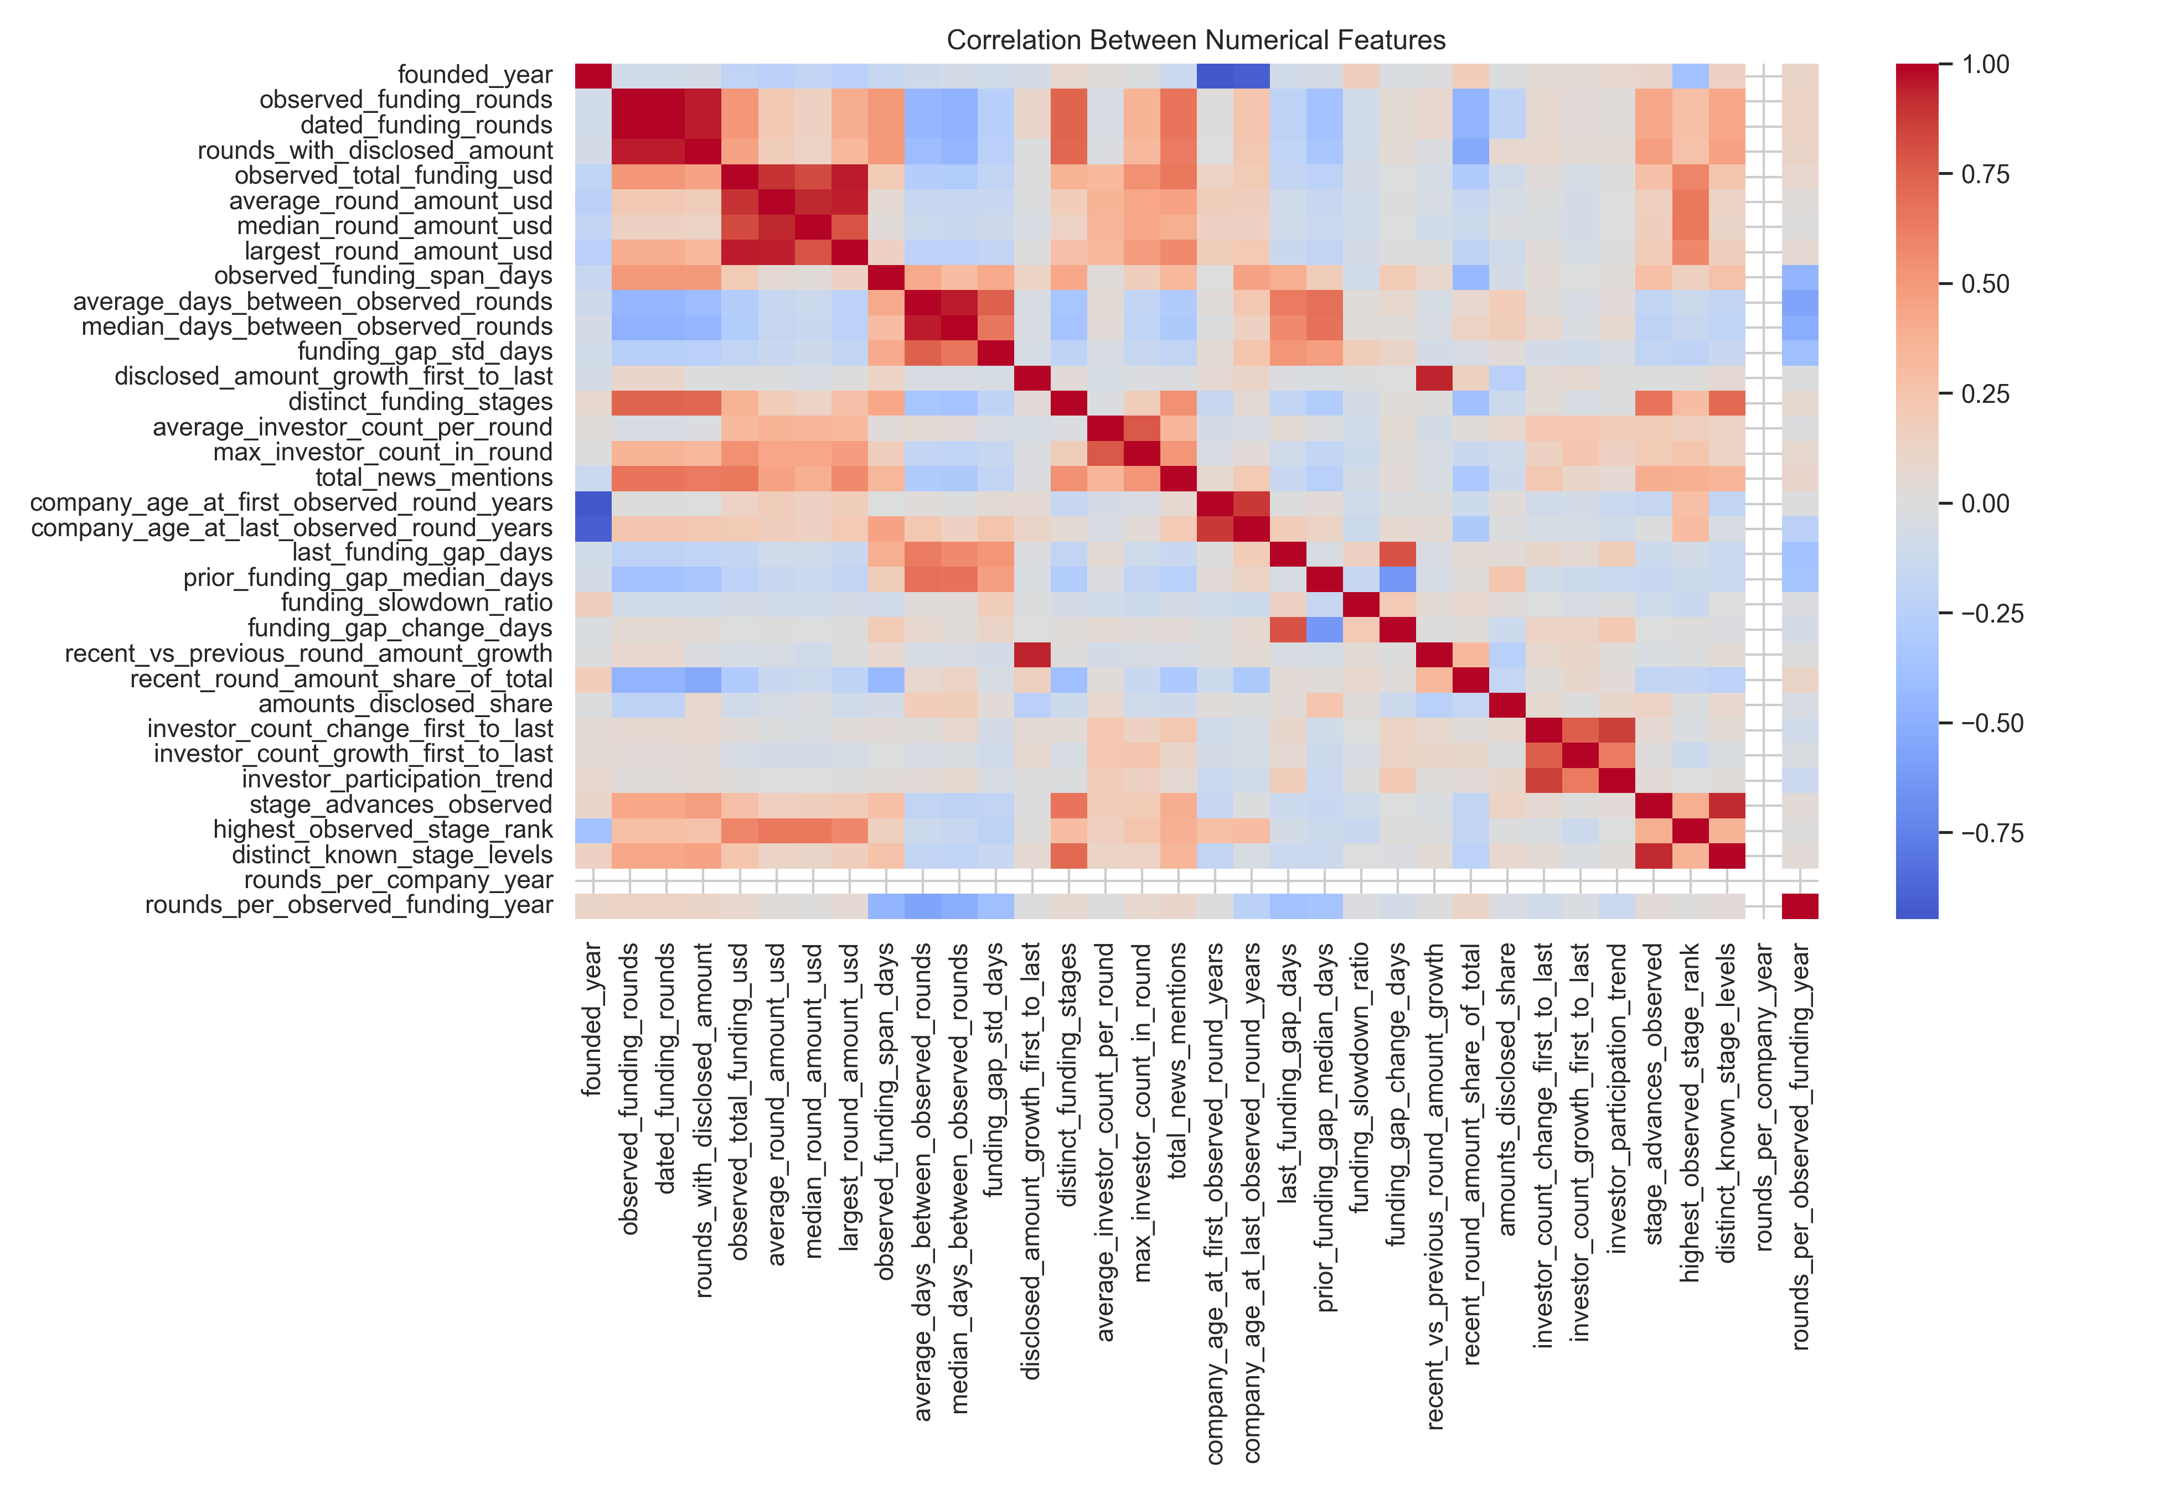

3.6 Model development
Three classifiers were evaluated in the final dashboard comparison:
Model | Role in the comparison | Interpretation
Logistic Regression | Interpretable linear baseline. | Provides a relatively simple decision boundary and is useful as a benchmark.
Random Forest | Tree-ensemble model. | Combines multiple decision trees and can represent nonlinear patterns and interactions.
Extra Trees | Randomised tree-ensemble model. | Uses additional randomisation in tree construction and provides a second ensemble comparison.

The reported comparison uses four-fold stratified cross-validation with shuffling and random_state = 42. Out-of-fold predictions are pooled to calculate the reported metrics. All three models are compared at a fixed classification threshold of 0.50. These results are cross-validation results, not results from a separate untouched holdout test set.

3.7 Evaluation metrics
Metric | Meaning in this project
Accuracy | Share of all companies classified correctly. Can be misleading when most observations belong to Operating.
Balanced accuracy | Average of recall for the two classes; gives equal weight to Operating and Failed recall.
Failure precision | Among companies predicted Failed, the share that are labelled Failed.
Failure recall | Among all companies labelled Failed, the share correctly identified.
Failure F1-score | Harmonic mean of failure precision and failure recall.
ROC-AUC | Measures ranking discrimination across thresholds using the ROC curve.
PR-AUC / Average Precision | Summarises the precision-recall trade-off and is particularly informative for a rare positive class.
Confusion matrix | Counts true negatives, false positives, false negatives and true positives.

3.8 Explainability and dashboard interpretation
The dashboard presents feature-level sensitivity information by changing one feature at a time relative to a typical training-cohort reference and observing how the model score changes. This is a model-sensitivity view. It is not a SHAP analysis, does not estimate causal effects and should not be described as a formal decomposition of an individual prediction. The initial project draft proposed SHAP, but the current dashboard implementation described here uses one-feature-at-a-time sensitivity. Unless a genuine SHAP computation and its plots are added to the implementation, references to SHAP as a completed method should be removed or framed as future work.
The dashboard’s numeric output should be called a model score or failure score, not a calibrated real-world probability. A threshold slider changes the classification boundary: scores at or above the selected threshold are classified as Failed, while scores below it are classified as Operating. Changing the threshold changes the classification rule; it does not calibrate the score.

3.9 Methodology workflow
- Data collection: Startup and funding information was collected from Crunchbase.
- Preprocessing: The data was cleaned and filtered to prepare the modelling sample.
- Feature engineering: Funding-round records were transformed into numerical features describing funding behaviour.
- Dataset preparation: Companies were assigned Operating or Failed labels.
- Validation: Four-fold stratified cross-validation was used to evaluate model performance.
- Model development: Logistic Regression, Random Forest and Extra Trees were compared.
- Evaluation: Multiple metrics were used, with particular attention to identifying Failed startups.
- Deployment: The model outputs were integrated into the StartupLens dashboard.

4. Results and Discussion

4.1 Final modelling sample
The final modelling workbook used by the dashboard contains 169 companies, of which 161 are labelled Operating and 8 are labelled Failed. The Failed class therefore accounts for approximately 4.7% of the sample. This severe imbalance is important when interpreting the results: a model can obtain high accuracy by predicting the majority Operating class while failing to identify any Failed companies.

4.2 Model comparison
Table 4 reports the four-fold stratified cross-validation results using pooled out-of-fold predictions and a fixed threshold of 0.50.
Metric | Logistic Regression | Random Forest | Extra Trees
Accuracy | 89.35% | 95.27% | 94.67%
Balanced accuracy | 64.71% | 50.00% | 49.69%
Failure precision | 18.75% | 0.00% | 0.00%
Failure recall | 37.50% | 0.00% | 0.00%
Failure F1-score | 0.250 | 0.000 | 0.000
ROC-AUC | 0.747 | 0.543 | 0.479
PR-AUC / Average Precision | 0.162 | 0.093 | 0.063

4.3 Confusion matrix interpretation
Model | True negatives (TN) | False positives (FP) | False negatives (FN) | True positives (TP)
Logistic Regression | 148 | 13 | 5 | 3
Random Forest | 161 | 0 | 8 | 0
Extra Trees | 160 | 1 | 8 | 0

Logistic Regression correctly identifies 3 of the 8 Failed companies, corresponding to 37.5% failure recall. It also produces 13 false positives, meaning that some Operating companies are classified as Failed at the 0.50 threshold. Random Forest and Extra Trees classify almost all observations as Operating and identify none of the 8 Failed companies. Their high overall accuracy therefore does not translate into useful failure detection at this threshold.
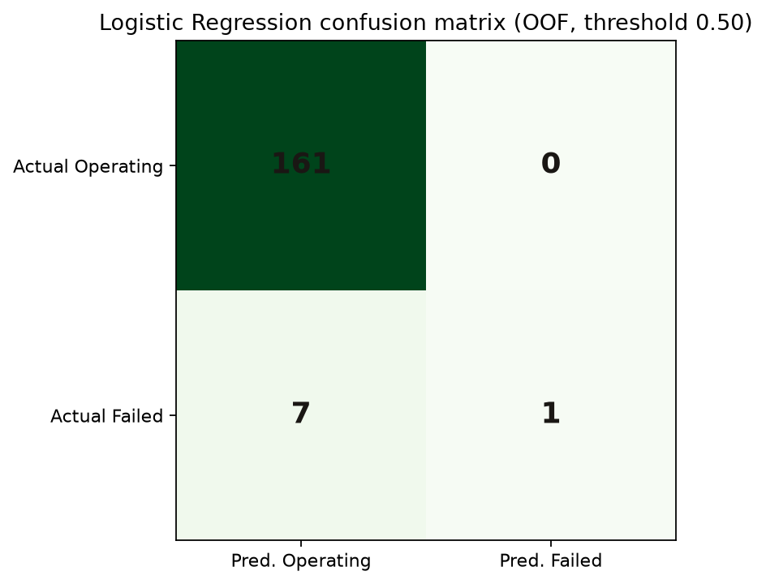

4.4 Selection of the primary model
Logistic Regression is selected as the primary model for the current dashboard comparison because it provides the strongest minority-class detection among the three evaluated models at the fixed 0.50 threshold. It has the highest balanced accuracy (64.71%), failure recall (37.50%), failure F1-score (0.250), ROC-AUC (0.747) and PR-AUC (0.162).
Random Forest has the highest accuracy at 95.27%, but its failure recall is zero because it predicts no Failed companies. Extra Trees also has zero failure recall. Given the purpose of screening for possible failure cases, the Logistic Regression result is more informative despite its lower overall accuracy. This does not establish that Logistic Regression will generalise well to a larger or future population; the small number of Failed observations makes the estimates uncertain.

4.5 Discussion of findings
The main result is the difference between majority-class accuracy and minority-class detection. The ensemble models appear strong when judged by accuracy, but their confusion matrices show that they do not detect the minority Failed class at the selected threshold. This illustrates why the evaluation includes balanced accuracy, failure precision, failure recall, F1-score and PR-AUC in addition to accuracy.
The Logistic Regression model offers a more balanced result in this experiment, but its failure precision is only 18.75%. In practical terms, most companies it flags as Failed are not labelled Failed in this sample. This limits the model’s suitability as a standalone decision rule. It may be used as an initial screening signal only when followed by human review and further due diligence.
The PR-AUC value of 0.162 should be interpreted in the context of the low prevalence of Failed companies (approximately 4.7%). The ROC-AUC of 0.747 suggests better ranking discrimination than the two tree ensembles in this experiment, but it does not mean that the model’s output is a calibrated probability or that it can accurately forecast future failure.

4.6 Threshold and classification behaviour
The dashboard allows the user to change the classification threshold. At the default threshold of 0.50, a model score greater than or equal to 0.50 is labelled Failed and a score below 0.50 is labelled Operating. A lower threshold may classify more companies as Failed, potentially increasing recall while also increasing false positives; a higher threshold may reduce false positives while missing more Failed cases. The published comparison table remains based on the fixed 0.50 threshold so that the three models are compared consistently.

4.7 Limitations
- Only 8 Failed companies are present in the final 169-company modelling workbook. This makes minority-class estimates unstable and limits the strength of conclusions.
- The reported metrics come from four-fold stratified cross-validation with pooled out-of-fold predictions, not from an independent external test set.
- The earlier draft’s 1,106-company population and the final 169-company modelling file require a documented filtering/reconciliation trail.
- Funding histories may be incomplete, and funding amounts are not disclosed for every round.
- Static company status is used as the target. Without a historical observation cutoff, some aggregated funding information may post-date the status outcome.
- The model scores are not calibrated probabilities and should not be interpreted as a quantified real-world chance of failure.
- The dashboard’s one-feature-at-a-time sensitivity explanation is not SHAP and does not establish causal influence.
- Founder capability, product-market fit, revenue, customer retention, governance, competitive position and other important factors are not fully represented.

4.8 Future work
- Document the complete data lineage from the broader source population to the final 169-company modelling sample.
- Increase the number and diversity of labelled Failed companies and evaluate performance on a larger, independently collected dataset.
- Introduce a clear historical prediction cutoff and construct features using only information available before that cutoff.
- Use a locked temporal or external test set to evaluate prospective generalisation.
- Assess threshold selection on training/validation data and report the operational trade-off between missed failures and false alarms.
- Evaluate probability calibration before displaying outputs as probabilities.
- Implement genuine SHAP explanations if global and local SHAP claims are required.
- Add more company fundamentals and contextual information where reliable data is available.

5. StartupLens: Application Development

5.1 Application overview
StartupLens is an interactive dashboard developed using Streamlit. It presents model performance and allows a user to assess an individual startup or upload a CSV file containing multiple company records. The application is intended to make the model outputs accessible to an investor or analyst while communicating that the classification is exploratory and should not replace due diligence.

5.2 Main application capabilities
- Model performance at a glance: displays headline performance metrics and an expandable comparison of the evaluated classifiers.
- Individual startup assessment: accepts company feature values and returns an Operating or Failed classification using the selected model and threshold.
- Model selection: allows the user to switch among Logistic Regression, Random Forest and Extra Trees.
- Classification threshold: allows the user to change the score threshold that determines the displayed class.
- Funding trajectory and risk-factor views: presents available feature information and model sensitivity outputs.
- CSV batch testing: accepts a CSV file with the required model feature columns, predicts each row and provides a downloadable results file.
- Investor-facing output: provides a structured view of the assessment and, where implemented in the app version, a downloadable PDF report.

5.3 CSV batch prediction
The CSV workflow allows a user to upload a file containing the required feature columns. Additional descriptive columns, such as a company name, may be retained in the output when supported by the application. The application applies the selected model and threshold to each row and produces a results file containing the predicted class. Users must ensure that the uploaded values use the same units, feature definitions and preprocessing expectations as the training data.

5.4 Screenshots of the application
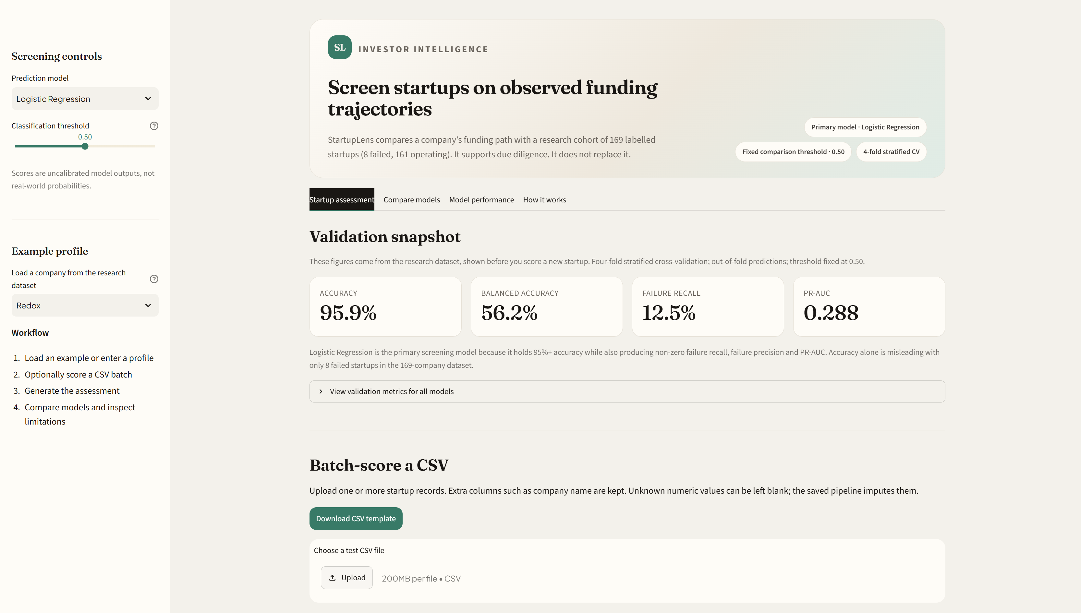

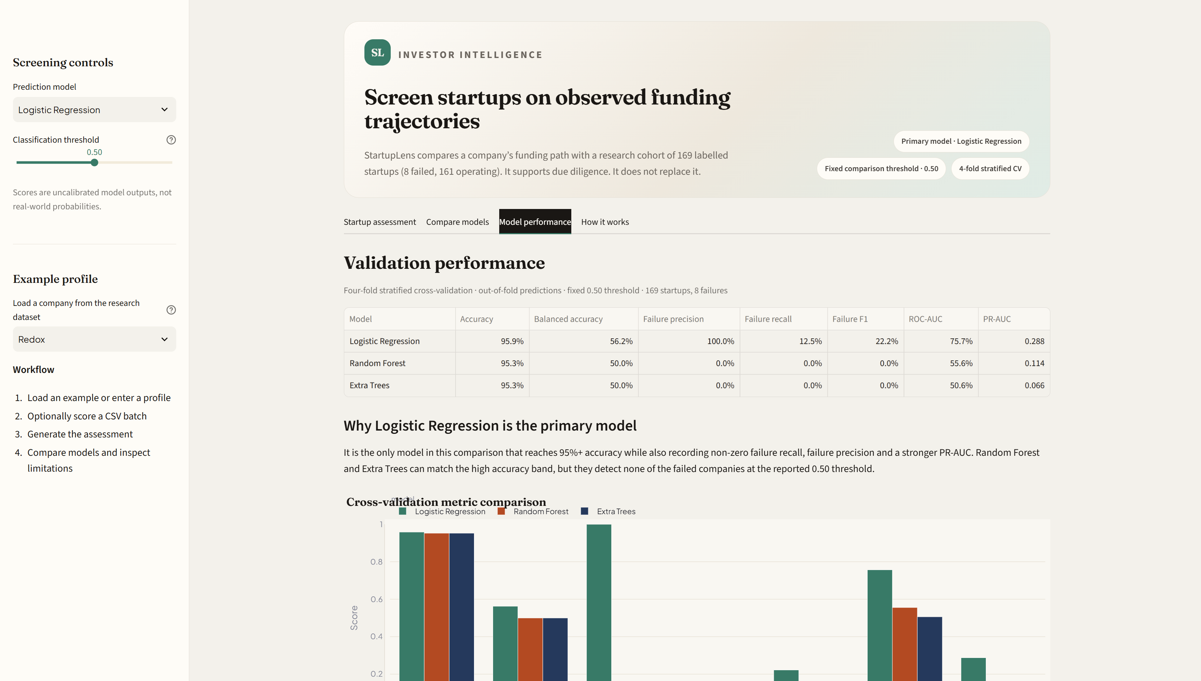
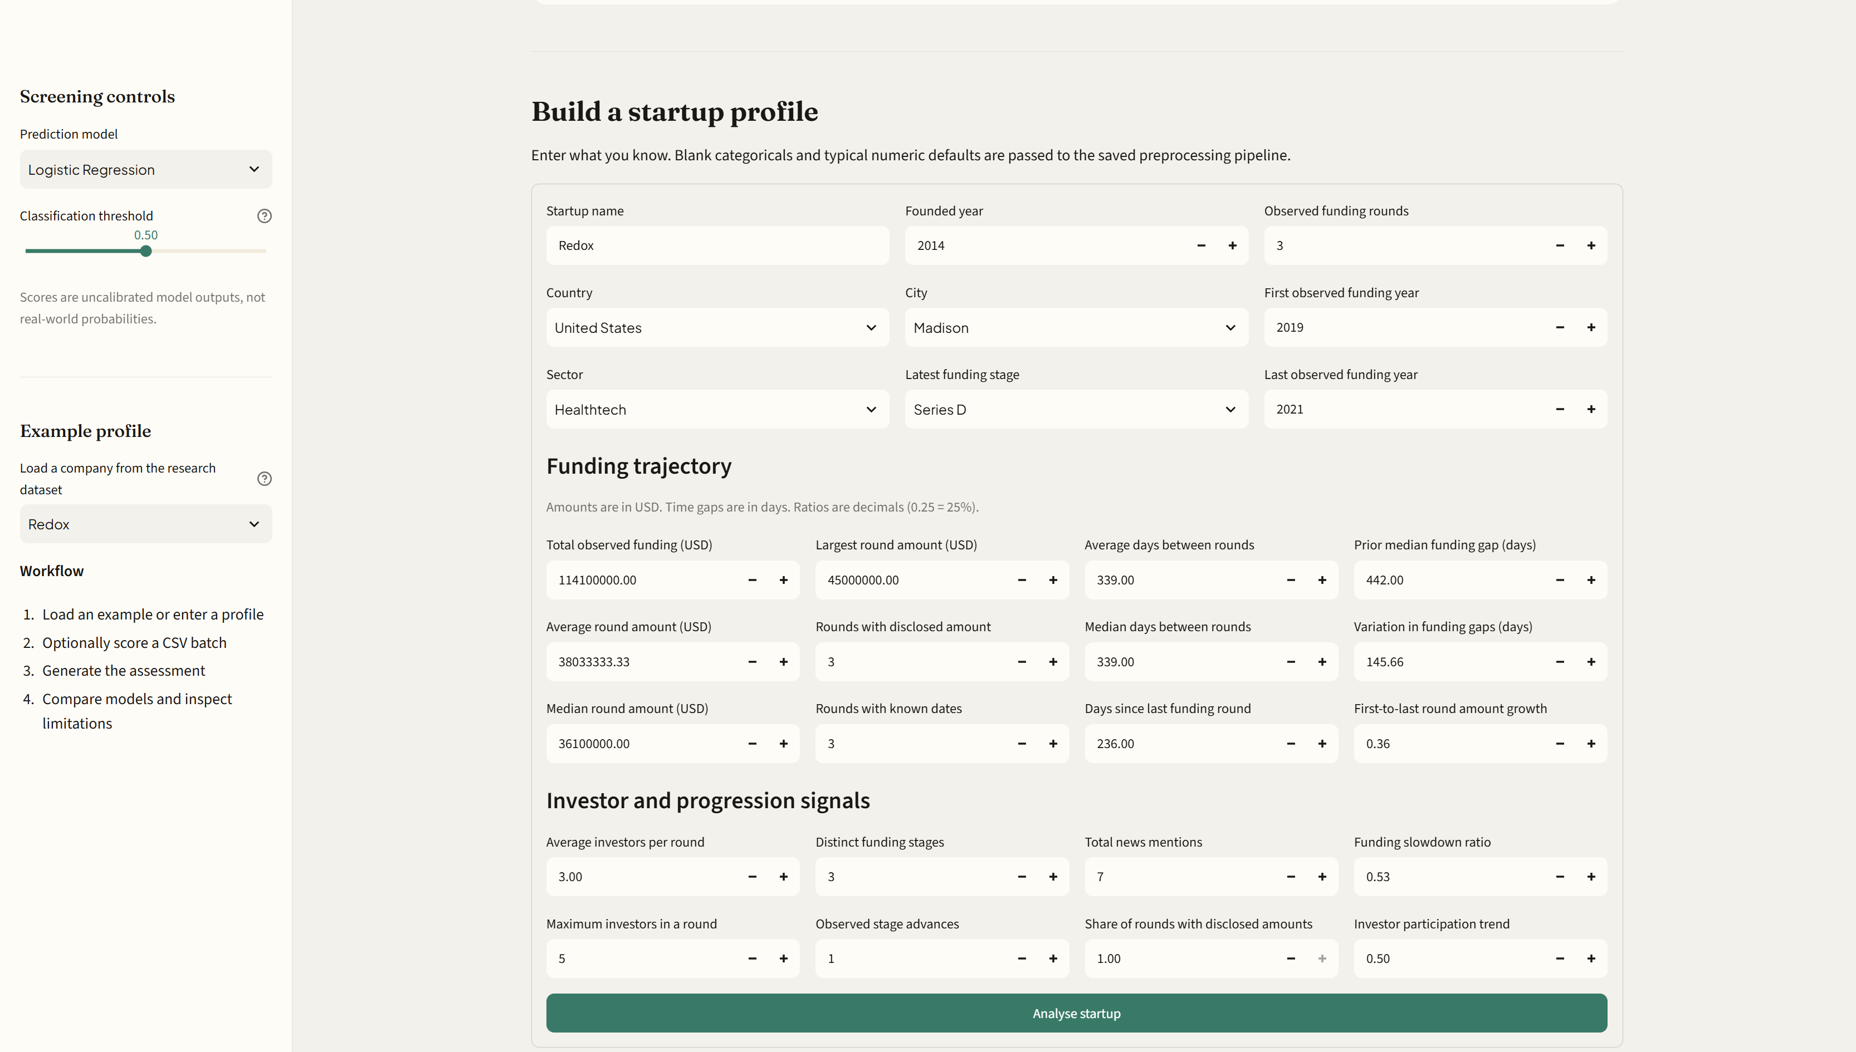
Figure 5. Individual startup assessment interface.

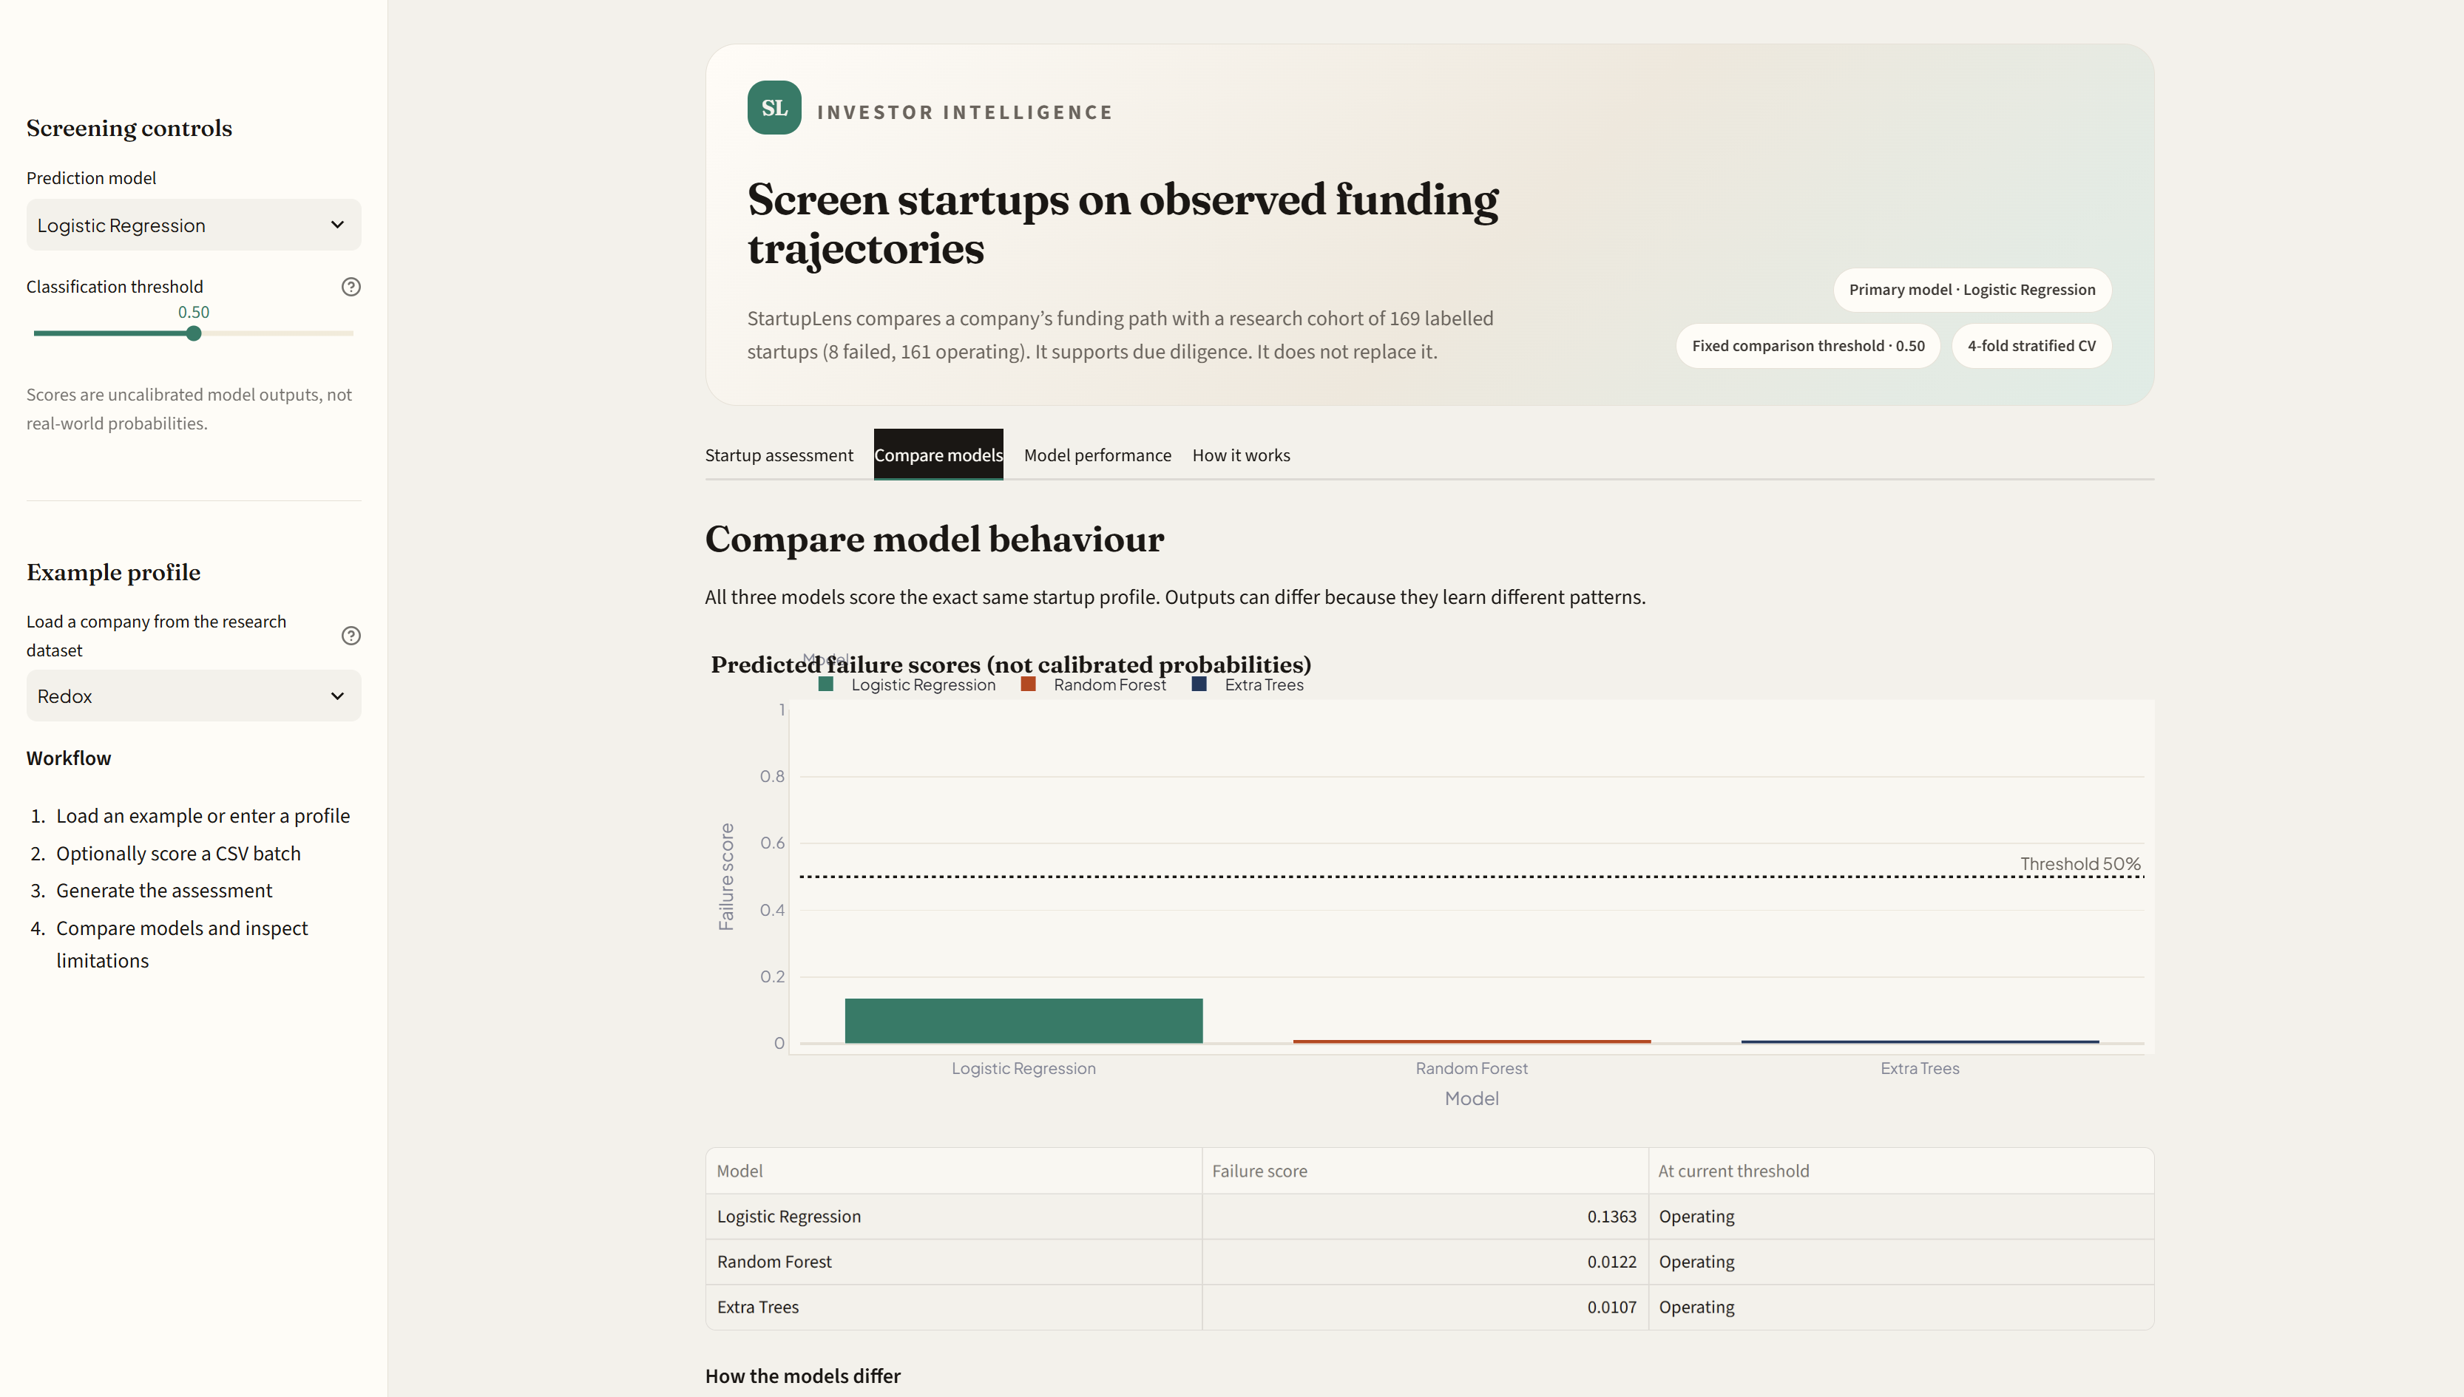

Figure 6. Model selection and classification threshold controls.

[INSERT EXPLAINABILITY / FUNDING TRAJECTORY HERE]
Capture the funding trajectory or feature sensitivity section. The caption should call this one-feature-at-a-time sensitivity if that is what the code implements; do not label it SHAP unless actual SHAP plots are present.
Figure 7. Funding-trajectory and model-sensitivity view.

[INSERT CSV UPLOAD AND BATCH RESULTS HERE]
Open the CSV upload section, upload a valid test file and capture the uploaded file summary plus the batch prediction table/download control. Remove private or sensitive data before taking the screenshot.
Figure 8. CSV-based batch classification.

[INSERT PDF INVESTOR REPORT HERE]
If the PDF export feature is enabled in the version being demonstrated, generate a sample report and capture its preview or the resulting report page. If the feature is not present, omit this figure.
Figure 9. Example investor-facing assessment report.

6. Conclusion
This project developed a funding-trajectory-based startup status classification workflow and an accompanying Streamlit dashboard. The final modelling workbook used in the application contains 169 companies, including 8 labelled Failed and 161 labelled Operating. Three classifiers were compared using four-fold stratified cross-validation and pooled out-of-fold predictions at a fixed 0.50 threshold.
Logistic Regression provides the strongest Failed-class detection among the evaluated models, identifying 3 of the 8 Failed companies and achieving 64.71% balanced accuracy, 37.50% failure recall, 0.250 failure F1-score, 0.747 ROC-AUC and 0.162 PR-AUC. Random Forest achieves the highest overall accuracy (95.27%) but identifies none of the Failed cases at the selected threshold. The results demonstrate why model selection for an imbalanced risk problem should not be based on accuracy alone.
The current system is best understood as an exploratory status-classification and investor-screening prototype. Its small number of Failed examples, lack of a strict historical cutoff, uncalibrated scores and incomplete representation of business fundamentals prevent it from being treated as a validated future-failure prediction system. Further work should strengthen the dataset, establish temporal validation, assess calibration and improve explainability before the system is used in consequential investment decisions.

7. References
[1] Ross, G., Das, S., Sciro, D. & Raza, H. (2021). CapitalVX: A machine learning model for startup selection and exit prediction. Journal of Finance and Data Science, 7, 94–114. https://doi.org/10.1016/j.jfds.2021.04.001.
[2] Bidgoli, M.R., Vanani, I.R. & Goodarzi, M. (2024). Predicting the success of startups using a machine learning approach. Journal of Innovation and Entrepreneurship, 13, 80. https://doi.org/10.1186/s13731-024-00436-x.
[3] Ang, Y.Q., Chia, A. & Saghafian, S. (2021). Using machine learning to demystify startups’ funding, post-money valuation, and success. In Innovative Technology at the Interface of Finance and Operations (pp. 271–296). Springer. https://doi.org/10.1007/978-3-030-75729-8_10.
[4] Kim, J., Kim, H. & Geum, Y. (2023). How to succeed in the market? Predicting startup success using a machine learning approach. Technological Forecasting and Social Change, 193, 122614. https://doi.org/10.1016/j.techfore.2023.122614.
[5] Żbikowski, K. & Antosiuk, P. (2021). A machine learning, bias-free approach for predicting business success using Crunchbase data. Information Processing & Management, 58(4), 102555. https://doi.org/10.1016/j.ipm.2021.102555.
[6] Sharchilev, B., Roizner, M., Rumyantsev, A.Y., Ozornin, D., Serdyukov, P. & de Rijke, M. (2018). Web-based startup success prediction. In Proceedings of the 27th ACM International Conference on Information and Knowledge Management (pp. 2283–2291). https://doi.org/10.1145/3269206.3272011.
[7] Berre, M. (2023). A machine learning approach to entrepreneurial finance modelling. In Operational Research Methods in Business, Finance and Economics (pp. 7–36). Springer. https://doi.org/10.1007/978-3-031-31241-0_2.
[8] Kamalesh, S., Nagaarjun, T.V. & Aswin Sankar, R. (2025). Machine learning-based prediction of startup success using founder’s background and funding features. In 2025 IEEE 7th International Conference on Computing, Communication and Automation (ICCCA). https://doi.org/10.1109/ICCCA66364.2025.11325516.
[9] Naik, P.M., Rihan, S., Rodrigues, S.M., Shetty, S.S. & Maurya, Y.V. (2026). Startup success predictor: A machine learning-based forecasting framework for early-stage venture assessment. In 2026 International Conference on Artificial Intelligence and Data Engineering (AIDE) (pp. 747–753). https://doi.org/10.1109/AIDE69088.2026.11544430.
[10] Khamphukun, R. & Narkbunnum, W. (2026). A leakage-controlled, calibration-first evaluation of machine learning models for startup outcome prediction: Evidence from Crunchbase. Information, 17(7), 702. https://doi.org/10.3390/info17070702.
[11] Krishna, A., Agrawal, A. & Choudhary, A. (2016). Predicting the outcome of startups: Less failure, more success. In 2016 IEEE 16th International Conference on Data Mining Workshops (pp. 798–805). https://doi.org/10.1109/ICDMW.2016.0118.
[12] Machine learning for liquidity risk modelling: A supervisory perspective. (2022). Economic Analysis and Policy, 74, 175–187. https://doi.org/10.1016/j.eap.2022.02.001.
[13] Wesson, N., Mienie, D. & Myatt, A. (2025). Machine learning and company failure prediction: Evidence from South Africa. Acta Commercii, 25(1), a1365. https://doi.org/10.4102/ac.v25i1.1365.
[14] Cabanillas-Carbonell, M. et al. (2024). Predicting business bankruptcy: A comparative analysis using machine learning models. Journal of Open Innovation: Technology, Market, and Complexity, 10(3), 100375. https://doi.org/10.1016/j.joitmc.2024.100375.
[15] Kaleem, M., Raza, H., Ashraf, S., Almeida, A.M. & Machado, L.P. (2024). Does ESG predict business failure in Brazil? An application of machine learning techniques. Risks, 12(12), 185. https://doi.org/10.3390/risks12120185.

8. Code, Dataset and Reproducibility
Repository URL: [INSERT YOUR GITHUB REPOSITORY URL]
Dataset location: [INSERT DATASET FILE OR REPOSITORY PATH]
Application entry point: app.py
Environment setup and launch commands:
python -m pip install -r requirements.txt
python -m streamlit run app.py
The repository should include the application source, model artefacts required by the app, the feature schema, dependency file, a safe sample CSV template and a README describing setup and usage. Do not publish private data, API keys, passwords or other credentials.

Appendix A. Where to find or create each diagram and screenshot

A1. Methodology flowchart
- Open diagrams.net (draw.io) in a browser, or use PowerPoint if preferred.
- Choose a blank flowchart. Add process boxes for source data, cleaning/filtering, feature engineering, labelled dataset, cross-validation, model training, evaluation and dashboard deployment.
- Add a decision/parallel branch from model training to Logistic Regression, Random Forest and Extra Trees, then connect these to evaluation.
- Use arrows to show the sequence. Keep labels short and make sure the final flow reflects the actual implemented pipeline.
- Export as PNG (high resolution) or SVG. In Word, use Insert → Pictures → This Device and select the exported image.
- Place it in Section 3.9 under the methodology workflow placeholder.

A2. EDA charts
- Open the final modelling workbook used by the app, not the earlier broad source workbook.
- Open the Python notebook or script that generated the final features. If charts were not saved, generate them from the final 169-row modelling file.
- Export each chart as PNG with a descriptive filename, for example class_distribution.png or funding_rounds_distribution.png.
- Use Insert → Pictures → This Device in Word and insert the relevant chart into Section 3.5.
- Add a caption that states what is plotted and the sample size. Do not invent chart values or imply that an ungenerated chart is an observed finding.

A3. Confusion matrix
- Open the model evaluation output folder used to produce model_comparison_metrics.csv.
- Find the confusion-matrix image for Logistic Regression generated from the pooled out-of-fold predictions at threshold 0.50.
- If no image exists, regenerate the matrix from the same out-of-fold predictions; do not use a training-set confusion matrix as a substitute.
- Insert the image in Section 4.3 and label the axes with actual and predicted classes.

A4. Streamlit screenshots
- Open the project folder in VS Code or File Explorer.
- Open PowerShell in that folder and run: python -m streamlit run app.py.
- Wait for the app to open at http://localhost:8501.
- Use Win + Shift + S to capture the dashboard metrics, individual assessment, model/threshold controls, sensitivity view and CSV upload/results.
- Paste each screenshot into its matching placeholder in Section 5.4. Crop out browser tabs or unrelated desktop content where possible.
- Use a sample company record for screenshots. Do not expose confidential company information or credentials.

A5. GitHub code and dataset links
- Open GitHub and navigate to the repository containing the final dashboard code.
- Copy the repository URL from the browser address bar and replace the repository placeholder in Section 8.
- Check that the README includes the installation and launch commands and that requirements.txt is present.
- Add a link to the dataset only if it is permitted to share. If the dataset cannot be public, state the access restriction and provide an approved sample or data dictionary instead.

Appendix B. Final consistency checks before submission
- Explain the transition from the initial 1,106-company population to the final 169-company modelling workbook. Keep the two sample counts clearly distinguished.
- Verify that the final report describes the implemented models (Logistic Regression, Random Forest and Extra Trees), not the earlier planned Decision Tree and XGBoost list.
- Do not claim SHAP was implemented unless actual SHAP outputs are generated and included. The current explanation described in this report is one-feature-at-a-time sensitivity.
- Describe the evaluation as four-fold stratified cross-validation with pooled out-of-fold predictions, not as a separate untouched test set.
- Use the term model score or failure score, not calibrated probability.
- Ensure all screenshots are from the final running app version and all charts come from the final modelling dataset.
- Verify each reference and DOI against the original publication and add in-text citations where the corresponding study is discussed.
- Insert the actual GitHub links and confirm that the repository can be accessed by the intended evaluator.

