

contact@thierryberger.com



**PROFILE**



**PROJECTS**

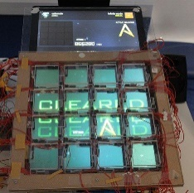

Jubeat Return

C, C++, Arduino, Processing, SFML

Versatile developer, I aspire to share my qualities and technique to the world.

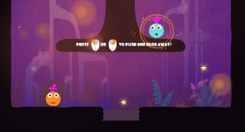

French

Trips

Video games

**Innovation 31 - Paris**

*iOS Research and Development*

Sept 2014 to

Feb 2015

iOS, Objective-C, C, Swift, Xcode, SVN

**Agile Partner - Luxembourg**

*Windows8 and iOS development*

Sept 2012 to April 2013

Objective-C, C, iOS, Windows 8, Xcode, C#, TFS, Agile, Visual Studio

June 2016 to

Nov 2017

**Voodoo - Strasbourg**

*Full Stack Developer*

Java, j2objc, AppEngine, Github, OVH, Proxy, IntelliJ, Xcode

Super Meet Ball

Game Jam, Unity3d, C#

Korean

English

**Scholarship**

**INTERESTS**

**Keimyung University** (South Korea)

Specialization : Mobile development

**Lycée Frédéric Chopin**

Bac STG - Mention Très Bien

**Epitech**

Expertise informatique

2007-2010

2013-2014

2010 - 2015

**Mobinlife - Paris**

*Development of CityDomination, mobile game*

Feb 2015 to Sept 2015

iOS, ObjC, C, Yodiz, SupersonicAds, TestFairy

**Ubisoft Mobile – Montreuil**

*Development, tests and support of internal tools*

Oct 2015 to

May 2016

C, C++, JNI, Android, iOS, C#, Unity, Facebook, SinaWeibo, Mercurial, Gradle, bash, Atom

Jan 2017 to present

**Altran - Strasbourg**

*Developer for Lyf Pay at Crédit Mutuel*

iOS, Swift, ObjC, Gitlab, Jenkins, NodeJS, C#

**EXPERIENCES**



Cooking

Strasbourg

06 78 21 34 75

Thierry

**BERGER**

Developer