[](https://www.linkedin.com/in/thierry-berger-614aa79a)

Thierry

**BERGER**

Developer



+33 6 78 21 34 75

contact@thierryberger.com

Charleville-Mézières, France



**PROJECTS**



[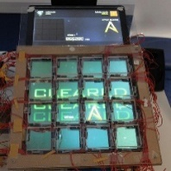](https://twitter.com/JubeatReturn)

Jubeat Return

C, C++, Arduino, Processing, SFML

Humble developer focused on teamwork and value creation.

[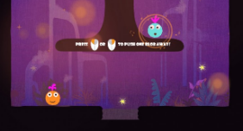](https://shurty.itch.io/super-meet-ball)

Super Meet Ball

Game Jam, Unity3d, C#

](https://github.com/Vrixyz/simon)

**NEXT?**

**Your Company**

*Developer,* ***Full Remote***

**Rust, git**, and whatever is needed!

Simon Game

**Bevy**, Arcade, Rustconf

Github profile

**Bevy**, **Rust, …**

**Vrixyz**





June 2019 to present

**OHM Games**

*Game Developer,* ***Full Remote***

Unity3d, C#, Git, iOS, Android

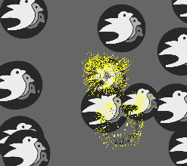

Whack a bevy

**Bevy**, Multiplayer

Jan 2017 to June 2019

**Altran - Strasbourg**

*Developer for Lyf Pay at Crédit Mutuel*

iOS, Swift, ObjC, Gitlab, Jenkins, NodeJS, C#

June 2016 to

Nov 2017

**Voodoo - Strasbourg**

*Game Developer*

Java, j2objc, AppEngine, Github, OVH, Proxy, IntelliJ, Xcode

**Lycée Frédéric Chopin**

Bac STG - Mention Très Bien

**Keimyung University** (South Korea)

Specialty: Mobile Game Development

**Epitech**Expertise informatique

2013 -2014

2007 -2010

2010 - 2015

**Ubisoft Mobile – Montreuil**

*Game Tools Developer*

Oct 2015 to

May 2016

C, C++, JNI, Android, iOS, C#, Unity, Facebook, SinaWeibo, Mercurial, Gradle, bash, Atom

**Mobinlife - Paris**

*Game Developer*

Feb 2015 to Sept 2015

iOS, ObjC, C, Yodiz, SupersonicAds, TestFairy

**Innovation 31 - Paris**

*iOS Research and Development*

Sept 2014 to

Feb 2015

iOS, Objective-C, C, Swift, Xcode, SVN



**Agile Partner - Luxembourg**

*Windows8 and iOS development*

Sept 2012 to April 2013

Objective-C, C, iOS, Windows 8, Xcode, C#, TFS, Agile, Visual Studio

Trips

Cooking

**EXPERIENCES**



Games

French

Korean

English

**Scholarship**

**INTERESTS**