Java OOP Laboratory Exercise

Campus Cafe Ordering System

Name: Jim Nelven B. Cuba

Section: D

November 10, 2026

Concept Explanation
Theprogramhassevenclasses:MenuItem(abstract),Beverage,Pastry,Meal,Customer,Order,andCafeApp.The table shows where each OOP concept is used and why.

Concept | Where andwhy it was used
ifStatement | Pastry.computePrice() adds the 10-peso warming fee only when the pastry is warmed, and Meal.computePrice()addsthe20-pesoupsizefeeonlywhenthemealisupsized.Asingleifisenough because there is no other branch.
if-elseStatement | MenuItem.setBasePrice()rejectsnegativeprices.Beverage.computePrice()usesanif-else-ifchainforsizes S, M, and L. Order.addItem() finds the first empty slot or reports that the order is full, and Order.computeTotal() applies the student discount and the voucher.
ClassesandObjects | Eachreal-worldthinginthecafeisaclass.CafeApp.main()createstheobjects:twoCustomers,sixmenu items, and two Orders.
Attributesand Behaviors | Everyclasshasinstancevariables(suchassizeinBeverageandloyaltyPointsinCustomer)andinstance methods (such as computePrice() and addPoints()), so each object keeps its own data and works on it.
ObjectInteraction | OrderholdsaCustomerandMenuItemobjects.printReceipt()callseachitem'scomputePrice()andthen customer.addPoints() to update the customer's loyalty points.
JavaNaming Conventions | ClassesusePascalCase(MenuItem),methodsandvariablesusecamelCase(basePrice,computeTotal), andconstantsuseUPPER_SNAKE_CASE(WARM_FEE,STUDENT_DISCOUNT_RATE),whichkeeps the code consistent and easy to read.
DefaultConstructor | MenuItem(),Beverage(),Pastry(),Meal(),andCustomer()giveobjectssafestartingvalues.HotChocolate and Beef Tapa were created this way and then filled in with setters.
Parameterized Constructor | AllMenuItemsubclasses,Customer,andOrdersettheirdatawhentheobjectiscreated.Thesubclasses call super(...) to pass the shared name, price, and code to MenuItem.
Constructor Overloading | Customer has three constructors: Customer(), Customer(String name), and Customer(String name, boolean student). They let an object be created with as much information as is available.
public/private/ protected | Methodsarepublicandfieldsareprivate.nameandbasePriceareprotectedinMenuItemsosubclasses can use basePrice directly when computing prices.
Getters,Setters,Data Hiding | Therearenopublicfields.Settersvalidateinput(negativeprice,negativeextrasides,invalidsize),soan object cannot hold invalid data. The output line "Error: base price cannot be negative." shows this.
MethodOverloading | Customer.addPoints(int)andaddPoints(double)shareanamebuttakedifferentinputs;thedoubleversion turnspesosintopoints.Order.computeTotal()andcomputeTotal(doublevoucher)workthesameway,with the second one subtracting a voucher.
MethodOverriding | Beverage,Pastry,andMealoverridecomputePrice()andgetDescription()with@Override.Eachtypehas its own price rule and description, and Order calls them through MenuItem references.
Abstraction | MenuItemisabstractanddeclarestheabstractmethodcomputePrice().Itcannotbeinstantiatedandforces every subclass to define its own pricing.

Program Output
Output of CafeApp compiled and run with javac and java. The computed values match the expected output: TOTAL
285.30 with 5 loyalty points for Order #1001, and TOTAL 205.00 with 4 loyalty points for Order #1002.
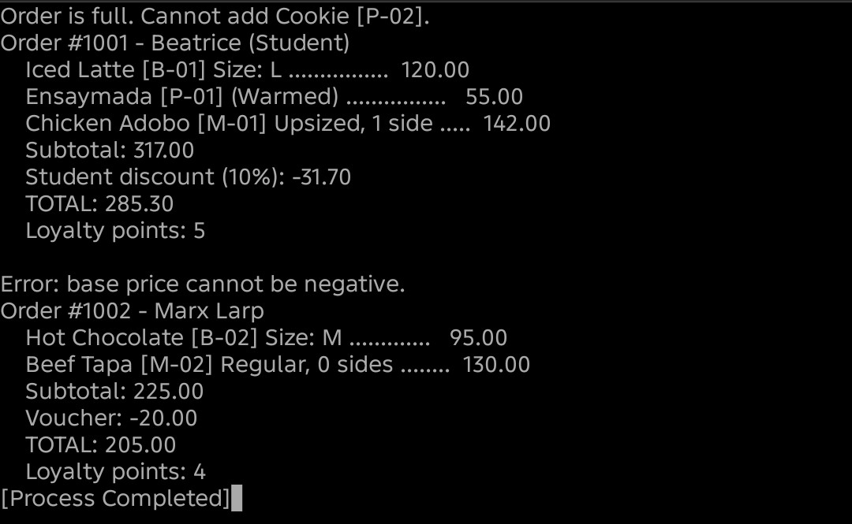

Challenges Encountered and How They Were Solved
  - Storing three items without an ArrayList. I used separate fields item1, item2, and item3. addItem() puts the item in the first empty slot with an if-else-if chain and returns false when all three are used, and computeSubtotal() adds only the slots that are not null.
  - Showing the voucher on the receipt. The sample output prints a voucher line, but printReceipt() has no parameter for it. I overloaded printReceipt (double voucher) and made printReceipt() call it with 0.
  - Loyalty points must be whole numbers. I divided the amount by 50 and cast the result to int, so 285.30 pesos gives 5 points and 205.00 pesos gives 4.
  - Validating values inside constructors. The parameterized constructors call the setters, so invalid values are rejected the same way as later changes. MenuItem's constructor first calls this() to start from safe defaults.

