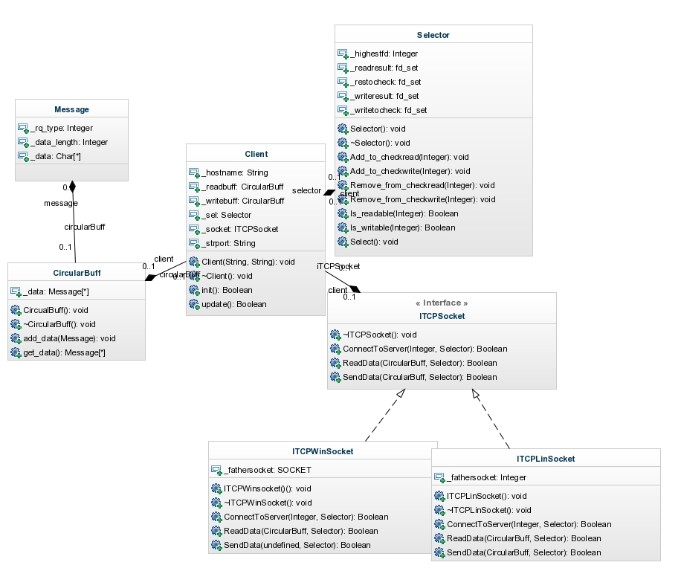

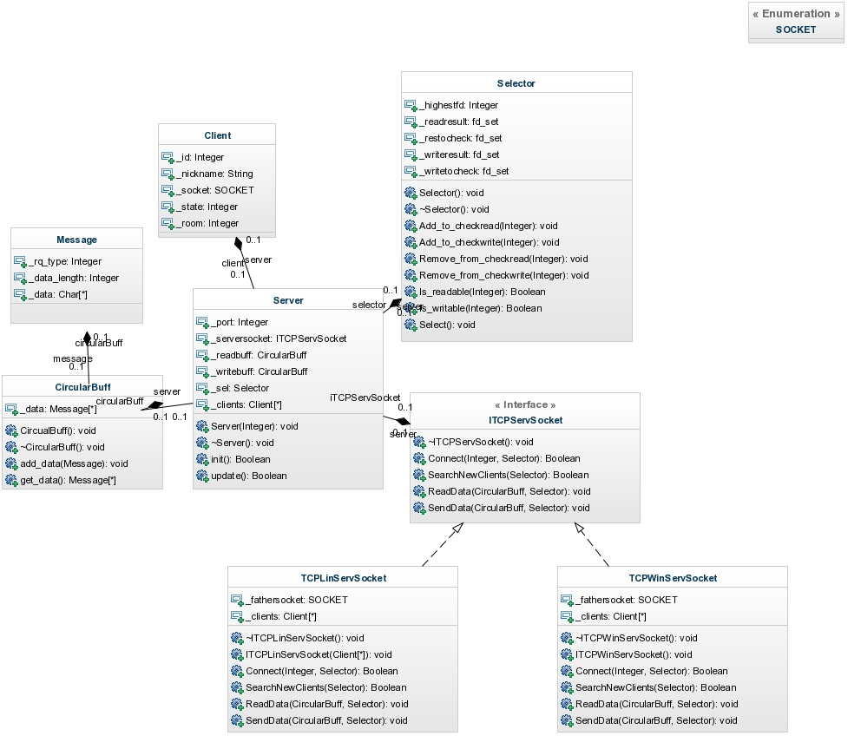

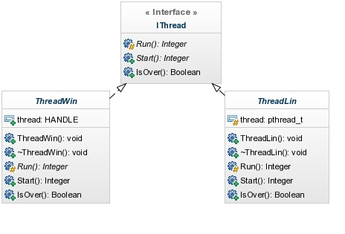

Network Working Group C.bajdek

Request for Comments: 4242 Epitech

Obsoletes: none November 2014

Category : Standarts Track

R-Type Protocol

Abstract

This protocol is intended to povide the R-Type service, and be used

between clients and servers on host computers.

Status of This Memo

This document specifies an Internet standards track protocol for the

Internet community, and requests discussion and suggestions for

improvements. Please refer to the current edition of the "Internet

Official Protocol Standards" (STD 1) for the standardization state

and status of this protocol. Distribution of this memo is unlimited.

Copyright Notice

Copyright (C) Epitech (November 2014). All Rights Reserved.

Table of Contents

1. Introduction .....................................................2

1.1. Conventions Used in This Document ...........................2

2. Pre Game Session Management ......................................2

3. Pre Game Message Exchanges .......................................3

4. Pre Game Data Unit Format ........................................4

5. Pre Game Request & Responses Values ..............................4

5.1. Request Values ..............................................5

5.2. Responses Values ............................................5

6. In Game Session Management .......................................6

Bajdek Standarts tracks [page 1]

RFC 4242 R-Type Protocol November 2014

1. Introduction

This Document describes how the R-Type project is runing using both

TCP and UDP client-server connection. TCP is described in [RFC0793].

UDP is described in [RFC0768].

1.1. Conventions Used in This Document

The key words "MUST", "MUST NOT", "REQUIRED", "SHALL", "SHALL NOT",

"SHOULD", "SHOULD NOT", "RECOMMENDED", "MAY", and "OPTIONAL" in this

document are to be interpreted as described in [RFC2119].

2. Pre Game Session Management

The in-game protocol used for data transfer is UDP, however, all the

pre game session including Connection, Authentication, Room creation

, Room joining and Game Launching, are to be processed using the TCP

protocol. The TCP connection occurs between two peers, one that

initiate the connection request and one that responds to the

connection request. The initiating peer is called the "client", and

the responding peer is called the "server". An R-Type server must

listen for TCP connection on a standart port (4242).

The client MUST issue a connection to the server specifying the

standart port (4242). The server MAY accept or not the new client,

depending on several parameters (server's occupation, availlable CPU,

...)

At Session start, the client MUST send a LOGIN command (wich contains

the nickname of the user). The client nickname MUST be unique on

the server, if this is not the case, the server SHALL send a NOK

response to the client so that he can try again using another name.

The session is normally ended by the client sending the LOGOUT

command. A server receiving the LOGOUT command MUST end the session

and close the TCP connection. A client MAY end a session in some

cases (game crash, unavaillable services ...).

A server MAY limit the life span of an established TCP connection.

Sessions that are inactive for more than a server-defined period

MAY be ended by a server. A server MAY also

close TCP connections that have been open and active for longer than

a server-defined period.

Bajdek Standarts tracks [page 2]

RFC 4242 R-Type Protocol November 2014

3. Pre Game Messages Exchanges

All Pre Game messages are in form of paquets as defined on the

section 4. The messages are initiated by the client in the form

of commands. A R-Type server MUST return a well formated response

to any command he receives on the same TCP connection that carried

the command. The clients commands and server responses are defined in

section 5.

General client-server message exhanging using TCP tropsport is

illustrated Figure 1.

Client Server

| |

| Connect |

| >>------------------------------->> |

| |

| Send Login |

| >>------------------------------->> |

| |

| Send Response |

| <<-------------------------------<< |

| |

| Send Command |

| >>------------------------------->> |

| |

| Send Response |

| <<-------------------------------<< |

| |

| Send LOGOUT |

| >>------------------------------->> |

| |

| Send Response & Disconnect |

| <<-------------------------------<< |

| |

Figure 1: TCP Client-Server Message Exchange

Bajdek Standarts tracks [page 3]

RFC 4242 R-Type Protocol November 2014

4. Pre Game Data Unit Format

The Pre Game data unit contains three fields :

A 32 bits field containing the Request/Response Type (see section 5).

A 32 bits field containing the length of the Additional Data field

measured in octects.

An additional Data field.

Data Unit Format (one tick mark represents one bit position):

0 1 2 3

0 1 2 3 4 5 6 7 8 9 0 1 2 3 4 5 6 7 8 9 0 1 2 3 4 5 6 7 8 9 0 1

+-+-+-+-+-+-+-+-+-+-+-+-+-+-+-+-+-+-+-+-+-+-+-+-+-+-+-+-+-+-+-+-+

| Request/Response Type |

+-+-+-+-+-+-+-+-+-+-+-+-+-+-+-+-+-+-+-+-+-+-+-+-+-+-+-+-+-+-+-+-+

| Additional Data Length |

+-+-+-+-+-+-+-+-+-+-+-+-+-+-+-+-+-+-+-+-+-+-+-+-+-+-+-+-+-+-+-+-+

| Additional Data |

+-+-+-+-+-+-+-+-+-+-+-+-+-+-+-+-+-+-+-+-+-+-+-+-+-+-+-+-+-+-+-+-+

Request Type (32 bits): The type of the request initiated by the

client. Different request types are defined in section 5.

Additional Data Length (32 bits): The length of the Additional Data

measured in octects int network (big endian) byte order.

Additional Data (variable length): A field containing any additional

data necessary for the intended request/response.

5. Pre Game Request & Responses Values

5.1. Request Values

This section describes the values of the field "Request/Response

Type" (see section 4), for the Request part. The Request are

initiated by the client only.

Bajdek Standarts tracks [page 4]

RFC 4242 R-Type Protocol November 2014

Request Code: Request Meaning: Request Value:

LOGIN To resister to the server 1

LOGOUT Disconnect from server 2

JOIN ROOM Join a game room 3

LEAVE ROOM Leave a game room 4

CREATE ROOM Create a game room 5

START GAME Start the game 6

5.2. Responses Values

This session describes the values of the field "Request/Response

Type" (see section 4), for the Response part. The responses are

sent by the server only and MAY respond to a client Request.

The responses may also be used to inform the client about the

state of the room (if he is in a room of course).

Response Code: Response Meaning: Response Value:

OK The request is fullfilled 1

NOK The request is not fullfilled 2

BUSY The server is busy 3

ADD_ALLY Add an ally in the current room 4

REMOVE_ALLY Remove an ally from the current room 5

Bajdek Standarts tracks [page 5]