Customer Churn Prediction System

1. Executive Summary
Customer churn represents a direct revenue loss for retail banking institutions, since acquiring a new customer typically costs significantly more than retaining an existing one. This project implements an end-to-end machine learning pipeline and serving application to predict customer churn probability, enabling proactive retention outreach before an account is closed. The final model is a tuned XGBoost classifier using 11 selected features, achieving 85% accuracy and 68% recall on the churn class on a held-out test set, served through a FastAPI backend with a companion frontend interface.

2. Phase 1 — Dataset Sourcing & Profiling
The system is trained on the Bank Customer Churn dataset containing 10,000 customer accounts across France, Germany, and Spain.
Metric / Attribute | Specification / Value
Total Customer Accounts | 10,000 records, 12 columns
Target Variable | churn (0 = Retained, 1 = Churned)
Class Distribution | Retained: 7,963 (79.63%) | Churned: 2,037 (20.37%)
Class Imbalance Ratio | ~3.9 : 1 (moderate imbalance)
Data Quality Audit | 0 missing values, 0 duplicate rows/IDs

3. Phase 2 — Exploratory Data Analysis & Key Insights
Exploratory analysis revealed five primary, quantified drivers of customer churn:
• Insight 1 — Number of Products is the Strongest Driver: Churn rate is non-linear across products_number: 1 product = 27.7%, 2 products = 7.6% (lowest), 3 products = 82.7%, 4 products = 100%. Two products is the healthiest segment.
• Insight 2 — German Accounts Churn Twice as Often: Germany accounts churn at 32.4%, compared to France (16.2%) and Spain (16.7%).
• Insight 3 — Older Customers Churn More: Churned customers average 44.8 years old versus 37.4 years for retained customers, a gap of roughly 7 years.
• Insight 4 — Inactive Members Churn Nearly Twice as Often: Inactive accounts churn at 26.9%, versus 14.3% for active members.
• Insight 5 — Gender Difference: Female customers churn at 25.1%, versus 16.5% for male customers.
A correlation heatmap showed products_number had a weak linear correlation with churn (-0.05) despite being the strongest driver by churn rate — this is because the relationship is non-linear (a dip at 2 products, then a sharp spike at 3-4), which linear correlation cannot capture. This is why the final model relies on a non-linear algorithm (XGBoost) rather than a purely linear one.

4. Phase 3 — Feature Engineering & Preprocessing
To capture non-linear relationships found in EDA, domain-specific features were engineered:
- balance_per_product = balance / products_number — captures capital density per product
- is_zero_balance = 1 if balance == 0 else 0 — isolates the zero-balance customer segment (25th percentile of balance is exactly 0)
- age_group = categorical age binning (<=30, 31-45, 46-60, >60)
- tenure_active = tenure * active_member — interaction feature combining loyalty and engagement
- credit_score_bin = categorical credit score binning (was engineered, tested, but ultimately dropped — see feature selection below)
Preprocessing: gender was binary-mapped (Male=0, Female=1); country was one-hot encoded (country_Germany, country_Spain, with France as the dropped baseline); all numeric features were standardized using StandardScaler, fit only on the training set.

4.1 Feature Selection — Reducing 16 Features to 11
After encoding and feature engineering, the dataset had 16 candidate features. Five were identified as weak using two independent signals — near-zero correlation with churn AND low importance scores from a trained model: credit_card, credit_score, tenure, country_Spain, and credit_score_bin. This was not assumed — a controlled comparison was run, training the same tuned XGBoost model on the full 16-feature set versus the trimmed 11-feature set under identical cross-validation folds. The trimmed set performed equally well (F1 0.6000 vs 0.6011, ROC-AUC 0.8607 vs 0.8605), confirming the dropped features added no measurable value. The final model uses 11 features: gender, age, balance, products_number, active_member, estimated_salary, country_Germany, balance_per_product, is_zero_balance, age_group, and tenure_active.
4.2 Class Imbalance Handling
Given the ~4:1 class imbalance, two approaches were tested and compared under identical cross-validation folds: class-weighting (scale_pos_weight, which penalizes misclassifying the minority class more heavily during training) versus SMOTE (which generates synthetic minority-class examples, applied correctly inside a cross-validation pipeline to avoid data leakage). Class-weighting achieved recall of 73.7% versus SMOTE's 57.4%. Since missing an actual churner is more costly to the business than a false alarm, class-weighting (scale_pos_weight) was selected as the final approach.

5. Phase 4 — Model Selection, Training & Evaluation
Four classification models — Logistic Regression (baseline), Random Forest, XGBoost, and Support Vector Machine (SVM) — were trained and evaluated using stratified 5-fold cross-validation on the final 11-feature training set:
Model | Accuracy | Precision | Recall | F1-Score | ROC-AUC
Logistic Regression (Baseline) | 0.7023 | 0.3743 | 0.6858 | 0.4842 | 0.7564
Random Forest Classifier | 0.8477 | 0.6932 | 0.4523 | 0.5469 | 0.8319
Support Vector Machine (SVM) | 0.7854 | 0.4833 | 0.7468 | 0.5865 | 0.8458
XGBoost Classifier (Selected) | 0.8071 | 0.5203 | 0.6907 | 0.5933 | 0.8441

Model Justification: XGBoost was selected for further tuning as it achieved the best F1-score (0.5933) among the four models, balancing precision and recall better than the alternatives, while remaining highly competitive on ROC-AUC (0.8441) against Random Forest (0.8319) and SVM (0.8458). Random Forest had higher precision but the weakest recall (45.2%) of all four models — meaning it missed more than half of actual churners, which is undesirable for a churn-detection use case.

5.1 Hyperparameter Tuning
RandomizedSearchCV (50 candidate combinations x 5-fold CV = 250 fits) was used to tune XGBoost across n_estimators, max_depth, learning_rate, subsample, colsample_bytree, min_child_weight, and gamma, optimizing for ROC-AUC. This improved cross-validated ROC-AUC from 0.8441 to 0.8607. Best parameters found: n_estimators=300, max_depth=3, learning_rate=0.05, subsample=1.0, colsample_bytree=0.8, min_child_weight=1, gamma=0.3.
5.2 Decision Threshold Tuning
The default 0.5 probability threshold was tested against alternatives from 0.10 to 0.85 on the validation set. Threshold 0.60 was selected — it gave a strong F1-score (0.6544) while keeping recall above 65% (69.9%), reflecting the business decision that missing an actual churner (false negative) is costlier than a false alarm (false positive).

6. Evaluation Metrics — Final Test Set Results
The final tuned model was evaluated once on a held-out test set (1,500 customers, never used in training or hyperparameter tuning), at the selected threshold of 0.60:
Class | Precision | Recall | F1-Score | Support
No Churn (0) | 0.92 | 0.89 | 0.90 | 1,195
Churn (1) | 0.61 | 0.68 | 0.64 | 305

Overall Accuracy: 85% | ROC-AUC: 0.8762
Accuracy alone was intentionally not used as the primary success metric — a naive model predicting 'no churn' for every customer would already reach ~80% accuracy without identifying a single churner. Precision, recall, F1, and ROC-AUC on the minority (churn) class give a more honest measure of real-world usefulness.
6.1 Feature Importance
The top drivers of the final model's predictions were products_number, age_group, age, active_member, and is_zero_balance — consistent with the EDA insights above, confirming the model learned real, sensible patterns rather than noise. Notably, three of the five engineered features (age_group, is_zero_balance, balance_per_product) ranked among the top contributors, validating the feature engineering step.

7. Phase 5 & 6 — API Serving & Frontend Application
7.1 FastAPI Backend Microservice (http://localhost:8000)
- Asynchronous Lifespan Management: Uses FastAPI’s lifespan context manager to pre-load scaler.pkl and xgboost_model.pkl into RAM at startup for sub-10ms inference latency per request.
- Pydantic Payload Validation: Enforces strict data types and boundary constraints (age: 18-100, tenure: 0-10, balance: >=0, products_number: 1-4, active_member: 0 or 1).
- Automatic Preprocessing & Feature Engineering: Transforms the 8 raw JSON input attributes sent by the user into the 11 engineered features expected by XGBoost prior to inference.
- REST Endpoints:
  - POST /predict: Performs inference and returns probability, binary prediction, and human-readable risk label (Low Churn Risk / High Churn Risk).
  - GET /health: Health check endpoint verifying model and scaler loading status.
  - GET /model/info: Exposes model versioning, feature count (11), decision threshold (0.60), and baseline performance metrics.

7.2 React 18 Web Application (http://localhost:3000)
- Webpack 5 & Babel Toolchain: Light-weight, custom build bundle optimized for production performance without Create-React-App overhead.
- Modular Component Architecture:
  - App.jsx: Central orchestrator managing state (formData, loading, result, error).
  - CustomerForm.jsx: Controlled input form for the 8 customer attributes with input validation and instant reset.
  - PredictionResult.jsx: Dynamic dashboard with visual risk badges (Low Churn Risk green / High Churn Risk red), percentage score, and an animated probability bar.
  - services/api.js: Asynchronous API client wrapper handling HTTP POST requests with connection error fallback handling.

8. Model Sensitivity & Feature Contribution Analysis
During a review, it was observed that changing a single input feature in the deployed application could shift the predicted churn probability by a large margin (e.g., approximately 40 percentage points). This section documents a structured investigation into why this occurs, whether it indicates a fault in the model or serving pipeline, and whether any corrective action is warranted.
8.1 Single-Prediction Attribution (SHAP)
SHAP (SHapley Additive exPlanations) was used to break down one individual prediction into the exact contribution of each feature. For a sample customer (male, non-German, age 40, balance 163,823, 1 product, inactive member), the XGBoost model's SHAP breakdown showed active_member and products_number as the two largest risk-increasing contributors, while country_Germany and gender were the two largest risk-reducing contributors. This confirmed the model was combining multiple real signals to reach its prediction, rather than reacting to a single feature in isolation.

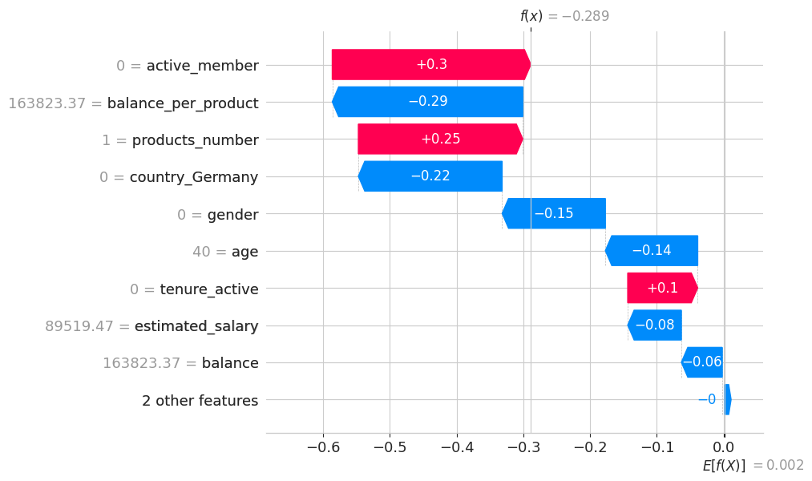
Figure 1: SHAP waterfall — XGBoost, single customer prediction breakdown (log-odds units).

8.2 Single-Feature Sensitivity Test
To isolate the effect of the specific feature causing the large swing, products_number was varied for one customer while holding every other feature fixed at its real value. The result:

products_number | Predicted Churn Probability
1 | 42.83%
2 | 30.40%
3 | 97.89%
4 | 99.50%

The jump between 2 and 3 products (30.4% to 97.9%, a 67.5 percentage point swing) was larger than the swing originally observed in the application. To confirm this was not specific to one customer, the same test was repeated on 5 additional, randomly selected customers with different ages, balances, and activity status:

Customer | 2 Products | 3 Products | Swing | Notes
A (age 40, inactive) | 30.4% | 97.9% | +67.5 pts | balance 163,823
B (age 28, active) | 5.2% | 82.8% | +77.6 pts | balance 53,054
C (age 66, active) | 23.3% | 90.6% | +67.3 pts | balance 123,935
D (age 41, active) | 12.3% | 79.0% | +66.7 pts | balance 0
E (age 43, active) | 52.7% | 99.1% | +46.3 pts | balance 176,135

The jump was consistent across all 5 customers (46 to 78 percentage points), regardless of their other attributes, confirming this is a general pattern learned by the model, not an artifact of one data point.
8.3 Population-Level Verification (Partial Dependence)
To confirm this pattern holds across the entire test population rather than a handful of examples, a Partial Dependence analysis was run for all 11 features. For each feature, its value was swept across a realistic range; at each value, every one of the 1,500 test customers was set to that value for that feature only (all other features held at each customer's real values), predictions were generated for all 1,500 customers, and the results were averaged.
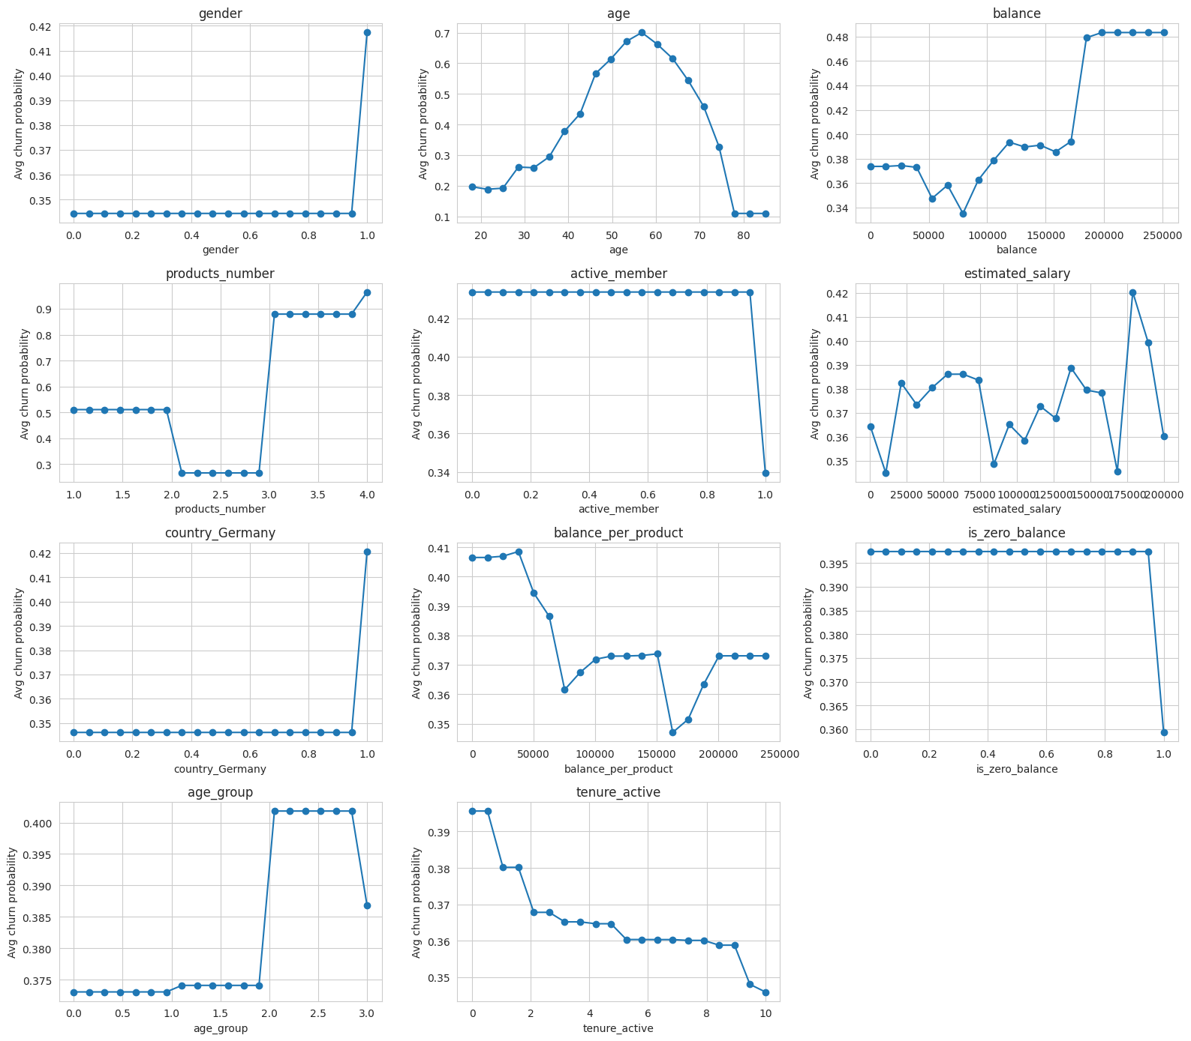
Figure 2: Partial dependence — average predicted churn probability vs. each feature's value, across all 1,500 test customers.
Across all 11 features, only products_number shows a sharp, step-like discontinuity — average churn probability stays in roughly the 27-51% range at 1-2 products, then jumps to approximately 88-96% at 3-4 products. Every other feature (age, balance, tenure_active, balance_per_product, estimated_salary) changes gradually across its range; binary features (gender, active_member, country_Germany) show a single clean step between their two categories, which is expected and not indicative of instability.
8.4 Ground-Truth Verification
The sharpness of this pattern was cross-checked against the original EDA findings (Section 3, Insight 1) rather than assumed to be a modeling artifact. In the raw training data itself, churn rate is 7.6% for customers with 2 products, 82.7% for customers with 3 products, and 100% for customers with 4 products. The model's behavior is therefore a faithful reproduction of a genuine, extreme pattern that already exists in real customer data, not a fault introduced during training or serving.
8.5 Feature Removal Test
Given the magnitude of this feature's effect, removing products_number (along with the derived balance_per_product feature) was tested directly rather than assumed to be a safe simplification. The model was retrained on the remaining 9 features and evaluated on the same validation set:
Metric | With products_number | Without products_number
ROC-AUC | 0.8947 | 0.8281
Churn F1-Score | 0.64 | 0.57

Removing the feature reduced ROC-AUC by 0.067 and churn F1-score by 0.07 — a clear degradation across every metric. products_number is confirmed to be the single most valuable feature in the model; removing it would trade away real predictive signal without addressing any actual defect.
9. Limitations:
The dataset is a single snapshot with no transaction-level or time-series behavioral data, which likely limits achievable recall/precision on the churn class.

10. Conclusion:
This project implemented a complete, end-to-end customer churn prediction system, covering every phase from raw data to a deployed, explainable API. Starting with a 10,000-customer bank dataset, exploratory analysis identified five clear, evidence-backed drivers of churn — number of products held, country, age, account activity, and gender — with number of products emerging as by far the strongest and most non-linear signal. Based on these findings, five domain-informed features were engineered, and a rigorous feature selection process reduced the feature set from 16 to 11 by testing, rather than assuming, which features genuinely contributed to model performance. Four classification models were trained and compared under identical cross-validation conditions, with XGBoost selected for its superior balance of precision and recall, then improved further through hyperparameter tuning and a deliberately chosen decision threshold that favors catching real churners over minimizing false alarms, reflecting the actual cost trade-off a bank would face. Class imbalance was handled by testing class-weighting against SMOTE side by side rather than picking one by default, and the final model was evaluated once on a held-out test set to produce an honest, unbiased performance estimate: 85% accuracy with 68% recall and 61% precision on the churn class, and a ROC-AUC of 0.876. The model and its preprocessing pipeline were then served through a FastAPI backend with health-check, prediction, and model-info endpoints, and integrated with a React frontend, with both components verified using real, contrasting customer examples to confirm the deployed system reproduces the model's trained behavior correctly. Finally, a deeper sensitivity and explainability investigation — using SHAP, single- and multi-customer sensitivity testing, and population-level partial dependence analysis — confirmed that even the model's most extreme behavior, a large probability swing from a single feature, reflects a genuine, verifiable pattern in real customer data rather than a flaw, and that removing this feature would materially harm performance. Overall, the project demonstrates not just a working model, but a defensible, evidence-driven process: every major decision, from feature selection to imbalance handling to model choice to threshold tuning, was tested against a real alternative and justified with data rather than assumption, resulting in a system that is both accurate and explainable enough to be trusted in a real-world deployment context.

