VIDEOTUTOR
An AI-Powered Video Learning and Study Assistant

1. Introduction
VideoTutor is an AI-powered learning assistant that converts a YouTube lecture into an interactive, searchable study tool. It answers questions grounded in the video's actual transcript, with clickable timestamps, and can generate full structured study notes reviewed by the student before being finalised.
- Problem: manually scrubbing long lectures to find a topic, and manually writing notes while watching, is slow and inconsistent.
- Problem: generic AI chatbots have no grounding in a specific video's content and can produce unverifiable answers.
- Solution: transcript is chunked, embedded, and stored in a vector database; an AI agent retrieves relevant chunks before answering, and cites exact timestamps.
- Study notes are treated as drafts requiring explicit human approval, not final output — a Human-in-the-Loop (HITL) workflow.

2. Objectives
- Convert a YouTube lecture transcript into a semantically searchable knowledge base.
- Answer natural-language questions grounded in the transcript, with exact timestamp citations.
- Auto-generate structured, topic-wise study notes spanning the full lecture.
- Keep a human reviewer in control of AI-generated notes via approval/revision before finalising.

3. System Architecture
Five layers, each with one responsibility: React frontend for UI, FastAPI backend for the REST interface, a LangGraph agent for decision-making, an MCP-style tool layer for actions, and the storage layer (YouTube transcript service + ChromaDB).
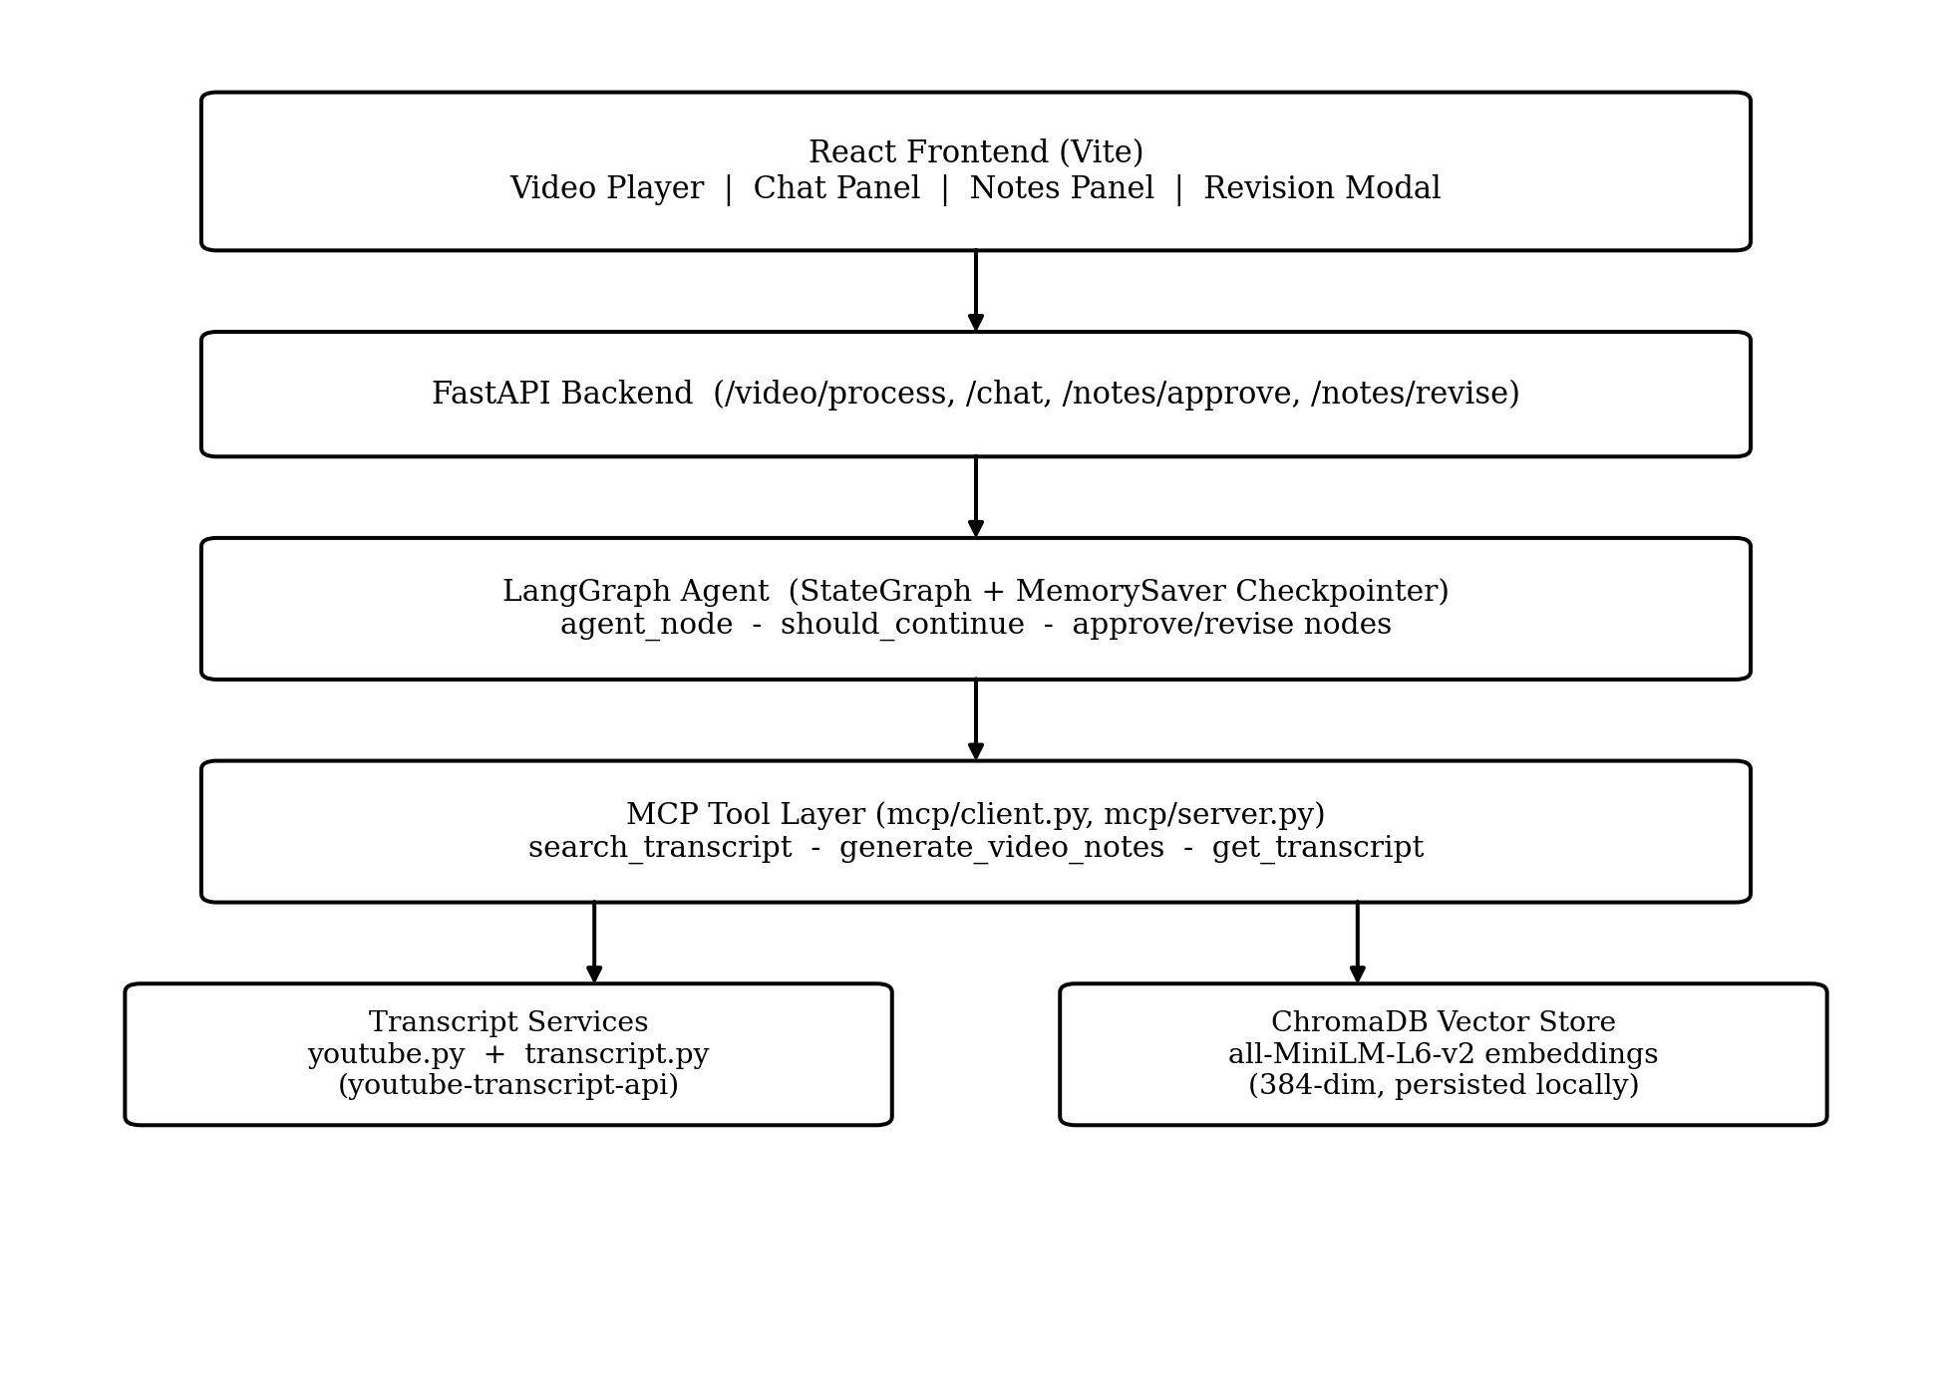
Figure 1: VideoTutor system architecture — request flow from frontend to storage.

4. Technology Stack and Key Configuration
Exact models, thresholds, and constants used in the system, with the reasoning behind each choice:
Component | Value | Why this choice
Primary LLM | Groq — compound-beta-mini | High-throughput, low-latency responses for real-time chat
Fallback LLM 1 | Google Gemini 1.5 Flash | Used automatically if Groq key is missing/unavailable
Fallback LLM 2 | OpenAI (configurable) | Second fallback if Gemini also unavailable
Fallback LLM 3 | Rule-based template text | Guarantees a response even with zero API keys configured
Embedding model | all-MiniLM-L6-v2 (384-dim) | Fast, lightweight sentence embeddings for semantic search
Fallback embedding | Custom 64-dim hash function | Keeps search working if sentence-transformers fails to load
Vector database | ChromaDB (persistent, local) | No external DB server needed; simple local persistence
Search relevance threshold | 1.65 (L2 distance) | Tuned higher than default to catch cross-lingual English/Hindi/Hinglish matches without false negatives
Transcript chunk size | ~1000 characters | About 1.5 minutes of speech; enough context per chunk for accurate search
Notes sampling | 8 milestone chunks, 220 chars each | Keeps whole-video note prompts small and within LLM request limits
Search top_k | 4 chunks | Number of chunks retrieved per specific-topic question
LLM temperature | 0.2 | Low temperature for factual, consistent, non-creative answers

5. Transcript Ingestion and Chunking
- URL accepted in any format: watch link, youtu.be, embed, shorts — normalised to an 11-character video ID.
- Captions fetched via youtube-transcript-api, with English/Hindi/Hinglish fallback and auto-translation.
- Small caption fragments merged into ~1000-character chunks (~1.5 min of speech) — too-short fragments give poor search results on their own.
- A short overlap is kept between chunks so a sentence split across a boundary isn't lost.
- Each chunk stores: text, start time, end time, video ID, chunk index — used later for clickable timestamp links.

6. Semantic Search and Vector Store
- Each chunk embedded with all-MiniLM-L6-v2 (384 dimensions) and stored in ChromaDB, filtered by video_id.
- A user query is embedded the same way; ChromaDB returns the closest chunks by meaning, not by exact words.
- Relevance threshold = 1.65 (distance). Below this = real match; above = topic is treated as not in this video.
- Concurrent-insert protection: a per-video lock prevents duplicate indexing if two requests process the same video at once.

7. LangGraph Agent and State Design
One LangGraph StateGraph is compiled at startup and reused for every conversation. A shared state object flows through the graph nodes:
- video_id, video_url, video_ready — identifies and tracks the active video.
- messages — full chat history; uses an accumulating reducer (add_messages) so new turns append instead of overwriting.
- retrieved_chunks, notes, human_feedback, requires_human_approval, final_response — updated per turn.
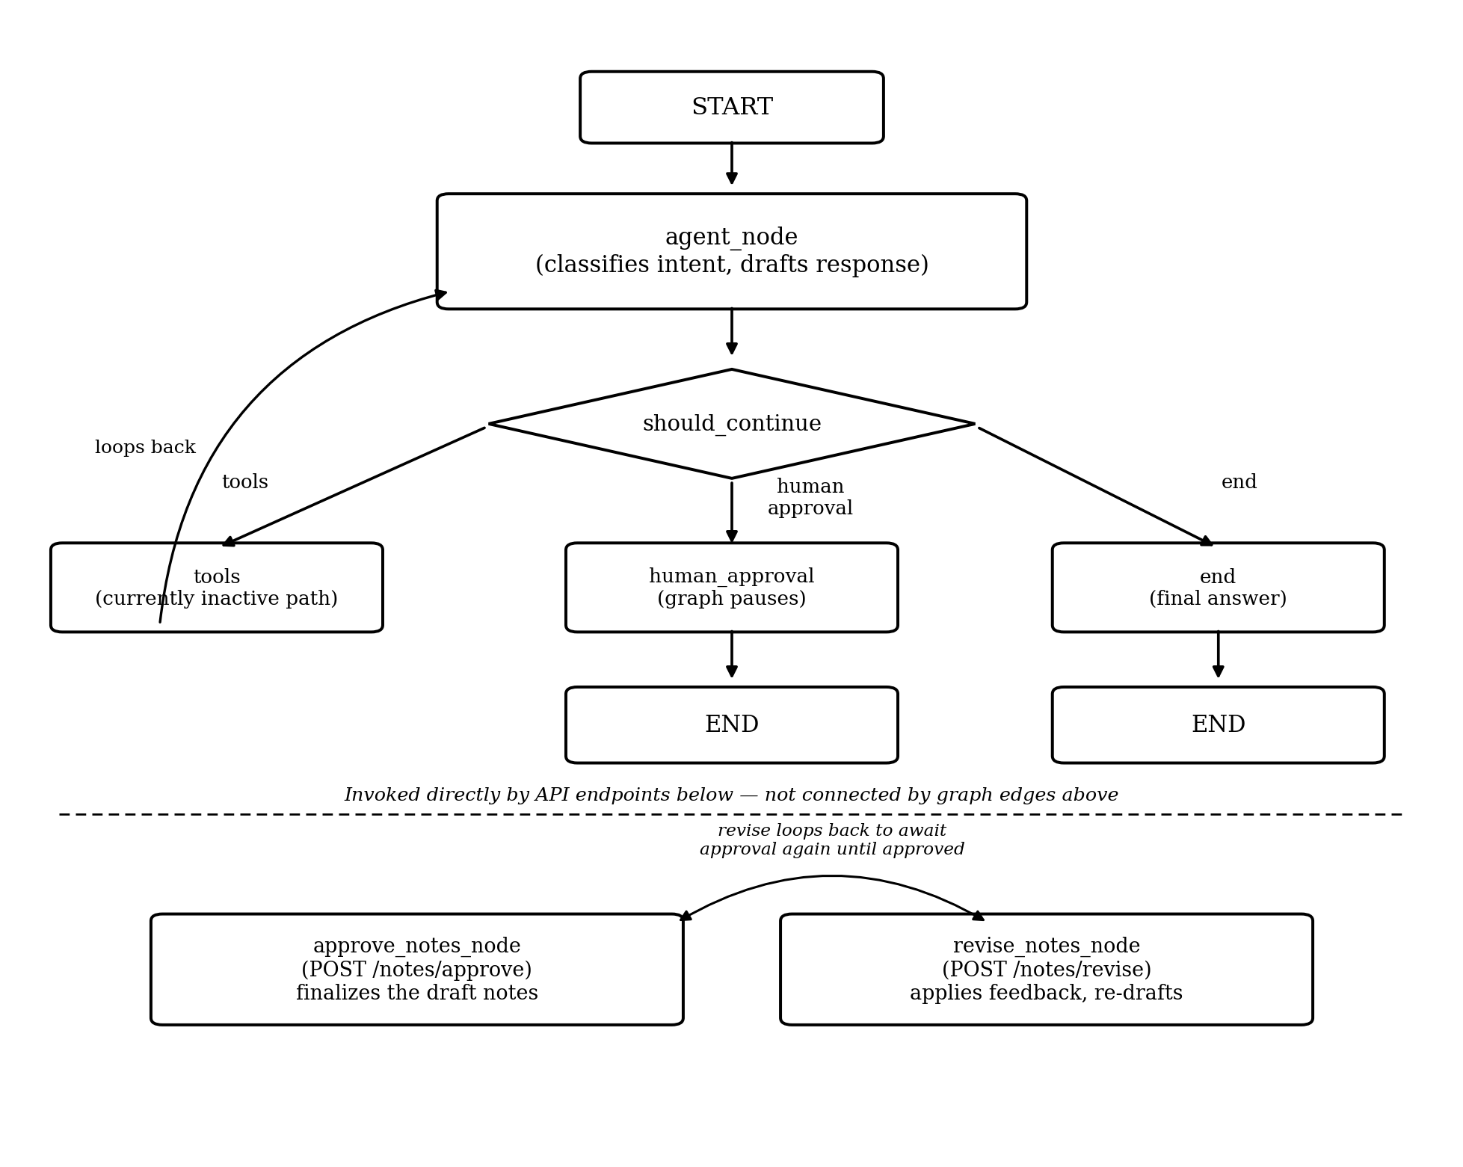
Figure 2: LangGraph state graph — main agent loop plus the separate approval/revision pathway.
- agent_node: classifies the request and drafts a response.
- should_continue: routes to tools (currently unused path), human_approval (pauses graph), or end.
- approve_notes_node / revise_notes_node: not connected by graph edges — invoked directly by /notes/approve and /notes/revise, using the saved thread checkpoint.

8. Intent Classification and Tool Selection
Design decision: the LLM classifies intent as a label (JSON); backend code — not the LLM — picks and calls the tool. This is deliberate, not a limitation:
- Why: with a small, fixed set of actions, code-driven routing is more predictable and testable than trusting free-form LLM tool-calling.
- Trade-off: less flexible than a full ReAct agent — can't improvise new tool combinations for unusual requests.
- Categories: whole_video (notes/summary/quiz), specific_search (topic question), out_of_video (general knowledge fallback).
- Scaffolding for a future full tool-calling migration already exists (tool_node, client-side tool registry) but is currently inactive by design.

9. Study Notes Generation
- Triggered by: notes, study, summary, guide, timeline, quiz, cheat-sheet keywords, or LLM classification.
- Samples 8 milestone chunks evenly spread across the full video (not the whole transcript) — keeps the prompt small.
- Each sampled chunk truncated to 220 characters max.
- Fixed output structure: Executive Summary, Topic-by-Topic Breakdown (with real-world analogies), Architecture/Comparison Table, Key Takeaways & Review Questions, Video Timeline with clickable links.

10. Human-in-the-Loop (HITL) Review Workflow
- Generated notes are a draft, not final — requires_human_approval flag is set to true.
- Graph execution pauses (ends) at this point; state is saved via MemorySaver, keyed by thread_id.
- Student choice: Approve (POST /notes/approve) finalises the notes, or Request Changes (POST /notes/revise) sends feedback and draft back to the LLM.
- Revised notes require approval again — this can repeat until the student is satisfied.

11. Frontend Features
Built with React + Vite. Key features of the interface:
- Universal YouTube ingestion — one-click loading for standard, shortened (youtu.be), shorts, and embed URLs.
- Three learning view modes — instant toggle between Study Notes, AI Tutor, and Split View.
- Interactive video player — embedded YouTube IFrame player with automated seek control from chat timestamps.
- AI Tutor Q&A chat — natural language Q&A with Markdown rendering, math/code syntax highlighting, and auto-scroll.
- One-click quick prompts — shortcut buttons for Create study notes, Key milestones, Summary, and Quiz.
- Markdown study notes panel — formatted preview with an integrated live Markdown editor.
- Copy and download — one-click clipboard copy and .md file download for offline study.
- Human-in-the-Loop approval — in-app banner to Approve or Revise AI-generated study notes.
- Note revision modal — popup dialog to enter natural language feedback to revise notes.
- Draggable, resizable layout — customisable column widths and video player height.

12. API Endpoints
Method | Endpoint | Purpose
GET | /health | Service status, active LLM model, active embedding mode
POST | /video/process | Extract transcript, chunk, and index a video into ChromaDB
POST | /chat | Send a message to the agent; returns answer or draft notes plus approval flag
POST | /notes/approve | Finalise the current draft study notes for a thread
POST | /notes/revise | Send feedback to revise the current draft notes

13. Design Trade-offs Summary
Decision | Benefit | Trade-off
Code-driven tool routing (not LLM tool-calling) | Predictable, testable, reliable | Less flexible for novel/compound requests
8-chunk milestone sampling for notes | Small, fast, fits LLM limits | Long lectures lose some fine detail
HITL only on notes, not on Q&A | Notes are reusable, worth verifying | Extra step only for notes, not chat
Per-video conversation threads | Clean isolation, no history mixing | Requires frontend to send a real thread_id
- Output:
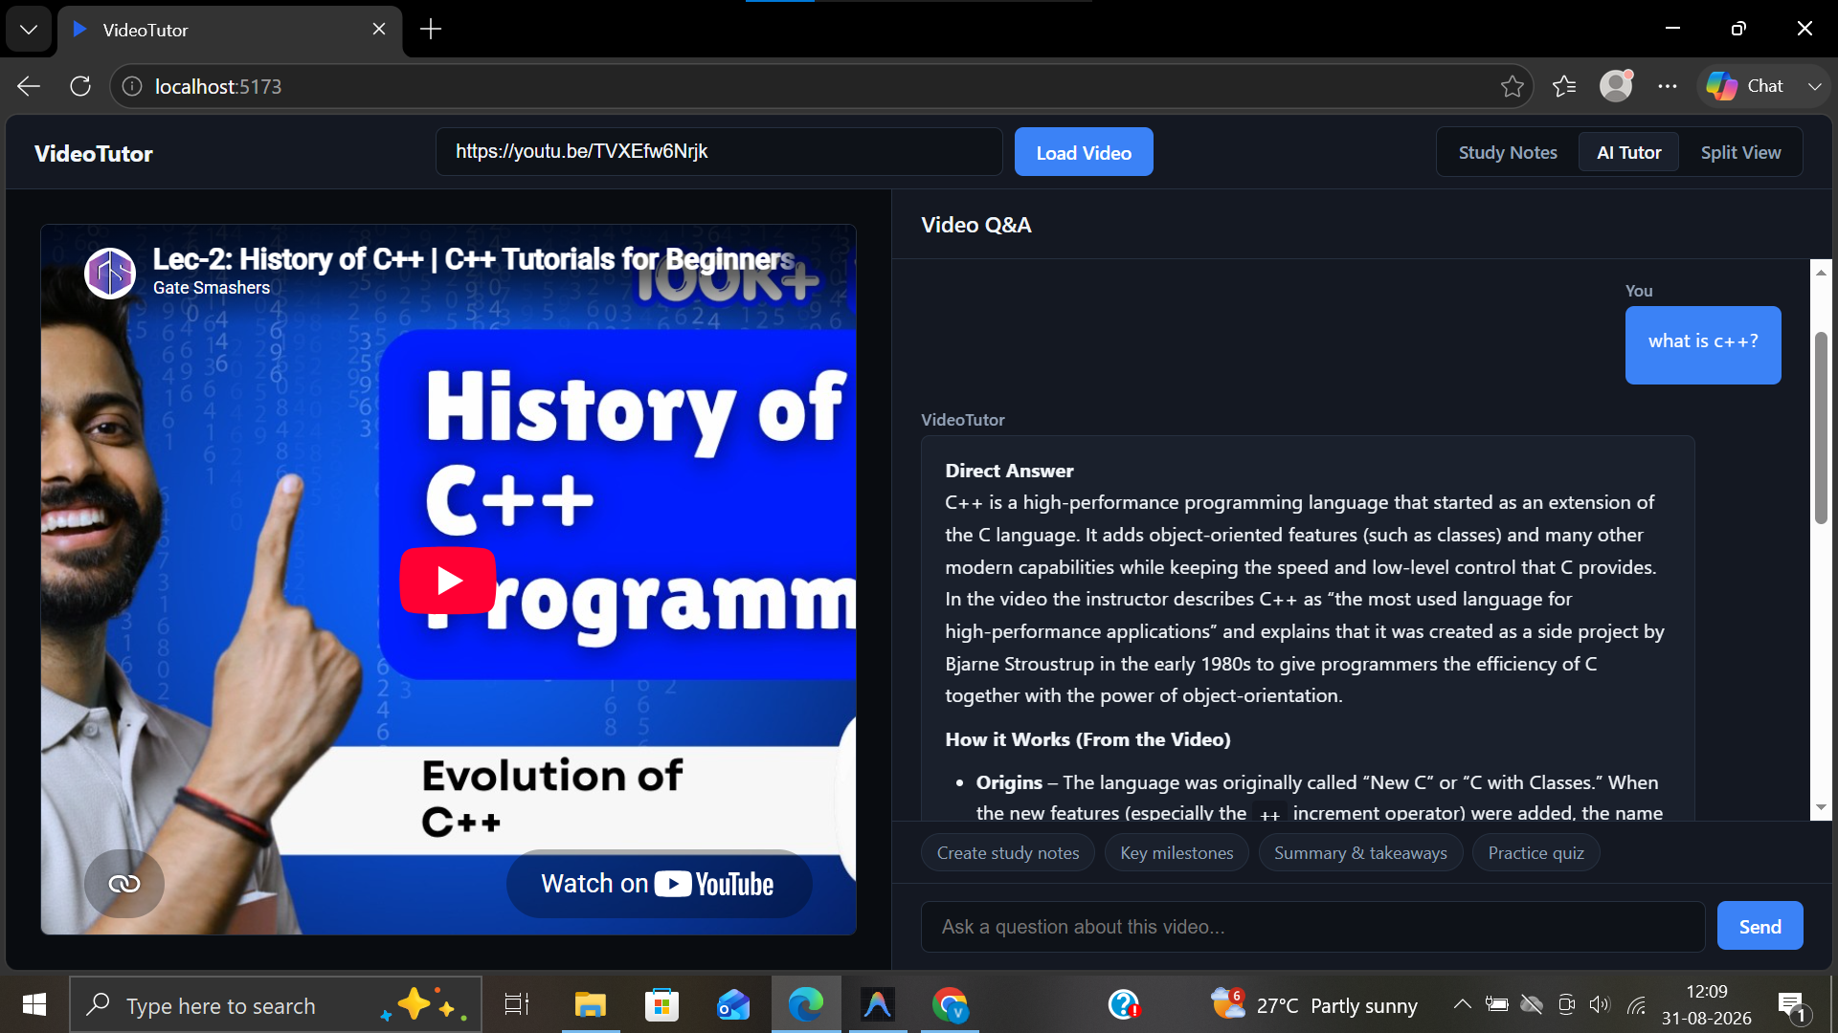
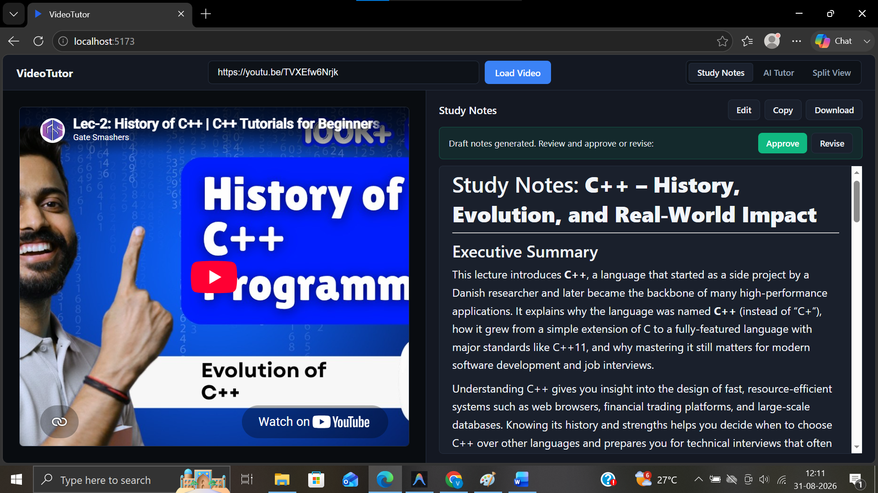
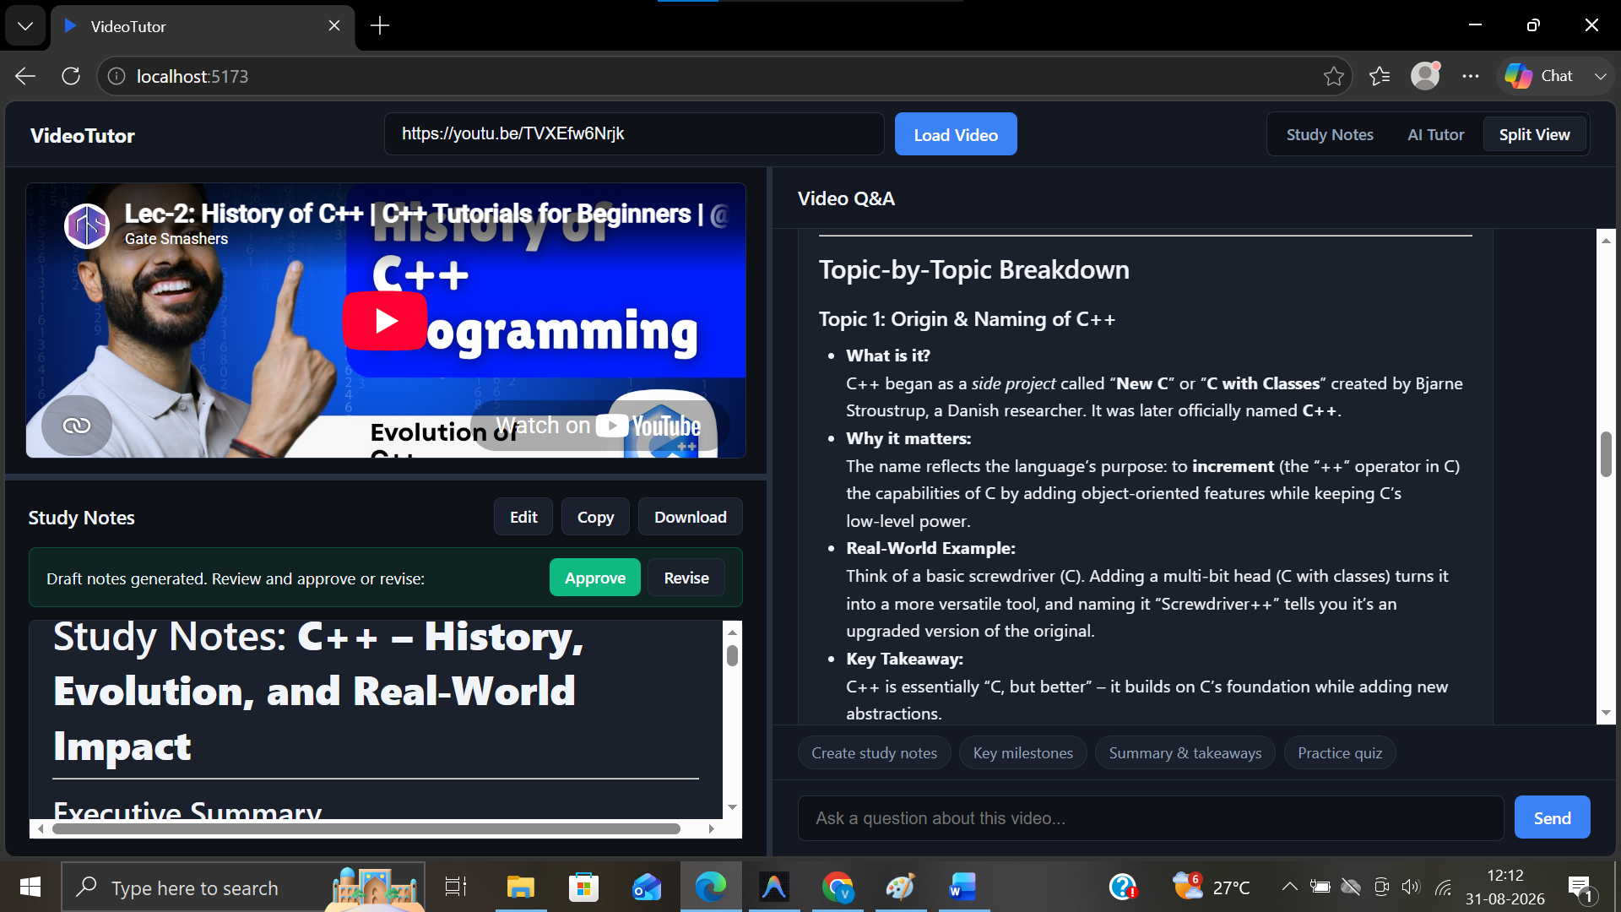

14. Limitations and Future Work
- 8-chunk sampling may miss fine detail in very long lectures — a hierarchical summarisation approach could improve this.
- Fallback hash-based embedding is meaningfully less accurate than the primary model — should be minimised in production.

15. Conclusion
VideoTutor combines transcript-aware chunking, semantic search, a LangGraph agent, and a Human-in-the-Loop review process to turn passive video-watching into grounded, interactive learning. Its design choices, including layered LLM fallback, deterministic tool routing, and per-video state isolation, prioritise reliability over unconstrained autonomy, while leaving a clear path to greater agentic flexibility as future work.

