Assignment No 09
ADS LAB

Vrushali Sangale
22510092

The CRUD Operations using mongodb and Casandra :

SO for mongo we have server.js file , For Cassandra we have index.js :

Run specififc backend accoridngly :

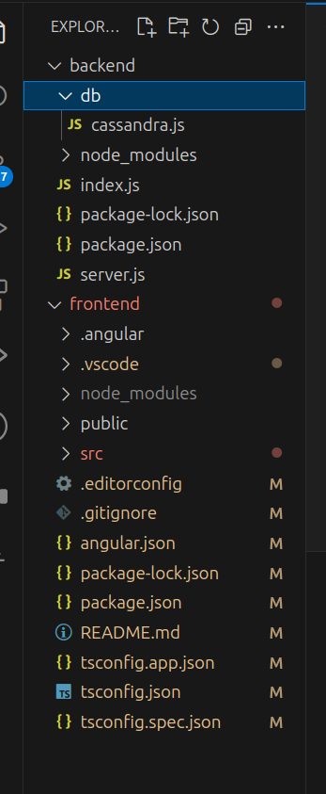
project structure :

For MongoDB :

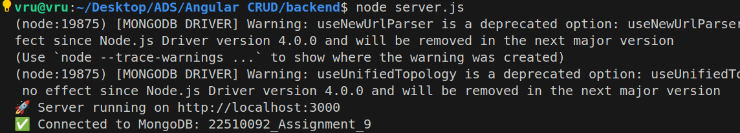

For Cassandra :
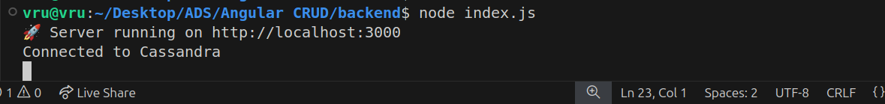

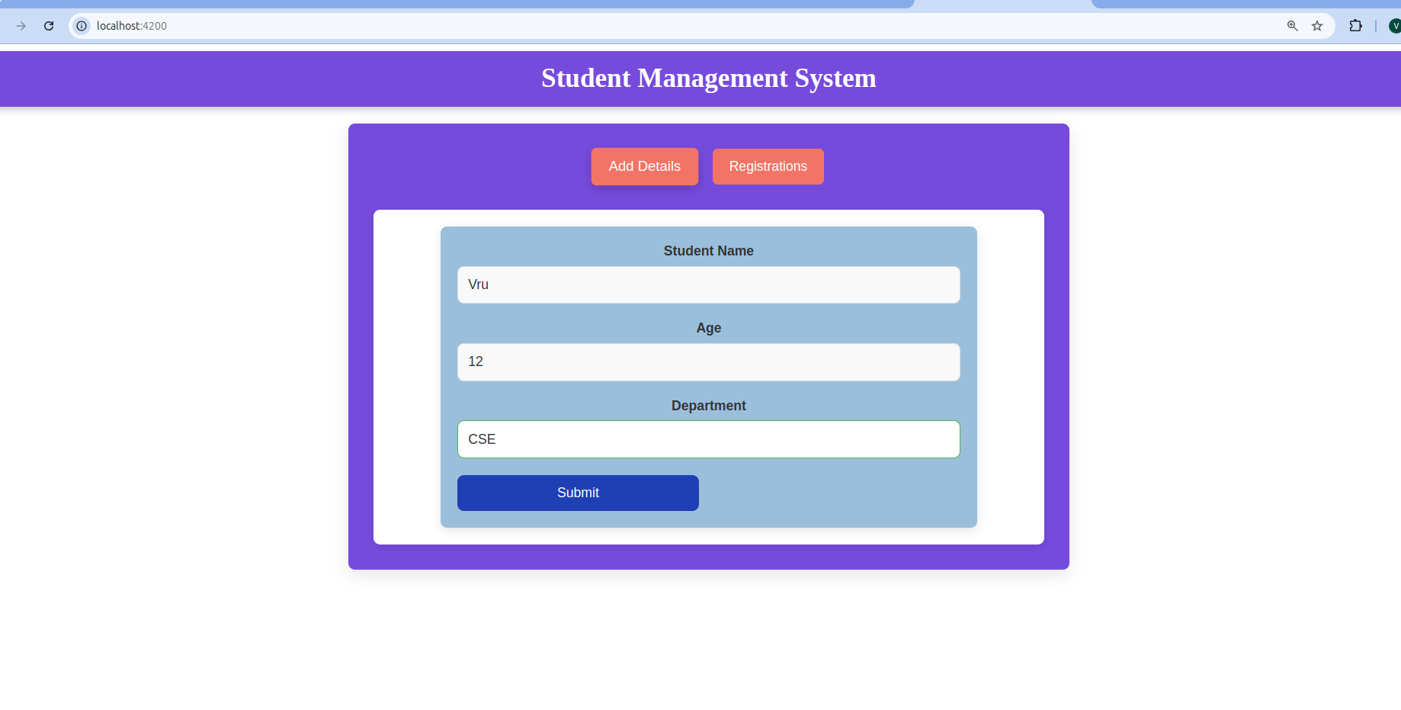
UI :

Submitted and saved :

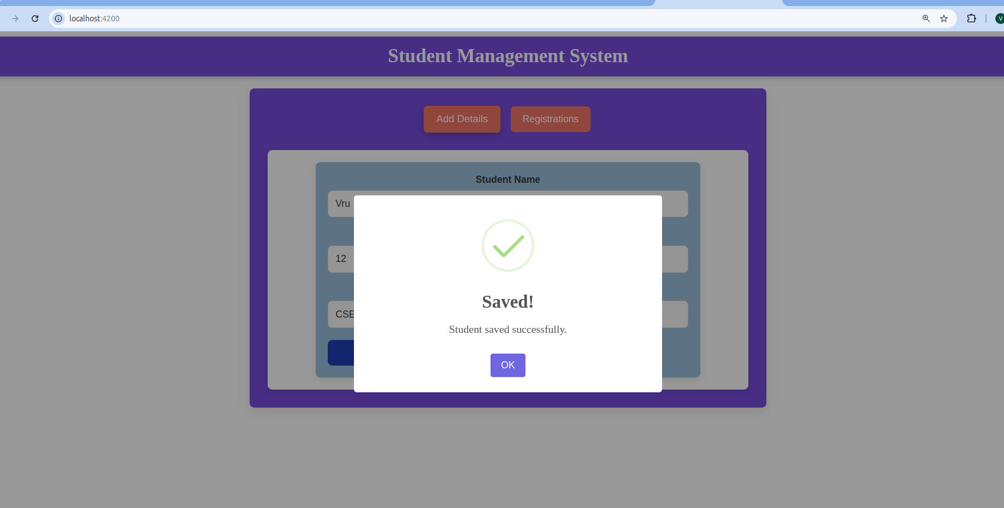

In Registration page :

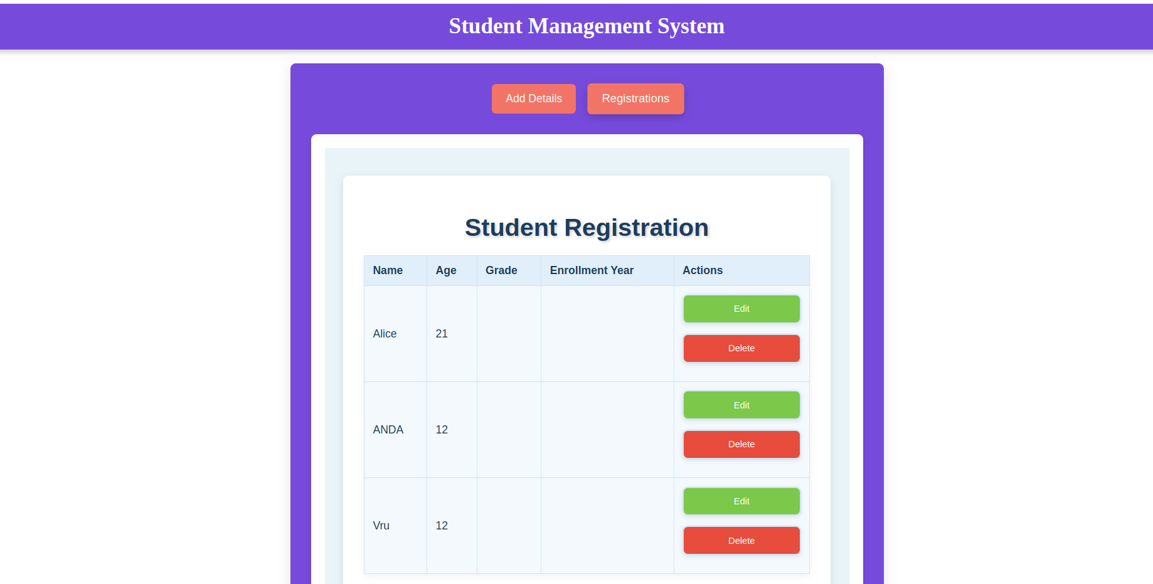

You can also delet the student :
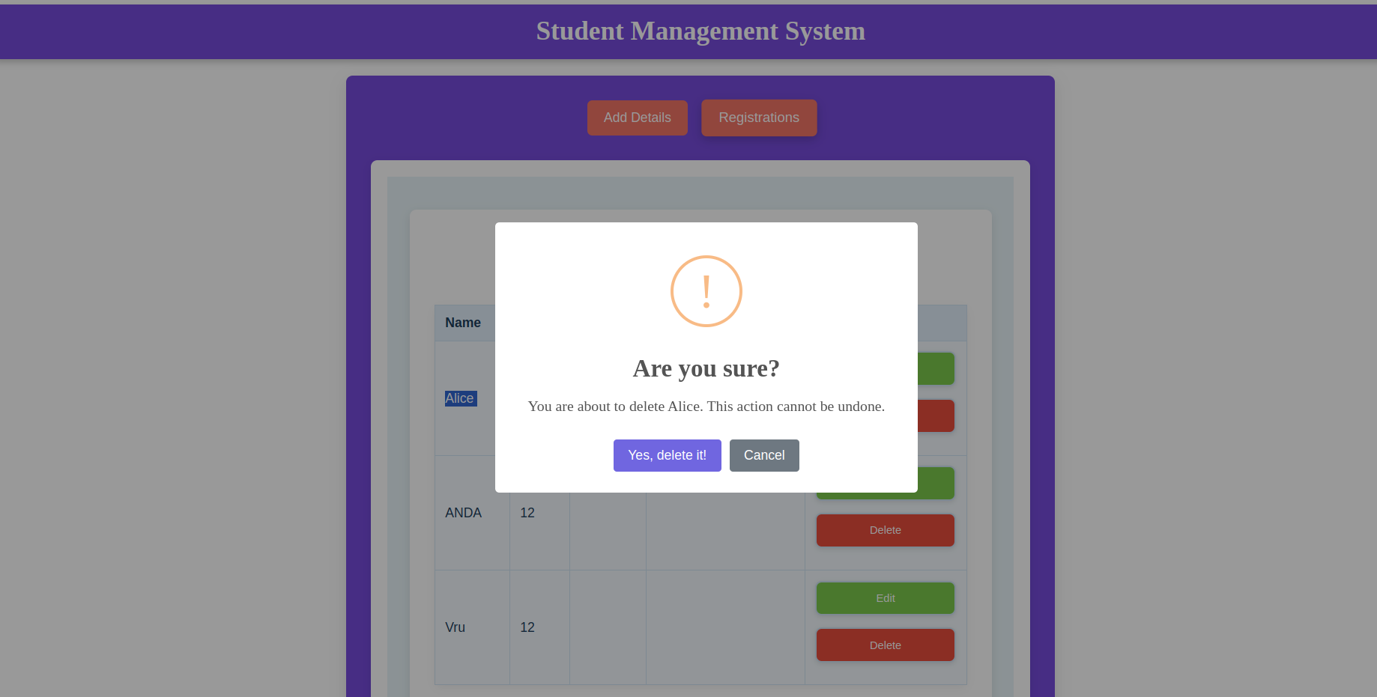

We can update the student details also :

