ASSIGNMENT – 11

ADS LAB

Vrushali Sangale

PRN : 22510092

In this we have given the data csv From that we have LOAD CSV in NEO4J and then perform some operations below is the code strucure for that project :

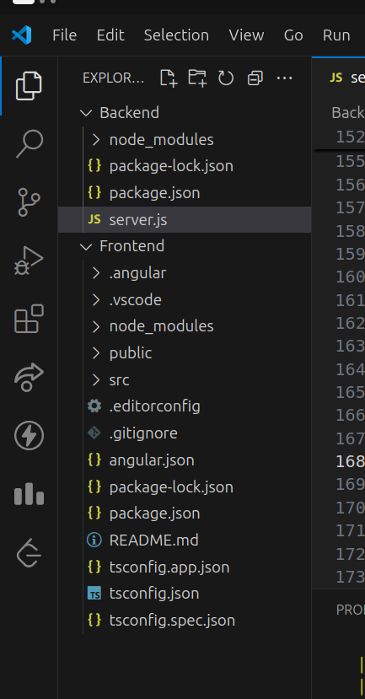

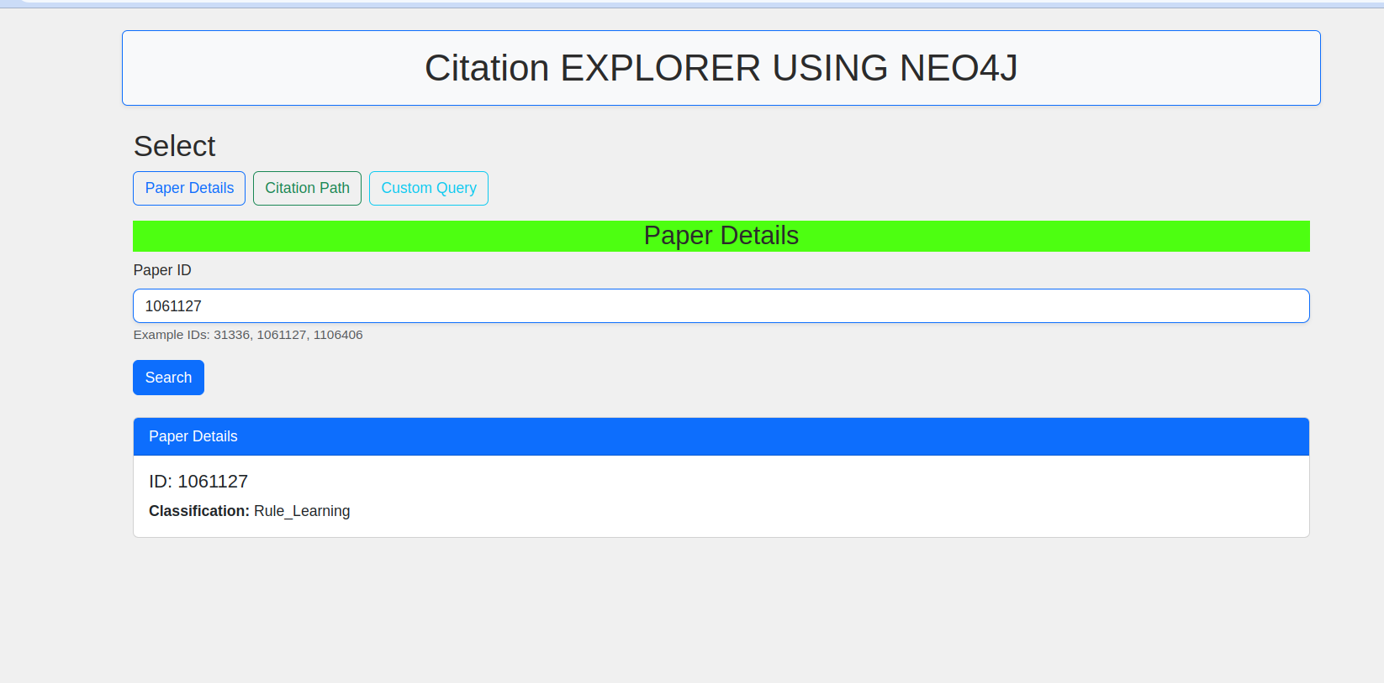
Paper-Details :

Citation path exists between two papers:

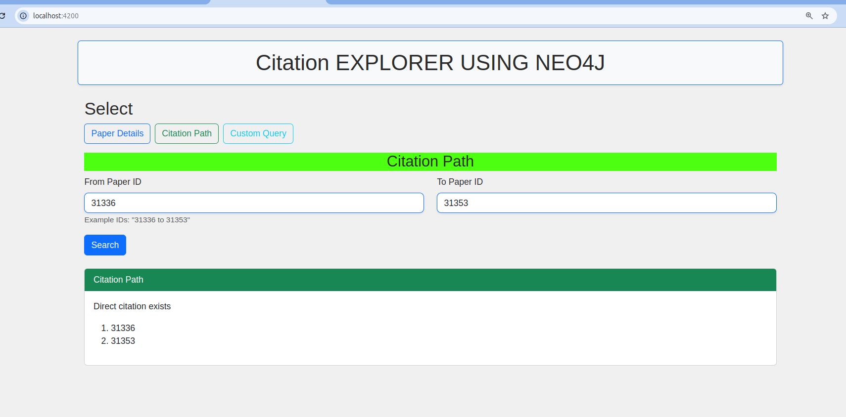

Custom Cypher Query :

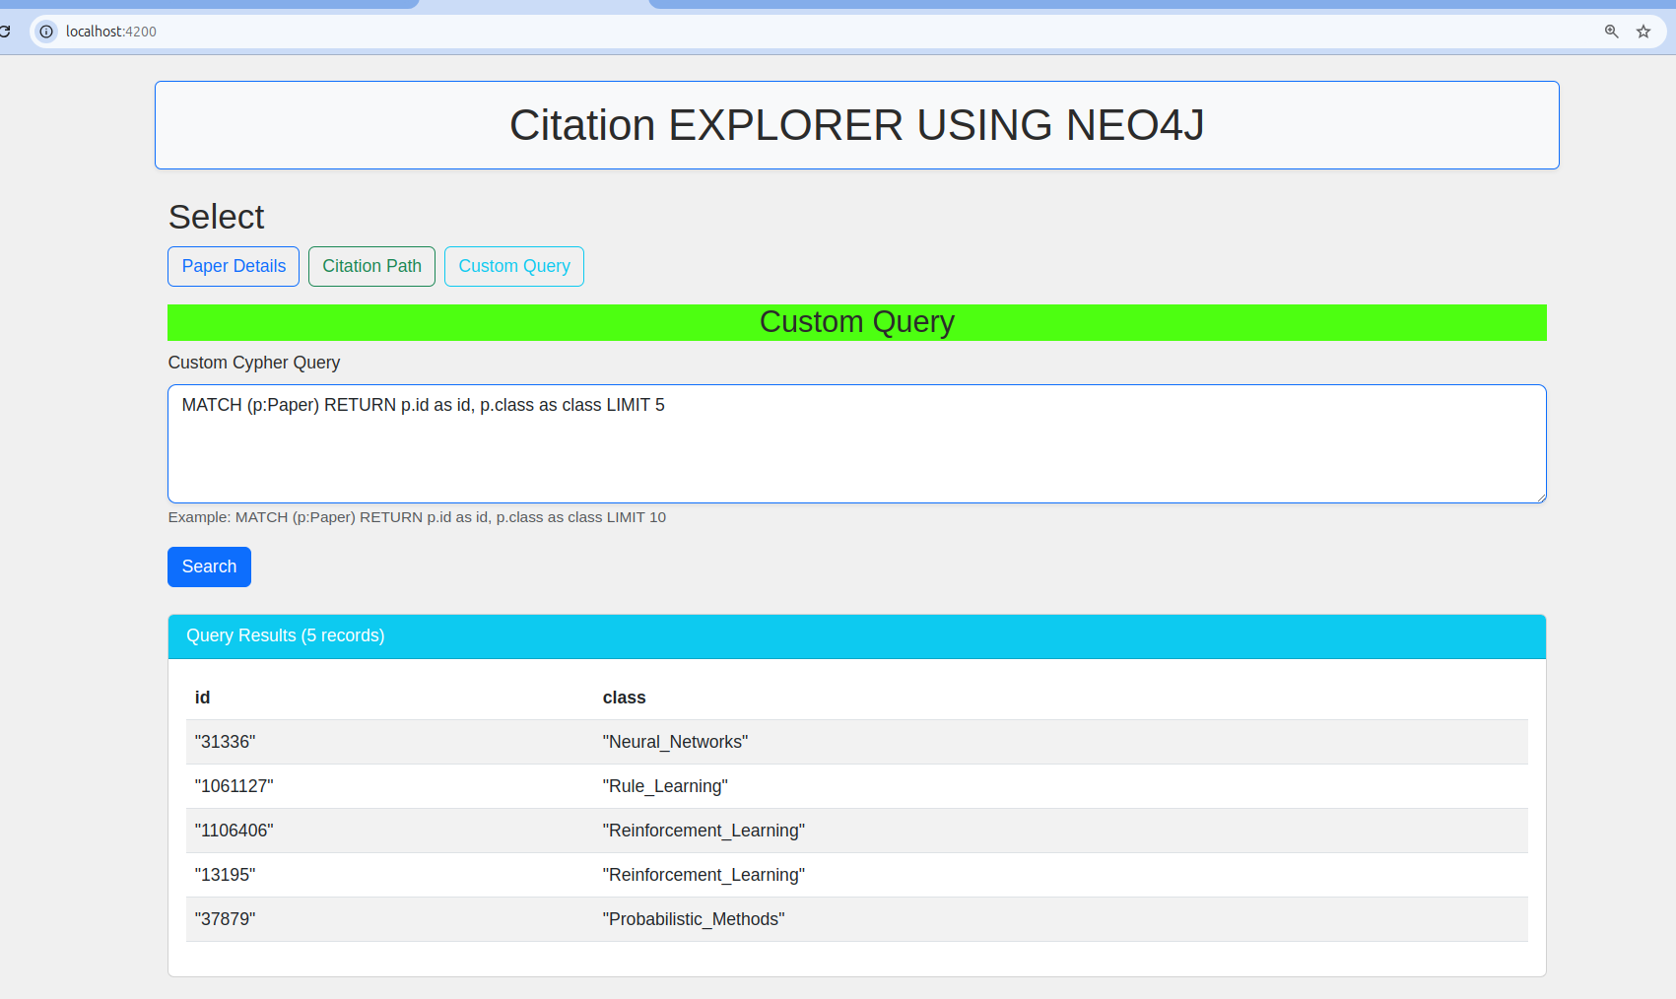

DB SS :

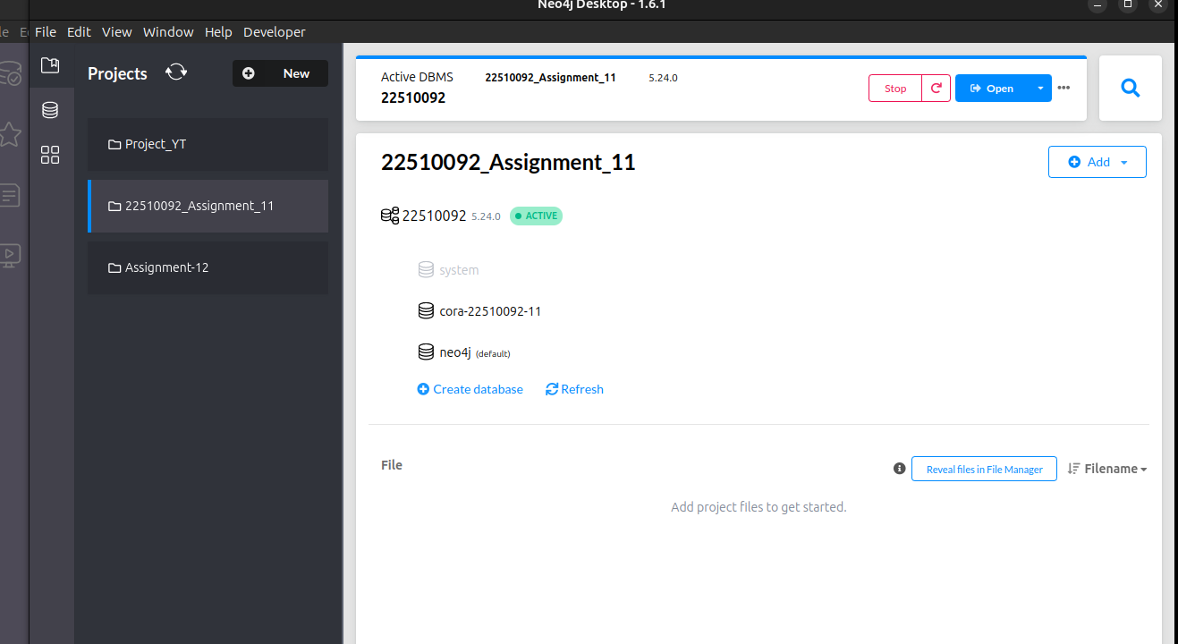

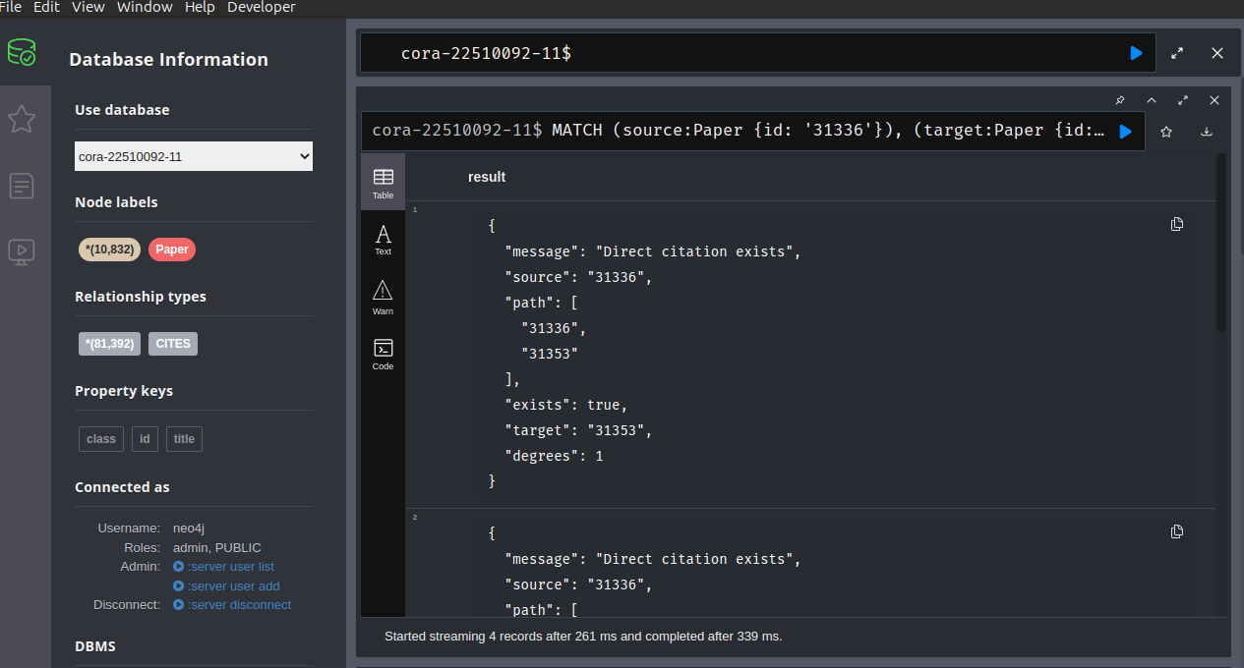

Graph :
