Name: Vrushali Sangale

PRN No: 22510092

Batch: B1

Github : https://github.com/Vru01/HPC_22510092

**High Performance Computing Lab**

**Practical No. 8**

**Problem Statement 1:** Study and implement 2D Convolution using MPI. Use a different number of processes and analyze the performance.

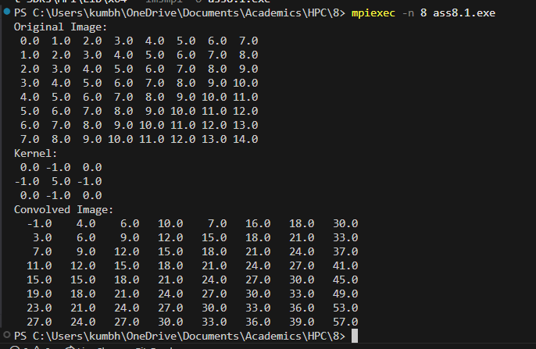 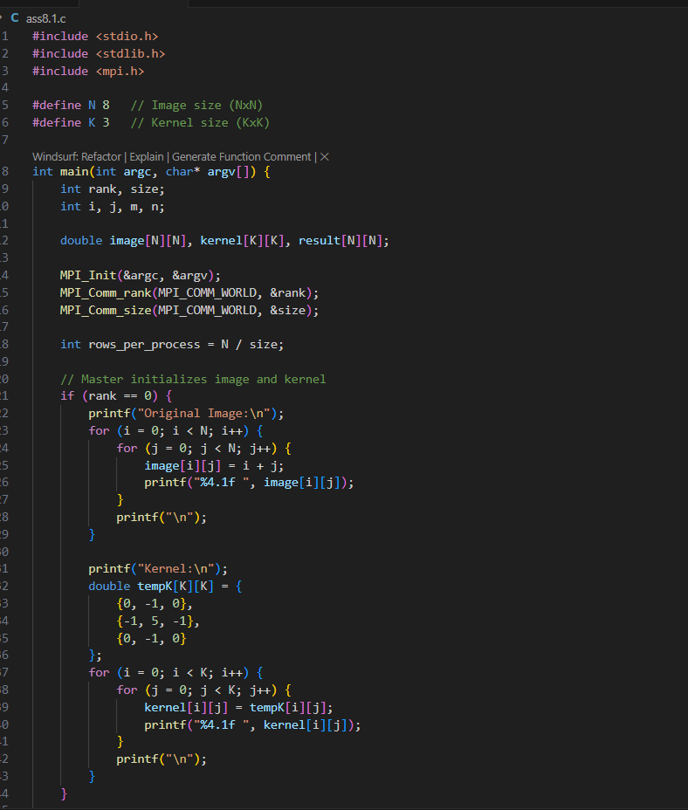 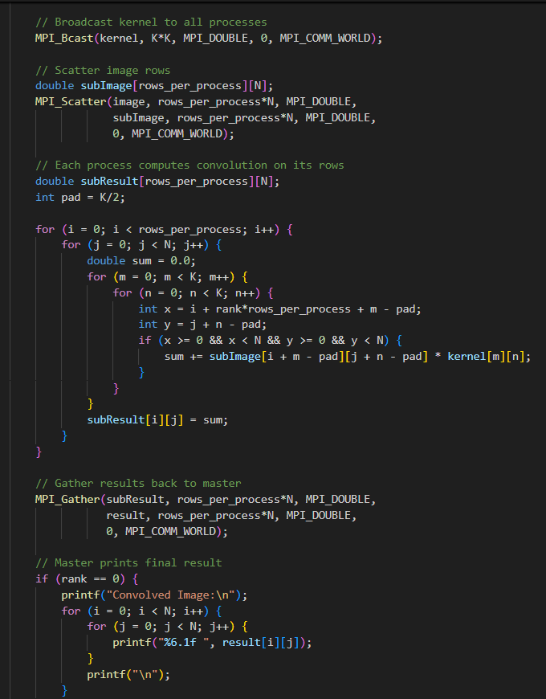

**Problem Statement 2:** Implement dot product using MPI. Use different number of processes and analyze the performance.

