**E learning**

**Introduction**

Create a user-friendly **web** application designed to facilitate online learning. The platform will offer courses, interactive quizzes, assignments, and provide valuable feedback mechanisms for both learners and instructors. It aims to enhance the educational experience by enabling effective online teaching and learning.

**Requirement**

**Functional:**

1. User Registration and Authentication.

2. User Profiles.

3. Course Management

4. Content Creation and Management.

5. Assessment and Progress Tracking.

6. Discussion and Collaboration.

7.Feedback and Rating System.

8. Accessibility.

**Non Functional:**

1. Performance.

2. Security.

3. Scalability.

4. Backup and Recovery.

5. Cost Efficiency.

6. Integration.

**System Architecture:**

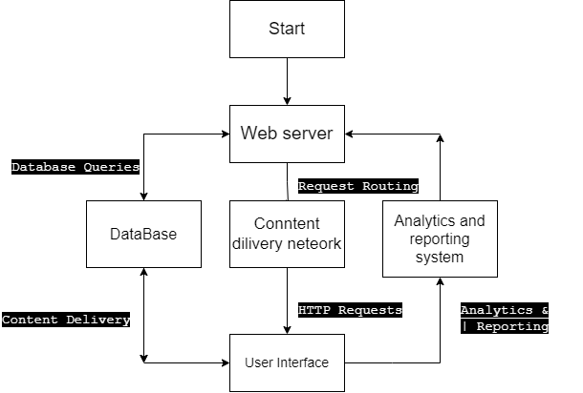

**Class Diagram**

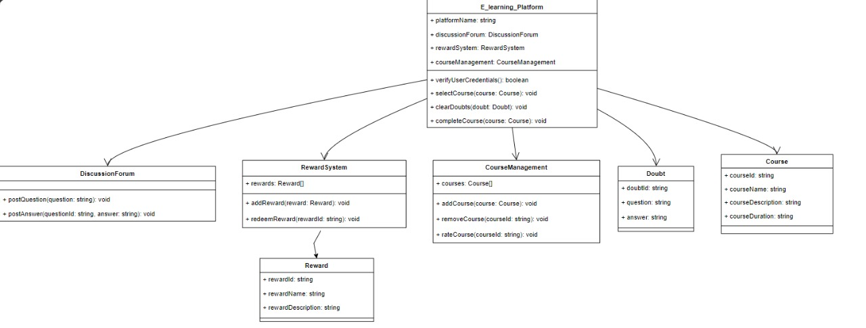

**Deployment:**

