**E-LEARNING PLATFORM**

**INTRODUCTION**

Create a user-friendly **web** application designed to facilitate online learning. The platform will offer courses, interactive quizzes, assignments, and provide valuable feedback mechanisms for both learners and instructors. It aims to enhance the educational experience by enabling effective online teaching and learning.

**TECH STACK**

**1. User Interface (UI):**

We will create a clean and user-friendly interface with HTML for structure, CSS for styling, and JavaScript for interactivity.

**2. User Experience (UX):**

we will implement intuitive navigation and user flows to enhance the overall learning experience.

**Frontend**:

1. HTML, CSS, JavaScript:

We will Build the frontend using HTML for structure, CSS for styling, and JavaScript for dynamic elements and interactivity. Focus on responsive design to adapt to different screen sizes.

**Backend**:

1. Python:

We will choose either Python for the backend, depending on our future functionalities. Implement user authentication, authorization, and routing for content delivery.

**Database:**

1. MongoDB:

We will be using MongoDB as the NoSQL database to store user data, course information, assignments, and other relevant data. Define database schemas to organize and retrieve data efficiently.

**Hosting and Development:**

1. Local Hosting:

During development and testing, the application will be hosted locally on our machines for rapid development and debugging.

**ACTIVITY DIAGRAM**

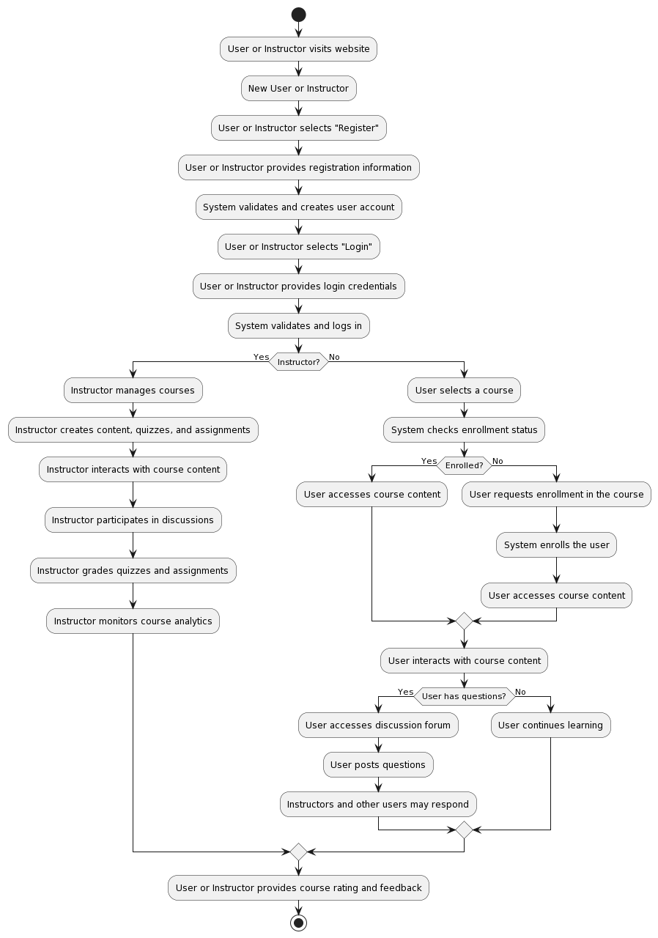

**SEQUENCE DIAGRAM**

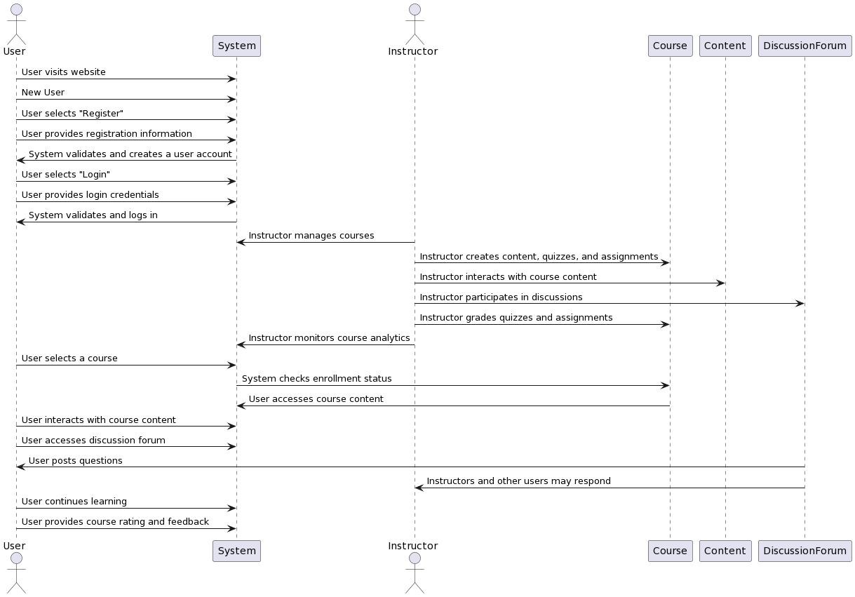

**CLASS DIAGRAM**

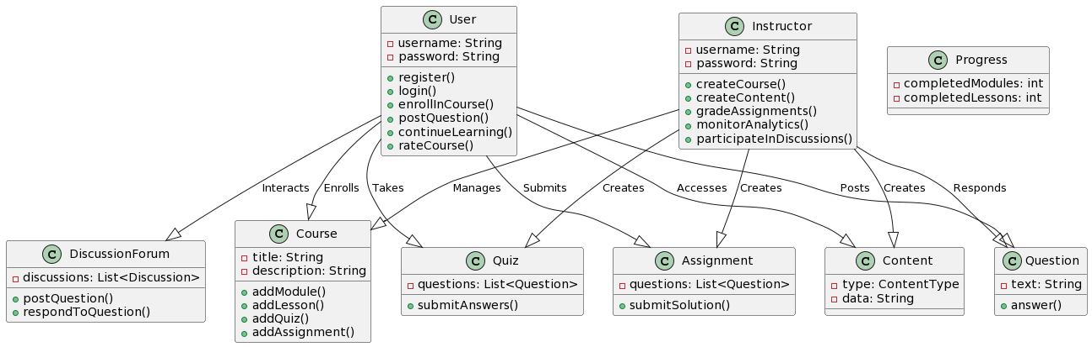

**SYSTEM ARCHITECTURE**

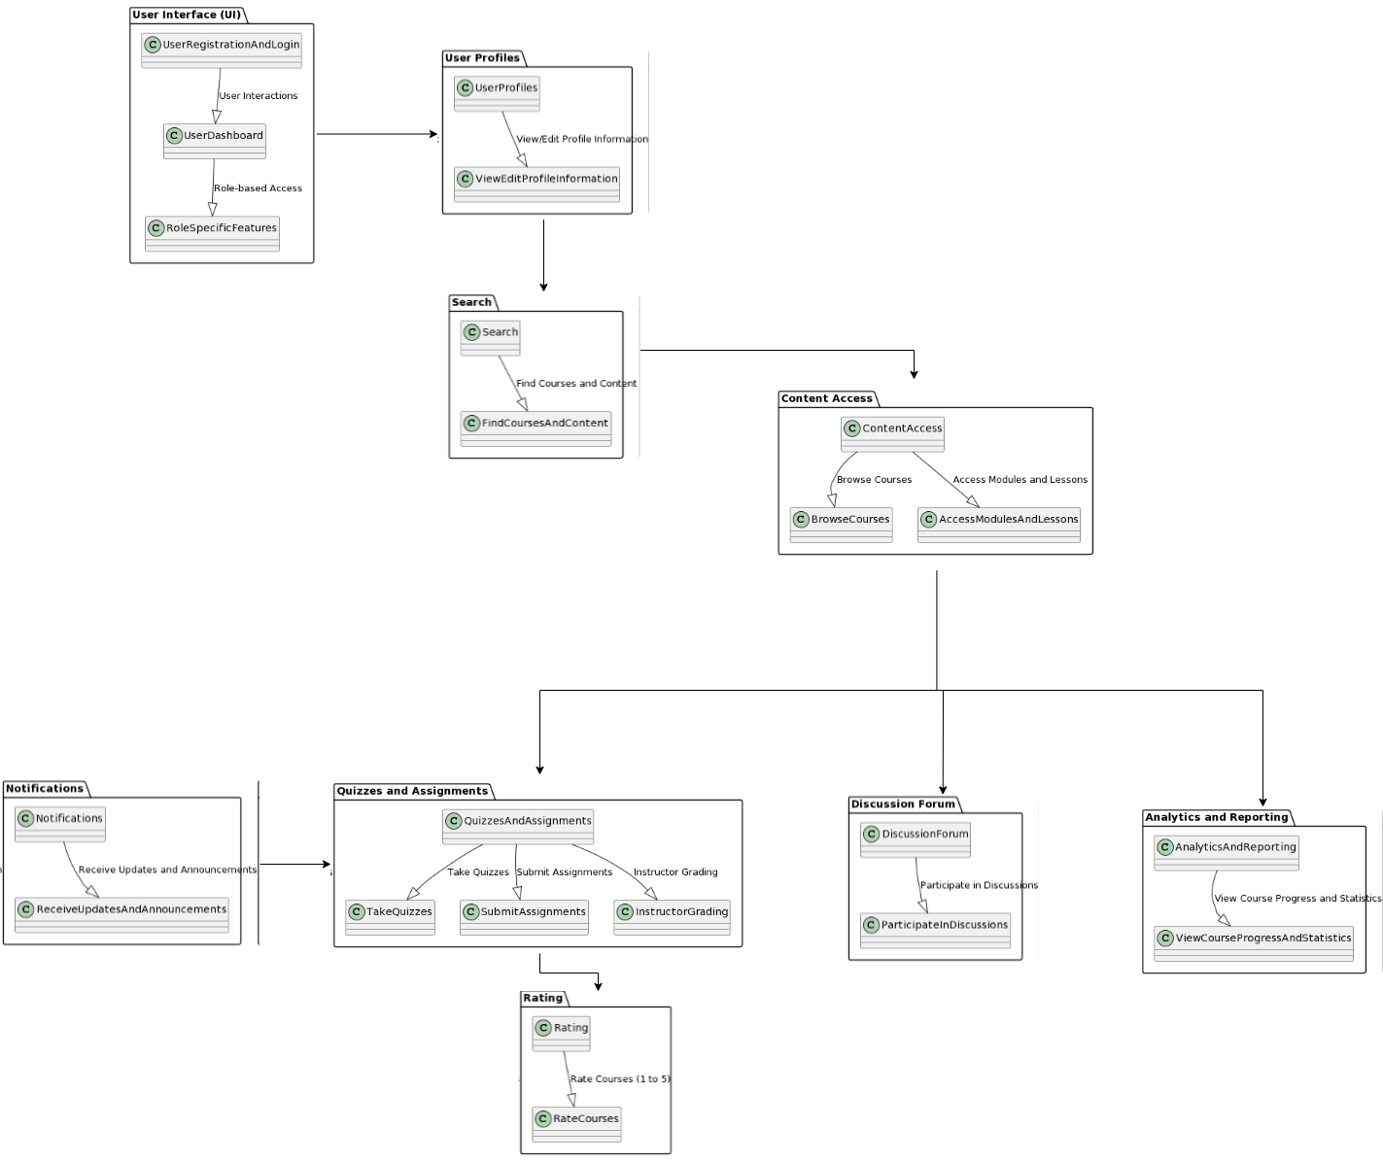

**DEPLOYMENT DIAGRAM**

