
Department of Computer Science Engineering
Institute of Technology, Nirma University, Ahmedabad
INNOVATIVE ASSIGNMENT
Course Code and Name
3CS524CC26 – Full Stack Development
CareDose: Medication & Caregiver Monitoring System
Submitted by
Vishesh Shah (24BCE311)
Vrund Sutariya (24BCE334)

Submitted to
Prof. Dr. Smita Agrawal

October 2026

1. Abstract and Project Overview
CareDose is a web-based medication adherence and caregiver monitoring system. It helps patients organize medicines, follow dose schedules, record whether a dose was taken or missed, and track remaining stock. Patients can link trusted caregivers through an invite code, allowing them to view adherence information and alerts for missed doses or low medicine stock.
The project applies full-stack development concepts through a React frontend, an Express REST API, and a relational database. It combines role-based access, dose logging, stock management, adherence analytics, and appointment notes in one application.

1.1 Problem Statement
Patients managing multiple medicines may forget doses or run out of stock. Family members who provide remote support often cannot confirm whether medication was recorded as taken. Basic alarms do not provide a shared history or stock visibility. CareDose addresses this gap with a central schedule and monitoring workflow.

1.2 Objectives
• Build a responsive web application with separate patient and caregiver experiences.
• Allow patients to manage medicines and generate daily schedule slots.
• Record taken/missed doses and update stock when a dose is taken.
• Link caregivers securely and show relevant alerts and adherence history.
• Provide 7-day and 30-day adherence summaries and appointment management.

1.3 Scope
Included: authentication, medicine cabinet, schedules, dose logs, stock/refill controls, caregiver linking, analytics, and appointments. Native mobile applications, prescription OCR, wearable integration, and external messaging notifications are outside the current scope.

2. Main Users
User | Main capabilities
Patient | Manage medicines, log doses, refill stock, view analytics, manage appointments and caregiver links.
Caregiver | View linked patients, review adherence history, and identify missed-dose or low-stock alerts.

3. System Architecture
CareDose follows a three-tier architecture. The frontend handles interaction and presentation; the backend validates requests and applies business rules; the database stores users, medicines, schedules, logs, links, and appointments.
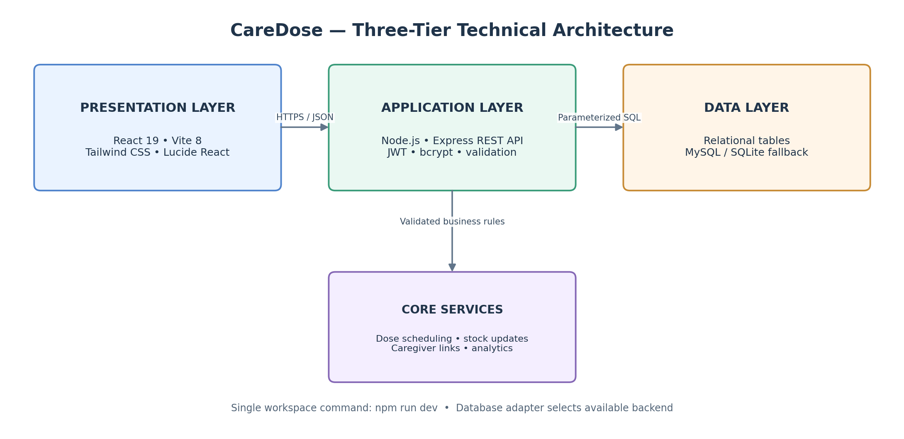

Tier | Technology | Responsibility
Presentation | React 19, Vite 8, Tailwind CSS, Lucide React | Forms, dashboards, dose cards, charts, navigation.
Application | Node.js, Express.js, JWT, bcrypt | Authentication, authorization, scheduling, stock updates, alert logic, analytics.
Data | MySQL with SQLite fallback | Persistent relational records, keys, constraints, and queries.

3.1 Request Flow
• The user interacts with the React application and sends JSON requests to the REST API.
• Middleware checks the token, role, input, and resource ownership before protected operations.
• Service logic processes the operation and uses parameterized SQL to access the database.
• The API returns the result; the interface refreshes dose status, stock, analytics, or caregiver alerts.
The root workspace is designed to start the client and server together with npm run dev. The database adapter attempts MySQL and can use embedded SQLite when MySQL is unavailable.

4. Core Workflow and Functional Modules
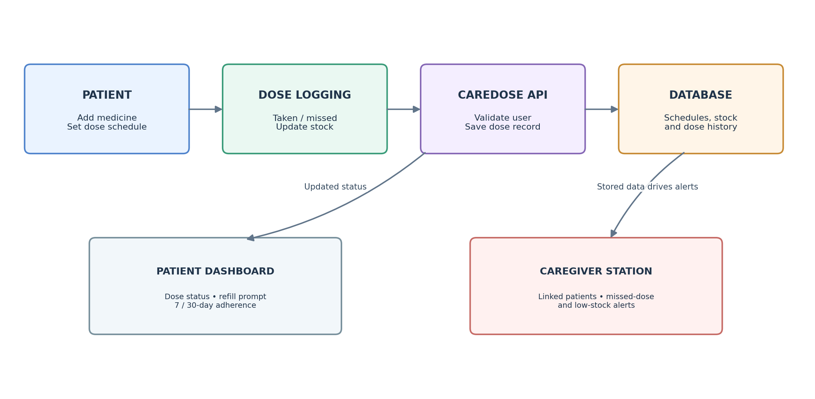

4.1 Patient Module
• Medicine cabinet: store medicine name, dosage, frequency, current stock, and refill threshold.
• Schedule generation: common frequencies map to daily time slots; custom times can be supported.
• Dose tracking: the patient records a dose as taken or missed. A taken dose reduces stock by one.
• Refill: a one-click action increases the stored quantity; low-stock status is based on a threshold.
• Appointments: record doctor, date/time, and optional notes.

4.2 Caregiver Module
• A caregiver submits a patient's invite code to request a link. Only active links should expose patient information.
• The Monitoring Station shows linked patients and alerts derived from dose history and medicine stock.
• A read-only inspection view presents medicine details, recent dose history, appointments, and adherence summaries.

4.3 Adherence Analytics
Adherence percentage is calculated as: (taken scheduled doses ÷ total scheduled doses) × 100. The application presents 7-day and 30-day summaries with daily values for a bar chart. The calculation depends on the schedule and dose-log records available for the selected period.

5. Database Design
The data model uses six related tables. Primary keys identify records; foreign keys connect dependent records. Unique constraints help prevent duplicate accounts, duplicate caregiver links, and multiple logs for the same schedule slot on the same date.

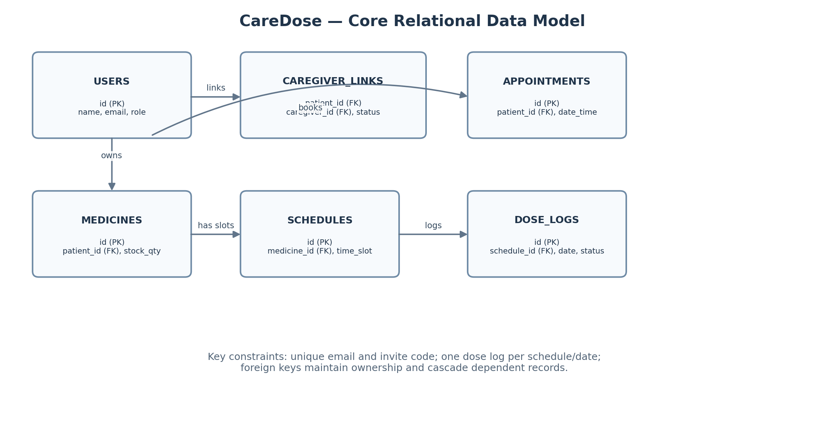

Table | Purpose / important fields
users | User identity, email, password hash, role, invite code.
caregiver_links | Patient, caregiver, link status, creation time.
medicines | Owner, medicine name, dosage, frequency, stock quantity, refill threshold.
schedules | Medicine reference and daily time slot.
dose_logs | Schedule reference, date, status (taken/missed/pending), logged time.
appointments | Patient, doctor name, date/time, notes.

5.1 Integrity and Normalization
• Medicine schedule times are stored as separate rows rather than a comma-separated list.
• Foreign keys connect medicines to users, schedules to medicines, and logs to schedules.
• A unique (schedule_id, date) constraint supports one dose record per slot per day.
• Adherence and alert values are derived from stored records rather than duplicated as manually maintained fields.

6. Implementation and Security

6.1 Authentication and Authorization
Registration validates required fields and stores a bcrypt password hash instead of a plain-text password. Successful login issues a signed JSON Web Token (JWT). Protected API routes verify the token and apply role checks. Object-level ownership checks are also required so a patient can access only their own records and a caregiver can access only patients linked to them.

6.2 Dose Logging and Stock Update
When a patient records a dose as taken, the API validates the schedule and patient ownership, saves the dose outcome, and decrements stock. The update should be atomic, reject negative stock, and prevent a repeated request from decrementing stock twice. A low-stock alert is raised when the remaining quantity reaches the configured threshold.

6.3 Security Controls
Control | Purpose
bcrypt password hashing | Reduces exposure if stored credential hashes are compromised.
JWT verification and role checks | Protects endpoints and separates patient and caregiver permissions.
Parameterized SQL | Separates user input from SQL commands to reduce injection risk.
Rate limiting | Limits repeated requests, especially to authentication endpoints.
Security headers and restricted CORS | Reduces selected browser-based risks and limits permitted origins.
Database constraints | Preserves relationships and prevents selected duplicate or invalid records.

6.4 Important Design Decisions
• The backend remains the authority for validation and business rules; frontend checks alone are not sufficient.
• Caregiver alerts are derived from dose logs and stock levels, reducing the need to store duplicate alert records.
• SQLite fallback simplifies local demonstrations; production deployments still need secure configuration, backups, and operational monitoring.

7. API Overview and Testing
The backend exposes REST endpoints that exchange JSON. Protected requests use an Authorization: Bearer token header. Exact endpoint names should match the final project repository.

Module | Typical operations
Authentication | Register, login, retrieve current profile.
Medicines | List, create, update, and delete a patient's medicines.
Schedules and doses | View schedule slots; record taken or missed status.
Stock | Refill a medicine and retrieve current stock/low-stock status.
Analytics | Retrieve 7-day or 30-day adherence values.
Caregiver | Request a link, list linked patients, inspect authorized patient data.
Appointments | Create, list, update, and delete appointments.

7.1 Test Plan
Test area | Expected result
Authentication | Valid credentials succeed; invalid credentials are rejected.
Role permissions | Caregiver cannot modify a patient's medicine or log doses on their behalf.
Dose logging | Taken status is saved and stock decreases once; missed status does not reduce stock.
Stock boundary | Stock never becomes negative; low-stock condition appears at the threshold.
Caregiver privacy | Unlinked or pending links cannot read protected patient information.
Analytics | Displayed adherence matches the dose records and selected time window.
Persistence | Records remain available after application restart using the configured database.

should include normal flows, invalid input, unauthorized access, duplicate dose requests, empty histories, low stock, and database fallback. Record actual execution results before submission; do not mark tests as passed unless they were run.

8. Results, Limitations and Future Scope

8.1 Implemented Project Outcomes
CareDose brings medicine scheduling, dose status, stock tracking, caregiver monitoring, adherence summaries, and appointment notes into a single web workflow. Its layered structure separates interface code from business logic and database access, making the application easier to maintain and test.
Area | Outcome represented in the system
Patient workflow | Medicine management, daily dose cards, taken/missed logging, refill controls.
Caregiver workflow | Invite-code linking, patient overview, derived alerts, read-only inspection.
Analytics | 7-day and 30-day compliance summaries with daily chart data.
Engineering | REST API, role-based access, relational data model, parameterized queries.

8.2 Limitations
• A dose log records the user's input; it does not independently verify that medicine was physically taken.
• The current web application does not provide native push, SMS, or WhatsApp notifications.
• SQLite fallback is useful for local use but is not a substitute for production deployment planning.
• The application is an academic support tool, not a replacement for medical advice or a clinician's prescription.

8.3 Future Enhancements
• Add opt-in reminders and caregiver notifications through a secure notification service.
• Provide mobile-friendly offline support and synchronize queued changes safely.
• Add prescription attachment/OCR with user confirmation and audit history.
• Strengthen deployment with automated tests, monitoring, encrypted backups, and documented recovery procedures.

9. Conclusion
CareDose demonstrates the application of full-stack development to a practical care-coordination problem. The project combines a role-aware frontend, REST backend, relational persistence, and a shared patient-caregiver workflow. Further testing and deployment hardening would be required before use with real clinical data.

10. References
1. Sabaté, E. (Ed.). (2003). Adherence to long-term therapies: Evidence for action. World Health Organization.
2. Osterberg, L., & Blaschke, T. (2005). Adherence to medication. New England Journal of Medicine, 353(5), 487–497.
3. DiMatteo, M. R. (2004). Social support and patient adherence to medical treatment: A meta-analysis. Health Psychology, 23(2), 207–218.
4. Dayer, L., Heldenbrand, S., Anderson, P., Gubbins, P. O., & Martin, B. C. (2013). Smartphone medication adherence apps: Potential benefits to patients and providers. Journal of the American Pharmacists Association, 53(2), 172–181.
5. Jones, M., Bradley, J., & Sakimura, N. (2015). JSON Web Token (JWT). RFC 7519. Internet Engineering Task Force.
6. OWASP Foundation. (2021). OWASP Top 10: The ten most critical web application security risks. https://owasp.org/www-project-top-ten/
7. OWASP Foundation. Password Storage Cheat Sheet. https://cheatsheetseries.owasp.org/
8. Provos, N., & Mazières, D. (1999). A future-adaptable password scheme. Proceedings of the USENIX Annual Technical Conference.
9. Elmasri, R., & Navathe, S. B. (2016). Fundamentals of database systems (7th ed.). Pearson.
10. Sommerville, I. (2016). Software engineering (10th ed.). Pearson.
Note: Verify reference details and ensure the final report describes only features and tests present in the submitted implementation.

