P R Pote Patil College of Engineering and Management, Amravati

HOSPITAL DATA MANAGEMENT
Suhani P. Shrivastava (Roll No. 102) Vrunda S. Mehare (Roll No. 106)
Sanika P. Mendhe (Roll No. 95) Sharvari P. Bodkhe (Roll No. 99)

Guided By
Dr P G Angaitkar
Assistant Professor



Department of Artificial Intelligence and Data Science
B.Tech. First Year -First Sem
2024-25

Chapter 1: Introduction
Here we have analysed the data of Hospital Management .

Objective of our data is based on “In the field of hospitality management, customer satisfaction is key, and the primary goal is to ensure the best customer experience possible.”

The Hospital Management Data is a comprehensive framework designed to handle the various operations of a hospital systematically. It includes collecting, storing, processing, and managing data related to doctor, medical resources, speciality of doctor and administrative activities. By centralizing this data, hospitals can achieve greater efficiency, improve patient care, and ensure compliance with regulatory standards.
KEY FEATURES:
- Centralized Database: Ensures all hospital data is stored and accessible in one location.
- Automation: Reduces manual workload and errors through automated processes.

- Data Security: Protects sensitive information with encryption, access controls, and compliance with legal standards.

- Integration: Combines multiple departments and functions for seamless communication and workflow.

GOALS:
Scheduling and Workload Management: To optimize work schedules and distribute workloads more evenly among doctors, preventing burnout and ensuring adequate staffing at all times.
Professional Development and Training: To identify areas where doctors might need further training or professional development, based on their performance data.
Patient Satisfaction: To gather insights on doctors' interactions with patients, which can inform improvements in communication and overall patient satisfaction.

Chapter 2: Result

- Implementated various Arithmetic Operation
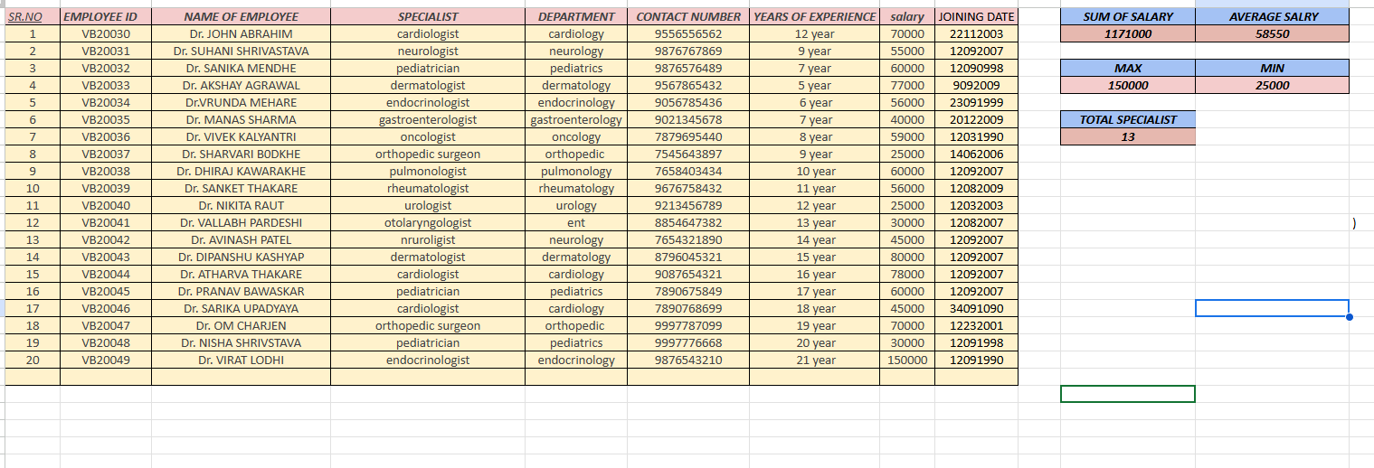

Here we have perform operations on salary . We find sum , Average, Max And Min. of doctor salary. And also we have find the total specialist of hospital by using various formulas.

2.Demonstrate various text functions :
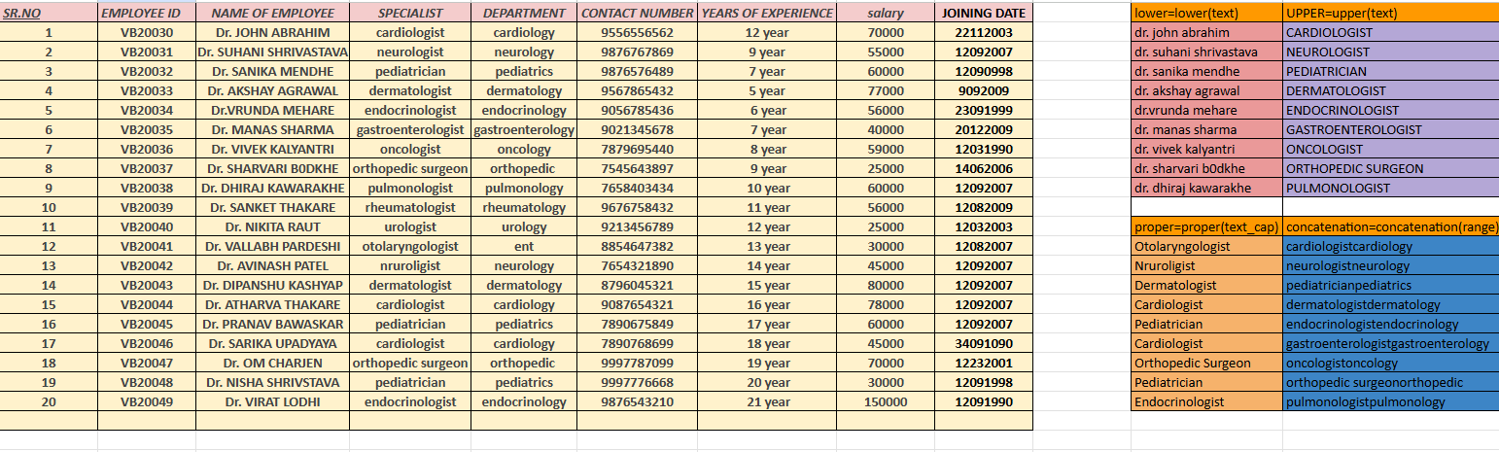

Here we have perform various text functions such as ‘lower’, ‘upper’, ‘proper’, ‘concatenation’ on doctors name , specialists and department for easier analysis.

.

.

3.Apply various functions in data excel

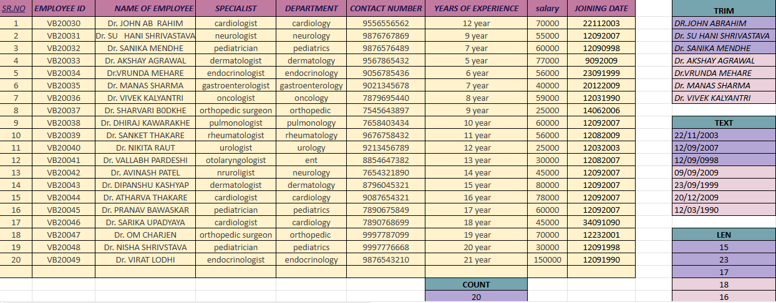

In hospital management data related to their employee name, specialist, department, years of experience so here we have applied the various formulas like Trim, Text, Len, Count to analysis a data.

4.Demonstrate if and counter if in excel
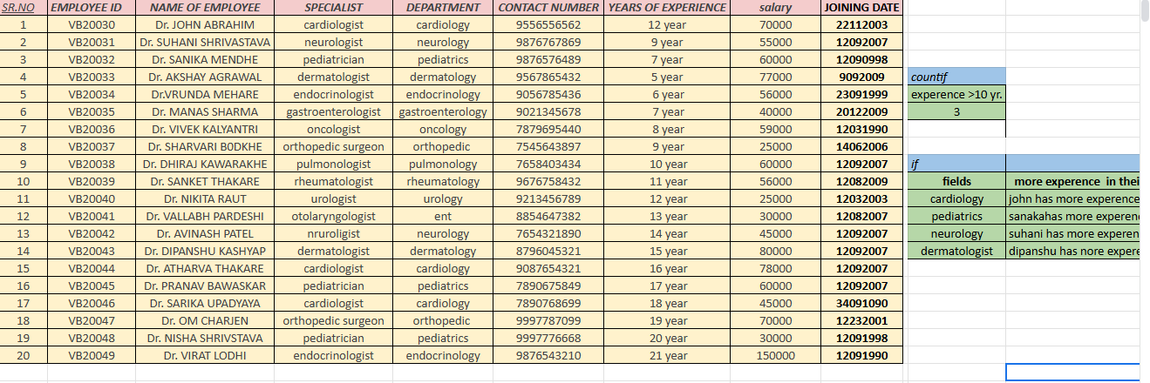
In this activity we perform if and countif functions on the data of doctors.
At first we count the doctor having more the 10 years of experience and in if we analysis who has more experience in their respective field

5.Apply search, Data sorting and Filtering

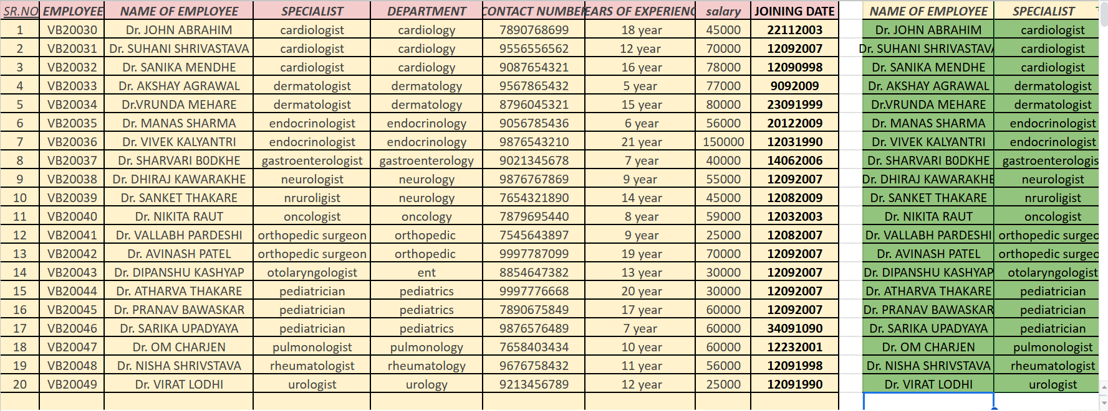

Here we have applied sorting and filters to the specialists and identify serially (A to Z) which doctor is special for what.

6.Implementation of Vlookup and Hlookup

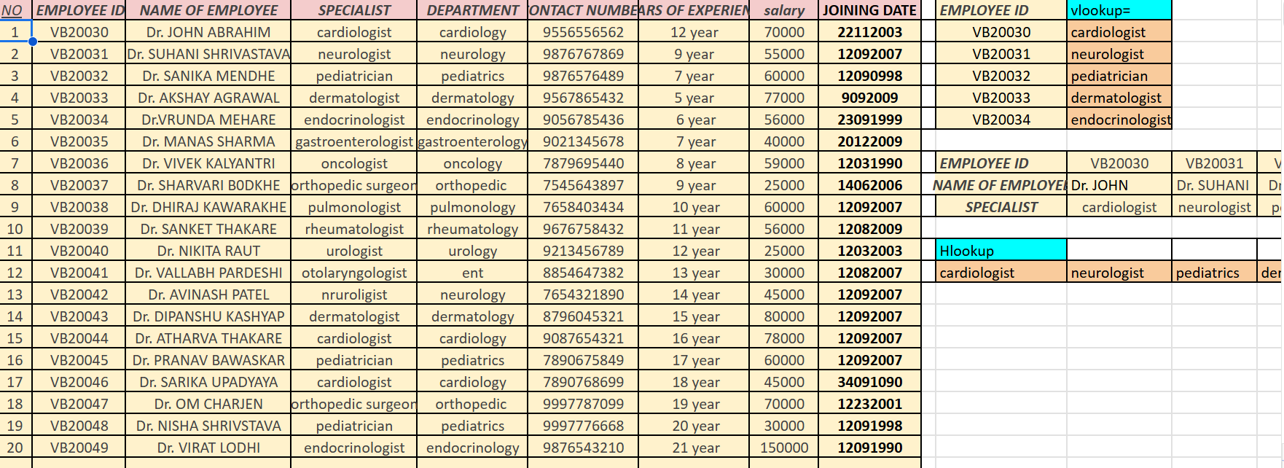

Here we have done ‘vlookup’ and ‘hlookup’ for finding specialist with the help of their employee id. In such a big data it is a easier way to find them.

7. Demonstrate data visualization (piec hart, graphs, etc.)

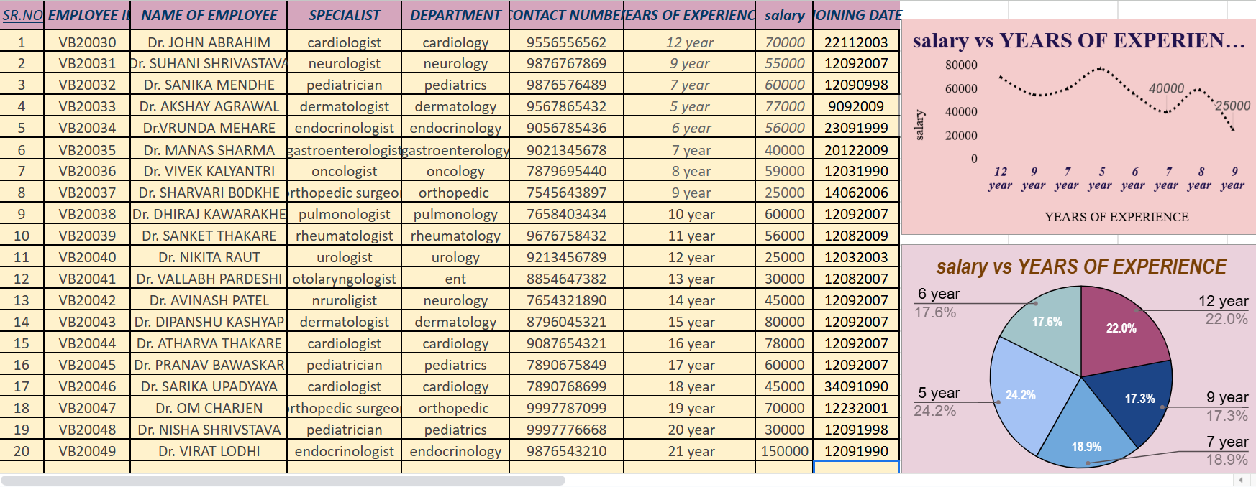

In hospital management, managing data related to employees (e.g., name, specialty, department, experience, and performance. Here we have use Table like pie chart, line chart manipulate, and analyze to our data.

8. Demonstrate Pivot Table in Excel

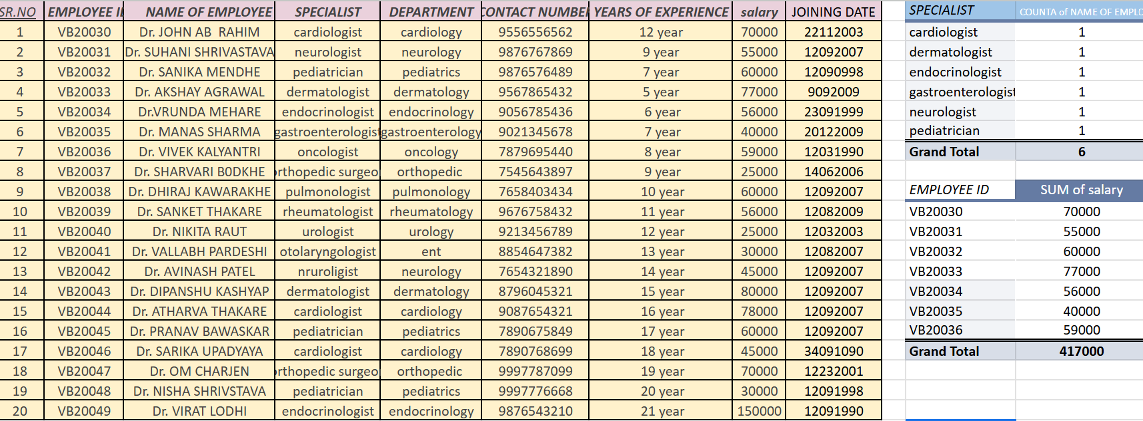

By using pivot table we are able to analysis the data in different ways to understand it better . In the above table we used pivot table in the data of hospital

Chapter 3 . Conclusion:

"By applying the [formula name] to the Excel sheet containing doctors' data, we were able to [achieve a specific goal, such as identifying trends, creating visualizations, or streamlining data analysis]. This application of the formula enabled us to [gain insights, make informed decisions, or improve data management]. The results of this analysis can be used to [inform policy, improve healthcare outcomes, or optimize resource allocation]."

