**TABLE OF CONTENTS**

|  |  |  |
| --- | --- | --- |
| **Sr. No.** | **Content** | **Page no.** |
| 1. | List of Figures | 9 |
| 2. | List of Tables | 9 |
| 3. | Introduction about Company | 10 |
| 4. | Problem Solving Study I | 12-19 |
| 5. | Problem Solving Study II | 20-29 |
| 6 | References | 38-39 |
| 7. | Annexure | 32 |
| 8. | Photo with Company Supervisor and Colleagues | 33 |
| 9. | Attendance Record | 40 |

**LIST OF FIGURES**

|  |  |  |
| --- | --- | --- |
| **Sr No.** | Title | **Page no.** |
| 1 | Figure no.1.1:-Gender | 26 |
| 2 | Figure no.1.2:-No. of worker | 27 |
| 3 | Figure no.1.3:-Employer interest | 28 |
| 4 | Figure no.1.4:-Employees Behavior | 29 |
| 5 | Figure no.1.5:-Employer Decision making | 30 |
| 6 | Figure no.1.6:-Employees Interest towards the company | 31 |
| 7 | Figure no.1.7:-Cost to company | 32 |
| 8 | Figure no.1.8:-Employers Motivation | 33 |

**LIST OF TABLES**

|  |  |  |
| --- | --- | --- |
| **Table no.** | **Title** | **Page no.** |
| 1 | **Table no 1.9** Current Investments Forecast | 16 |
| 2 | **Table no 1.10** Non-Current Investments Forecast | 16 |
| 3 | **Table no 1.11** Profit/Loss For The Following Period | 17 |
| 4 | Table no 1.12 Non current Investment | 17 |

# Introduction about Company

Cojag is a group of young enthusiastic technocrats currently creating our footprints in various domains of IT sector, agriculture, education and consultancy services. The firm also provides platform to young talent with a vision of acknowledging and materializing their innovative ideas. We have major investments in IoT , web development, App development and mentorship. We promote the idea of co-working space and provide industrial space on rent to set up new plants.

**Internet of Things**

Cojag is making IoT based Bulbs, Switch, and sensors which has application in agriculture and power sector.

**Application Development**

The idea of sharing thoughts, knowledge and equipment between different people in vicinity so as to build up a creative environment while working is co-working space. Although it is an idea first seen in 2006, it has been boosted up in year 2016. Being a young idea for evolving era it is majorly promoted by start-ups, entrepreneurs and small offices globally.

**Entrance exam Mentorship**

Cojag finds its branches in education sector too. Here we have qualified and experienced expertise who help the freshers for campus and placements preparation, guides MBA and MTech aspirations for competitive examinations like CAT, CMAT, XAT, GATE, MICAT etc.

**Web design and development**

Cojag is making IoT based Bulbs, Switch, and sensors which has application in agriculture and power sector.

**Co-working and Industrial Space**

The idea of sharing thoughts, knowledge and equipment between different people in vicinity so as to build up a creative environment while working is co-working space. Although it is an idea first seen in 2006, it has been boosted up in year 2016. Being a young idea for evolving era it is majorly promoted by start-ups, entrepreneurs and small offices globally.

**Business Analysis and strategy**

Cojag finds its branches in education sector too. Here we have qualified and experienced expertise who help the freshers for campus and placements preparation, guides MBA and MTech aspirations for competitive examinations like CAT,CMAT, XAT, GATE, MICAT etc.

# PROBLEM SOLVING STUDY I

|  |  |
| --- | --- |
| **Title of Study:** | A Study On Intercorporate Investment Satisfaction In Indian Stock Market. |

## Introduction about Topic:

Intercorporate investments (investments in other companies) can have a significant impact on an investing company’s financial performance and position. Companies invest in the debt and equity securities of other companies to diversify their asset base, enter new markets, obtain competitive advantages, deploy excess cash, and achieve additional profitability. Debt securities include commercial paper, corporate and government bonds and notes, redeemable preferred stock, and asset-backed securities. Equity securities include common stock and non-redeemable preferred stock. The percentage of equity ownership a company acquires in an investee depends on the resources available, the ability to acquire the shares, and the desired level of influence or control.

The International Accounting Standards Board (IASB) and the US Financial Accounting Standards Board (FASB) worked to reduce differences in accounting standards that apply to the classification, measurement, and disclosure of intercorporate investments. The resulting standards have improved the relevance, transparency, and comparability of information provided in financial statements.

Complete convergence between IFRS accounting standards and US GAAP did not occur for accounting for financial instruments, and some differences still exist. The terminology used in this reading is IFRS-oriented. US GAAP may not use identical terminology, but in most cases the terminology is similar.

# Problem Statement:-

It is very important for a company to maintain their quality services for growth and development. Here to find out whether six sigma helps in training and development for the company to improving performance.

# Problem Definition:-

Intercorporate investments are undertaken when companies invest in the equity or debt of other firms. The reasons why one company would invest in another are many but could include the desire to gain access to another market, increase its asset base, gain a competitive advantage, or simply increase profitability through an ownership (or creditor) stake in another company.

# Objectives:

* To know whether the company is satisfied by their intercorporate investment after loss.
* To see what are the impact on company if the intercorporate investment goes in loss.

## RESEARCH METHODOLOGY

The study is based on secondary data collected from annual report of

the company and Decisional Research. The study is partly descriptive and partly analytical in

nature as efforts are taken to describe the various areas of intercorporate investment.

* **DATA COLLECTION**

The secondary data is collected from the published annual documents and the website.

## DATA ANALYSIS

1. **Current Investments Forecast**

|  |  |  |  |
| --- | --- | --- | --- |
| **Company Name** | **March 22** | **March 21** | **March 20** |
| Tata Motors Ltd. | 29,256.39 | 16,114.91 | 15,730.86 |
| Bajaj Auto Ltd. | 18,849.63 | 14,602.84 | 15,416.20 |
| Infosys Ltd. | 22,869.00 | 22,118.00 | 13,916.00 |
| TCS Ltd. | 2,405.00 | 2,405.00 | 2,189.00 |
| Polyplex | 46.99 | 46.99 | 46.99 |

**Table no. 1.9 current investment**

**Interpretation:-** Above table shows the current investment of the company which was made in the specific year. Through which I notice that all above company mentioned does intercorporate investment for the various purpose

|  |  |  |  |
| --- | --- | --- | --- |
| Company Name | March 22 | March 21 | March 20 |
| TCS | 38,187.00 | 30,960.00 | 33,260.00 |
| Tata Motors | (-1,640.05) | (-2,274.72) | (-7,127.34) |
| Bajaj Auto Ltd. | 5,018.87 | 4,554.59 | 5,099.98 |
| Infosys Ltd. | 21,235.00 | 18,048.00 | 15,543.00 |
| Polyplex | 35.00 | 2.0 | 72.1 |

1. **Non-Current Investments Forecast**

**Table no 1.10 Non-current investment forecasting.**

**Interpretation: -** Above table shows the non current investment of the company which was made in the specific year. This data will help in to find out the investment which are made by the company for more than 1 year of time period.

## Profit/Loss For The Following Period

|  |  |  |  |
| --- | --- | --- | --- |
| Company Name | March 22 | March 21 | March 20 |
| Tata Motors Ltd. | 5,143.08 | 1,578.26 | 885.31 |
| Bajaj Auto Ltd. | 4,969.13 | 8,028.11 | 2,779.75 |
| Infosys Ltd. | 5,467.00 | 2,037.00 | 4,006.00 |
| TCS Ltd. | 29,262.00 | 28,324.00 | 25,686.00 |
| Polyplex | 35 | 2 | 72.18 |

**Table no 1.11 Profit and loss statement**

**Interpretation: -** Above table shows the profit and loss of the company in the specific year. Above data can also be considered to know whether the company is making loss or profit every year. As per my study I recognize that all company is making profit and are sustainable. I have used the above data to calculate how much profit and loss is made by intercorporate investment.

## Finding.

## Interpretation:-Figure number.01 shows the investment made by the company in current year with respect to time.

**Fig no. 1.1**

**Figure no 1.1 current investment**

Above graph shows the investment of company which are made in specific year in march 2020 till march 2022.Following are the study which I have researched.

* Tata motors is increasing their investment every year and as per study the company is making profit also.
* Bajaj auto ltd makes their investment according to the profit which are made in every financial year or by forecasting assessment year.
* As per my study Infosys ltd also follows the same strategy which Bajaj Auto ltd is following.
* TCS is also increasing their invest and as per the graph every year they are increasing some percentage of invest with respect to profit which are made in assessment year.

## Non current Investment

**Figure no 1.2 Non current investment.**

## Interpretation: - It shows the non-current investment made by the company with respect to time. From the above graph I have noticed that the company are increasing their investment in a positive way, which are very helpful as per it affects our GDP directly. In non-current investment their maybe some investment which are carry forward according to circumstances. Here in non-current investment the investment are for more than 1 year of time period.

# Finding

* From the above data of various company we can see that company every year do intercorporate investment whether company faces profit or loss.
* Companies could be interested in investing in parent company only to expand their business and to grow.
* As per finding it is been noticed that if company bears a losses from intercorporate investment then they don’t provide dividend usually.
* If company is not applicable for dividend then incorporate losses are mentioned in current asset in balance sheet of the company.
* If company suffering from huge loss which cannot be cover in current year then company carry forward the losses to next year.

# Suggestions.

According to my research, I have found that the company do not invest much in start up because doing so entails a high degree of risk. I do advise managing risk when investing in a beginning business and suggest to invest in startup company. As many companies do not get chance just because they don’t have specific amount of fund but at the other side their may be a risk for the company to invest in more startup as they may lack in proper talent or skills due to which the company may required to bear huge amount loss. According to my PPS study,it may help to the company to cover one of the parameters.

We examine the determinants of intercorporate investments for a sample of 4 firms listed in the National Stock Exchange (NSE)

Following are the suggestion which company can implement: -

* To get serious about diversifying portfolio which can make the company’s performance better.
* Company can take advantage of tax efficient investing.
* Continue mode of intercorporate investing.
* During bull markets, strong investment returns can easily convince you that continued contributions are no longer necessary.
* During bear markets, you may become convinced that contributing to your investment portfolio is an exercise in throwing good money after bad.
* Think for the long term investment.

# Conclusion

This PSS is about to see whether the companies are satisfied by making intercorporate invest and what are the behavior of the company if the investment is converted into losses. So as per my study I have found the following parameter in which the company may to need to develop themselves or to work on it.

The overall conclusion is that the company are interested and satisfied even thought intercorporate investment goes in loss and even it has come to the noticed that for saving tax the few company do intercorporate investment. Even at the other end of side the company do intercorporate investment to develop and to extend their business.

Following are the pros :-

* Utilize the carry forward option to save taxes.
* By doing intercorporate investment, company can get extra tax benefits.
* It will also help other company to grow faster.
* By doing investment it helps GDP to grow more.

Following are the con of intercorporate investment: -

* It is risky for company to invest in start-up as company can bear loss.
* Long term investment can slow down the liquidation of cashflow.

**PROBLEM SOLVING STUDY II**

|  |  |
| --- | --- |
| **Title of the Study** :- | A study on the Impact of six sigma in development with reference to Cojag. |

**Introduction about the Topic:**

Six Sigma focuses on improving quality (i.e. reduce waste) by helping organizations produce products and services better, faster and cheaper. Six Sigma focuses mainly on defect prevention, cycle time reduction, and cost savings. Unlike mindless cost cutting programs, which reduce value and quality, Six Sigma identifies and eliminates costs, which provide no value to customers and the production process. To understand the concept of Six-Sigma one must understand the concept of normal curve.

**Problem Definition**

Quality services are very important aspect in order to satisfy the customer/consumer through having continuous improvement and their perception is an important aspect to reveal how satisfied the customer/consumer towards the company contribution in helping them in learning process and developing.

# Objectives

* To find out the where the company lacks in development over six sigma.
* To check the stability of performance towards development of company.
* To give suggestions by applying six sigma measures and process performance.

**RESEARCH METHODOLOGY**

# SAMPLE DESIGN :-

## The study's target audience is made up of a variety of respondents from different locations. Data from the respondents were gathered for this survey.

# SAMPLE SIZE :-

After careful deliberation with the firm manager and the college guide, while also taking the needs of the company into consideration, the sample size for the research that was determined to be suitable for the study was 30.

The study makes use of both primary and secondary data. Primary data is collected in the course of doing descriptive research by doing survey. Secondary data is collected from internet, websites etc.

# Primary data collection

Primary data will be collected from well-formed questionnaire.

Sampling size 30 (Sample area Nagpur region)

# Secondary data collection

**•** Website

• Books and magazine.

**DATA ANALYSIS :**

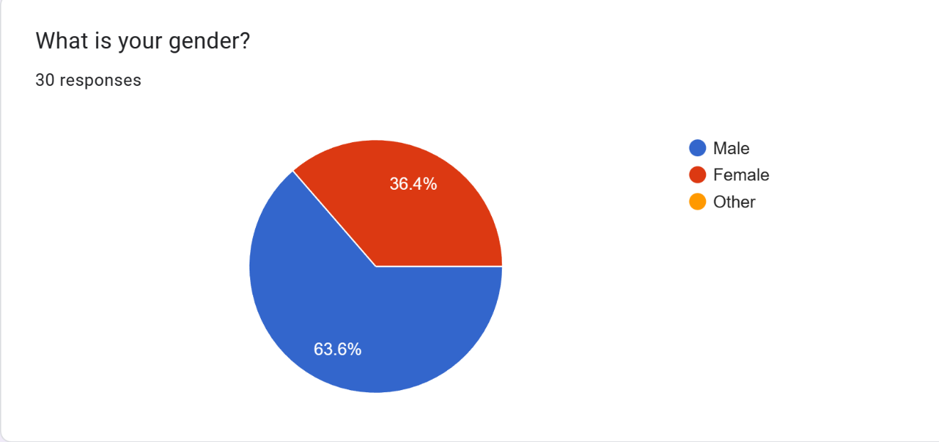

**Fig no. 1.1**

**Interpretation: -Figure no. 03** shows the following information.

* 63.6% of employees or a gender are male. According to this data it shows the ratio between male and female.
* 36.4% of employees or a gender are female.
* As per my study I noticed that the ratio of male population is higher than the female.

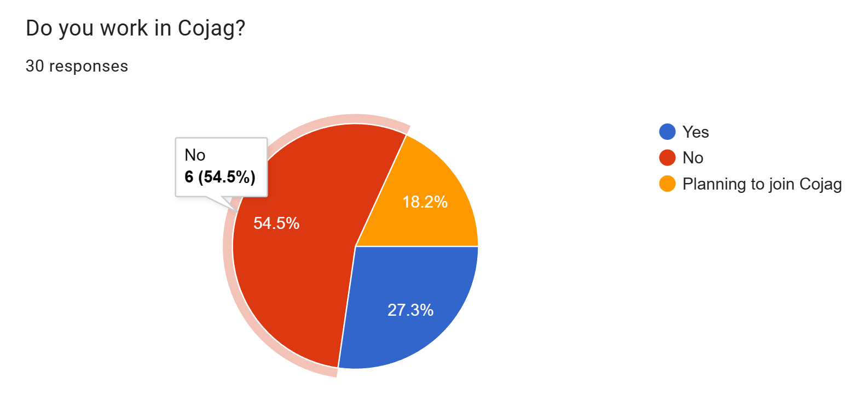

**Fig no. 1.2**

**Interpretation:-Figure no.04** shows the following information.

* 54.5% of people works in Cojag company and through which I studied the behaviour of employees. Through this data company can improve the parameter which are affecting the mentality of their employees.
* 18.2% of the respondent are willing to join Cojag.
* 27.3% of respondent are currently working in Cojag.

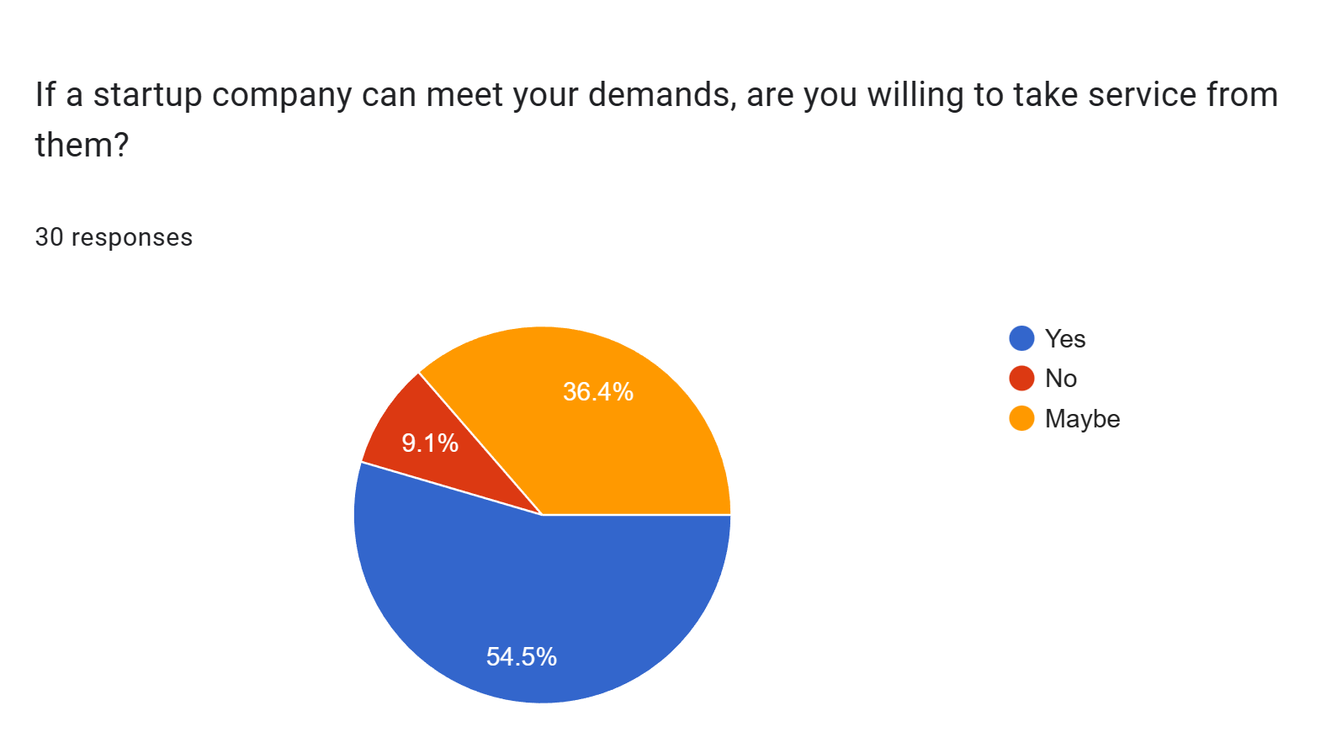

**Fig no. 1.3**

**Interpretation:-Figure no. 05** shows the following information:-

* 54.5% of respondent do not affect by brands.
* 9.1% of respondent are affected by brand which is difficult for a company to gain a trust according to their requirement.
* 36.4% of respondent are confused between which brand they have to go for taking services.
* From the above data 45.5% of respondent are willing to work with Cojag.

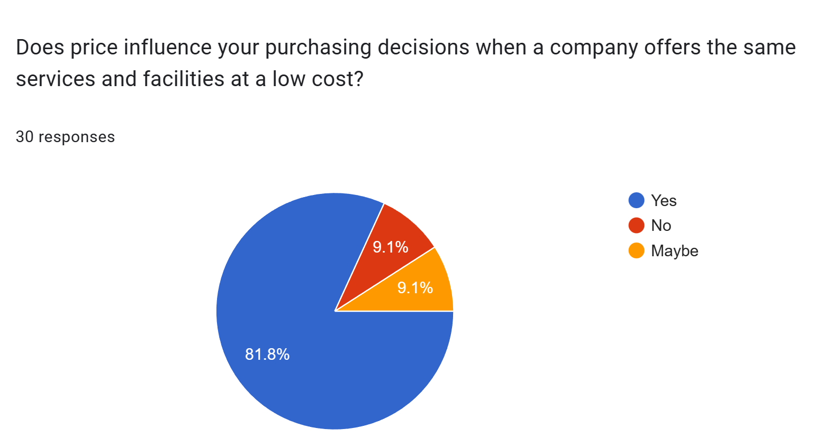

**Fig no 1.4**

**Interpretation:-Figure number 06** shows the following information:-

* 81.8% of respondent are affected by price.
* 9.1% of respondent wants to stick with the company who gains their trust.
* Another 9.1% respondent are confused in making their decision which maybe be a plus point for the company.
* 18.2% of respondent are employees which maybe not be interested in working with Cojag.

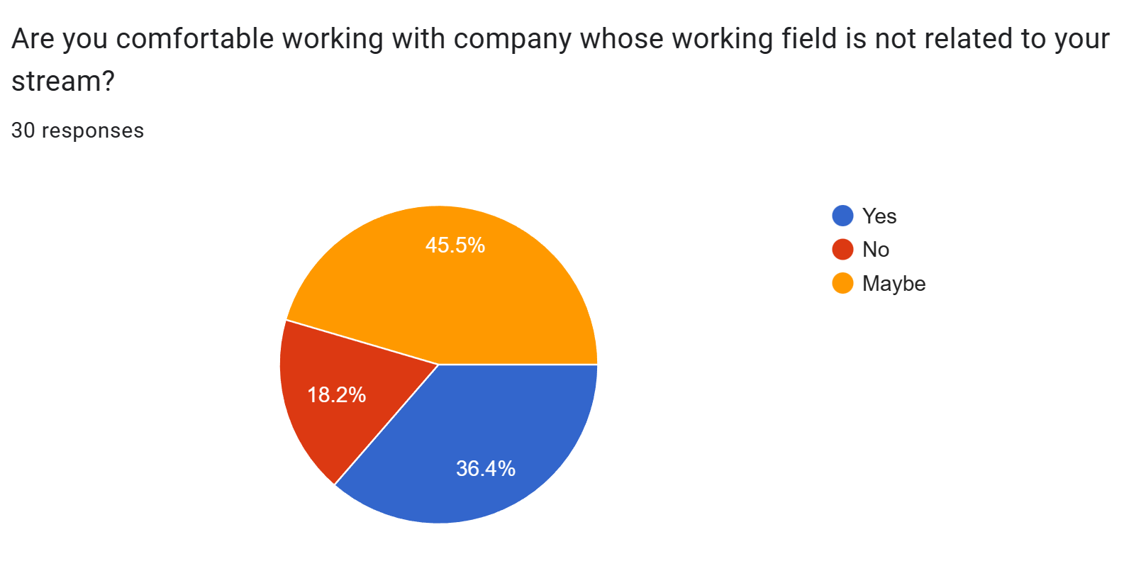

**Fig no 1.5**

**Interpretation:-Figure number 07** shows the following information:-

* 45.5% of respondent have mixed feeling to work in Cojag in the future.
* 18.2% are not interested in working with Cojag if they don’t find the work is related to their stream.
* 36.4% respondent doesn’t matter if the work is related to their stream.

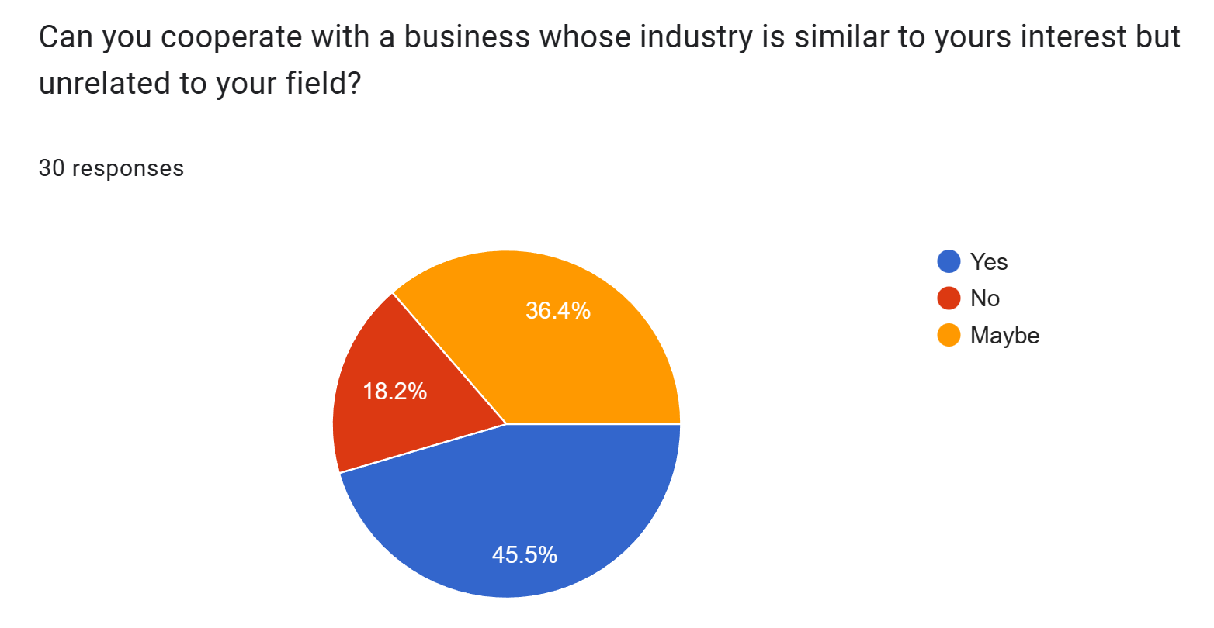

**Fig no. 1.6**

**Interpretation:-Figure number 08** shows the following information:-

* 45.5% of employees are interested in working with Cojag if their works is interesting according to them.
* 18.2% of respondent are having straight decision if they think work is not related to their field.
* 36.4% of respondent are confuse and it would be a great opportunity for company to make improvement.

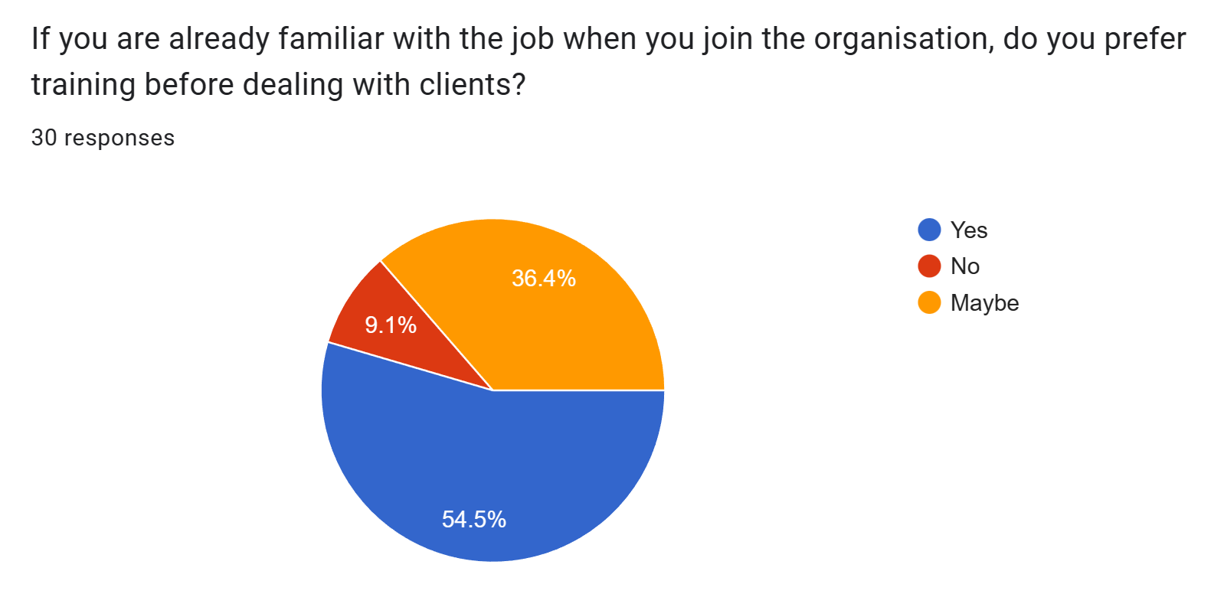

**Fig no 1.7**

**Interpretation:-Figure number 09** shows the following information:-

* 54.5% of respondent wants training while they join Cojag.
* 9.1% of respondent maybe confident enough to present themselves in any live project.
* 36.4% of respondent are not confident enough to work comfortability.

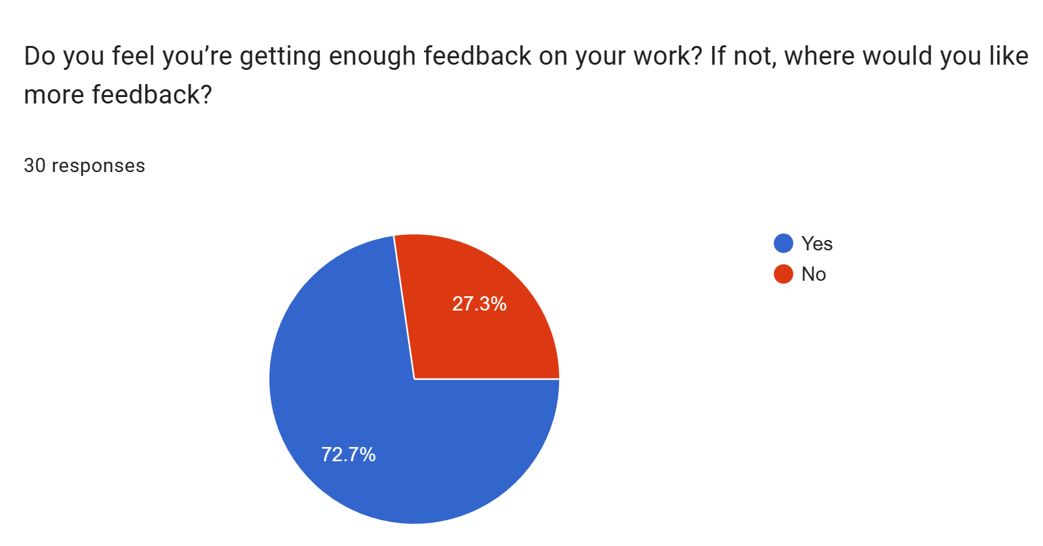

**Fig no. 1.8**

**Interpretation:-Figure no 10** shows the following information:-

* 72.7% of respondent are getting proper motivation.
* 27.3% of respondent are not getting enough feedback as compare to their work.

# Findings

* Majority 63.6% of the respondents are male and rest remaining's are female.
* Majority 54.5% of employees are interested in working with startup company.
* Majority 81.8% influenced by price same services are provided by other company.
* Majority 45.5% are not interested in working with the company if their work is different from their interest.
* Majority 45.5% employees are interested working with the company if work matches to their field.
* Majority 54.5% employees want training when they are newly joined.
* Majority 72.7% of employees are getting proper feedback.

# Solution and result

In PSS II,I have found following suggestion which company can implement to focus on these parameters to improve the company performance.

* The company have to focus more over on providing training to their employees while they are joining the company.
* The company may appoint team leader to every specific department according to requirement.
* As per study I have found that there are no improvement in hiring process but have to improve giving training while they are new join.
* Company can use this following data to make more improvement or to make some upgradation according to it.
* The company have to work on how to utilize time of employees.

# Conclusion

This PSS is about how company can use six sigma to make improvement and development to their company. The limitation of this PSS is only working on one parameter which is development. As per my study I have found various factors which are affecting the growth of company. Company lacks in providing proper training to their employees which can directly affect the performance of the company. On the other way company can also work on specific problem which will help the company to make improvement in their performance as some percentages of employees are interested in joining Cojag.

Following are the pros of the Company

* High concern for excellence in operation.
* Continue development in workforce.
* No place for displacing power.
* A good teamwork.
* A desired to change adverse situation.

Following are the cons of the company.

* Underutilization of decision-making power.
* No team leader appointed for specific department.

# What I Learn From Problem Solving Studies & Internship

During my internship period I have learned many things as following: -

* Work experience as we have to directly dealing with clients.
* Self-improvement like language barrier towards dealing with client.
* How to handle work pressure in short period of time.
* How to deal with demotivation when we are on job/internship.
* How to utilize time to balance work load.

Overall internship helped me in improving my skill and even it helped in upgrading my skills. As during my internship period I have learned that how the working environment is, how to deal with clients, how to approach properly to others.

# REFERENCEs

# Reference 6.1

* Bøhren, Øyvind, and Jørgen Haug. 2006. Managing earnings with intercorporate investments. *Journal of Business Finance & Accounting* 33: 671–95.
* Lambert, Cecilia, and Christopher Lambert. 2003. An investigation of earnings management through investments in associated companies: An Australian perspective. *Journal of Business & Economics Research* 1: 13–23.
* McNaughton, Rod B., and Milford B. Green. 2006. Inter-corporate ownership and diversification in the Canadian economy 1976–1995. *Journal of Management History* 12: 71–89.
* Myers, S. C., and N. S. Majluf. 1984. Corporate financing and investment decisions when firms have information that investors do not have. *Journal of Financial Economics* 13: 187–221.
* Osano, H. 1996. Intercorporate shareholdings and corporate control in the Japanese firm. *Journal of Banking & Finance* 20: 1047–68.
* [Google Scholar](https://scholar.google.com/)
* [www.moneycontrol.com](http://www.moneycontrol.com)

# Reference 6.2

* Modestus O. Okwu, Lagouge K. Tartibu, Dolor Roy Enarevba April 5 - 8, 2021
* Brady, J.E. and Allen, T.T. (2006), "Six Sigma Literature: A Review and Agenda for Future Research", Quality and Reliability Engineering International, vol. 22, pp.335-367
* Breyfogle III, F. W. (2008), “Better Fostering Innovation: 9 steps that improve lean six sigma”, Business Performance Management Magazine, vol. 6, no. 3, pp. 16-20
* Koning, H. and de Mast, J. (2006), “A rational reconstruction of Six-Sigma’s breakthrough cookbook”, International Journal of Quality & Reliability Management, vol. 23, no. 7, pp.766-787
* Desai, T. N., & Shrivastava, R. L. (2008).Six Sigma - A New Direction to Quality and Productivity
* Management. Wcecs 2008: World Congress on Engineering and Computer Science, (2004), 1047–1052\r1208. <https://doi.org/10.1016/j.ijproman.2010.01.006>.
* [http://www.cojagtech.com](http://www.cojagtech.com/)
* <https://evocon.com/>

**ANNEXURES**

# 1.1 Questionnaire (PSS II)

Following are the questionnaire which was used in studying PPS 2 which is “A study on the Impact of six sigma in development with reference to Cojag”.

* What is your name?
* What is your gender?
* Do you work in Cojag?
* If a startup company can meet your demands, are you willing to take service from them?
* Does price influence your purchasing decisions when a company offers the same services and facilities at a low cost?
* Are you comfortable working with company whose working field is not related to your stream?
* Can you cooperate with a business whose industry is similar to yours interest but unrelated to your field?
* If you are already familiar with the job when you join the organisation, do you prefer training before dealing with clients?
* Do you feel you’re getting enough feedback on your work? If not, where would you like more feedback?