**Topics: Descriptive Statistics and Probability**

1. Look at the data given below. Plot the data, find the outliers and find out $μ, σ, σ^{2}$

|  |  |
| --- | --- |
| **Name of company** | **Measure X** |
| Allied Signal | 24.23% |
| Bankers Trust | 25.53% |
| General Mills | 25.41% |
| ITT Industries | 24.14% |
| J.P.Morgan & Co. | 29.62% |
| Lehman Brothers | 28.25% |
| Marriott | 25.81% |
| MCI | 24.39% |
| Merrill Lynch | 40.26% |
| Microsoft | 32.95% |
| Morgan Stanley | 91.36% |
| Sun Microsystems | 25.99% |
| Travelers | 39.42% |
| US Airways | 26.71% |
| Warner-Lambert | 35.00% |

ANS: Mean( $μ)$ = 33.2713 , Variance( $σ)$ = 287.1466

Standard Deviation ($σ^{2}$) = 16.94500

Outlier = Morgan Stanley is an outlier of 91.36

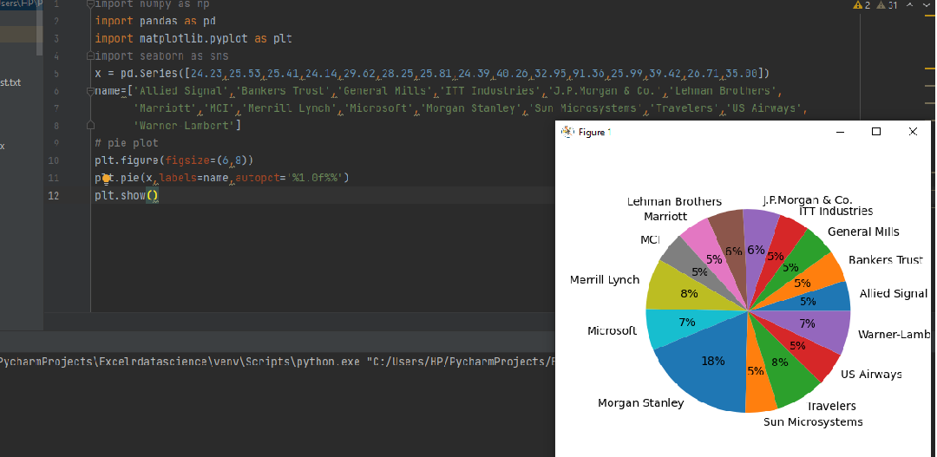

2.



Answer the following three questions based on the box-plot above.

1. What is inter-quartile range of this dataset? (please approximate the numbers) In one line, explain what this value implies.
2. What can we say about the skewness of this dataset?
3. If it was found that the data point with the value 25 is actually 2.5, how would the new box-plot be affected?

ANS :

1. First Quartile = 5

Third Quartile = 13

IQR : Q3-Q1 = 13-5 = 8

The Inter-quartile range is from 5 to 8, viscous 0 to 19. And 1 outlier

The Box-Plot is left skewness(“negative-skewness”)

3) it scale the chart

3.



Answer the following three questions based on the histogram above.

1. Where would the mode of this dataset lie?
2. Comment on the skewness of the dataset.
3. Suppose that the above histogram and the box-plot in question 2 are plotted for the same dataset. Explain how these graphs complement each other in providing information about any dataset.

**ANS:** 1) the mode of the dataset lie between 4 to 8

2) the dataset is the left skewness

3) We can’t diff mode in box plot but we can do that in histogram

4. AT&T was running commercials in 1990 aimed at luring back customers who had switched to one of the other long-distance phone service providers. One such commercial shows a businessman trying to reach Phoenix and mistakenly getting Fiji, where a half-naked native on a beach responds incomprehensibly in Polynesian. When asked about this advertisement, AT&T admitted that the portrayed incident did not actually take place but added that this was an enactment of something that “could happen.” Suppose that one in 200 long-distance telephone calls is misdirected. What is the probability that at least one in five attempted telephone calls reaches the wrong number? (Assume independence of attempts.)

**ANS:**

**Given :**one in 200 long-distance telephone calls is misdirected.

**To find :**probability that at least one in five attempted telephone calls reaches the wrong number

**Solution:**

one in 200 long-distance telephone calls is misdirected

=>  probability of call misdirecting  p = 1/200

     Probability of call not Misdirecting = 1 - 1/200 = 199/200

Number of Calls = 5

P(x) = ⁿCₓpˣqⁿ⁻ˣ

n = 5

p = 1/200

q = 199/200

at least one in five attempted telephone calls reaches the wrong number

= 1  -  none of the call reaches the wrong number

= 1  - P(0)

= 1   -  ⁵C₀(1/200)⁰(199/200)⁵⁻⁰

= 1  -  (199/200)⁵

= 0.02475

**probability that at least one in five attempted telephone calls reaches the wrong number = 0.02475**

1. Returns on a certain business venture, to the nearest $1,000, are known to follow the following probability distribution

|  |  |
| --- | --- |
| x | P(x) |
| -2,000 | 0.1 |
| -1,000 | 0.1 |
| 0 | 0.2 |
| 1000 | 0.2 |
| 2000 | 0.3 |
| 3000 | 0.1 |

1. What is the most likely monetary outcome of the business venture?
2. Is the venture likely to be successful? Explain
3. What is the long-term average earning of business ventures of this kind? Explain
4. What is the good measure of the risk involved in a venture of this kind? Compute this measure

**ANS:**

1) As the probability (0.3) is more for 2000 $ as compared to others,

Therefore, most likely monetary outcome of the business venture = 2000$

2) Long term average = \sum{P(xi)*Xi} = (-2000*0.1) +(-1000*0.1) +(0) +(1000*0.2) +(2000*0.3) +(3000*0.1) = 800$

As the long-term average gives positive numbers the Business venture likely to be successful.

3) Long term average = \sum{P(xi)*Xi} = (-2000*0.1) +(-1000*0.1) +(0) +(1000*0.2) +(2000*0.3) +(3000*0.1) = 800$

Means on an average Return will be 800 $

4) P(loss) = P(x= -2000)+P(x=-1000)=0.2. So the risk associated with this venture is 20%.