**Flight Booking System**

This app allows user to book flight tickets whenever needed by logging in into the system. Also admin can schedule the flights and update the schedules according to the requirement. This project can be achieved with technologies like node js, react, mongodb etc. Given below is the use case diagram of the system:

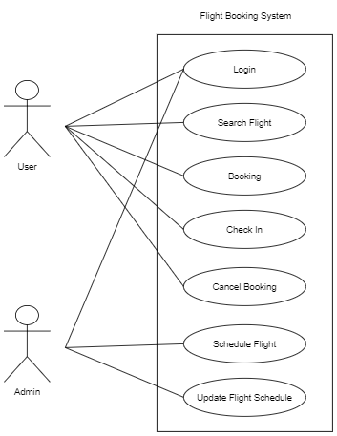

Fig: Use Case Diagram

**Features**

**For Users:**

* Login: User has to first perform login to use the system by entering valid credentials.
* Search Flights: By entering the start & destination place and the date user can search available flights.
* Booking: Whenever user will select particular flight & for the selected flight he or she can book tickets by entering personal details. Internally fare will be calculated based on tickets quantity. Reference booking number is generated after successful booking.
* Check In: User can enter the reference number and search for booking & then can perform check in which will allocate seat no.
* Cancel Booking: User can cancel booking too if he or she wants by entering corresponding reference booking number.

**For admin:**

* Schedule Flights: Admin can schedule the flights by adding details about the flight like take off & landing places, date flight name etc.
* Update Flight Schedule: If for some reason flight is delayed then admin should update that so that users could know about the delay.

Some screenshots are given for better understanding of the system.

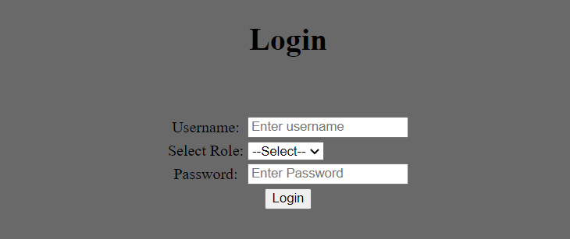

Fig: Login

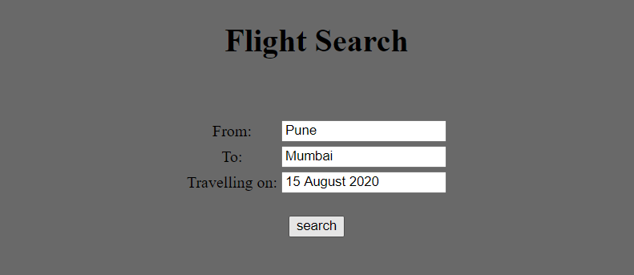

Fig: Search Flights

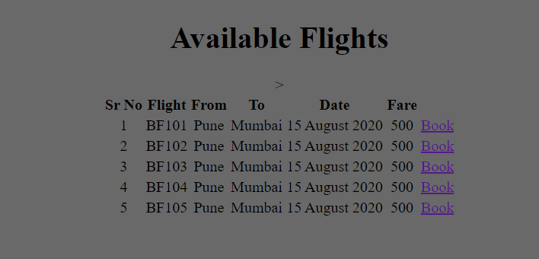

Fig: Available Flights

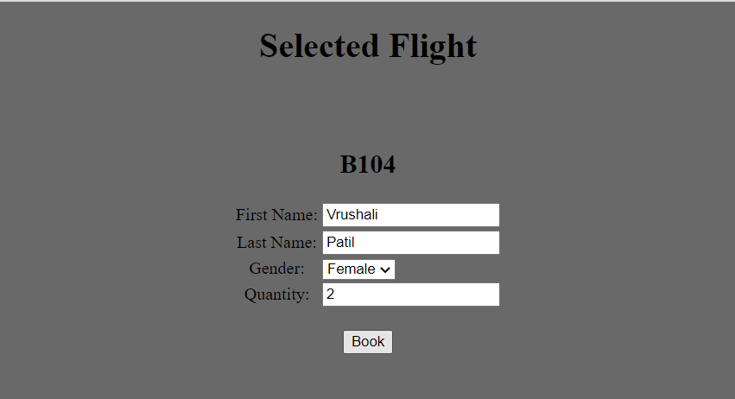

Fig: Book Flight Tickets

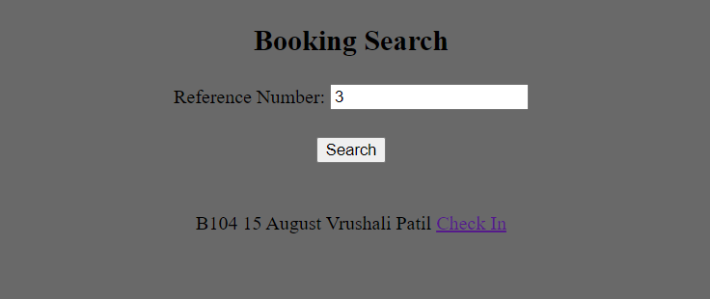

Fig: Search Bookings

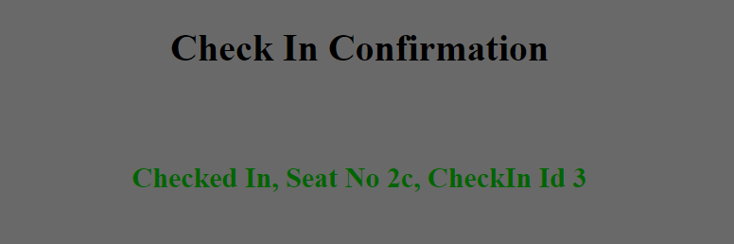

Fig: Check In

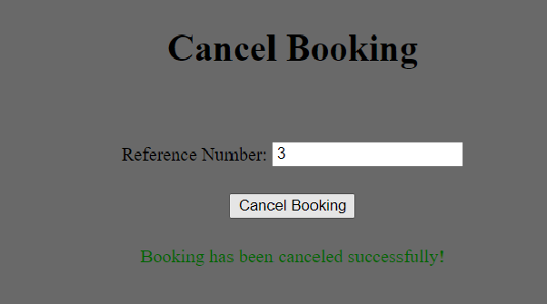

Fig: Cancel Booking

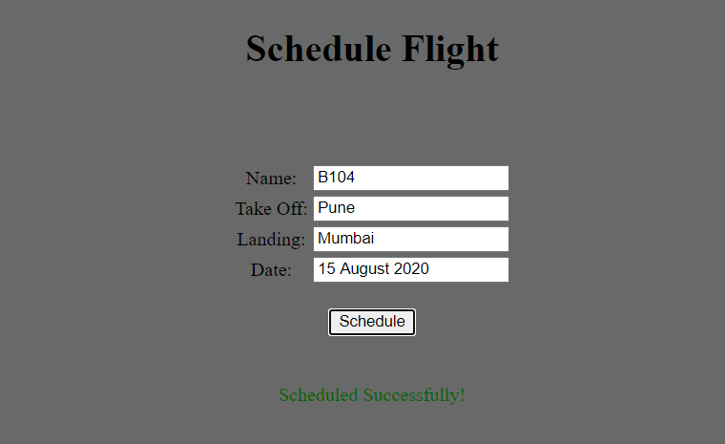

Fig: Schedule Flights

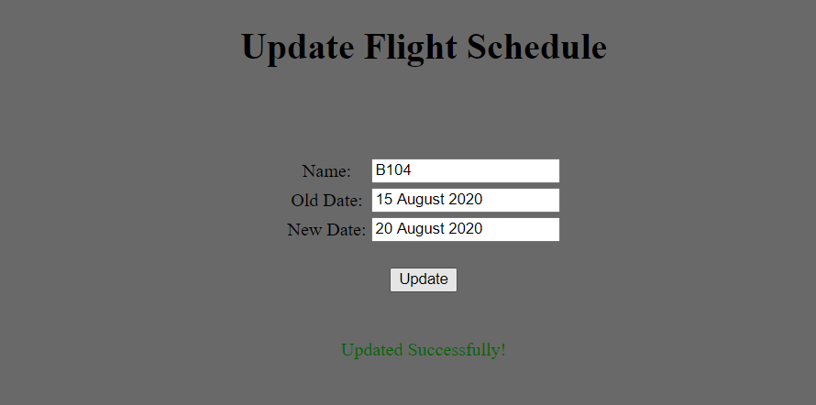

Fig: Update Schedule

**Milestone 1:**

* Microservices implementation should be completed in this week along with their testing with postman to ensure that all of them are working fine.
* Microservices are designed according to the functionalities. So there are microservices like search, booking, flight, check-n, login.
* Also login and register pages with integration of microservices should be done.
* Headers and Footers of each page in the application should be ready.
* So each day one microservice will be created and also header & footer of minimum two pages should be ready.

**Milestone 2:**

* Designing of UI should get finished in this week along with integrating it with microservices.
* 4 microservices will be integrated with the front end along with complete designing of ui in 4 days of the week.
* Last one day will be utilized for improvisation of ui and code.

**Milestone 3:**

* Unit testing should be implemented in two days.
* Additional functionalities are implemented remaining three days.