**Final Assignment submission**

**GitHub -**[**https://github.com/Vrushali0318/FSE.git**](https://github.com/Vrushali0318/FSE.git)

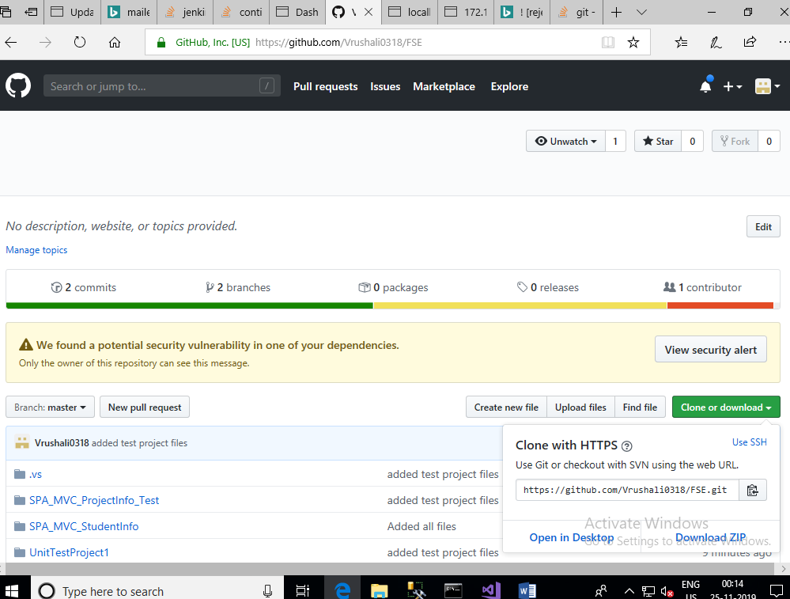

**Jenkis Related**

1. Go to C:\169937_FinalFSEProject\Jenkins path and open cmd from this path and Run

java -jar Jenkins.war --httpPort=9090

1. Login to Jenkins using URL <http://localhost:9090/job/FSE_ProjectManager/>

Please use User Id as –FSEAdmin

and Pass as - admin

1. Commit any change inside gitlab using Repository

<https://github.com/Vrushali0318/FSE>

1. And verify build using Jenkins
2. You can trigger the build remotely from below address:

<http://172.18.4.52:9090/job/FSE_ProjectManager/build?token=1234>

1. You can trigger locally by

<http://localhost:9090/job/FSE_ProjectManager/build?token=1234>

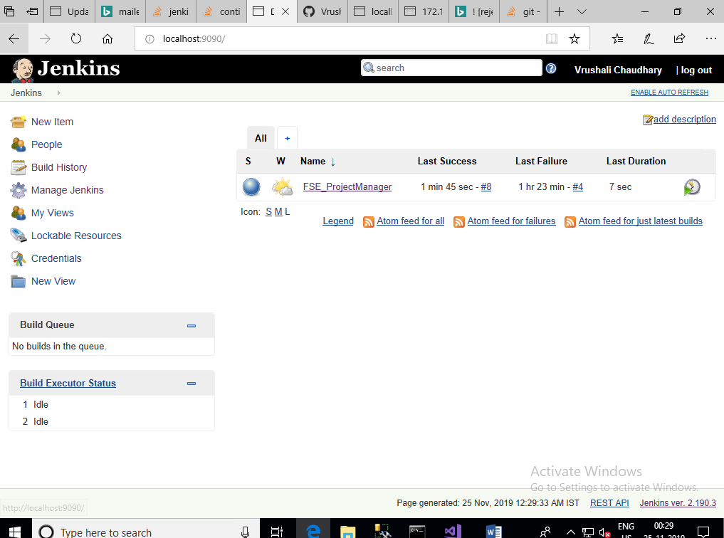

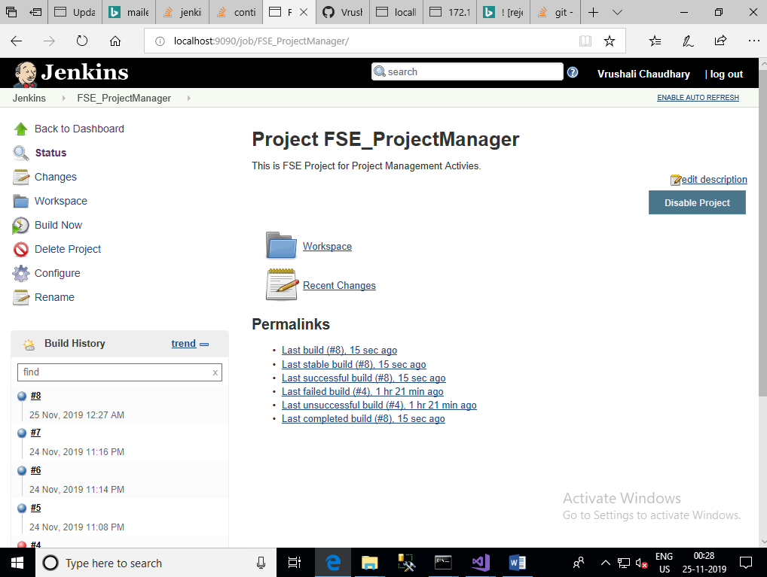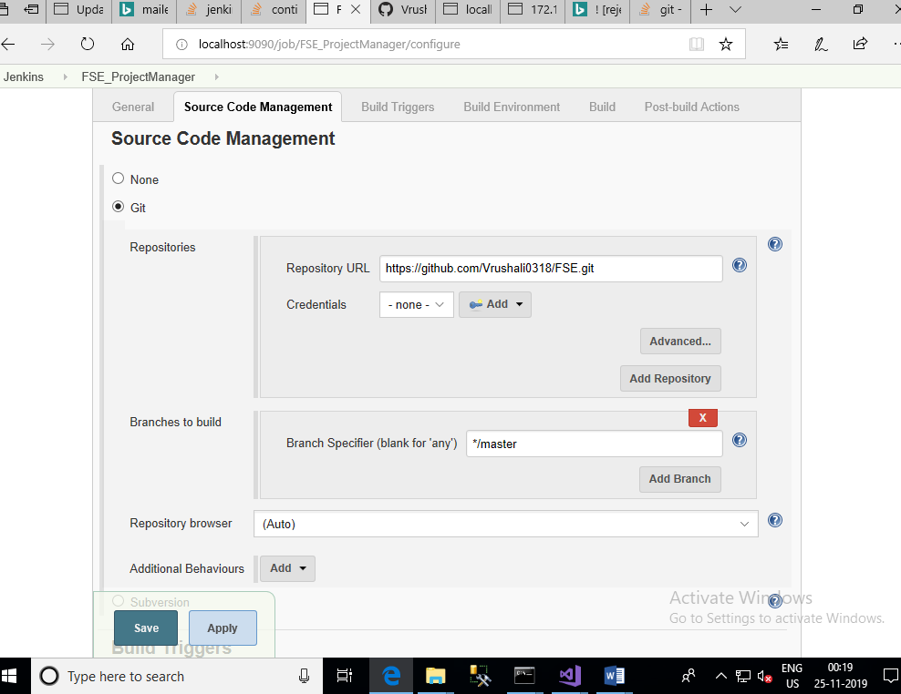

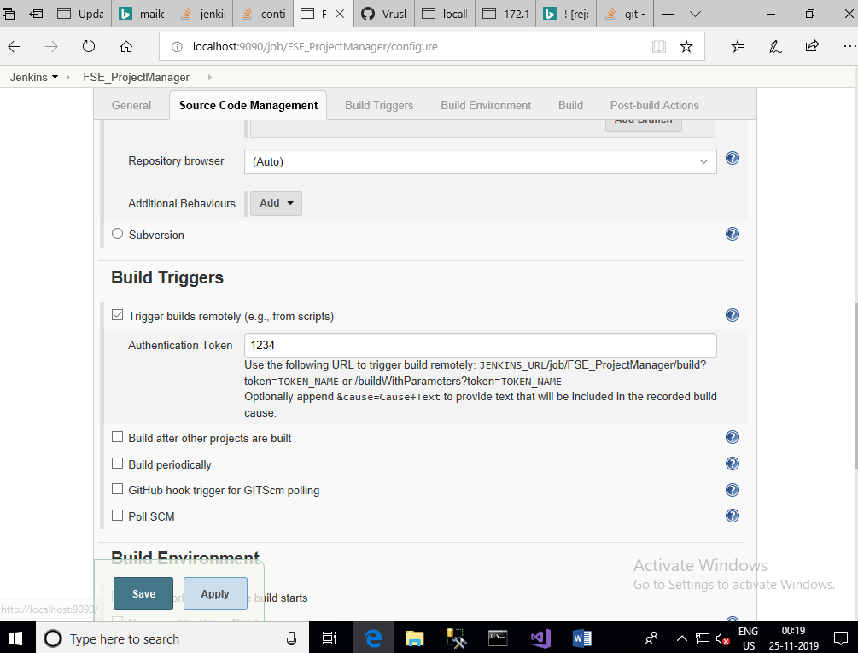

**Deploy on IIS**

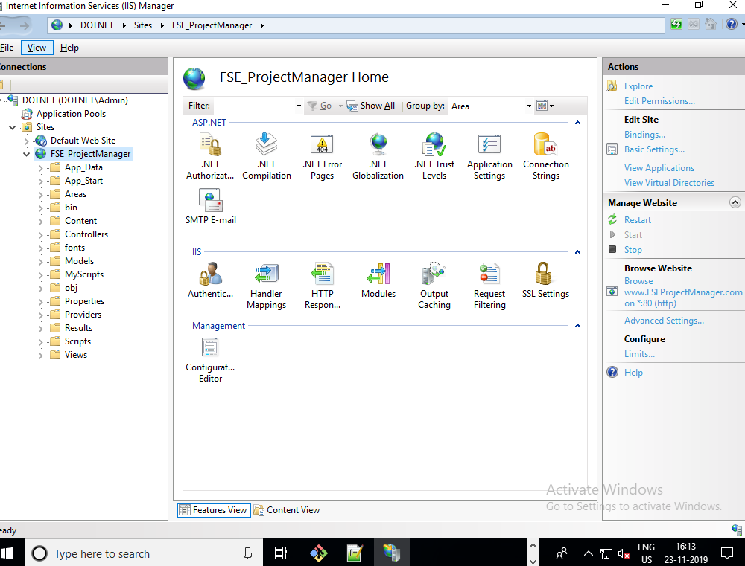

**Screenshots of screens developed**

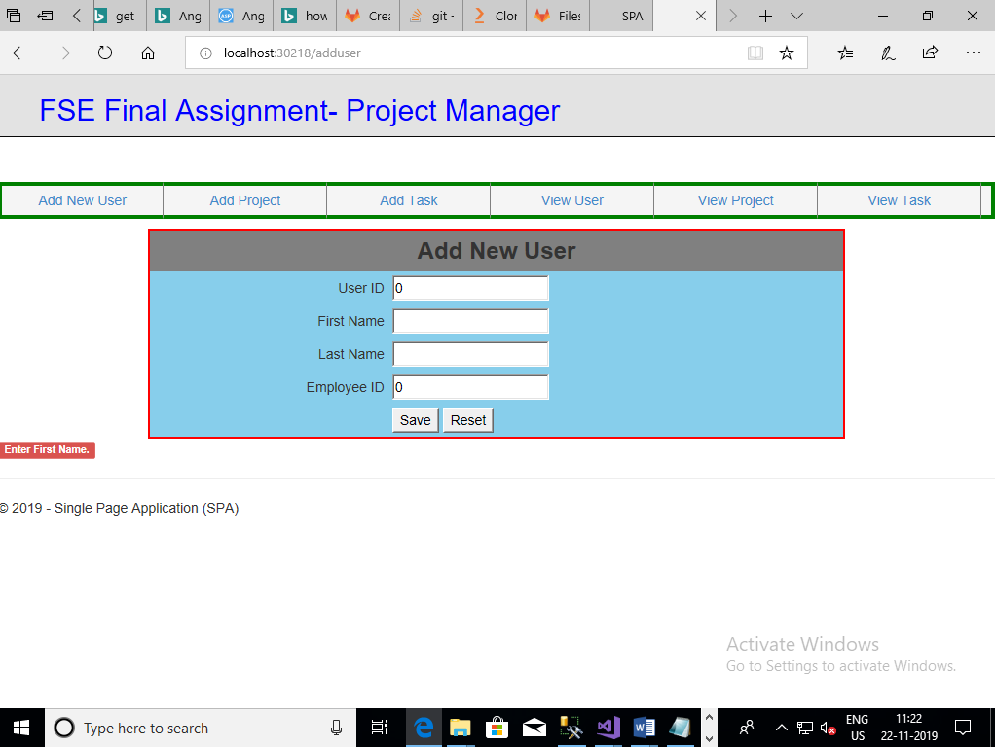

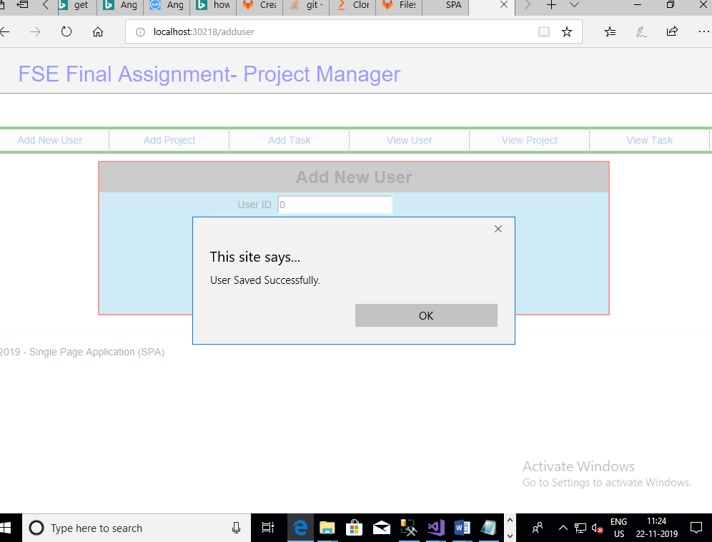

Reset

