**­Title of the Project**

**Electricity Billing System**

**111803112 Bhakti M. Neralwar & 111803049 Vrushali P. Date**

**Introduction of Project Electricity Billing System:**

Our project entitled “Electricity Billing System” aims to generate electricity bill with all the charges and penalty. Manual system that is employed is extremely laborious and quite inadequate. It only makes the process more difficult and hard.

The aim of our project is to develop a system that is meant to partially computerize the work performed in the Electricity Board like generating monthly electricity bill, record of consuming unit of energy, store record of the customer and previous unpaid record.

We used HTML, CSS, JS, BOOTSTRAP as front end, PHP as back end and MYSQL as database for developing our project.

**Software Details for running Online Electricity Billing System :**

* WAMP/XAMPP server
* MySQL(Database)

**Parts of the project :**

**There are 2 parts admin and the user , both have separate login and they have to login with the registered email id and password .**

The **ADMIN** can :

* Generate bills.
* Remove defaulting users .
* View the status of bills and complaints generated .
* View the info about the users registered .
* Solve the complaints .

The **USER** can :

* View the bills.
* Get info about the transactions.
* Change the password , view profile.
* Make transactions.
* Make complaints.
* New users can register on the website.

**Future scope and further enhancement of the project:**

Today, the market place is flooded with several Electricity Billing System options for shoppers to choose from. A variety of innovative products and services are being offered spoiling customers for choice. In the last couple of years, the growth of Electricity Billing System industry in India has been phenomenal as more shoppers have started discovering the benefits of using Online Electricity Billing System platform.

We hope that the project will serve its purpose for which it is developed there by underlining success of process.

**Some Screenshots of the project**:

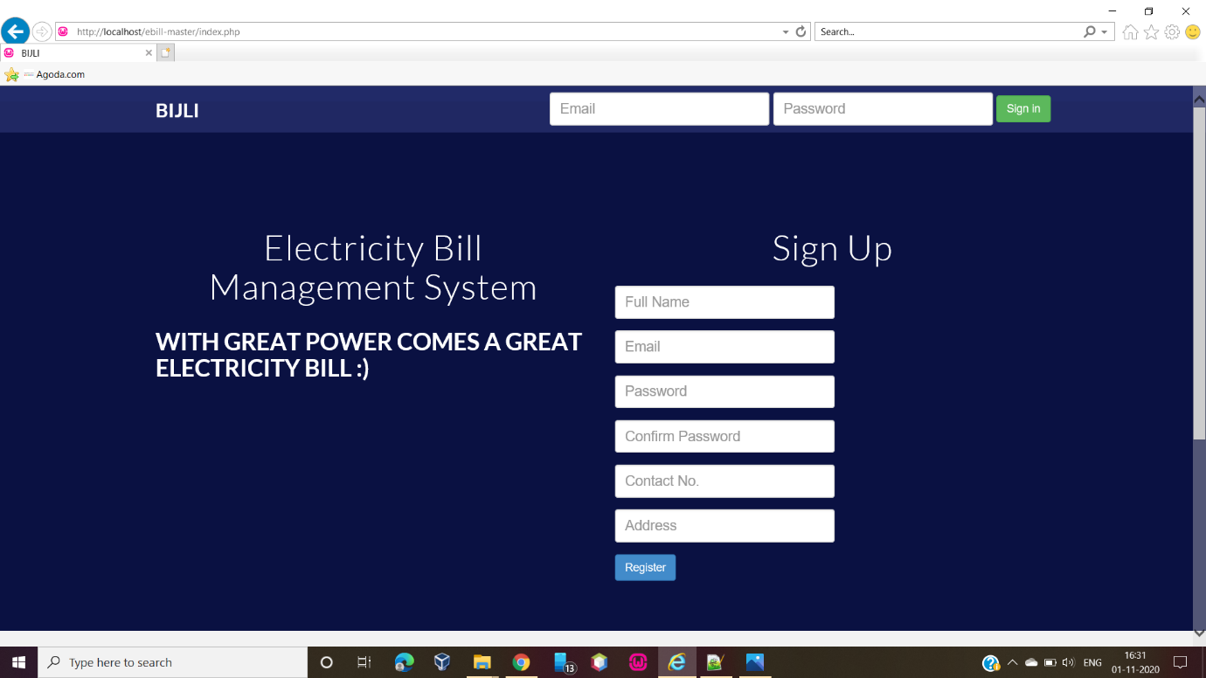

**ADMIN :**

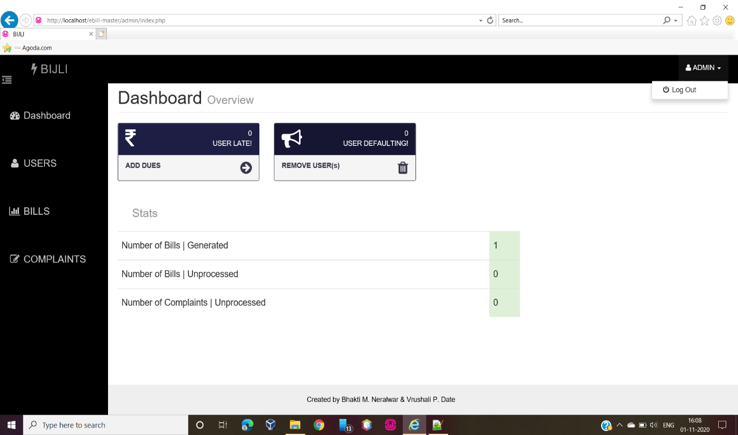

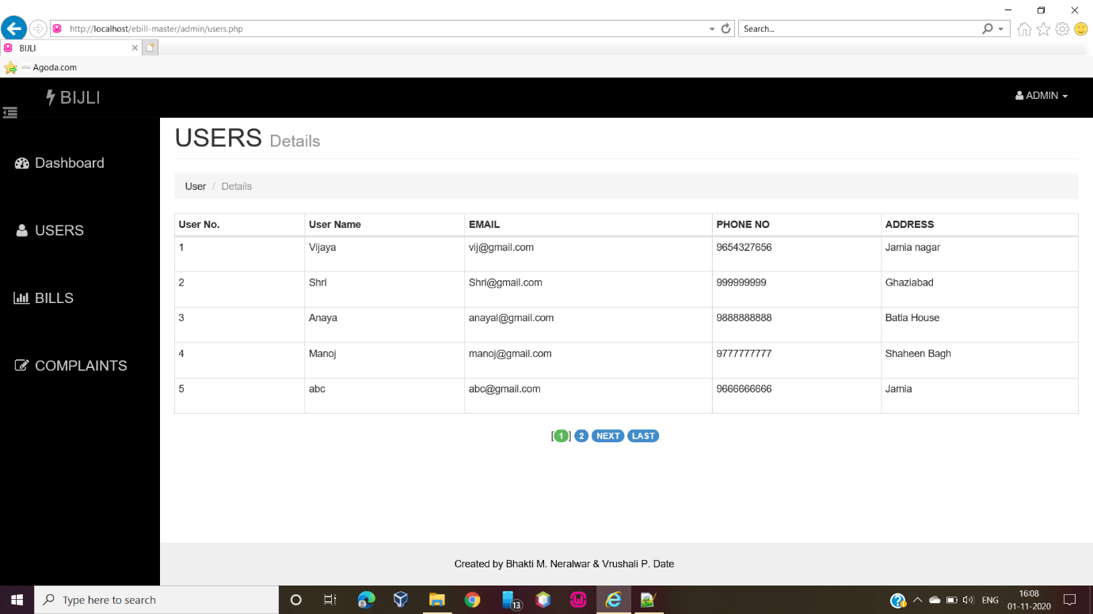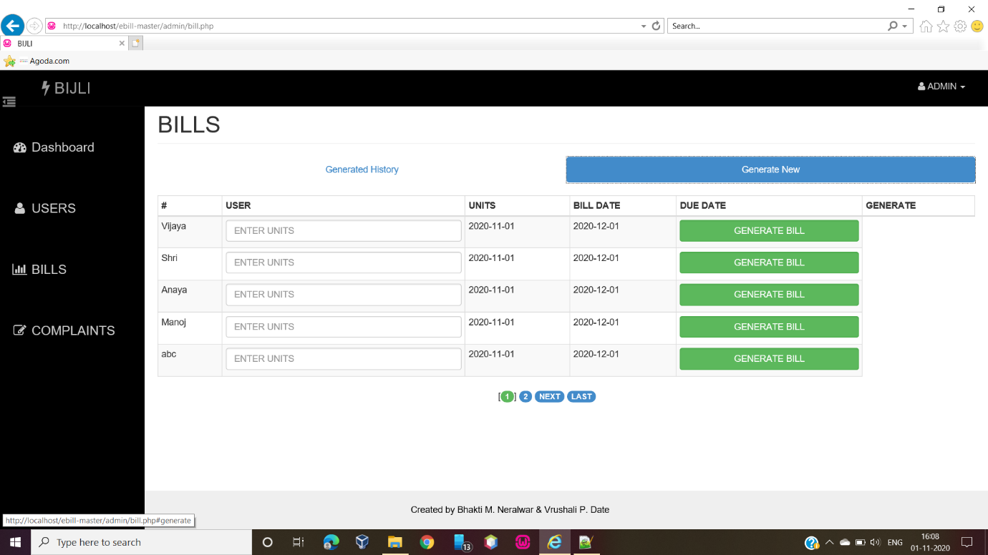

**USER :**

