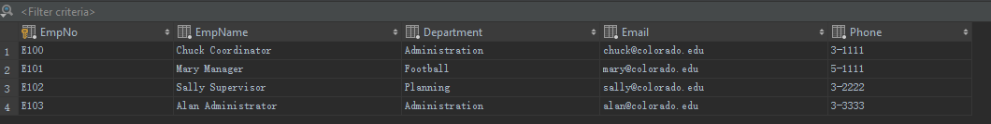

CREATE TABLE Employee

(

EmpNo CHAR(8) PRIMARY KEY NOT NULL,

EmpName VARCHAR(50) NOT NULL,

Department VARCHAR(50) NOT NULL,

Email VARCHAR(50) NOT NULL,

Phone CHAR(6) NOT NULL

);