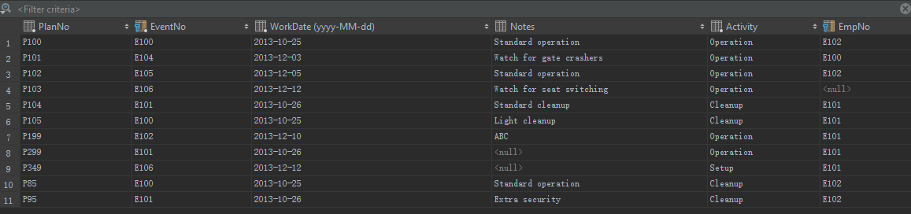

**CREATE TABLE** EventPlan  
(  
 PlanNo **CHAR**(8) **NOT NULL PRIMARY KEY**,  
 EventNo **CHAR**(8) **NOT NULL**,  
 WorkDate **DATE NOT NULL**,  
 Notes **VARCHAR**(50),  
 Activity **VARCHAR**(10) **NOT NULL**,  
 EmpNo **CHAR**(8),  
 **CONSTRAINT** EventPlan_eventrequest_EventNo_fk **FOREIGN KEY** (EventNo) **REFERENCES** eventrequest (EventNo),  
 **CONSTRAINT** EventPlan_employee_EmpNo_fk **FOREIGN KEY** (EmpNo) **REFERENCES** employee (EmpNo)  
)